SMART TRAFFIC CONTROL SYSTEM USING MATLAB
(4-Way Intersection with Vehicle Detection Simulation)

Abstract:
This project presents the design and simulation of a smart traffic control system for a four-way intersection using MATLAB App Designer. The system dynamically adjusts traffic signal timing based on vehicle density detected from road images using image processing techniques. Each road is analyzed individually to estimate vehicle count through grayscale conversion, thresholding, and connected component analysis. Unlike conventional fixed-time traffic systems, this model prioritizes roads with higher traffic and sequentially clears congestion. The system also incorporates signal transitions (Red, Yellow, Green), graphical visualization, and vehicle flow simulation, providing a realistic representation of intelligent traffic management systems.
Introduction:
Traffic congestion is a major problem in urban areas due to inefficient traffic management systems. Traditional traffic signals operate on fixed timing regardless of traffic conditions, leading to unnecessary delays and increased waiting time.
This project aims to overcome these limitations by developing a smart traffic control system that uses image processing techniques to detect vehicle density on each road. Road images are analyzed to estimate traffic conditions, and signal timing is adjusted dynamically based on the detected vehicle count.
The system is implemented using MATLAB App Designer and provides a real-time simulation of traffic flow with graphical visualization and signal transitions. This approach demonstrates a practical and intelligent solution for modern traffic management systems.
Objectives:
- To simulate a 4-way traffic intersection using MATLAB
- To implement vehicle detection using image processing techniques
- To estimate vehicle density from road images
- To design a dynamic traffic signal control system based on detected traffic
- To visualize traffic conditions using real-time graphs
- To simulate signal transitions (Red, Yellow, Green)
- To demonstrate efficient traffic flow management

Methodology:
The proposed smart traffic control system is designed to simulate an intelligent four-way intersection using MATLAB App Designer. The methodology focuses on replicating real-world traffic behavior through logical decision-making, dynamic signal control, and continuous system updates. The overall system is divided into multiple stages to ensure clarity, modularity, and efficient functioning.

- Vehicle Detection using Image Processing
In this system, vehicle detection is performed using image processing techniques instead of random data generation. Images corresponding to each road are provided as input to the system. Each image is processed individually to estimate the number of vehicles present.
The process begins by converting the input image into grayscale, which simplifies the image by removing color information. The grayscale image is then converted into a binary image using thresholding, where the foreground (vehicles) is separated from the background.
To improve accuracy, noise and small unwanted regions are removed using morphological operations. The cleaned binary image is then analyzed using connected component labeling to identify distinct objects, where each object represents a vehicle or group of vehicles.
The number of detected objects is used as an estimate of vehicle count for each road. This method provides a realistic and practical approach for traffic density estimation.
- Traffic Density Analysis
Once the vehicle data is generated, the system analyzes traffic density across all four roads. This is achieved by comparing the number of vehicles on each road and arranging them in descending order.
The sorting process helps in identifying the road with the highest traffic congestion. This prioritization mechanism ensures that roads with heavier traffic are serviced first, thereby reducing waiting time and improving overall traffic efficiency.

- Signal Control Logic
The signal control system is designed to mimic real-world traffic signals with three primary states:
RED – Indicates stop
YELLOW – Indicates transition/preparation
GREEN – Indicates movement
The system first sets all roads to RED to ensure safety. It then activates the YELLOW signal for the selected road as a transition phase. After a brief delay, the signal changes to GREEN, allowing vehicles on that road to pass.
This structured transition improves realism and reflects actual traffic signal behavior.

- Dynamic Signal Timing
Unlike traditional traffic systems that use fixed time intervals, this project implements a dynamic timing mechanism. The duration of the GREEN signal is determined based on the number of vehicles present on the selected road.
A higher vehicle count results in a longer GREEN signal duration, while a lower count results in a shorter duration. This adaptive approach ensures efficient utilization of time and reduces unnecessary waiting periods.

- Traffic Flow Simulation
To simulate real-world traffic movement, the system reduces the number of vehicles during the GREEN signal phase. This is achieved by decrementing the vehicle count at each time interval.
The reduction process continues until either the signal duration ends or the vehicle count reaches zero. This feature effectively represents vehicles passing through the intersection and adds realism to the simulation.

- Sequential Road Processing
The system does not stop after servicing a single road. Instead, it processes all four roads sequentially based on their traffic density ranking.
Each road is given a turn in decreasing order of vehicle count. This ensures fairness and prevents starvation of less congested roads while still prioritizing heavy traffic.

- Graphical Visualization
To enhance understanding and provide visual feedback, the system includes a graphical representation of traffic density using bar graphs.
The graph is updated in real time as vehicle counts change. This allows users to observe traffic flow dynamics and analyze how the system responds to varying conditions.
The use of drawnow ensures that the graphical interface updates instantly during simulation.

- User Interface Design
The system is implemented using MATLAB App Designer, which provides an interactive graphical user interface. The interface includes:
- Numeric fields to display vehicle count
- Labels to indicate signal status
- Color-coded signal indicators (RED, YELLOW, GREEN)
- A graph area for visualization
- Control buttons for simulation
This design ensures user-friendly interaction and improves the overall presentation of the system.

- System Execution Flow
The complete workflow of the system can be summarized as follows:
    - Load road images for all four directions
    - Perform image processing to detect vehicles
    - Calculate vehicle count for each road
    - Display initial traffic data
    - Analyze and sort traffic density
    - Select highest priority road
    - Apply YELLOW signal
    - Transition to GREEN signal
    - Reduce vehicle count dynamically
    - Update graph and interface
    - Repeat for remaining roads
    - Complete one cycle of traffic control

- Real-Time Simulation Behavior
The system operates in a time-controlled manner using delays (pause) to simulate real-time signal durations. Combined with continuous updates and visualization, this creates a realistic simulation environment.
The inclusion of dynamic updates and interactive elements ensures that the system closely resembles actual traffic management systems used in modern smart cities.
System Components:
Software: MATLAB, App Designer
Modules: Detection, Decision, Signal Control, Visualization, UI
Algorithm:
The smart traffic control system follows a structured algorithm to simulate dynamic traffic signal operation at a four-way intersection using image-based vehicle detection.
- Start the System
Initialize the MATLAB App Designer environment and prepare all user interface components, including signal indicators, vehicle display fields, and graphical axes.
- Load Road Images
Load images corresponding to each of the four roads using MATLAB functions.
- Perform Image Processing
Convert each image into grayscale, apply binary thresholding, and remove noise using morphological operations.
- Detect and Count Vehicles
Apply connected component labeling to identify distinct objects and estimate the number of vehicles present on each road.
- Store Vehicle Data
Store the detected vehicle counts in an array representing all four roads.
- Display Initial Traffic Condition
Update the user interface to display vehicle counts and plot a graph representing traffic density.
- Analyze Traffic Density
Sort the vehicle counts in descending order to determine road priority.
- Select Priority Road
Choose the road with the highest vehicle count for signal activation.
- Set All Signals to RED
Ensure all signals are initially set to RED to maintain safety.
- Activate YELLOW Signal (Transition Phase)
Set the selected road signal to YELLOW and wait for a short duration.
- Switch to GREEN Signal (Movement Phase)
Allow vehicles to move by turning the signal GREEN.
- Calculate Dynamic Signal Timing
Determine GREEN signal duration based on vehicle density.
- Simulate Vehicle Movement
Gradually reduce vehicle count during GREEN phase and update the display.
- Update Graphical Representation
Continuously update the graph to reflect real-time traffic conditions.
- Repeat for Remaining Roads
Process all roads sequentially based on priority.
- Complete One Traffic Cycle
After all roads are processed, complete one cycle.
- End the Simulation
Stop the system or wait for further execution.
Code Implementation:
- Image-Based Vehicle Detection
img1 = imread('road1.jpg');
gray1 = rgb2gray(img1);
bw1 = imbinarize(gray1);
bw1 = imcomplement(bw1);
bw1 = bwareaopen(bw1, 500);
[~, v1] = bwlabel(bw1);
Explanation:
Vehicle detection is performed using image processing techniques. The input image is converted into grayscale to simplify processing, followed by binary thresholding to separate vehicles from the background. Noise is removed using morphological operations, and connected component labeling is used to count detected vehicles.

- Multi-Road Vehicle Detection
vehicles = [v1 v2 v3 v4];
Explanation:
Vehicle counts from all four road images are stored in an array, which represents the traffic density of each road.
- Traffic Prioritization
[sortedVehicles, order] = sort(vehicles, 'descend');
Explanation:
The roads are sorted based on vehicle density so that the road with the highest traffic is given priority.
- Signal Initialization
app.Signal1.Text = 'RED';
app.Signal2.Text = 'RED';
app.Signal3.Text = 'RED';
app.Signal4.Text = 'RED';
Explanation:
All traffic signals are initially set to RED to ensure safety.
- Signal Transition
app.Signal1.Text = 'YELLOW';
app.Signal1.FontColor = [1 1 0];
Explanation:
The YELLOW signal indicates the transition phase before turning GREEN.
- Dynamic Signal Timing
green_time = 3 + round(sortedVehicles(i)/5);
Explanation:
The duration of the GREEN signal is dynamically adjusted based on vehicle density.
- Vehicle Reduction Logic
vehicles(road) = max(vehicles(road) - randi([1 3]), 0);
Explanation:
Vehicle count decreases during the GREEN signal phase to simulate traffic movement.

- Graph Visualization
bar(app.UIAxes, vehicles);
drawnow;
Explanation:
The graph is updated in real-time to represent current traffic conditions.

Output:
The smart traffic control system was successfully implemented and tested using MATLAB App Designer. The system performs image-based vehicle detection and dynamically controls traffic signals based on the detected vehicle density.
The following outputs were observed during simulation:
- Vehicle detection is performed using image processing techniques for all four roads
- Binary images are generated to highlight detected vehicle regions
- Vehicle counts are calculated for each road and displayed in the interface
- A real-time graph is plotted to represent traffic density across all roads
- Traffic signals transition between RED, YELLOW, and GREEN based on priority
- Vehicle count decreases dynamically during the GREEN signal phase
Figure 1: Road 1 Vehicle Detection
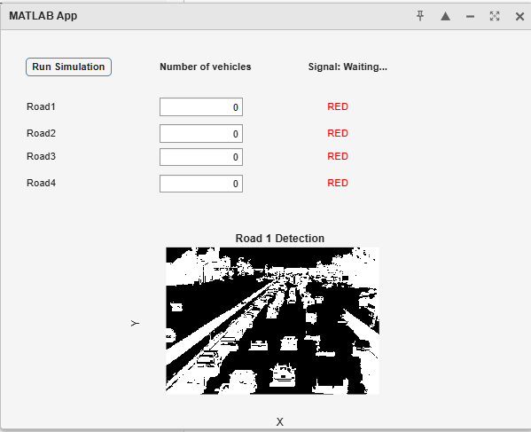

Figure 2: Road 2 Vehicle Detection
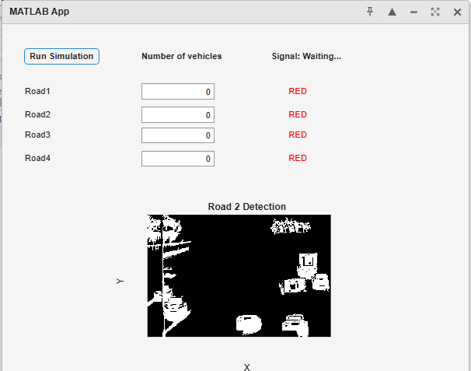
Figure 3: Road 3 Vehicle Detection
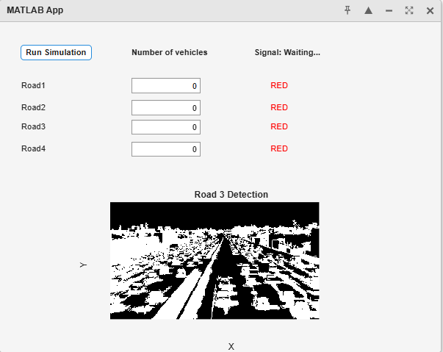
Figure 4: Road 4 Vehicle Detection
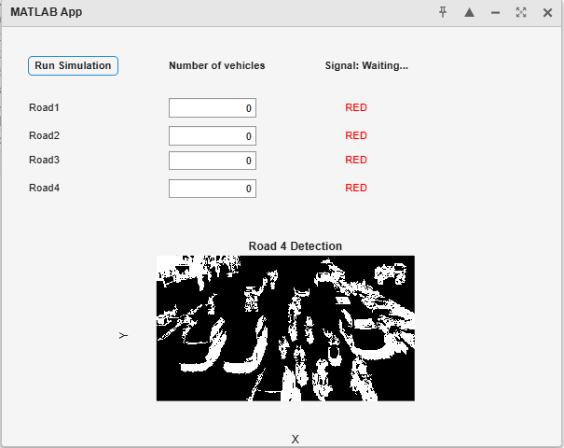
Figure 5: Traffic Density Graph
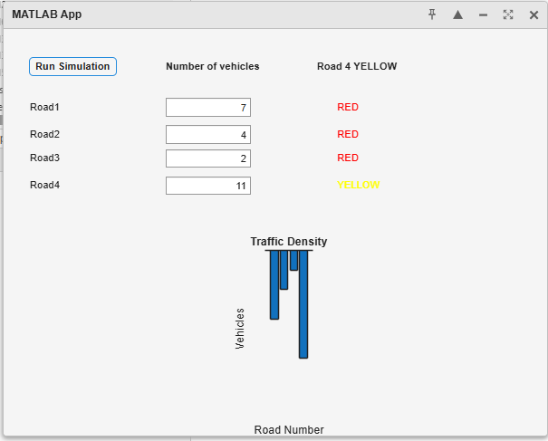
Figure 6: Signal Operation
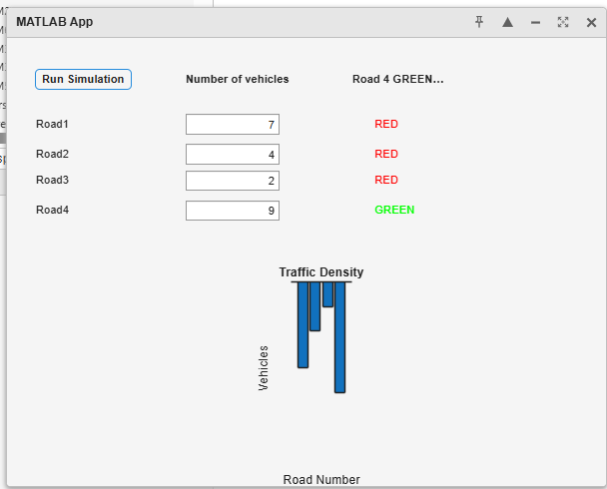
Figure 7: Final Traffic Clearance
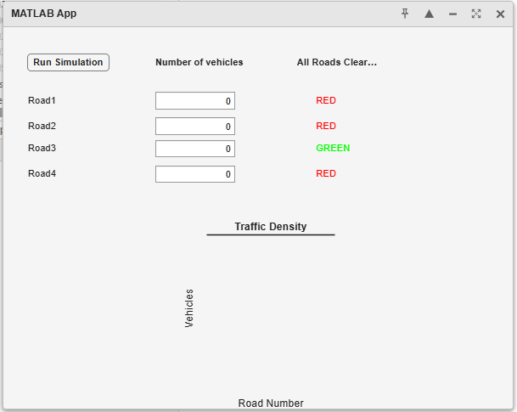
Applications:
The proposed smart traffic control system using image-based vehicle detection has several practical applications in modern transportation and intelligent systems.
- Smart Traffic Management Systems
The system can be implemented at urban intersections to dynamically control traffic signals based on real-time vehicle density detected from road images.
- Smart Cities and Urban Infrastructure
It can be integrated into smart city frameworks to improve traffic flow, reduce congestion, and optimize transportation efficiency.
- Congestion Monitoring and Control
The system helps in identifying high-traffic areas and prioritizing roads accordingly, reducing waiting time and traffic jams.
- Image-Based Traffic Analysis
The project can be used for analyzing traffic patterns using image processing techniques, which is useful for research and planning.
- Emergency Vehicle Prioritization (Future Extension)
The system can be enhanced to detect emergency vehicles and provide immediate signal clearance.
- Automated Traffic Signal Systems
It reduces the need for manual traffic control by enabling automated signal operation based on real-time conditions.
- Campus and Industrial Traffic Management
The system can be applied in controlled environments such as universities and industrial areas to manage internal traffic efficiently.
- Integration with IoT and AI Systems
The model can be extended using IoT sensors and AI algorithms for real-time monitoring and predictive traffic management.
Advantages:
The system improves traffic efficiency by dynamically adjusting signal timing based on vehicle density detected using image processing. It reduces congestion and minimizes unnecessary waiting time at intersections. Additionally, it provides real-time visualization and automated control, making it easy to monitor and manage traffic effectively.

Future Scope:
The system can be enhanced by integrating real-time camera feeds for live vehicle detection instead of static images. Advanced image processing and deep learning techniques can be used to improve detection accuracy and identify different types of vehicles. Additionally, the model can be extended with IoT-based systems and smart city infrastructure for fully automated and intelligent traffic management.
Conclusion:
The project successfully demonstrates the design and implementation of a smart traffic control system using MATLAB App Designer with image-based vehicle detection. By analyzing road images using image processing techniques, the system is able to estimate vehicle density and dynamically adjust traffic signal timing. This approach improves traffic efficiency and overcomes the limitations of traditional fixed-time traffic systems.
The integration of image processing with real-time simulation, graphical visualization, and signal control provides a practical and effective solution for modern traffic management. The project highlights how intelligent systems can be developed using simple techniques and can be further extended into real-world applications using advanced technologies such as IoT and artificial intelligence.
Project Demonstration Link:
The complete project including source code and documentation is available at:
CHETHAN-GUPTA-ANNAM/Smart-Traffic-Control-System: MATLAB based smart traffic control system simulation

