“Economic Model-Predictive Control Strategies for Aircraft Deep-stall Recovery with Stability Guarantees”

* In this paper, we propose a loss of altitude (LOA) minimizing economic model predictive control (EMPC) strategy for deep-stall recovery
* LOA is an important performance metric for upset recovery maneuvers
* MPC is promising since it can handle nonlinearities, actuator saturation, and state constraints.
* Longitudinal aircraft dynamics ,which is given by:

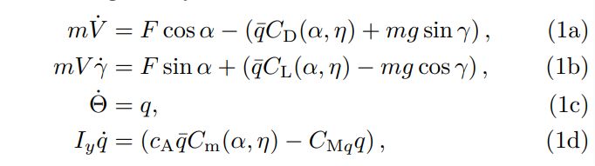

with airspeed V , inclination $γ$, pitch rate q, angle of attack $α$, pitch angle $Θ=γ+ α$, and elevator deflection $η$, where $\overline{q}=\frac{1}{2}ϱSV^{2}$ and $C_{Mq}> 0$ is a linear damping parameter. The aircraft’s descent rate is then

$$\dot{z_{g}}=-V\sin\left(γ\right)$$

The aerodynamic coefficients $C_{L},C_{D},Cm$ are given as continuous piecewise polynomial models

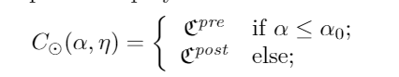

With $α_{0}=16.29$ ° and ${ e}^{pre},e^{post}$ is polynomials and remaining parameters are provide in [31]

(R[$α, η$] is the set of polynomials with real coefficients

and [31] is (T. Cunis and A. la Cour-Harbo, “Piecewise PolynomialModel of the Aerodynamic Coefficients of theCumulus OneUnmanned Aircraft,” Sky-Watch A/S, Støvring, DK, Tech.Rep.hal-02280789. [Online]. Available:https://hal-enac.archives-ouvertes.fr/hal-02280789)

and superscripts pre and post denote low and high-angle of attack dynamics)

“Optimization of aircraft spin recovery maneuvers”

* Aircraft spin is a nonlinear post-stall phenomena in which an aircraft develops a high rotational-rate and descends almost vertically in a helical trajectory. Asymmetric aerodynamics, instabilities and loss of control in lateral direction at angles-of-attack beyond stall cause an aircraft to depart and enter into a spin.
* In this paper, the problem of aircraft spin recovery is solved as a trajectory optimization problem using direct multiple shooting method with time and altitude-loss as cost functions to be minimized.
* Equations of motion:

The nonlinear equations of motion of a rigid-body aircraft are given by []: (P. Raghavendra, T. Sahai, PA. Kumar, M. Chauhan, N. Ananthkrishnan, Aircraft spin recovery, with and without thrust vectoring, using nonlinear dynamic inversion, J. Aircr. 42 (6) (2005) 1492-1503.)

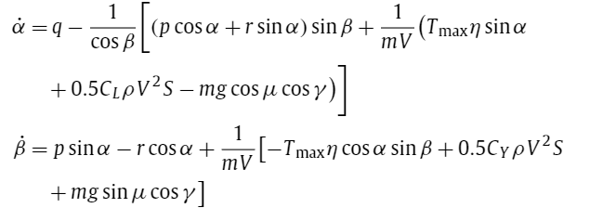

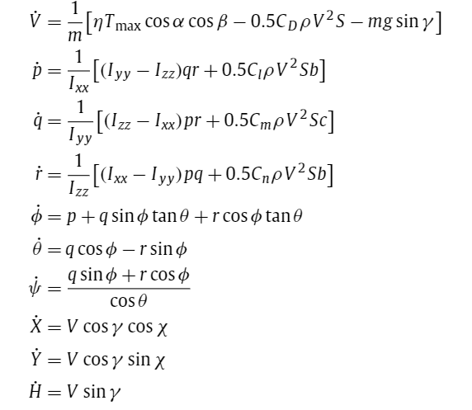

where $α,β$ and V are angle-of-attack, sideslip angle, and total velocity, respectively; p, q and r are angular velocities; $ϕ,θ$ and $ψ$ are Euler angles; X, Y and Z are position variables in Earth frame-of-reference. The trigonometric expressions in $γ,μ$ and $χ$ are related to other variables as

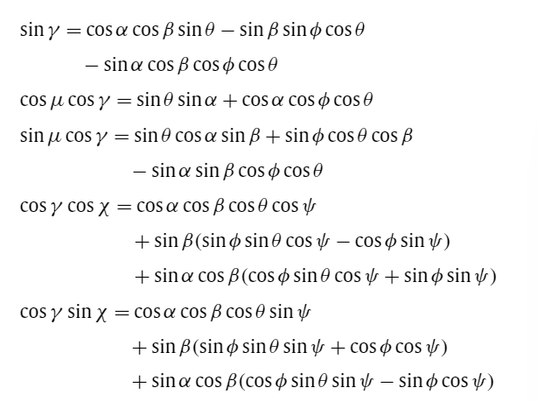

In the presence of wind, body-axis velocities, u, v, and w, are used instead of $α, β$, and V. Time-derivatives of position are also modified to include wind speeds [20].( W. Frost, RL. Bowles, Wind shear terms in the equations of aircraft motion, J. Aircr. 21 (11) (1984) 866-872.)

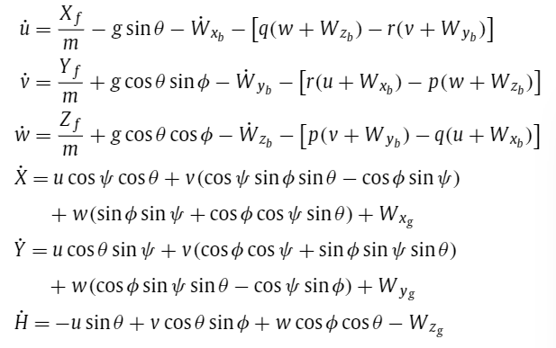

* The aerodynamic force and moment coefficients are related to the stability derivatives as

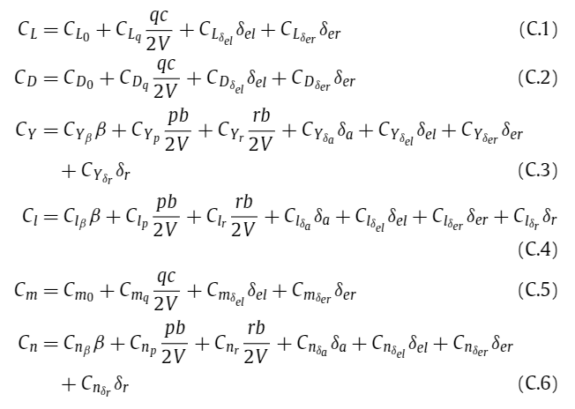

“Deep Reinforcement Learning as Control Methdo for Autonomous UAVs”

* The results of the study support the idea of full control of an autonomous drone through DRL methods since we achieved an 80% success rate in solving the task under a near human-level of performance
* this thesis aims to solely conduct the training of the DRL method in a simulated environment and leave it to future work to investigate the transfer to the real world

Reward设置：

只考虑了roll，pitch，roll_rate, pitch_rate , elevator , aileron

首先是飞机姿态和平稳状态的距离，其次是actions[elevator aileron]离预想动作的距离，在aileron应该和roll相反方向，在考虑roll_rate的影响，若roll_rate与roll同向，aileron应往相反方向变化更大，反之则减小。Pitch同理。我下面的公式计算

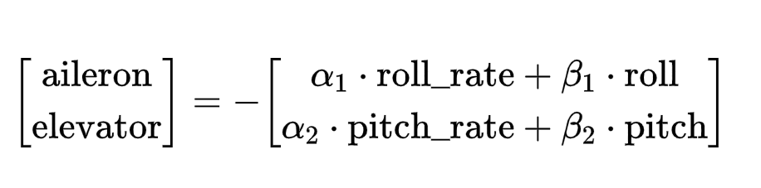

$α,β$ 是自己设的权重参数, 为了方便 $α_{1}=α_{2},β_{1}=β_{2}$

Reward先直接用两个距离的和的负数(距离越大减的越多)，在附加上额外奖励(或许不用？)。

不足：没有考虑油门，yaw等

