**Problem Statement 1:**

**Find the list of players that have been selected in the qualifying round (DEFENSE>55).**

**===============================================================**

grunt> REGISTER '/home/cloudera/chhaya/pokemon_usecase/piggybank-0.15.0.jar';

grunt> load_data = LOAD '/home/cloudera/chhaya/pokemon_usecase/Pokemon.csv' USING PigStorage(',') AS (Sno:int,Name:chararray,Type1:chararray,Type2:chararray,Total:int,HP:int,Attack:int,Defense:int,SpaAtk:int,SpaDef:int,Speed:int);

grunt> selected_list = FILTER load_data BY Defense > 55 ;

grunt> dump selected_list ;

Output:

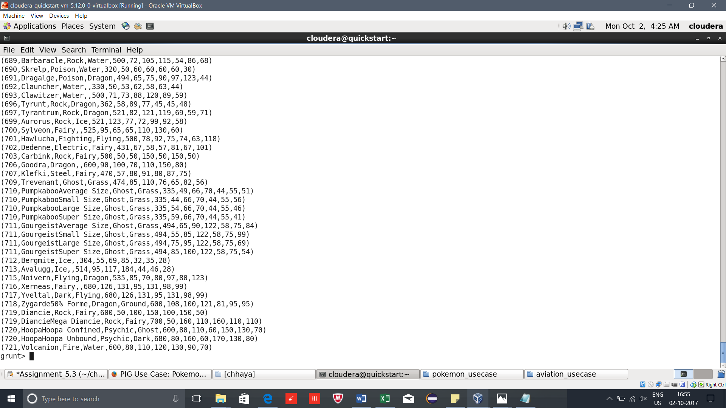

**===============================================================**

**Problem Statement 2 :**

grunt> group_selected_list = GROUP selected_list All;

grunt> describe group_selected_list;

group_selected_list: {group: chararray,selected_list: {(Sno: int,Name: chararray,Type1: chararray,Type2: chararray,Total: int,HP: int,Attack: int,Defense: int,SpaAtk: int,SpaDef: int,Speed: int)}}

grunt> count_group_selected_list = FOREACH group_selected_list GENERATE COUNT(selected_list);

grunt> describe count_group_selected_list ;

count_group_selected_list: {long}

grunt> dump count_group_selected_list;

Output:



**===============================================================**

**Problem Statement 3:**

grunt> describe selected_list;

selected_list: {Sno: int,Name: chararray,Type1: chararray,Type2: chararray,Total: int,HP: int,Attack: int,Defense: int,SpaAtk: int,SpaDef: int,Speed: int}

grunt> random_include1 = FOREACH selected_list GENERATE RANDOM(),Name,Type1,Type2,Total,HP,Attack,Defense,SpaAtk,SpaDef,Speed;

grunt> DUMP random_include1 ;

Output:

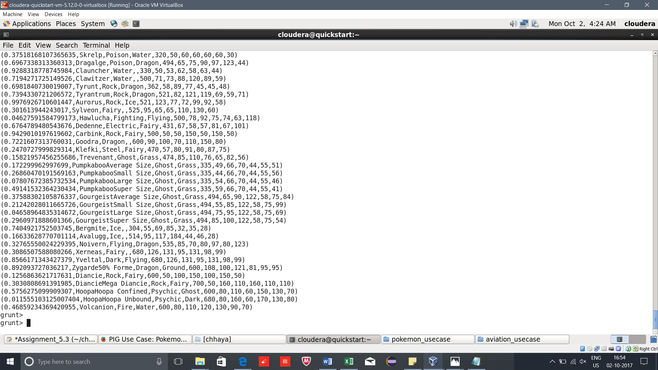

**===============================================================**

**Problem Statement 4: Arrange the new list in a descending order according to a column randomly.**

grunt> random1_desending = ORDER random_include1 BY $0 DESC;

grunt> DUMP random1_desending ;

Output:

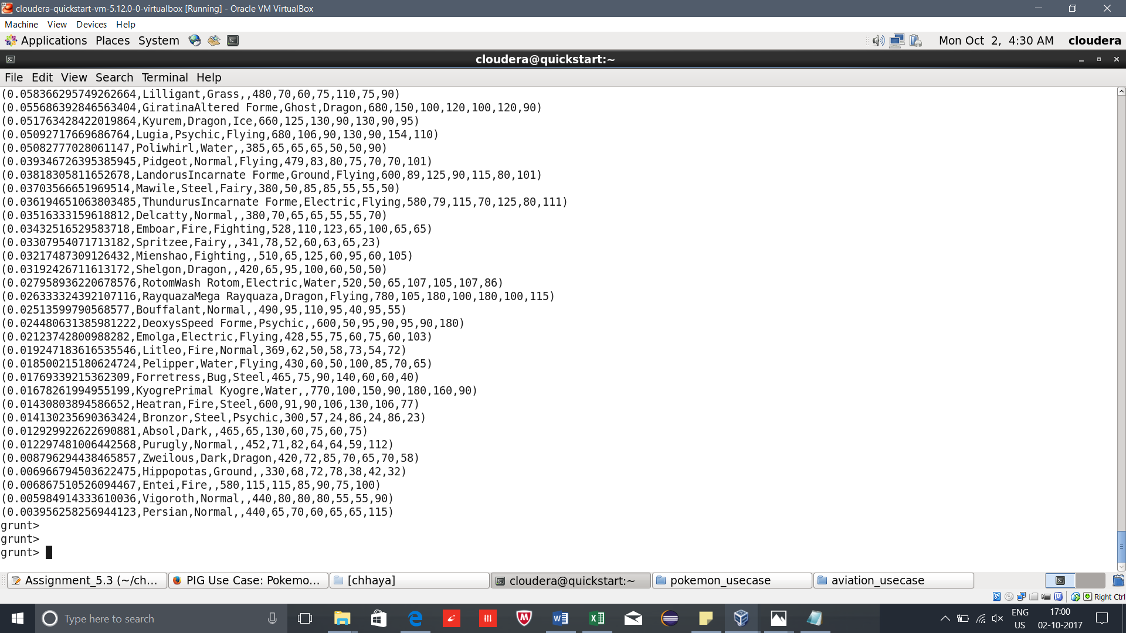

**===============================================================**

**Problem Statement 5:**

On a new relation again associate random numbers for each Pokémon and arrange in descending order according to column random.

grunt> random_include2 = FOREACH selected_list GENERATE RANDOM(),Name,Type1,Type2,Total,HP,Attack,Defense,SpaAtk,SpaDef,Speed;

grunt> random2_desending = ORDER random_include2 BY $0 DESC;

grunt> dump random2_desending;

Output:

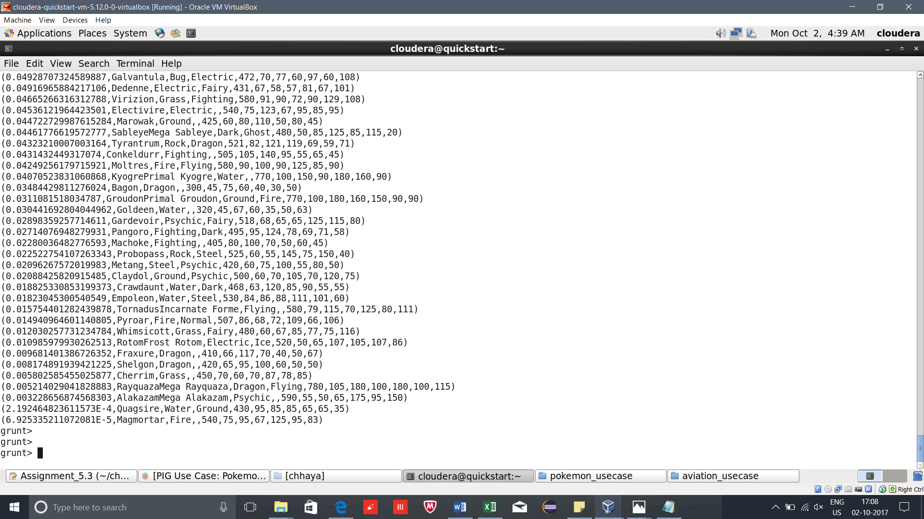

**===============================================================**

**Problem Statement 6:**

From the two different descending lists of random Pokémons, select the top 5 Pokémons for 2 different players.

grunt> describe random1_desending;

random1_desending: {org.apache.pig.builtin.random_69: double,Name: chararray,Type1: chararray,Type2: chararray,Total: int,HP: int,Attack: int,Defense: int,SpaAtk: int,SpaDef: int,Speed: int}

grunt> describe random2_desending;

random2_desending: {org.apache.pig.builtin.random_76: double,Name: chararray,Type1: chararray,Type2: chararray,Total: int,HP: int,Attack: int,Defense: int,SpaAtk: int,SpaDef: int,Speed: int}

grunt> limit_data_random1_desending = LIMIT random1_desending 5;

grunt> limit_data_random2_desending = LIMIT random2_desending 5;

grunt> DUMP limit_data_random1_desending;

Output:

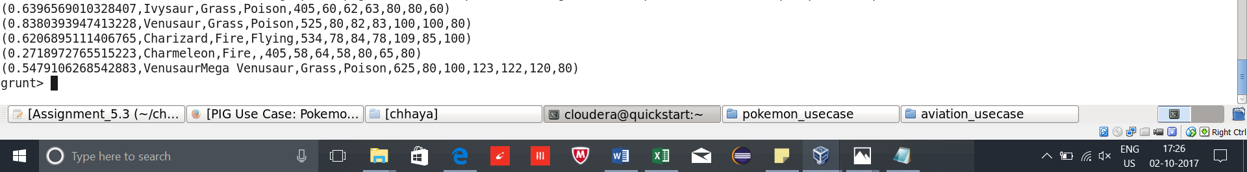

grunt> DUMP limit_data_random2_desending;

Output:

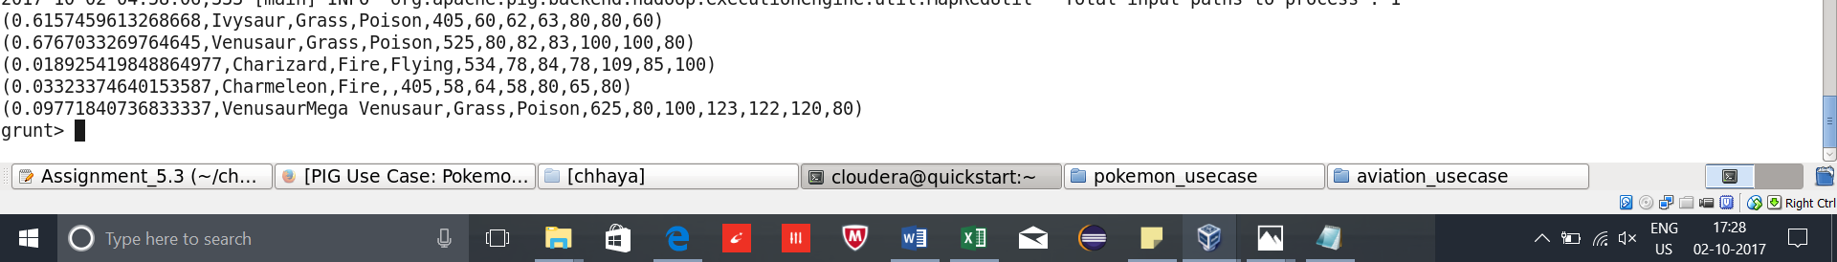

**===============================================================**

**Problem Statement 7:**

**Store the data on a local drive to announce for the final match. By the name player1 and player2 (only show the NAME and HP).**

grunt> filter_only_name1 = FOREACH limit_data_random1_desending Generate ($1,HP);

grunt> filter_only_name2 = FOREACH limit_data_random2_desending Generate ($1,HP);

grunt> DUMP filter_only_name1;

Output:

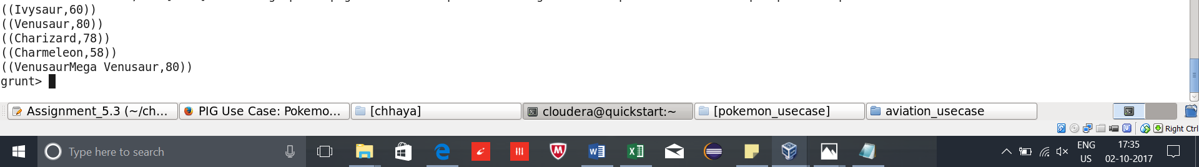

grunt> DUMP filter_only_name2;

Output:



grunt> STORE limit_data_random1_desending INTO '/home/cloudera/chhaya/pokemon_usecase/player1.txt' ;

Output:

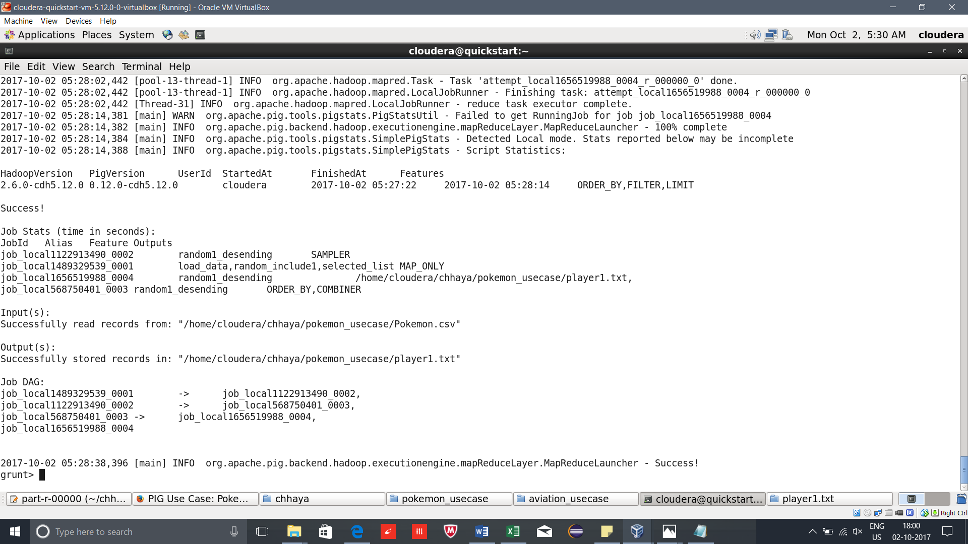

grunt> STORE limit_data_random2_desending INTO '/home/cloudera/chhaya/pokemon_usecase/player2.txt' ;

Output:



