CREATE DATABASE IF NOT EXISTS organization;  
  
CREATE TABLE IF NOT EXISTS employee  
(  
emp_id int,  
emp_name string,  
emp_salary int,  
emp_unit string  
)  
row format delimited fields terminated by ','  ;  
LOAD DATA LOCAL INPATH "/home/cloudera/chhaya/hive/emp.txt" INTO TABLE employee ;

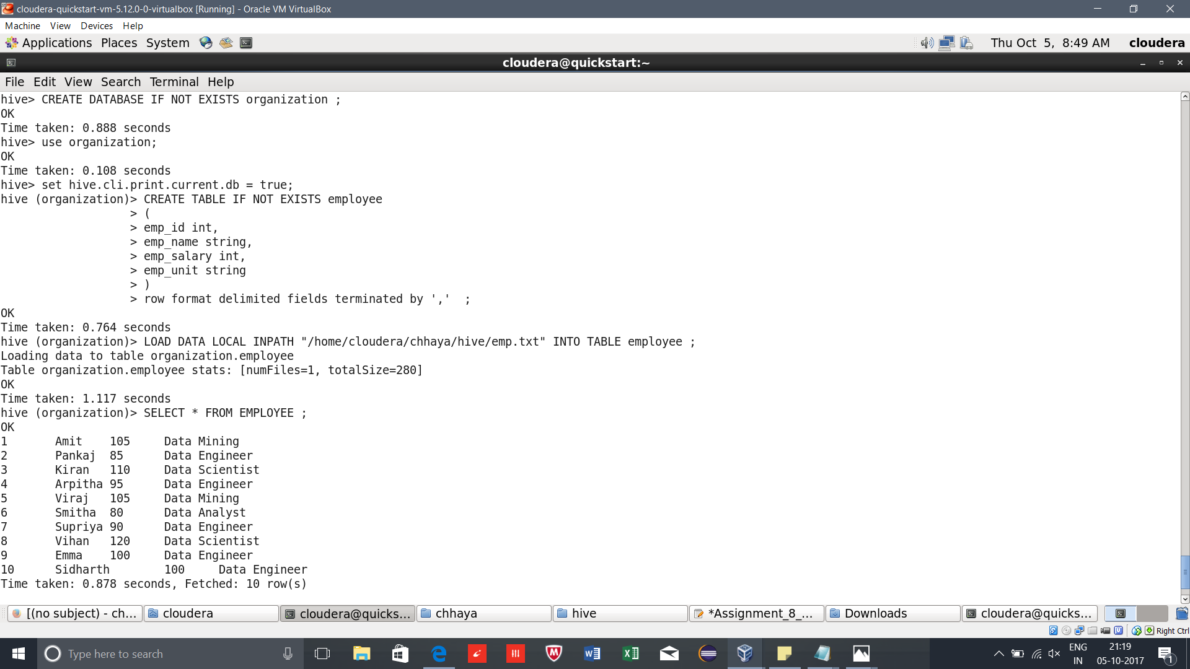

**Problem Statement 8.1:**

**get a list of employees who receive a salary less than 100, compared to their immediate employee with higher salary in the same unit.**  
  
select emp_id , emp_name, emp_salary, emp_unit , maximum from (  
select max(emp_salary) over(partition by emp_unit) as maximum, emp_id,emp_name,emp_salary,emp_unit from employee) temp  
where emp_salary < 100;

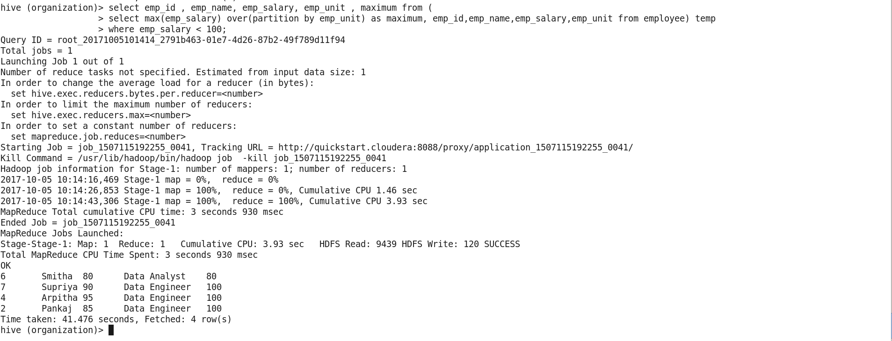

**Problem Statement 8.2:**  
**list of all employees who draw higher salary than the average salary of that department.**  
  
select emp_id , emp_name, emp_salary, emp_unit ,avgr from (  
select avg(emp_salary) over(partition by emp_unit) as avgr, emp_id,emp_name,emp_salary,emp_unit from employee) temp   
where avgr < emp_salary;

