**Input Command 1:**

ADD JAR /home/cloudera/Downloads/finaludf.jar ;

**Input Command 2:**

CREATE TEMPORARY FUNCTION concat_ws AS ‘packageHive.MyUDF’;

**Input Command 3:**

CREATE DATABASE IF NOT EXISTS MYUDFDEMO;

**Input Command 4:**

CREATE TABLE IF NOT EXISTS teamplayer( empid int, role array<string>,salary int)

Row format field terminated by ‘,’

Collection items terminated by ‘~’

;

**Input Command 5:**

LOAD DATA LOCAL INPATH ‘/home/cloudera/chhaya/hive/role.txt’

INTO TABLE teamplayer;

**Input Command 6:**

SELECT * FROM teamplayer :

**Input Command 7:**

SELECT concat_ws(“:”,role) FROM teamplayer;

**Input Command 8:**

SELECT concat_ws(“~”,role) FROM teamplayer;

**Input Command 9:**

SELECT concat_ws(“,”, role) , salary FROM teamplayer;

**Input Command 10** :

SELECT empid, concat_ws(“^^”,role), salary FROM teamplayer ;

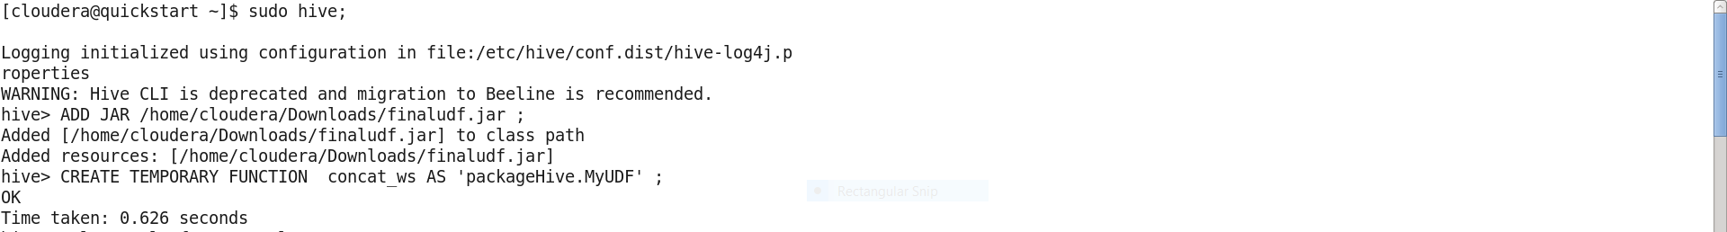



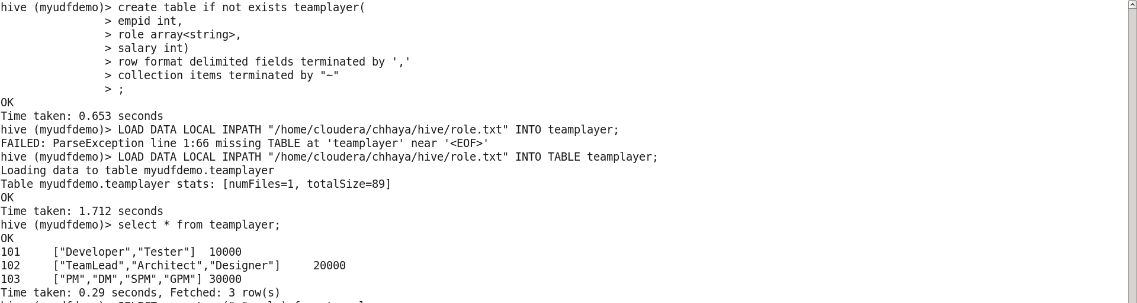

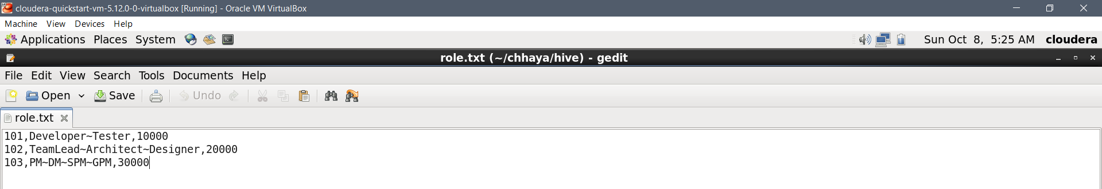

**FINAL OUTPUT:**

