**SPARK ASSIGNMENT 17.1**

_______________________________________________________________________________________________________

**Problem Statement**

1. Write a program to read a text file and print the number of rows of data in the document.

2. Write a program to read a text file and print the number of words in the document.

3. We have a document where the word separator is -, instead of space. Write a spark

code, to obtain the count of the total number of words present in the document.

Sample document :

This-is-my-first-assignment.

It-will-count-the-number-of-lines-in-this-document.

The-total-number-of-lines-is-3

_______________________________________________________________________________________________________

//starting the HDFS

[acadgild@localhost sparkdata]$ start-dfs.sh

//creating and editing the input file at LOCAL filesystem

[acadgild@localhost sparkdata]$ gedit chhaya.txt

//Browsing the contents of text file

[acadgild@localhost sparkdata]$ cat chhaya.txt

//creation of user directory at HDFS

[acadgild@localhost sparkdata]$ hadoop fs -mkdir -p /user/acadgild/spark/

//Browsing through the HDFS user directory

[acadgild@localhost sparkdata]$ hadoop fs -ls /user/acadgild/spark/

//moving file from local filesystem to HDFS

[acadgild@localhost sparkdata]$ hadoop fs -copyFromLocal chhaya.txt /user/acadgild/spark/

//Browsing through hdfs directory to verify the file

[acadgild@localhost sparkdata]$ hadoop fs -ls /user/acadgild/spark/

Found 1 items

-rw-r--r-- 1 acadgild supergroup 192 2017-11-21 02:35 /user/acadgild/spark/chhaya.txt

//View the HDFS file

[acadgild@localhost sparkdata]$ hadoop fs -cat /user/acadgild/spark/chhaya.txt

// Initiating the spark shell prompt

acadgild@localhost sparkdata]$ spark-shell

_______________________________________________________________________________________________________

//read the text file from hdfs via spark context object

val rdd1 = sc.textFile("hdfs://localhost:9000//user/acadgild/spark/chhaya.txt",1)

//flattening the text file and splitting it linewise.

val rdd2 = rdd1.flatMap(lines => if (lines.equals("")) Array[String]() else lines.split("\n"))

//removing empty lines to get exact amount if the file contains empty lines.

val rdd3 = rdd2.filter(lines => !lines.equals(""))

//calculating the total count of non empty lines in document

val totallines = rdd3.count()

//display total nr of non empty lines

println(totallines)

**Input file Screenshot:**

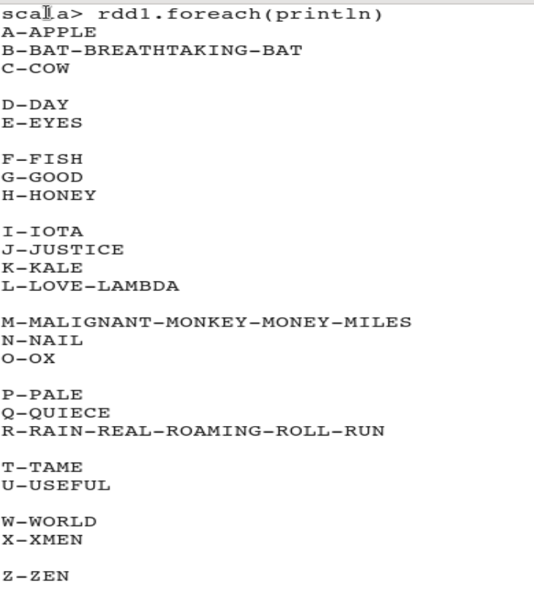

**Output_1 : Print total number of rows in document.**

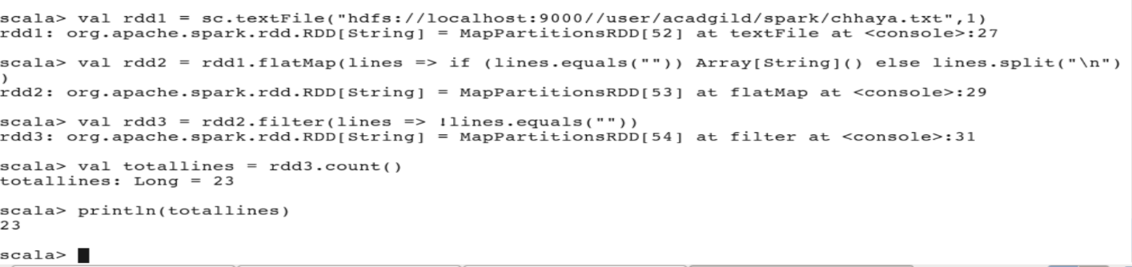

_______________________________________________________________________________________________________

//read the text file from hdfs via spark context object

val rdd1 = sc.textFile("hdfs://localhost:9000//user/acadgild/spark/chhaya.txt",1)

//flattening the text file and splitting it space delimiter.

val rdd2 = rdd1.flatMap(lines => if (lines.equals("")) Array[String]()

else lines.split(" ")).count()

// print the number of words in the document separated by space delimiter.

println(rdd2)

**Output_2 : Total number of words delimited by space in document.**

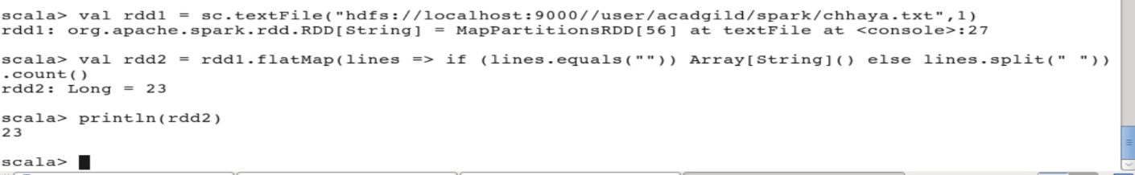

_______________________________________________________________________________________________________

//read the text file from hdfs via spark context object

val rdd1 = sc.textFile("hdfs://localhost:9000//user/acadgild/spark/chhaya.txt",1)

//flattening the text file and splitting it hyphen delimiter.

val rdd2 = rdd1.flatMap(lines => if (lines.equals("")) Array[String]()

else lines.split("-")).count()

// print the number of words in the document separated by hyphen delimiter.

println(rdd2)

**Output_3 : Total Number of words separated by hypen delimiter in document.**

