<http://mcdc.missouri.edu/data/acs/Readme.shtml>



<http://mcdc.missouri.edu/data/acs/Readme.shtml#current>



<http://mcdc2.missouri.edu/cgi-bin/uexplore?/pub/data/acs2013>





<http://mcdc.missouri.edu/cgi-bin/broker?_PROGRAM=websas.uex2dex.sas&_SERVICE=appdev&path=/pub/data/acs2013&dset=ustracts5yr&view=0>

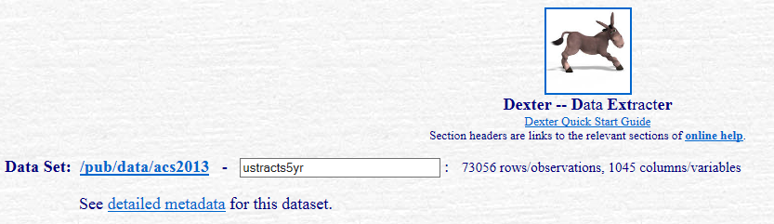

Detailed metadata:

<http://mcdc2.missouri.edu/cgi-bin/broker?_PROGRAM=websas.dispdada.sas&_SERVICE=appdev&libname=acs2013&memname=ustracts5yr&libpath=/pub/data/acs2013>

Metadata Report for /pub/data/acs2013/ustracts5yr

<http://mcdc2.missouri.edu/cgi-bin/broker?_PROGRAM=websas.qmeta.sas&_SERVICE=appdev&path=/pub/data/acs2013&sasdset=ustracts5yr&idonly=0>

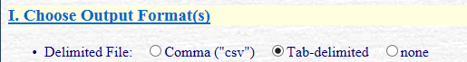

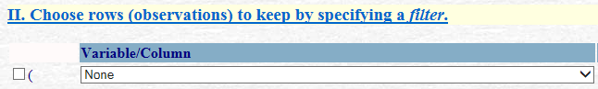

No filter

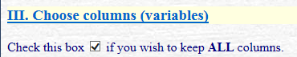



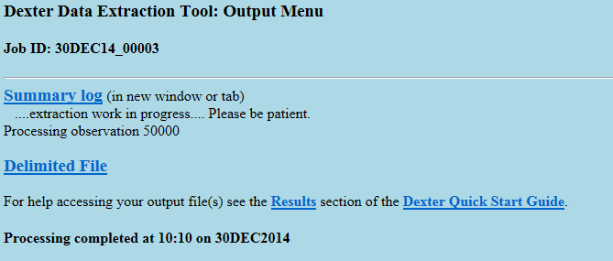

Summary Log link:

<http://mcdc.missouri.edu/tmpscratch/30DEC14_00003.dexter/dexter_log.html>

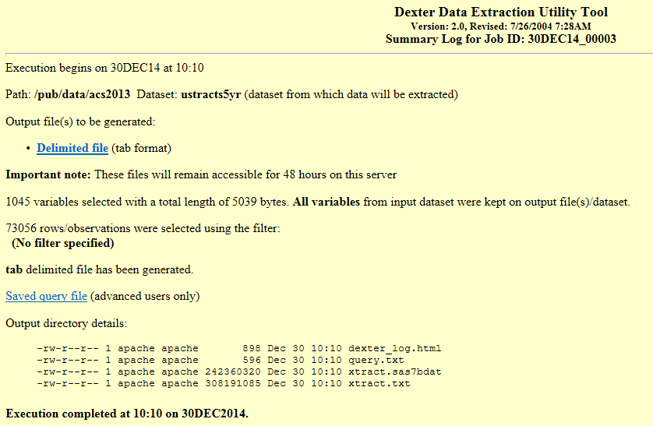

Saved Query File

<http://mcdc.missouri.edu/tmpscratch/30DEC14_00003.dexter/query.txt>

*----dexter saved query file----*;

%let path=/pub/data/acs2013;

%let sasdset=ustracts5yr;

%let view=0;

%let nomenu=0;

%let dlm=tab;

%let lst=none;

%let dbfile=none;

%let _aggby=;

%let _agglvl=1;

%let _grand=NO;

%let _dropvars=_lvl_ _nag_;

%let _means=;

%let _mweights=;

%let _nodupagg=0;

%let where =;

%let _labelopt=;

%let rept_byvars=;

%let rept_idvars=;

%let odsstyle=sasweb;

%let orient=portrait;

%let fmtstmt=;

%let renamestmt=;

%let labelstmt=;

%let keepvars2=_all_;

%let keepvars1=&keepvars2;

%let morexyvars= ;

%let maxobs=;

%let title2=;

%let sortby=;

%let subtitle= ;

%let footnote= ;

Delimited File link:

<http://mcdc.missouri.edu/tmpscratch/30DEC14_00003.dexter/xtract.txt>

Downloaded to

C:\Data\US-Government\Census-Bureau\Missouri-Census-Data-Center\Census-Tracts