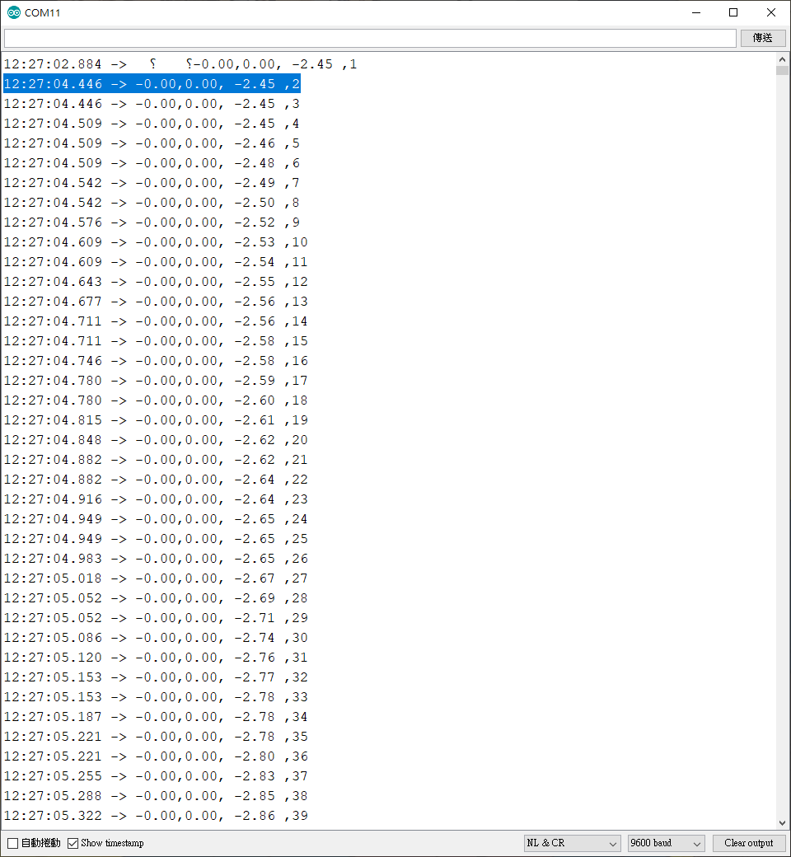

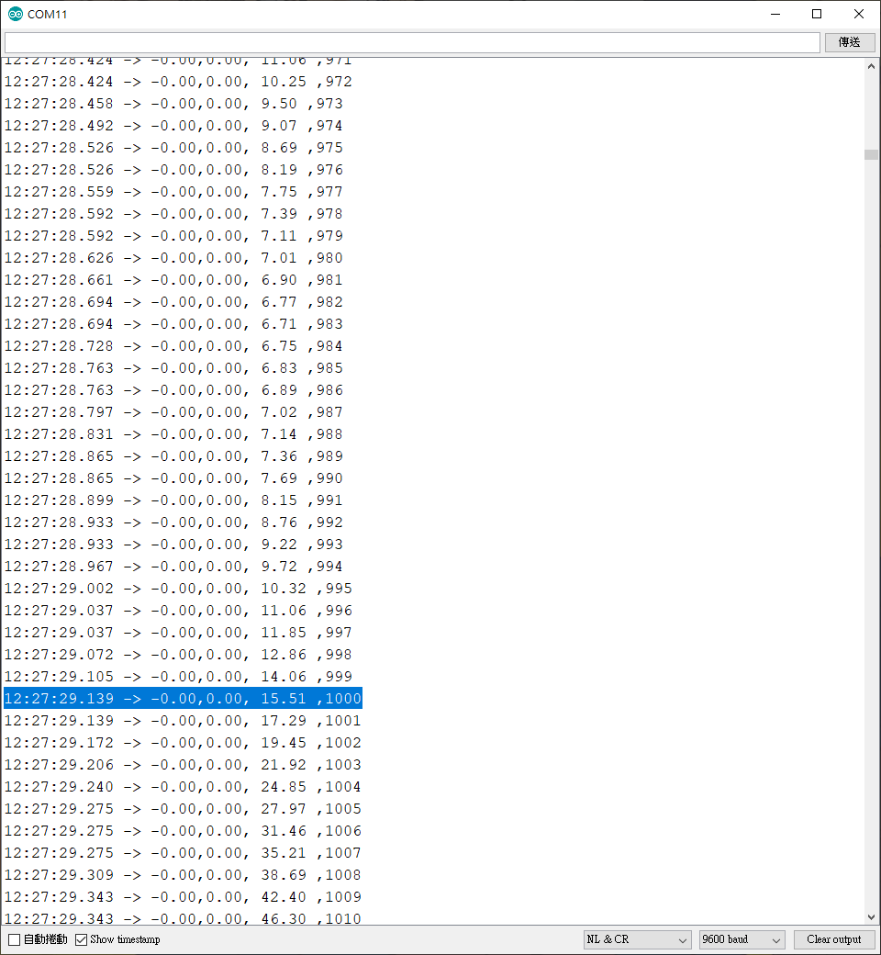

Max sampling rate = 1000/25s = 40Hz

因此我們把sampling time改成0.05s, i.e., 20Hz

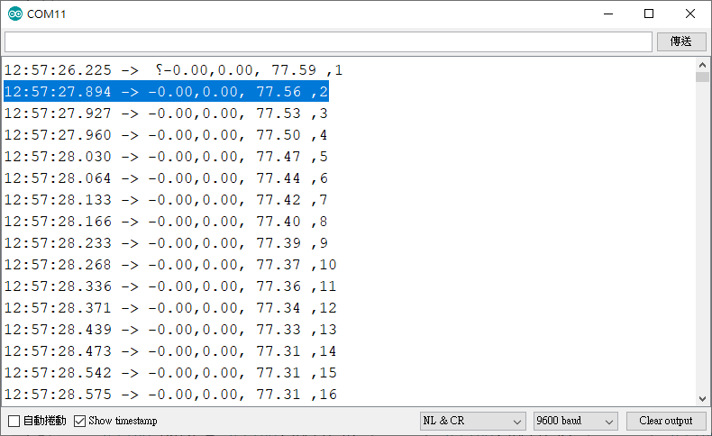

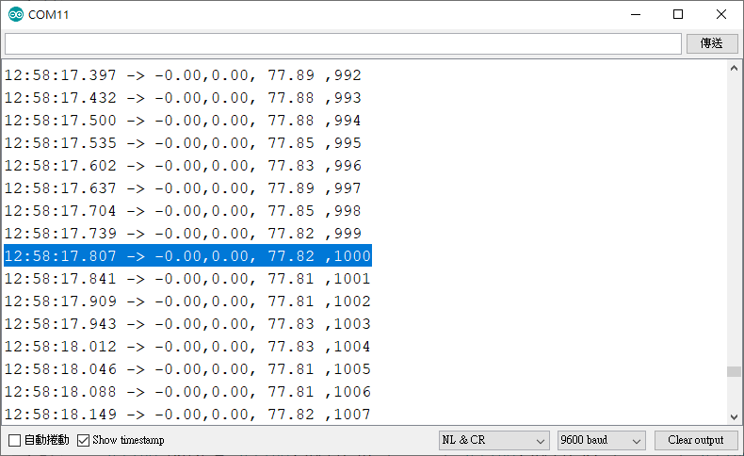

sampling rate = 1000/50s = 20Hz

sampling time = 0.05s