影像處理導論

宋其諭0510888

Project goal

Apply histogram-specification method to the image below, assume desired  
histogram: *nk*=1248, 0*≤k*≤63 and 192*≤k*≤255 , *nk*=800, 64*≤k*≤191.  
Determine the transformation function *z* = *T*(*r*) and the output image after  
applying the transformation function to the image.

1. Figures of the original and output histograms

在Histogram 的分佈中我們可以觀察到，如果 Histogram 分佈的峰值 靠近左側(靠近0 )，則代表這張影像偏暗；如果 Histogram 分佈的峰值 靠近右側(靠近255 )，則代表這張影像偏亮；如果 Histogram 分佈的峰值 非常集中在中間，則明暗的對比就不太明顯。，**Histogram Equalization最理想分佈狀況就是平均分佈**

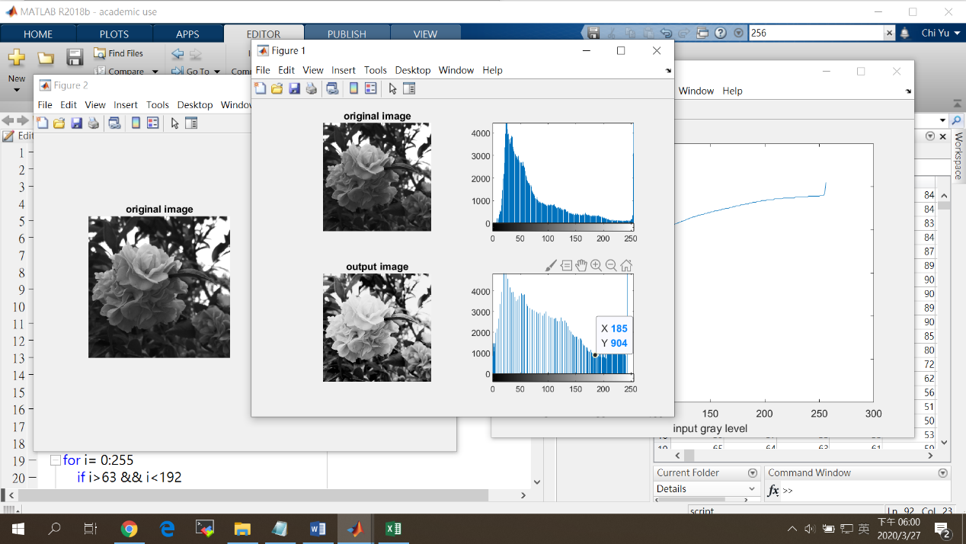

1. Figure of the output image after applying the histogram-specification scheme

從結果來看經過灰階均化後圖形效果較能看到細節的部分也較為清晰

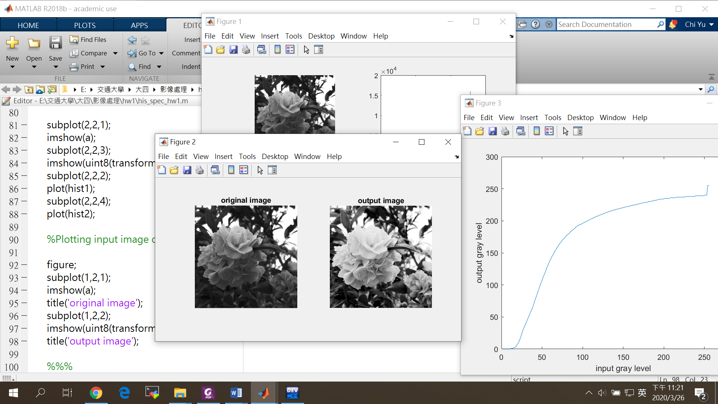

1. Table of transformation function to show the mapping from the input gray level r to the output gray level z

將做完轉換的灰階值存放在一個矩陣內

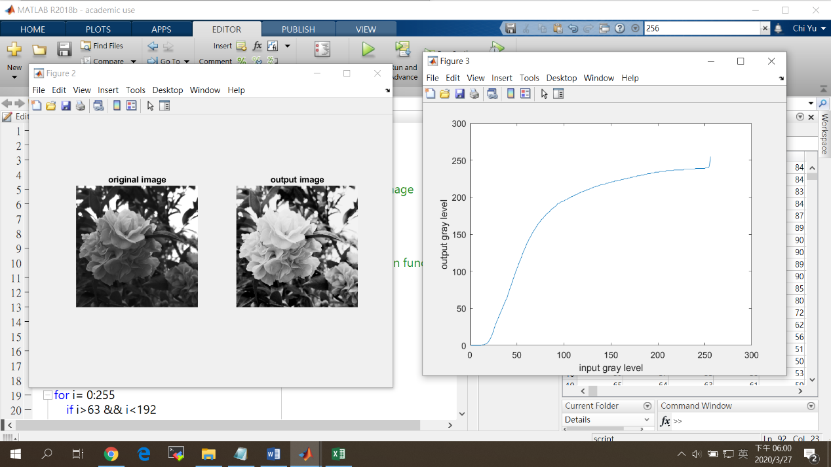

Output gray level:

0 0 0 0 0 0 0 0 0 0 0 0 1 1 1 2 2 3 4 6 8 10 13 16 20 24 28 31 34 37 40 43 46 49 52 55 58 61 63 67 71 75 79 82 86 90 93 97 101 104 107 111 114 117 120 124 127 130 133 136 139 141 144 146 148 151 153 155 157 159 161 163 165 166 168 170 171 172 174 175 177 178 179 180 181 183 184 185 186 187 188 189 191 192 192 193 194 194 195 195 196 197 197 198 199 199 200 201 201 202 203 203 204 204 205 206 206 207 207 208 208 209 209 210 210 211 211 212 212 213 213 214 214 215 215 215 216 216 217 217 217 218 218 218 219 219 219 220 220 220 221 221 221 222 222 222 222 223 223 223 224 224 224 225 225 225 225 226 226 226 227 227 227 228 228 228 228 229 229 229 229 230 230 230 230 231 231 231 232 232 232 232 233 233 233 233 234 234 234 234 234 235 235 235 235 235 235 235 236 236 236 236 236 236 236 236 237 237 237 237 237 237 237 237 237 237 237 238 238 238 238 238 238 238 238 238 238 238 238 239 239 239 239 239 239 239 239 239 239 239 240 240 240 240 243 255

1. Source codes

本次實驗使用Matlab 軟體分析(含註解)

clc;

clear;

close;

a = imread('camellia (mono) 512x512.tif'); %Read the Image

b = size(a);

scale = 1;

shift = 0;

r = 0:255; %Defining input pixels

d = round(scale*r)+ shift; %linear Transformation function

count = zeros(3,256);

spec = zeros(1,256);

ep = zeros(b);

transform = zeros(b);

%loop for spec gray level accumulation

for i= 0:255

if i>63 && i<192

spec(1,i+1)=spec(1,i)+800;

elseif i==0

spec(1,i+1)=1248;

else

spec(1,i+1)=spec(1,i)+1248;

end

end

%loop for count input image gray level

for i=1:b(1) %loop tracing the rows of image

for j=1:b(2) %loop tracing thes columns of image

t=(a(i,j)+1); %pixel values in image

ep(i,j)=d(t); %Making the ouput image using

count(1,ep(i,j))=count(1,ep(i,j))+1; %counting

end

end

%loop for count input gray level accumulation

for i= 0:255

if i==0

count(2,i+1)=0;

else

count(2,i+1)=count(2,i)+count(1,i+1);

end

end

%loop for comparsion

for i=1:256 %loop tracing the arrary count

for j=1:256 %loop tracing thes columns of image

if count (2,i)>spec(1,j)

count (3,i)=j;

end

end

end

%transform

for i=1:b(1) %loop tracing the rows of image

for j=1:b(2) %loop tracing thes columns of image

t=(a(i,j)+1); %pixel values in image

ep(i,j)=d(t); %Making the ouput image using

transform(i,j)=count(3,ep(i,j)); %counting

end

end

%Procedure for plotting histogram

hist1 = zeros(1,256); %prealocation space for input histogram

hist2 = zeros(1,256); %prealocation space for output histogram

for i1=1:b(1) %loop tracing the rows of image

for j1=1:b(2) %loop tracing the Columns of image

for k1=0:255 %loop checking which graylevel

if a(i1,j1)==k1 %match found at k1

hist1(k1+1)=hist1(k1+1)+1; %increase the value at k1

end

if transform(i1,j1)==k1 %for output image

hist2(k1+1)=hist2(k1+1)+1;

end

end

end

end

%Plotting input image output image and their respective histograms

subplot(2,2,1);

imshow(a);

title('original image');

subplot(2,2,3);

imshow(uint8(transform));

title('output image');

subplot(2,2,2);

plot(hist1);

subplot(2,2,4);

plot(hist2);

%Plotting input image output image

figure;

subplot(1,2,1);

imshow(a);

title('original image');

subplot(1,2,2);

imshow(uint8(transform));

title('output image');

%%%

figure;

plot(count(3,:));

xlabel('input gray level');

ylabel('output gray level');