影像處理導論

宋其諭0510888

Project goal

Apply For the bird image below, compute the 512 $×$ 512 DFT and determine  
the frequencies (u,v) of the largest 25 DFT magnitudes.

1. Figures of the Fourier magnitude (using log scale after centering) and  
   phase spectrum (after centering)

在做Fourier magnitude時，我先將原始圖的gray scale作padding，然後再用fft的function後shift移至中心，

註:

Y = fftshift([X](https://ww2.mathworks.cn/help/matlab/ref/fftshift.html#bviss0f-1-X))通過將零頻分量移動到數組中心，重新排列傅里葉變換X。

* 如果X是向量，則fftshift會將X的左右兩半部分進行交換。
* 如果X是矩陣，則fftshift會將X的第一象限與第三象限交換，將第二象限與第四象限交換。
* 如果X是多維數組，則fftshift會沿每個維度交換X的半空間。

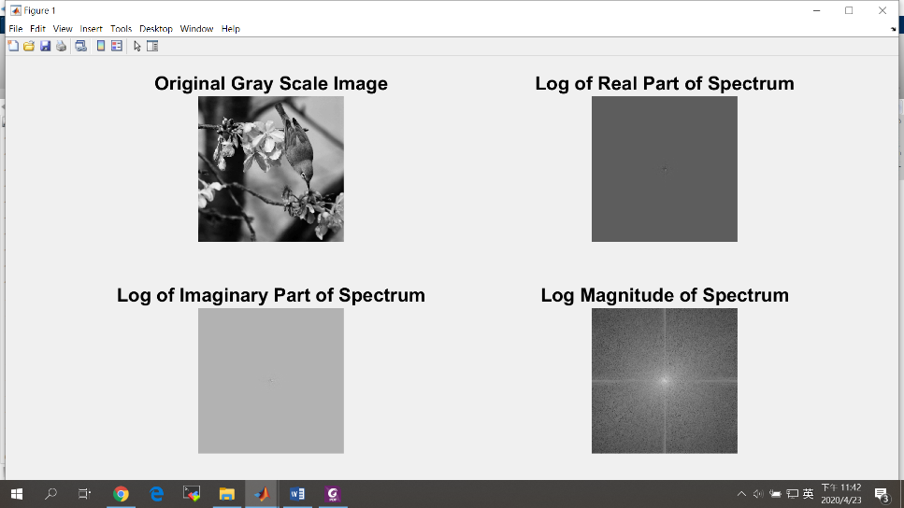

1. Figures of the Fourier phase spectrum (after centering)

此處用angle 的函數取出其相角

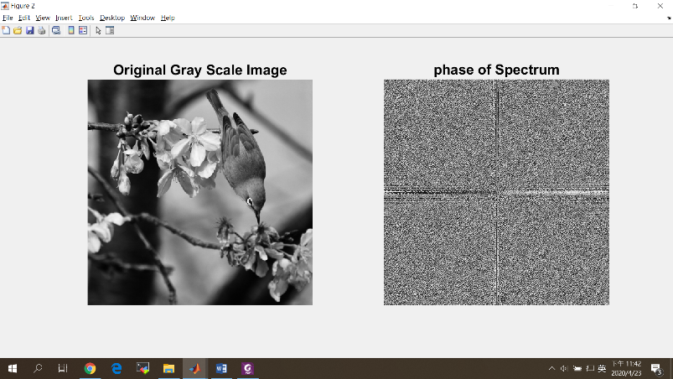

3. Table of top 25 DFT frequencies (*u*,*v*)

|  |  |  |  |
| --- | --- | --- | --- |
|  | frequency | u | v |
| 1 | 27969071 | 1 | 1024 |
| 2 | 19121545.1463803 | 2 | 1 |
| 1 | 19121545.1463803 | 1024 | 1 |
| 4 | 18778260.6414633 | 1 | 2 |
| 5 | 18778260.6414633 | 1 | 1024 |
| 6 | 13678309.1126368 | 2 | 2 |
| 7 | 13678309.1126368 | 1024 | 1024 |
| 8 | 11798906.0349677 | 2 | 1024 |
| 9 | 11798906.0349677 | 1024 | 2 |
| 10 | 6187170.27831592 | 1 | 6 |
| 11 | 6187170.27831592 | 1 | 1020 |
| 12 | 5026761.92972146 | 4 | 1 |
| 13 | 5026761.92972146 | 1022 | 1 |
| 14 | 4463423.53626522 | 1 | 5 |
| 15 | 4463423.53626522 | 1 | 1021 |
| 16 | 4191128.63013627 | 2 | 6 |
| 17 | 4191128.63013627 | 1024 | 1020 |
| 18 | 4064473.30463883 | 4 | 2 |
| 19 | 4064473.30463883 | 1022 | 1024 |
| 20 | 4054158.45883519 | 1 | 3 |
| 21 | 4054158.45883519 | 1 | 1023 |
| 22 | 3951252.11355008 | 1024 | 6 |
| 23 | 3951252.11355008 | 2 | 1020 |
| 24 | 3819357.68652558 | 2 | 3 |
| 25 | 3819357.68652558 | 1024 | 1023 |

Source codes

本次實驗使用Matlab 軟體分析(含註解)

% 2D DFT Demo

clc; % Clear the command window.

close all; % Close all figures (except those of imtool.)

imtool close all; % Close all imtool figures.

clear; % Erase all existing variables.

workspace; % Make sure the workspace panel is showing.

format longg;

format compact;

fontSize = 20;

% Read in image.

grayImage = imread('Bird 1.tif');

[rows columns numberOfColorChannels] = size(grayImage)

if numberOfColorChannels > 1

grayImage = rgb2gray(grayImage);

end

%zero padding

padding_grayImage=zeros(1024,1024);

for i = 1:1024

for j = 1:1024

if i <= 512 && j<= 512

padding_grayImage(i,j) = grayImage(i,j);

else

padding_grayImage(i,j) = 0;

end

end

end

% Display original grayscale image.

input_phase=zeros(1024,1024);

input_shiftedFFT=zeros(1024,1024);

subplot(2, 2, 1);

imshow(grayImage)

title('Original Gray Scale Image', 'FontSize', fontSize)

% Perform 2D FFTs

fftOriginal = fft2(double(padding_grayImage));

shiftedFFT = fftshift(fftOriginal);

subplot(2, 2, 2);

scaledFFTr = 255 * mat2gray(real(shiftedFFT));

imshow(log(scaledFFTr), []);

title('Log of Real Part of Spectrum', 'FontSize', fontSize)

subplot(2, 2, 3);

scaledFFTi = mat2gray(imag(shiftedFFT));

imshow(log(scaledFFTi), []);

title('Log of Imaginary Part of Spectrum', 'FontSize', fontSize)

% Display magnitude of 2D FFTs

subplot(2, 2, 4);

input_magnitude=log(abs(shiftedFFT )+1);

imshow(log(abs(shiftedFFT )),[]);

colormap gray

title('Log Magnitude of Spectrum', 'FontSize', fontSize)

% Enlarge figure to full screen.

set(gcf, 'units','normalized','outerposition',[0 0 1 1]);

% Display phase of 2D FFTs

figure;

subplot(1, 2, 1);

imshow(grayImage)

title('Original Gray Scale Image', 'FontSize', fontSize)

input_phase=angle(shiftedFFT);

subplot(1, 2, 2);

imshow(angle(shiftedFFT),[]);

title('phase of Spectrum', 'FontSize', fontSize)

%count top 25 frequency

top_25_freq=zeros(1,25);

top_25_freq=maxk(abs(fftOriginal(:)),25)