影像處理導論HW3

宋其諭0510888

Project goal

According to the DFT property of *Laplacian*, it appears we may  
implement Laplacian operation by designing a digital filter with  
frequency response *H*(*u*,*v*) = *K*(*u*2+*v*2) where *K* is a scaling factor to  
make the magnitude of*H*(*u*,*v*) in the range [0, 1]. Use this frequency domain scheme to find the Laplacian image for the bird image.

1. Figures of the Fourier magnitude (using log scale after centering) and  
   phase spectrum (after centering)

在做Fourier magnitude時，我先將原始圖的gray scale作padding，然後再用fft的function後shift移至中心，

註:

Y = fftshift([X](https://ww2.mathworks.cn/help/matlab/ref/fftshift.html#bviss0f-1-X))通過將零頻分量移動到數組中心，重新排列傅里葉變換X。

* 如果X是向量，則fftshift會將X的左右兩半部分進行交換。
* 如果X是矩陣，則fftshift會將X的第一象限與第三象限交換，將第二象限與第四象限交換。
* 如果X是多維數組，則fftshift會沿每個維度交換X的半空間。

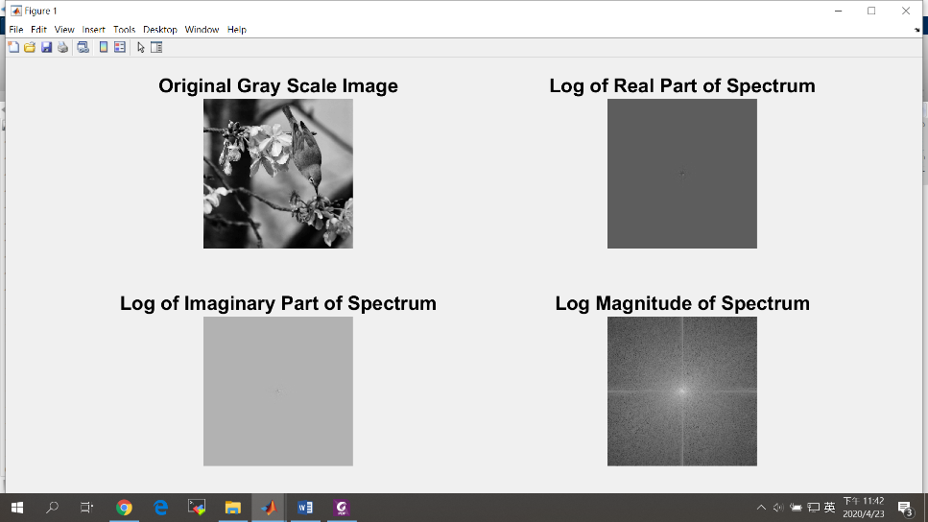

1. Figures of the Fourier magnitude spectra of the *bird* image  
   after applying Laplacian filtering

此處

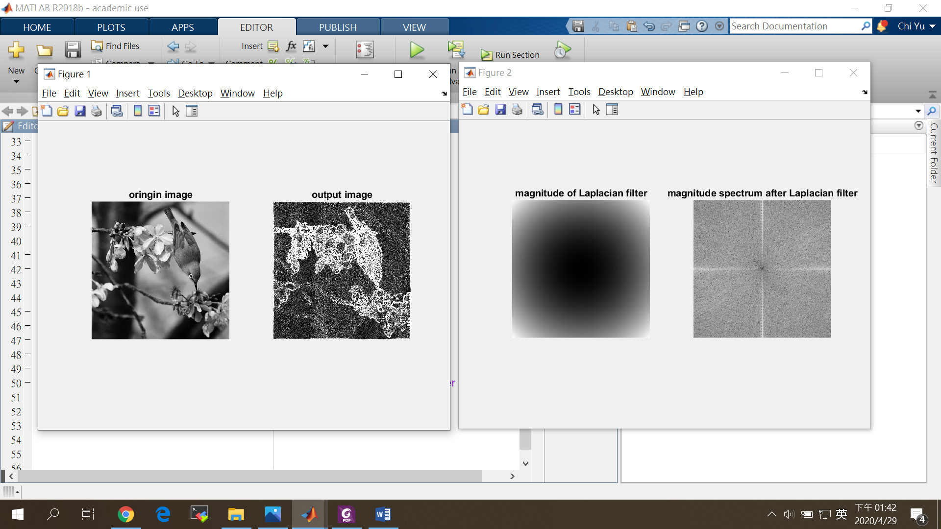

1. Figure of the Fourier magnitude of Laplacian filter *H*(*u*,*v*)



1. Figure of the output image

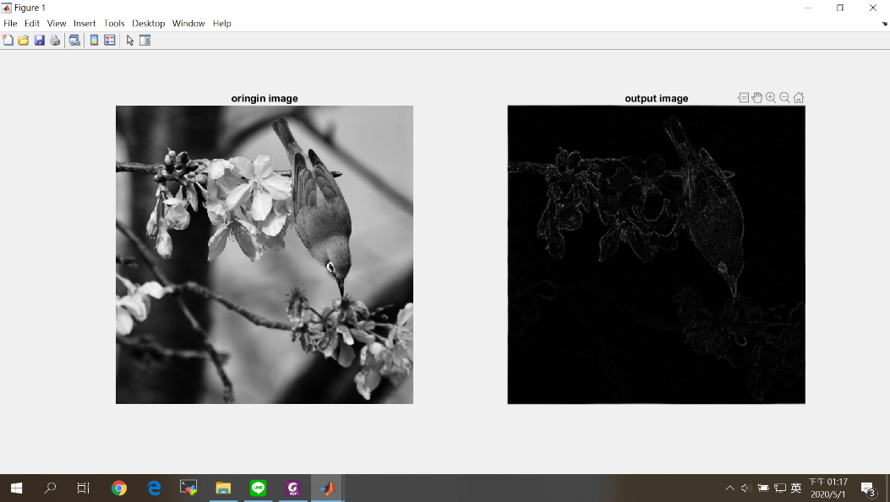

1. Table of top 25 DFT frequencies (*u*,*v*) after Laplacian  
   filtering

|  |  |  |  |
| --- | --- | --- | --- |
|  | frequency | u | v |
| 1 | 33336.1947662107 | 512 | 3 |
| 2 | 33336.1947662107 | 512 | 1021 |
| 1 | 32977.2262149754 | 512 | 1 |
| 4 | 32977.2262149754 | 512 | 1023 |
| 5 | 32621.7622137203 | 512 | 7 |
| 6 | 32621.7622137203 | 512 | 1017 |
| 7 | 31957.4559552902 | 512 | 13 |
| 8 | 31957.4559552902 | 512 | 1011 |
| 9 | 31538.1146104059 | 512 | 9 |
| 10 | 31538.1146104059 | 512 | 1015 |
| 11 | 31315.4941806038 | 512 | 17 |
| 12 | 31315.4941806038 | 512 | 1007 |
| 13 | 31310.6466979876 | 512 | 11 |
| 14 | 31310.6466979876 | 512 | 1013 |
| 15 | 31228.9218102309 | 512 | 5 |
| 16 | 31228.9218102309 | 512 | 1019 |
| 17 | 30931.8379418139 | 512 | 15 |
| 18 | 30931.8379418139 | 512 | 1009 |
| 19 | 30719.8540104983 | 512 | 21 |
| 20 | 30719.8540104983 | 512 | 1003 |
| 21 | 30561.3730992668 | 512 | 23 |
| 22 | 30561.3730992668 | 512 | 1001 |
| 23 | 30530.8588578354 | 512 | 27 |
| 24 | 30530.8588578354 | 512 | 997 |
| 25 | 30142.3727544918 | 512 | 19 |

Source codes

本次實驗使用Matlab 軟體分析(含註解)

% 2D Laplacian Demo

clc; % Clear the command window.

close all; % Close all figures (except those of imtool.)

imtool close all; % Close all imtool figures.

clear; % Erase all existing variables.

workspace; % Make sure the workspace panel is showing.

% Read in image.

grayImage = imread('Bird 1.tif');

[rows columns numberOfColorChannels] = size(grayImage);

if numberOfColorChannels > 1

grayImage = rgb2gray(grayImage);

end

%%Process 2D DFT to origin image

fft_inti_img = fftshift(fft2(grayImage, 1024, 1024));

% Figures of the Fourier magnitude spectra of the bird image

%after applying Laplacian filtering

%1024*1024*2 = 2097152, 512*512*2 = 524288, 256*256*2 =

for u = 0:1023

for v = 0:1023

H(u+1, v+1) = ((u-512).^2 + (v-512).^2)/524288;

end

end

%%process laplacian in frequency domain

fft_filter_img = fft_inti_img.*H;

abs_filter_img = abs(fft_filter_img);

%Table of top 25 DFT frequencies (u,v) after Laplacian filtering

freq_table = sort(abs_filter_img(:), 'descend');

location = find(abs_filter_img >= freq_table(25));

for i= 1:25

%location = find(abs_filter_img == freq_table(i));

data(i, 1) = freq_table(i);

data(i, 2) = location(i);

data(i, 3) = mod(location(i),1024)-1;

data(i, 4) = fix(location(i)/1024);

end

%inverse fft

img = ifft2(ifftshift(fft_filter_img));

output_img = img(1:512, 1:512);

%Figure of the output image

figure;

subplot(1,2,1), imshow(grayImage), title('oringin image');

subplot(1,2,2), imshow(abs(output_img),[]), title('output image');

figure;

subplot(1,2,1), imshow(H.*255, []), title('magnitude of Laplacian filter');

subplot(1,2,2), imshow(log(1+abs_filter_img), []), title('magnitude spectrum after Laplacian filter');