影像處理導論HW4

宋其諭0510888

Project goal

Consider the RGB color image, **violet (clolr).tif** below.  
(a) Determine and plot the H, S and I component images.  
(b) Apply sphere-based color slicing to the image, using the  
prototypical color (i) ***a*1** = (134, 51, 143), and (ii) ***a*2** = (131,  
132, 4), and the same radius of the sphere, *R*0 = 30.

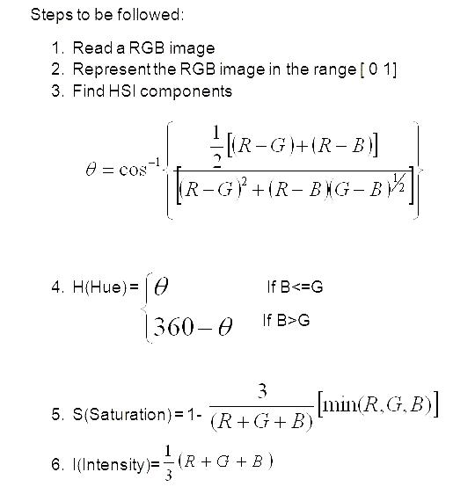

1. Figures of H, S and I component images(30%)

Hue component image(H)

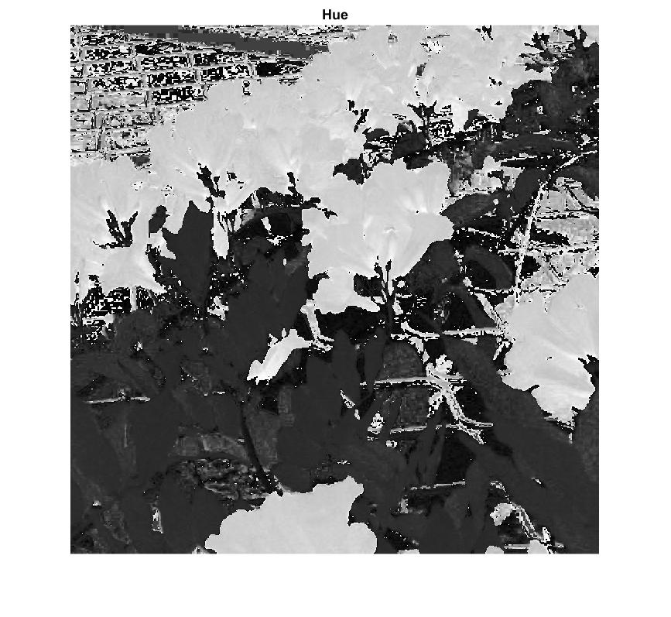

Saturation component image(S)

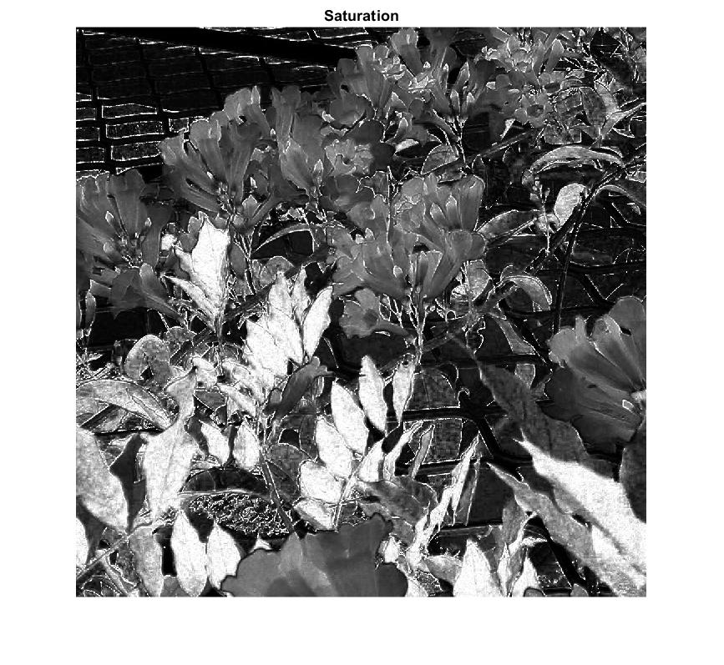

Intensity component image(I)

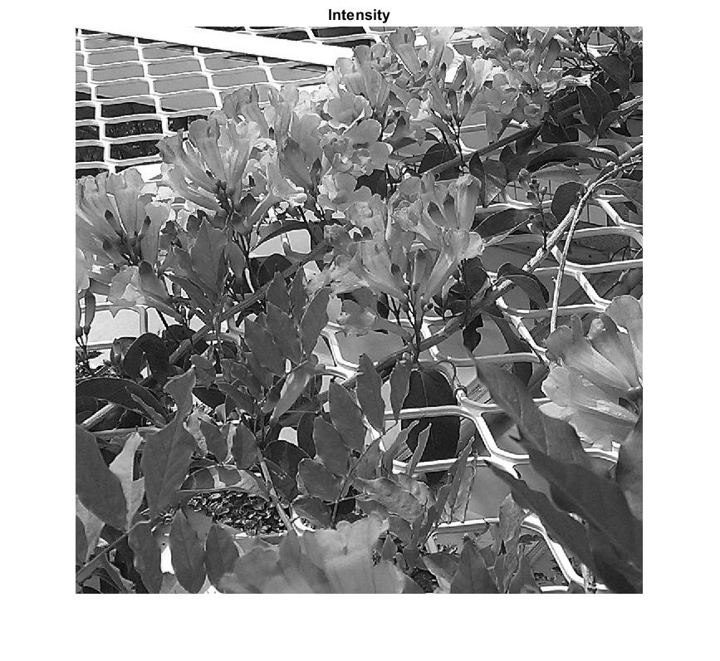

1. Figure of color-slicing image using ***a*1** (20%)

Color slicing $a_{1}=(134, 51, 143)$

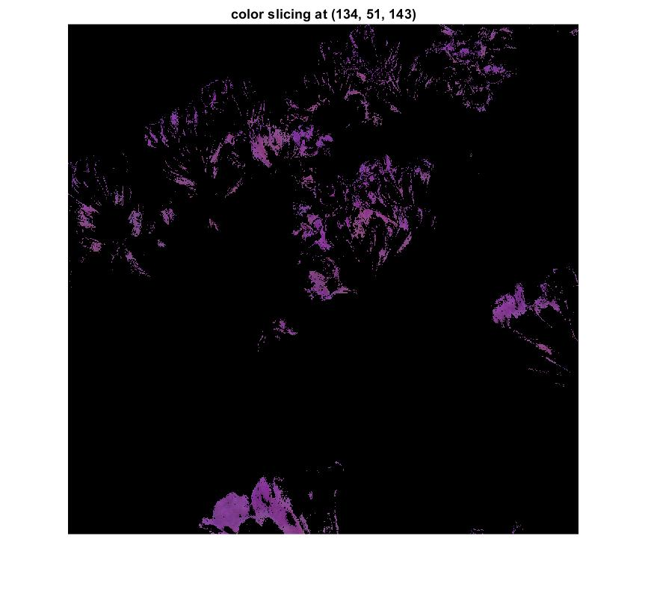

1. Figure of color-slicing image using ***a*2** (20%)

Color slicing $a_{1}=(131, 132, 4)$

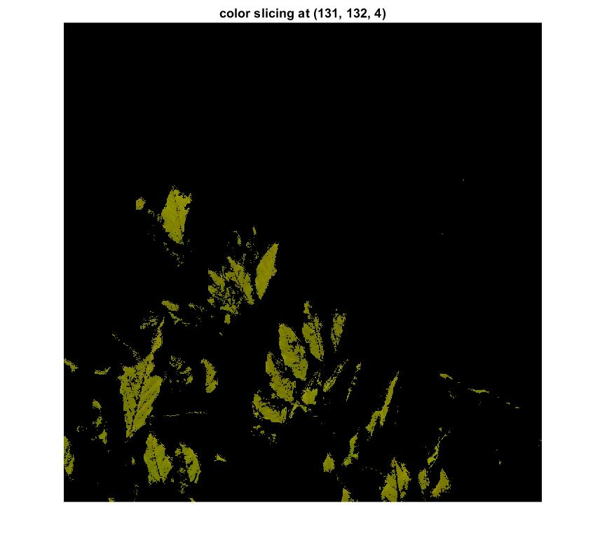

Source codes

本次實驗使用Matlab 軟體分析(含註解)

clear all; close all; clc;

% 1024*1024

origin_img = imread('violet (color).tif');

img = im2double(origin_img);

% (a)-------------------------------------------------------------------

% RGB(double)

R = img(:,:,1);

G = img(:,:,2);

B = img(:,:,3);

% Hue

numi=1/2*((R-G)+(R-B));

denom=((R-G).^2+((R-B).*(G-B))).^0.5;

H=acosd(numi./(denom+0.000001));

H(B>G)=360-H(B>G);

H=H/360;

%Saturation

S=1 - (3./(sum(img,3)+0.000001)).*min(img,[],3);

%Intensity

I=sum(img, 3)./3;

figure;

subplot(2,3,2), imshow(origin_img), title('origin image');

subplot(2,3,4), imshow(H, []), title('Hue');

subplot(2,3,5), imshow(S, []), title('Saturation');

subplot(2,3,6), imshow(I, []), title('Intensity');

% (b)-------------------------------------------------------------------

% RGB(integer)

int_R = double(origin_img(:,:,1));

int_G = double(origin_img(:,:,2));

int_B = double(origin_img(:,:,3));

output = zeros(1024,1024,3);

for i = 1:1024

for j = 1:1024

% a1 = [134 51 143]

a1 = int_R(i, j)-134;

b1 = int_G(i, j)-51;

c1 = int_B(i, j)-143;

distance1 = a1.^2 + b1.^2 + c1.^2;

if distance1 <= 900

output1(i,j,:) = img(i, j, :);

end

% a2 = [131 132 4]

a2 = int_R(i, j)-131;

b2 = int_G(i, j)-132;

c2 = int_B(i, j)-4;

distance2 = a2.^2 + b2.^2 + c2.^2;

if distance2 <= 900

output2(i,j,:) = img(i, j, :);

end

end

end

figure;

subplot(1,3,1), imshow(origin_img), title('origin image');

subplot(1,3,2), imshow(output1, []),title('color slicing at (134, 51, 143)');

subplot(1,3,3), imshow(output2, []),title('color slicing at (131, 132, 4)');