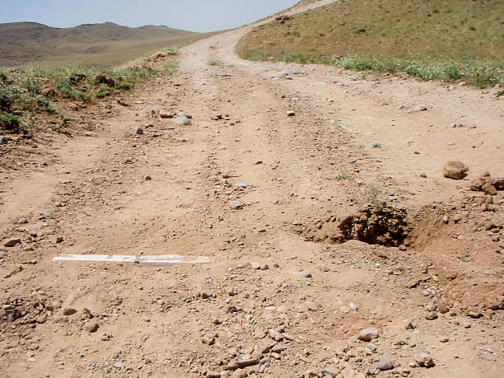

**Conduct a Tactical Road March**

Unit’s mission. Company A, 3-69 Armor, conducts a tactical road march along ROUTE PACKERS to occupy the zone of separation designated by the United Nations no later than 03002Z July 20XX, to conduct peace enforcement operations.

Situation. The battalion intelligence staff officer developed a modified combined obstacle overlay and produced an obstacle and mine overlay indicating the presence of many known (marked) and unknown (unmarked) obstacles and minefields throughout your area of operations and spanning your route of march. Intelligence indicates enemy armed forces are operating in three-to-five-person reconnaissance teams. Contact with the enemy is unlikely, but if made, the enemy is expected to break contact and not fight.

Conditions. As the company commander of A Company, 3-69 Armor, you have just received a warning order dated 011400 July 20XX from your battalion commander. The unit has been in country for ten days and is combat ready. The battalion conducted extensive pre-deployment training. It is prepared for the terrain, consisting of moderately sized rolling hills and cool, wet conditions. The roads are unimproved, with sharp curves and steep embankments. Temperatures have been in the mid-50s to 60s during the day and mid-40s at night, with four straight days of rain.

Facts.

• The company commander and platoon leaders have been assigned ten months.

• The company is task-organized into two tank platoons and one mechanized platoon with an engineer section (with combat engineer vehicles and armored combat earthmovers, an air defense artillery section, and military police section).

• The two tank platoons do not have mine rollers.

• The two tank platoons and mechanized platoon are used to working together.

• The other elements were assigned when you entered the theater.

• All vehicles are in good condition.

• Map reconnaissance indicates the objective is 20 kilometers (12 miles) away.

Mission analysis.

• Terrain and weather. The roads are unimproved, with sharp curves and steep embankments. They are generally bordered by open terrain that would provide little cover and concealment for dismounted troops. The weather forecast calls for rain to continue several days. Overcast conditions will limit natural illumination.

• Enemy. Enemy armed forces are operating in three-to-five-person reconnaissance teams equipped with direct weapons (individual weapons, machine guns, and a very limited number of outdated anti-tank missiles and anti-armor weapons).

• Troops. Experience level is high within the tank and mechanized units. The experience level of the troops recently attached to you is unknown.

• Civil considerations. The area is sparsely populated and the local nationals are supportive of our mission.

• Time. 13 hours to start point.

Risk assessment.

• Threat-based risks. Land mine potential; small arms antitank rocket ambush.

• Hazard-based risks. Rain and cold, limited visibility, limited surface traction, narrow

roads, fatigue of troops, and inexperienced personnel.