# 问题一

* **问题要求**

**设计一个状态机，状态机有三个状态，IDLE，S1和S0，有两个输入key1和key2，以及两个输出cnt_en和load。注：初始状态为IDLE，所有信号与时钟同步。**

**在IDLE状态时，cnt_en=0，load=1。当key1=1，则跳转到S1状态，同时cnt_en=1，load=0，否则保持当前状态不变；**

**在S1状态下，当key1=1，则跳转到S2状态，同时cnt_en=0，否则保持当前状态不变；**

**在S2状态下，当key1=1，则跳转到S1状态，同时cnt_en=1；当key2=1，则跳转到IDLE状态，同时load=1。**

**根据以上描述练习画出状态转移图，下图是参考状态图，（也可以练习写出状态转移表）使用三段式状态机描述方法编写代码，并仿真验证。提交源程序，仿真程序和仿真波形（最好包含状态寄存器）。**

* **源程序：**

fsm.v

module fsm(

input clk,

input key1,

input key2,

output cnt_en,load

);

parameter IDLE = 2'b00,

S1 = 2'b01,

S2 = 2'b10;

reg [1:0] cstate = IDLE, nstate = IDLE;

always @(posedge clk)

cstate = nstate;

always @*

if((cstate == IDLE) && (key1 == 1)) nstate <= S1;

else if((cstate == S1) && (key1 == 1)) nstate <= S2;

else if((cstate == S2) && (key1 == 1)) nstate <= S1;

else if((cstate == S2) && (key2 == 1)) nstate <= IDLE;

assign cnt_en = (cstate == S1)?1:0;

assign load = (cstate == IDLE)?1:0;

endmodule

* **仿真程序：**

sim_fsm.v

module sim_fsm(

output reg clk = 0,

output reg [1:0] key = 0

);

fsm u1(

.clk(clk),

.key1(key[0]),

.key2(key[1]));

always

#1 clk = !clk;

initial

#0.5

while(1)

begin

#2 key[0] = $random;

key[1] = !key[0];

end

initial

#100 $stop;

endmodule

* **仿真波形：**

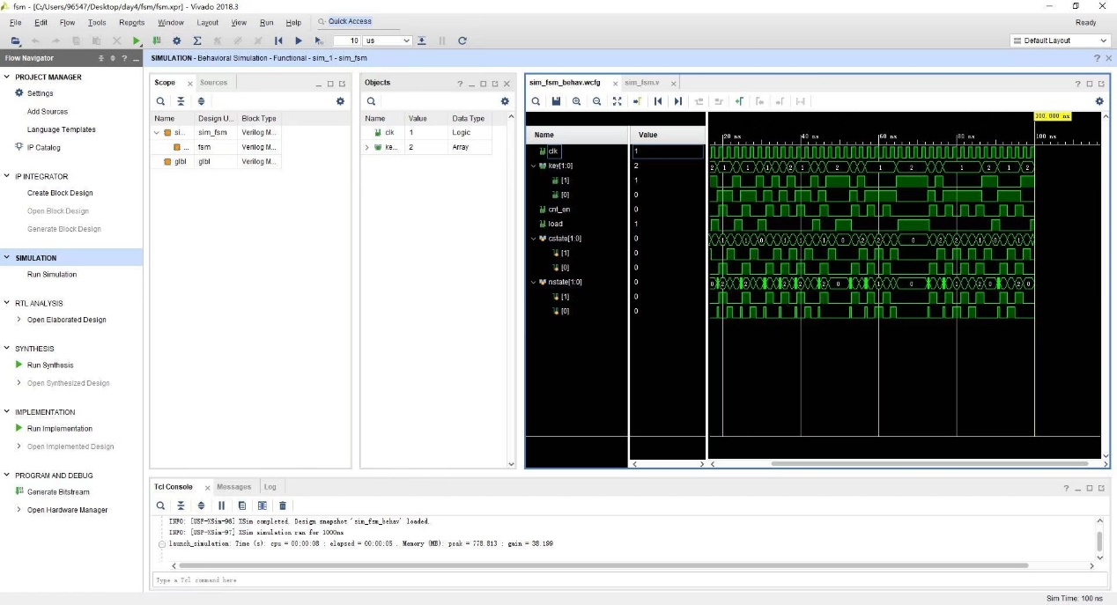

# 问题二

* **问题要求**

**按键去抖动设计，按键去抖动模块至少有一个输出信号为1个clk（系统时钟）周期的按键有效信号。提交设计程序。按键去抖动有多种方法，也可以试着采用状态机完成。**

* **源程序：**

top.v

module top#(parameter DEBUG = 0) (

input clk,

input keyIn,

input keyOut

);

wire clk100ms, keyDejitter;

sec

#(.MAX((DEBUG == 1)?50:5_000_000)) clklow

(

.clk(clk),

.rst(1),

.sec(clk100ms));

fsm trigger(

.clk(clk),

.clk100ms(clk100ms),

.keyIn(keyIn),

.keyOut(keyDejitter));

differenciator diff(

.clk(clk),

.NumIn(keyDejitter),

.NumOut(keyOut));

Endmodule

Fsm.v

module fsm#(parameter DEBUG = 0)

(

input clk,

input clk100ms,

input keyIn,

output keyOut

);

parameter [1:0] IDLE = 0, RESPOND = 1,PRESSED = 2;

reg [1:0] cstate = IDLE, nstate = IDLE;

wire keyHold;

always @(posedge clk)

cstate = nstate;

always @(posedge clk100ms)

if(keyIn == 1)

if(cstate == IDLE) nstate = RESPOND;

else nstate = PRESSED;

else nstate = IDLE;

assign keyOut = (cstate == RESPOND)?1:0;

endmodule

differenciator.v

module differenciator(

input clk,

input NumIn,

input NumOut

);

reg cstate = 0, nstate = 0;

always @(posedge clk)

cstate = nstate;

always @(posedge clk)

nstate = NumIn;

assign NumOut = (cstate == 0) && (nstate == 1)?1:0;

endmodule

* **仿真程序：**

sim_fsm.v

module sim_fsm(

output reg clk = 0,

output reg keyIn = 0

);

top #(1)

u1(

.clk(clk),

.keyIn(keyIn));

always

#1 clk = !clk;

always begin

#(200 + $random %200)

repeat(20) #1 keyIn = $random;

keyIn = 1;

#(200 + $random %100)

repeat(20) #1 keyIn = $random;

keyIn = 0;

end

initial

#10000 $stop;

Endmodule

* **仿真波形：**

