Select one power electronic equipment in your daily life and:  
◼ Describe its function, input and output features  
◼ Take a picture and then differentiate as well as mark down:  
 ◆ Power stage  
 ◆ Drive circuit  
 ◆ Control circuit  
◼ Find the model of the power electronic device and component used in this  
equipment and describe its major parameters

变流器

Converter

Function:

In some practical situations, the device needs the direct current. However, the majority of power supply mode is AC power supply. Therefore, we need a kind of equipment to convert alternating current into direct current, which is called rectifier circuit. In other practical situation, a kind of equipment is needed to convert direct current to alternating current, called inverter circuit.

Output characteristics

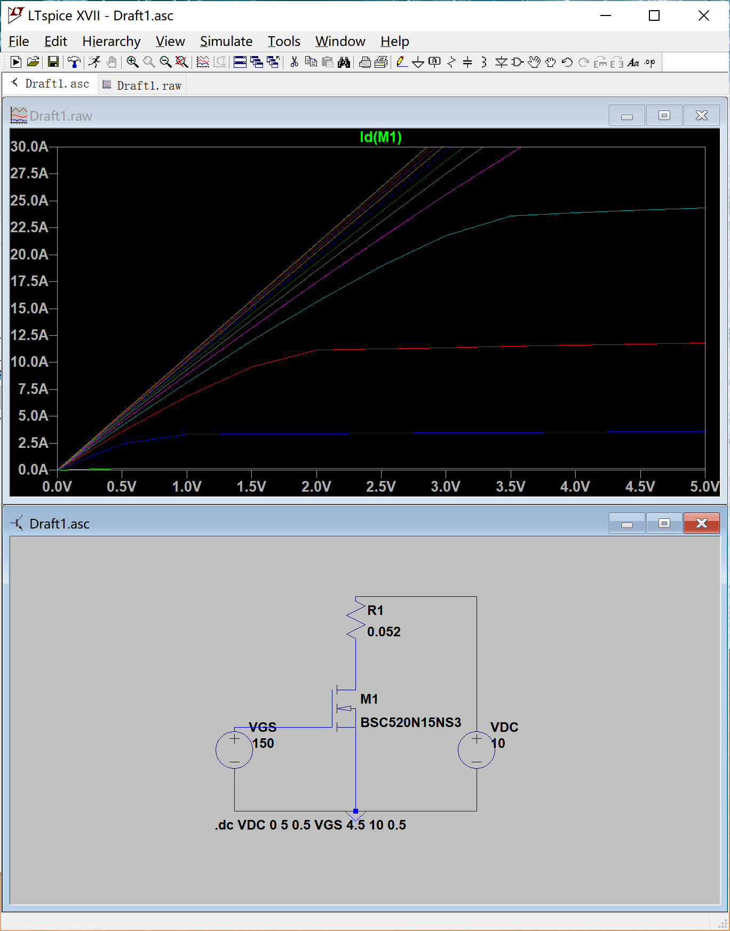

Drain-source on resistance

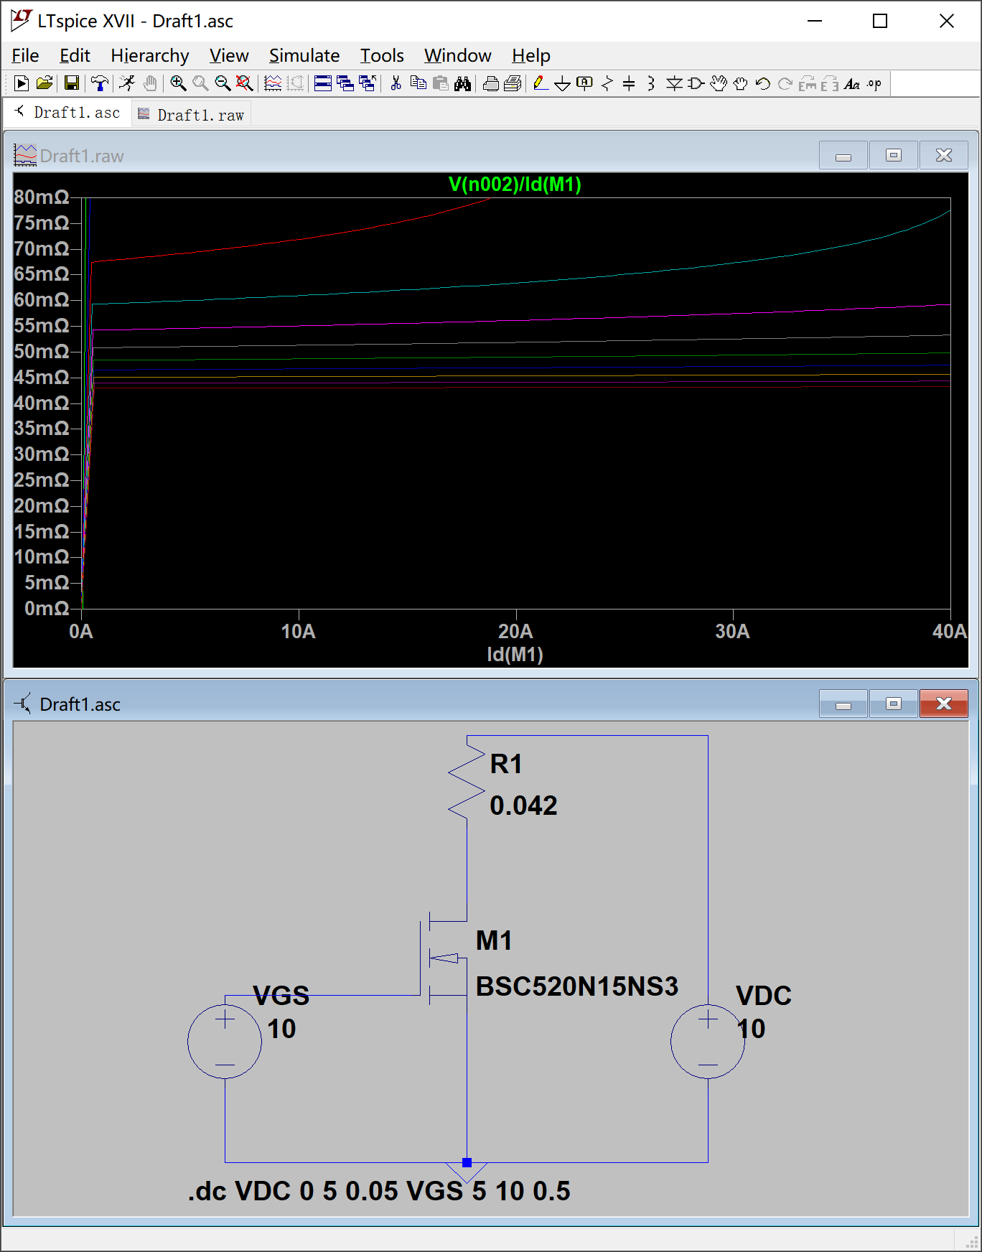

Transfer characteristic

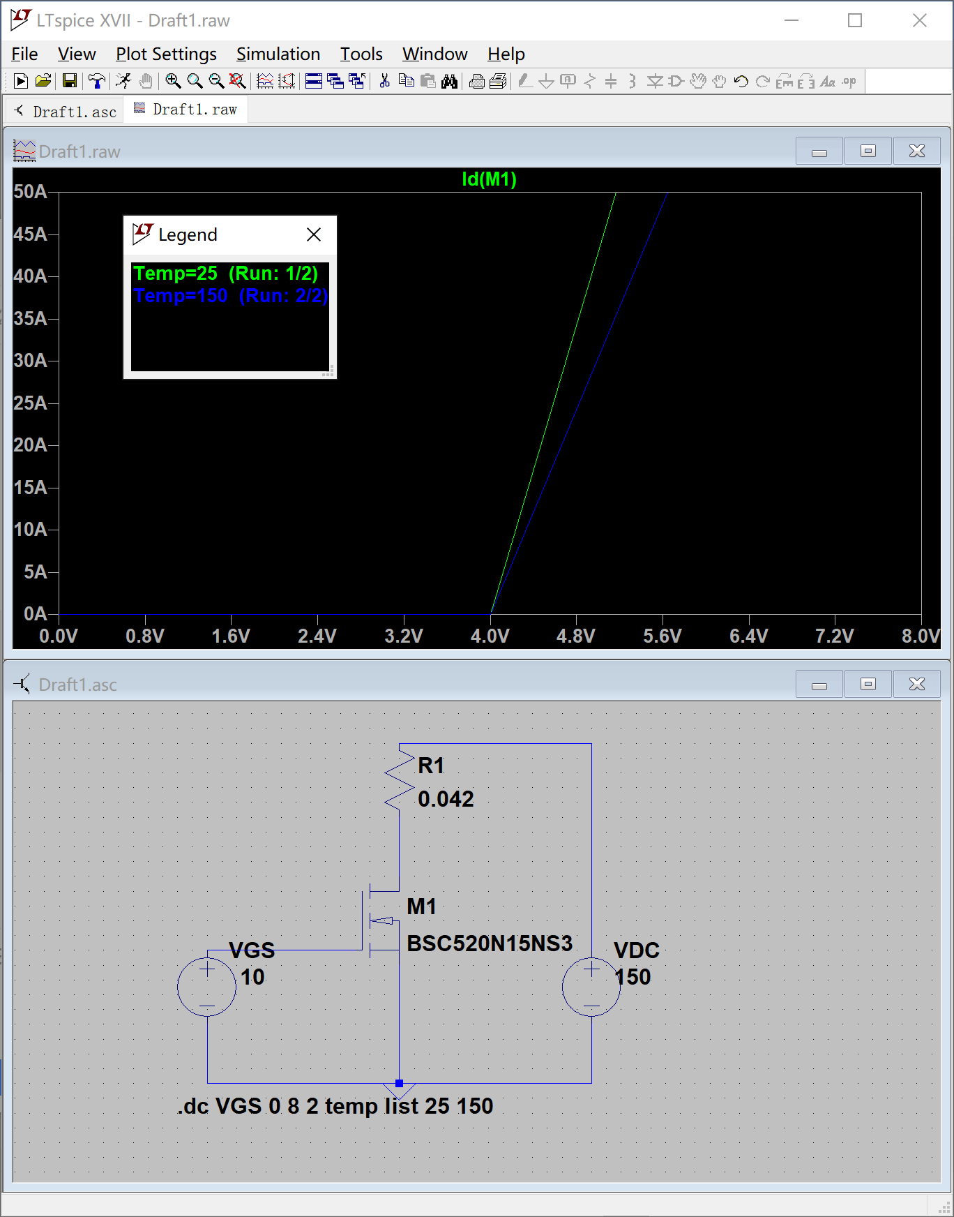

Forward characteristics of reverse diode

Switching waveform

