**Seminar 2**

CHANG YI 2181411877

**Part 1:**

# Topic

Three-Phase Full Bridge Rectifier (thyristor version)

# Simulation Model

There are two models established to simulate three-phase full bridge rectifier (thyristor version)

## *2.1 (Simulation model 1)*

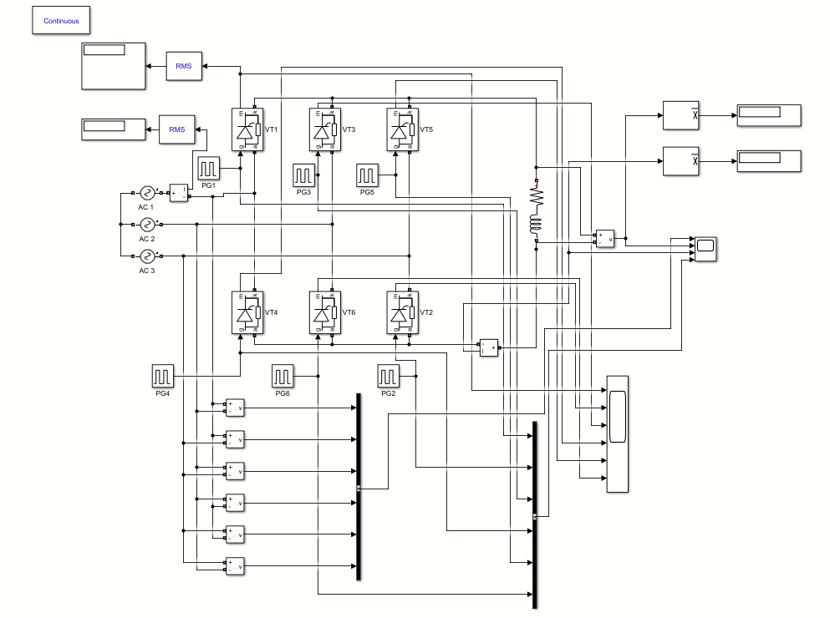

Figure 1: Simulation model 1

This model is established to simulate three-phase full bridge rectifier (thyristor version) under rectification mode. It includes three AC sources, six thyristors with six pulse generators correspondingly, and an inductive load. In order to observe the waveforms of Ud, Id, phase to phase voltage, pulse voltage and current of thyristor, there are also some voltage measurements, current measurements, bus creators and scopes. And we also use some RMS blocks, mean blocks and displayers to display simulation results .

## *2.2 (model 2)*

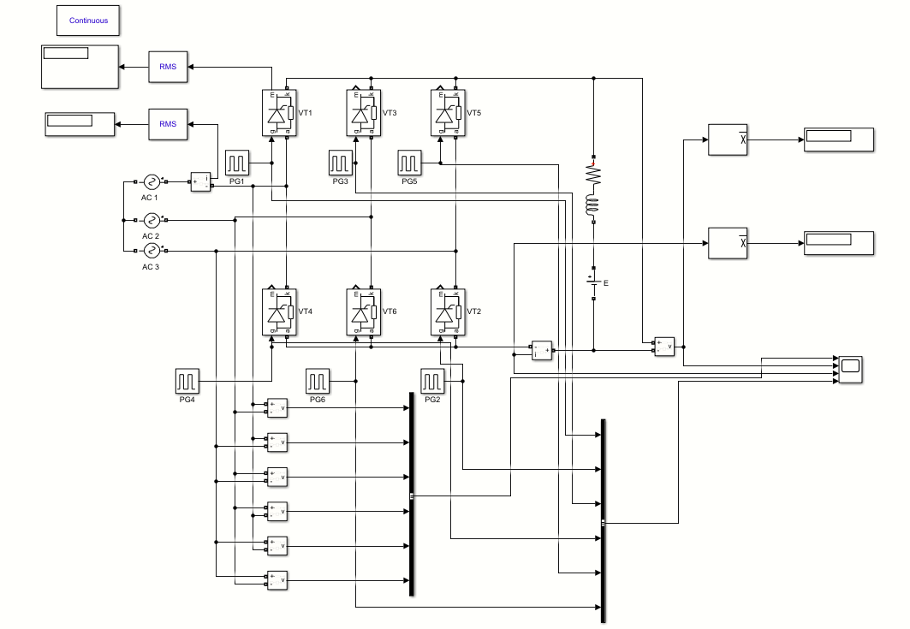

Figure 2: Simulation model 2

This model is established to simulate three-phase full bridge rectifier (thyristor version) under active inversion mode. It includes three AC sources, six thyristors with six pulse generators correspondingly, an inductive load and a back EMF. In order to observe the waveforms of Ud, Id, phase to phase voltage and pulse voltage, there are also some voltage measurements, current measurements, bus creators and scopes. And we also use some RMS blocks, mean blocks and displayers to display simulation results .

# Parameter Setup

*3.1 (AC source parameters)*

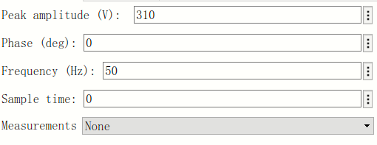

Figure 3: AC1 source parameters

*3.1 (Pulse Generator parameters)*

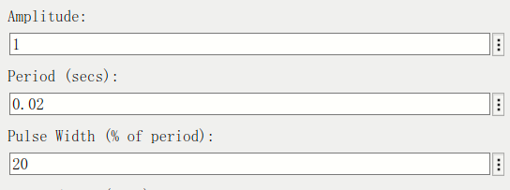

Figure 4: pulse generator parameters

*3.2(Pulse trigger time)*

|  |  |
| --- | --- |
| code | result |
| a=85;  f=50;  T=1/f;  VT1=(a+30)/360*T  VT2=(a+30+60)/360*T  VT3=(a+30+120)/360*T  VT4=(a+30+180)/360*T  VT5=(a+30+240)/360*T  VT6=(a+30+300)/360*T | VT1 = 0.0064  VT2 =0.0097  VT3 =0.0131  VT4 =0.0164  VT5 =0.0197  VT6 =0.0231 |
| a=170;  f=50;  T=1/f;  VT1=(a+30)/360*T  VT2=(a+30+60)/360*T  VT3=(a+30+120)/360*T  VT4=(a+30+180)/360*T  VT5=(a+30+240)/360*T  VT6=(a+30+300)/360*T | VT1 =0.0111  VT2 =0.0144  VT3 =0.0178  VT4 = 0.0211  VT5 =0.0244  VT6 = 0.0278 |

*3.3(other parameters)*

|  |  |  |  |  |
| --- | --- | --- | --- | --- |
| **L** | **R** | **E** | **α1** | **α2** |
| 5mH | 1Ω | -400V | 85° | 170° |

# Simulation Results

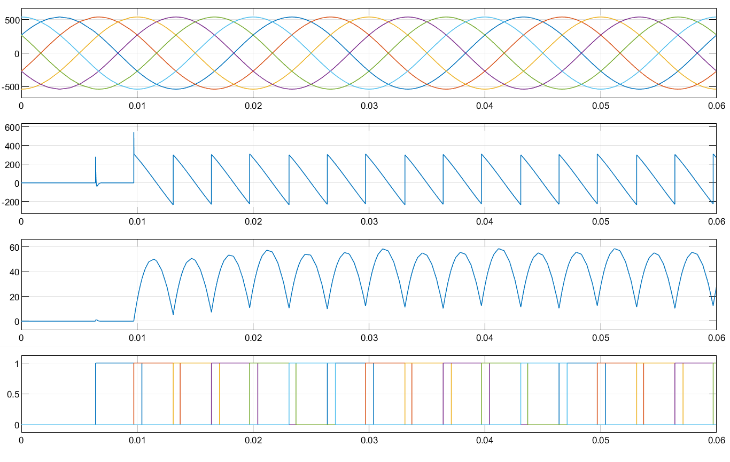

Figure 5: waveforms of phase to phase voltage, Ud, Id, and pulse voltage (**α1=**85°)

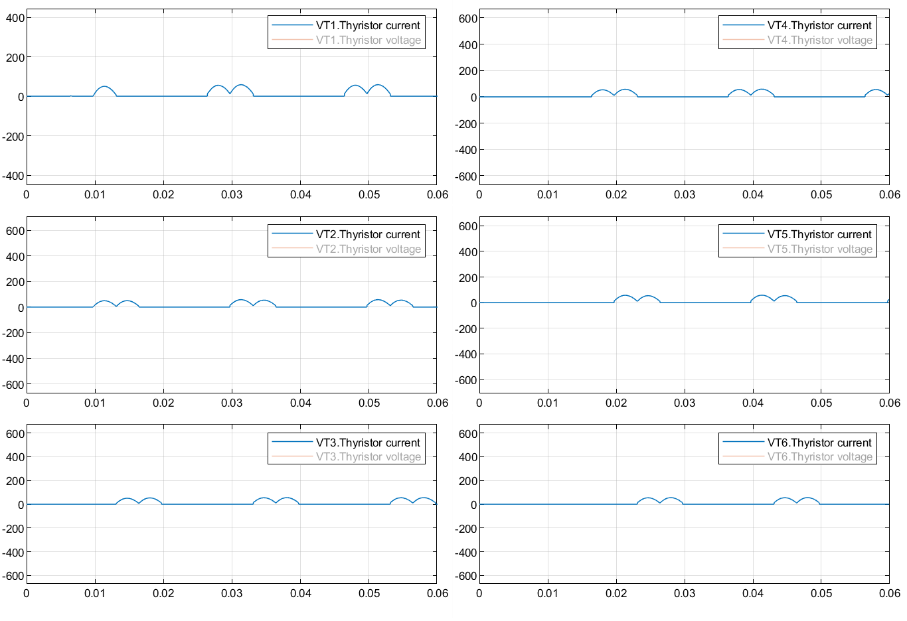

Figure 6: waveforms of current of thyristor

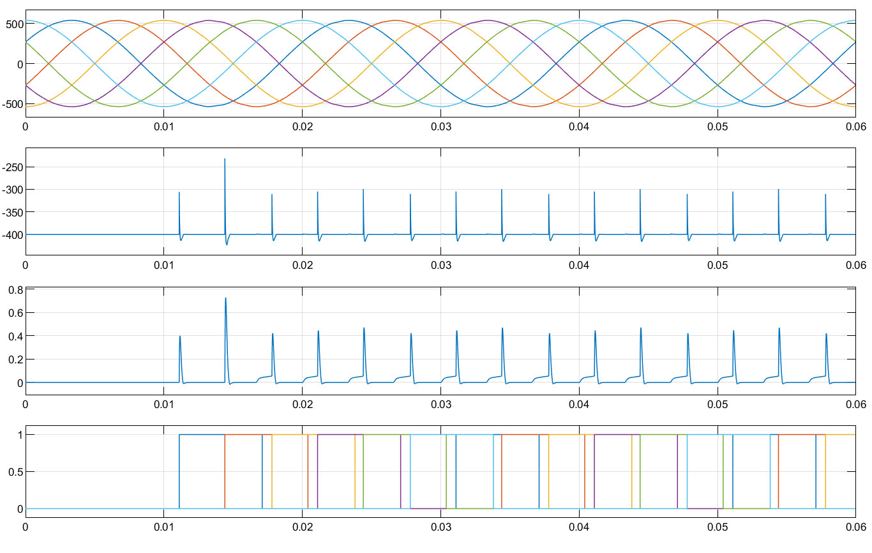

Figure 7: waveforms of phase to phase voltage, Ud, Id, and pulse voltage with back EMF (**α2=170°**)

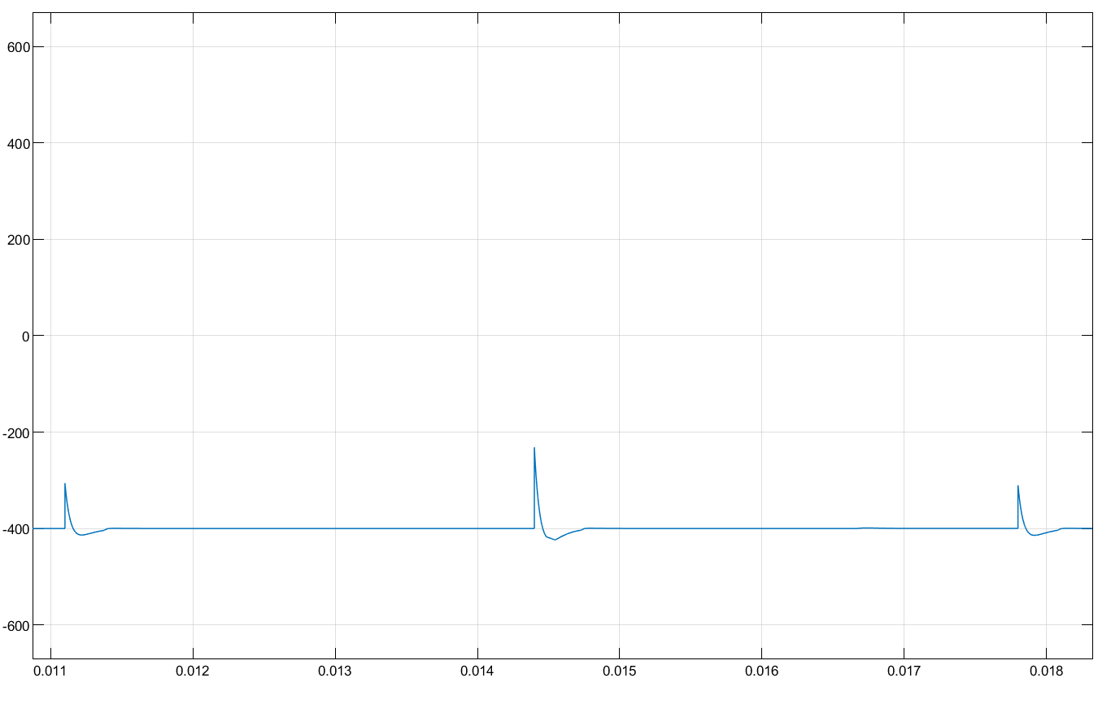

Figure 8: waveform of Ud

# Analysis of the Results

|  |  |
| --- | --- |
| theoretical calculations of rectification mode | theoretical calculations of inversion mode |
|  |  |

|  |  |  |  |  |  |
| --- | --- | --- | --- | --- | --- |
|  | Rectification Mode | | | Active Inversion Mode | |
| theoretical results | simulation results | deviation | theoretical results | simulation results |
| Ud | 44.87V | 42.31V | 5.71% | -506.98V | -400V |
| Id | 44.87A | 40.87A | 8.91% | -106.98A | 0.03187A |
| I2 | 36.64A | 33.92A | 7.42% | -87.39A | 0.07383A |
| IVT | 25.91A | 28.46A | 9.84% | -61.76A | 0.07439A |

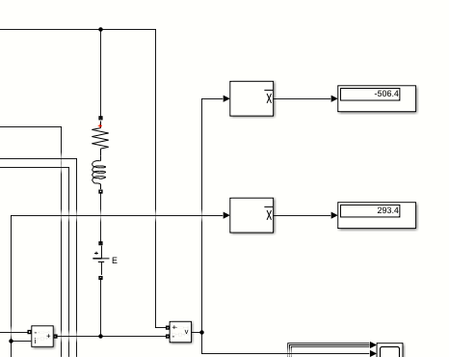

Figure 9: simulation results of Ud and Id

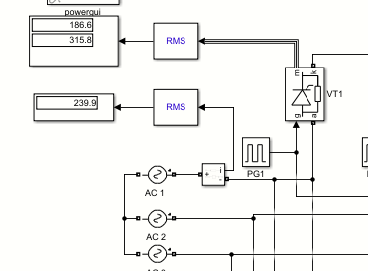

Figure 10: simulation results of IVT and I2

We find that the absolute value of E is less than the absolute value of Ud when calculated according to the given data, and the calculated current is negative. From the conduction characteristics of thyristor, it is impossible to happen in practice. When we change E to -800V, the simulation results are in good agreement with the theoretical value. This is because when the absolute value of E is less than the absolute value of UD, E is not enough to send electric energy from DC side to AC side.

**Part 2:**

# Topic

Three-Phase Full Bridge Rectifier ( power diode version)

# Simulation Model

There is one model established to simulate three-phase full bridge rectifier ( power diode version)

*2.1 (Simulation model )*

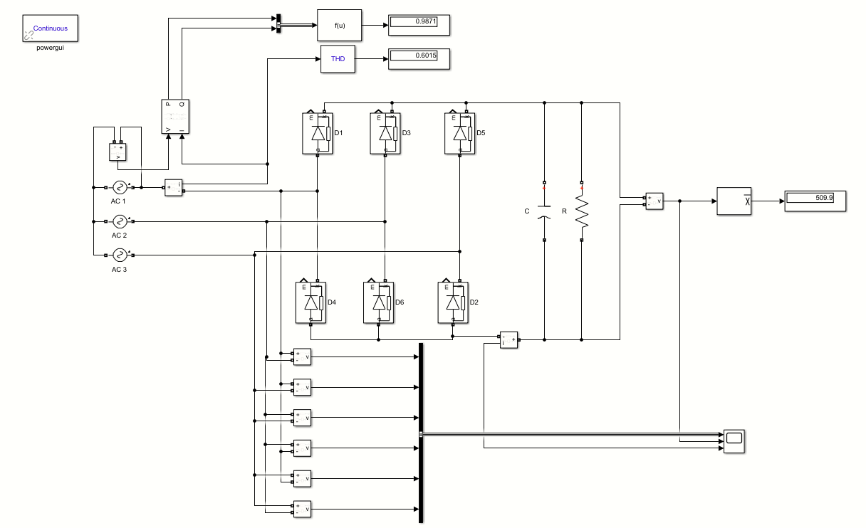

Figure 1: Simulation model 1

This model is established to simulate three-phase full bridge rectifier (power diode version). It includes three AC sources, six power diodes, a resistor and a capacitor. In order to observe the waveforms of Ud, Id, phase to phase voltage, there are also some voltage measurements, current measurements, power measurements, bus creators and scopes. And we also use some RMS blocks, mean blocks, THD blocks, function blocks, and displayers to display simulation results .

# Parameter Setup

*3.1 (AC source parameters)*



Figure 2: AC1 source parameters

*3.2(other parameter)*

|  |  |
| --- | --- |
| **C** | 5.5mF |

# Simulation Results

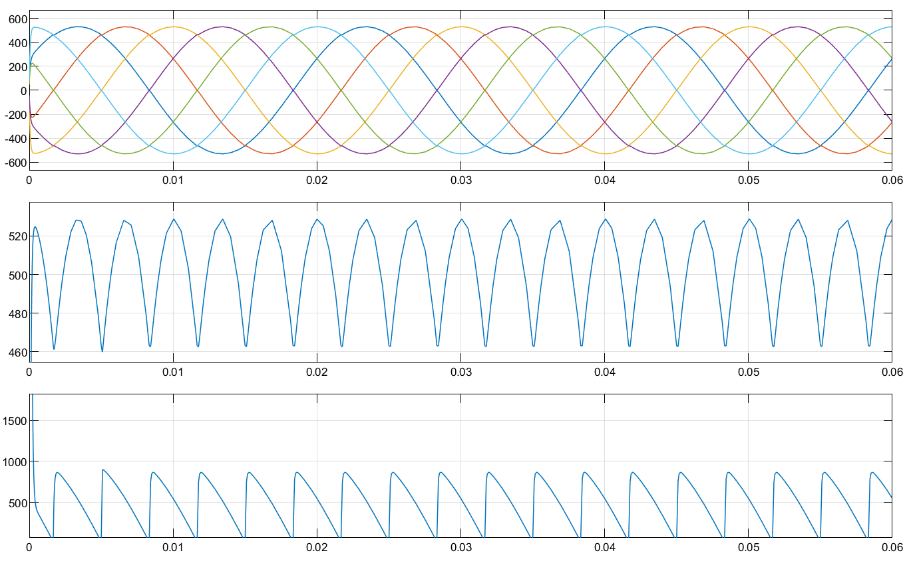

Figure 3: waveforms of phase to phase voltage, Ud and Id

# Analysis of the Results

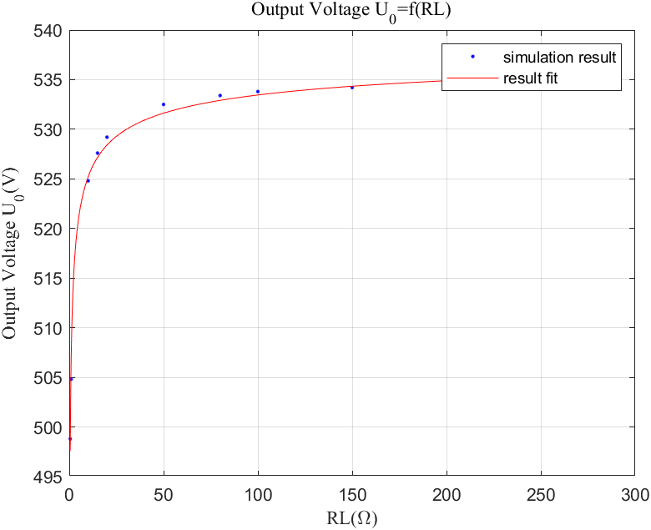

Figure 4: Uo = f(RL)

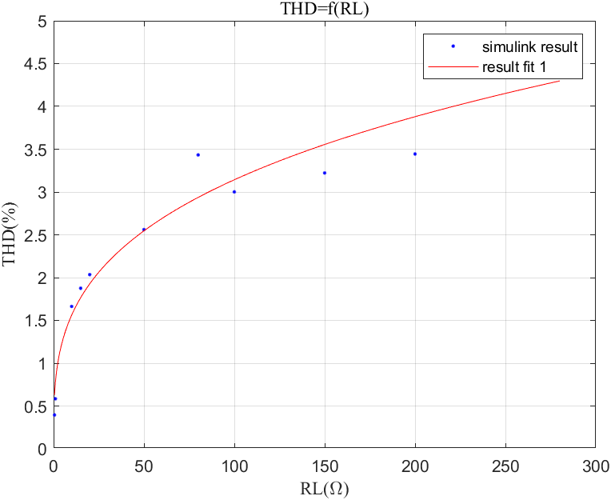

Figure 5: THD = f(RL)

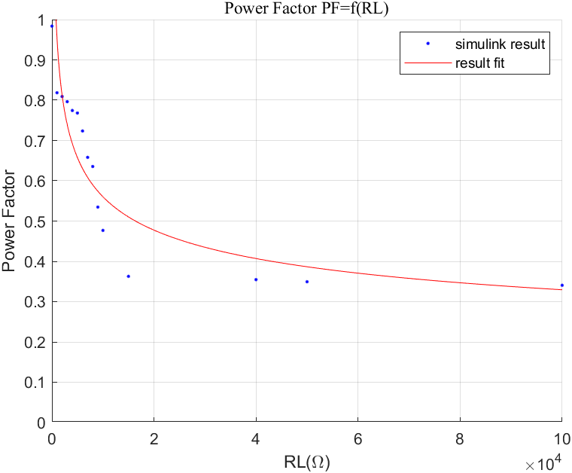

Figure 6 :PF = f(RL)