**Seminar Report**

Class 68 SUN Xunhang 2160400228

This seminar consists of two parts, which are both regarding passive inverter. For the two parts, we carried out simulations with Simulink.

**1 Series connection of 2 single-phase VSIs**

In this part, the simulation is regarding series connection of 2 single-phase VSIs with single-phase full bridge inverter, and the simulation is based on the circuit diagram shown below.

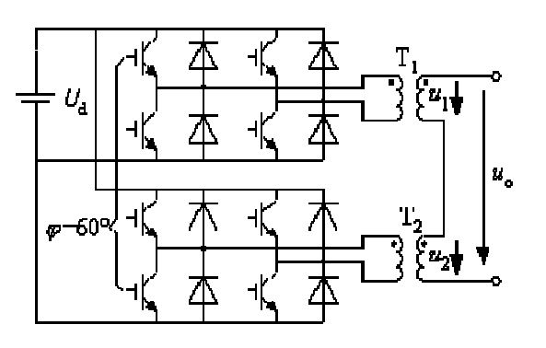

Fig. 1-1 Series connection of 2 single-phase VSIs with single-phase full bridge inverter

The simulation model and parameters we used in Simulink is as below.

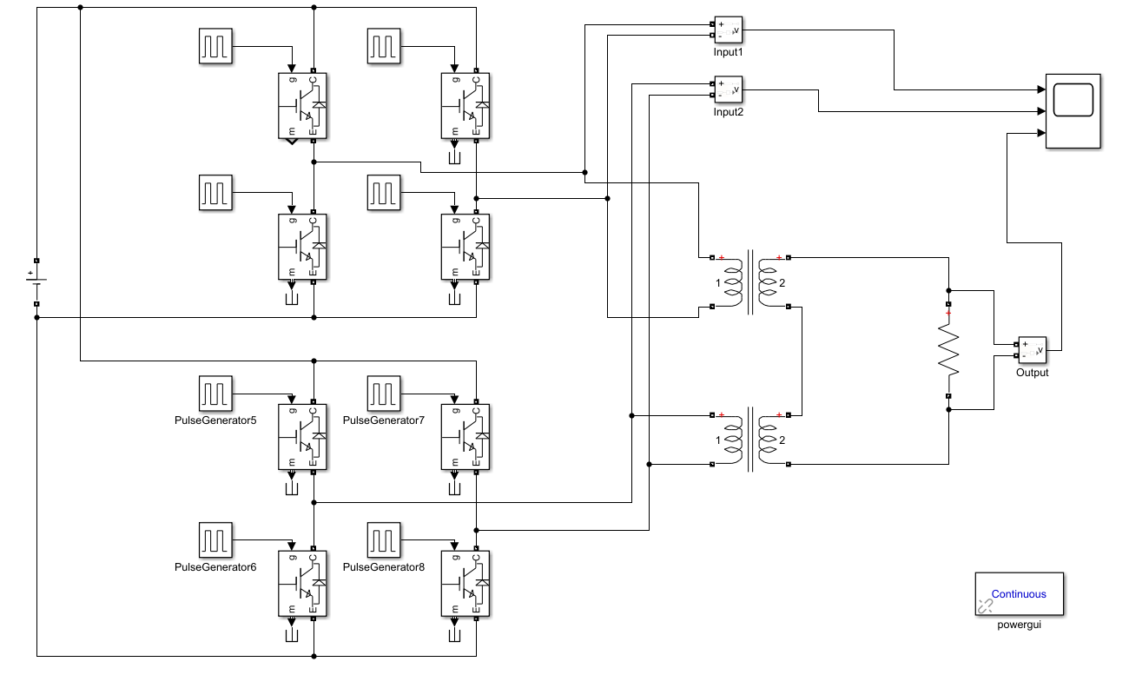

Fig. 1-2 Simulation model

Table 1 Distributed parameters

|  |  |
| --- | --- |
| Inverter type | Single-phase full-bridge inverter |
| Internal phase-shifting angle | $θ$ =150° |
| $$V_{DC}$$ | 400V |
| $$R_{load}$$ | 8Ω |

We used the model to carry out simulation and then we are required to change the external phase-shifting angle $φ$ between inverters to observe characteristics about the circuit.

* 1. **Task 1**

**1.1.1 Task requirement**

Observe the single inverter’s time sequence waveform and input/output voltage relationships.

**1.1.2 Time sequence waveform**

When we set $θ=150°$, for the full-bridge inverter, four IGBTs are conducted by for triggering pulses respectively. The pulse trigger waveforms of $V_{1}$ to $V_{4}$ are shown below.

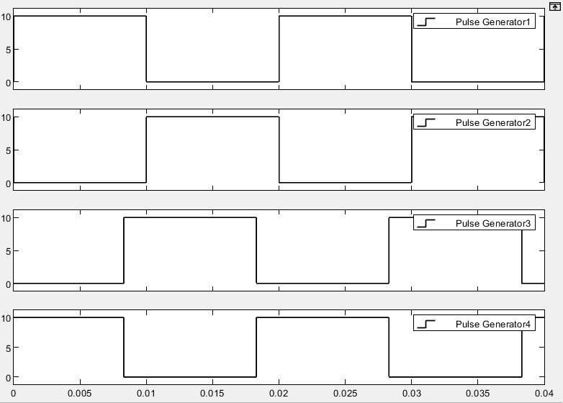

$$θ$$

Fig. 1-3 Pulse trigger waveforms of $V_{1}$ to $V_{4}$

By visual inspection, we can get the four switches are conducted in turn and the sequence is $V1$ → $V3$ → $V2$ → $V4$. (In the simulation, power diode and IGBT are in the same block, so when either diode or IGBT is conducting, the switch will be at on state.)

**1.1.3 Input/output voltage relationships**

Firstly, we set $φ=60°$, and the waveforms of input and output are shown in fig. 1-4.

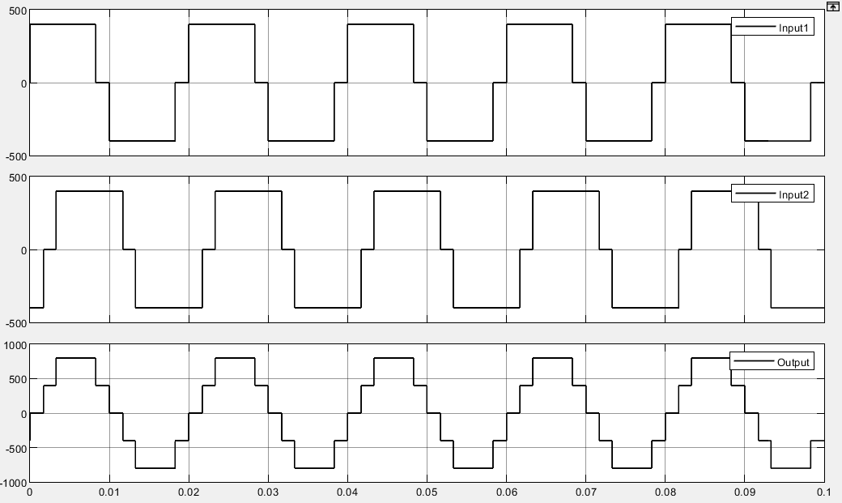

Fig. 1-4 Waveforms of input and output

From the figure, we can discover for the 2 single-phase VSIs, the output voltage of inverter equals to the superposition of output voltage of each single-phase VSI.

* 1. **Task2**

**1.2.1 Task requirement**

Study the basic operating principle of series connection of multiple single-phase VSIs.

**1.2.2 Operating principle**

Series connection of multiple single-phase VSIs consists of two single-phase full-bridge inverters and they are connected by transformer $T_{1}$ and $T_{2}$. From Task1, we have already known that the output voltage of inverter equals to the superposition of output voltage of each single-phase VSI. Besides, we can change the output waveform by changing the external phase-shifting angle $φ$.

In figure 1-5 to 1-7, we get the input and output waveform when $φ$ equals to $0°, 15°, 30°$ respectively.

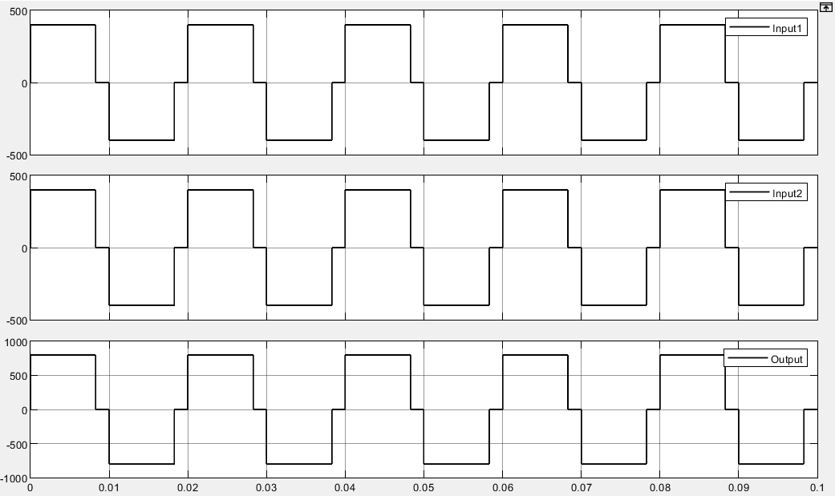

Fig. 1-5 $φ=0°$

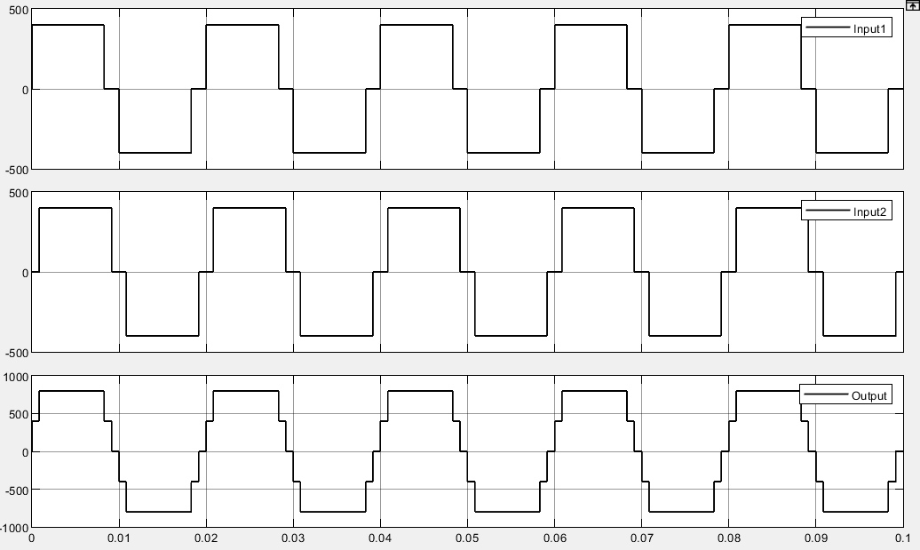

Fig. 1-6 $φ=15°$

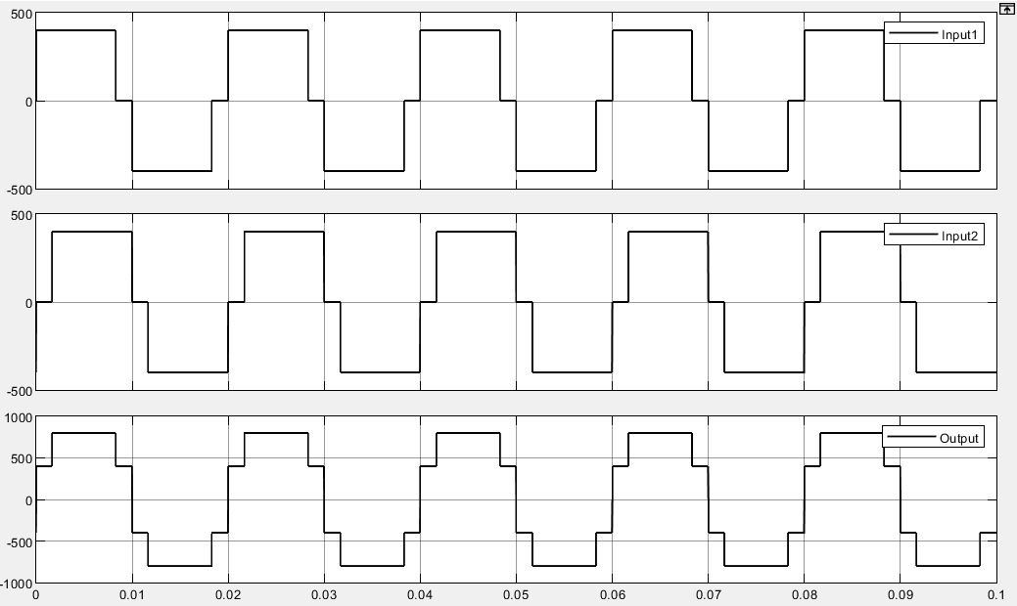

Fig. 1-7 $φ=30°$

In our circuit $θ=150°$, so the first critical angle is $30°(180°-150°=30°)$. When external phase-shifting angle is within the interval of $0°\sim 30°$, the proportion of zero part in output voltage is decreasing, i.e. the duty cycle is increasing.

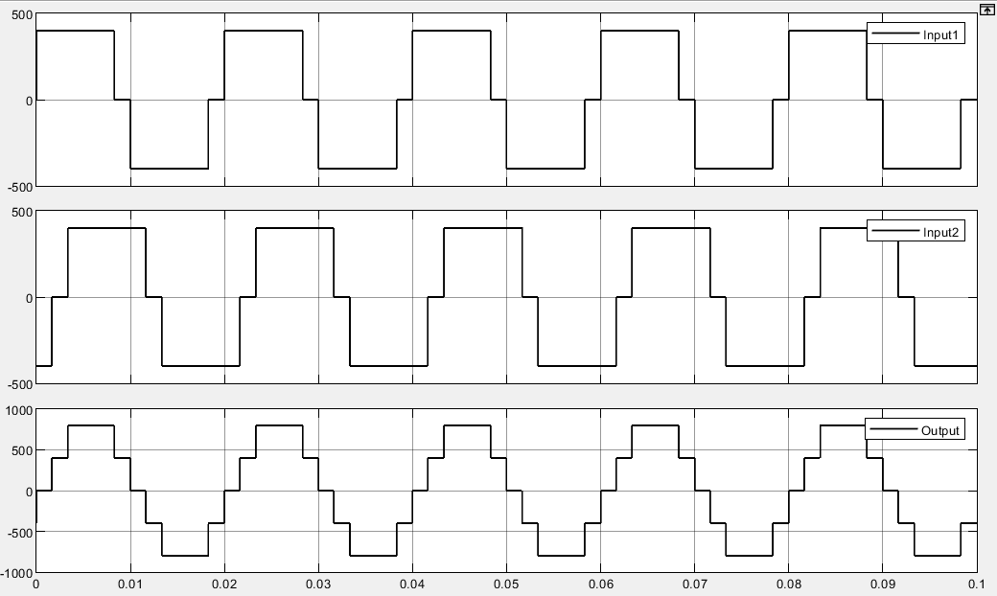

Fig. 1-8 $φ=60°$

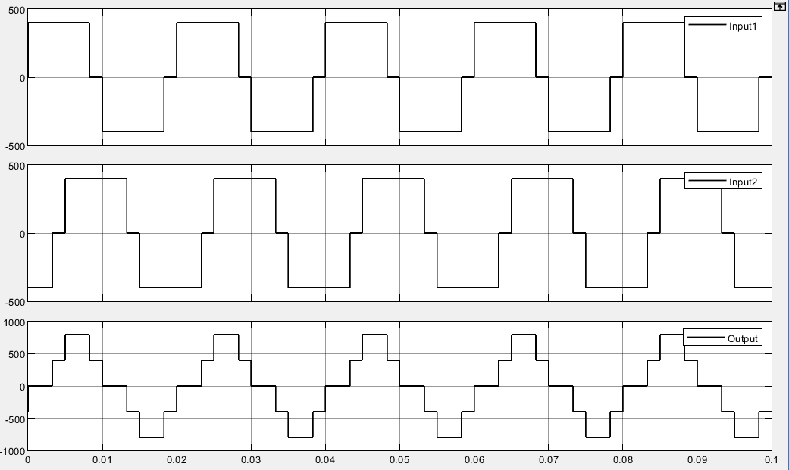

Fig. 1-9 $φ=90°$

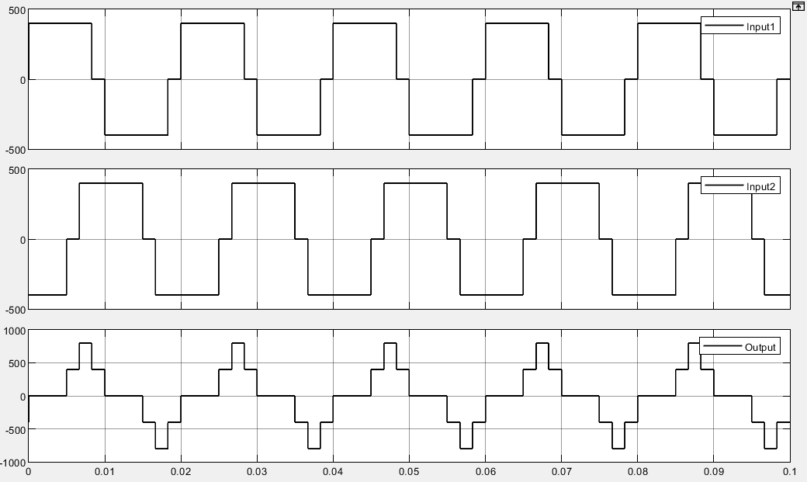

Fig. 1-10 $φ=120°$

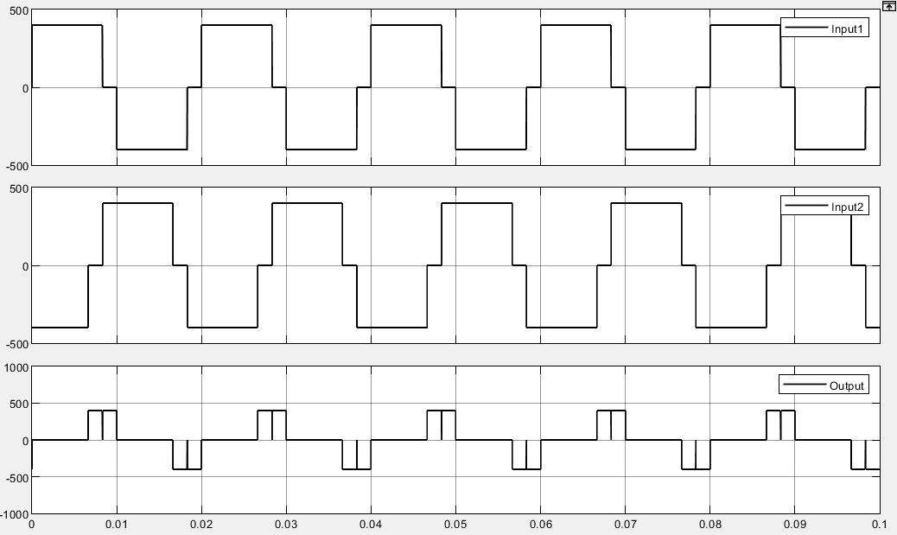

Fig. 1-11 $φ=150°$

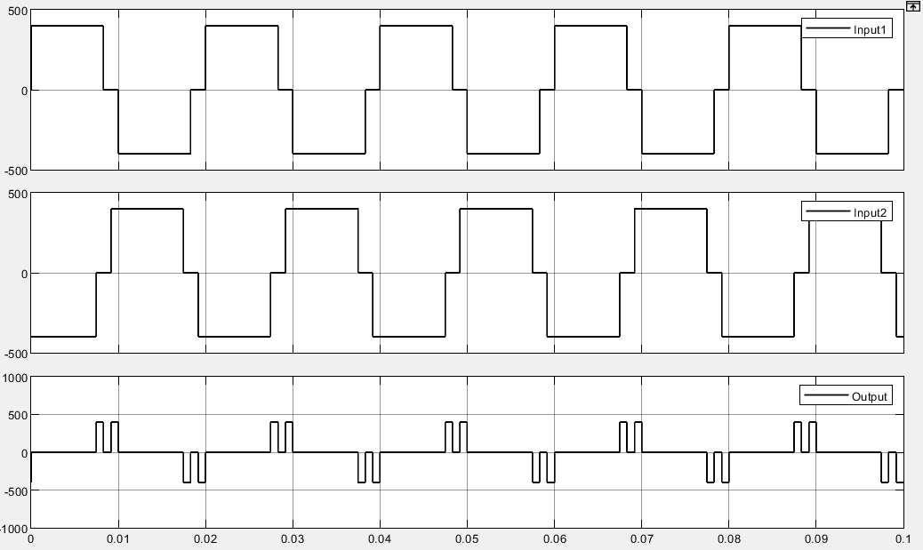

Fig. 1-12 $φ=165°$

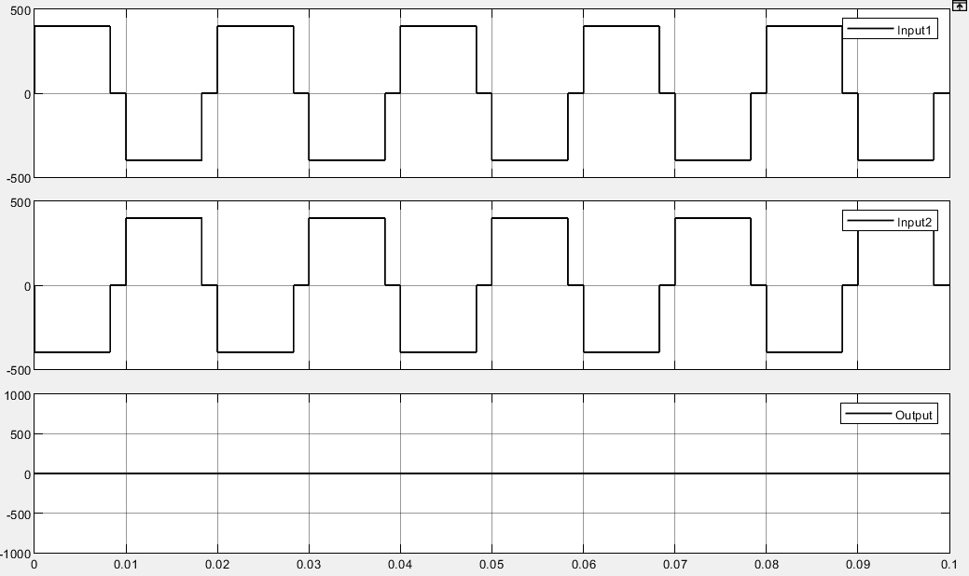

Fig. 1-13 $φ=180°$

When external phase-shifting angle is within the interval of $30°\sim 180°$, the proportion of zero part in output voltage is increasing, i.e. the duty cycle is decreasing. If $φ=180°$, we can see the output voltage is constant zero. In this part, we get the second critical angle $φ=150°$. When $φ<150°$, with $φ$ increases, the shape of output voltage changes little. We can get in Fig. 1-10 to 1-12, $150°$ is the critical angle of shape change of waveform.

And, during the interval of $180°\sim 360°$, the regularity of output is symmetrical to the interval of $0°\sim 180°$.

Then, we do harmonic analysis. From the one period waveform of $u_{1}$ in Fig. 1-14, we can get the Fourier coefficient of $u_{1}$.

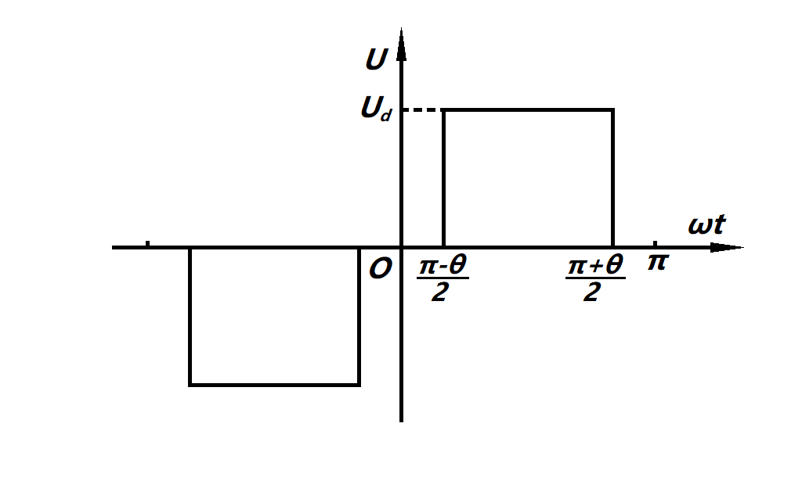

Fig. 1-14 One period of $u_{1}$

$$a_{n}=0 b_{n}=\frac{2}{π}\int_{\frac{π-θ}{2}}^{\frac{π+θ}{2}}{U_{d}sinnxdx=\frac{4U_{d}}{nπ}sin\frac{nπ}{2}sin\frac{nθ}{2}}$$

Therefore, we can get the Fourier series of $u_{1}$ and $u_{2}$ as below.

$$u_{1}=\sum_{n=1}^{∞}{\frac{4U_{d}}{nπ}sin\frac{nπ}{2}sin\frac{nθ}{2}}sinnωt$$

$${ u}_{2}=\sum_{n=1}^{∞}{\frac{4U_{d}}{nπ}sin\frac{nπ}{2}sin\frac{nθ}{2}}sinn\left(ωt-φ\right)$$

Then, we can get $u_{o}$.

$$u_{o}=u_{1}+u_{2}= \sum_{n=1}^{∞}{\frac{4U_{d}}{nπ}sin\frac{nπ}{2}sin\frac{nθ}{2}[}sinnωt+ sinn\left(ωt-φ\right)]$$

$$=\sum_{n=1}^{∞}{\frac{8U_{d}}{nπ}sin\frac{nπ}{2}sin\frac{nθ}{2}cos\frac{nφ}{2}}sin\frac{n(2ωt-φ)}{2}$$

Due to $sin\frac{nπ}{2}$, there is no even harmonics in the output.

For instance, we set $φ=60° θ=180°$, and we will get the Fourier series of output as below.

$$u_{1}=\sum_{n=1}^{∞}{\frac{4U_{d}}{nπ}}sinnωt$$

$${ u}_{2}=\sum_{n=1}^{∞}{\frac{4U_{d}}{nπ}}sinn\left(ωt-\frac{π}{3}\right) n=1,3,5…$$

$$u_{o}=u_{1}+u_{2}=\sum_{n=1}^{∞}{\frac{4U_{d}}{nπ}}\left[sinnωt+sinn\left(ωt-\frac{π}{3}\right)\right]$$

$=\frac{4\sqrt{3}U_{d}}{π}[sin⁡\left(ωt- \frac{π}{6}\right)-\frac{1}{5}sin5\left(ωt- \frac{π}{6}\right)-\frac{1}{7}sin7\left(ωt- \frac{π}{6}\right)+\frac{1}{11}$ $sin11\left(ωt- \frac{π}{6}\right)$

+ $\frac{1}{13}$ $sin13\left(ωt- \frac{π}{6}\right)-…]$

$u_{o}$ only has ${6k±1}^{th}(k=1,2,3,…)$ harmonic components while ${3k}^{th}(k=1,2,3,…)$ harmonic components are all counteracted.

As for the third harmonic component of $u_{1}$ and $u_{2}$, when we set the external phase-shifting angle $φ=60°$, the phase deviation of third harmonic component is $3×60°=180°$. Therefore, through the series connection of two transformers, the third harmonic components of $u_{1}$ and $u_{2}$ are counteracted and $u_{o}$ doesn’t have the third harmonic component. Similarly, ${3k}^{th}(k=1,2,3,…)$ harmonic components are all counteracted.

So, if we combine some output of inverters as definite phase deviation and make some main harmonic components of them counteracted, we can get the waveform which is very close to sine wave.

**1.3 Task3**

**1.3.1 Task requirement**

Plot the curves characterizing the relationships between external phase-shifting angle $φ$ and:

* + RMS value of the fundamental component in output voltage;
  + output voltage THD;
  + 3rd 5th 6th 7th and 9th harmonics components.

By using scripting language which is shown in appendix, we change $φ$ from $0°$ to $180°$ and then get the curves.

**1.3.2 Relationship between fundamental component and $φ$**

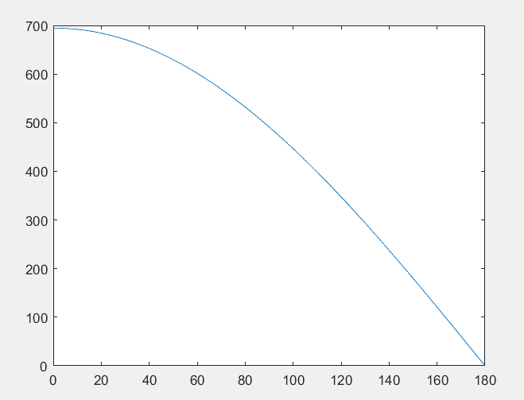

Fig. 1-15 The curve of relationship between fundamental component and $φ$

The RMS value of fundamental component in output voltage decreases with the increase of $φ$.

Through Fourier analysis, we can get the RMS of fundamental component in the formula as below:

$$U_{1}=\frac{4\sqrt{2}}{π}U_{d}sin\frac{θ}{2}cos\frac{φ}{2}$$

We can see $U_{1}$ is in direct proportion to $cos\frac{φ}{2}$. From the function monotonicity, we can easily get $U_{1}$ decreases while $φ$ is increasing.

**1.3.3 Relationship between THD and $φ$**

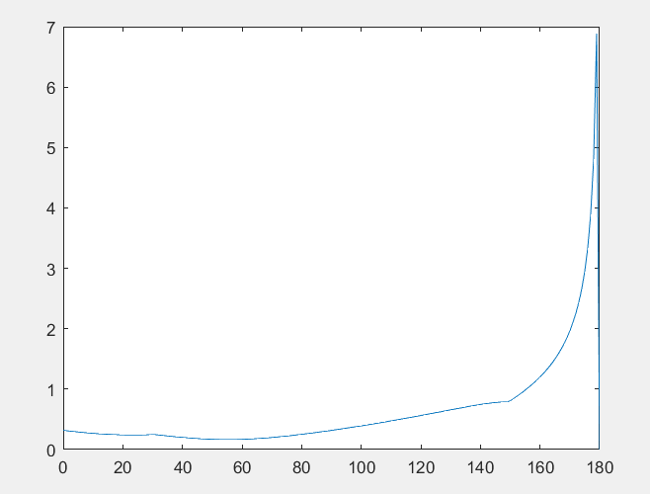

Fig. 1-16 The curve of relationship between THD and $φ$

The curve is smooth during the interval from $0°$ to $150°$ and increase rapidly beyond $150°$. The reason is that beyond $150°$, there is shape change in voltage waveform. Besides, when $φ$ equals to $180°$, the output is constant zero, so THD is non-existent. In the simulation curve, we can see THD is 0 when $φ$ equals to $180°$.

And when $φ=60°$, the curve gets its minimum value. From Fig. 1-18, $3^{rd}$ harmonic is the main part in harmonics. At $60°$, there is no $3^{rd}$ harmonic while fundamental component is still very large. Therefore, the THD will get its minimum value.

**1.3.4 Relationship between 3rd 5th 6th 7th and 9th harmonics components and $φ$**

In the former discussion, we have known there is no even harmonic in the output. Therefore, we shouldn’t have got 6th harmonic component in the simulation. The figure below is the relationship between 6th harmonic component and $φ$.

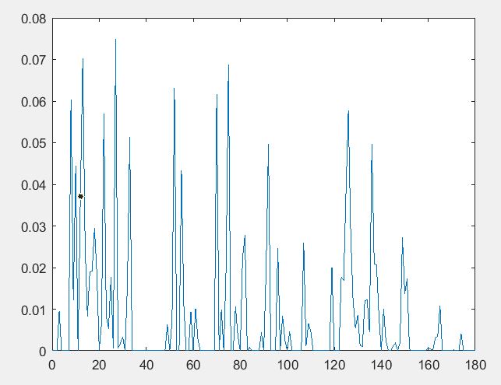

Fig. 1-17 The curve of relationship between 6th harmonic component and $φ$

In the simulation result, we can see the $6^{th}$ is nearly zero. However, due to the algorithm of Simulink, there is small fluctuation in the figure.

We also get the curve of relationship between $3^{rd},5^{th},7^{th} and 9^{th}$ harmonic component and $φ$.

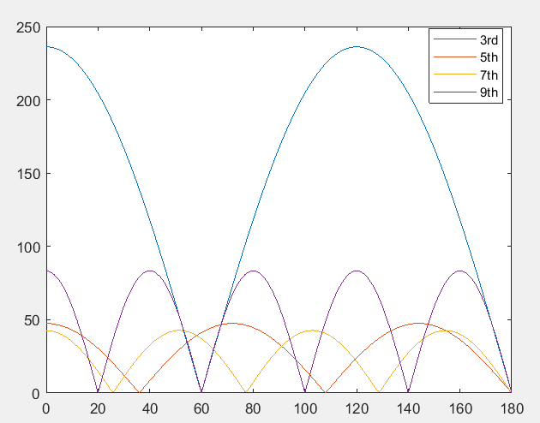

Fig. 1-18 Relationship between $3^{rd},5^{th},7^{th} and 9^{th}$ harmonic component and $φ$

By Fourier analyzation, we can get the peak value of harmonics as below.

$$|U_{nm}|=\frac{8U_{d}}{nπ}|sin\frac{nπ}{2}sin\frac{nθ}{2}cos\frac{nφ}{2}|$$

We can see the simulation result is the same as theoretical analyzation.

**2 Three-phase bridge inverters**

In this part, the simulation is regarding three-phase bridge inverters and the simulation model is shown below.

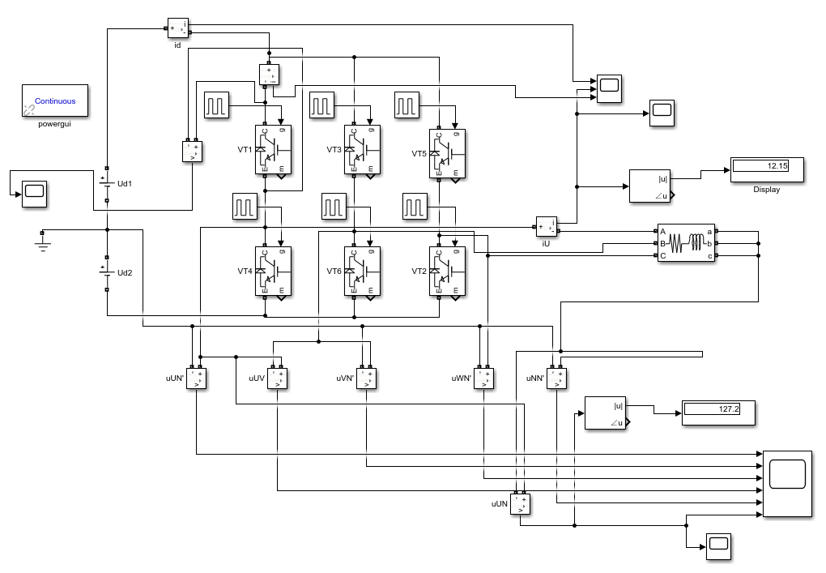

Fig. 2-1 Simulation model

The parameters of the circuit are $V_{Dc}=200V$, $f=50Hz$, $R=10Ω$ and $L=10mH$.

**2.1 The output voltage and current**

We do the simulation and get the waveform of voltage. Firstly, the waveforms of $U_{UN'}, U_{VN^{'}}$ and $U_{WN'}$ are shown as below.

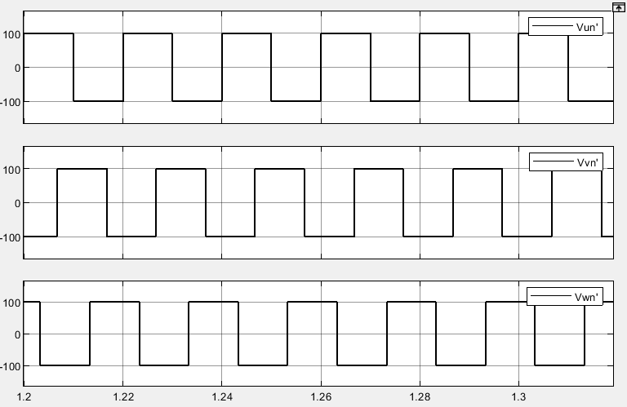

Fig. 2-2 The waveforms of $U_{UN'}, U_{VN^{'}}$ and $U_{WN'}$

Secondly, we get the waveforms of $U_{UV}, U_{NN^{'}}$ and $U_{UN}$.

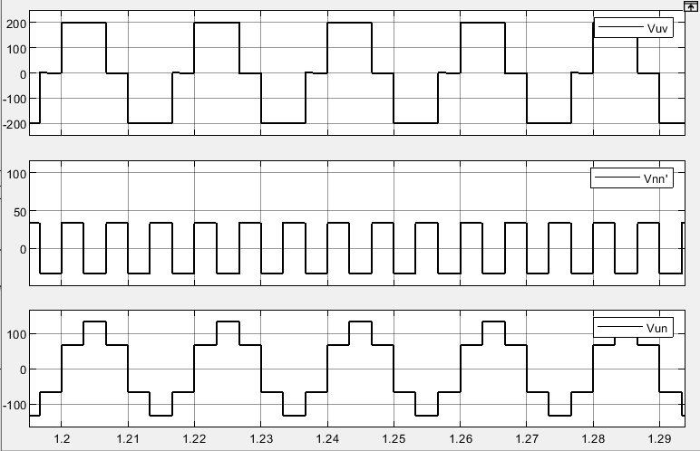

Fig. 2-3 The waveforms of $U_{UV}, U_{NN^{'}}$ and $U_{UN}$

And the waveform of $i_{U}$ and $i_{d}$ are shown as below.

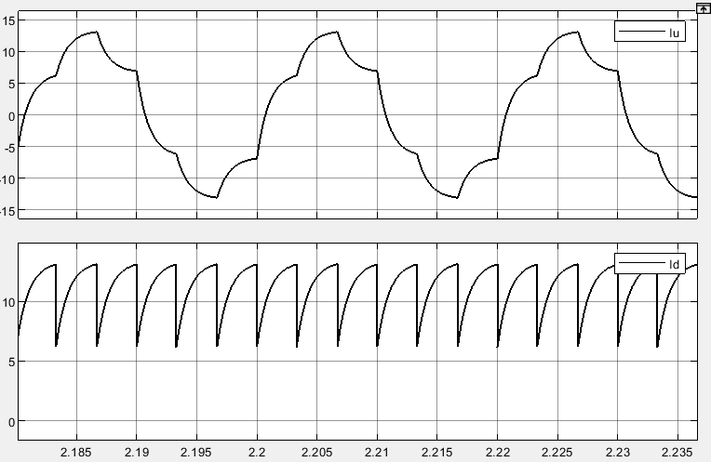

Fig. 2-4 Waveform of $i_{U}$ and $i_{d}$

**2.2 The voltage and current about power switch**

These 6 IGBTs are triggered following the order from 1 to 6. The delay of each IGBT is $60°$. Each group of IGBTs can be divided into 3 groups (VT1 and VT4, VT3 and VT6, VT5 and VT2). There is only one IGBT of each group conducted at the same time, which means at every moment there will be 3 IGBTs conducted.

The waveform of voltage and current about first group (VT1 and VT4) are shown as below.

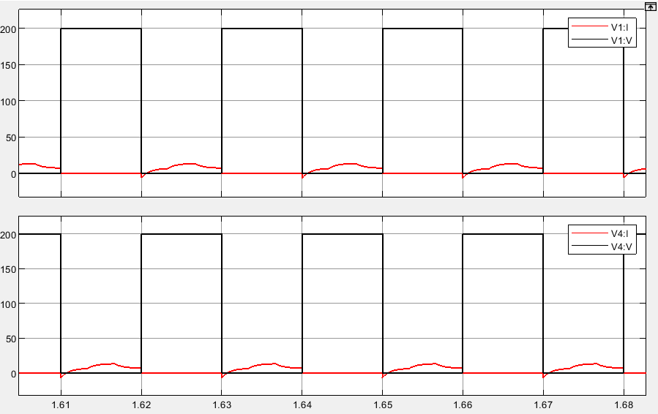

Fig. 2-5 The waveform of voltage and current about VT1 and VT4

Owing to the inductance load, a small part of time of current through each bridge arm is opposite current. And during this small part of time, IGBT is not conducted, in that the free-wheeling diode is conducting current. When the current is positive, IGBT will be conducted. From the figure, we can see there is only one IGBT in this group of bridge arm is conducted during half period.

And the waveform of voltage and current about six bridge arms are shown as below.

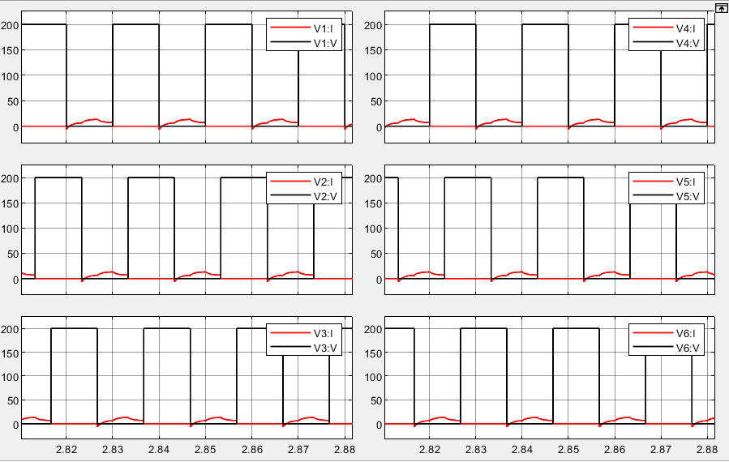

Fig. 2-6 The waveform of voltage and current about 6 IGBTs

**2.3 Calculation of harmonic components in output voltage**

Decompose the output phase voltage $u_{UN}$ to Fourier series:

$u_{UN}$ $=\frac{2U_{d}}{π}[sinωt+\frac{1}{5}sin5ωt+\frac{1}{7}sin7ωt+\frac{1}{11}$ $sin11ωt$ + $\frac{1}{13}$ $sin13ωt-…]$

$$=\frac{2U_{d}}{π}\left[sinωt+\sum_{n}{\frac{1}{n}sinnωt}\right] (n=6k±1)$$

RMS value:

$$U_{UN}=\sqrt{\frac{1}{2π}\int_{0}^{2π}{u_{UN}^{2}dωt}}=0.471U_{d}=0.471×200=94.2V$$

From our simulation, we get $U_{UN}=$ 92.18V

The fundamental wave of output voltage

$$U_{UN1m}=\frac{2U_{d}}{π}=127.32395V$$

The simulation value is 127.3240V, and the percentage deviation is nearly 0.

The amplitude value of $5^{th},7^{th} ,{11}^{th} and {13}^{th}$ harmonic components are shown as below.

$$U_{UN5m}=\frac{2U_{d}}{5π}=25.4648V$$

$$U_{UN7m}=\frac{2U_{d}}{7π}=18.1891V$$

$$U_{UN11m}=\frac{2U_{d}}{11π}=11.5749V$$

$$U_{UN13m}=\frac{2U_{d}}{13π}=9.7942V$$

Table 2 Comparison of simulation value and theoretical value of harmonic components

|  |  |  |  |
| --- | --- | --- | --- |
| Harmonic number | Simulation value | Theoretical value | Percentage deviation |
| 5 | 25.35 | 25.46 | 0.43% |
| 7 | 18.23 | 18.19 | 0.22% |
| 11 | 11.54 | 11.57 | 0.26% |
| 13 | 9.786 | 9.794 | 0.08% |

Then we calculate HRVn and compare the simulation value and theoretical value.

Table 3 Comparison of simulation value and theoretical value of HRVn

|  |  |  |
| --- | --- | --- |
| Harmonic number | Simulation value | Theoretical value |
| 5 | 19.91% | 20.00% |
| 7 | 14.32% | 14.29% |
| 11 | 9.06% | 9.09% |
| 13 | 7.69% | 7.69% |

Concluding from the table, there is no obvious difference between simulation value and theoretical value.

**2.4 Calculation of harmonic components in output current**

Decompose the output phase current $I_{UN}$ to Fourier series and do the calculation.

$$I_{UN1m}=\frac{U_{UN1m}}{\sqrt{R^{2}+{(ω_{1}L)}^{2}}}=12.1471A$$

$$I_{UN5m}=\frac{U_{UN5m}}{\sqrt{R^{2}+{(ω_{5}L)}^{2}}}=1.3675A$$

$$I_{UN7m}=\frac{U_{UN7m}}{\sqrt{R^{2}+{(ω_{7}L)}^{2}}}=0.7529A$$

$$I_{UN11m}=\frac{U_{UN11m}}{\sqrt{R^{2}+{(ω_{11}L)}^{2}}}=0.3217A$$

$$I_{UN13m}=\frac{U_{UN13m}}{\sqrt{R^{2}+{(ω_{13}L)}^{2}}}=0.2329A$$

Table 4 Comparison of simulation value and theoretical value of harmonic components

|  |  |  |  |
| --- | --- | --- | --- |
| Harmonic number | Simulation value | Theoretical value | Percentage deviation |
| 1 | 12.15 | 12.14 | 0.08% |
| 5 | 1.365 | 1.367 | 0.15% |
| 7 | 0.7556 | 0.7529 | 0.36% |
| 11 | 0.3237 | 0.3217 | 0.62% |
| 13 | 0.2351 | 0.2329 | 0.94% |

And we calculate HRIn and compare the simulation value and theoretical value.

$${HRI}_{n}=\frac{1}{n}\sqrt{\frac{R^{2}+{(ω_{1}L)}^{2}}{R^{2}+{(ω_{n}L)}^{2}}}×100\%$$

Table 5 Comparison of simulation value and theoretical value of HRIn

|  |  |  |
| --- | --- | --- |
| Harmonic number | Simulation value | Theoretical value |
| 5 | 11.23% | 11.26% |
| 7 | 6.22% | 6.20% |
| 11 | 2.66% | 2.65% |
| 13 | 1.93% | 1.92% |

There is no obvious difference between simulation value and theoretical value.

**Appendix**

It’s the scripting language we used in 1.3 .

clear

clc

rms1=zeros(1,181);

thd1=zeros(1,181);

f3=zeros(1,181);

f5=zeros(1,181);

f6=zeros(1,181);

f7=zeros(1,181);

f9=zeros(1,181);

for i=0:1:180

set_param('inverter/PulseGenerator5','Phasedelay','i/360*0.02');

set_param('inverter/PulseGenerator6','Phasedelay','i/360*0.02+0.01');

set_param('inverter/PulseGenerator7','Phasedelay','i/360*0.02+0.0083');

set_param('inverter/PulseGenerator8','Phasedelay','i/360*0.02+0.0183');

sim('inverter',[0,0.2]);

rms1(1,i+1)=R.data(end,1);

thd1(1,i+1)=T.data(end,1);

f3(1,i+1)=F3.data(end,1);

f5(1,i+1)=F5.data(end,1);

f6(1,i+1)=F6.data(end,1);

f7(1,i+1)=F7.data(end,1);

f9(1,i+1)=F9.data(end,1);

end

m=0:1:180;

figure(1)

plot(m,rms1)

figure(2)

plot(m,thd1)

figure(3)

plot(m,f3)

hold on

plot(m,f5)

hold on

plot(m,f7)

hold on

plot(m,f9)