**Seminar Report**

SUN Xunhang Class 68 2160400228

This seminar consists of two parts, which are both regarding DC-DC converter. For the two parts, we carried out simulations with Simulink.

**1 Buck converter**

In Simulink, we use the model as below to carry out simulation.

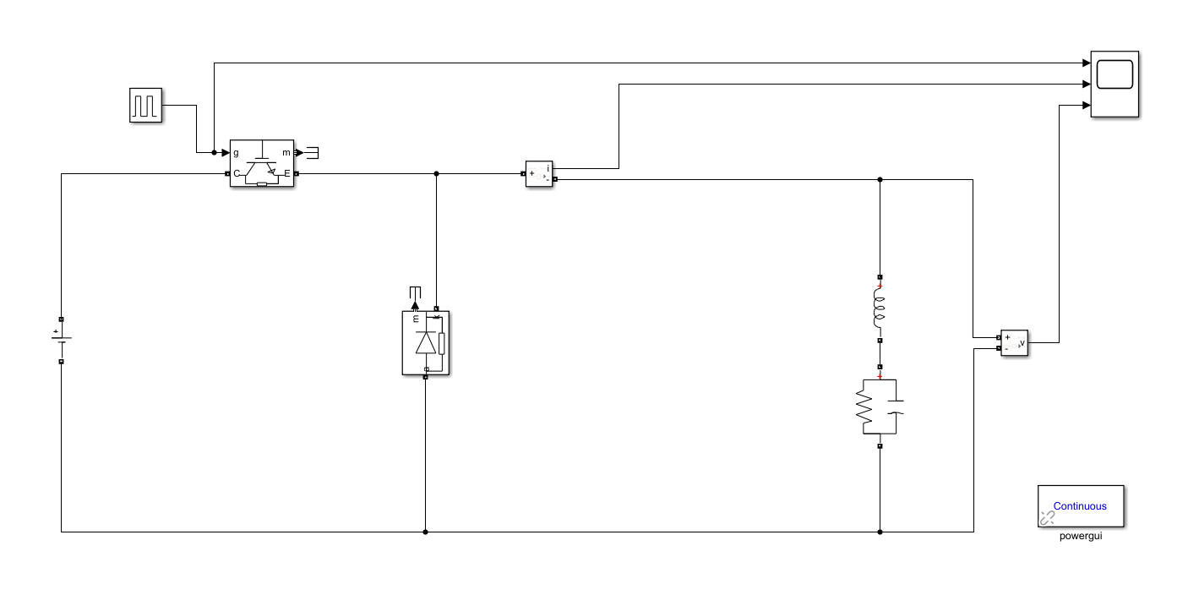

Fig. 1-1 Simulation model

And the parameters in the circuit are $V_{in}=400V, V_{o}=300V, f_{s}=100kHz, R_{L}=20Ω,$ $L=2mH, C=50μF$. For buck converter, we know that $V_{o}=DV_{in}$. Therefore, we set the duty ratio to 75% so as to make the output voltage be $300V$.

At steady state, we plot the waveform of the output.

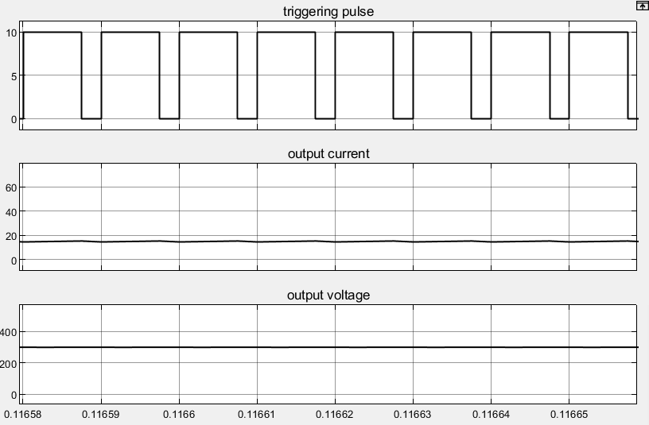

Fig. 1-2 Output voltage and current

When the duty cycle is 75%, we can get the output voltage is 300V and from Ohm’s law, we know the output current is 15A, which are the same as we can see in the simulation result.

**1.1 Task 1**

**1.1.1 Task requirement**

For given input/output voltage and circuit parameters, we need to calculate the theoretical value of inductor current ripple, capacitor voltage ripple and do simulations to verify the calculation results.

**1.1.2 Inductor current ripple**

In the buck converter, the output voltage ripple is very small. Hence, we can assume the output voltage is a constant and there is no current flowing through the capacitor. We define $i_{1}$ as the on-state inductor current and $i_{2}$ as the off-state inductor current.

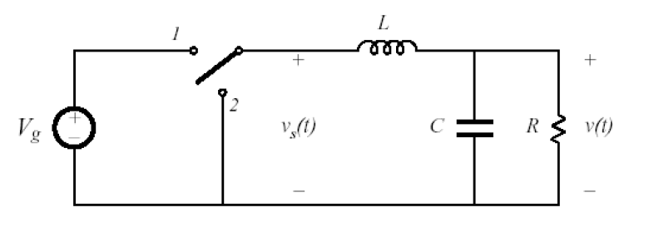

Fig. 1-3 Main circuit of buck converter

At on state, we have

$$V_{in}=L\frac{di_{1}}{dt}+Ri_{1}$$

Solving the differential equation, we can get

$$i_{1}=I_{10}e^{- \frac{t}{τ}}+\frac{V_{in}}{R}(1-e^{- \frac{t}{τ}})$$

In the equation, $I_{10}$ is the initial value of on-state current and $τ$ is the time constant which value is $\frac{L}{R}$.

At off state, we have

$$L\frac{di_{2}}{dt}+Ri_{2}=0$$

Similarly, we get

$$i_{2}=I_{20}e^{- \frac{t-t_{on}}{τ}}$$

When the circuit is at steady state, we have

$$I_{10}=i_{2}(T)$$

$$I_{20}=i_{1}(t_{1})$$

Therefore, we have

$$I_{10}=\frac{e^{Dρ}-1}{e^{ρ}-1}∙\frac{V_{in}}{R}=14.6190A$$

$$I_{20}=\frac{{1-e}^{-Dρ}}{{1-e}^{-ρ}}∙\frac{V_{in}}{R}=15.3685A$$

In the equation, $ρ=\frac{T}{τ}$. Then, we have

$${∆i}_{L}=I_{20}-I_{10}=0.7495A$$

**1.1.3 Capacitor voltage ripple**

In the circuit, there is a capacitor and a resistor as load. By KCL, we will get

$$i_{L}=i_{R}+i_{C}$$

$i_{L}, i_{R} and i_{C}$ are the current flows through the conductor, resistor and capacitor, respectively.

Owing to the capacitor, $i_{R}$ is almost a constant so that $∆i_{R}$ is extremely small. So, we have

$$∆i_{L}={∆i}_{R}+{∆i}_{C}≈{∆i}_{C}$$

For the capacitor, we can get the current via

$$i_{C}=C\frac{du_{C}}{dt}$$

Then we will get the changing voltage across the capacitor

$$∆u_{C}=\frac{∆Q}{C}=\frac{1}{C}\int{i_{C}dt}=\frac{1}{C}\int{i_{L}dt}$$

In short time, we can calculate by assuming the current changes linearly. Therefore, we can get the capacitor voltage ripple

$$∆u_{C}=\frac{1}{C}\int{i_{L}dt=\frac{1}{C}∙\frac{1}{2}∙\frac{∆i_{L}}{2}∙\frac{T}{2}=\frac{∆i_{L}T}{8C}}=0.0187V$$

**1.1.4 Comparison between theory and simulation**

The output with ripple is shown as below.

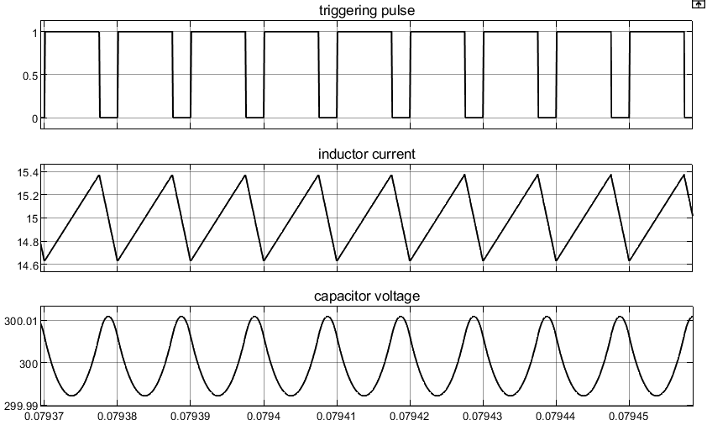

Fig. 1-4 The ripple output

Getting the simulation value from the figure, we analyze the error as below.

Tab. 1-1 Comparison of theoretical and simulation value

|  |  |  |  |
| --- | --- | --- | --- |
|  | Theoretical value | Simulation value | Percentage error |
| Inductor current ripple | 0.7495A | 0.7500A | 0.07% |
| Capacitor voltage ripple | 0.0187V | 0.0187V | $≈$ 0 |

From the comparison, we can see the theoretical value and simulation value are almost the same.

**1.2 Task 2**

**1.2.1 Task requirement**

For buck converter, we have to adjust the duty cycle D from 0 to 0.8, describe the relationships between duty cycle D and inductor current ripple, capacitor voltage ripple, voltage gain and verify your results through simulation.

**1.2.2 Relationship between G and D**

In Simulink, we plot the curve between G and D.

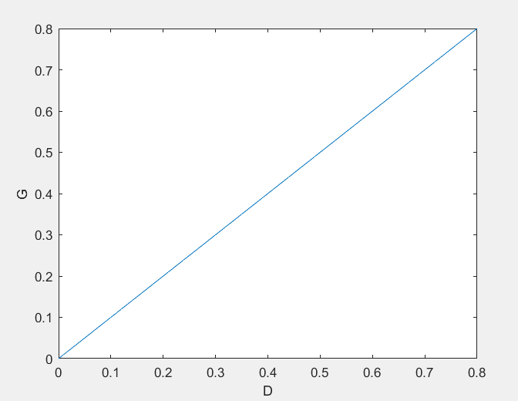

Fig. 1-5 Relationship between G and D

For buck converter, we all know that $V_{o}=DV_{in}$. Therefore, we can easily get the relationship between voltage gain and D as

$$G=\frac{V_{o}}{V_{in}}=\frac{DV_{in}}{V_{in}}=D$$

It’s to say the voltage gain is the equal to the duty cycle. Therefore, we can see G is in direct proportion to D in the simulation result.

**1.2.3 Relationship between inductor current ripple and D**

In our simulation, we get the curve between inductor current ripple and duty cycle as below.

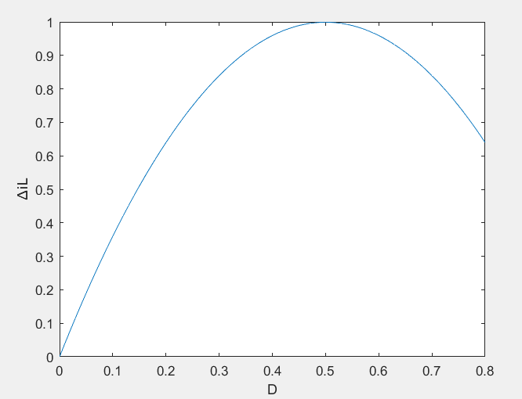

Fig. 1-6 Relationship between ${∆i}_{L}$ and $D$

From the differential equation, we get the expression of ${∆i}_{L}$ as below

$$∆i_{L}=\frac{V_{in}}{R}(\frac{e^{ρ}+1}{e^{ρ}-1}-\frac{e^{\left(1-D\right)ρ}+e^{Dρ}}{e^{ρ}-1})$$

We can see $∆i_{L}$ is determined by

$$f\left(D\right)=e^{\left(1-D\right)ρ}+e^{Dρ}$$

$f\left(D\right)$ is a symmetrical function. When $e^{\left(1-D\right)ρ}=e^{Dρ}$, i.e. $D=0.5$, $f\left(D\right)$ gets its maximum. Therefore, $∆i_{L}$ is symmetrical and gets maximum with $D=0.5$. It’s the same in our simulation result.

**1.2.4 Relationship between capacitor voltage ripple and D**

In Simulink, we plot the curve between $∆u_{C}$ and $D$.

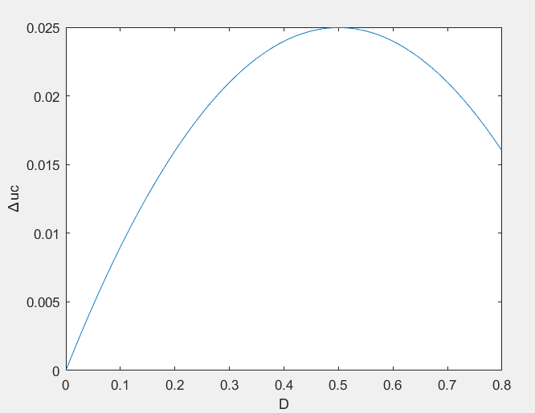

Fig. 1-7 Relationship between $∆u_{C}$ and $D$

From our former analyzation, we know that $∆u_{C}=\frac{∆i_{L}T}{8C}$, therefore, the curve has the same form as Fig. 1-6.

**2 Indirect DC-DC converter**

In Simulink, we use the model as below to carry out simulation.

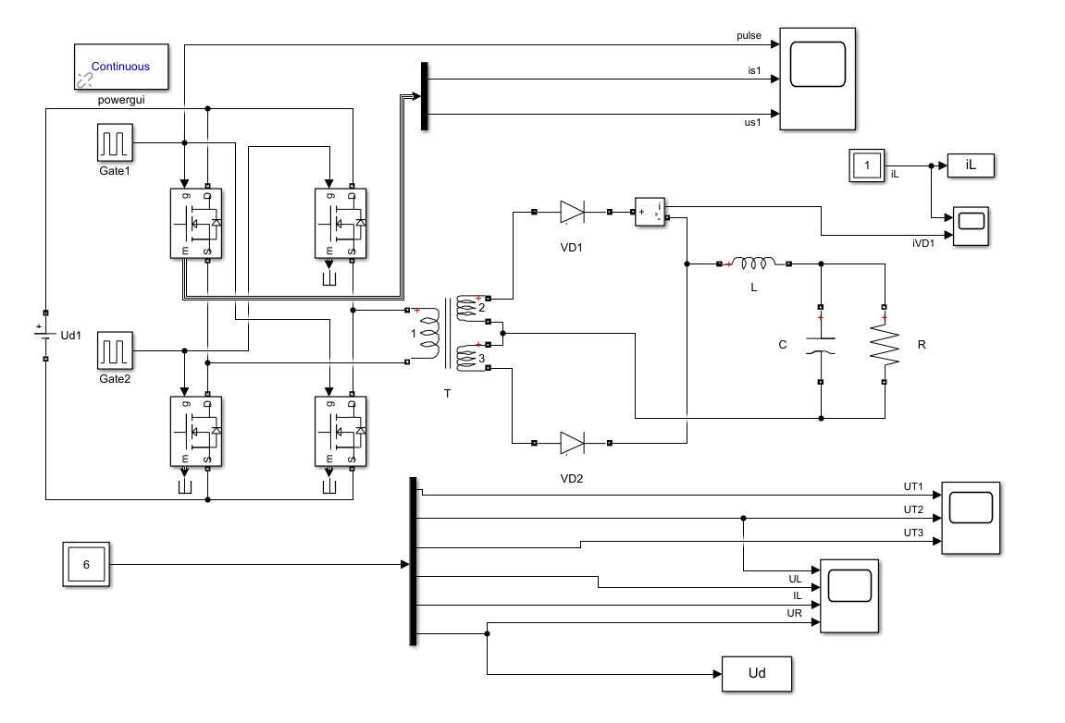

Fig. 2-1 Simulink model

And the parameters in the circuit are $V_{in}=500V, V_{o}=200V, f_{s}=100kHz, R_{L}=10Ω,$ $L=1mH, C=100μF, k=2:1:1$.

In the circuit, we have that $\frac{V_{o}}{V_{in}}=\frac{2D}{T}$. Therefore, we set the duty ratio to 40% so as to make the output voltage be $200V$.

**2.1 Task 1**

**2.1.1 Task requirement**

For given input/output voltage and circuit parameters, we need to do simulations to study the operating principle and analyze the operating sequence.

**2.1.2 Operating principle and sequence**

This circuit can be divided into two parts by the transformer, a full-bridge inverter on the left and a full-wave rectifier on the right. Through the inverter, the direct current will be transformed into alternating current. Then, the transformer will convert the voltage level. Owing to the two power diodes, the AC will be converted to DC finally. Therefore, the structure is an indirect DC to DC converter.

**i) Full-bridge inverter**

In the full-bridge inverter, the four MOSFETs are divided into two groups. S1 and S4 are in group 1 and group 2 consists of S2 and S3. MOSFETs in one group conduct together and the two groups conduct alternant. The duty cycle D is defined as the time one group conducts in one period.

We set $D=0.4$ to learn the principle of the circuit. Waveforms of triggering pulses and MOSFET voltage and current are shown as below.

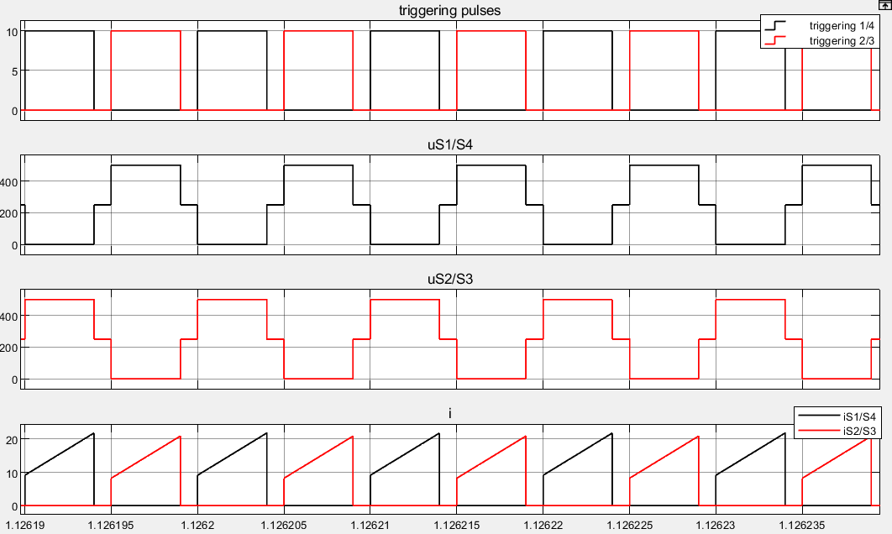

Fig. 2-2 Waveforms of triggering and voltage and current of MOSFET

We have $V_{in}=500V .$ When S1 and S4 at on state, the current flow through S2 and S3 increases gradually and the voltage across S2/S3 is 500V. When S2 and S3 are on, the situation is the same. When S1-S4 are all at off state, the voltage across each MOSFET is $\frac{V_{in}}{2}=250V$.

From the figure, we can easily get operating sequence shown as below.

Tab. 2-1 Operating sequence

|  |  |
| --- | --- |
| Time interval | Conductive MOSFET |
| 0-DT | S1, S4 |
| DT-T/2 | \ |
| T/2-(D+1/2) T | S2, S3 |
| (D+1/2) T-T | \ |

**ii) Full-wave rectifier**

The voltage waveforms of primary side and secondary side of the linear transformer are shown below.

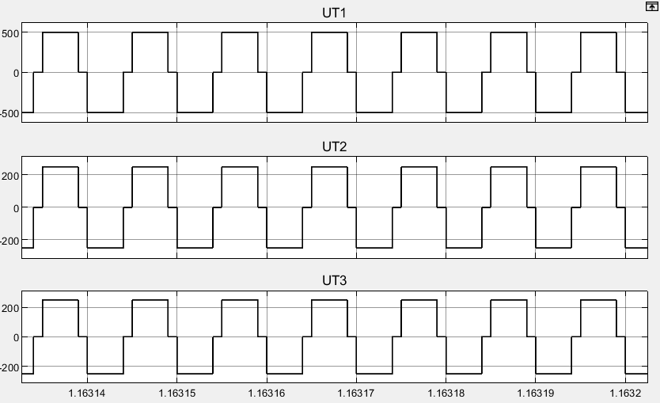

Fig. 2-3 Transformer voltage waveform

Across the transformer, the amplitude value of voltage decreases to 250V owing to the ratio of transformation 2:1:1. And the current is exactly AC.

Then we plot the waveforms of load conductor and two diodes current.

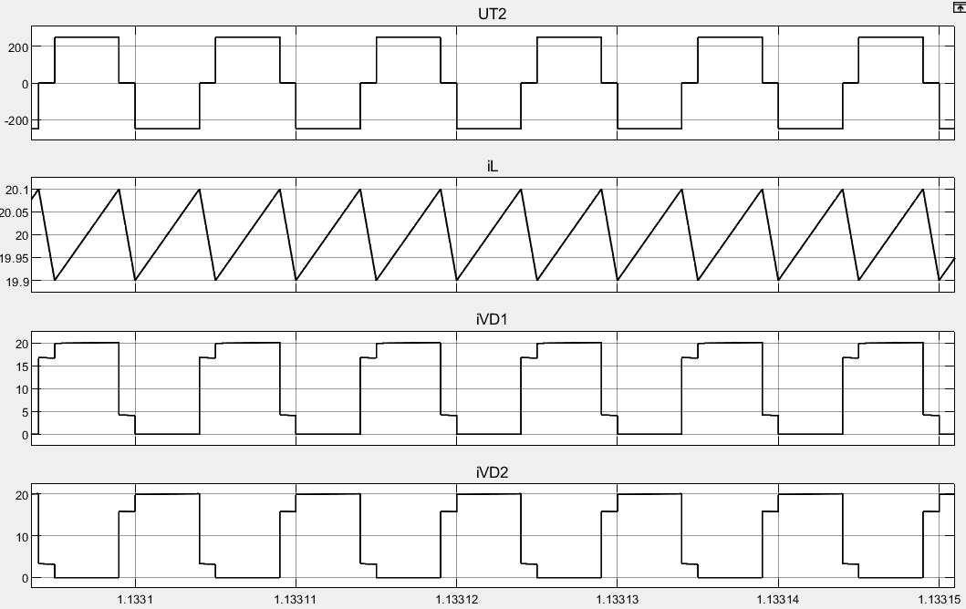

Fig. 2-4 Sequence of two diodes

When S1 and S4 conduct, UT2 is positive and VD1 is at on-state. When S2 and S3 conduct, UT2 is negative and VD2 is at on-state. If the four MOSFET are all at off-state, the conductor discharges through the two diodes.

Finally, we plot the conductor current and voltage and output voltage.

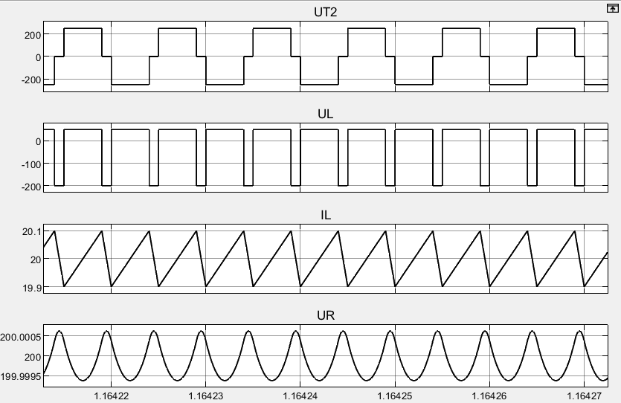

Fig. 2-5 Conductor voltage and current and output voltage

We all know $u_{L}=L\frac{di}{dt},$ so when the conductor is charging, the voltage is positive and when it’s discharging, the voltage is negative. The conductor and capacitor make up a low-pass filter, which leads the output is almost a constant voltage with small ripple.

**2.2 Task 2**

**2.2.1 Task requirement**

We need to adjust the load resistor to realize continuous current mode (CCM) and discontinuous current mode (DCM) and verify through simulation.

**2.2.2 Theoretical analyzation**

In the indirect DC converter, CCM and DCM is determined by the conductor current. Due to the current ripple, in some case the conductor ripple may be zero and we term this mode is DCM. On the contrary, if the current is always bigger than zero, the mode is termed CCM.

In this part, the circuit consists of a full-bridge inverter and a full-wave rectifier. In order to analyze the inductor current, the circuit can be equivalent to a buck converter. And the equivalent circuit and parameters are shown as below.



Fig. 2-6 Equivalent buck converter

Tab. 2-2 Equivalent parameters

|  |  |  |
| --- | --- | --- |
| Parameters | Equivalent parameters | Value |
| $$V_{in}$$ | $$\frac{V_{in}}{k}$$ | 250V |
| $$V_{o}$$ | $$V_{o}$$ | 200V |
| $$D$$ | $$2D$$ | 0.8 |
| $$f_{s}$$ | $$2f_{s}$$ | 200kHz |
| $$R$$ | $$R$$ | 10Ω |
| $$L$$ | $$L$$ | 1mH |
| $$C$$ | $$C$$ | 100μF |

From the former analyzation, we know output voltage ripple is very small, so we can neglect the voltage ripple and think the output is constant voltage $v_{o}$.

In Fig. 2-7, we can see the on state of the buck converter.

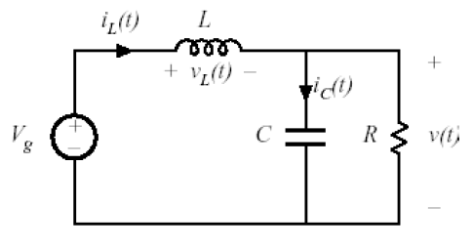

Fig. 2-7 On state of buck converter

We assume output is a constant voltage, so we have

$$V_{in}-V_{o}=L\frac{di_{L}}{dt}$$

The slope of inductor current is constant

$$\frac{di_{L}}{dt}=\frac{V_{in}-V_{o}}{L}$$

Similarly, at the off state, the slope of inductor current is also constant.

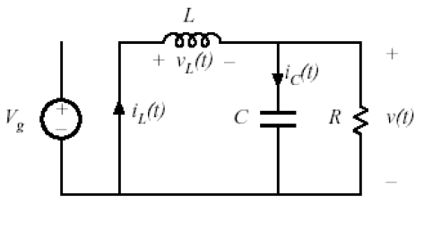

Fig. 2-8 Off state of buck converter

$$-V_{o}=L\frac{di_{L}}{dt}$$

$$\frac{di_{L}}{dt}=-\frac{V_{o}}{L}$$

Therefore, the waveform of inductor current is linearly as below.

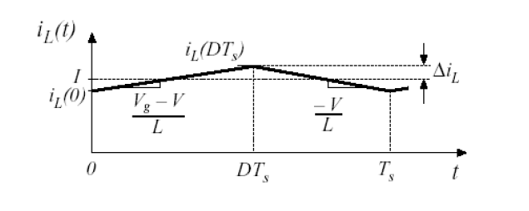

Fig. 2-9 Waveform of inductor current

When the current is continuous, we have

$$\frac{V_{o}}{R}>∆i=\frac{V_{in}-V_{o}}{2L}DT$$

$$R<\frac{2LV_{o}}{{(V}_{in}-V_{o})DT}=2000Ω$$

**2.2.3 Simulation verification**

From the calculation, we know the critical resistance is 2000Ω. In Simulink, we plot the waveform of the current.

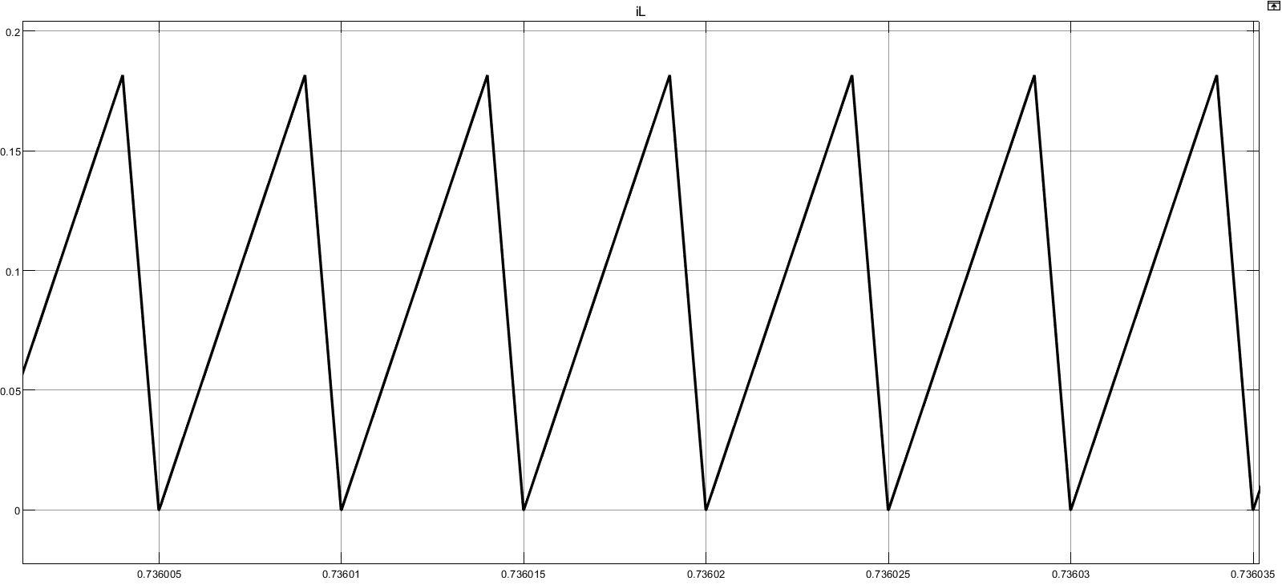

Fig. 2-10 Critical mode current

From the waveform, we can see the minimum of the current is 0.

Actually in the simulation, we cannot get the ideal current when $R=2000Ω$. We get Fig. 2-10 with $R=2080Ω$. The deviation may be led by the nonideal devices in the simulation circuit.

With $R=1700Ω$ and $R=2300Ω$, we get the current waveforms under CCM and DCM and show them below respectively.

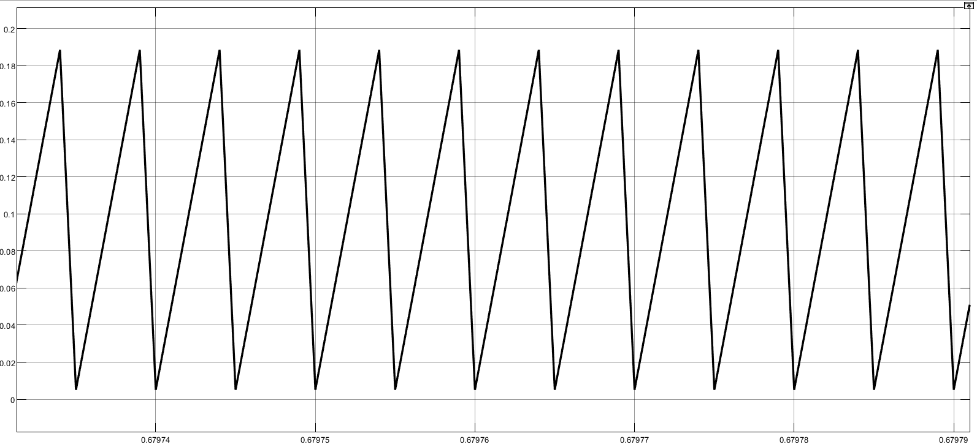

Fig. 2-11 CCM inductor current

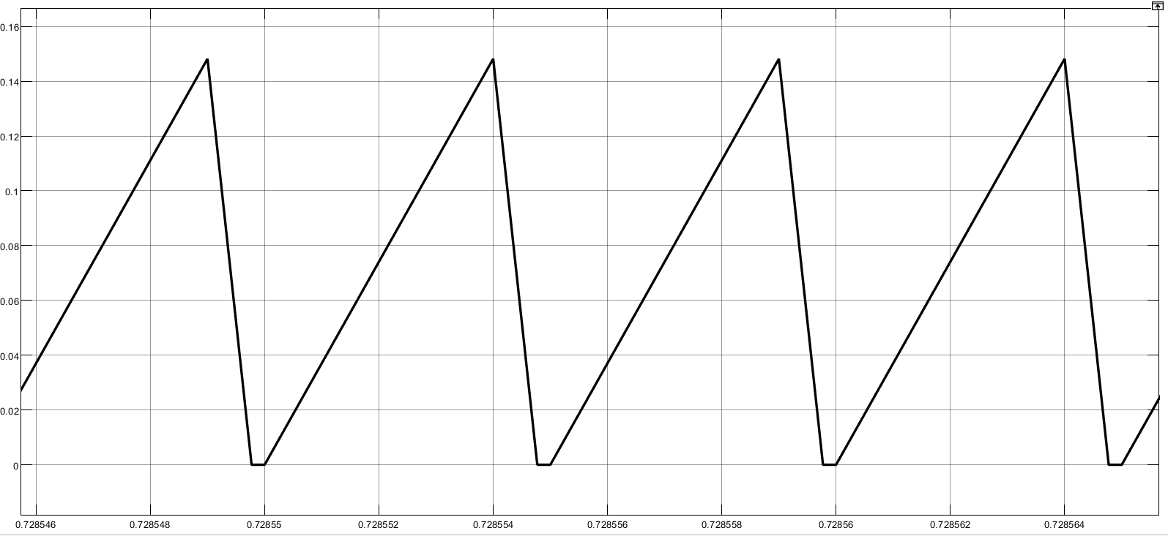

Fig. 2-12 DCM inductor current

**2.3 Task 3**

**2.3.1 Task requirement**

In this task we need to adjust duty cycle D and analyze the relationships between D and voltage gain.

**2.3.2 Simulation result and analyzation**

In order to avoid the situation where the four MOSFETs conduct together during the commutation (it may destroy the circuit), duty cycle shouldn’t be bigger than 0.5. We adjust D from 0 to 0.5 to carry out the simulation and get the result as below.

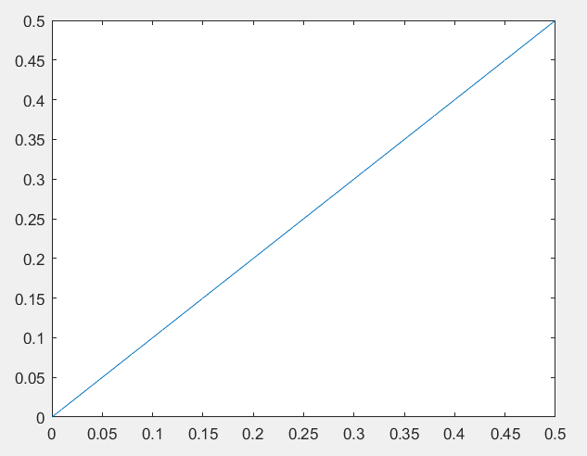

Fig. 2-12 Relationship between G and D

We can see the relationship between G and D is almost linear.

Actually, we have

$$G=\frac{V_{o}}{V_{in}}=\frac{2D}{k}=D$$

Therefore, G is equal to D.