**Seminar #5 Report**

**Group 1**

EE810 Nie Yongxin 2186113564

This seminar consists of two parts, which are AC voltage controller and AC chopper. For the two parts, we carried out simulations with Simulink.

# The single-phase AC voltage controller

This simulation is concerning the single-phase AC voltage controller, whose main function is to control current, voltage or the conduction of the circuit without changing the frequency.

## Simulation Model

There are three characteristics to be specified and a model is established correspondingly

### Circuit Diagram

The following diagram is the circuit diagram of the AC voltage controller.

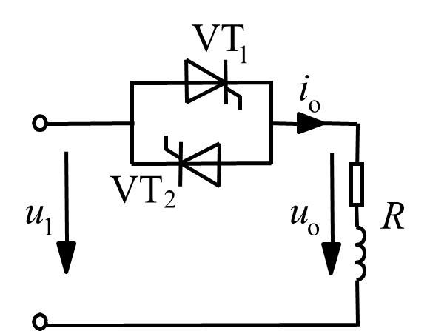

* + - 1. AC Voltage Controller

## Simulink circuit diagram

In Simulink, we use the model as below to carry out simulation.

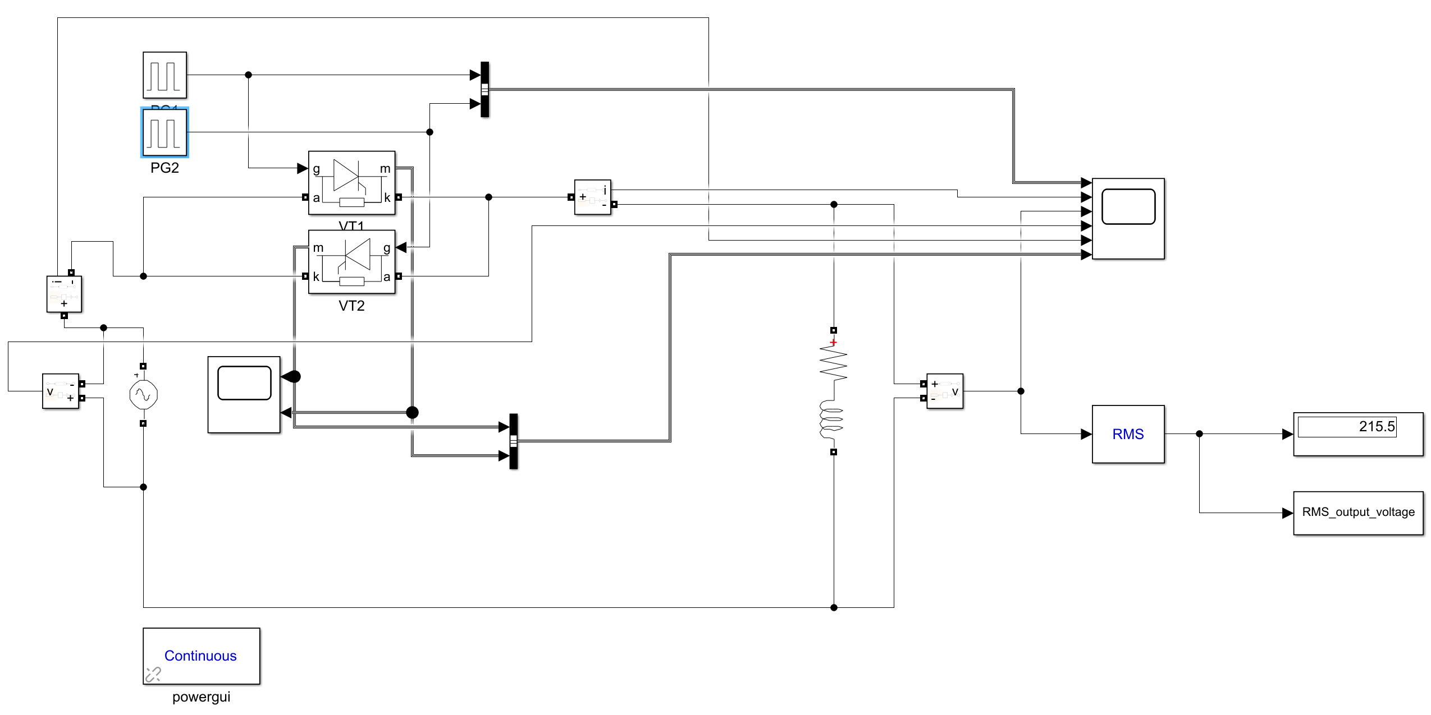

* + - 1. Simulation model

## Parameter Setup

Tab. 1-1 Parameter setup of our group

|  |  |  |  |
| --- | --- | --- | --- |
| Uin | fin | Load Inductance | Load Resistance |
| 220V | 50Hz | 2.2mH | 10Ω |

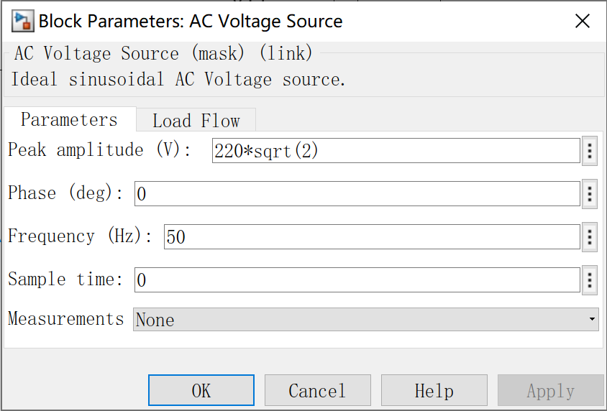 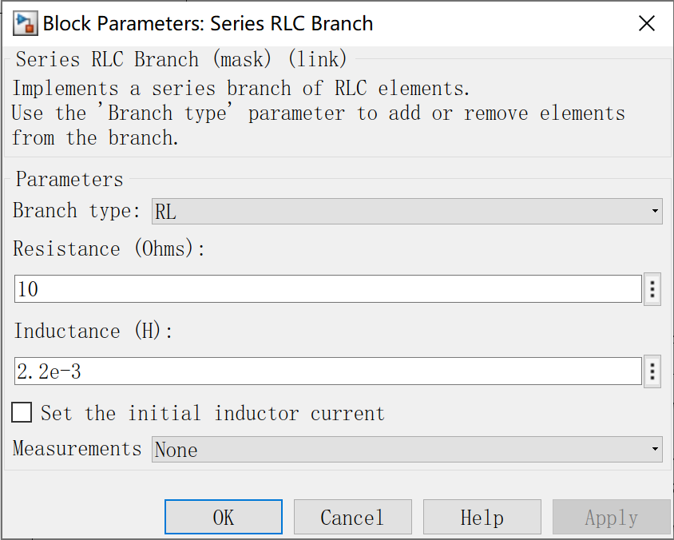

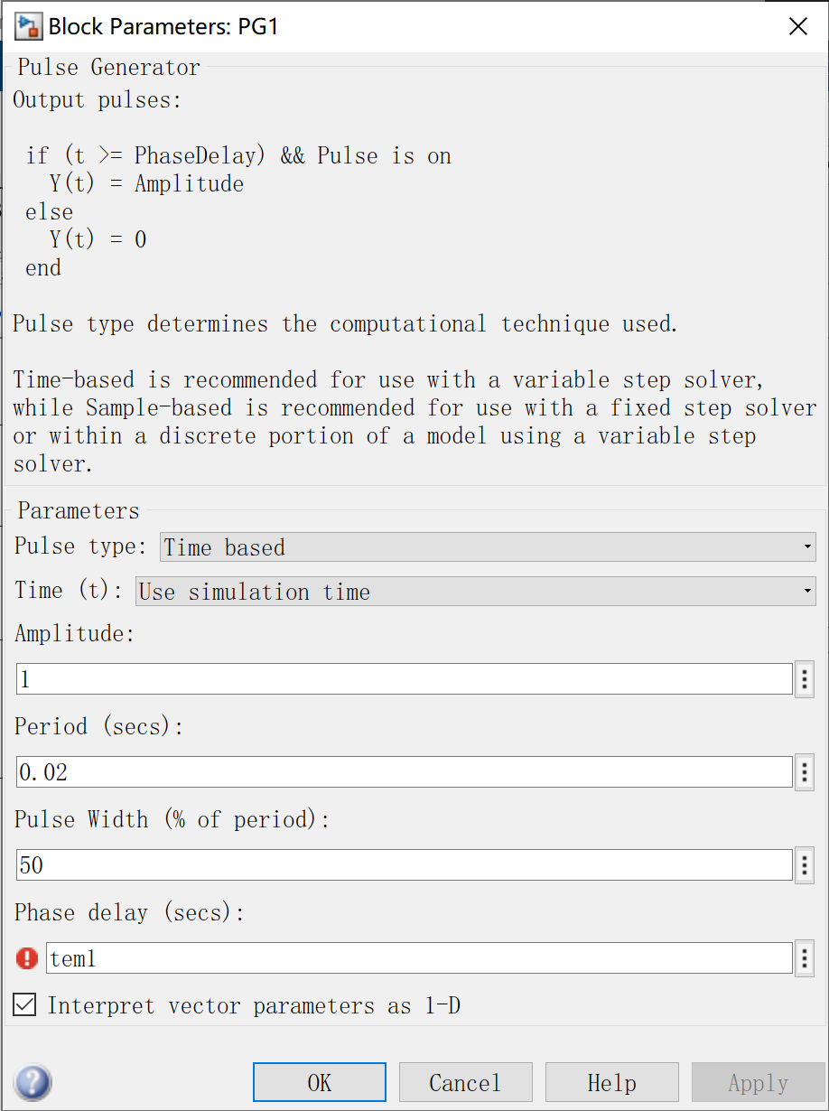 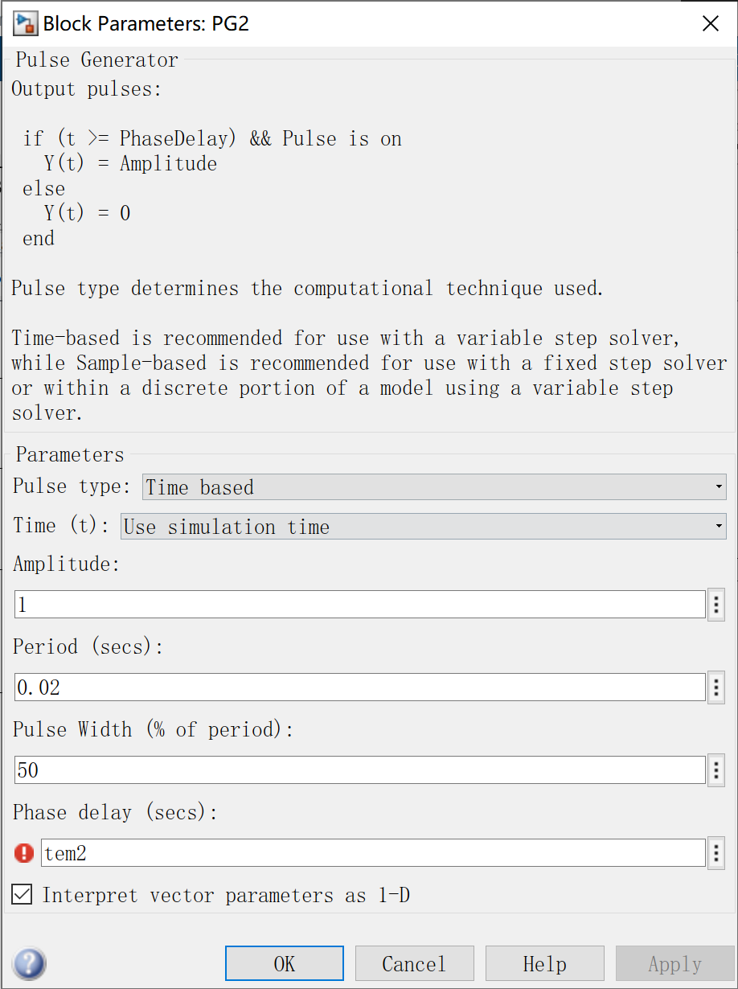

* + - 1. Parameter setup of our group

## Task 1

### Task requirement

For single-phase AC voltage controller (phase control) with fixed load: varying delay angle, simulate to observe output voltage waveform and input current waveform with grid voltage as reference.

### Simulation Results

Therefore, we changed the phase delay of the pulse generator from 30° to 180° by the step of 30° to observe the waveform of pulse signal, output voltage and current signal, input voltage and current signal and the switching signal:

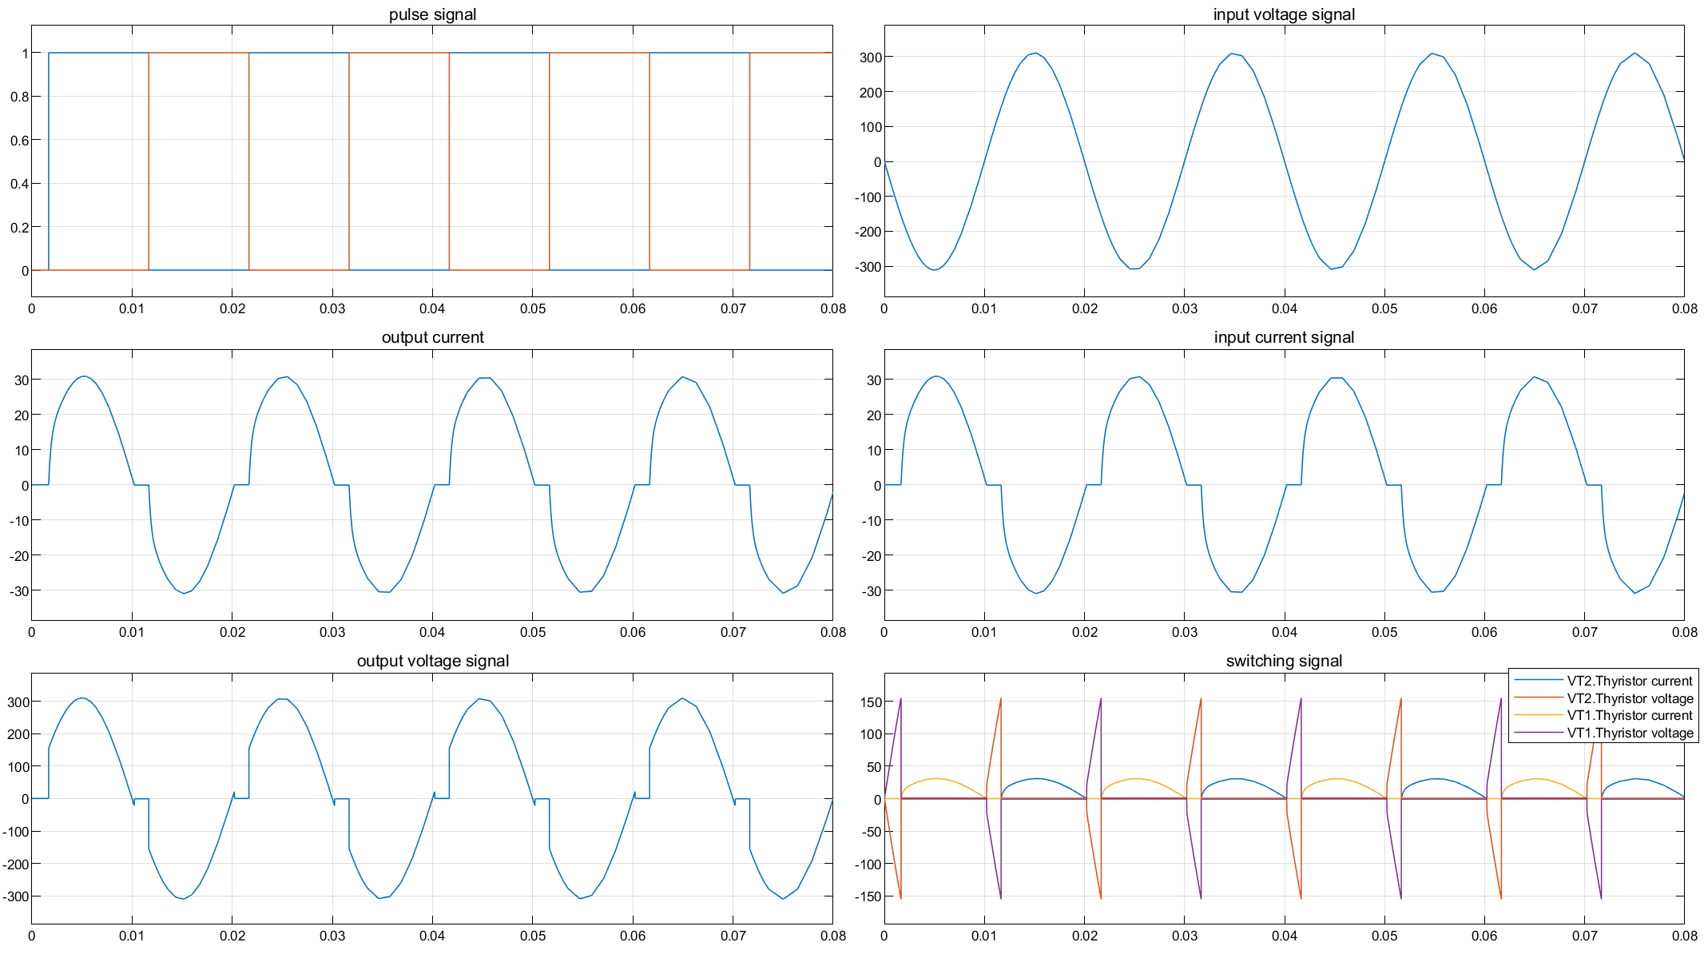

* + - 1. Phase delay equals to 30°

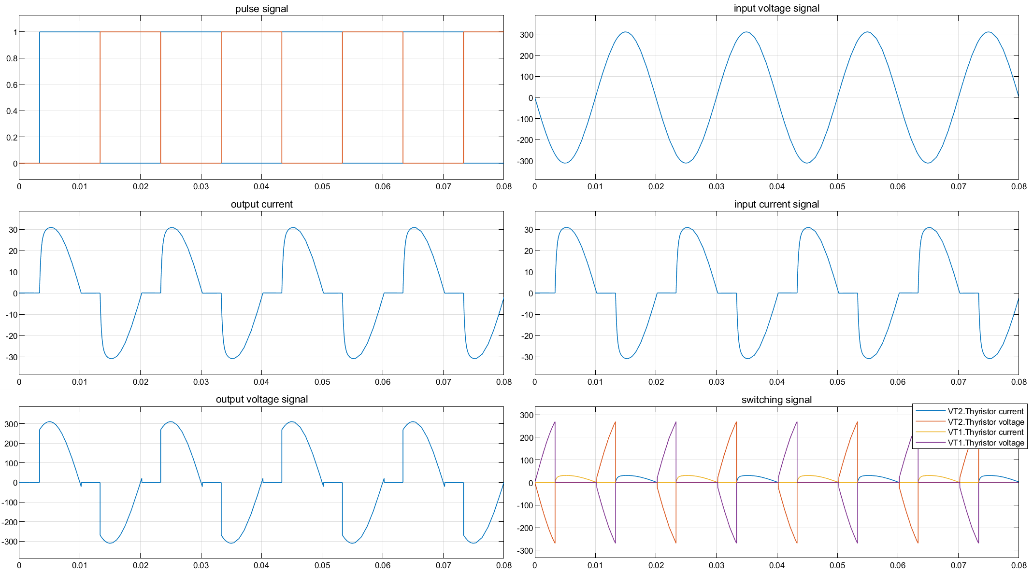

Fig 1-5 Phase delay equals to 60°

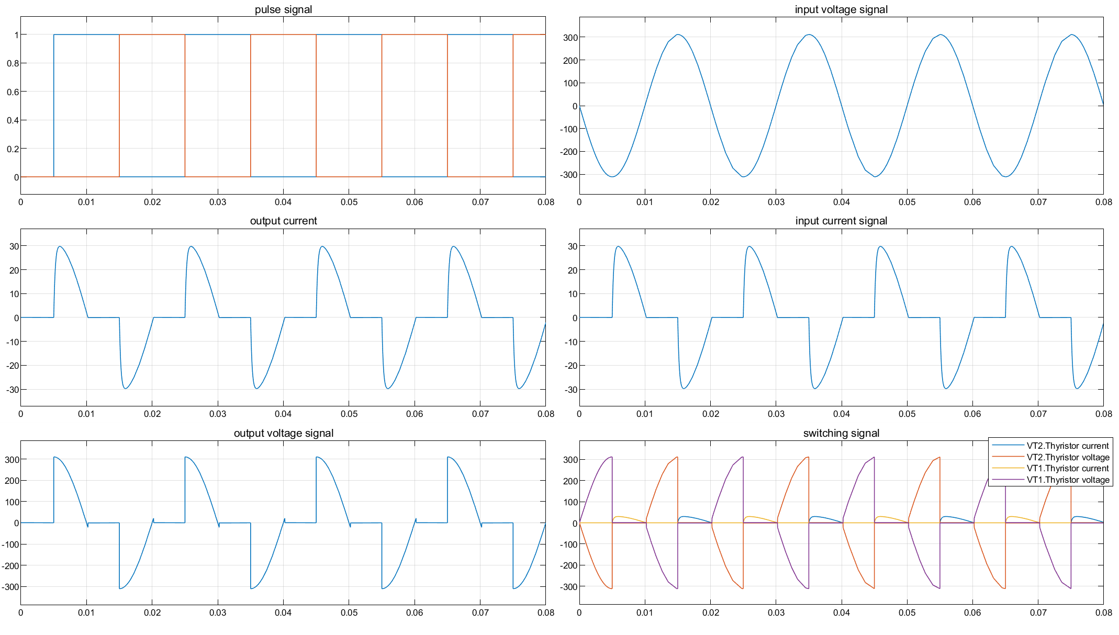

Fig 1-6 Phase delay equals to 90°

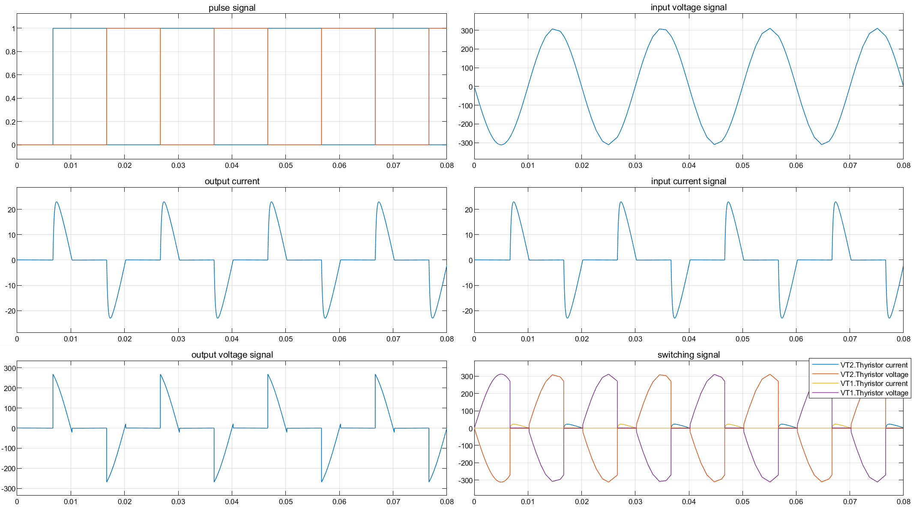

Fig 1-7 Phase delay equals to 120°

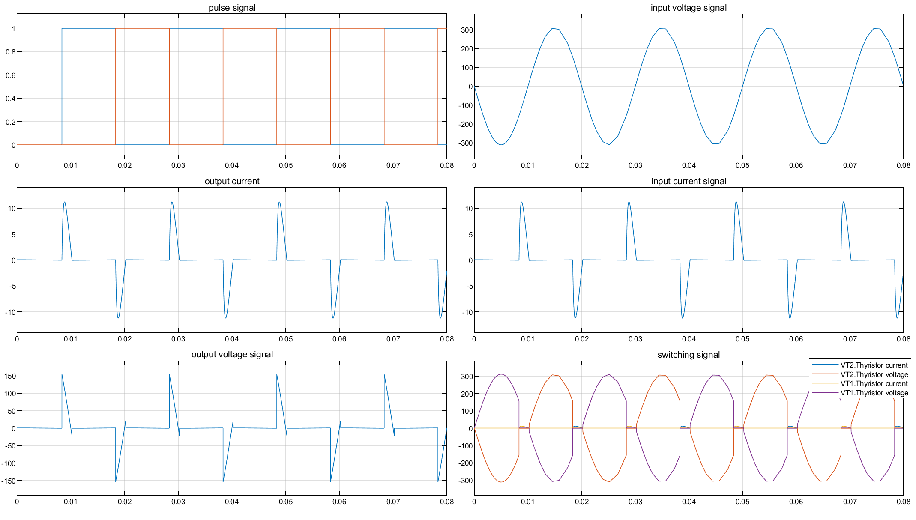

Fig 1-8 Phase delay equals to 150°

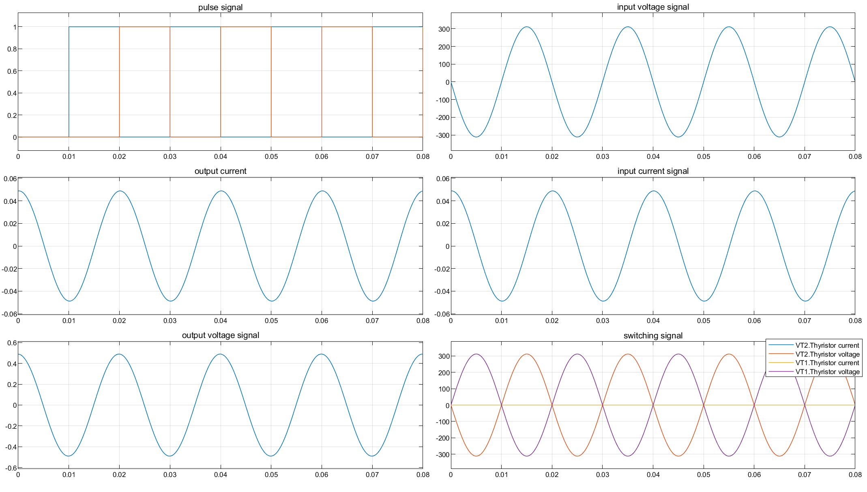

Fig 1-9 Phase delay equals to 180°

### Analysis of the Results

The phase shift range of trigger angle α is

*φ*≤*α*≤180°

and *φ* is the impedance angle of resistive load



From the above images, we can see that the gap of the output voltage waveform, that is, the intermittent part of the voltage waveform gradually widens with the increase of the trigger angle, and the effective value of the output voltage decreases; the intermittent part of the input current waveform also widens with the increase of the trigger angle, and the amplitude is decreasing.

## Task 2

### Task requirement

For single-phase AC voltage controller (phase control) with fixed load: Study the relationships between the RMS value of output voltage and delay angle.

### Simulation Results

The following diagram shows the relationship between the RMS value of output voltage and delay angle:

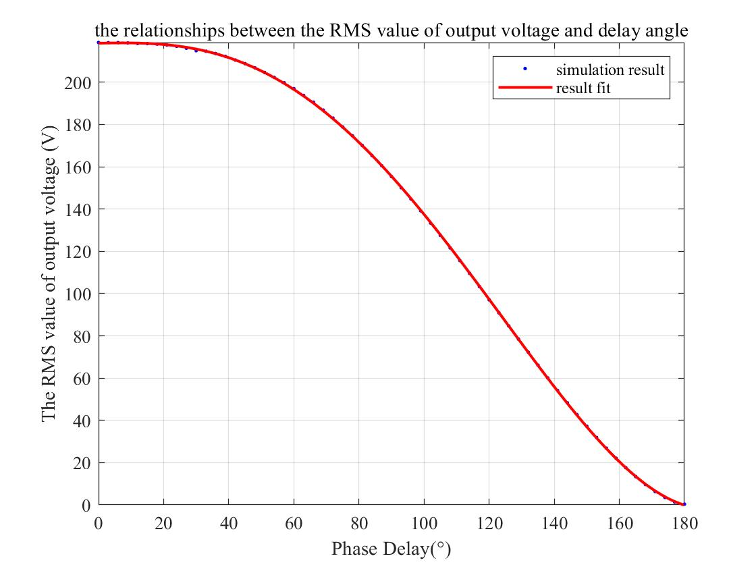

Fig 1-10 the relationship between the RMS value and delay angle

### Analysis of the Results

With the increase of trigger angle, the effective value of output voltage decreases.

When *α = φ*, the effective value of output voltage is basically equal to the effective value of input voltage, which is 220V. At this time, the waveform of output voltage is continuous in a cycle. Supposing the voltage drop of thyristor is not considered, the output voltage should be equal to the input voltage. When *α =* 180 °, the effective value of output voltage decreases to 0 because the thyristor in the circuit will not conduct in the whole cycle so that the output voltage is 0V.

## Task 3

### Task requirement

For single-phase AC voltage controller (phase control) with fixed load: Study and verify the conditions of CCM (continuous current mode)

### Simulation Results

The following figure shows the sequence waveform when the trigger angle α = 90 °. The following image shows that the output voltage are just half of the sin wave:

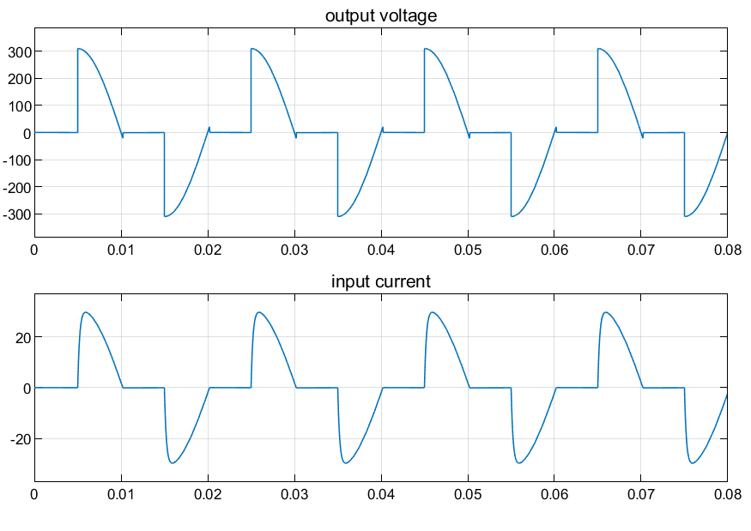

### Analysis of the Results

Since the impedance angle of the resistive load is φ, that is, the phase of the input voltage lags behind the load voltage, and the zero crossing of the input voltage is specified as t = 0, then if there is no switch, the output voltage should cross zero when ω t = φ. At this time, trigger pulse is added to the thyristor, and the thyristor will immediately bear the forward voltage and conduct, and there will be no intermittent current and voltage. The input current should be in phase with the output voltage, so the input current will not be intermittent at this time, and the waveform is a complete sine wave.

# AC chopper

## Circuit diagram

The following diagram is the circuit diagram of the AC voltage chopper.

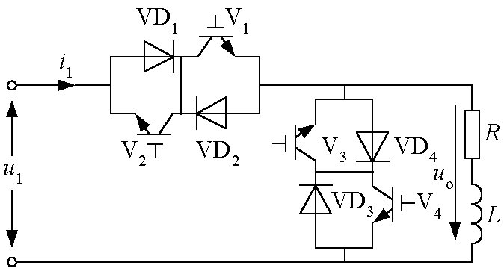

Fig.2 AC Chopper

## Simulink circuit diagram

In Simulink, we use the model as below to carry out simulation.

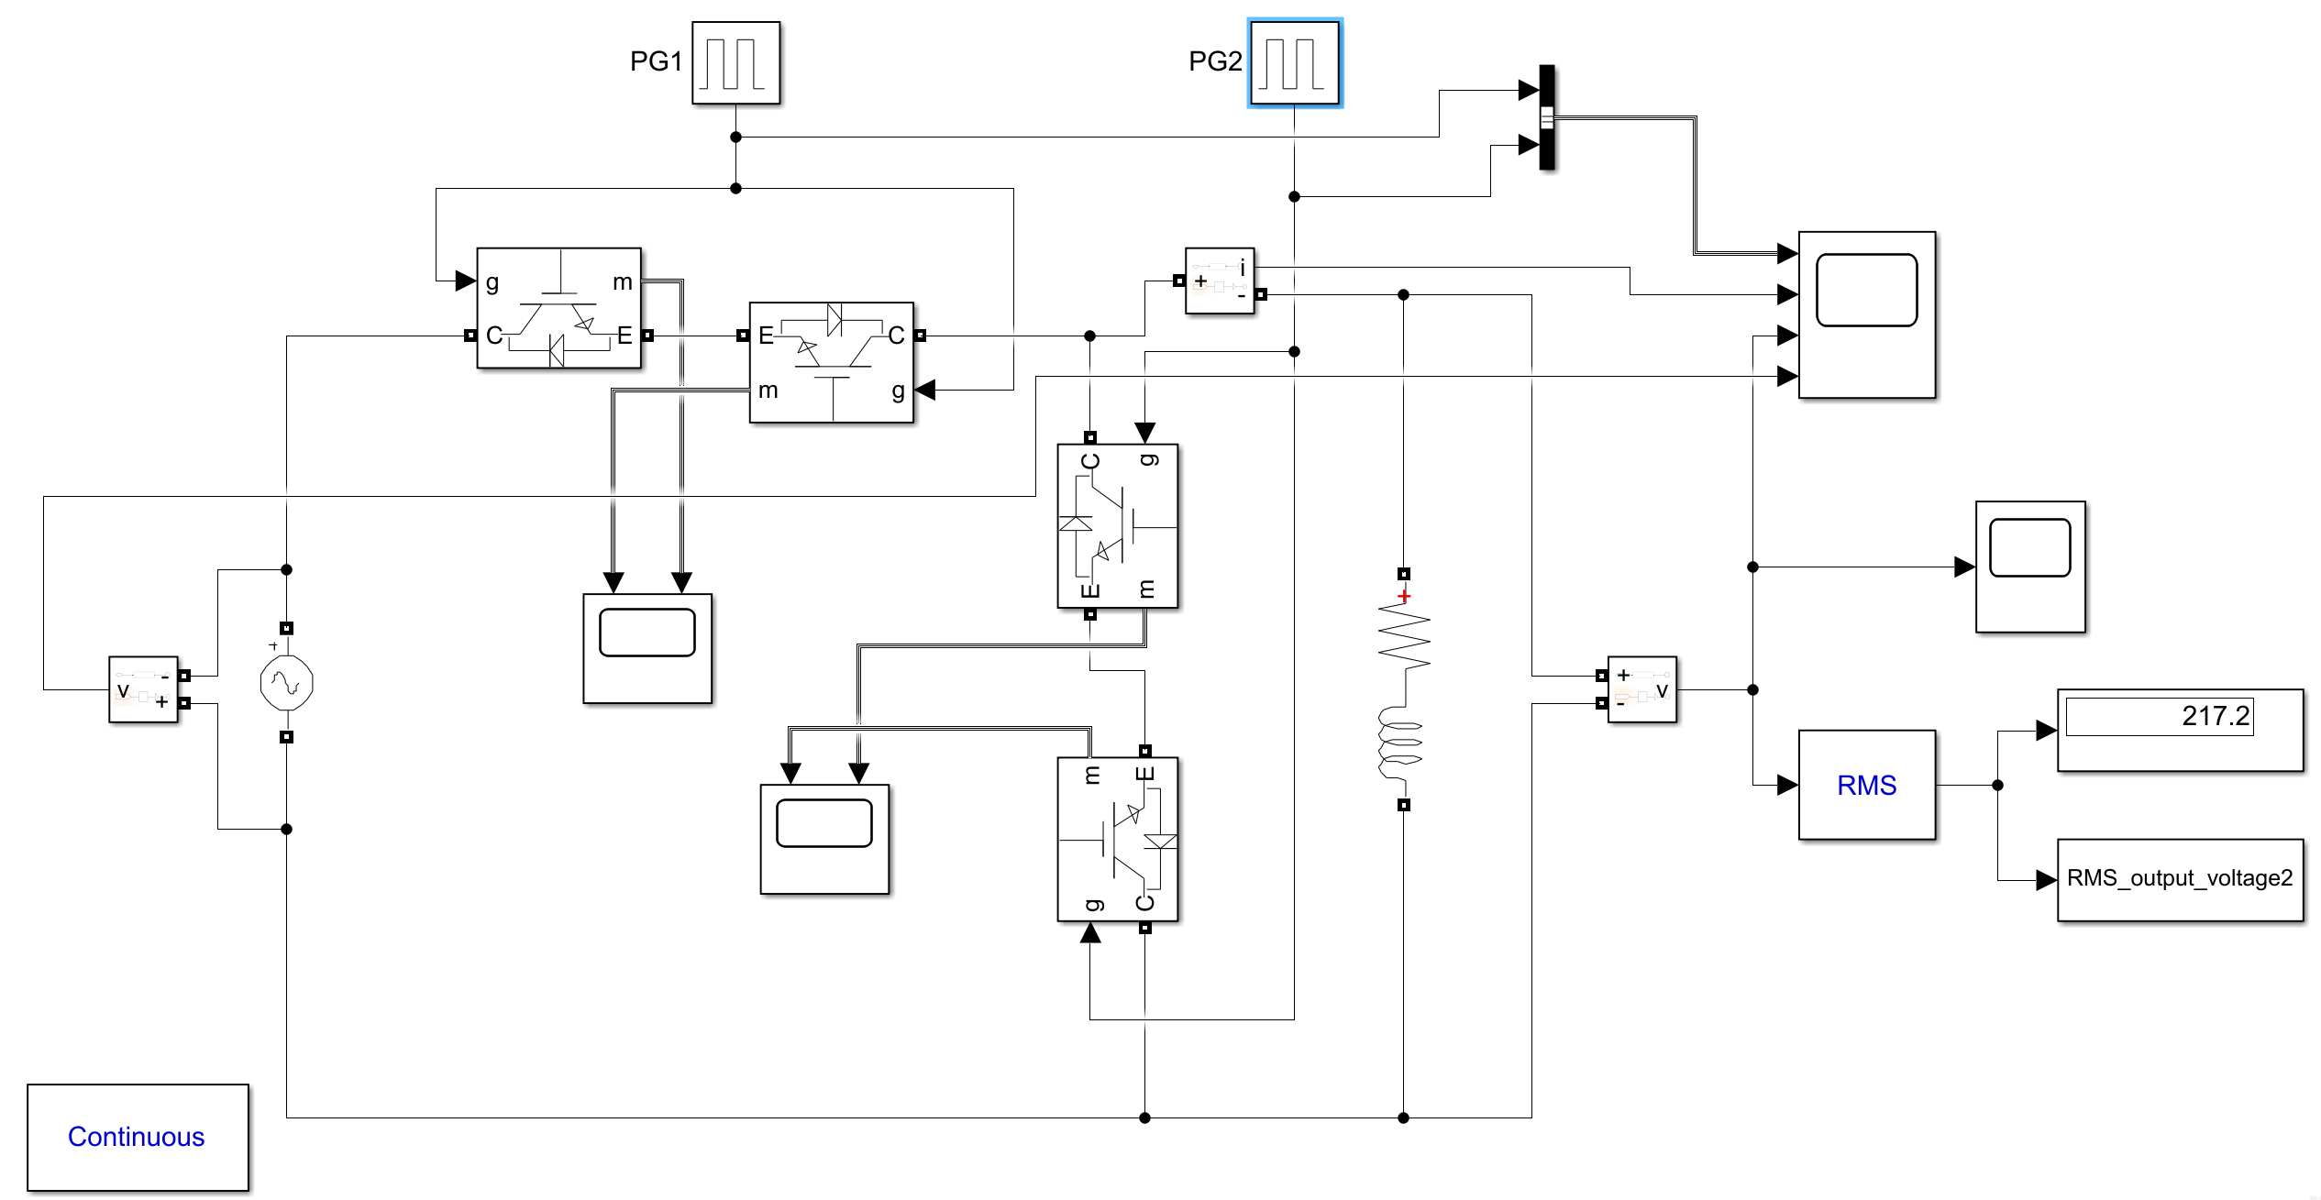

* + - 1. Simulation model

## Parameter Setup

Tab. 1-1 Parameter setup of our group

|  |  |  |  |
| --- | --- | --- | --- |
| Uin | fin | Load Inductance | Load Resistance |
| 220V | 50Hz | 2.2mH | 10Ω |

 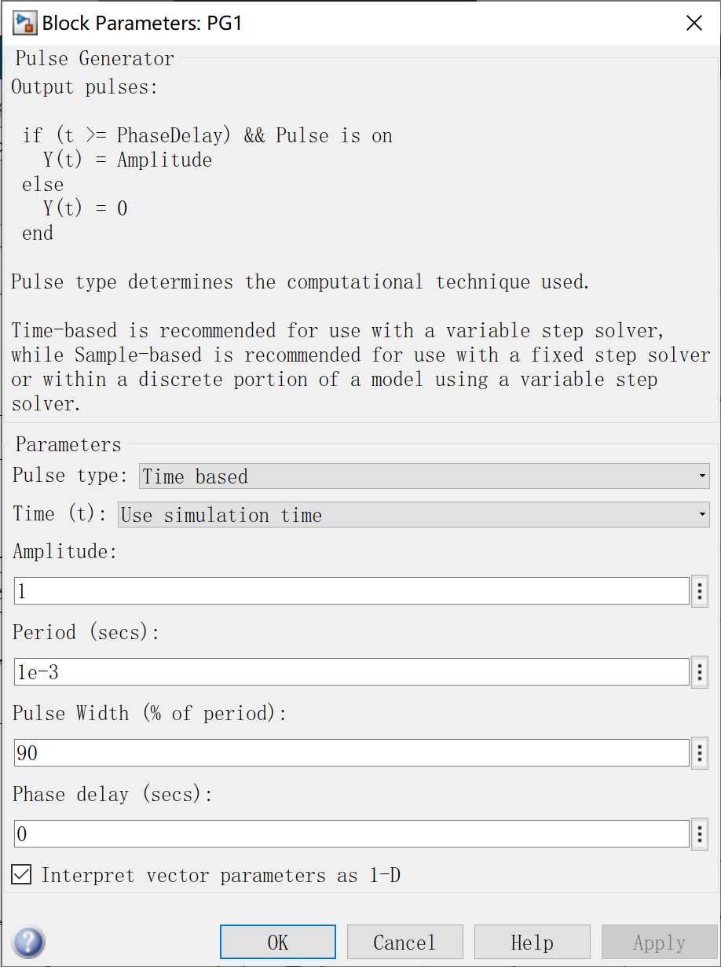 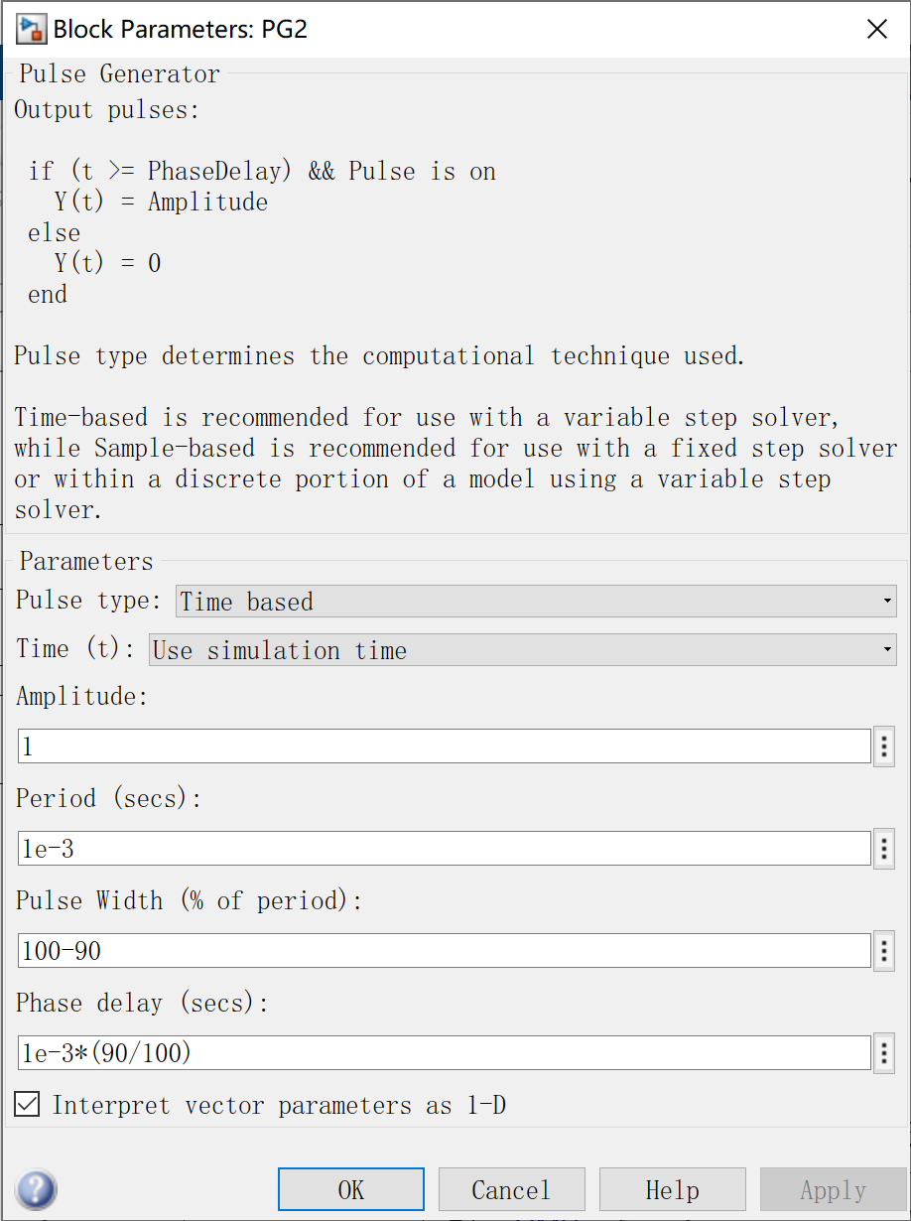

* + - 1. Parameter setup of our group

## Task 1

### Task requirement

2) For single-phase AC chopper (chopping control) with the same load and input voltage as shown in 1): Varying duty cycle, simulate to observe output voltage waveform and input current waveform with grid voltage as reference

### Simulation Results

Therefore, we changed the duty circle from 0.1 to 0.9 by the step of 0.2 to observe the waveform of pulse signal, output voltage and current signal, input voltage signal:

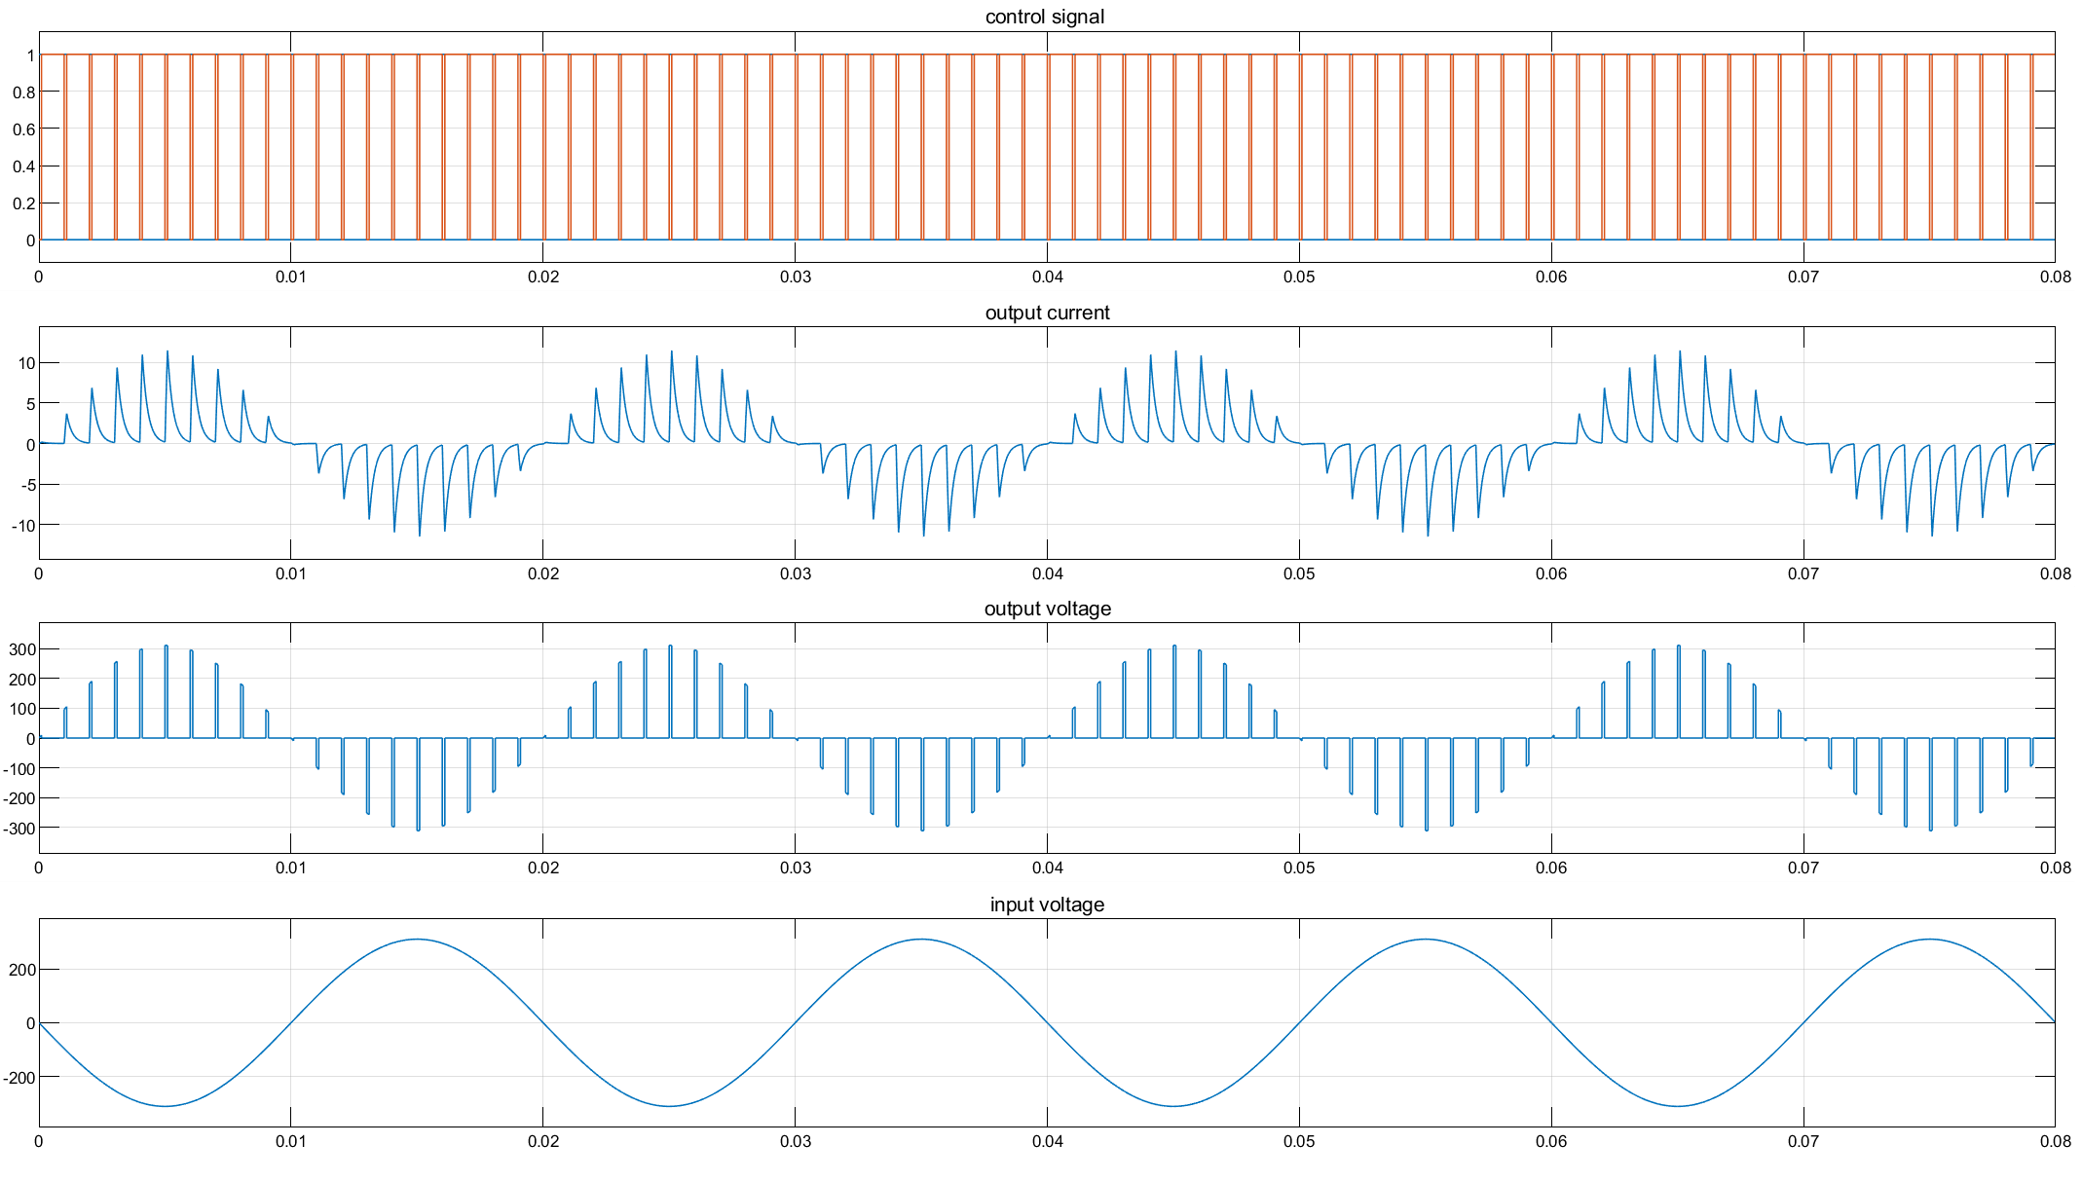

* + - 1. Duty circle equals to 0.1

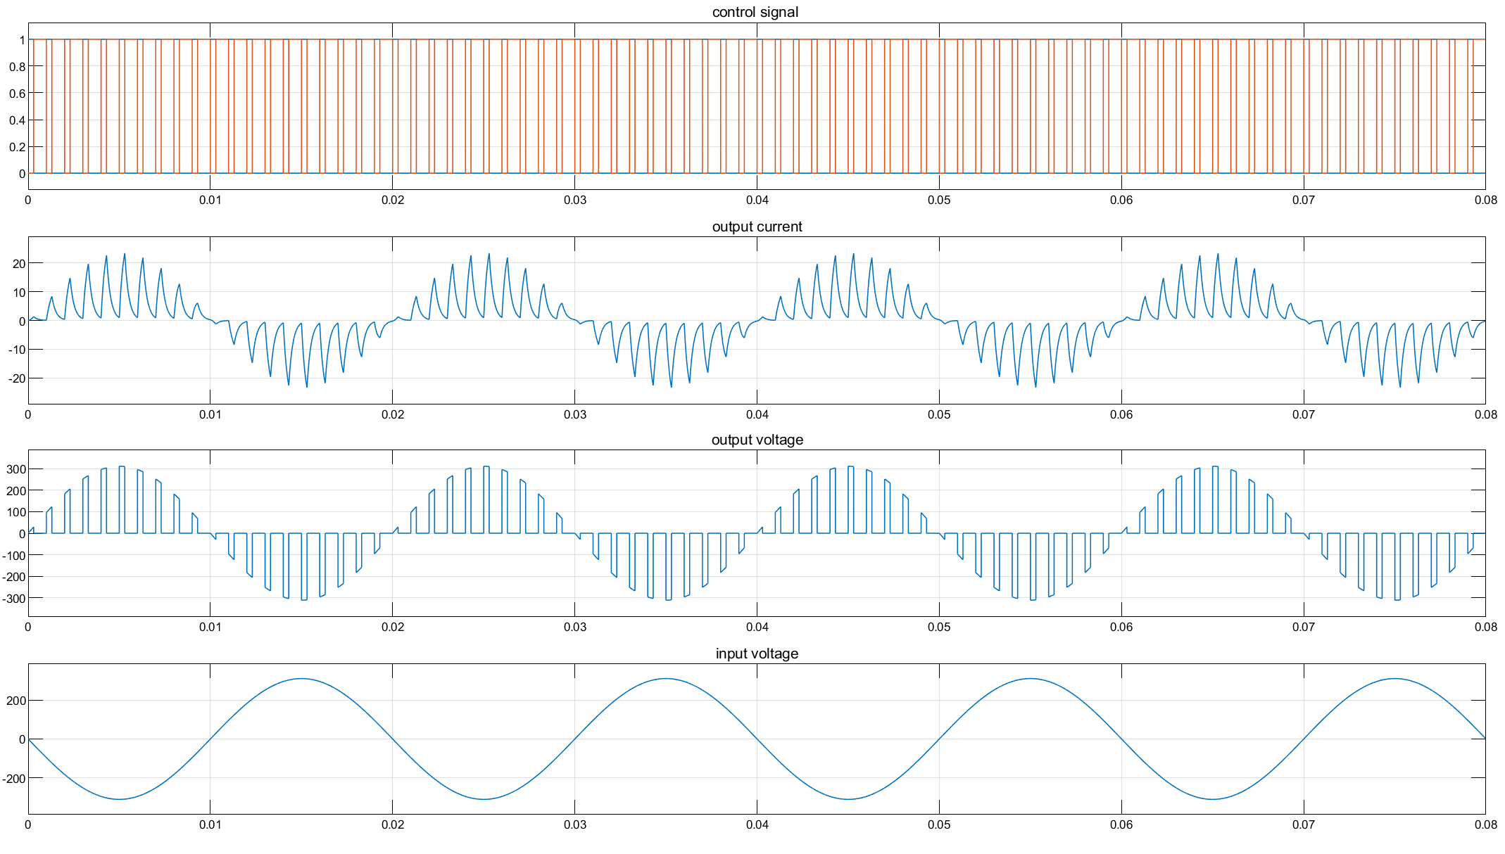

Fig 2-5 Duty circle equals to 0.3

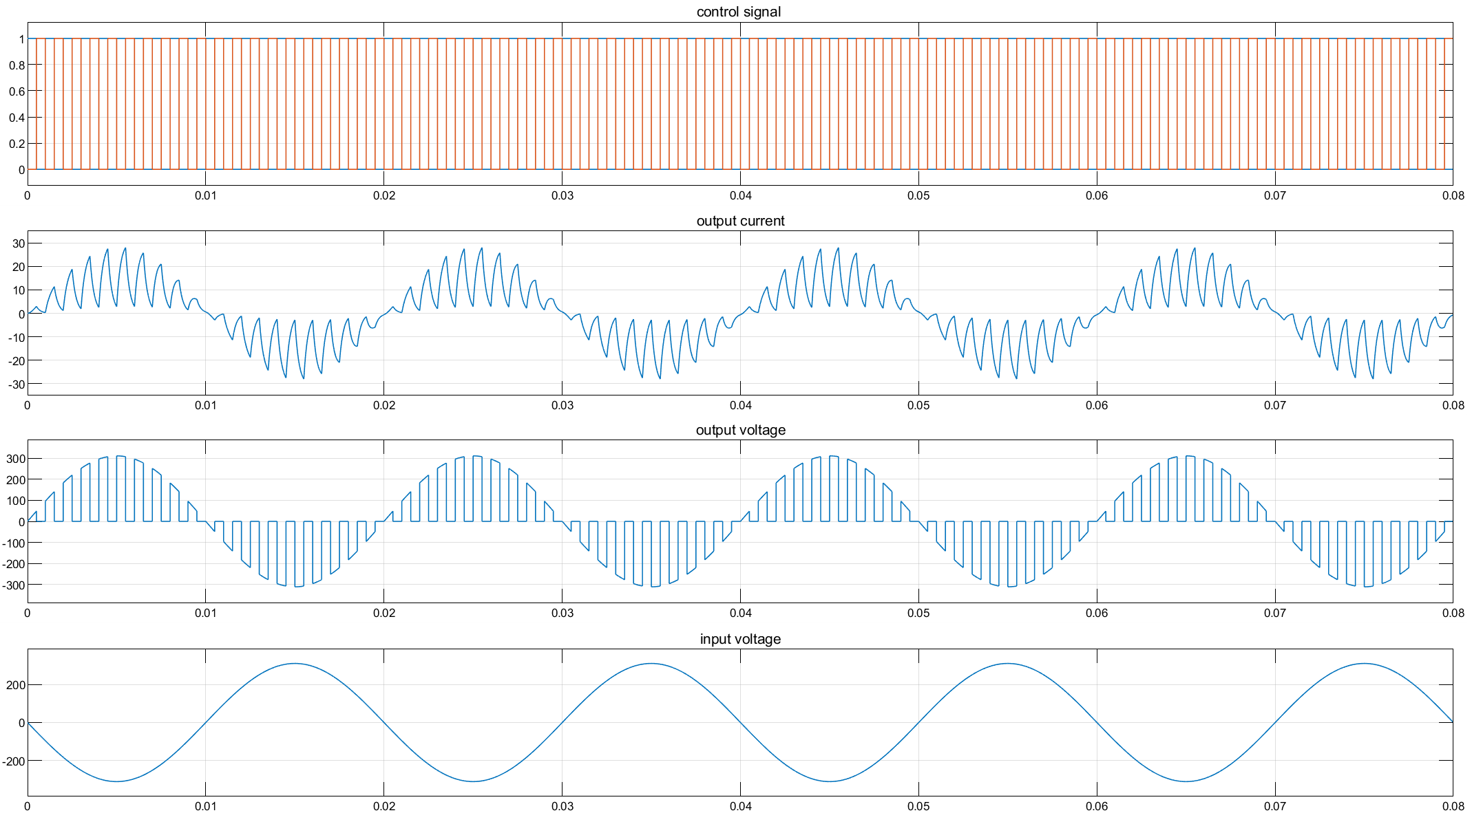

Fig 2-6 Duty circle equals to 0.5

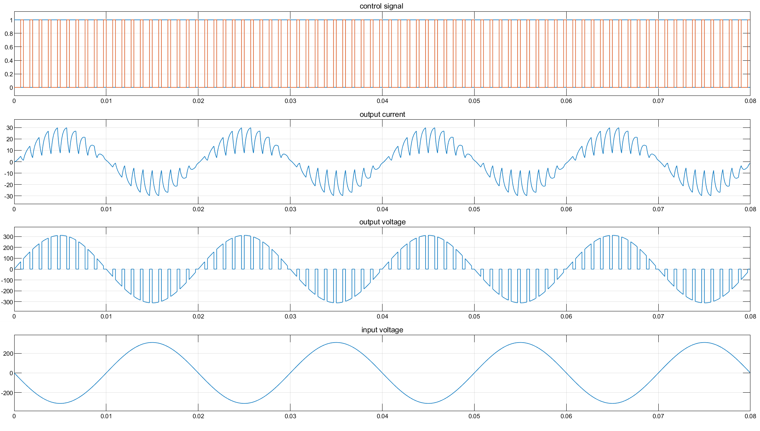

Fig 2-7 Duty circle equals to 0.7

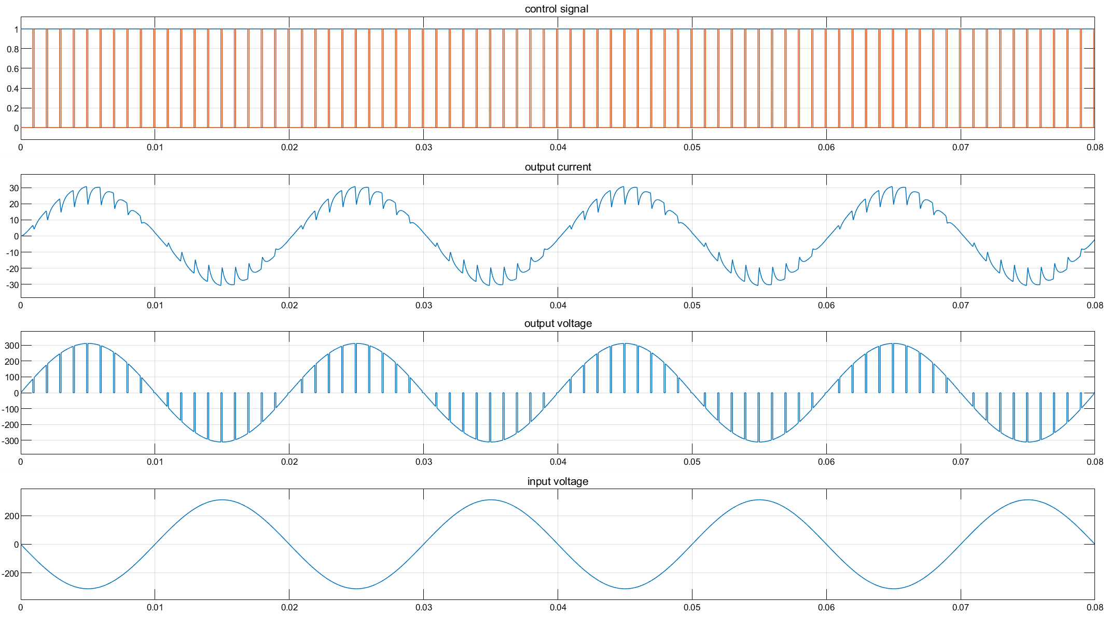

Fig 2-7 Duty circle equals to 0.9

### Analysis of the Results

With the increase of the input current waveform, we can find that the width of the intermittent part is decreasing, and the amplitude is increasing. The ratio of continuous part to the whole cycle T is the duty cycle α. Besides the difference of amplitude, the shape and change trend of the output voltage waveform are basically consistent with the input current, and the phase is ahead of the input current.

The phase gap between input current and output voltage:

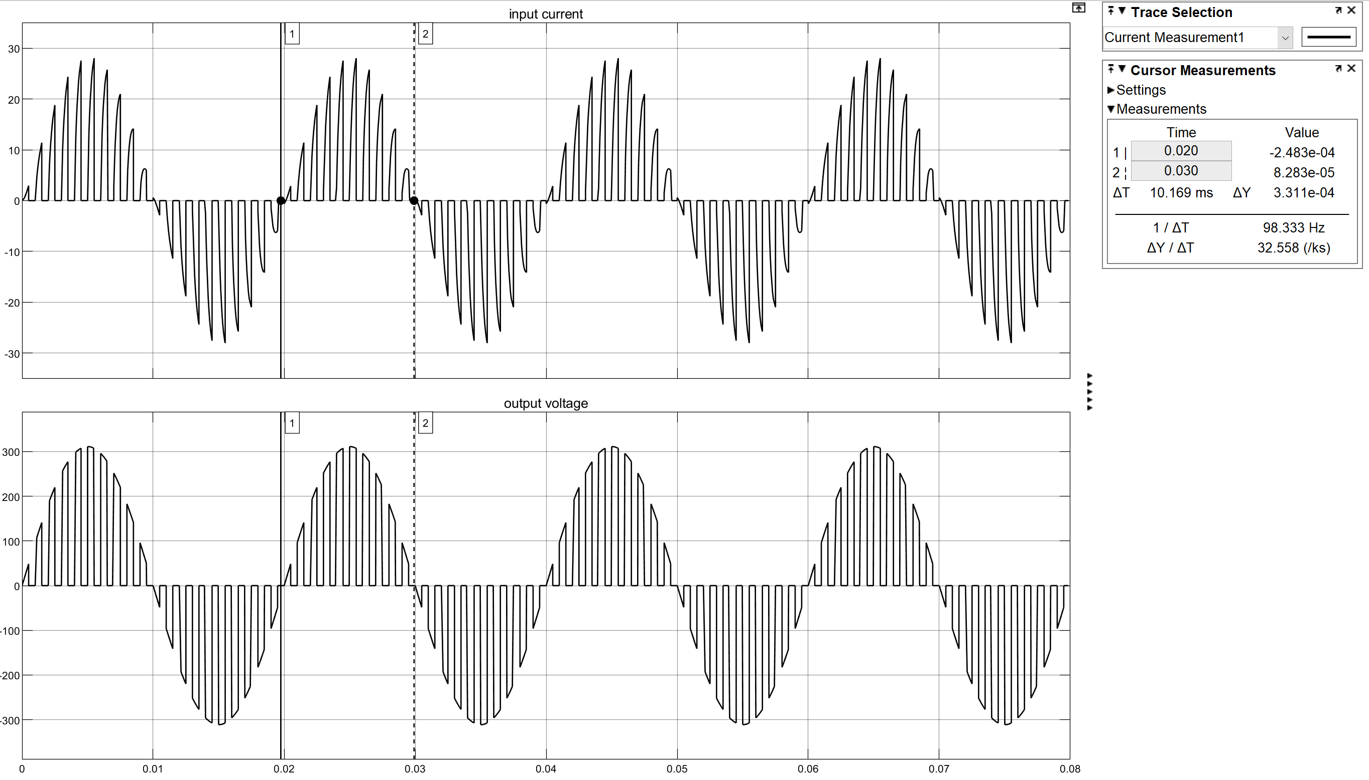

Fig 2-8 the phase gap between input current and output voltage

From the figure 2-8, we find that the fundamental component of input current and output voltage is at the same phase angle. It matches the the theoretical result of the textbook.

## Task 2

### Task requirement

For single-phase AC chopper (chopping control) with the same load and input voltage as shown: analyze commutation process.

### Analysis of the Commutation process

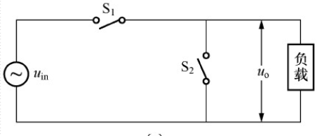

Fig 2-9 the principle circuit of AC chopper

The control formula is



The output voltage is



*uin* and *uip* are the synchronous signals corresponding to the positive and negative half cycles of AC, which control the reference direction of the AC switch. When *uip* is valid, VT1 and VT3 apply driving signals alternately. When *uin* is valid, VT2 and VT4 apply driving signals alternately.

The current of inductive load lags behind, and the direction of inductance current and voltage is reversed near the zero point of voltage. Meanwhile, the switching of switch group also causes the current interruption. Therefore, the transformation of switch will cause the intermittence of the current.

## Task 3

### Task requirement

For single-phase AC chopper (chopping control) with the same load and input voltage as shown: Study the relationships between the RMS value of output voltage and duty cycle

### Simulation Results

The following diagram shows the relationship between the RMS value of output voltage and duty circle:

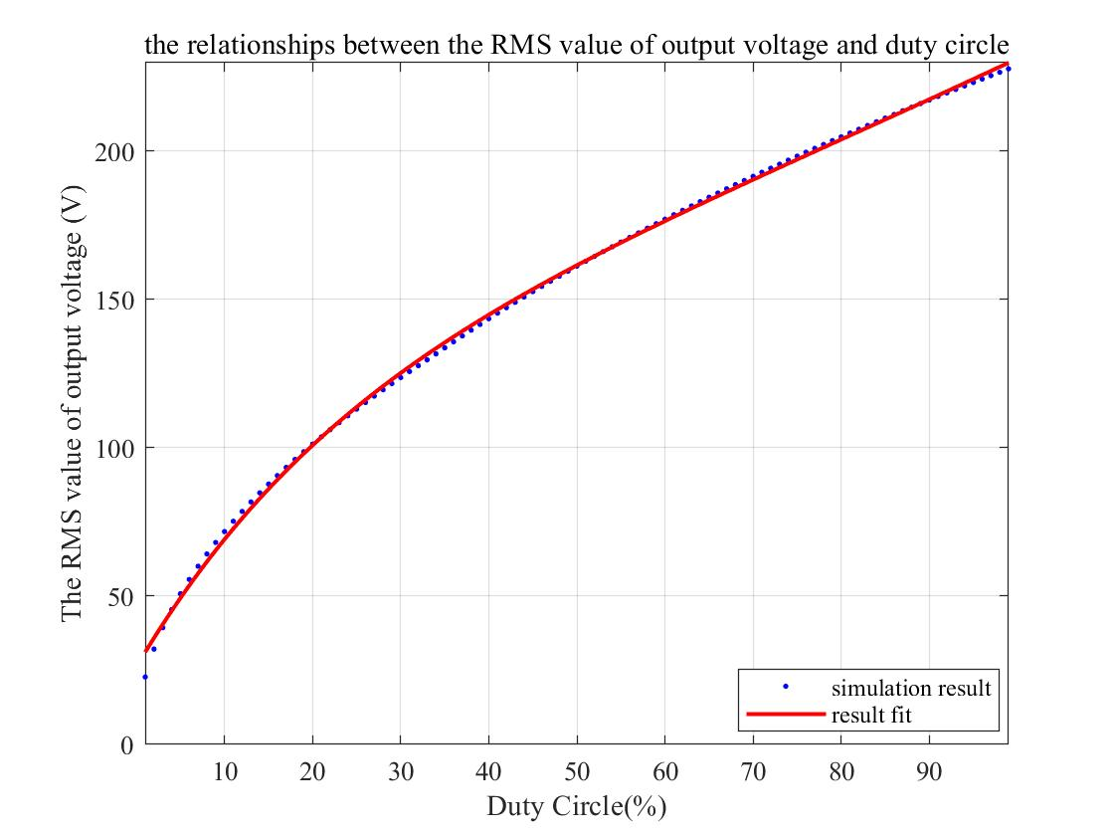

Fig 2-8 the relationship between the RMS value of output voltage and duty circle

### Analysis of the Results

From the graph, we can find that the effective value of the output voltage increases with the increase of α. This is because the part with the voltage of 0 in the output voltage waveform will gradually narrow with the increase of duty cycle, and the work done in a cycle will increase, so the effective value will become larger.

# the differences of output voltage’s harmonic components

## Task requirement

Given that the above two converters share the same fundamental component of output voltage, compare and analyze the differences of output voltage’s harmonic components.

## Result

The following figures are the FFT analysis of the output voltage for the AC controller and AC chopper:

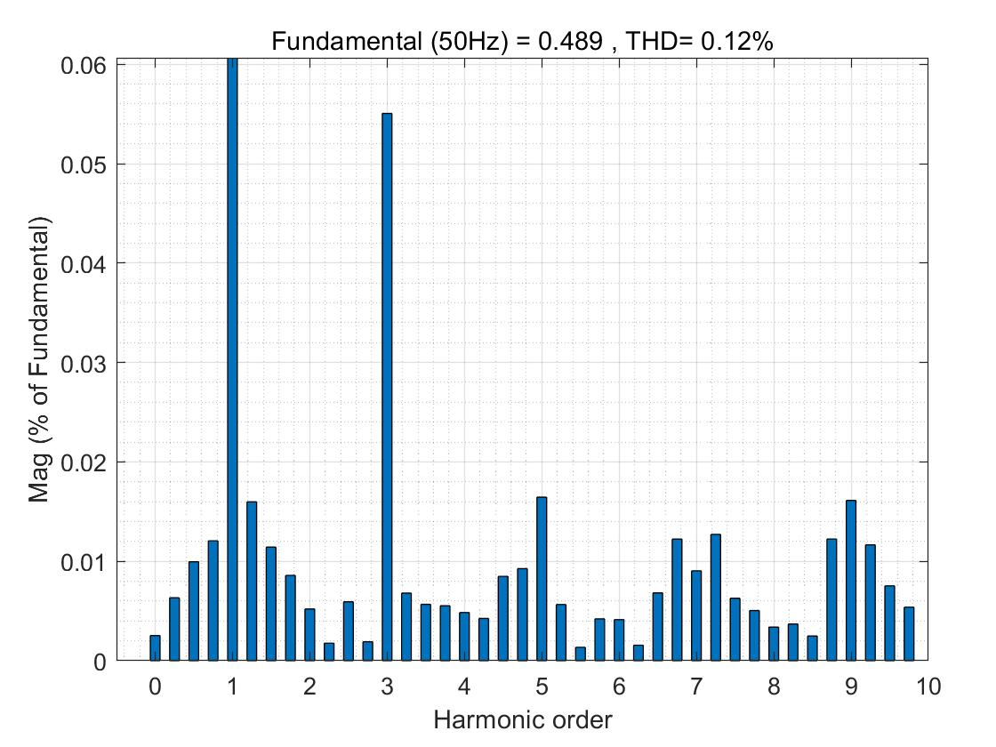

Fig 3-1 the harmonics component of AC controller

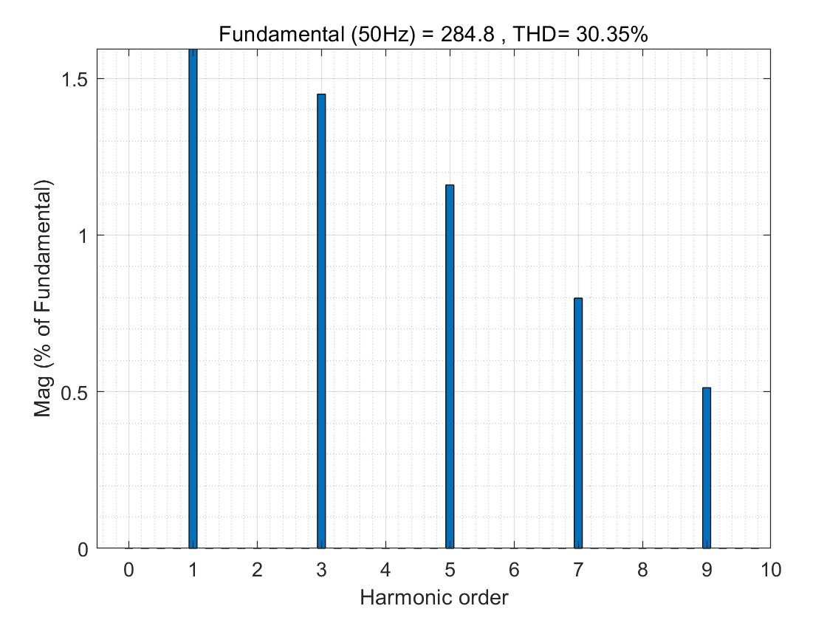

Fig 3-2 the harmonics component of AC chopper

## Analysis

For single phase AC controller, because the positive and negative half wave of the waveform is symmetrical, it does not contain the direct current component and even harmonics. It is expressed by Fourier series as follows







  

The effective value of fundamental wave and each harmonic can be obtained by the following formula:

 

The simulation results show that the output voltage of the single-phase AC voltage regulating circuit contains 3,5,7 odd harmonics besides the fundamental wave, and the harmonic content decreases with the increase of frequency. Because of its low harmonic frequency, it is difficult to filter out the output voltage.

However, the output voltage of single-phase AC chopper only contains high-order harmonics related to switching frequency. These harmonics can be eliminated by a small filter, so the output voltage can be filtered to obtain the ideal waveform

# Appendix

## The MATLAB program for analysis——S5_analysis.m

clc;

clear;

close all;

%% Topic 1

% initial parameters

j = 1;

rms_uo1 = zeros(1,61);

phase_delay1 = [0:3:180];

disp('$$$$$$$$$$$$$$$$$$$$$$$$$$$$$$$$$$$$$$$$$$$$$$$$$$$');

disp('topic 1 simulation begin：')

% run the simulation of topic 1

for i = 0:3:180

% change the phase dalay of trigger signal

tem1 = i./360.*0.02;

tem2 = i./360.*0.02 + 0.01;

set_param('seminar5_topic1/PG1','Phasedelay','tem1');

set_param('seminar5_topic1/PG2','Phasedelay','tem2');

sim('seminar5_topic1',[0,0.2]);

rms_uo1(j) = RMS_output_voltage(end);

% display the RMS value to check

disp(['When the delay angle is ',num2str(phase_delay1(j)),' degree']);

disp(['The RMS value of output voltage is ',num2str(rms_uo1(j)),'V']);

disp('~~~~~~~~~~~~~~~~~~~~~~~~~~~~~~~~~~~~~~~~~~~~~~~~~~~~~~~');

j = j + 1;

end

disp('topic 1 simulation finished.')

disp('$$$$$$$$$$$$$$$$$$$$$$$$$$$$$$$$$$$$$$$$$$$$$$$$$$$');

%% Topic 2

% initial parameters

j = 1;

rms_uo2 = zeros(1,61);

duty_circle2 = [1:1:99];

disp('$$$$$$$$$$$$$$$$$$$$$$$$$$$$$$$$$$$$$$$$$$$$$$$$$$$');

disp('topic 2 simulation begin：')

% run the simulation of topic 1

for i = 1:1:99

% change the phase dalay of trigger signal

tem1 = i;

tem2 = 100 - i;

tem3 = 1e-3.*(i./100);

set_param('seminar5_topic2/PG1','PulseWidth','tem1');

set_param('seminar5_topic2/PG2','PulseWidth','tem2');

set_param('seminar5_topic2/PG2','Phasedelay','tem3');

sim('seminar5_topic2',[0,0.2]);

rms_uo2(j) = RMS_output_voltage2(end);

% display the RMS value to check

disp(['When the delay angle is ',num2str(duty_circle2(j)),'%']);

disp(['The RMS value of output voltage is ',num2str(rms_uo2(j)),'V']);

disp('~~~~~~~~~~~~~~~~~~~~~~~~~~~~~~~~~~~~~~~~~~~~~~~~~~~~~~~');

j = j + 1;

end

disp('topic 2 simulation finished.')

disp('$$$$$$$$$$$$$$$$$$$$$$$$$$$$$$$$$$$$$$$$$$$$$$$$$$$');

%% plot the figure

[fitresult, gof] = createFit1(phase_delay1, rms_uo1);

[fitresult, gof] = createFit2(duty_circle2, rms_uo2);

## The MATLAB program for result fit——CreateFit1.m

### Fit1

function [fitresult, gof] = createFit1(phase_dalay, rms_uo)

[xData, yData] = prepareCurveData( phase_dalay, rms_uo );

%% Set up fittype and options.

ft = fittype( 'poly4' );

%% Fit model to data.

[fitresult, gof] = fit( xData, yData, ft );

%% Plot fit with data.

figure( 'Name', 'topic 1' );

plot( fitresult, xData, yData );

xlabel('Phase Delay(\circ)')

ylabel('The RMS value of output voltage (V)')

axis([-inf,inf,0,inf]);

set(gca,'FontName','Times New Roman');

set(findobj('Type','line'),'LineWidth',1.5)

legend('simulation result','result fit');

title('the relationships between the RMS value of output voltage and delay angle')

grid on

### fit2

function [fitresult, gof] = createFit2(duty_circle2, rms_uo2)

[xData, yData] = prepareCurveData( duty_circle2, rms_uo2 );

% Set up fittype and options.

ft = fittype( 'exp2' );

opts = fitoptions( 'Method', 'NonlinearLeastSquares' );

opts.Display = 'Off';

opts.StartPoint = [153.366721777444 0.00436053598548988 -120.909013517091 -0.0283854068125582];

% Fit model to data.

[fitresult, gof] = fit( xData, yData, ft, opts );

% Plot fit with data.

figure( 'Name', 'Topic 2' );

plot( fitresult, xData, yData );

xlabel('Duty Circle(%)')

ylabel('The RMS value of output voltage (V)')

axis([-inf,inf,0,inf]);

set(gca,'FontName','Times New Roman');

set(findobj('Type','line'),'LineWidth',1.5)

legend('simulation result','result fit');

title('the relationships between the RMS value of output voltage and duty circle')

grid on