**Seminar #6 Report**

**Group 9**

**EE810 Nie Yongxin 2186113564**

This seminar consists of two parts, which are three phase PWM voltage source inverter (VSI) and single-phase PWM full-bridge voltage source converter (VSC).

PWM control technology is widely used in inverter circuit. At present, almost all medium and small power inverter circuits adopt PWM technology. Inverter circuit is the most important application of PWM control technology. At present, almost all PWM inverter circuits in practical application are voltage circuit. In this seminar, we will take three-phase bridge voltage source PWM inverter as the research object, study the frequency spectrum component change of output voltage under different modulation systems, and analyze its working sequence according to the simulation waveform.

Therefore, to testify the principle of PWM control technology, we carried out simulations with Simulink.

# Three phase PWM voltage source inverter

This simulation is concerning the three phase PWM voltage source inverter, whose main function is to control current, voltage or the conduction of the circuit without changing the frequency.

## Simulation Model

There are two characteristics to be specified and a model is established correspondingly

### Circuit Diagram

The following diagram is the circuit diagram of three phase PWM voltage source inverter.

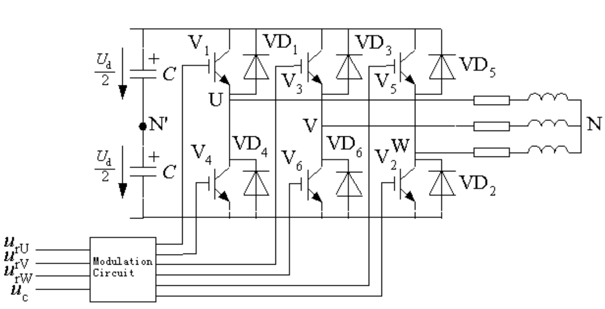

* + - 1. Three phase PWM voltage source inverter

Three phase inverters are commonly used to supply three phase loads. It’s possible to supply a three phase load by means of three separate single-phase inverters, where each inverter produces an output displaced by 120° (of the fundamental frequency) with respect to each other.

Three phase bridge PWM inverter circuit adopts bipolar control mode. The three-phase U, V and W PWM controller usually share a triangular wave carrier *u*, and the difference of three-phase modulation signals is 120° in turn. The control sequence of U, V and W phase power switch devices is the same.

## Simulink circuit diagram

In Simulink, we use the model as below to carry out simulation.

This circuit is composed of three parts: the modulation circuit, the three-phase inverter part and the measurement part as shown below.

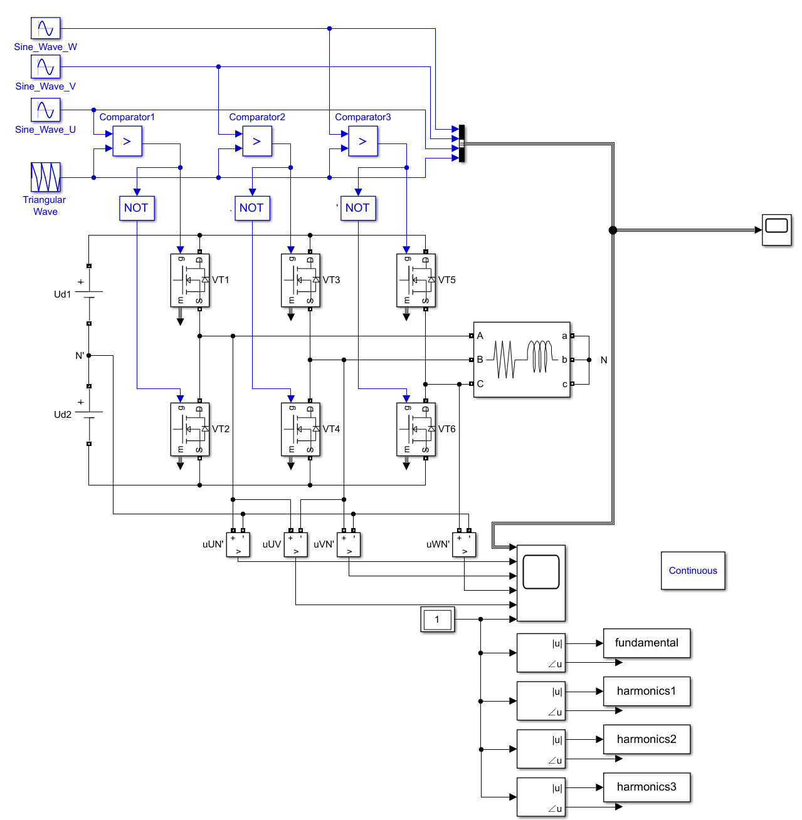

* + - 1. Simulation model

## Parameter Setup

Tab. 1-1 Parameter setup of our group

|  |  |  |  |  |
| --- | --- | --- | --- | --- |
| Udc | fline | fs | R  Load Resistance | L  Load Inductance |
| 550V | 50Hz | 6kHz | 3Ω | 1mH |

The setup windows in the Simulink are shown as below:

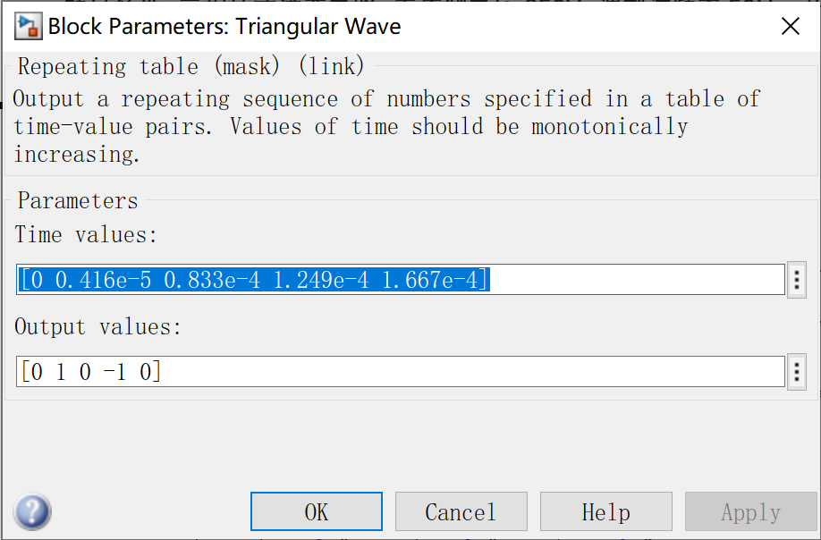 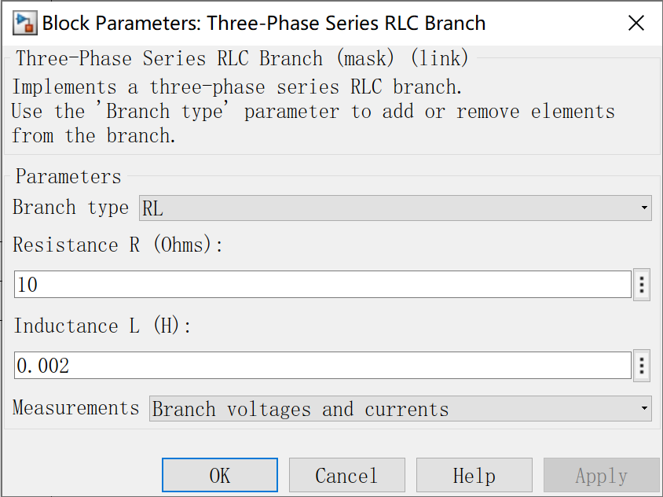

Fig 1-3 Parameter setup of our group

In order to show the imaginary neutral point, the DC side power supply adopts two DC voltage sources with the amplitude of 475V:

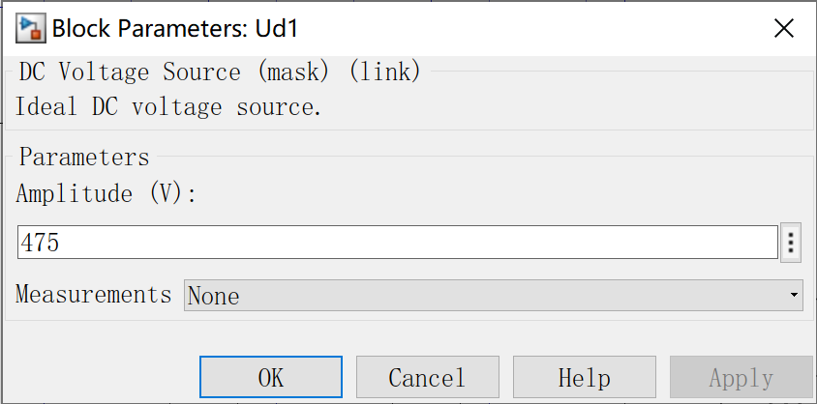 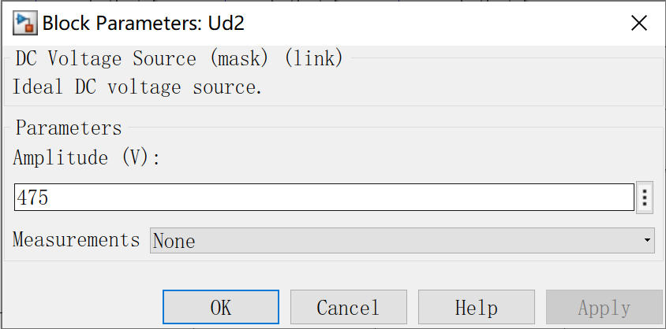

Fig 1-4 DC voltage source

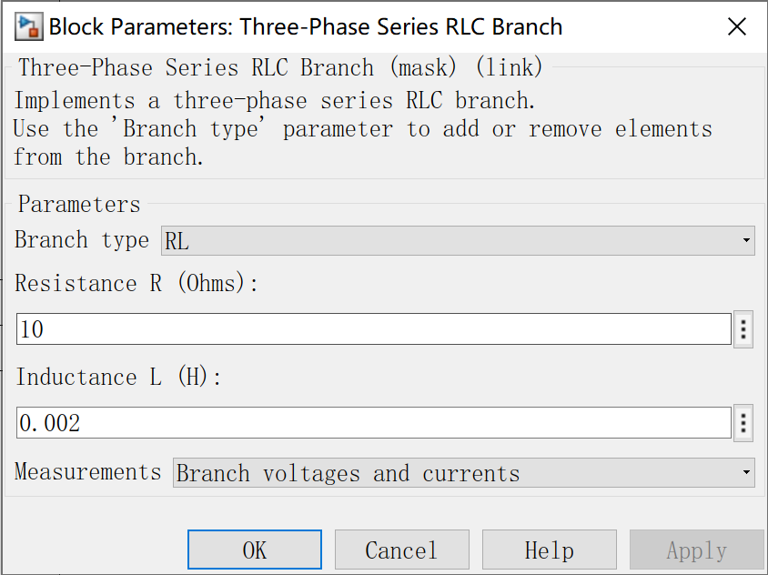

Fig 1-5 Parameter setup of RLC branch

## Task 1

### Task requirement

For three-phase PWM voltage-source inverter(VSI): Study how frequency spectrum of output voltage changes with respect to the variation of amplitude modulation ratio m

### Simulation Results

PWM inverter circuit can make output voltage and current close to sine wave, but because of using carrier wave to modulate sine signal wave, it also produces harmonic component related to carrier wave. The frequency and amplitude of these harmonic components are one of the important indexes to measure the performance of PWM inverter circuit, so it is necessary to analyze the harmonic of PWM waveform.

As a consequence, we changed amplitude modulation ratio m from 0.1 to 1 by step of 0.2 and analysis the harmonics component by the FFT analysis in the powergui. And we got the following results:

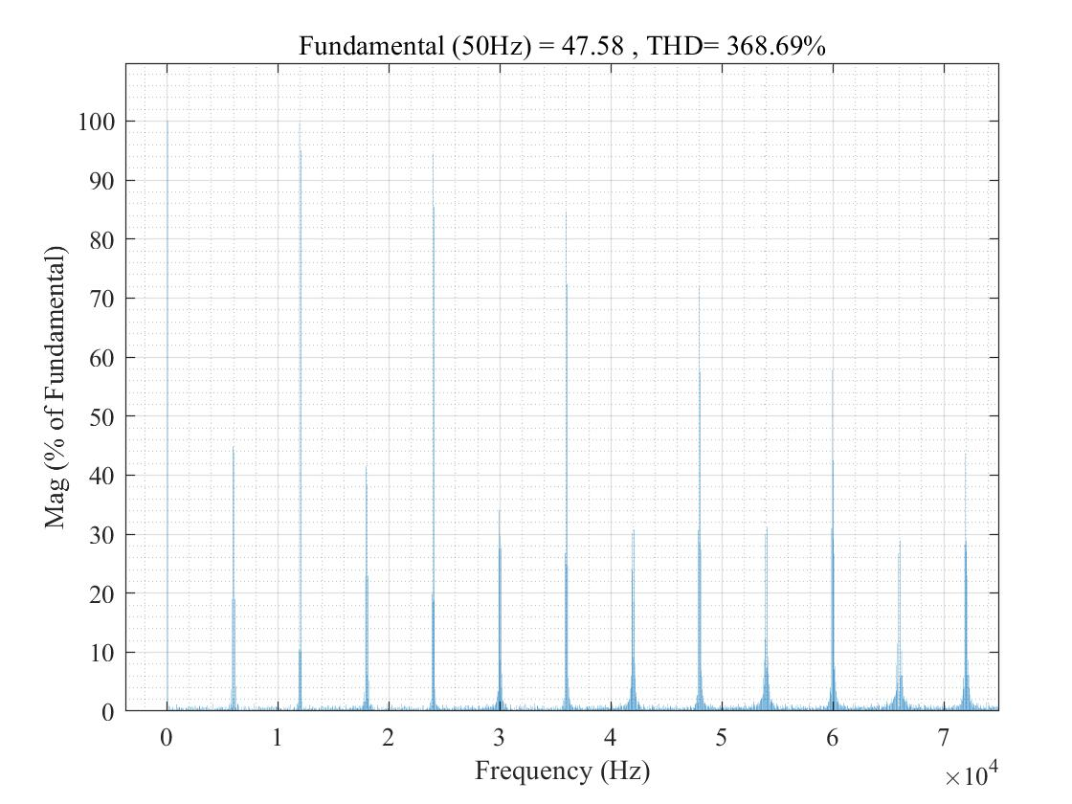

Fig 1-6 modulation ratio m=0.1

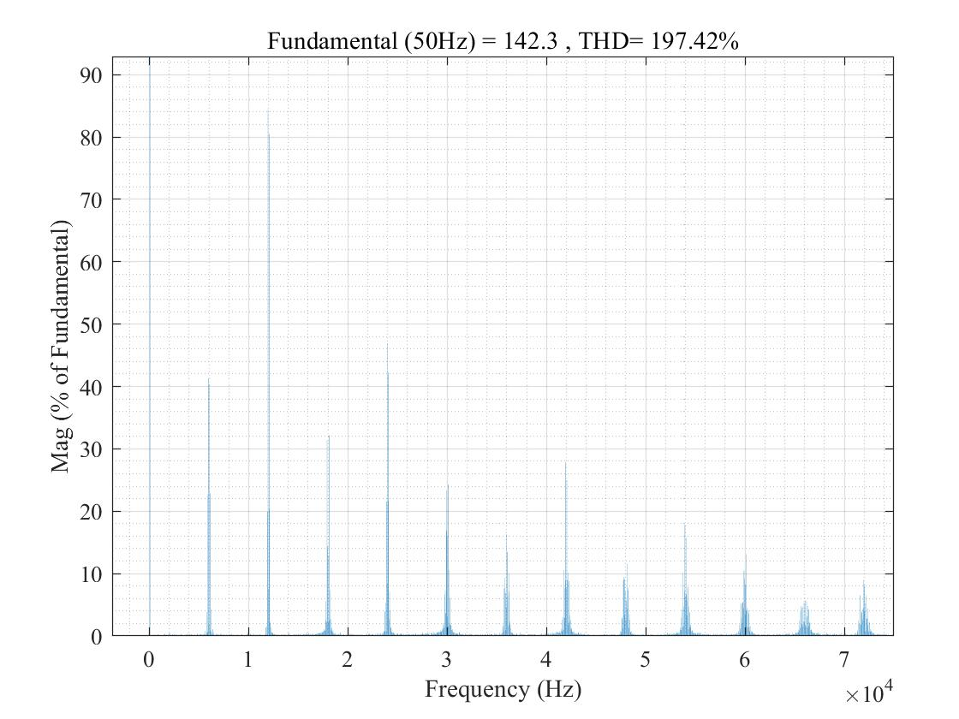

Fig 1-7 modulation ratio m=0.3

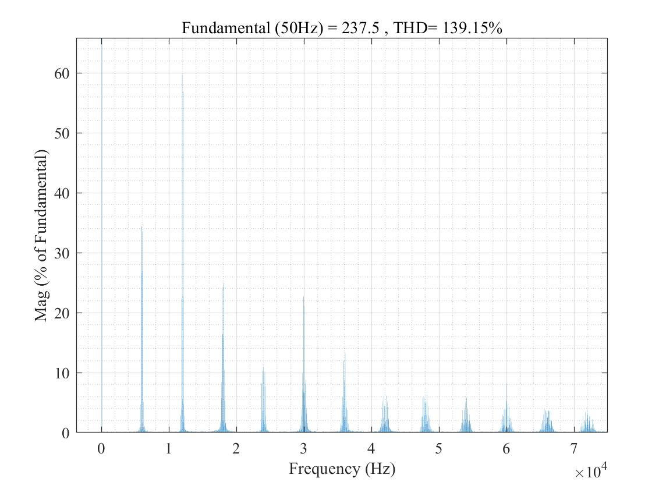

Fig 1-8 modulation ratio m=0.5

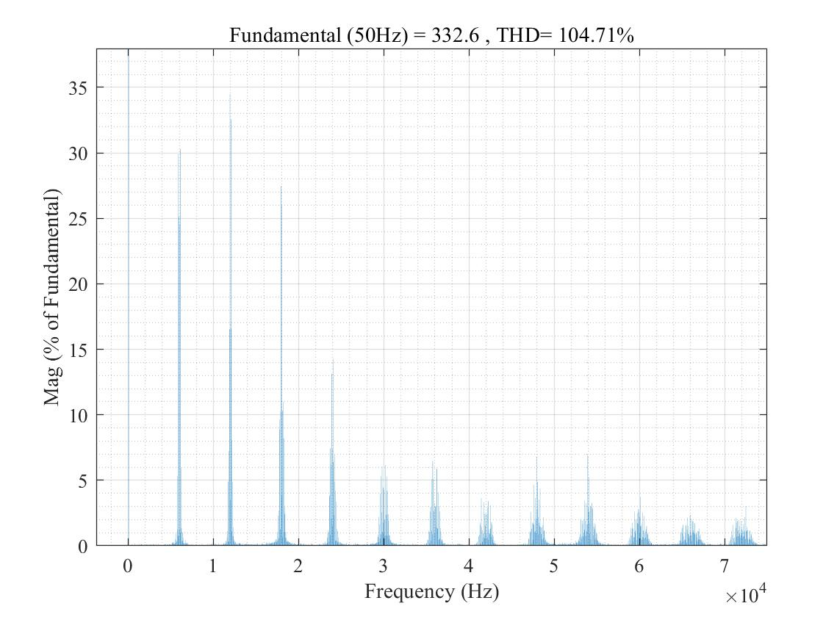

Fig 1-9 modulation ratio m=0.7

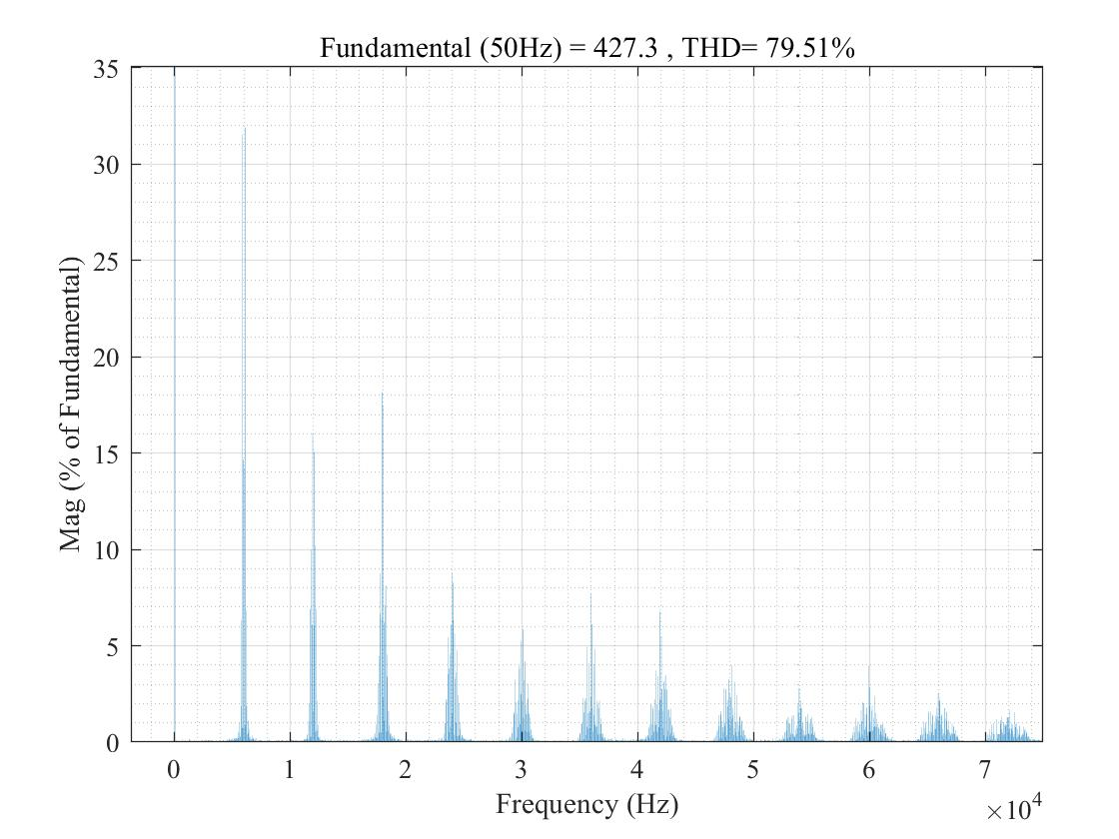

Fig 1-10 modulation ratio m=0.9

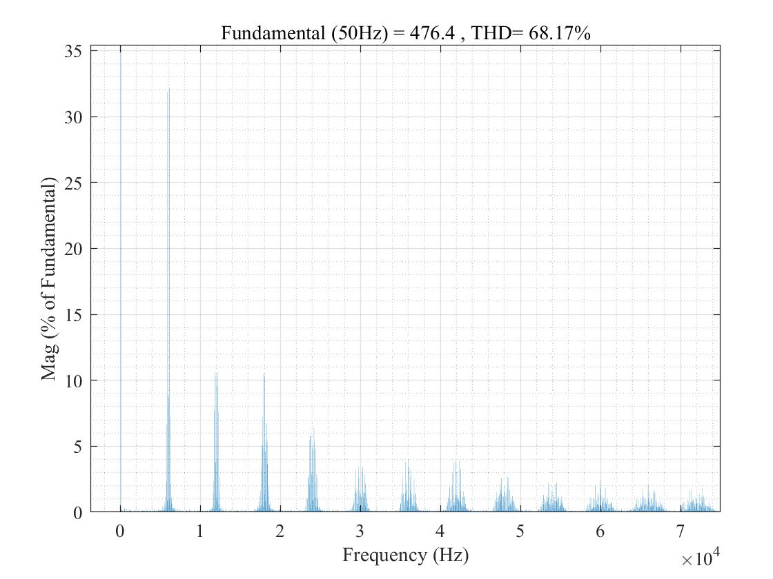

Fig 1-11 modulation ratio m=1.0

Synchronous modulation is a special case of Asynchronous Modulation, so only the analysis of asynchronous modulation can be done. When asynchronous modulation is used, the PWM waveforms of different signal wave periods are different, so it is impossible to directly carry out Fourier analysis based on the signal wave period. Based on the carrier period, the Fourier expression of PWM wave can be derived by using Bessel function, but the analysis process is very complicated. Therefore, we only make the spectrum of typical analysis results as below.

### Analysis of the Results

Suppose the voltage between the load neutral point N and the imaginary neutral point N' of the DC power supply is *u*NN’, then the phase voltages of each phase of the load are



Add up all the above equations



If the load is a three-phase symmetrical load, then the sum of the three-phase voltages is zero. The load phase voltage can be obtained from the following equation:



It can be seen from the waveform following that the PWM wave of load phase voltage is ,  and 0 are common species levels.

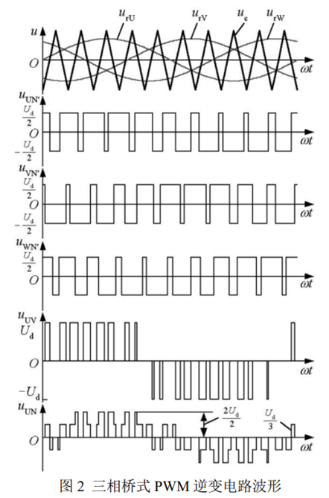

Fig 1-12 the waveform of three phase PWM voltage source inverter

Three phase bridge PWM inverter circuit uses one carrier signal type in three phases, and the angular frequency contained in the output line voltage is



Fig 1-13 shows the frequency spectrum of output line voltage of three-phase bridge PWM inverter circuit with different amplitude modulation ratio *m*. It can be seen that the PWM wave does not contain low order harmonics or integral multiple of carrier angular frequency. It only contains harmonics with angular frequency ωc nearby and the frequency 2ωc, 3ωc nearby. Among the above harmonics, the harmonic component with high amplitude and the greatest influence is



The result shows that the amplitude of the fundamental wave in the output line voltage of the three-phase bridge PWM inverter increases linearly with the increase of the regulation. At the same time, there are some harmonic components whose amplitude is about 1% of the fundamental amplitude near the adjacent multiple carrier angular frequency.

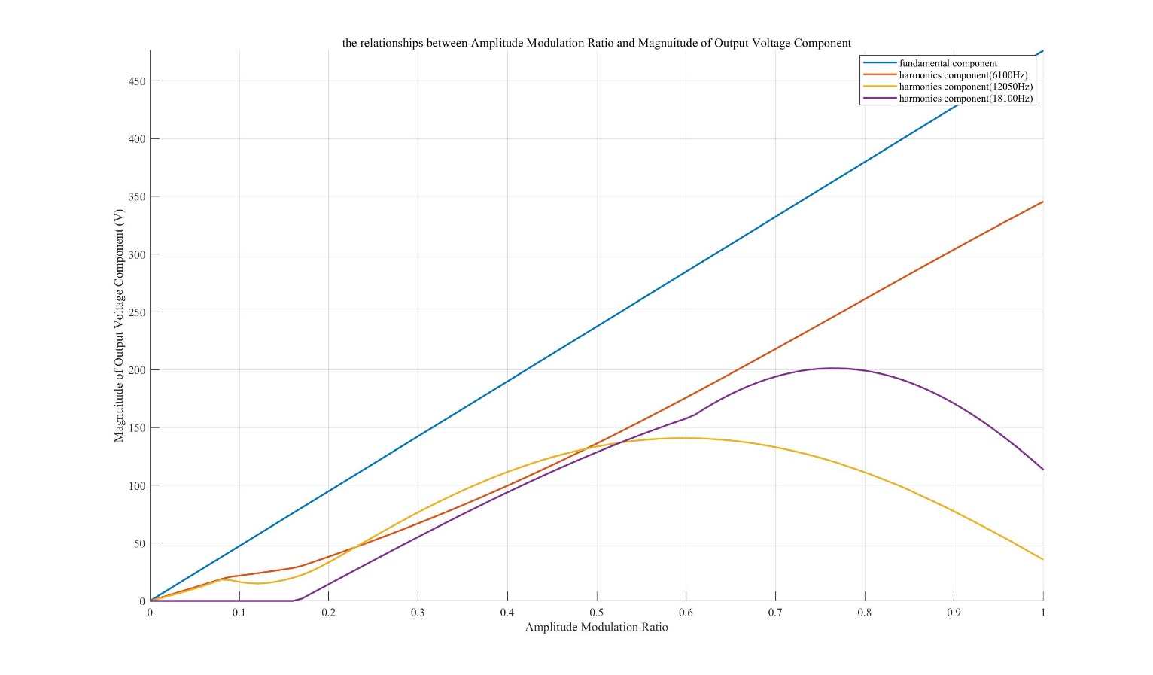

Fig 1-13 the relationship between Amplitude Modulation Ratio and Amplitude of Output Voltage

When *m* = 1, the ratio of the fundamental amplitude of line voltage to DC voltage is about 0.866, that is , which corresponds to the utilization ratio of DC voltage of three-phase bridge PWM inverter circuit.

All the above analyses are carried out under ideal conditions. In the actual circuit, the distribution of harmonics will be more complex due to the error of sampling time and the influence of dead zone to avoid the straight through of upper and lower bridge arms in the same phase. Generally speaking, the harmonic content in the actual circuit is more than that under ideal conditions, and even a small amount of low order harmonics will appear.

The main harmonic in SPWM waveform is the angular frequency of *ωc*, 2*ωc* and nearby harmonics. Generally, *ωc* ≫ *ωr*. Therefore, the frequency of main harmonic in PWM waveform is much higher than that of fundamental wave, which is easy to filter out. The higher the carrier frequency is, the higher the harmonic frequency in SPWM waveform is, and the smaller the filter volume is.

In addition, the general filter has a certain bandwidth. If the filter is designed according to the carrier frequency, the harmonics near the carrier can also be filtered. If the filter is designed as a low-pass filter, and according to the carrier angular frequency *ωc*, the harmonics with the angular frequency is 2*ωc* and 3*ωc* and its vicinity are also filtered out.

### Appendix – MATLAB program for harmonics analysis

clc;

clear;

close all;

%% setup the parameter

j = 1;

step = 0.01;

amplitude_modulation = [0:step:1];

n = length(amplitude_modulation);

fun_result = zeros(n,1);

har1_result = zeros(n,1);

har2_result = zeros(n,1);

har3_result = zeros(n,1);

%% run the simulation

for i = 0:step:1

tem = i; % middle tem

set_param('Seminar6_topic1/Sine_Wave_W','Amplitude','tem');

set_param('Seminar6_topic1/Sine_Wave_V','Amplitude','tem');

set_param('Seminar6_topic1/Sine_Wave_U','Amplitude','tem');

sim('Seminar6_topic1',[0,0.03]); % Run simulation

fun_result(j) = fundamental(end);

har1_result(j) = harmonics1(end);

har2_result(j) = harmonics2(end);

har3_result(j) = harmonics3(end);

% result check

disp(['amplitude modulation ratio m = ',num2str(i)]);

disp(['the fundamental magnitude of output voltage is ',num2str(fundamental(end)),'V']);

disp(['the harmonics(2*50+6000) magnitude of output voltage is ',num2str(harmonics1(end)),'V']);

disp(['the harmonics(50+2*6000) magnitude of output voltage is ',num2str(harmonics2(end)),'V']);

disp(['the harmonics(3*6000+2*50) magnitude of output voltage is ',num2str(harmonics3(end)),'V']);

disp('~~~~~~~~~~~~~~~~~~~~~~~~~~~~~~~~~~~~~~~~~~~~~~~')

j = j+1;

end

%% plot the figure

figure(1)

hold on

plot(amplitude_modulation,fun_result);

plot(amplitude_modulation,har1_result);

plot(amplitude_modulation,har2_result);

plot(amplitude_modulation,har3_result);

hold off

xlabel('Amplitude Modulation Ratio')

ylabel('Magnuitude of Output Voltage Component (V)')

axis([-inf,inf,0,inf]);

set(gca,'FontName','Times New Roman');

set(findobj('Type','line'),'LineWidth',1.5)

legend('fundamental component','harmonics component(6100Hz)','harmonics component(12050Hz)','harmonics component(18100Hz)');

title('the relationships between Amplitude Modulation Ratio and Magnuitude of Output Voltage Component')

grid on

## Task 2

### Task requirement

For three-phase PWM voltage-source inverter(VSI): Analyze the operating sequence according to simulation waveforms

### Simulation Results

The MOSFET with reverse parallel diode is selected for power electronic devices. The on state resistance Ron = 0, the forward conduction voltage drop Vf = 0V, and the conduction voltage drop of parallel diode VFD = 0V.

And we run the simulation with the amplitude modulation ratio, *m*, equaling to 0.7. The waveform of triangular carrier in PWM generator is shown in the figure as well as output voltage of all the phase voltage.

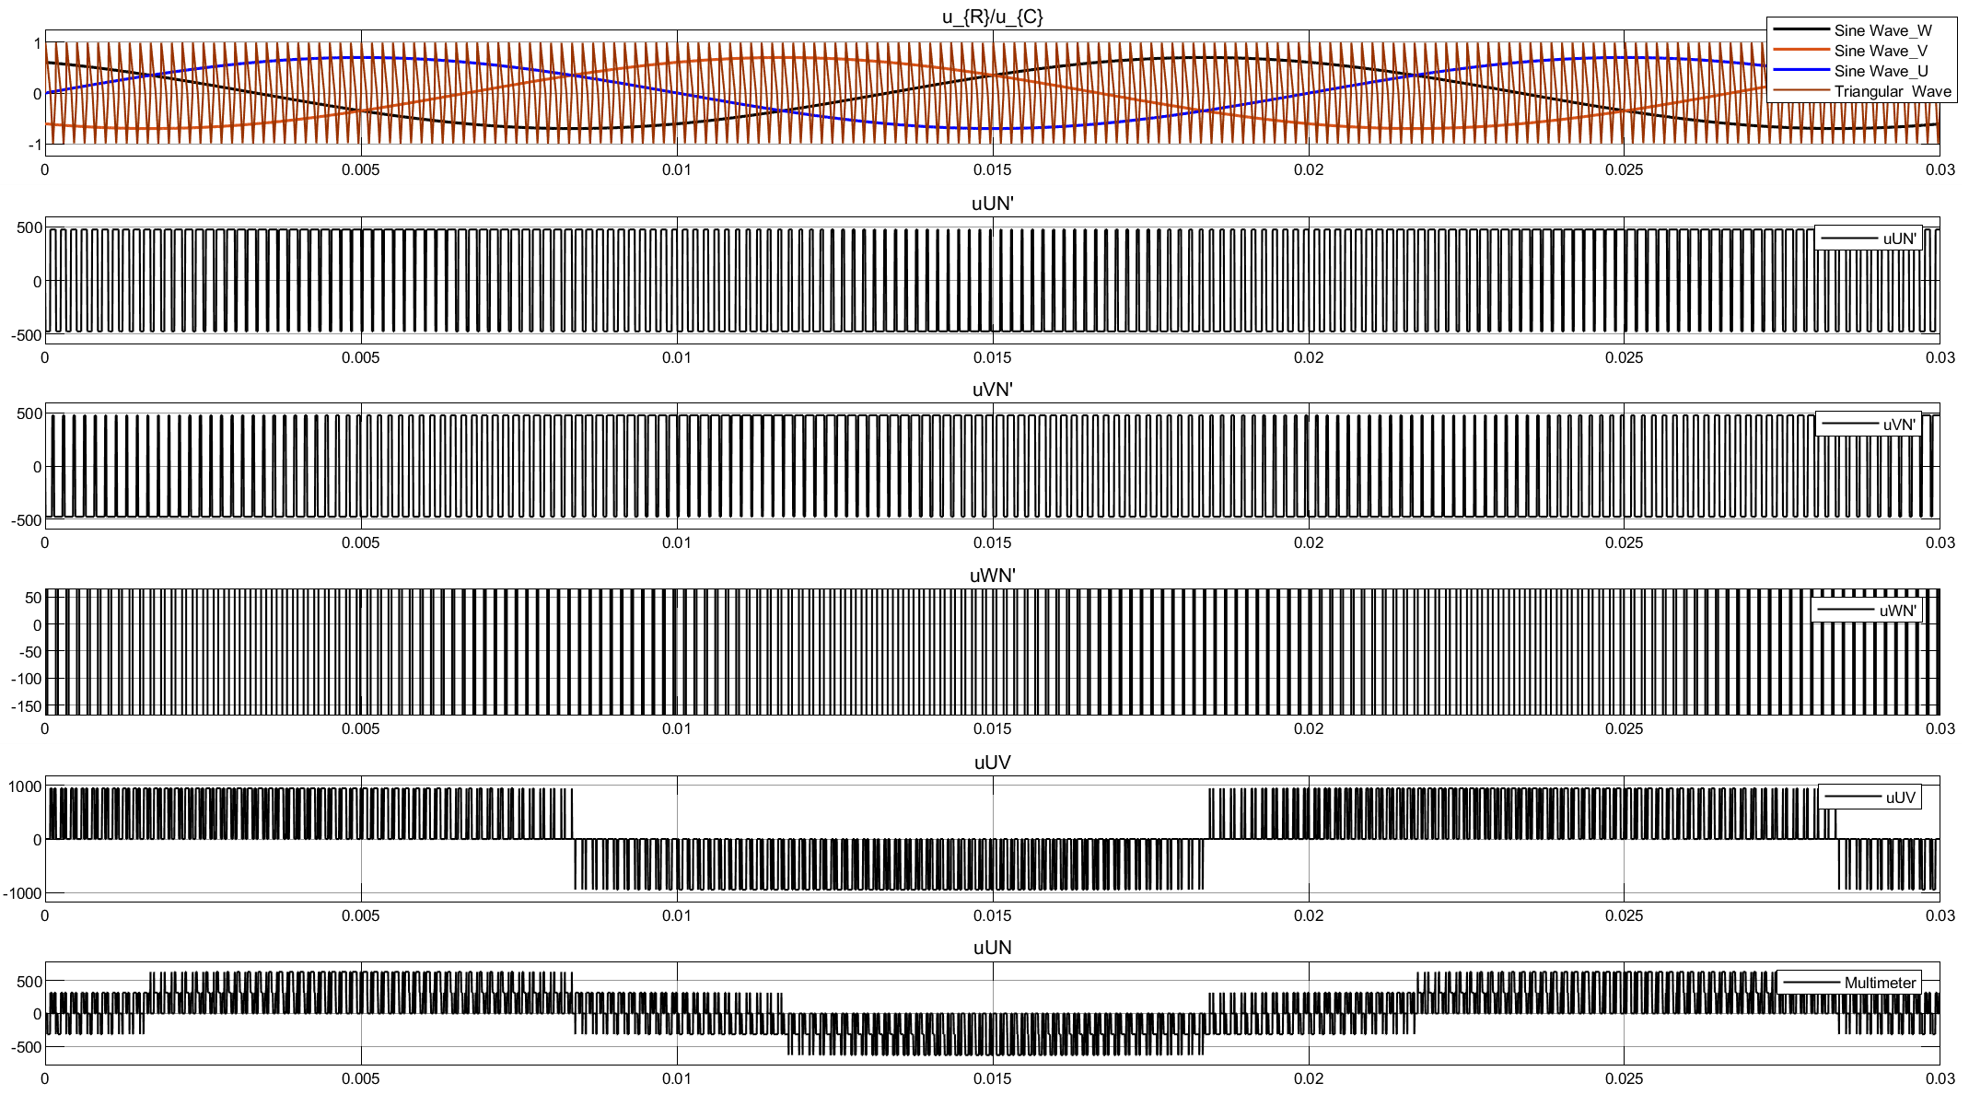

Fig 1-14 Result waveform

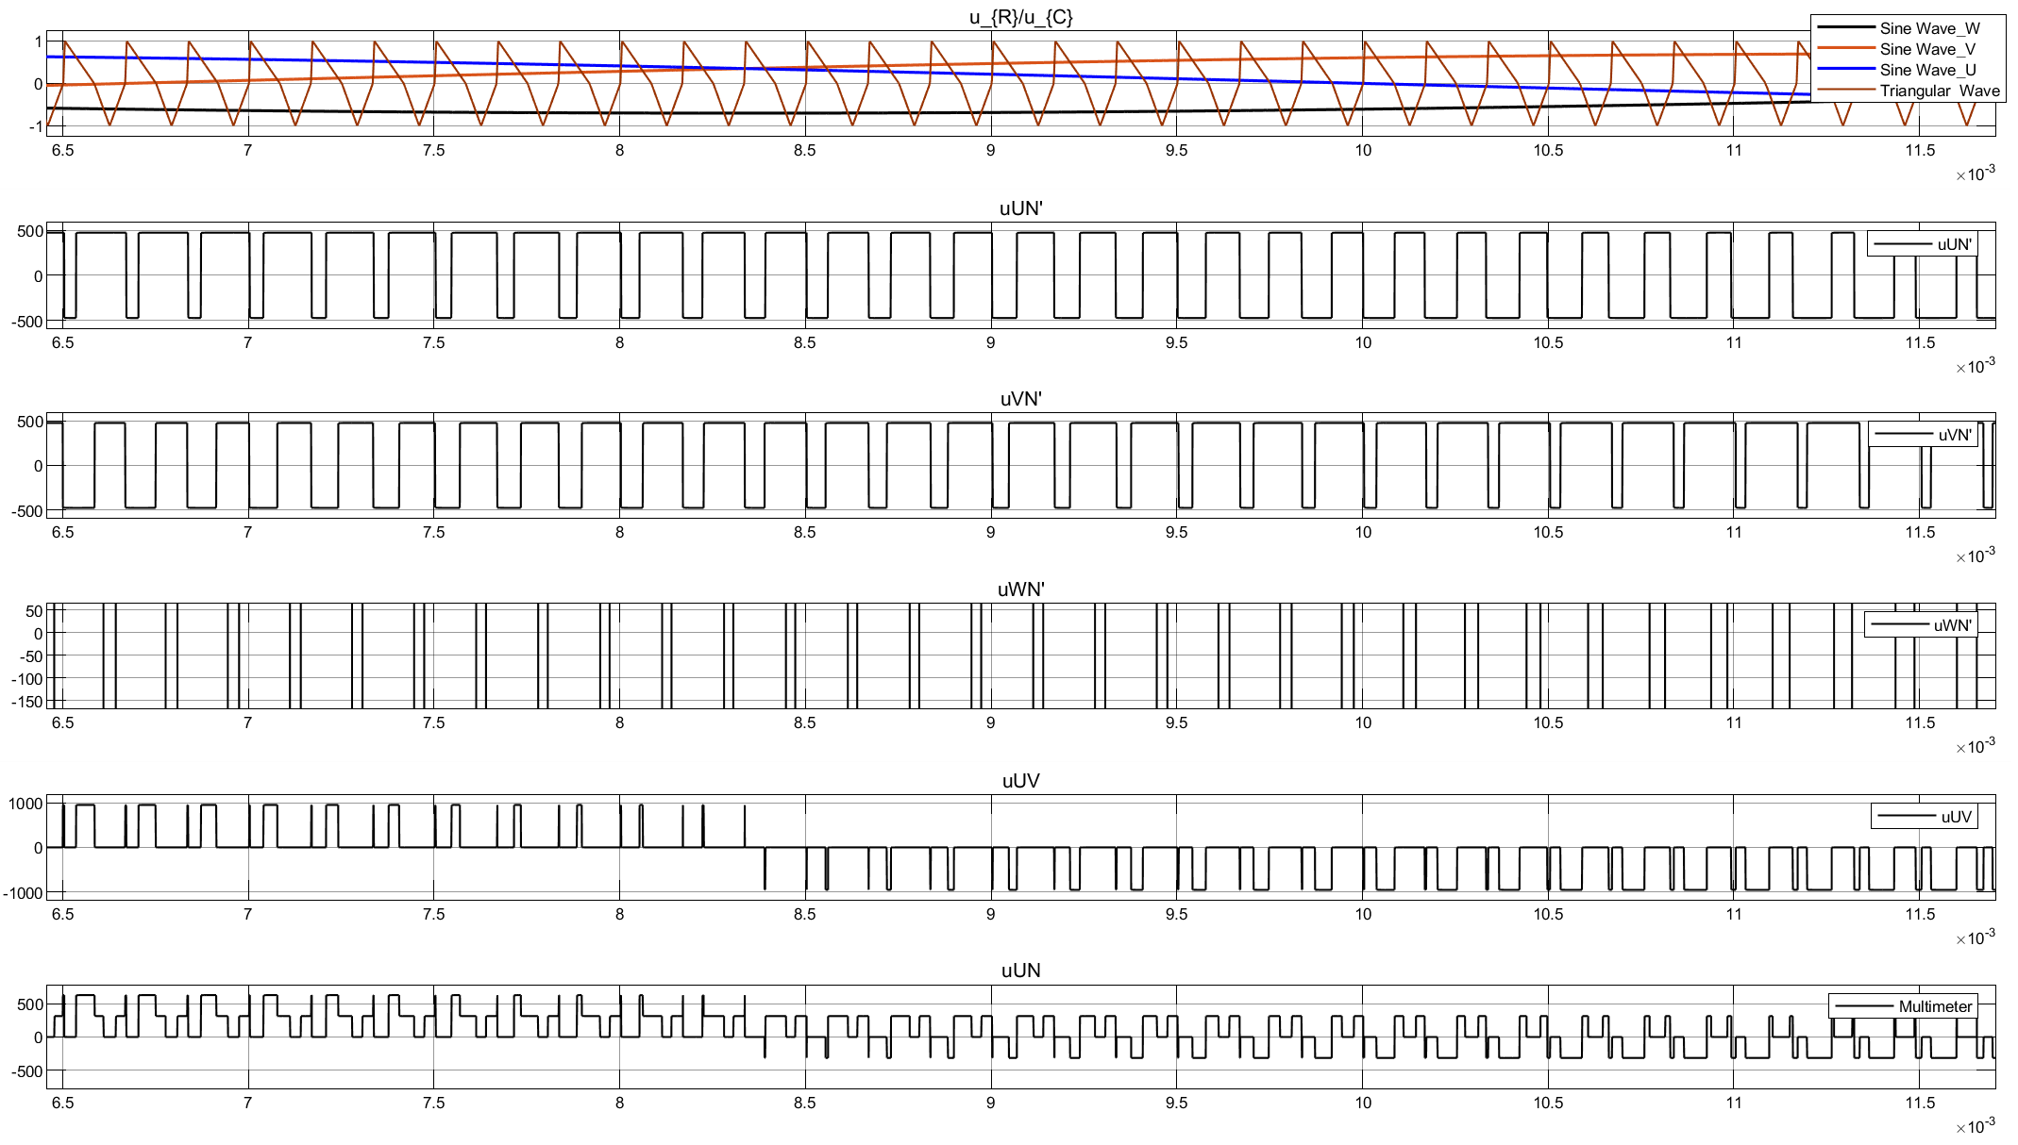

Fig 1-15 Result waveform (zoom in)

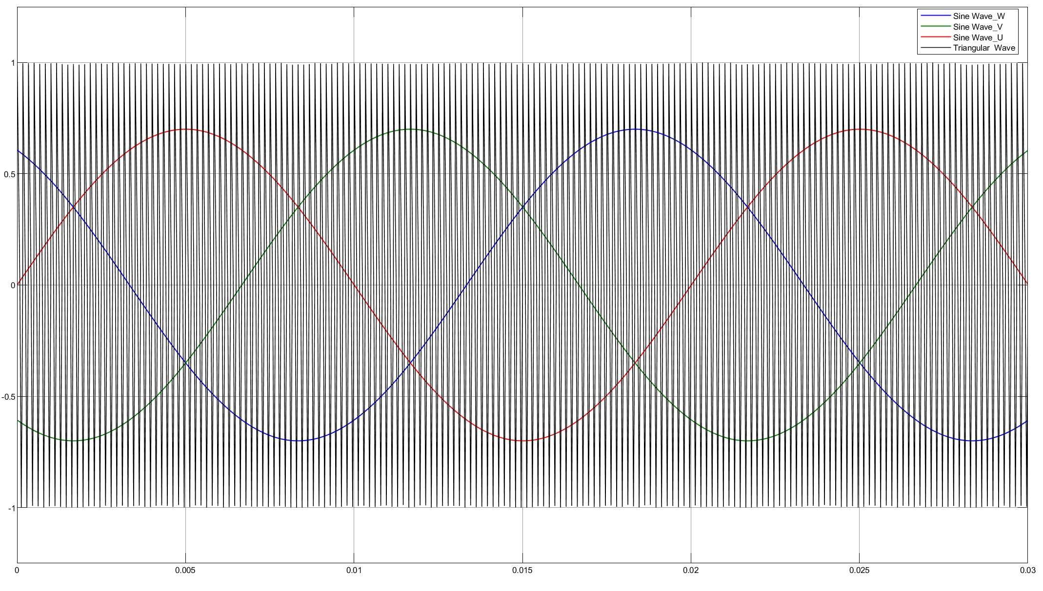

Fig 1-16 Waveform of triangular carrier uc and ur in PWM generator

### Analysis of the Results

The objective in pulse-width-modulated three-phase inverters is to shape and control the three phase output voltages in magnitude and frequency with an essentially constant input input voltage Vd. To obtain balanced three-phase output voltages in a three-phase PWM inverter, the same triangular voltage waveform is compared with three sinusoidal control voltages that are 120° of phase as shown below.



Fig 1-17 the waveform of three phase PWM voltage source inverter

*V1* ~ *V6* is six switching devices of the inverter, each of which is reversely paralleled by a freewheeling diode. The whole inverter is powered by constant DC voltage. The triangular carrier signal *uc* is shared. After being compared with the reference voltage of each phase, the saturation output of "positive" or "zero" is given, and the SPWM pulse sequence wave *Uda*, *Udb* and *Udc* are generated as drive control signals of inverter power switch devices.

Taking U phase as an example, When *u*rU > *u*c, the upper bridge arm *v*1 is given a conduction signal and the lower bridge arm *v*4 is given a turn off signal. The output voltage of U phase *u*UN’ relative to the imaginary neutral point N' of DC power supply equals to .

When *u*rU < *u*c, the upper bridge arm *v*1 is given a conduction signal and the lower bridge arm *v*4 is given a turn off signal. The output voltage of U phase *u*UN’ relative to the imaginary neutral point N' of DC power supply equals to .

The driving signals of *v*1 and *v*4 are always complementary. When the conduction signal is added to *v*1(*v*4), it may be *v*1(*v*4) conduction or diode *VD1(VD4)* freewheeling conduction, which is determined by the current direction in the resistive load, which is the same as the single-phase bridge PWM inverter circuit in bipolar control. The control methods of U phase, V phase and W phase are the same.

In order to prevent the short circuit caused by the straight through of the upper and lower arms, a short period of dead time is reserved for both the upper and lower arms to apply the off signal. The length of dead time is mainly determined by the turn off time of switching devices. The dead time will affect the output PWM wave and make it deviate from the sine wave slightly.

# Single-phase PWM full-bridge voltage source converter

## Circuit diagram

The following diagram is the circuit diagram of single-phase PWM full-bridge voltage source converter.

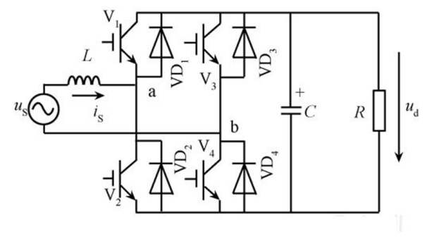

Fig 2-1 Single-phase PWM full-bridge voltage source converter

The single-phase bridge voltage type PWM rectifier circuit is shown in Fig. 2.1. Each bridge arm is composed of a full control device and a reverse parallel rectifier diode. L is the additional inductance at AC side, which is an important component in PWM rectifier circuit, which can balance voltage, support reactive power and store energy. To simplify the analysis, the resistance of l can be ignored. When the fully controlled device is turned off, the DC side capacitor C provides a current path for the inductance current to buffer the impulse current. At the same time, the capacitor also stores energy, stabilizes the DC side voltage and suppresses the DC side harmonic voltage. The main power will be consumed on load R.

For single-phase voltage source PWM rectifier, there are two PWM control modes of AC side fundamental voltage control, namely bipolar modulation and unipolar modulation. Because bipolar control is simple and effective, this paper mainly describes the working principle of bipolar debugging.

When the bipolar modulation is adopted, the DC side voltage is regarded as basically unchanged, then the AC measured voltage Uab(t) will be switched between Vdc and -Vdc to realize the PWM control of AC voltage measurement. Therefore, there are only two switching modes in the process of single-phase voltage PWM rectification, which can be described by bipolar binary logic switching function P



The two switch modes are shown in the table 1-1:

Table 2-1 Single phase voltage source PWM bipolar switch mode

|  |  |  |
| --- | --- | --- |
| Switch mode | 1 | 2 |
| Conduction device | V1(VD1)&V4(VD4) | V2(VD2)&V3(VD3) |
| switching function | P=1 | P=-1 |

It should be noted that there will be different current loops in the same switching mode when the *i(t)* direction of the grid side current is different. The current loop of single-phase voltage source PWM rectifier circuit with different switching modes is shown in Figure 2 below.

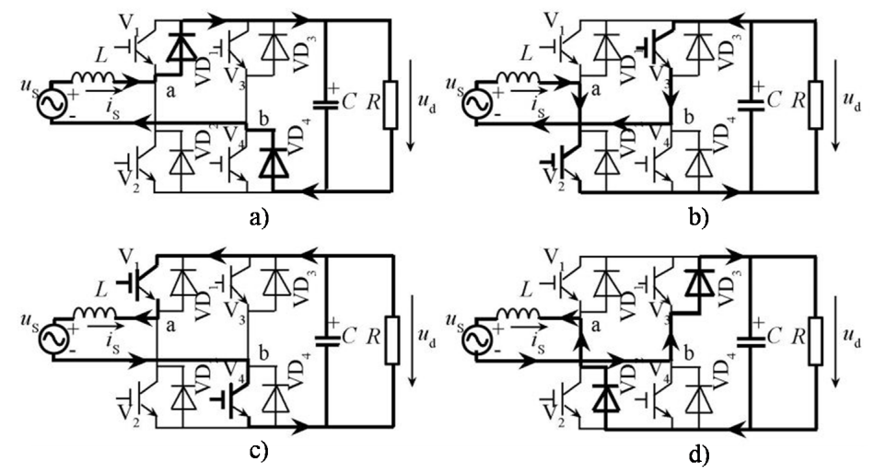

Fig 2-2 Current loop of bipolar modulation with different switching modes

a) Switch mode 1, and i(t) > 0 b) Switch mode 2, and i(t) > 0

c) Switch mode 1, and i(t) < 0 d) Switch mode 2, and i(t) < 0

When the current is positive, VD1 and VD4 are on, AC power outputs energy, DC side absorbs energy, and the circuit is in rectification state; when current is negative, V1 and V4 are on; when AC power absorbs energy, DC side releases energy and is in energy feedback state. When the current is positive, V2 and V3 are on, AC power supply and DC side both output energy and Load inductance store energy; when current is negative, VD2 and VD3 are on, AC power supply and DC side both absorb energy and Load inductance releases energy.

For the circuit in the diagram V1~V4, if SPWM control is used, then *uAB* is also SPWM wave and contains fundamental wave components with the same frequency and amplitude as sinusoidal signal wave, and high-order harmonics related to triangular wave, but not low-order harmonics. The influence of high order harmonics can be ignored because of the inductance.

When the frequency of the sine wave is the same as that of the power supply, *iS* is also a sine wave with the same frequency as the power supply. Under certain conditions of AC power supply, the amplitude and phase of *iS* are only determined by the fundamental component of *uAB* and its relation and the phase difference of *uS*. Change the phase and amplitude of *uAB* can make *iS* and *uS* S phase difference is any angle required, but due to the small radian value, the calculation of effective digits has a great influence on the error, so we adopt to adjust the phase angle of AC voltage source instead of adjusting *uAB* phase angle has the same effect.

## Simulink circuit diagram

In Simulink, we use the model as below to carry out simulation.

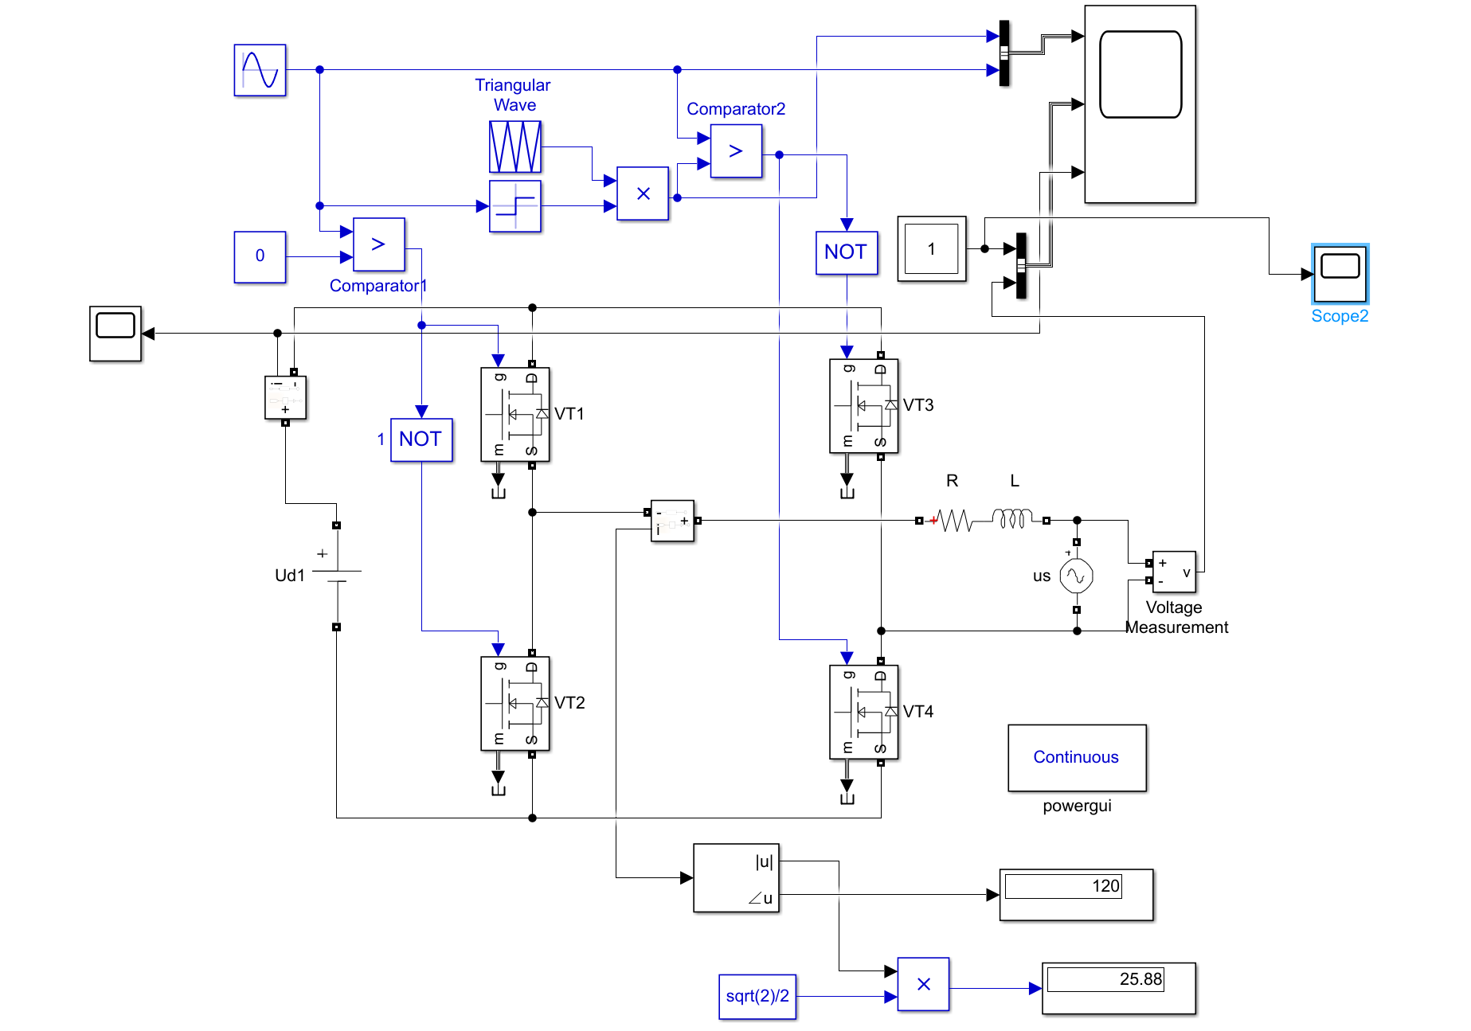

Fig 2-3 Simulation model

## Task 1

### Task requirement

For single-phase PWM full-bridge voltage-source converter(VSC): Control the power stage so that the requirement of AC side current amplitude as well as phase difference between AC side voltage and current could be satisfied.

### Theoretical calculation

The following is a theoretical analysis of the situation in Fig. 3-2d. The state in figure 3-2d is the state of the problem to be solved. At this time, the current leads the voltage by an angle, and the circuit contains both active and reactive components.

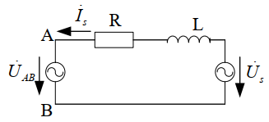

Fig 2-4 Equivalent circuit

If the phase of *U* is 0, then we got:



According to the parameter setup, *Is* is ahead of *Us* 120°, then we got that:



According to the KVL, we can get the equation:



Then we got the equation:



In equation 3-2, 𝛿 is the angle between  and , which is further simplified as



According to the equation we can get the RMS value of  and *δ*



The amplitude modulation ratio is



With all these mentioned above, when R=0.7255Ω and the amplitude modulation ratio m=0.601 are set in the circuit, the AC current measurement is 25A and the phase is 120° ahead of the AC power supply voltage.

### Parameter Setup

Tab. 2-2 Parameter setup of our group for topic 2

|  |  |  |  |  |  |  |
| --- | --- | --- | --- | --- | --- | --- |
| *Uac*  (RMS) | L  Load Inductance | *Udc* | fline | fs | Iac  (RMS) | *φ*(*v,i*) |
| 220V | 6mH | 630V | 50Hz | 20kHz | 25A | 120° |

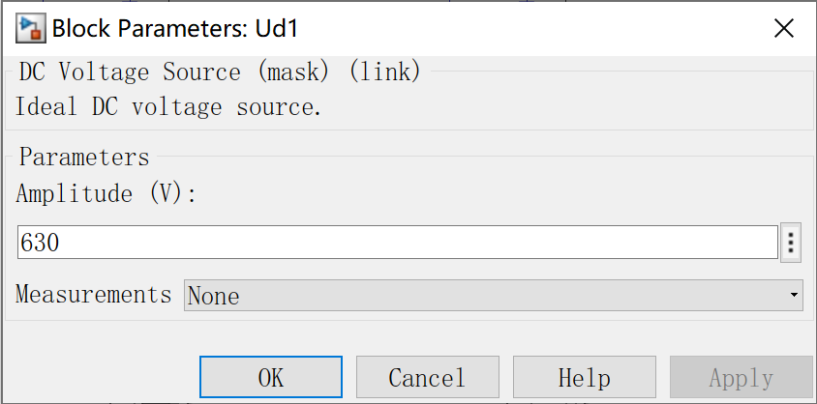

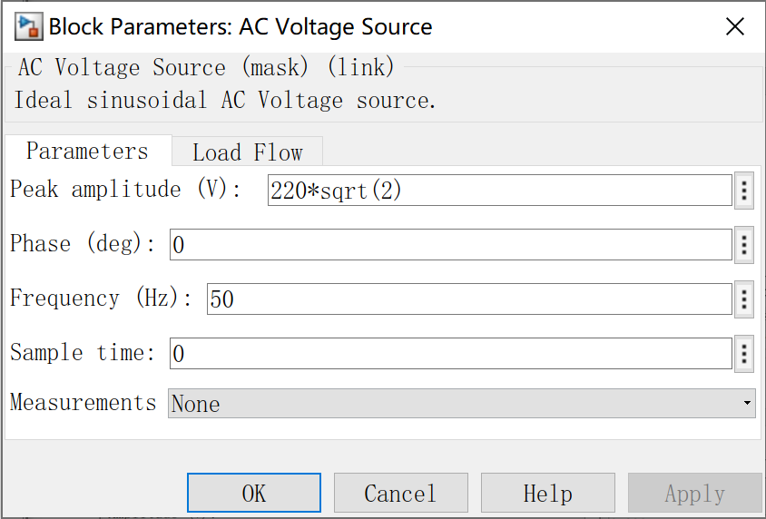 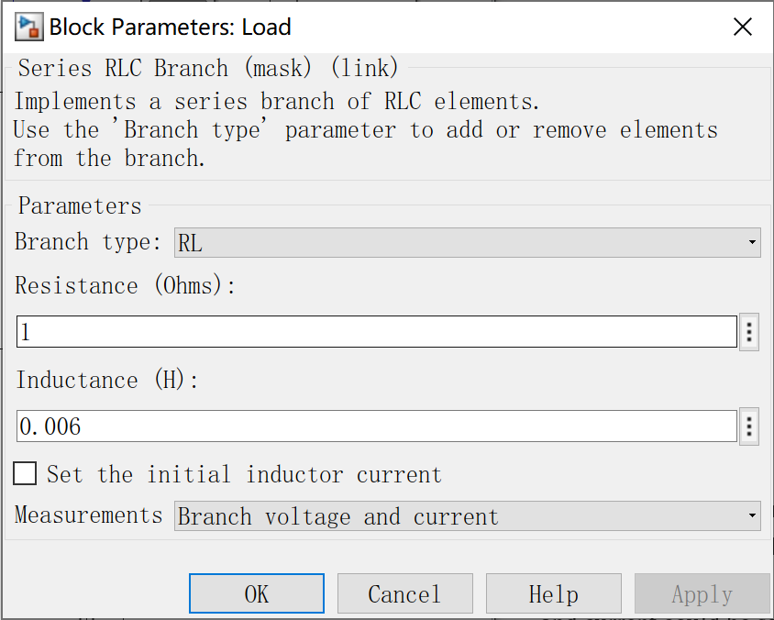

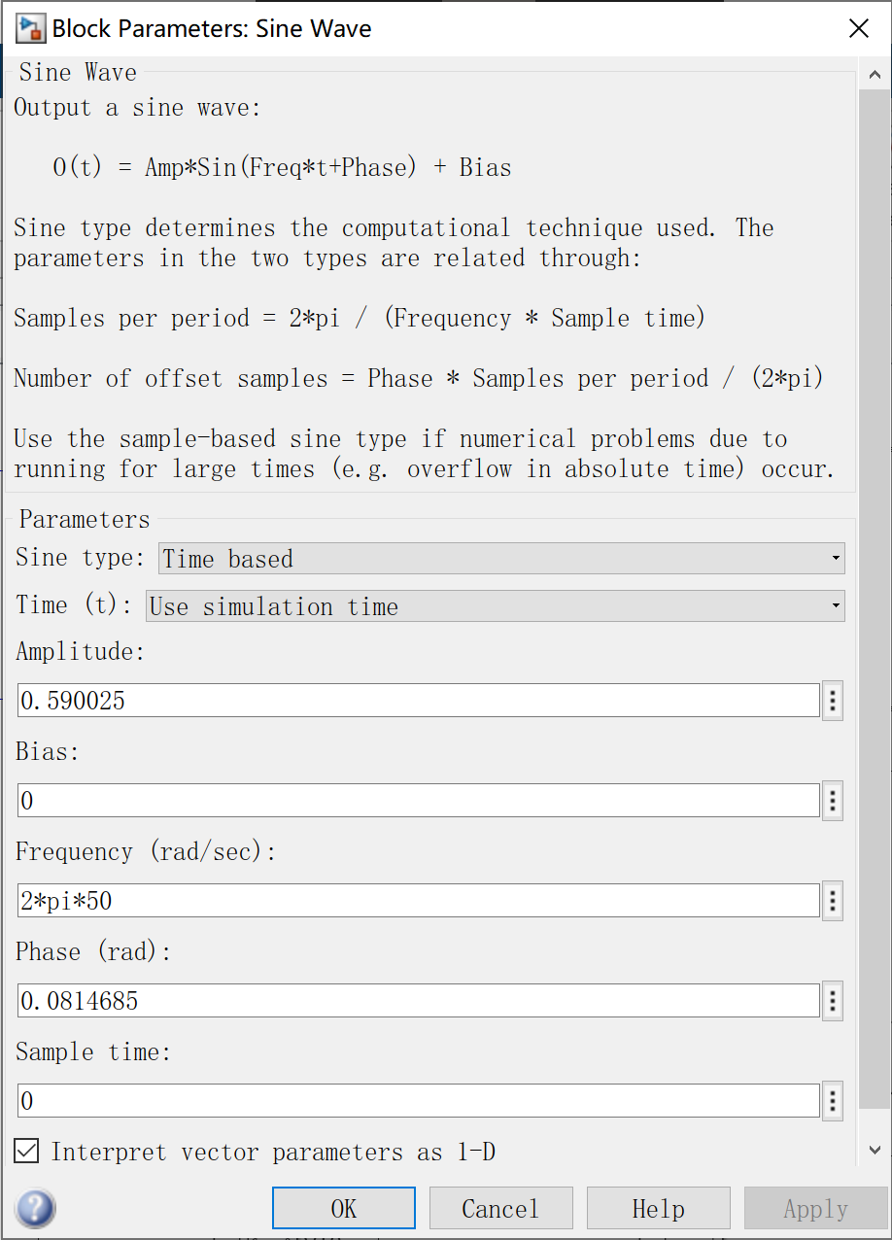

Fig 2-5 Parameter setup of our group

### Simulation Results

The current and voltage waveform of DC side and The current waveform of AC side is shown in Fig. 2-6

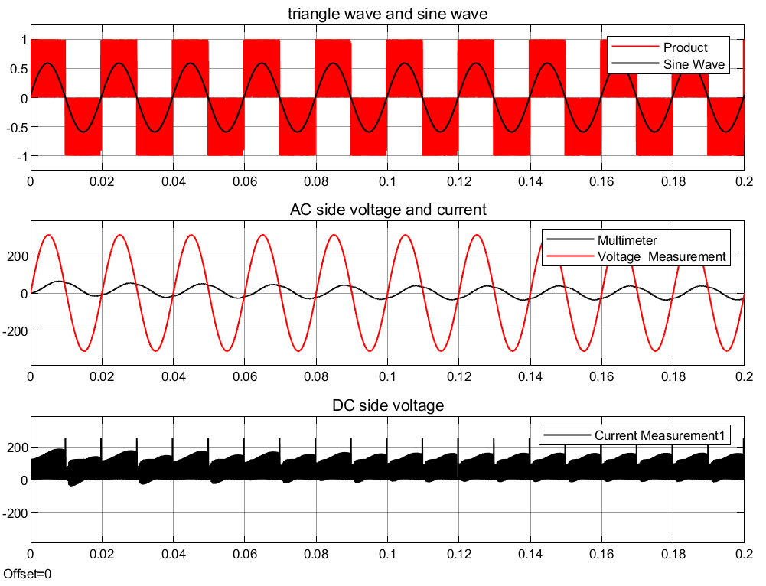

Fig 2-6 Waveform of DC side voltage and AC side voltage and current

Zoom in the AC current measurement waveform, as shown in Fig. 2-17. We can see that the current waveform is actually pieced together, which is the principle of PWM technology to generate waveform.

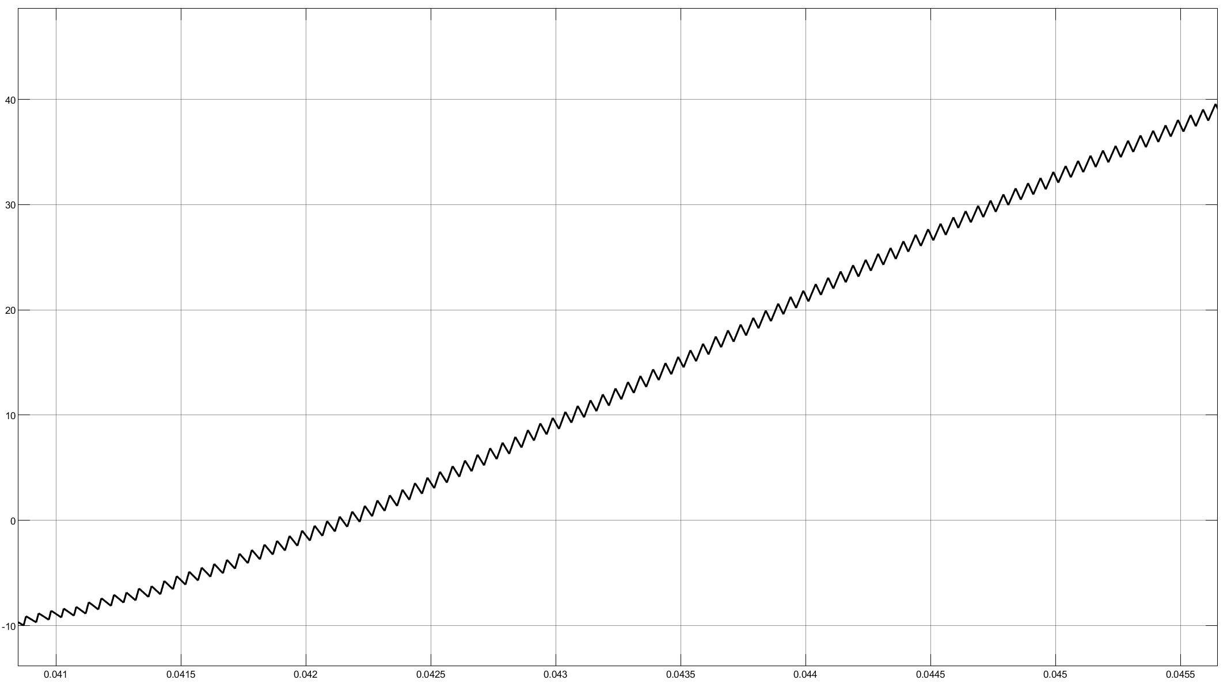

Fig 2-7 Waveform of DC side voltage and AC side voltage and current (Zoom in)

The Fourier module added in the circuit diagram reads out the maximum fundamental wave value and phase angle in the AC side current, as shown in Fig. 2-8.

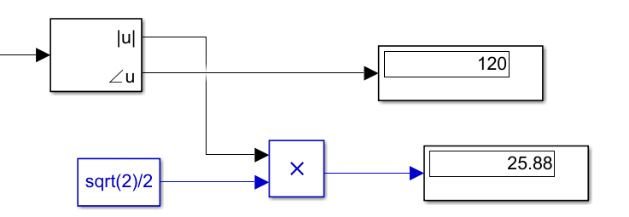

Fig 2-8 the simulation result of current value and *φ*

### Analysis of the Results

The result is shown below in the table 2-3. It can be seen that the fundamental wave lags behind the power supply voltage, which meets the backward requirements in the subject parameters. At the same time, its effective value is, which also conforms to the effective value condition of the question.

Tab. 2-3 Comparison between simulation results and theoretical results

|  |  |  |  |
| --- | --- | --- | --- |
| Theoretical current value (A) | 25 | Error | 3.52% |
| Simulation current value (A) | 25.88 |
| Theoretical *φ*(*v,i*) | 120° | Error | 0% |
| Simulation *φ*(*v,i*) | 120° |

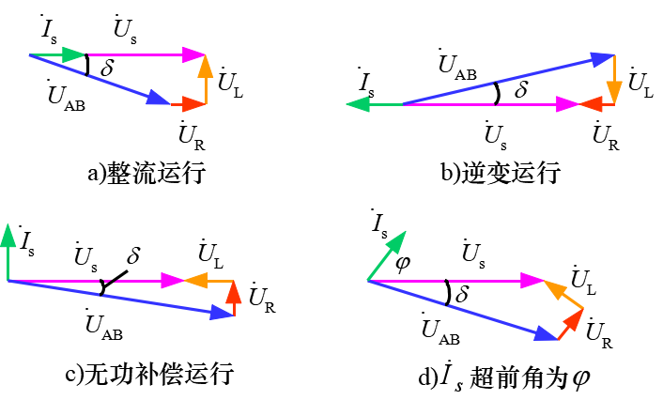

Fig 2-9 Current loop of bipolar modulation with different switching modes

As shown in Fig 2-9, , ,  and  is AC supply voltage, inductance voltage, resistance voltage and the vector of *iS*. In Fig. 3 the circuit is changed into a static reactive power generator_ By controlling the amplitude and phase of ,  is more than  leads or lags any phase.