**Seminar #7 Report**

**Group 1**

EE810 Nie Yongxin 2186113564

This seminar consists of two parts, which are hard-switching buck converter and ZVS QRC buck converter. For the two parts, we carried out simulations with LTspice.

# Hard-switching Buck Converter

This simulation is concerning hard-switching buck converter, whose main function is to control current, voltage or the conduction of the circuit without changing the frequency.

## Simulation Model

There are three characteristics to be specified and a model is established correspondingly

### Circuit Diagram

The following diagram is the circuit diagram of the AC voltage controller.



* + - 1. hard-switching buck converter

## Simulink circuit diagram

In LTspice, we use the model as below to carry out simulation.

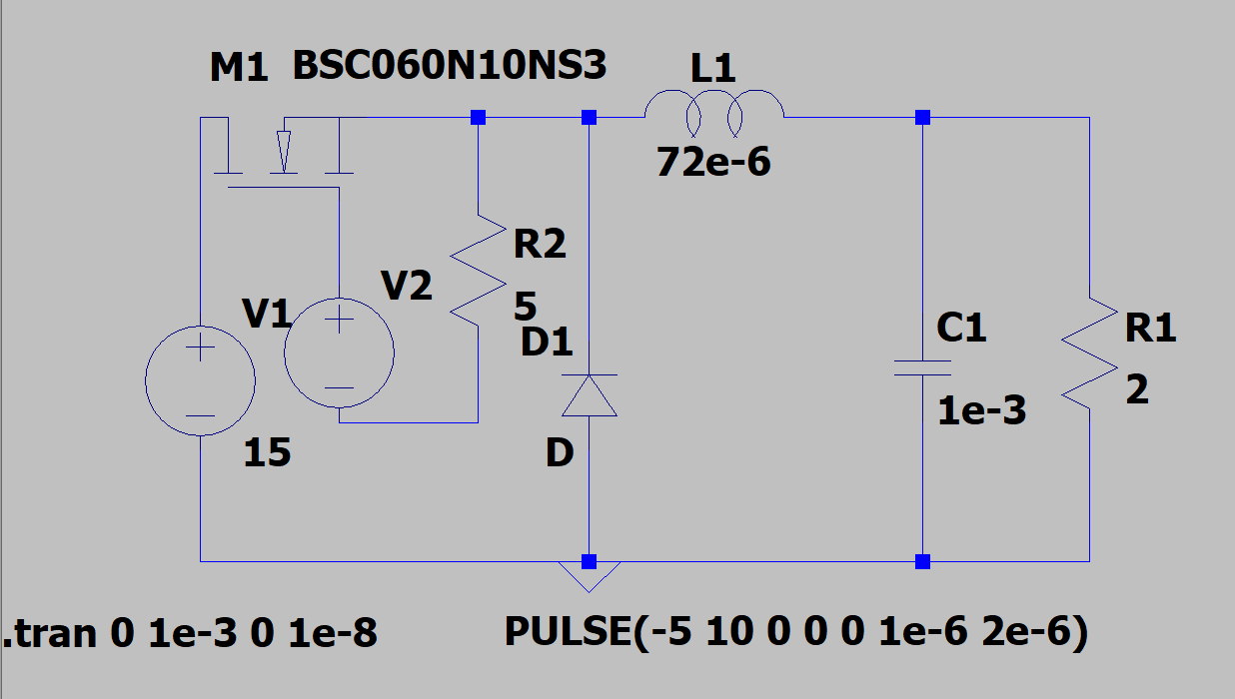

* + - 1. Simulation model

## Parameter Setup

Tab. 1-1 Parameter setup of our group

|  |  |  |  |  |  |  |
| --- | --- | --- | --- | --- | --- | --- |
| L | C | R | Q | D | fs | Vin |
| 72uH | 1000uF | 2Ω | BSC060N10NS3 | 0.5 | 500kHz | 15V |

## Task

### Task requirement

For hard-switching buck converter: observe the switching waveform of power switch Q and plot loss curve.

### Simulation Results

We choose the ideal diode as our VD. The driving voltage is 5V~10V, resistor can be chosen as 5Ω.

The circuit timing sequence:

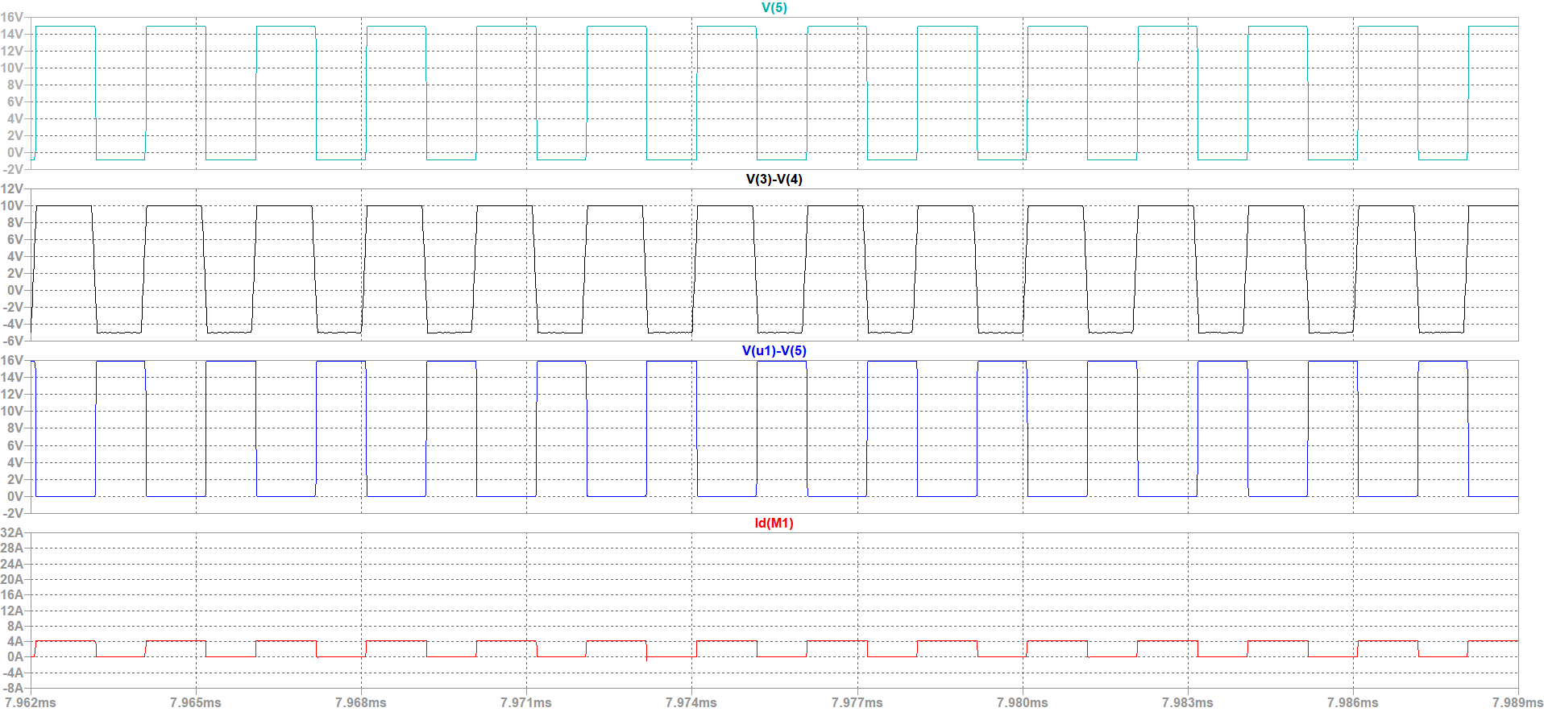

* + - 1. The circuit timing sequence waveform 1

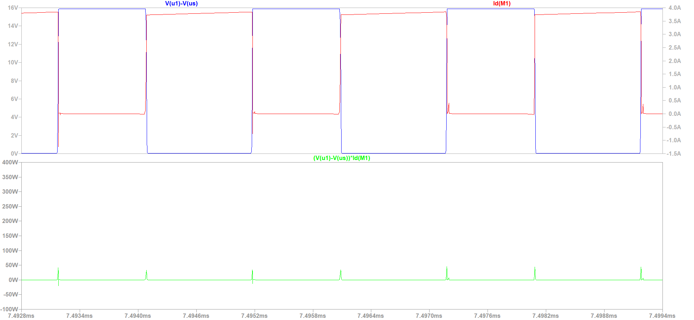

Fig 1-5 The circuit timing sequence waveform 2

According to the change curves of the power, it can be seen that in the process of turning on and turning off the semiconductor device, the highest instantaneous power is 38.40W, and the switch device has large switching loss and switching noise.

In order to analyze the switching sequence waveform, the simulation waveform of switch tube voltage *us* and switch tube current *is* is amplified locally during the switching period.

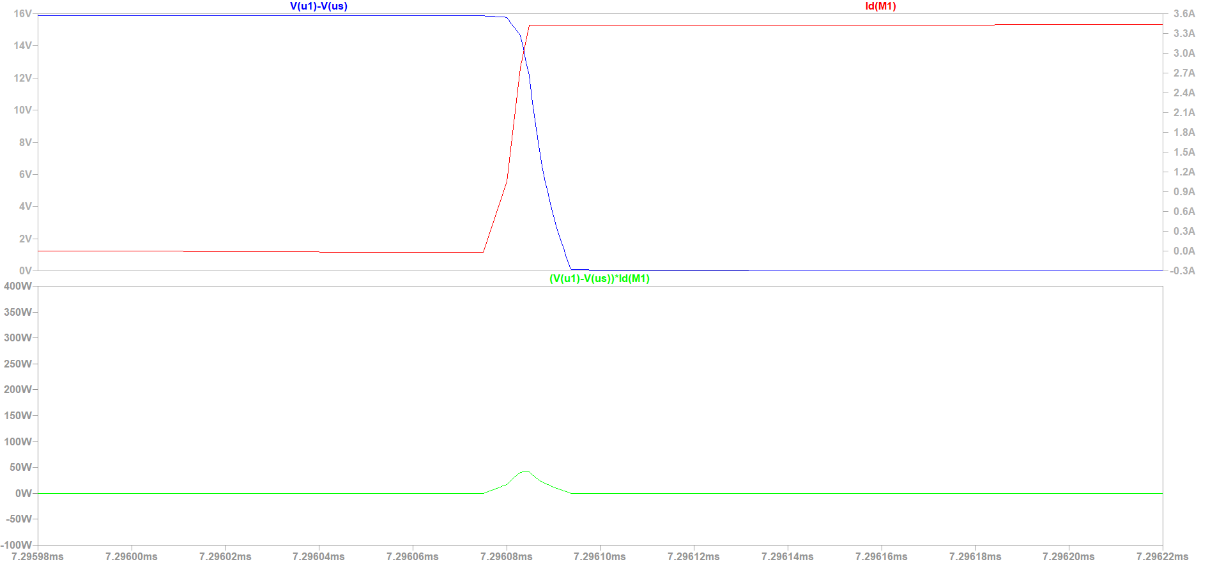

Fig 1-6 opening process

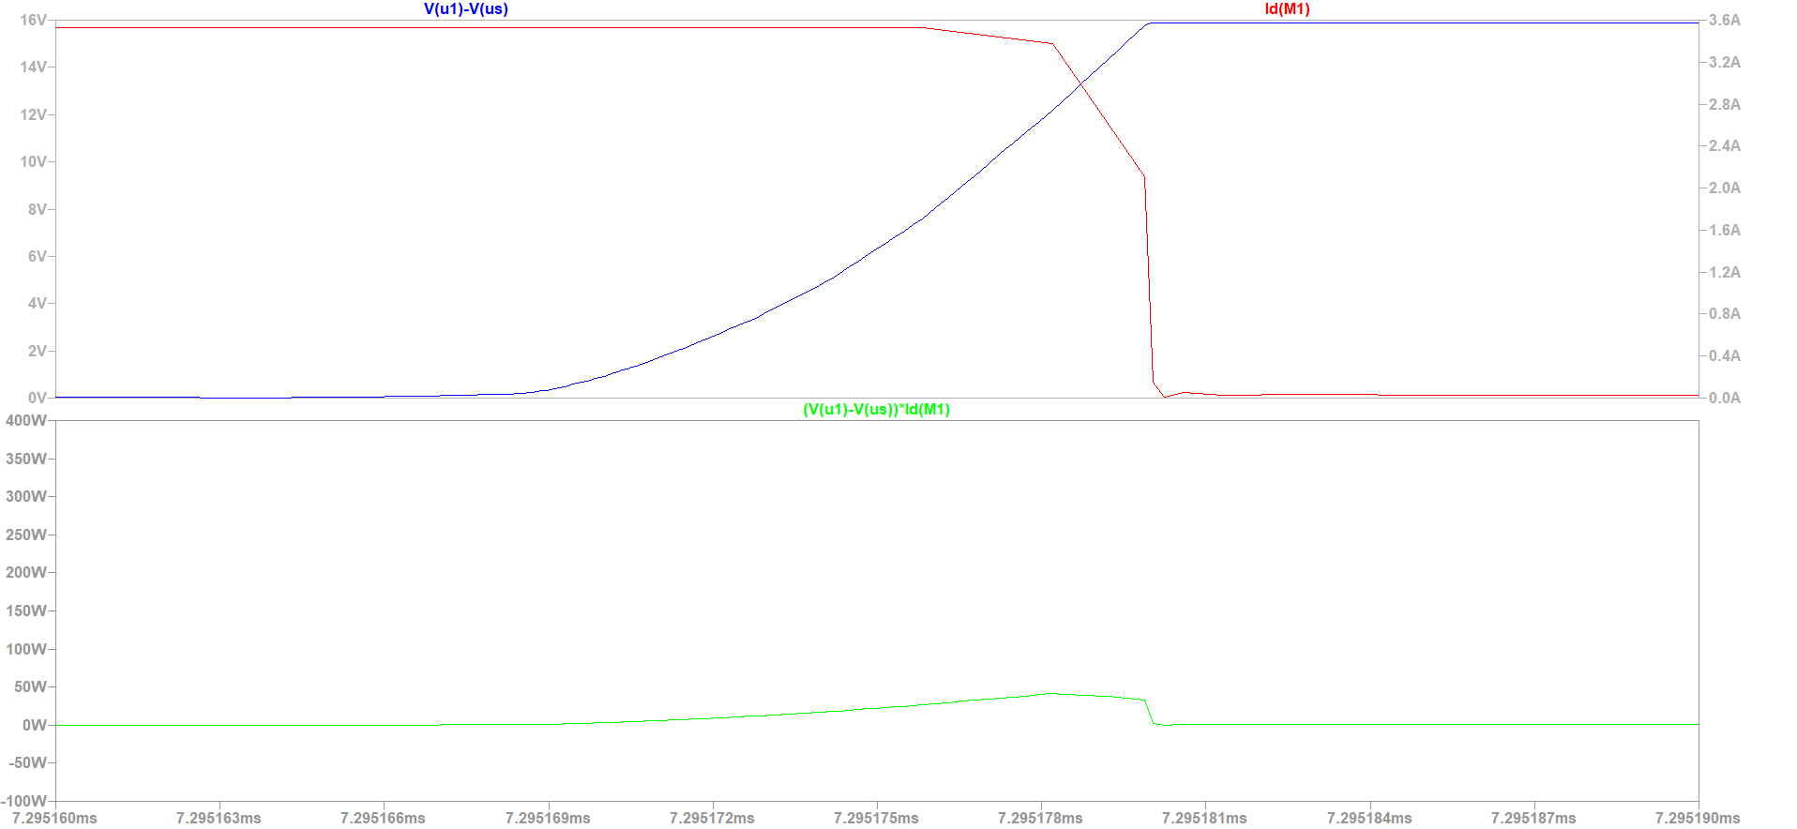

Fig 1-7 Turn-off Transient

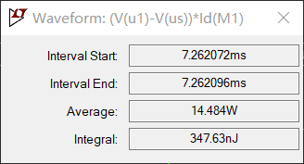

Fig 1-8 Turn-on loss

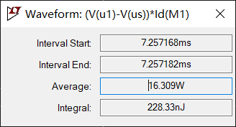

Fig 1-9 turn-off loss

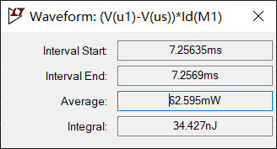

Fig 1-10 on-state loss

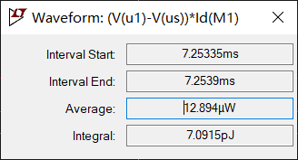

Fig 1-11 off state loss

Table 1-2 losses of hard-switching buck converter

|  |  |  |  |
| --- | --- | --- | --- |
|  | Measurement period | Average power | Energy loss |
| Turn-on loss | 7.262072ms-7.262069ms | 14.484W | 347.63nJ |
| Turn-off loss | 7.257168ms-7.257182ms | 16.309mW | 228.33nJ |
| Off-state loss | 7.256350ms-7.256900ms | 62.595mW | 34.427nJ |
| On-state loss | 7.253350ms-7.253900ms | 12.894mW | 7.0915nJ |

### Analysis of the Results

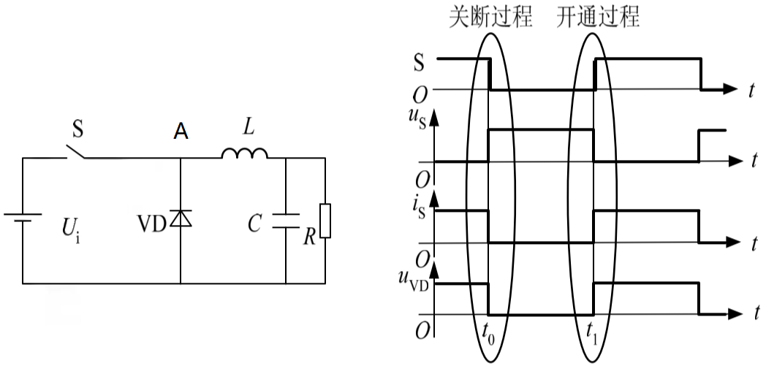

Fig 1-12 waveform of hard switching buck chopper circuit

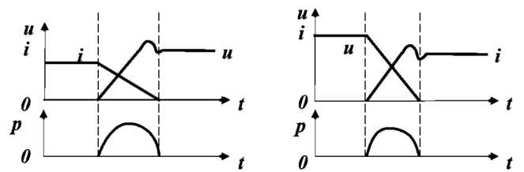

Fig 1-13 voltage and current waveforms in hard switching

The buck chopper circuit composed of hard switch is shown in Figure 1-1. In such a circuit, the voltage and current waveforms in the process of switching on and off are shown in Fig. 1-13. The voltage and current are not zero in the switching process, and there is overlap, so there is significant switching loss. Moreover, the voltage and current change very fast, and the waveform has obvious overshoot, resulting in switching noise.

From the switching waveform shown in the Fig 1-13 above, it can be found that during the opening process, the current of MOSFET changes first. When the voltage *uS* begins to decrease when it increases to basically unchanged, and during the turn-off process, the voltage of MOSFET changes first, and the current begins to decrease when it increases to basically unchanged.

The above switching timing can be explained by the topology of the circuit. In the circuit shown in Fig 1-12, Kirchhoff's current law is applied to node A, and the current flowing through inductive L is equal to the current flowing through the switch tube *S* and the current flowing through the diode VD. Assuming a very large inductive value of inductive *L* is a constant value, in the process of switching tube *S* from blocking state to on state, when it does not rise to equal, diode VD must be on and flowing through the current, VD on so that the power level of point A is always about 0V, that is, the voltage at both ends of S is maintained at the supply voltage; Similarly, during the switch tube S switching from the on state to the blocking state when the supply voltage is not rising, the power level of point A is always higher than 0V, the diode VD does not meet the positive bias conditions, the VD branch is blocked, at this time the current flowing through S remains unchanged.

The voltage and current are large when conducting and turning off. In the on and off state, the voltage and current are low. In addition, due to the on resistance of the switch in the on state, and the switch current in the off state is 0. Therefore, the loss of the on-state is greater than the loss of off-state.

# ZVS QRC Buck converter

## Circuit diagram

The following diagram is the circuit diagram of the ZVS QRC Buck converter.



Fig 2-1 ZVS QRC Buck converter

## Simulink circuit diagram

In LTspice, we use the model as below to carry out simulation.

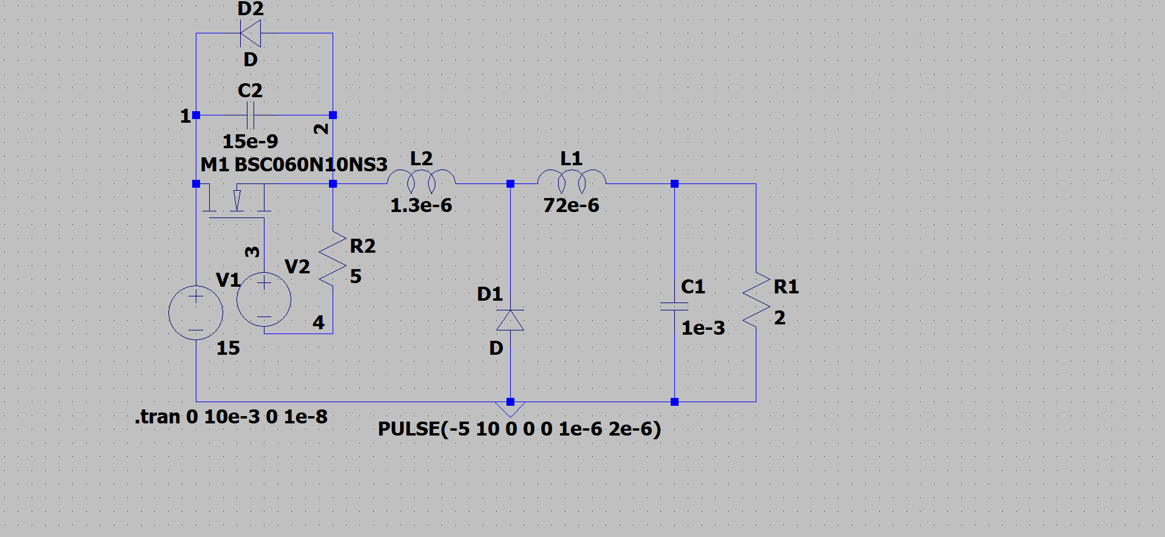

Fig 2-2 Simulation model

## Parameter Setup

Tab. 2-1 Parameter setup of our group

|  |  |  |  |  |  |  |  |  |
| --- | --- | --- | --- | --- | --- | --- | --- | --- |
| Lr | Cr | L | C | R | Q | D | fs | Vin |
| 1.3uH | 15nF | 72uH | 1000uF | 2Ω | BSC060N10NS3 | 0.5 | 500kHz | 15V |

## Task

### Task requirement

For ZVS QRC Buck converter: observe the switching waveform of power switch Q. Plot loss curve and compare with previous case

### Simulation Results

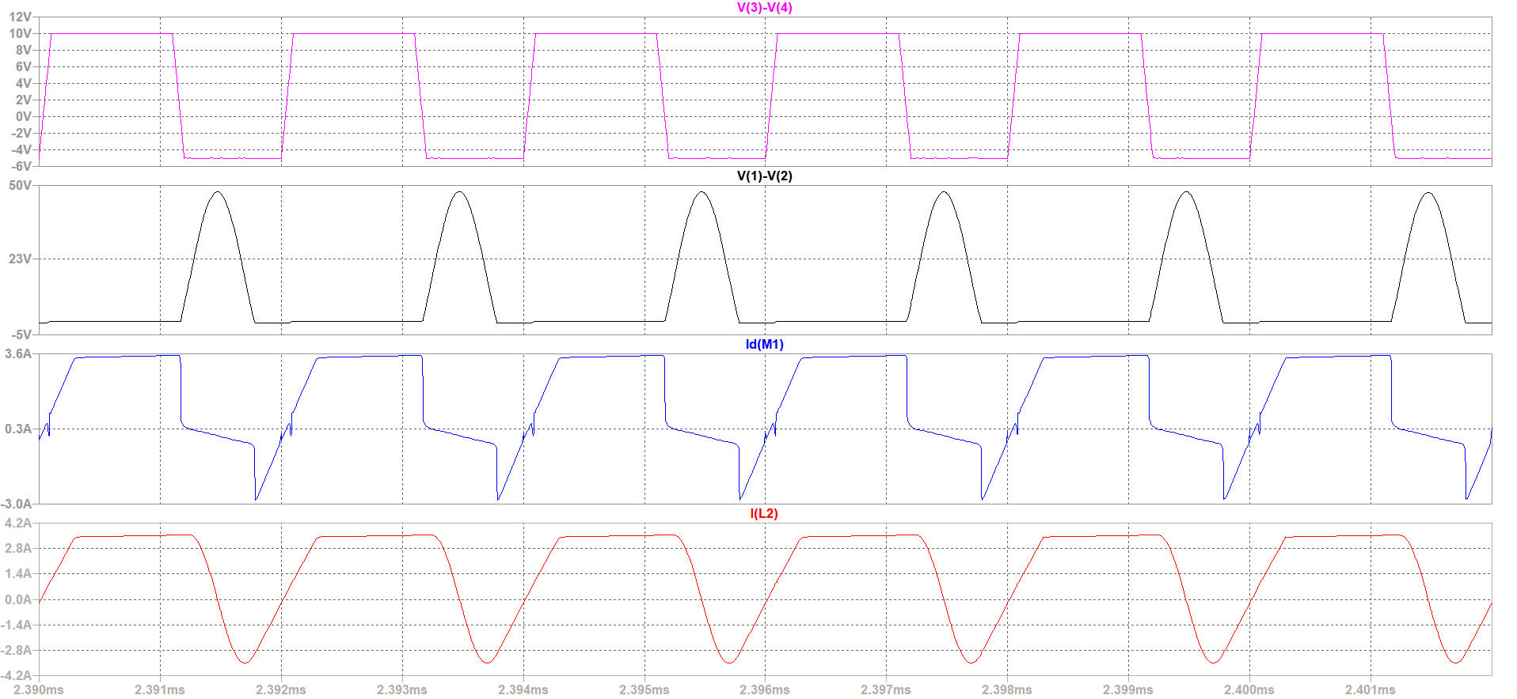

Fig 2-3 the circuit timing sequence

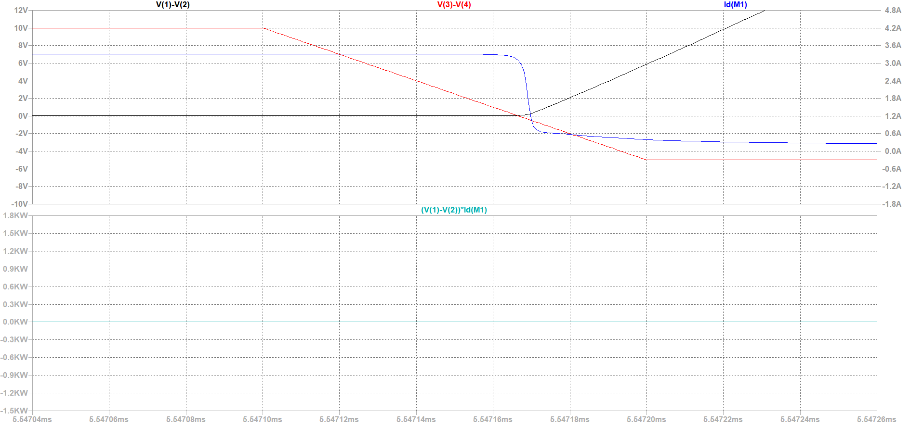

Fig 2-4 turning-off process

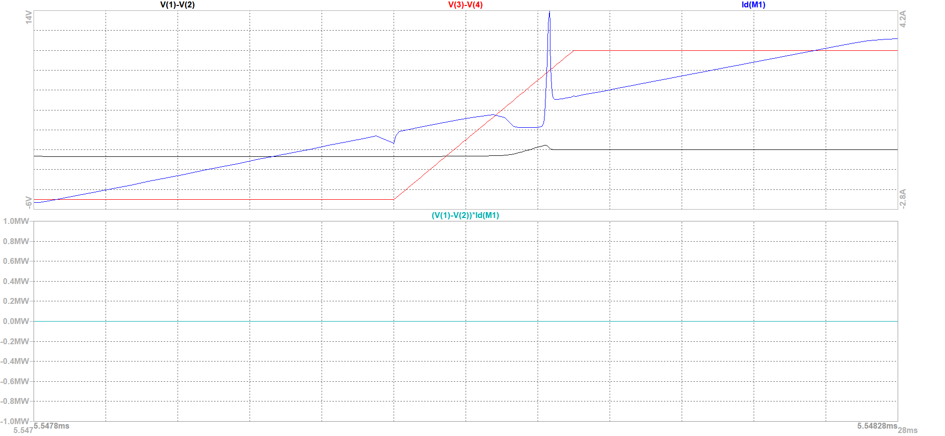

Fig 2-5 turning-on process

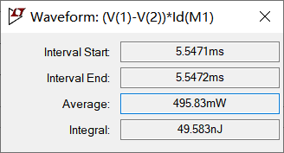

Fig 2-6 Turn-on loss

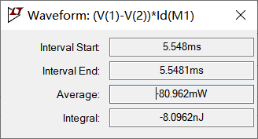

Fig 2-7 Turn-off loss

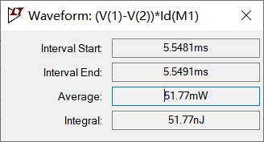

Fig 2-8 on-state loss

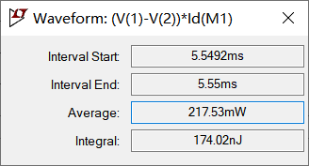

Fig 2-9 off-state loss

Table 2-2 losses of ZVS QRC Buck converter

|  |  |  |  |
| --- | --- | --- | --- |
|  | Measurement period | Average power | Energy loss |
| Turn-on loss | 5.5471ms-5.5472ms | 496.83mW | 49.583nJ |
| Turn-off loss | 5.548ms-5.481ms | -80.962mW | -8.0962nJ |
| Off-state loss | 5.5481ms-5.5491ms | 51.77mW | 51.77nJ |
| On-state loss | 5.5492ms-5.55ms | 217.53mW | 174.02nJ |

### Analysis of the Results

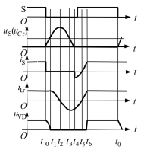

Fig 2-10 the theoretical waveform of ZVS QRC Buck converter

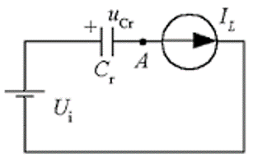

Fig 2-11 equivalent circuit of turning-on process



Fig 2-12 equivalent circuit of turning-off process

***Period t0 - t1*:**

Before the moment *t0*, the switch S is on, the diode VD is off, . And at the moment *t0*, the capacitor *Cr*, which is in parallel with it, slows the voltage rise after the switch *S* shuts off, so the turn-off loss of switch *S* decreases. After the switch S is turned off, the VD is not yet turned on. Inductive *Lr* and *L* charge *Cr*, because the inductive value is very large, can be equivalent to the current source. Linear rise, while the voltage at both ends of the VD gradually decreases until the moment is 0, VD on. This period is available



***Period t1 - t2*:**

The moment diode t2, VD turned on, inductive L conducts through VD. *Cr*, *Lr* and *Ui* form a resonant circuit, as shown in Figure 5. During the resonant process, *Lr* charges *Cr*, rising and falling until the moment, down to zero, reaching resonant peak.

***Period t2 - t3*:**

After the moment, Cr discharges to Lr, changes direction, and continues to drop until the moment, when the voltage at both ends of the Lr is zero, reaching the peak of reverse resonance.

***Period t3 – t4*:**

After the moment, Lr charges cr in reverse and continues to drop until the moment is 0.

***Period t1 – t4*:**

The equation for the circuit resonance process during the period is



***Period t4 – t5*:**

Clamped at zero, Lr voltage at both ends, linear attenuation until the moment, . Since the voltage at both ends of the switch S is zero during this time period, the S must be turned on during this time period so that no opening loss is generated.



***Period t5 – t6*:**

Switch *S* is the general state and *iLr*rises linearly until the moment, the VD is off.

***Period t4 – t6*:**

The rate of change in the current during the period

***Period t6 – t0+T*:**

*S* is pass state and VD is broken state.

The resonance process is the most important part of the operation of the soft switch circuit, which is available by solving (1.2) (i.e. the voltage of switch S).



The resonant peak expression is obtained from its maximum value of [*t1, t4*], which is the peak voltage that switch *S* is subjected to, i.e



As can be seen from the type (1.4), if the amplitude of the sine term is less than , it is impossible to resonance to zero, and switch S is not possible to achieve zero voltage opening, therefore



is the zero voltage switch quasi-resonant circuit to achieve the conditions of soft switch.

The comparision between the result of the hard switching buck converter and ZVS QRC buck converter is shown below.

Table 2-3 the result of hard switching buck converter and ZVS QRC buck converter

|  |  |  |
| --- | --- | --- |
|  | Hard-switching Buck converter | ZVS QRC Buck converter |
| Terminal peak-voltage | 15.871V | 45.568V |
| Turn-on loss | 347.63nJ | 8.0962nJ |
| Turn-off loss | 228.33nJ | 49.583nJ |
| On-state loss | 34.427nJ | 51.77nJ |
| Off-state loss | 7.0915pJ | 174.02nJ |
| Total loss | 610.394nJ | 283.469nJ |

As can be seen from the above table, the total loss of soft switches is smaller than that of hard switches. The switching loss of soft switches (on and off) is less than the switching loss of hard switches. Because the voltage rises slowly when the switch is turned off, compared with the hard switch, the product of voltage and current overlap is smaller, and the power consumption is also smaller. When the switch is turned on, the voltage will drop to 0 earlier, and the voltage and current will not overlap, and the natural loss is very small. The reason for the increased loss in the off state is that the switch contains a capacitor in the off state and its current is not zero. Although the capacitor itself has no loss, the small resistance in the switch will still produce a certain loss in the current conversion process, but the total loss is significantly less than that of the hard switch, indicating that the soft switch has a good loss reduction characteristic.