**Seminar Report 7**

Tan Jiaxin 2186123730

# Topic Buck Converter

For hard-switching Buck converter: Observe the switching waveform of power switch Q and plot loss curve.



Figure 1: Hard-Switching Buck Converter

For ZVS QRC Buck converter: Observe the switching waveform of power switch Q and plot loss curve and compare with previous case.



Figure 2: ZVS QRC Buck Converter

# Simulation Model

## *1.1 Hard-switching Buck Converter*

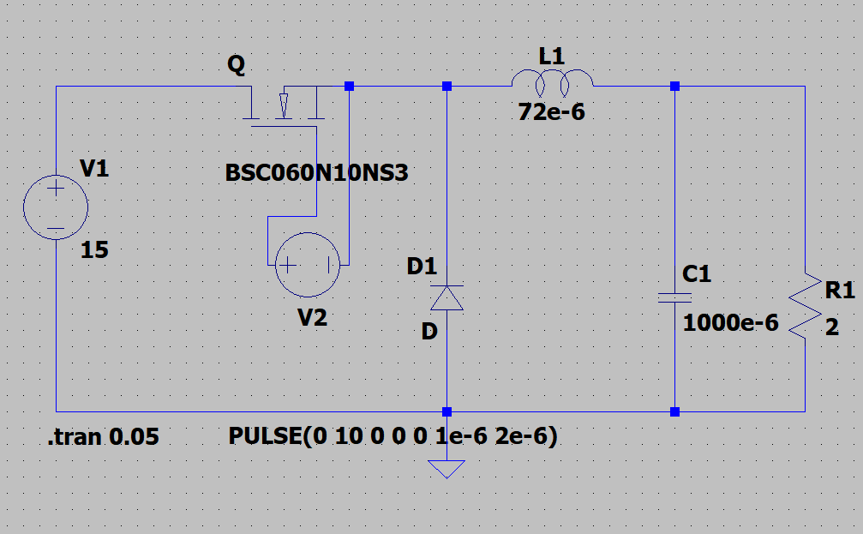

Figure 3: Model 1

This model is established to observe the changing of current and voltage of the switch during turning-on and turning-off process. Also, we can study the power loss during turning-on and turning-off process. It includes a DC voltage source, a power MOSFET, a pulse generator, two diodes, an inductor, a large capacitor, and a resistor.

## *1.2 ZVS QRC Buck Converter*

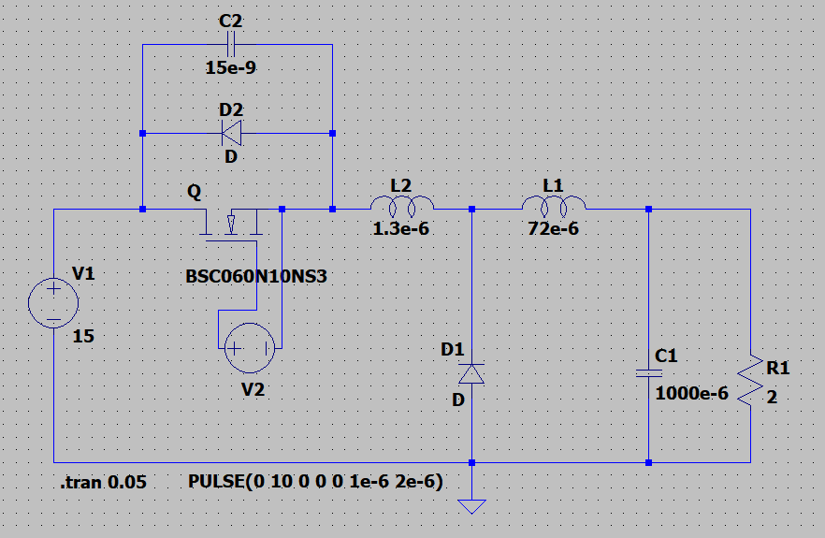

Figure 4: Model 2

This model is established to observe the ZVS QRC converter. It includes a DC voltage source, a power MOSFET, a pulse generator, two diodes, an inductor, a large capacitor, and a resistor. Besides, to realize zero-voltage turning-on, it also includes a small inductor and a small capacitor.

# Parameter Setup

|  |  |  |  |  |  |  |  |  |  |
| --- | --- | --- | --- | --- | --- | --- | --- | --- | --- |
| Group | Lr | Cr | L | C | R | Q | D | fs | Vin |
| 1 | 1.3uH | 15nF | 72uH | 1000uF | 2Ω | BSC060N10NS3 | 0.5 | 500kHz | 15V |

# Simulation Results

## *3.1 Hard-switching Buck Converter*

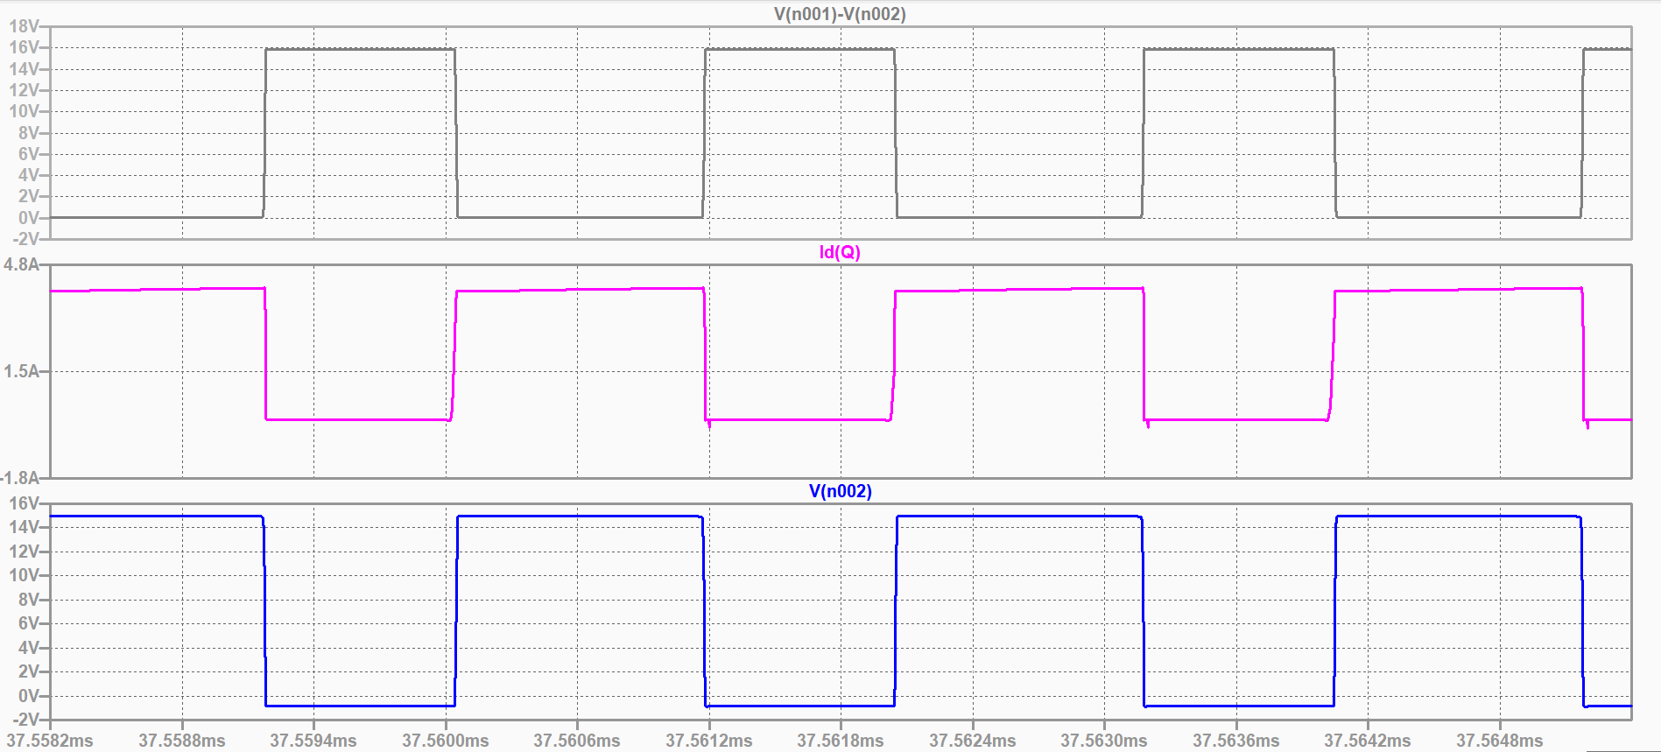

Figure 5: us, is, uVD

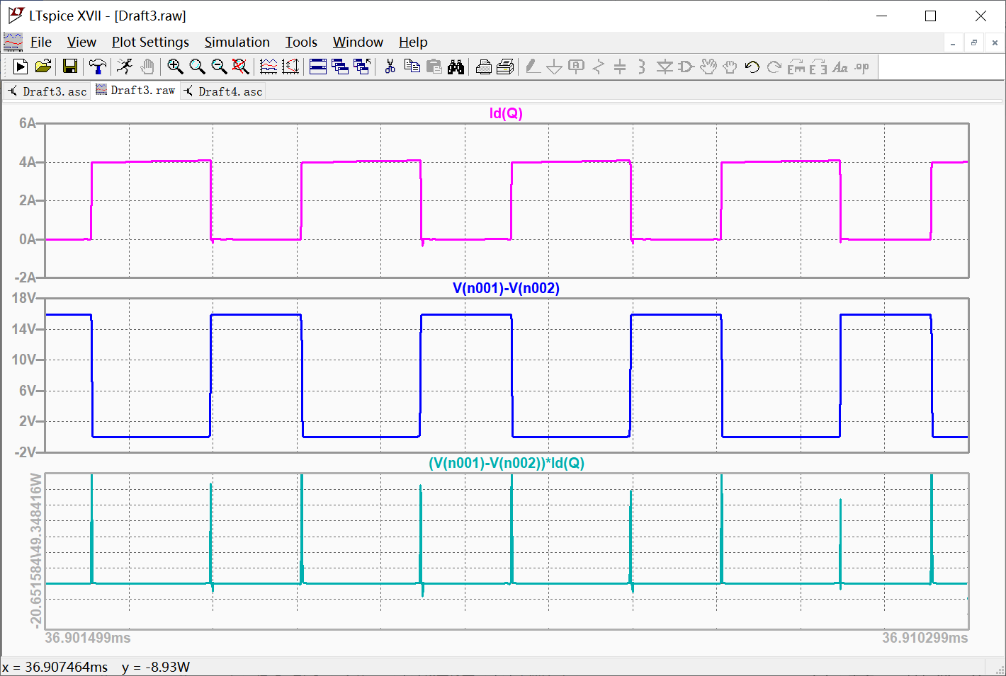

Figure 6: us, is, loss curve p

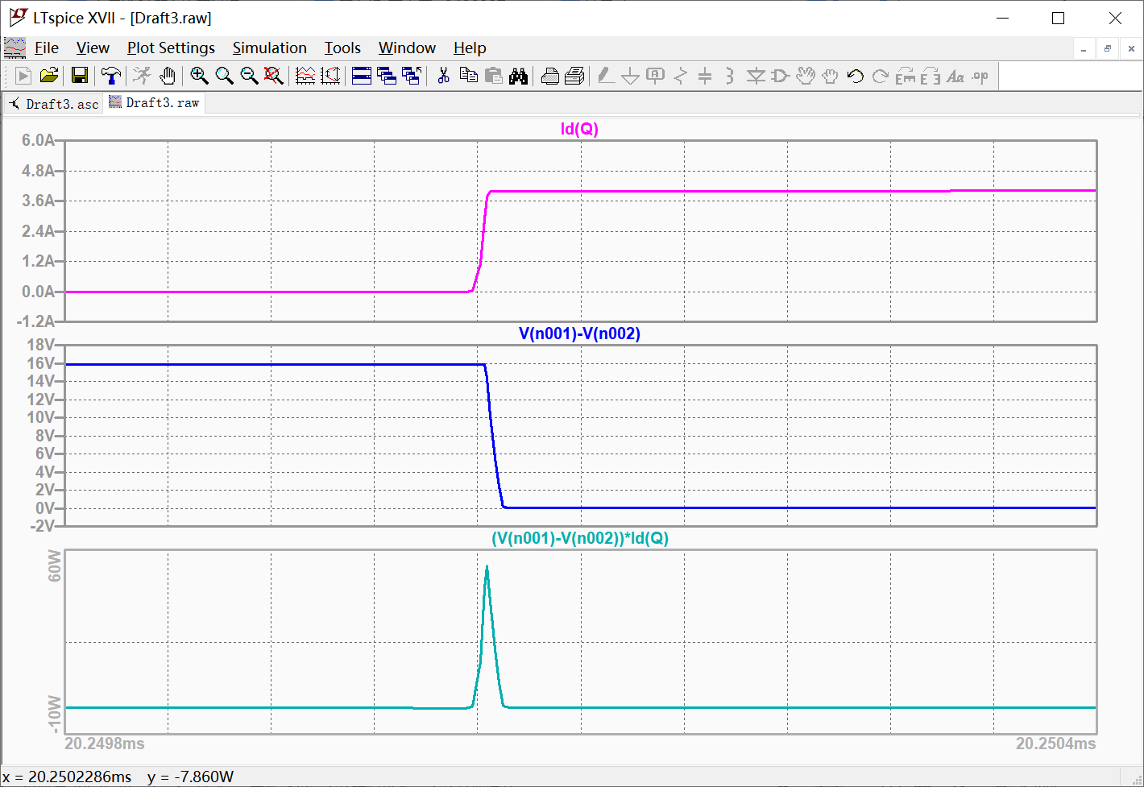

Figure 7: turn-on process

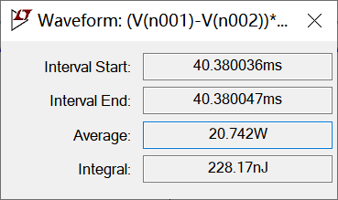

Figure 8: power loss in turn-on process

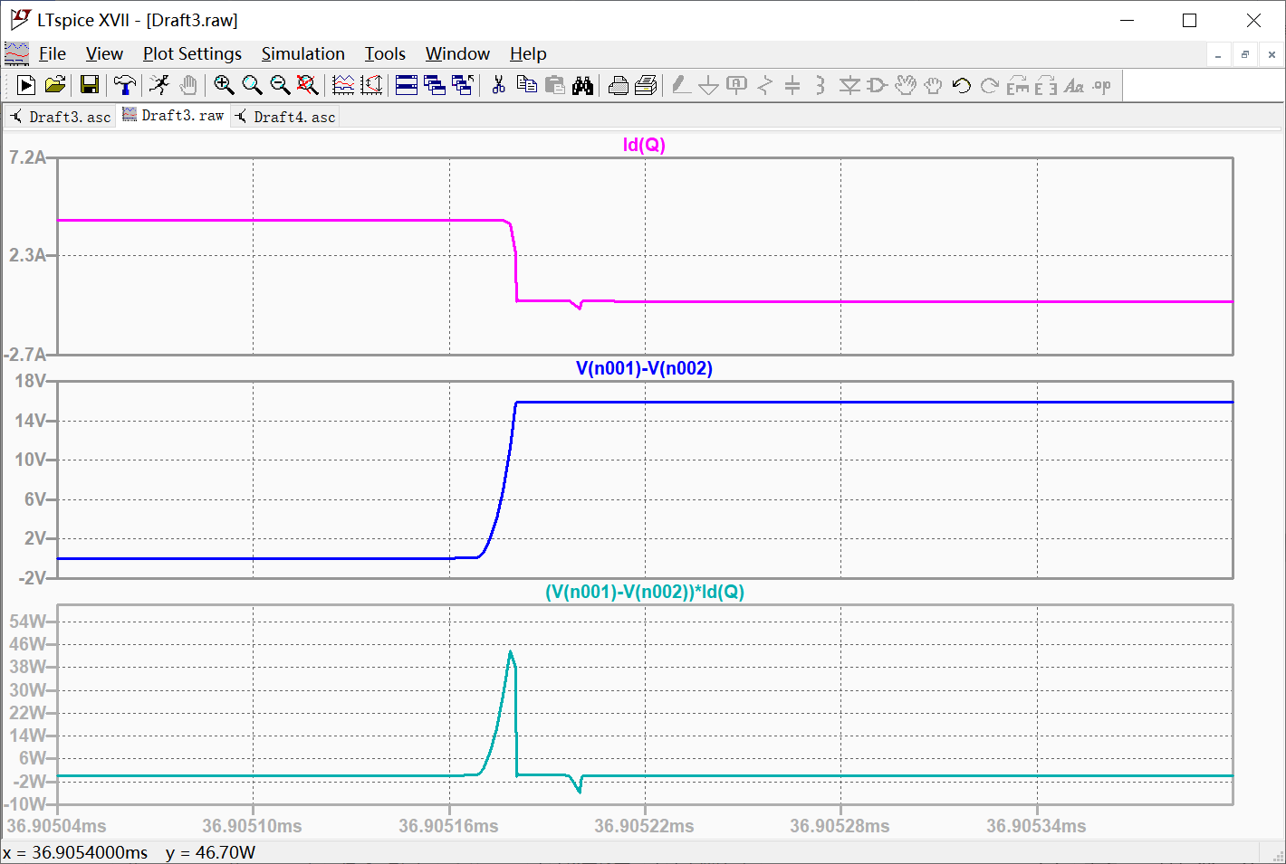

Figure 9: turn-off process

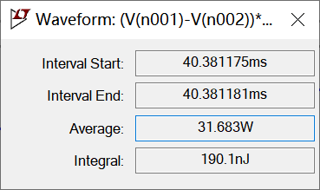

Figure 10: power loss in turn-off process

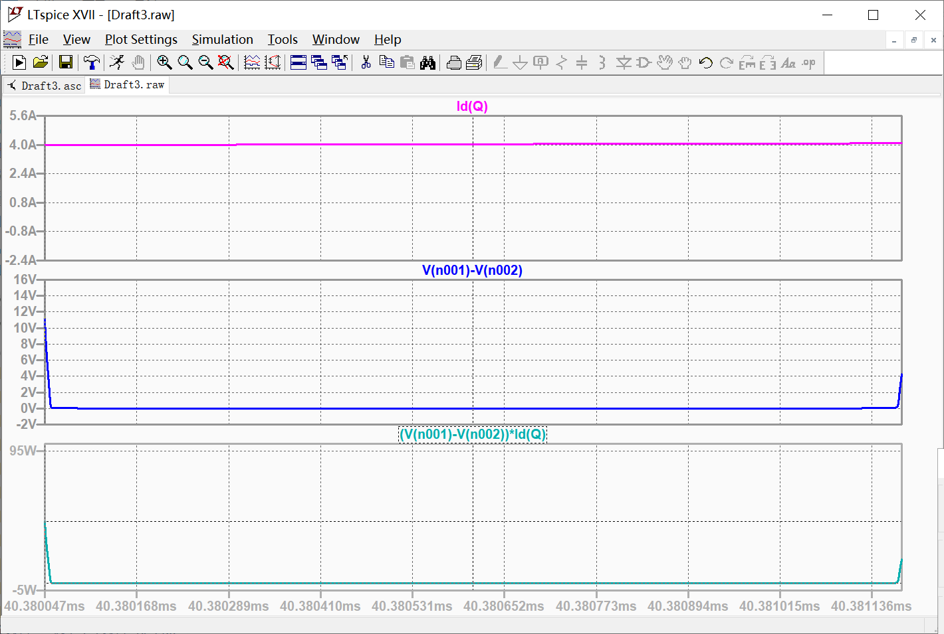Figure 11: on-state

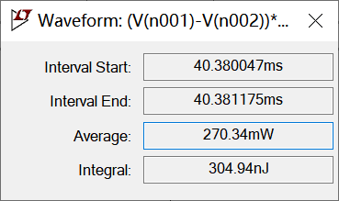

Figure 12: power loss in on-state

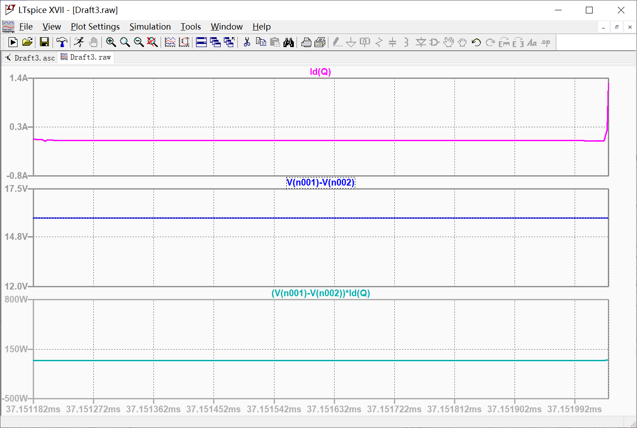

Figure 13: off-state

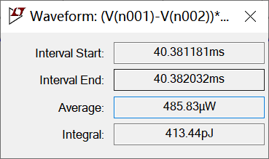

Figure 14: power loss in off-state

## *3.2 ZVS QRC Buck Converter*

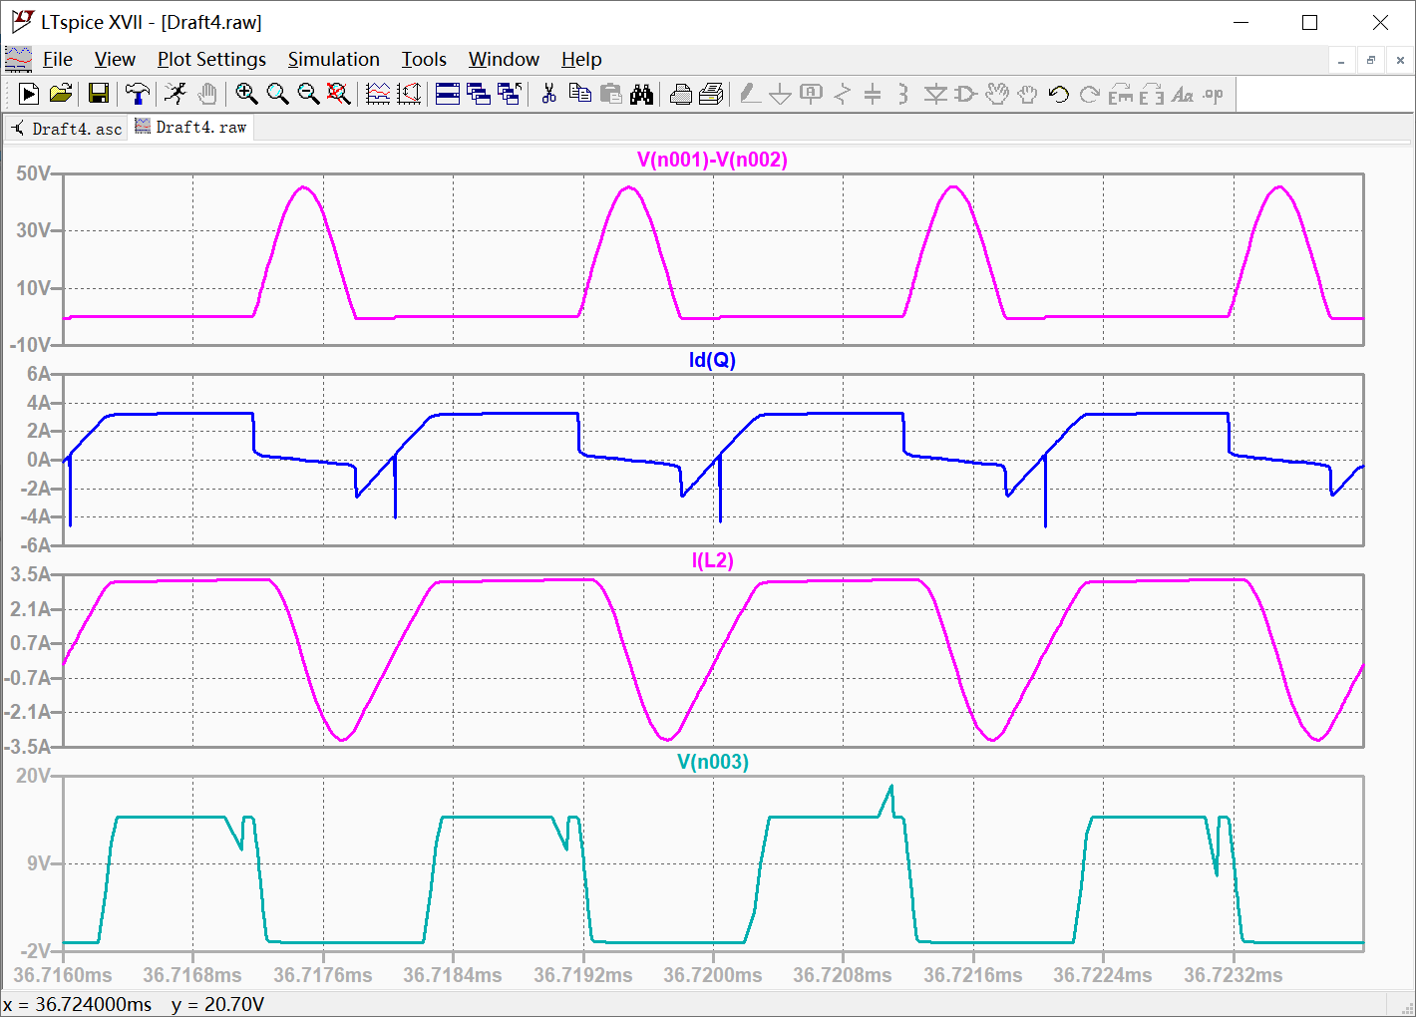

Figure 15: us, is, iL, uVD

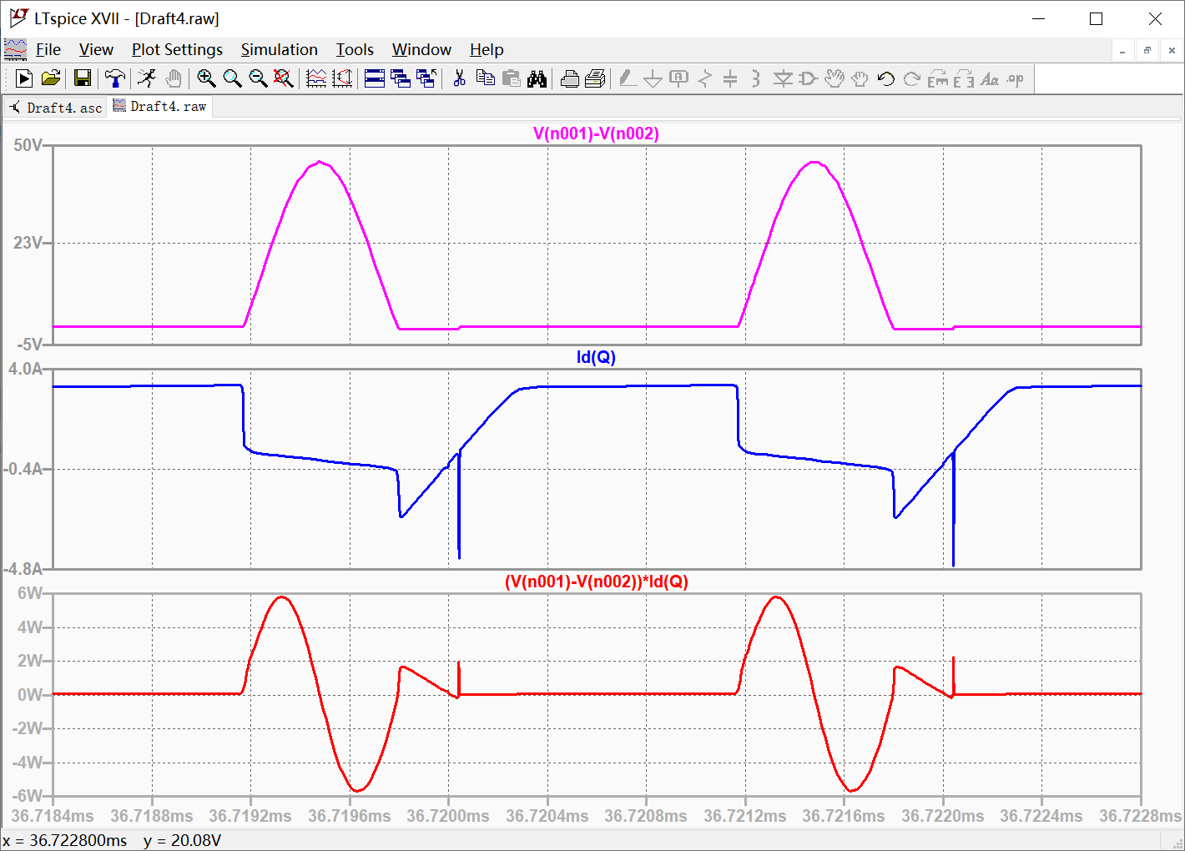

Figure 16: us, is, loss curve p

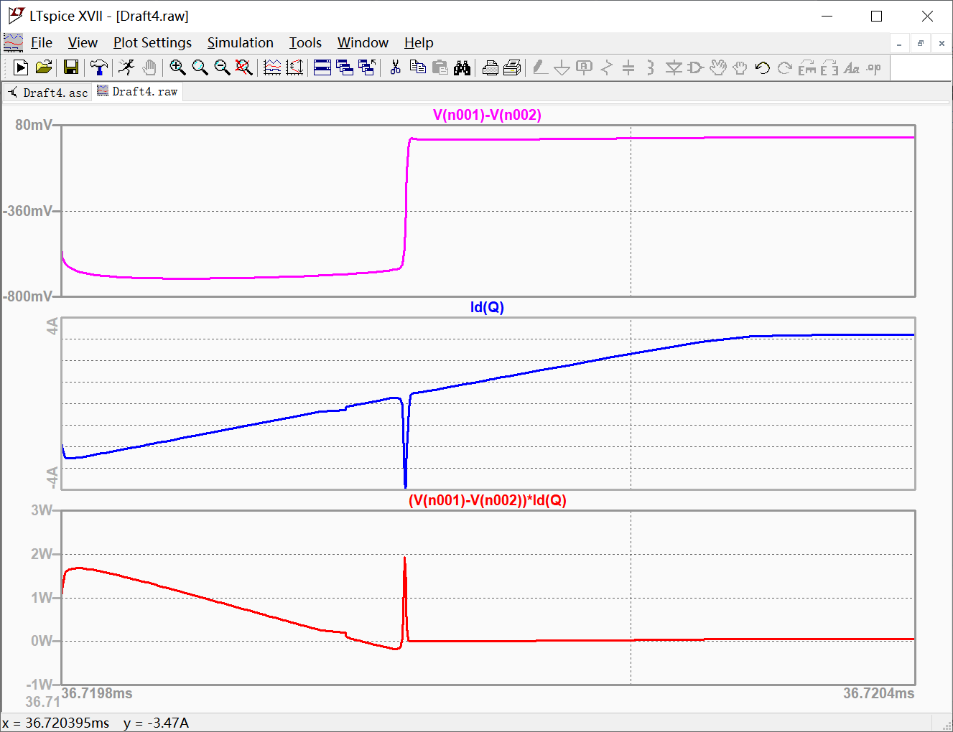

Figure 17: turn-on process

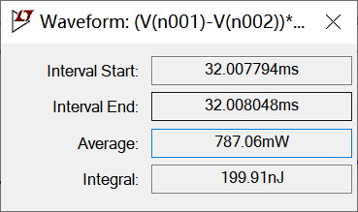

Figure 18: power loss in turn-on process

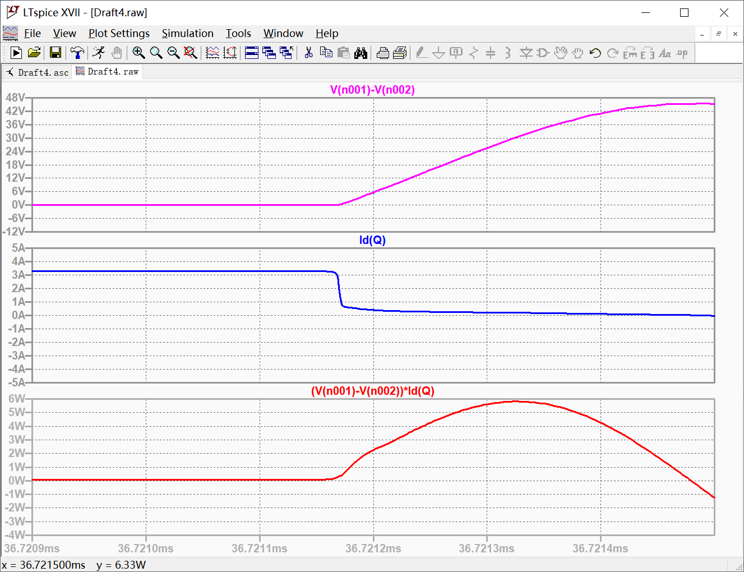

Figure 19: turn-off process

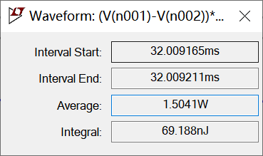

Figure 20: power loss in turn-on process

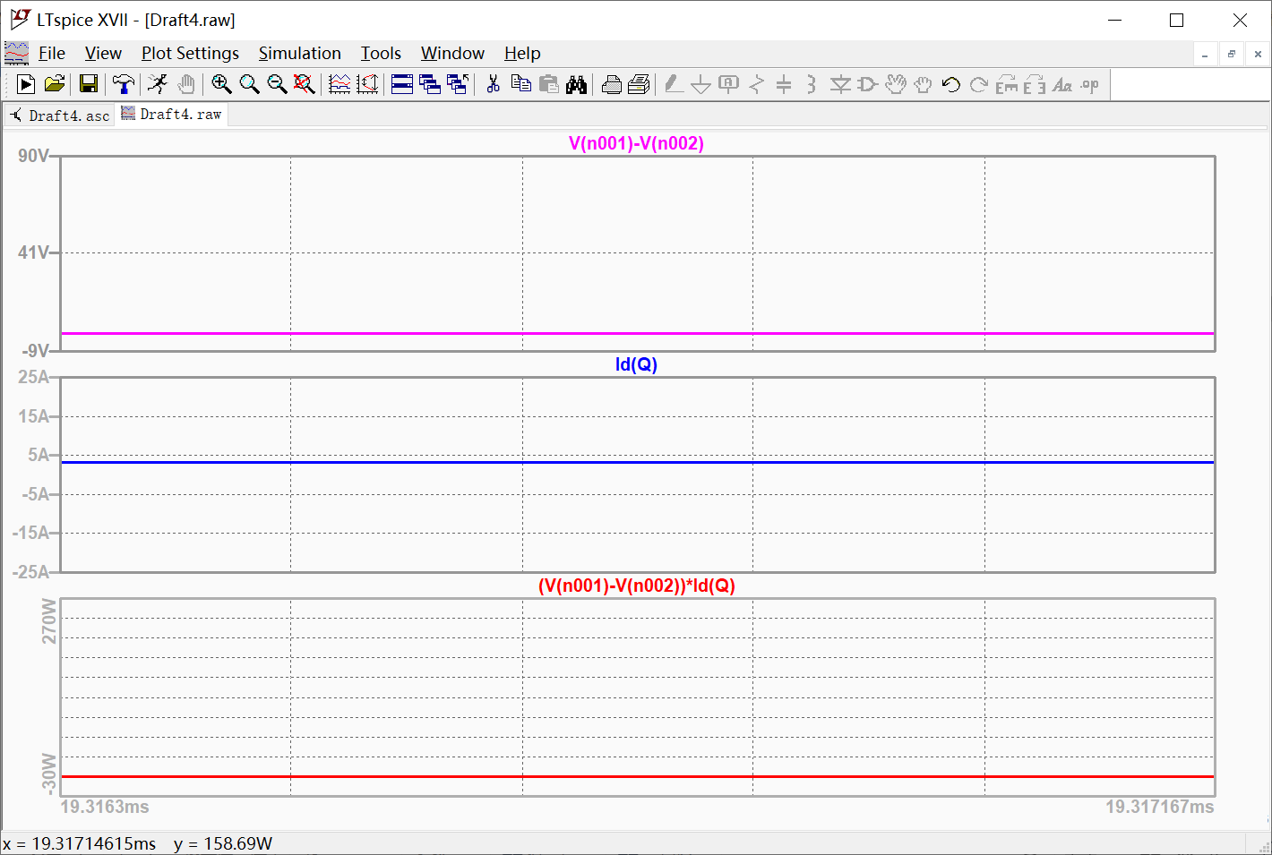

Figure 21: on-state

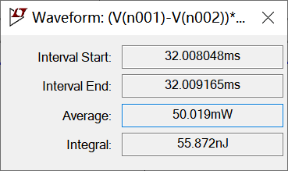

Figure 22: power loss in on-state

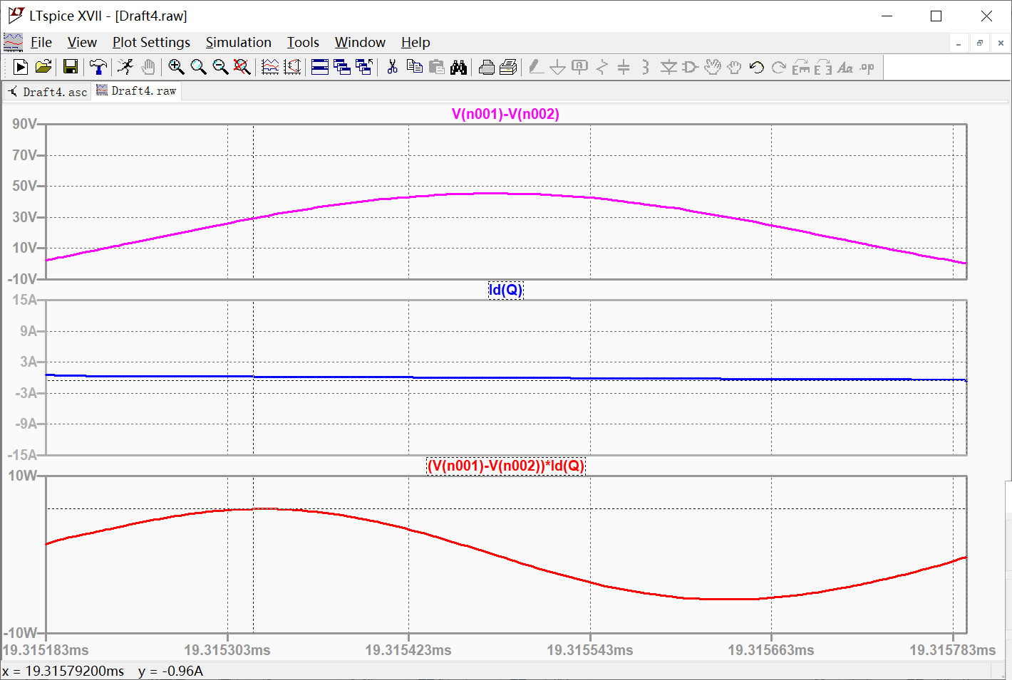

Figure 23: off-state

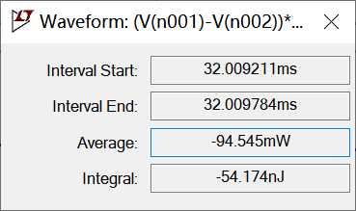

Figure 24: power loss in off-state

# Analysis of the Results

*4.1 Hard-switching Buck Converter*

For the hard switching buck circuit, the voltage and current are not zero during the turn-off process and turn-on process, so there is a certain switching loss, and the voltage and current change very fast, the waveform appears obvious overshoot, resulting in switching noise.

The switch voltage is approximately a symmetrical square wave signal. Due to the conduction voltage drop of diodes and switches, there is a small error between the high and low voltage values and the ideal values.

The waveform of the switch current is a symmetrical square wave signal, but there is a certain reverse current in the turn off process, that is, the reverse recovery current of the body diode of the switch. This current is related to the parasitic inductance of the circuit, the switching speed of MOSFET and the forward current if of the body diode.

The waveform of terminal voltage is also similar to symmetrical square wave signal. The high-level voltage is input voltage minus the on-off voltage drop of switch tube, and the low-level voltage is the on-off voltage drop of diode with negative value, which has a small error with the ideal value.

## *4.2 ZVS QRC Buck Converter*

For ZVS QRC buck circuit, resonance occurs between Lr and Cr after S is turned off, and the voltage and current waveforms in the circuit are similar to sine waves. Resonance slows down the change of voltage and current in the process of switching voltage, and makes the voltage at both ends of S drop to zero before it turns on, which greatly reduces the switching loss and switching noise.

The waveforms of switch voltage and resonant inductor current have little error with the theoretical waveforms.

The whole waveform of the switch current is the same as the theoretical waveform, but there are two big differences: one is that the horizontal zero level part of the ideal waveform is a slowly decreasing curve in the simulation waveform. Through waveform analysis, it can be seen that the drain current id is the superposition of the gate current ig and the source current is. At this time, there is a reverse recovery current in is, and ig is due to the large du/dt in the turn-off process, However, due to the parasitic capacitance of the switch, ig can not change suddenly, but can only change slowly. The superposition effect of the two leads to the slow decline of id in this period. Secondly, there is a big peak in the process of turning on. By analyzing the voltage waveform of the switch, it is found that there is a voltage change of about 0.7V at the corresponding time. It is inferred that this is the conduction voltage drop of the body diode, resulting in du/dt is very large, which leads to current spike.

The error between the end voltage waveform and the theoretical waveform is also very small. The high-level voltage is the input voltage minus the on-off voltage of the switch tube and then minus the voltage drop of the resonant inductor, and the low-level voltage is the on-off voltage of the diode with negative value. In the waveform, it is found that there is a small oscillation peak in the high-level, and the size and shape of the peak are consistent with the maximum step size set by simulation.

## *4.3 Comparison*

|  |  |  |  |
| --- | --- | --- | --- |
|  | Measurement period | Average power | Energy loss |
| Turning-on loss | 40.380036-40.380047ms | 20.742W | 228.17nJ |
| On-state loss | 40.380047-40.381175ms | 270.34mW | 304.94nJ |
| Turning-off loss | 40.381175-40.381181ms | 31.683W | 190.1nJ |
| Off-state loss | 40.381181-40.382032ms | 485.83μW | 413.44pJ |
| Total loss | 40.380036-40.382032ms | 362.54mW | 723.64nJ |

Table 1: Average Power and Energy Loss of Hard-Switching Converter in Different Period

|  |  |  |  |
| --- | --- | --- | --- |
|  | Measurement period | Average power | Energy loss |
| Turning-on loss | 32.007794-32.008048ms | 787.06mW | 199.91nJ |
| On-state loss | 32.008048-32.009165ms | 50.019mW | 55.872nJ |
| Turning-off loss | 32.009165-32.009211ms | 1.5041W | 69.188nJ |
| Off-state loss | 32.009211-32.009784ms | -94.545mW | -54.174nJ |
| Total loss | 32.007794-32.009784ms | 136.08mW | 270.8nJ |

Table 2: Average Power and Energy Loss of ZVS QRC in Different Period

|  |  |  |  |  |
| --- | --- | --- | --- | --- |
|  | Hard-switching converter | | Soft-switching converter | |
|  | Average power | Energy loss | Average power | Energy loss |
| Turning-on loss | 20.742W | 228.17nJ | 787.06mW | 199.91nJ |
| On-state loss | 270.34mW | 304.94nJ | 50.019mW | 55.872nJ |
| Turning-off loss | 31.683W | 190.1nJ | 1.5041W | 69.188nJ |
| Off-state loss | 485.83μW | 413.44pJ | -94.545mW | -54.174nJ |
| Total loss | 362.54mW | 723.64nJ | 136.08mW | 270.8nJ |

Table 3: Average Power and Energy Loss of ZVS QRC in Different Period

The di/dt and du/dt of the soft switching circuit are much smaller than those of the hard switching circuit; the peak value of the terminal voltage of the hard switching circuit is the input power supply voltage minus the switch on voltage, but the terminal voltage of the soft switching circuit is the input power supply voltage minus the switch voltage and the resonant inductance voltage, so its peak value is slightly less than the power supply voltage; but the loss of the soft switching circuit is less than that of the hard switching circuit.