**Seminar Report**

Zhu Jiayi 2186123528

# Topic 1

For hard-switching Buck converter:

* Observe the switching waveform of power switch Q
* Plot loss curve



Figure Hard-Switching Buck Converter

# Simulation Model

There are several characteristics of hard-switching buck converter to be specified and one model is established correspondingly.

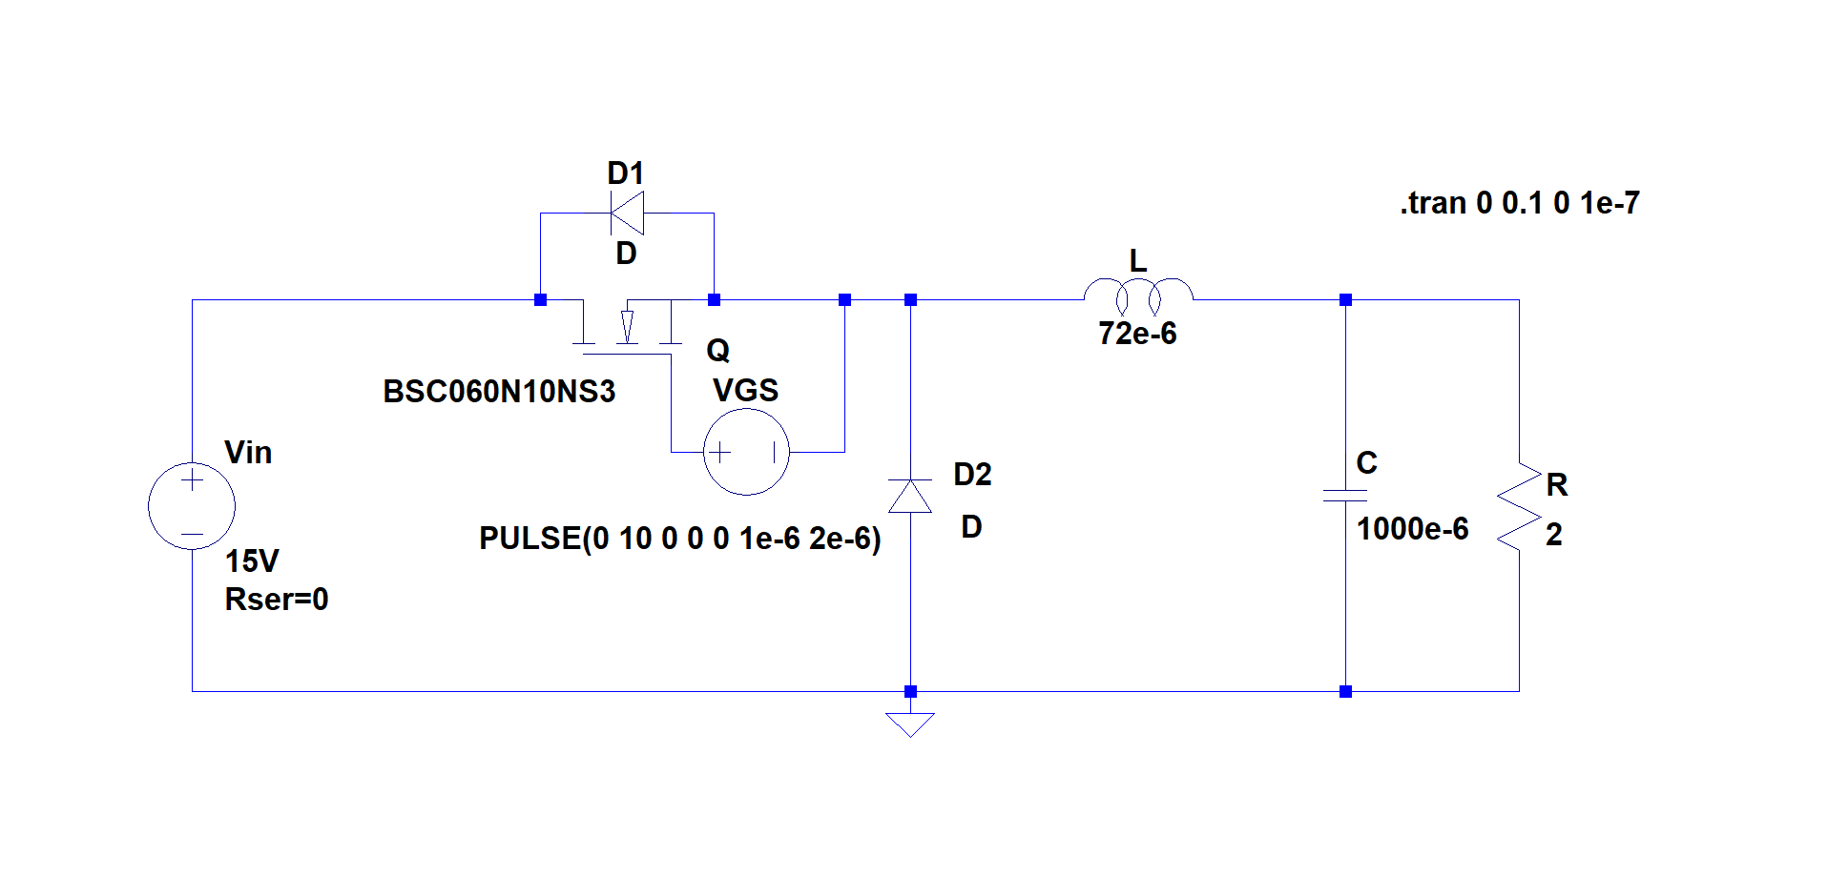

Figure Simulation Model for Topic1

This model is established to observe the changing of current and voltage of the switch during turning-on and turning-off process. Also, we can study the power loss during turning-on and turning-off process.

It includes a DC voltage source, a power MOSFET, a pulse generator, two diodes, an inductor, a large capacitor, and a resistor.

When we set DC voltage source at a given value, and give a pulse signal to MOSFET’s gate to turn on and turn off it, we can observe the current and voltage waveforms in the plot plane, and we can plot the power loss of MOSFET in it.

# Parameter Setup

In our model, we set the value of input DC voltage source at , the frequency of the pulse signal at , the duty cycle of the pulse signal at 0.5. Besides, we set the inductance at , the capacitance at , the resistance at . And our MOSFET is BSC060N10NS3.

 

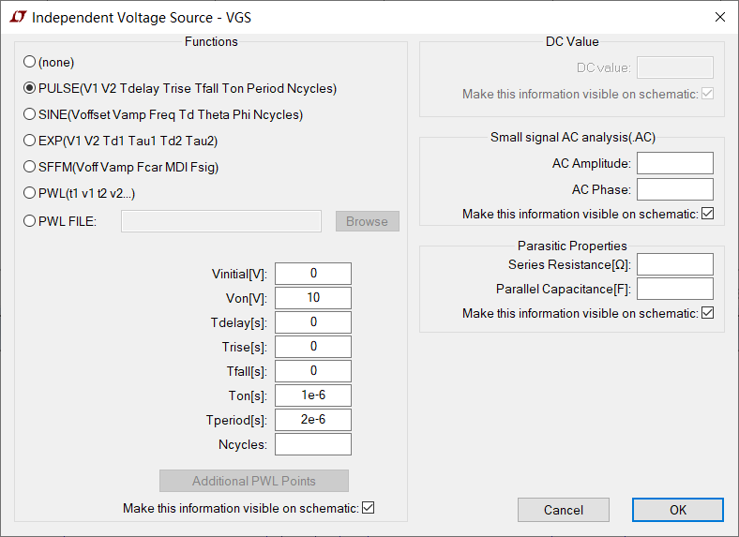

Figure 3 Parameter Setup

# Simulation Results

## *4.1 Switching Waveform of Power Switch and Power Loss Curve*

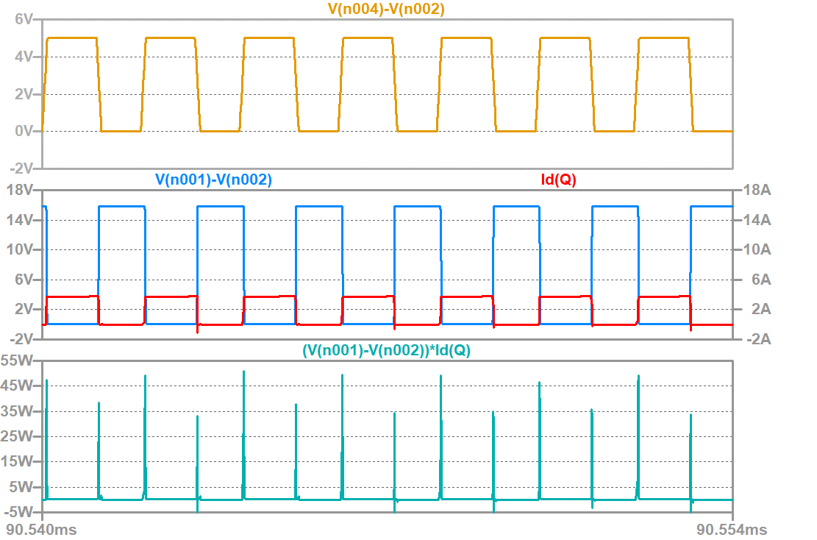

Figure Gate Signal, VDS, Id Waveform, and Power Loss of the MOSFET

Figure 4 shows the gate signals, VDS waveform and Id waveform (the current flowing into the drain terminal), as well as the power loss of the MOSFET. We can obviously find that there are many large spikes in the power loss waveform at the instants when the switch is turned on and turned off, which means it has a large turning-on and turning-off power loss.

## *4.2 Power Loss Curve of the MOSFET During Turning-off Process*

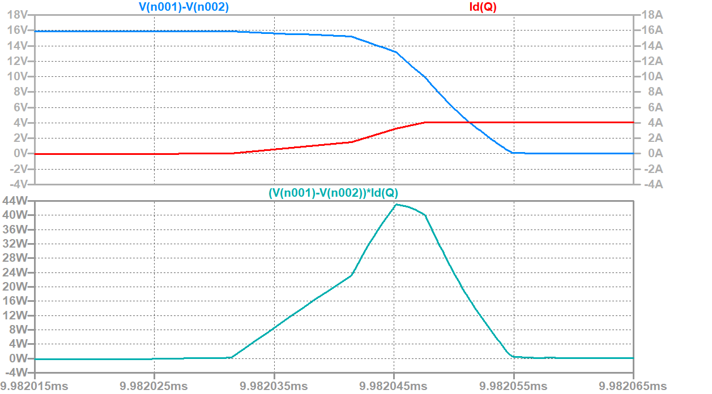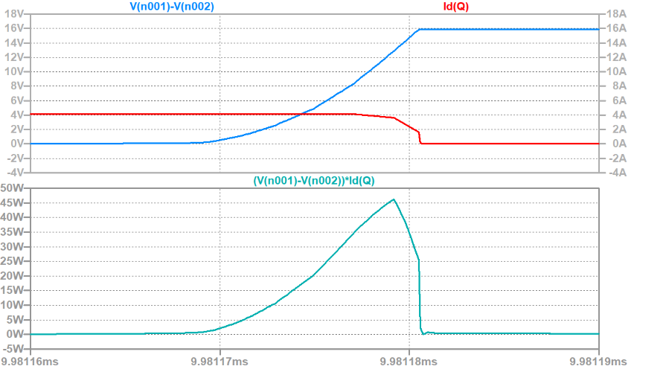

Figure Turning-on and Turning-off Process of Hard Switch

Figure 5 shows the power loss curve of the MOSFET during the turning-on and turning-off process. We find that during the switching process, both the voltage and current of the switch is not zero, leading to switching loss.

## *4.3 Power Loss During Different Process*

To better study MOSFET’s power loss during different process, we use LTspice to calculate MOSFET’s average power and energy loss during the following four processes:

1. When MOSFET is in turning-off process

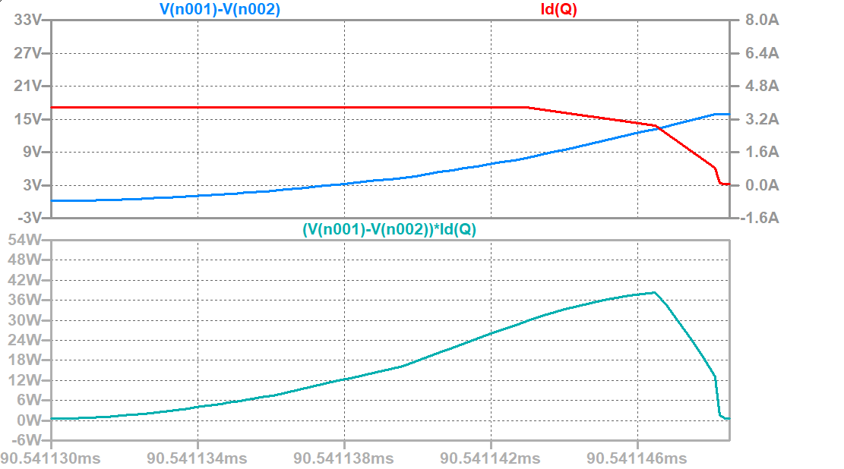

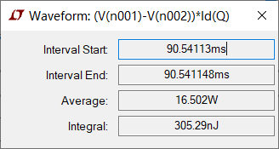

Figure Voltage, Current, Power Waveform and Statistics of the Power Loss (when MOSFET is in turning-off process)

1. When MOSFET is in off process

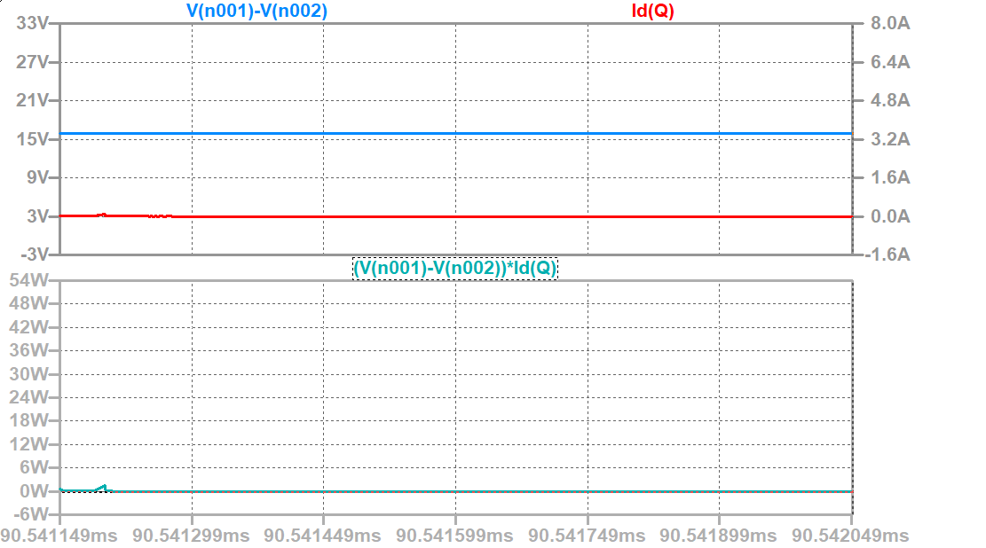

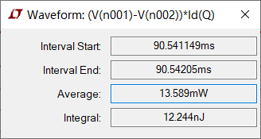

Figure Voltage, Current, Power Waveform and Statistics of the Power Loss (when MOSFET is off)

1. When MOSFET is in turning-on process

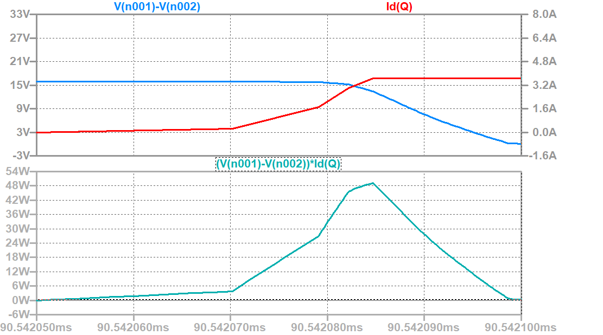

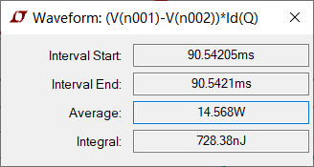

Figure Voltage, Current, Power Waveform and Statistics of the Power Loss (when MOSFET is in turning-on process)

1. When MOSFET is in on process

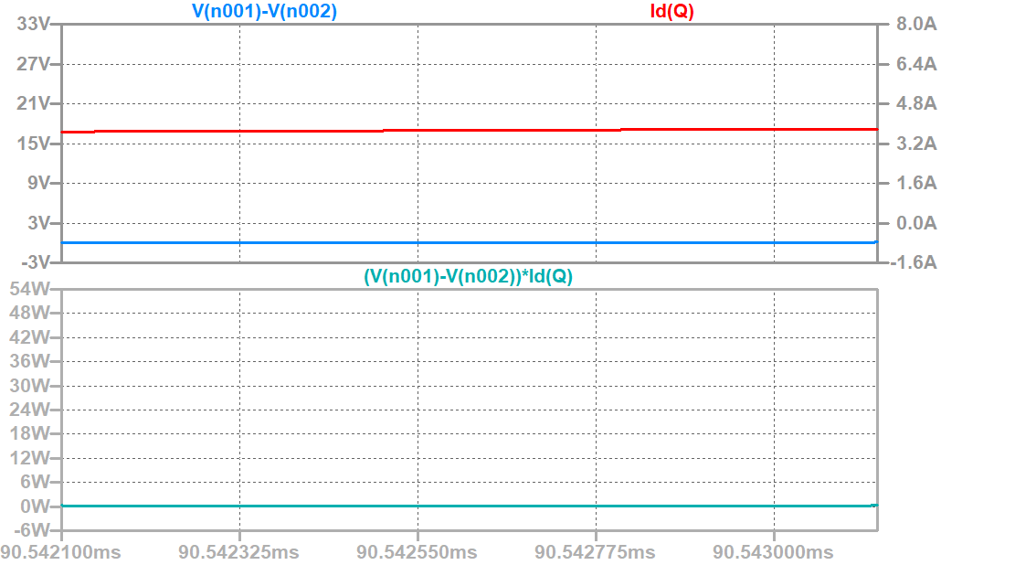

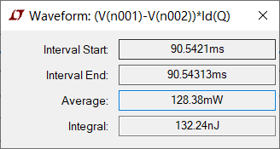

Figure Voltage, Current, Power Waveform and Statistics of the Power Loss (when MOSFET is on)

# Analysis of the Results

## *5.1 Switching Waveform of Power Switch*

From Figure 4 we can find the following phenomenon:

Firstly, although we have set the duty cycle of the drive signal to be 0.5, the turn on time of the MOSFET is not half of a cycle. In fact, the turning-on time is larger than half of a cycle. This is because our MOSFET has a gate capacitor, the gate capacitor needs time to be charging and discharging. And the turning-on time of the MOSFET will be affected.

Secondly, when MOSFET conducts current, the voltage of it will be nearly zero, and when MOSFET is off, the current flowing through it will be nearly zero. So when MOSFET is on or off, the power loss of it will be very small. But every time when the MOSFET is turned on or turned off, we can see a large spike in the power loss waveform.

## *5.2 Power Loss Curve of the MOSFET during Turning-on and Turning-off Process*

From Figure 5 we can find that when the MOSFET is turning on, the current will increase and the voltage will decrease, and the current will achieve a steady state firstly. During the whole process, both voltage and current are not zero. Therefore, the switch will have a relatively large power loss comparing to when it is on off-state and on-state.

When the MOSFET is turning off, the current will decrease and the voltage will increase, and the current will not change until the voltage increases to a specific value. This is because when the voltage is small, the voltage of the freewheeling diode VD will be a reversed voltage, so VD will not be turned on. And because there is a large inductor to maintain a constant current value, the current flowing through the switch will not change. After VDS reaches to a specific value, VD is turned on. The load current can be flowing through the diode, and the switch current will decrease.

## *5.3 Power Loss of Hard-Switching Buck Converter*

According to Figure 6-9, we summarize the results in the following table.

**Table 1 Average Power and Energy Loss of Hard-Switching Converter in Different Period**

|  |  |  |  |
| --- | --- | --- | --- |
|  | Measurement period | Average power | Energy loss |
| Turning-off loss | 90.54113-90.541148ms | 16.502W | 305.29nJ |
| Off-state loss | 90.541149-90.54205ms | 13.589mW | 12.244nJ |
| Turning-on loss | 90.54205-90.5421ms | 14.568W | 728.38nJ |
| On-state loss | 90.5421-90.54313ms | 128.38mW | 132.24nJ |
| Total loss | 90.54113-90.54313ms | 589.077mW | 1178.154nJ |

We can see that there is a large energy loss during the turning-on and turning-off process, and the average power of the two process is very large. This huge energy loss is not expected, especially when we want to use PWM technique to control our circuit. Because the energy loss in one second will be proportional to the switching frequency.

# Topic 2

For ZVS QRC Buck converter:

* Observe the switching waveform of power switch Q
* Plot loss curve and compare with previous case



Figure ZVS QRC Buck Converter

# Simulation Model

There are several characteristics of ZVS QRC Buck converter to be specified and one model is established correspondingly.

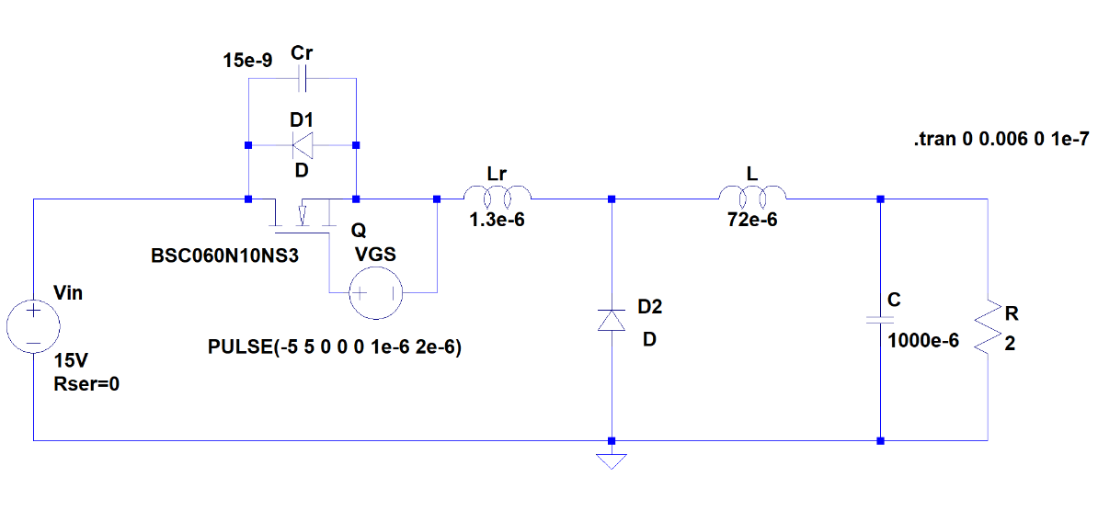

Figure 11 Simulation Model for Topic2

This model is established to observe the changing of current and voltage of the switch during turning-on and turning-off process. Also we can study the operating principle of ZVS QRC converter, and how it can reduce switching power loss.

It includes a DC voltage source, a power MOSFET, a pulse generator, two diodes, an inductor, a large capacitor, and a resistor. Besides, to realize zero-voltage turning-on, it also includes a small inductor and a small capacitor.

When we set DC voltage source at a given value, and give a pulse signal to MOSFET’s gate to turn on and turn off it, we can observe the current and voltage waveforms in the plot plane, and we can plot the power loss of MOSFET in it.

# Parameter Setup

In our model, we set the value of input DC voltage source at , the frequency of the pulse signal at , the duty cycle of the pulse signal at 0.5, the resonance inductance at , the resonance capacitance at . Besides, we set the load side inductance at , the load side capacitance at , the resistance at . And our MOSFET is BSC060N10NS3.

 



Figure Parameter Setup

# Simulation Results

## *4.1 Switching Waveform and Power Loss Curve of Power Switch*

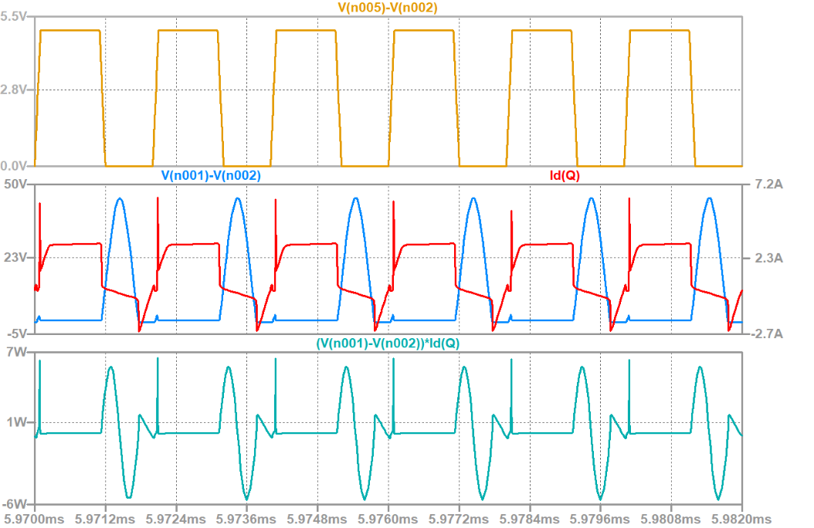

Figure Gate Signal, VDS, Id Waveform, and Power Loss of the MOSFET

Figure 13 shows the gate signals, VDS waveform and Id waveform (the current flowing into the drain terminal), as well as the power loss of the MOSFET. We can find that during turning-off process, there is nearly no power loss, and during turning-on process, the power loss curve has a large spike. And when the MOSFET is off, it will produce some reactive power.

To better study the operating principle of ZVS QRC, we enlarge our curves to see the turning-on and turning-off process and off state of MOSFET. And to better understand the changing of the switch current, we plot the resonance inductor’s current as reference.

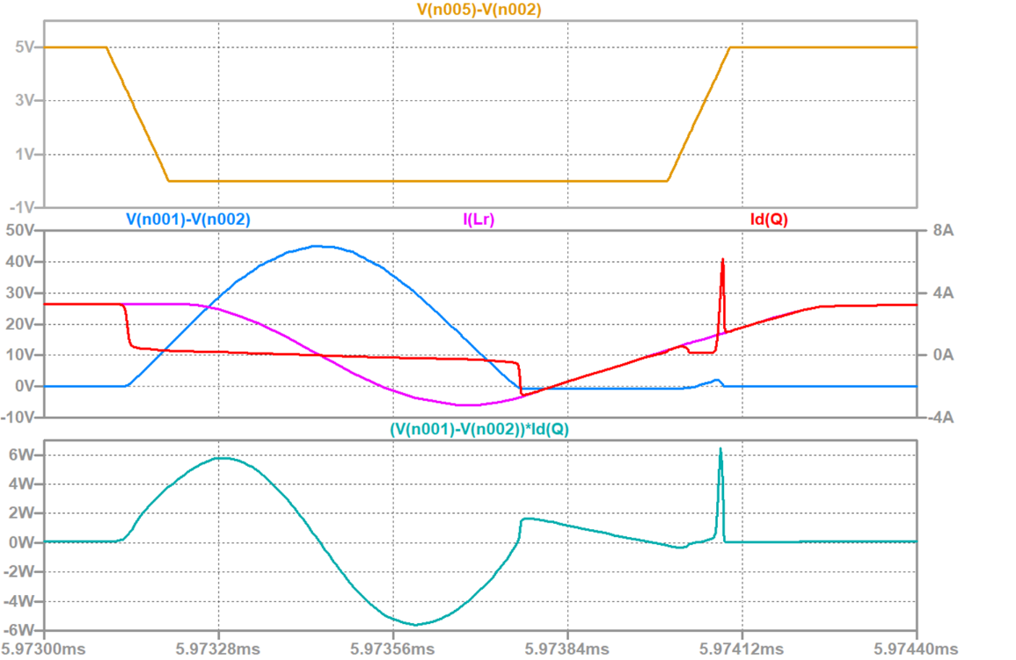

Figure Gate Signal, VDS, Id Waveform, and Power Loss of the MOSFET (enlarged map)

## *4.2 Power Loss During Different Process*

To better study MOSFET’s power loss during different process, we use LTspice to calculate MOSFET’s average power and energy loss during the following four processes:

1. When MOSFET is in turning-off process

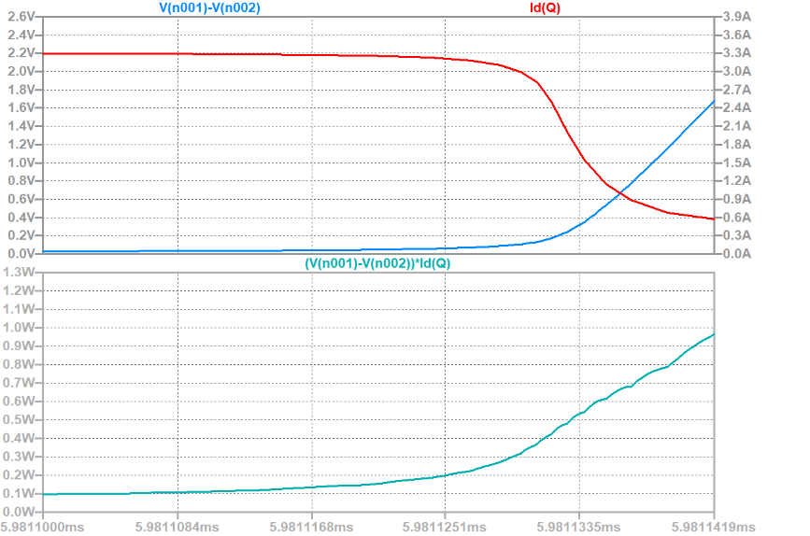

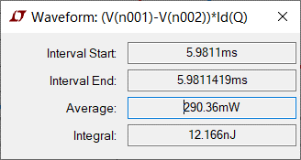

Figure Voltage, Current, Power Waveform and Statistics of the Power Loss (when MOSFET is in turning-off process)

1. When MOSFET is off

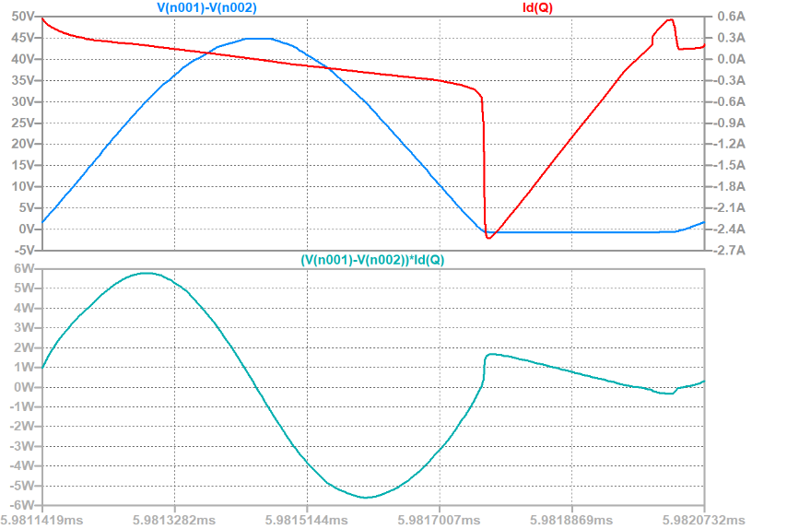

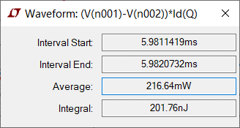

Figure Voltage, Current, Power Waveform and Statistics of the Power Loss (when MOSFET is off)

1. When MOSFET is in turning-on process

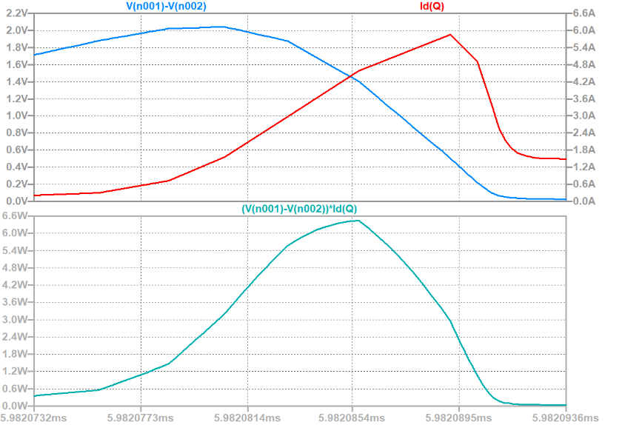

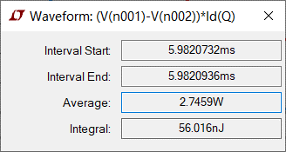

Figure Voltage, Current, Power Waveform and Statistics of the Power Loss (when MOSFET is in turning-on process)

1. When MOSFET is on

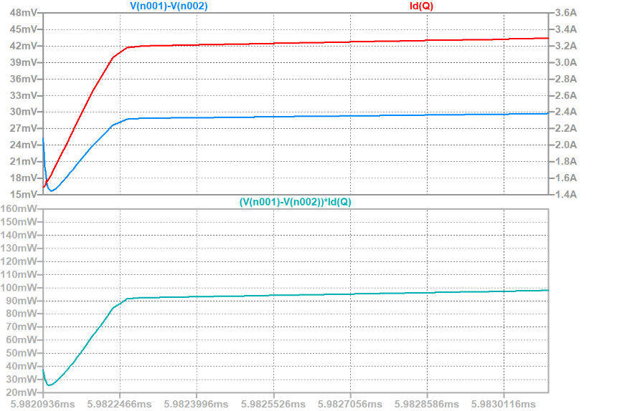

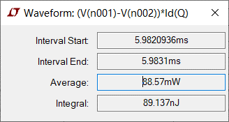

Figure Voltage, Current, Power Waveform and Statistics of the Power Loss (when MOSFET is on)

# Analysis of the Results

*5.1 Switching Waveform and Power Loss Curve of Power Switch*

From Figure 13 and Figure 14 we can see the changing of voltage and current and power loss of the MOSFET. And to better analyze the waveforms we separate the time into several intervals in Figure 19. Then We will analyze the operating principle of those intervals one by one.

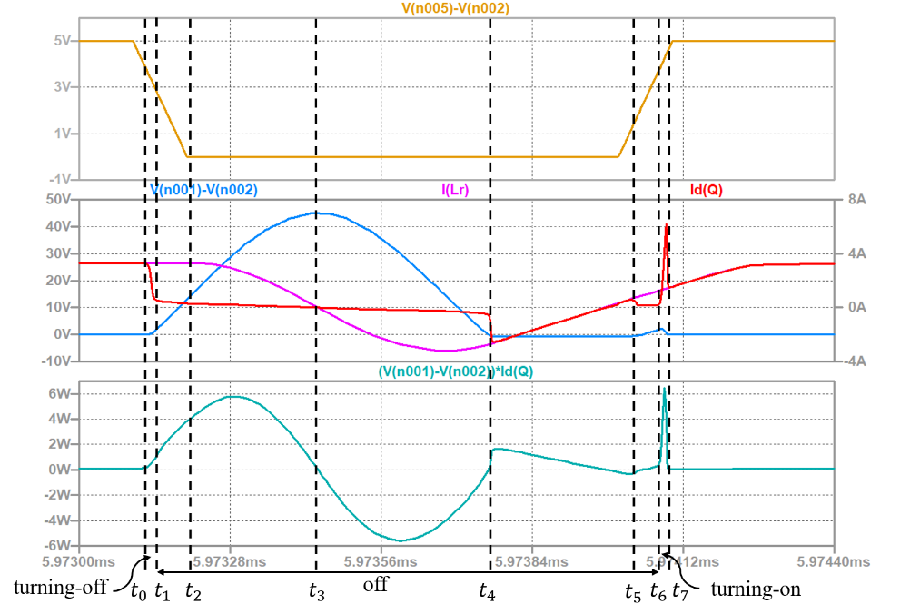

Figure Waveforms of ZVS QRC

When the switch is in turning-off process (), the current flowing through it will fast drop to zero, and the voltage of the switch will change very slowly because of the parallel capacitor. So when the current is changing, the voltage will always be nearly zero. Therefore, the power loss during turning-off process is very small.

When the switch is off (), firstly, during interval, its voltage will increase linearly. This is because current flowing through the resonance inductor is a constant and the resonance capacitor will be charged by the constant value

At instant, the voltage of the switch reaches to , so the freewheeling diode will be turned on. During interval, the capacitor and inductor will be resonant. The switch voltage will be changing as a sine wave, and the current flowing through it will be nearly zero. The switch voltage can be calculated by the following equation:

And we can derive the requirement for the value of resonant inductor and capacitor by equation (2-3). To realize soft switching technique, we expect the voltage of the switch to be zero when it is turned on. So, the minimum value of the switch should be less than zero (if the minimum value is less than zero, it can’t be reached in reality. Because when the voltage drops to zero, it will be clamped at that value)

Equation (2-4) should be the requirement for the choosing of and .

At instant, the switch voltage drops to zero, the current flowing through the switch will have a dramatical increasing (in the reverse direction). This is because the current flowing through the resonance inductor can’t change suddenly. And then, during interval, the switch current will decrease linearly. The switch current can be calculated by the following equation:

At instant, the current decreases to zero, and continues to increase linearly in the positive direction. The voltage of the switch begins to increase, because the parallel capacitor begins to be charged, which means the capacitor and inductor will resonate for the second time. So, the perfect time for the switch to be turned on should be period, when the voltage is zero. But according to our requirement, our switch will be turned on after that perfect period, leading to a larger turning-on power loss.

When the switch is in turning-on process (), the voltage of the switch will drop to zero. And the current flowing though it will have a large spike, because the parallel current will discharge quickly.

After the switch is turned on, the current flowing through it will continue to increase until the value of it equals to the value of the load current. And at that time, the freewheeling diode VD will be turned off. Then the current of the switch will be nearly a constant value for the rest on state.

## *5.2 Power Loss of ZVS QRC*

According to Figure 15-18, we summarize the results in the following table.

**Table 2 Average Power and Energy Loss of ZVS QRC in Different Period**

|  |  |  |  |
| --- | --- | --- | --- |
|  | Measurement period | Average power | Energy loss |
| Turning-off loss | 5.9811-5.9811419ms | 290.36mW | 12.166nJ |
| Off-state loss | 5.9811419-5.9820732ms | 216.64mW | 201.76nJ |
| Turning-on loss | 5.9820732-5.9820936ms | 2.7459W | 56.016nJ |
| On-state loss | 5.9820936-5.9831ms | 88.57mW | 89.137nJ |
| Total loss | 5.9811-5.9831ms | 179.54mW | 359.079nJ |

We can see there is a relatively large energy loss when the switch is on off-state. This is because during that period, the capacitor and inductor will resonate, and the resonance will lead to a large voltage of the switch. The maximum value can be about 45V, which is almost three times of the input DC voltage.

Also, we find that the average power and energy loss of the turning-on process is far larger than the turning-off process. This is because we don’t turn on the switch during the perfect period, which is in Figure 19. And if we want to turn on the switch in that period, we need to change the frequency of the drive signal.

And we can compare the average power and energy loss of hard-switching converter and ZVS QRC in Table 3.

**Table 3 Comparison of Average Power and Energy Loss between Hard-Switching Converter and ZVS QRC**

|  |  |  |  |  |
| --- | --- | --- | --- | --- |
|  | Hard-switching converter | | Soft-switching converter | |
|  | Average power | Energy loss | Average power | Energy loss |
| Turning-off loss | 16.502W | 305.29nJ | 290.36mW | 12.166nJ |
| Off-state loss | 13.589mW | 12.244nJ | 216.64mW | 201.76nJ |
| Turning-on loss | 14.568W | 728.38nJ | 2.7459W | 56.016nJ |
| On-state loss | 128.38mW | 132.24nJ | 88.57mW | 89.137nJ |
| Total loss | 589.077mW | 1178.154nJ | 179.54mW | 359.079nJ |

We can find that the total loss of ZVS QRC is far less than that of the hard-switching converter. And ZVS QRC reduces the energy loss mainly by reducing the energy loss during turning-on and turning-off process.