**Seminar #8 Report**

**Group 8**

EE810 Nie Yongxin 2186113564

This seminar consists of two parts, which are electric motor drive system and AC-DC-AC VFD (Variable Frequency Drive). For the two parts, we carried out simulations with Simulink.

This simulation is concerning VFD (Variable Frequency Drive). Frequency converter is a kind of power control device which uses the on-off function of power semiconductor device Bai to convert the power frequency power supply to another frequency. Variable frequency motor is a kind of motor that runs continuously in the range of 10% ~ 100% rated speed with 100% rated load under standard environmental conditions, and the temperature rise will not exceed the allowable value of the motor.

# Analysis of speed regulation method of asynchronous motor

Because the mechanical characteristic curve of the motor is determined by several electrical parameters of the motor itself, different artificial mechanical characteristics can be obtained by changing these electrical parameters to form a new stable intersection point and realize stable speed regulation. This is the basic principle of introducing frequency converter to drive the motor to realize speed regulation.

There are two ways to realize frequency conversion, namely AC-AC frequency conversion and AC-DC-AC frequency conversion.

The control mode of frequency converter is mainly to control the frequency and voltage parameters by pointer to realize the control of motor flux and torque. At present, the common control methods of general inverter in the market are VF control, vector control and direct torque control.

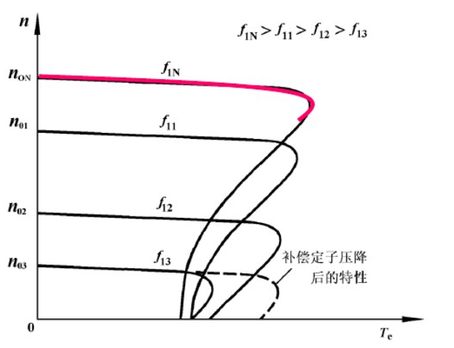

Fig 1.1 Characteristic curve of variable frequency speed regulation for asynchronous motor

With the increase of the load, the slip becomes larger. The actual speed is much smaller than the synchronous speed.

VF control is a kind of simple control, universal, good economy, for speed accuracy requirements are not very strict or load changes small occasions. Therefore, VF control method controls the voltage and frequency of three-phase alternating current. However, there are three elements of alternating current, that is, in addition to the voltage and frequency, there is also phase. VF control does not control the phase of the voltage, which leads to the motor speed will slow down in the process of transient changes, such as sudden load, but the motor power supply frequency, that is, synchronous speed, will remain unchanged. In this way, the asynchronous motor will produce instantaneous out of step, which will cause torque and speed oscillation, and maintain balance under a larger slip after a period of time. There is no phase control in this transient process, so the recovery process is slow, and the motor speed will change with the load, which is the reason why the so-called VF control accuracy is not high and the response is slow.

Next, we will deduce the parameters needed in this simulation

Speed formula of asynchronous motor is



The back EMF formula of three-phase asynchronous motor is



The mechanical characteristic expression of asynchronous motor is



# Double-sided PWM converters (open loop)

## Simulation Model

There are three characteristics to be specified and a model is established correspondingly

### Circuit Diagram

The following diagram is the circuit diagram of the AC-DC-AC VFD.

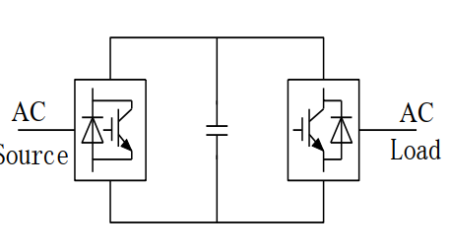

Fig 1.2 theoretical circuit diagram

## Simulink circuit diagram

In Simulink, we use the model as below to carry out simulation.

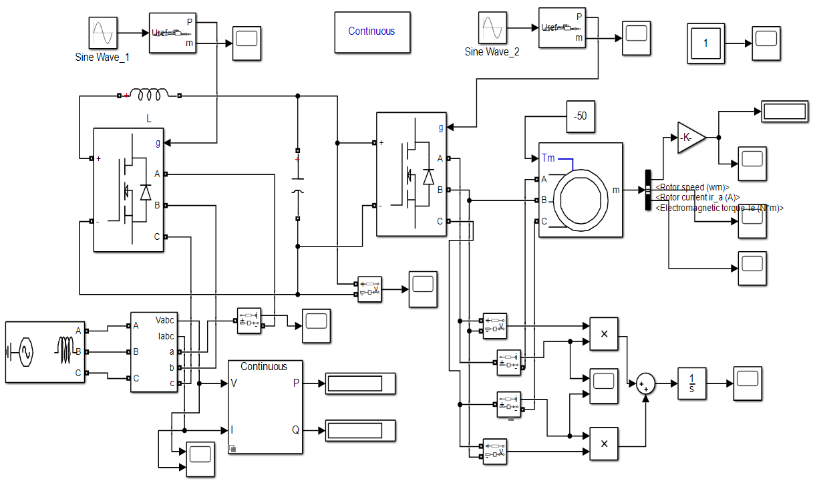

Fig 1.3 Simulation model

The simulation of the rectifier circuit is as follows:

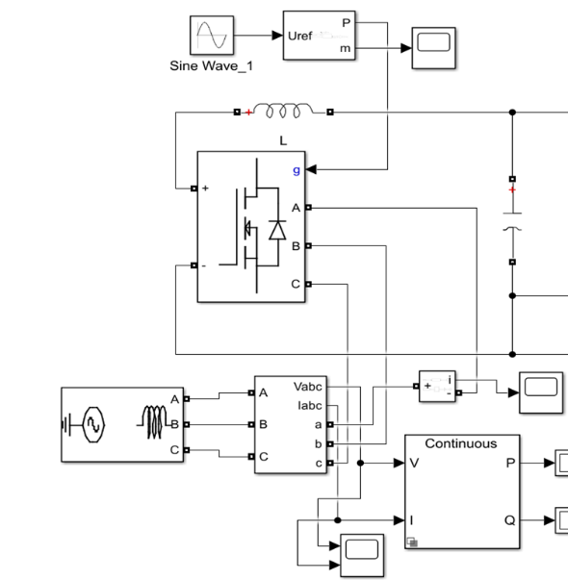

Fig 1.4 Rectification Part of the Circuit

The circuit diagram of rectifier is as follows:

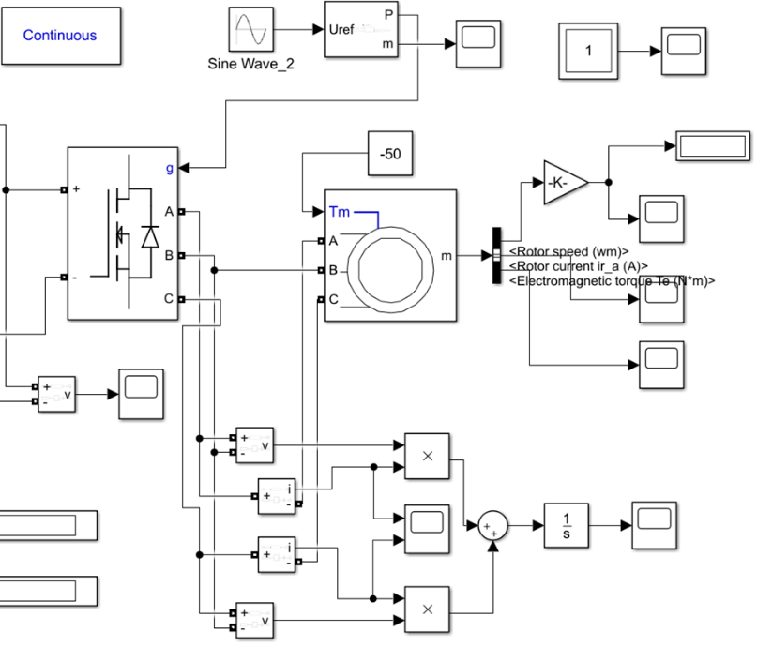

Fig 1.5 Inversion Part of the Circuit

The 50 Hz AC voltage source is transformed into DC through PWM rectifier circuit, and then into AC of specific frequency through PWM inverter circuit, and finally to the motor with external torque.

## Parameter Setup

Tab. 1-1 Parameter setup of our group

|  |  |  |  |  |  |
| --- | --- | --- | --- | --- | --- |
| mode | positive and negative speed | mode | positive and negative speed | Rotor type | Mechanical input |
| motor | 900r/min | generator | 1200r/min | Squirrel-cage | Torque Tm |
| Nominal power  Pn (VA) | Voltage  (line-line)  Vn (Vrms) | Frequency  fn (Hz) | Stator resistance  Rs(ohm) | Stator inductance  Lls(H) | Mutual inductance  Lm (H) |
| 2400 | 110 | 50 | 0.635 | 2.0e-3 | 90.31e-3 |
| Rotor resistance  Rr'(ohm) | Rotor inductance  Llr'(H) | Inertia  J(kg.m^2) | friction factor  F(N.m.s) | Pole pair | phase voltage |
| 0.816 | 1.5e-3 | 0.159 | 0 | 2 | 110V |

Select Torque Tm (default) to specify a torque input, in N.m or in pu, and change labeling of the block input to Tm. The machine speed is determined by the machine Inertia J (or inertia constant H for the pu machine) and by the difference between the applied mechanical torque Tm and the internal electromagnetic torque Te. The sign convention for the mechanical torque is: when the speed is positive, a positive torque signal indicates motor mode and a negative signal indicates generator mode.

## Task 1

### Task requirement

Electric Motor Drive System, AC-DC-AC VFD (Variable Frequency Drive). Three-phase AC voltage source (phase voltage 220V) as input, control Squirrel-Cage Asynchronous Motor rotating speed to realize the operation of in 4 quadrants. Machine operates in motor mode with positive and negative speed (i.e. clockwise and counter-clockwise rotation) of 900r/min). Machine operates in generator mode with positive and negative speed of 1500r/min. By varying the frequency and amplitude three-phase VFD output voltage, adjust the machine rotating speed.

### Simulation Results

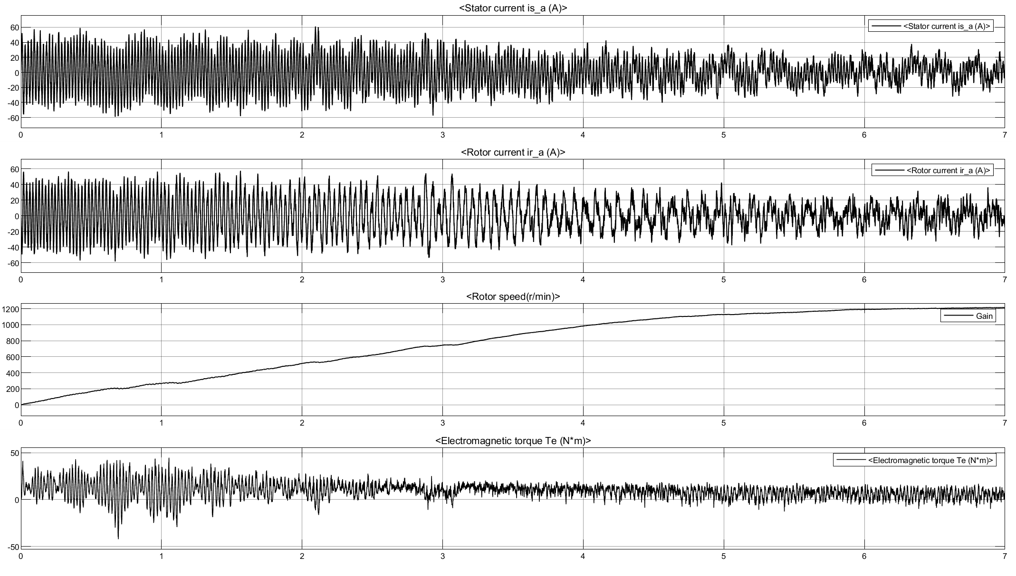

Fig. 1.6 the Stator current, Rotor current, Rotor speed and Electromagnetic torque

## Task 2

### Task requirement

Electric Motor Drive System, AC-DC-AC VFD (Variable Frequency Drive). Three-phase AC voltage source (phase voltage 220V) as input, control Squirrel-Cage Asynchronous Motor rotating speed to realize the operation of in 4 quadrants. Machine operates in motor mode with positive and negative speed (i.e. clockwise and counter-clockwise rotation) of 900r/min). Machine operates in generator mode with positive and negative speed of 1500r/min. By changing the machine load torque Tm, enable the machine to work under motor mode and generator mode.

### Simulation Results

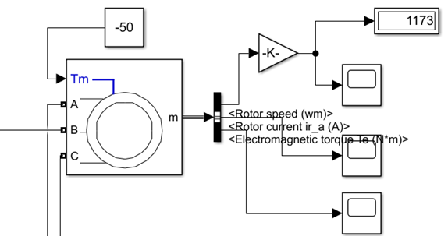

Fig 1.8 Generator Mode (clockwise, The torque is - 50nm and the AC frequency is 35Hz)

The simulation results show that the torque is 1173t / min and the frequency is - 3550 Hz.

Use two meters to measure the power of three-phase power supply. After power integration, the output energy of three-phase power supply to the circuit is obtained, as shown in the figure below:

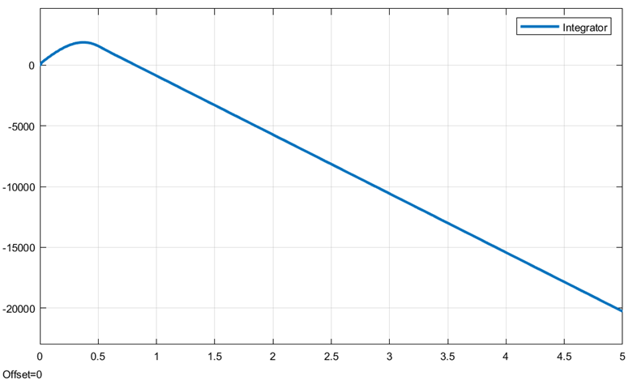

Fig 1.9 Diagram of output energy from three phase power supply to circuit

The torque T is adjusted to 10nm, and the AC frequency is adjusted to 35Hz:

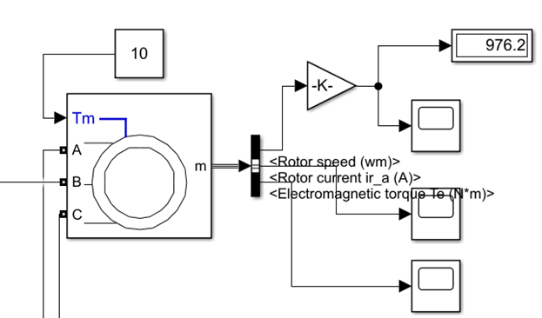

Fig 1.10 Motor Mode (clockwise, The torque is 10nm and the AC frequency is 35Hz)

The simulation results show that the torque T is adjusted to 10nm, the AC frequency is adjusted to 35Hz, and the speed is 976.2r/min.

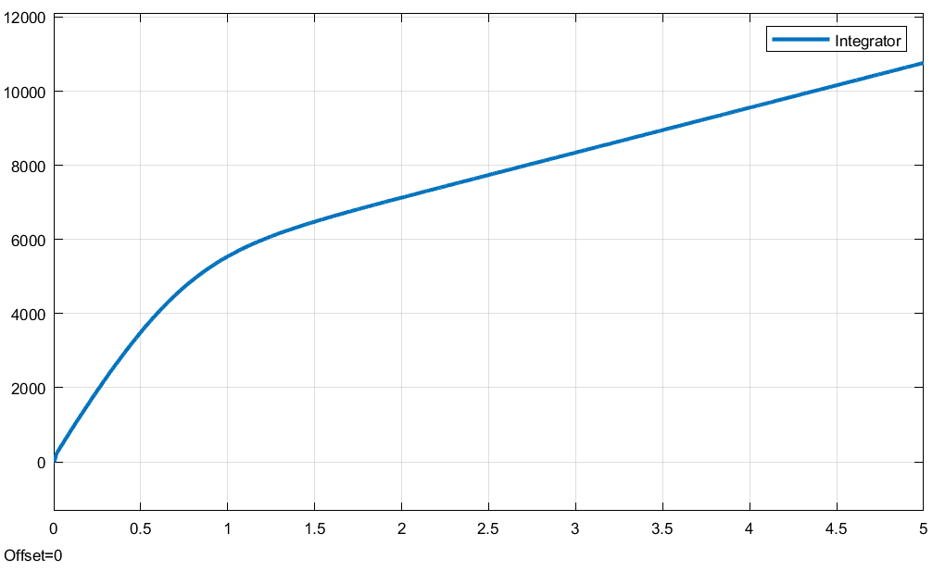

Fig. 1.11 Diagram of output energy from three phase power supply to circuit

It’s shown in Fig that after the motor is stable, the power is transmitted to the motor.

### Working characteristic analysis

By changing the mechanical torque, we get the mechanical characteristics of the asynchronous motor. By changing the mechanical torque, we realize the forward and reverse rotation of the motor.

Tab. 1-2 Working characteristics of asynchronous motor

|  |  |  |  |  |
| --- | --- | --- | --- | --- |
| T/(N·m) | n(r/min) | P(W) | Q(W) | cos*φ* |
| -50 | 1235 | -3483 | -2542 | 0.807752147 |
| -40 | 1234 | -2956 | -1891 | 0.842380068 |
| -30 | 1231 | -2337 | -1396 | 0.8584961 |
| -20 | 1227 | -1677 | -789.3 | 0.904793023 |
| -10 | 1220 | -901.4 | -254.1 | 0.962489008 |
| 10 | 870.5 | 934.4 | 1951 | 0.431949426 |
| 20 | 826.5 | 2156 | 496.2 | 0.974523581 |
| 30 | 753.5 | 3471 | 1266 | 0.939461076 |

The relationship between motor torque T and speed n is as follows:

图表, 折线图

已生成极高可信度的说明

Fig 1.12 Working characteristics of asynchronous motor

## Task 3

### Task requirement

Electric Motor Drive System, AC-DC-AC VFD (Variable Frequency Drive). Three-phase AC voltage source (phase voltage 220V) as input, control Squirrel-Cage Asynchronous Motor rotating speed to realize the operation of in 4 quadrants. Machine operates in motor mode with positive and negative speed (i.e. clockwise and counter-clockwise rotation) of 900r/min). Machine operates in generator mode with positive and negative speed of 1500r/min. By changing the phase sequence of VFD output voltage, enable the machine to rotate with positive and negative speed.

### Simulation Results

The rotor speed is set to the asked value as follow.

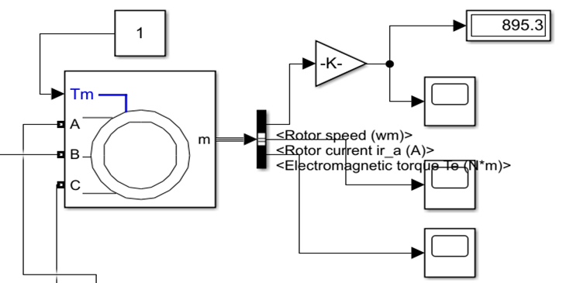

Fig 1.13 Motor Mode (clockwise)

The simulation results show that the motor is in forward direction and the speed is 895.3r/min

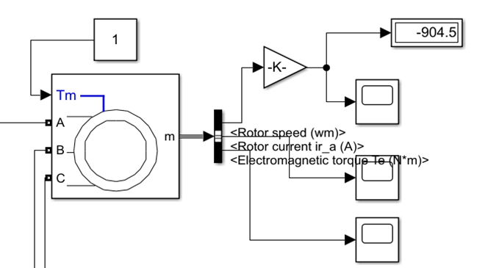

Fig 1.14 Motor Mode (counter-clockwise)

The simulation results show that the motor is in reverse direction, and the speed is 904.5 r/min.

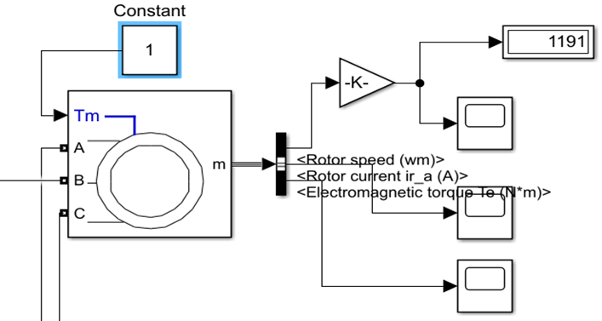

Fig 1.15 Generator Mode (clockwise)

The simulation results show that the generator is in forward direction and the speed is 1191 r/min

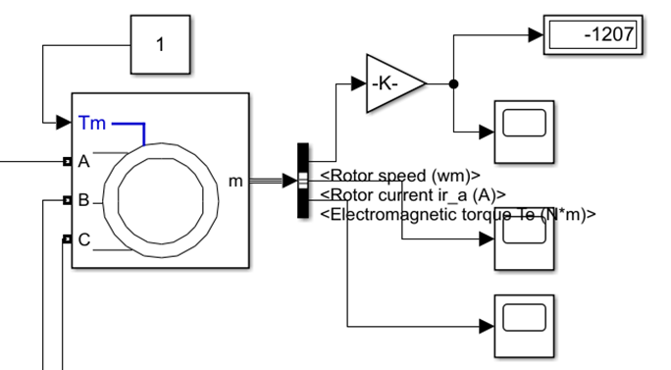

Fig 1.16 Generator Mode (counter-clockwise)

The simulation results show that the generator is in reverse direction and the speed is 1207r / min.

# Inversion-mode thyristor rectifier circuit

## Simulation Model

There are three characteristics to be specified and a model is established correspondingly

### Circuit Diagram

The following diagram is the circuit diagram of the AC-DC-AC VFD.

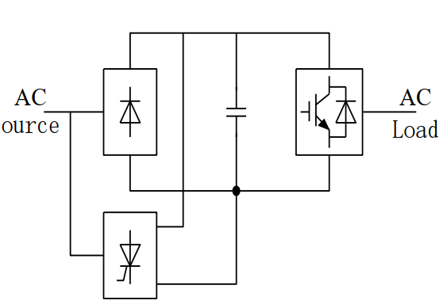

Fig 2.1 theoretical circuit diagram

## Simulink circuit diagram

In Simulink, we use the model as below to carry out simulation.

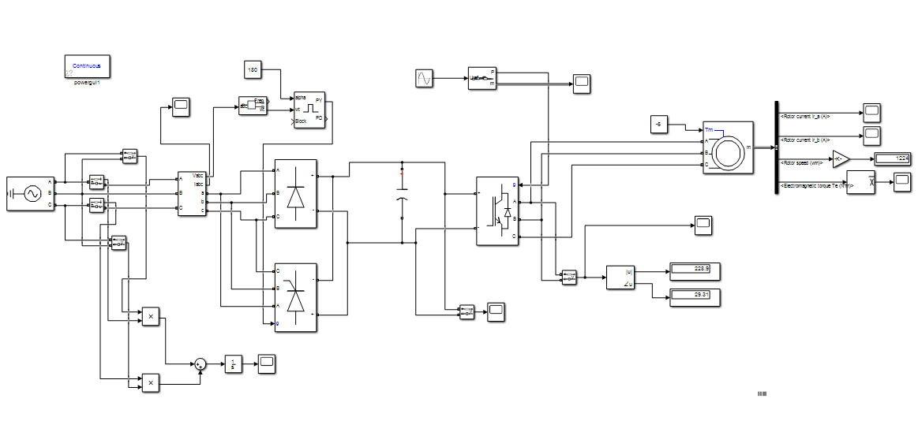

Fig 2.1 Simulation model

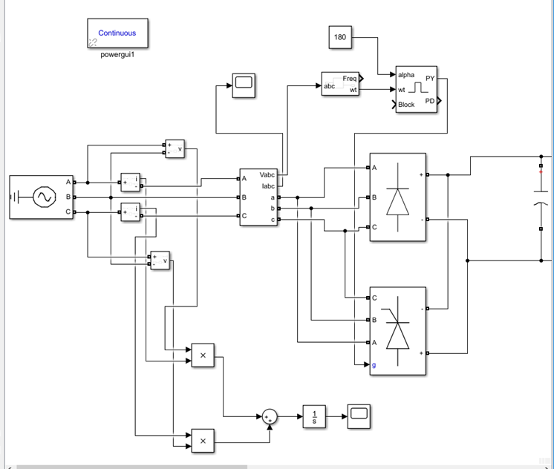

Fig. 2-3 Rectification Part of the Circuit

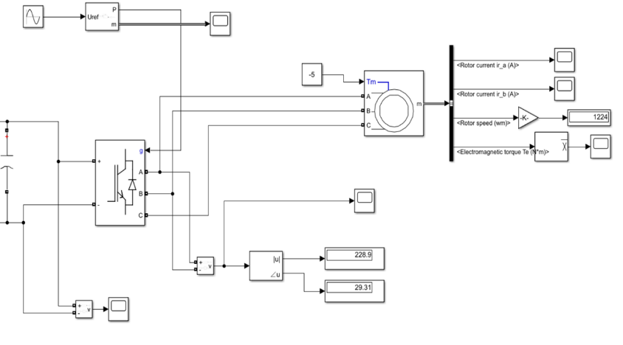

Fig. 2-4 Inversion Part of the Circuit

## Parameter Setup

Tab. 1-1 Parameter setup of our group

|  |  |  |  |  |  |
| --- | --- | --- | --- | --- | --- |
| mode | positive and negative speed | mode | positive and negative speed | Rotor type | Mechanical input |
| motor | 900r/min | generator | 1200r/min | Squirrel-cage | Torque Tm |
| Nominal power  Pn (VA) | Voltage  (line-line)  Vn (Vrms) | Frequency  fn (Hz) | Stator resistance  Rs(ohm) | Stator inductance  Lls(H) | Mutual inductance  Lm (H) |
| 2400 | 110 | 50 | 0.635 | 2.0e-3 | 90.31e-3 |
| Rotor resistance  Rr'(ohm) | Rotor inductance  Llr'(H) | Inertia  J(kg.m^2) | friction factor  F(N.m.s) | Pole pair | phase voltage |
| 0.816 | 1.5e-3 | 0.159 | 0 | 2 | 110V |

## Task 1

### Task requirement

Electric Motor Drive System, AC-DC-AC VFD (Variable Frequency Drive). Three-phase AC voltage source (phase voltage 220V) as input, control Squirrel-Cage Asynchronous Motor rotating speed to realize the operation of in 4 quadrants. Machine operates in motor mode with positive and negative speed (i.e. clockwise and counter-clockwise rotation) of 900r/min). Machine operates in generator mode with positive and negative speed of 1500r/min. By varying the frequency and amplitude three-phase VFD output voltage, adjust the machine rotating speed.

### Simulation Results

As shown in Figure 1, it is necessary to add a set of converter circuit to make it work in the active inverter state to realize the regenerative braking of the motor. When the load feeds back energy, the intermediate DC voltage rises, which makes the uncontrollable rectifier circuit stop working, and the controllable converter works in the active inverter state. The polarity of the intermediate DC voltage remains unchanged, while the current reverses, and the electric energy is fed back to the grid through the controllable converter.

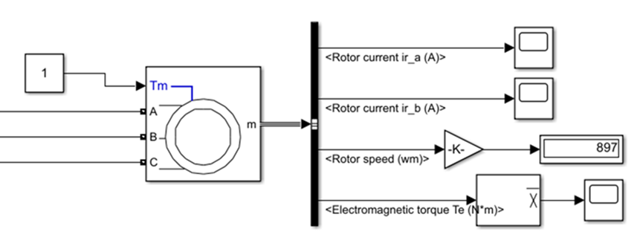

Fig 2.5 Motor Mode (clockwise)

The simulation results show that the motor is in forward direction and the speed is 897 r/min.

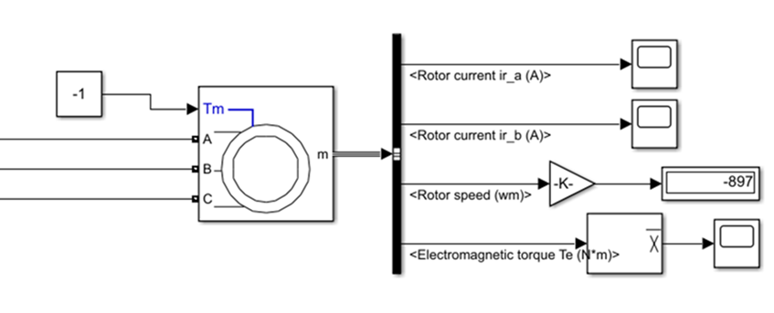

Fig 2.6 Motor Mode (counter-clockwise)

The simulation results show that the motor is in reverse direction, and the speed is 897 r/min.

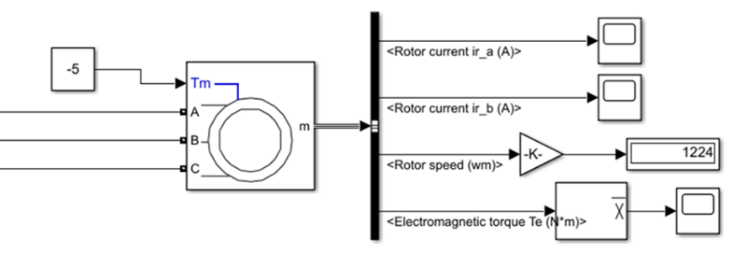

Fig 2.7 Generator Mode (clockwise)

The simulation results show that the generator is in forward direction and the speed is 1224 r/min.

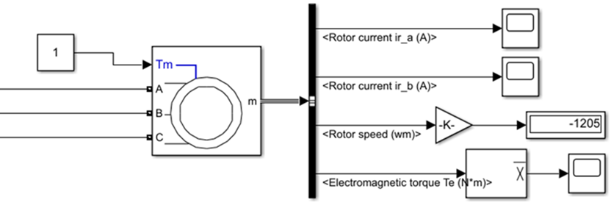

Fig 2.8 Generator Mode (counter-clockwise)

The simulation results show that the generator is in reverse direction and the speed is 1205 r/min.

## Task 2

### Task requirement

Electric Motor Drive System, AC-DC-AC VFD (Variable Frequency Drive). Three-phase AC voltage source (phase voltage 220V) as input, control Squirrel-Cage Asynchronous Motor rotating speed to realize the operation of in 4 quadrants. Machine operates in motor mode with positive and negative speed (i.e. clockwise and counter-clockwise rotation) of 900r/min). Machine operates in generator mode with positive and negative speed of 1500r/min. By changing the machine load torque Tm, enable the machine to work under motor mode and generator mode.

### Simulation Results

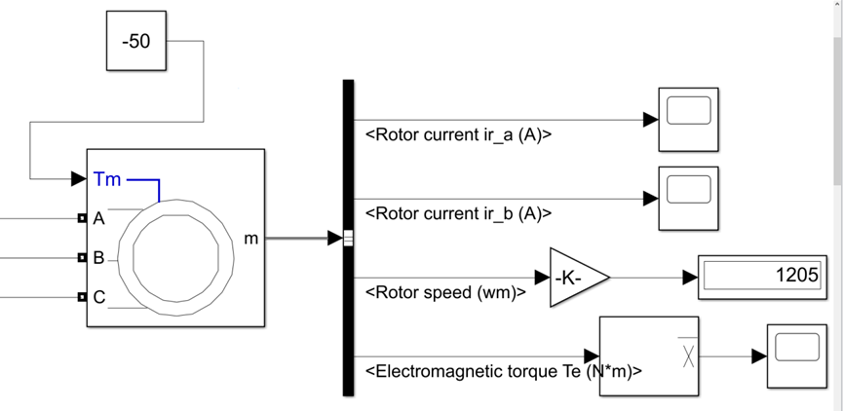

Fig 2.9 The torque T is adjusted to - 50nm, and the AC frequency is adjusted to 35Hz

As shown in Figure 9, the simulation results show that the torque T is adjusted to - 50nm, the AC frequency is adjusted to 35Hz, and the speed is 1205r / min.

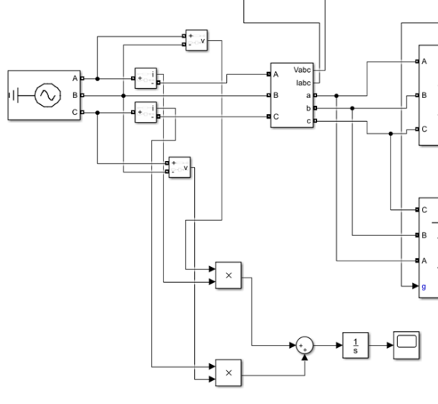

Fig 2.10 Two meter simulation circuit diagram

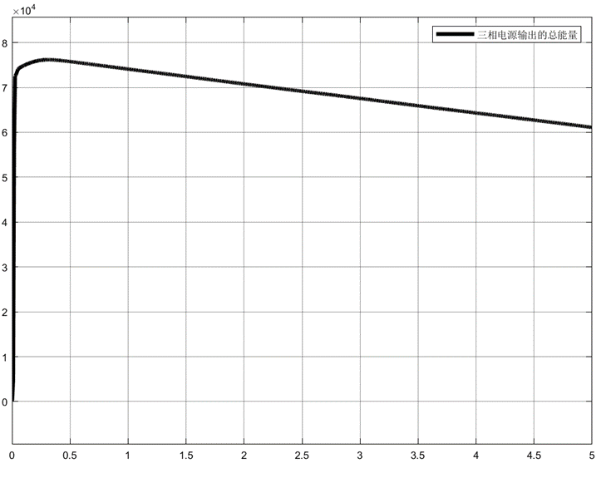

Fig 2.11 Diagram of output energy from three phase power supply to circuit

After the motor is stable, the motor transmits power to the power supply

# Comparison of two methods

For method 1, double-sided PWM converters, the current at three-phase AC power supply is shown in the figure below.

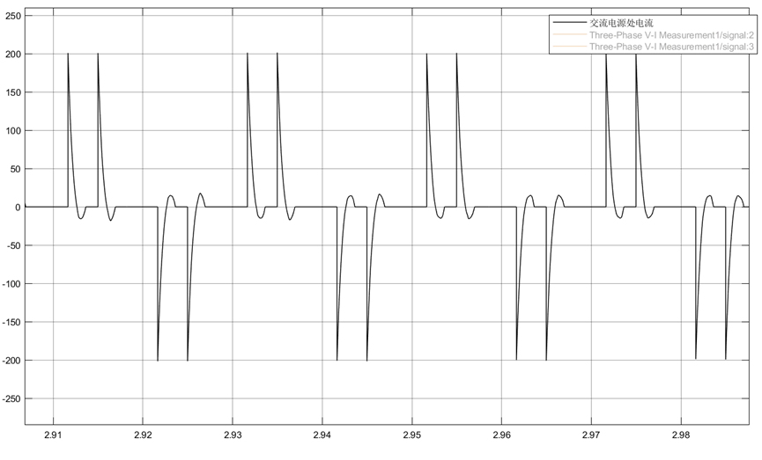

Fig 3.1 the current at three-phase AC power supply (double-sided PWM converters)

For method 2, inversion-mode thyristor rectifier circuit, the current at three-phase AC power supply is shown in the figure below

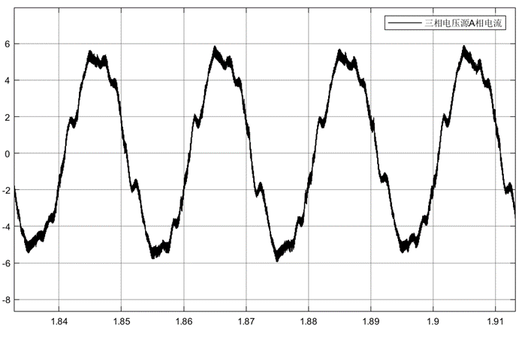

Fig 3.2 the current at three-phase AC power supply (inversion-mode thyristor rectifier circuit)

By comparison, we can know that when PWM rectifier is used, the current waveform of AC power supply is closer to sine wave, the total distortion rate of current harmonic is smaller, and the feedback signal can be added to adjust the phase of signal wave, so that the power factor of the whole circuit is close to 1, so the effect of PWM rectifier is better.