**Homework 3**

**Page 95, Chinese textbook**

**Question 2**

Figure 3-10 shows a single-phase full-wave controlled rectifier with a transformer center tap. Is there a problem of dc magnetization in this transformer? Please explain:

(1) The maximum forward and reverse voltage of the thyristor is 

(2) When the load is a resistor or an inductor, the waveform of the output voltage and current is the same as that of the Single-phase Bridge controlled rectifier.

**Question 3**

Single-phase Bridge controlled rectifier, , , The value of L is very large, when :

(1) Draw the waveforms of 、、and 

(2) Solve the rectified average output voltage of ,、the current of  and the RMS value of transformer secondary current of 

(3) Determine the rated voltage and current of the thyristor considering the safety margin.

**Question 5**

Single-phase Bridge controlled rectifier, , , The value of L is very large, back electromotive force E=100V, when:

(1) Draw the waveforms of 、、and 

(2) Solve the rectified average output voltage of ,、the current of  and the RMS value of transformer secondary current of 

(3) Determine the rated voltage and current of the thyristor considering the safety margin.

**Question 7**

Considering a three-phase half-wave controlled rectifier circuit under a resistive or inductive load, respectively, draw the rectifier voltage waveform $u_{d}$ when the trigger signal of phase $a$ disappeared.

**Question 11**

Considering a three-phase half-wave controlled rectifier circuit with $U_{2}=100V$, under a resistive and inductive load with $R=5Ω$ and very large inductance, when $α=60°$:

(1) Draw the waveform of $u_{d}$, $i_{d}$ and $i_{VT_{1}}$;

(2) Calculate $U_{d}$, $I_{d}$, $I_{dVT}$, and $I_{VT}$.

**Answer 3.2**

There isn’t a problem of DC magnetization in this transformer.

In the transformer secondary winding of the single-phase full wave controlled rectifier, the current flows in opposite directions during the positive and negative half cycle. Besides, the waveform is symmetrical. The average current of the whole cycle is zero. So there isn’t a problem of DC magnetization in this transformer.

1. When the VT1 is turned on, the thyristor VT2 parallels with both transformer secondary windings through the VT1, so the maximum forward and reverse voltage of the thyristor is . When the VT2 is turned on, the condition is similar.

2. Assume that trigger angle is *α.*

For the resistance loads, when phase position in 0 ~ *α*, there is no thyristor turned on, so the output voltage is 0. When phase position in *α* ~ *π*, the VT1 of the single-phase full wave controlled thyristor is turned on. The VT1 and the VT4 of the single-phase bridge controlled thyristor are turned on. And the output voltage is equal to the supply voltage. When phase position in *π ~ π+α*, there is no thyristor turned on, so the output voltage is zero. When phase position in *π+α ~ 2π*, the VT2 of the single-phase full wave controlled thyristor is turned on. The VT2 and the VT3 of the single-phase bridge controlled thyristor are turned on. And the output voltage is equal to the supply voltage.

For the inductive loads, when phase position in *α* ~ *π+α*, the VT1 of the single-phase full wave controlled thyristor is turned on. The VT1 and the VT4 of the single-phase bridge controlled thyristor are turned on. And the output voltage is equal to the supply voltage. When phase position in *π+α ~ 2π+α*, the VT2 of the single-phase full wave controlled thyristor is turned on. The VT2 and the VT3 of the single-phase bridge controlled thyristor are turned on. And the output voltage is equal to the supply voltage.

With all these mentioned above, the curves of output voltage for the different loads are the same.

**Answer 3.3**

1. 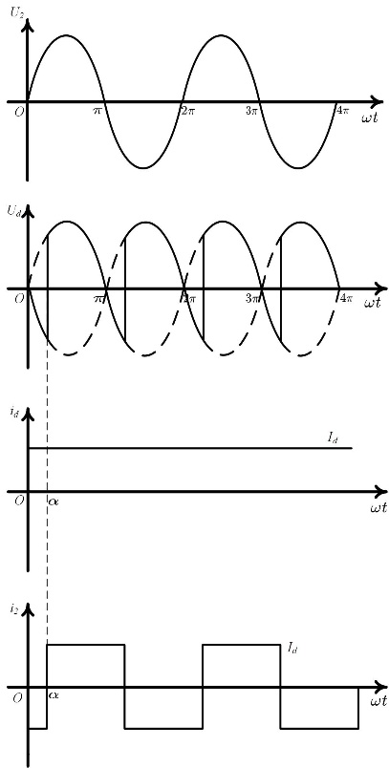

2.



3.



**Answer 3.5**

1. 

2.



3.



**Answer 3.7**

When the load is a resistor, the waveform of *ud* :

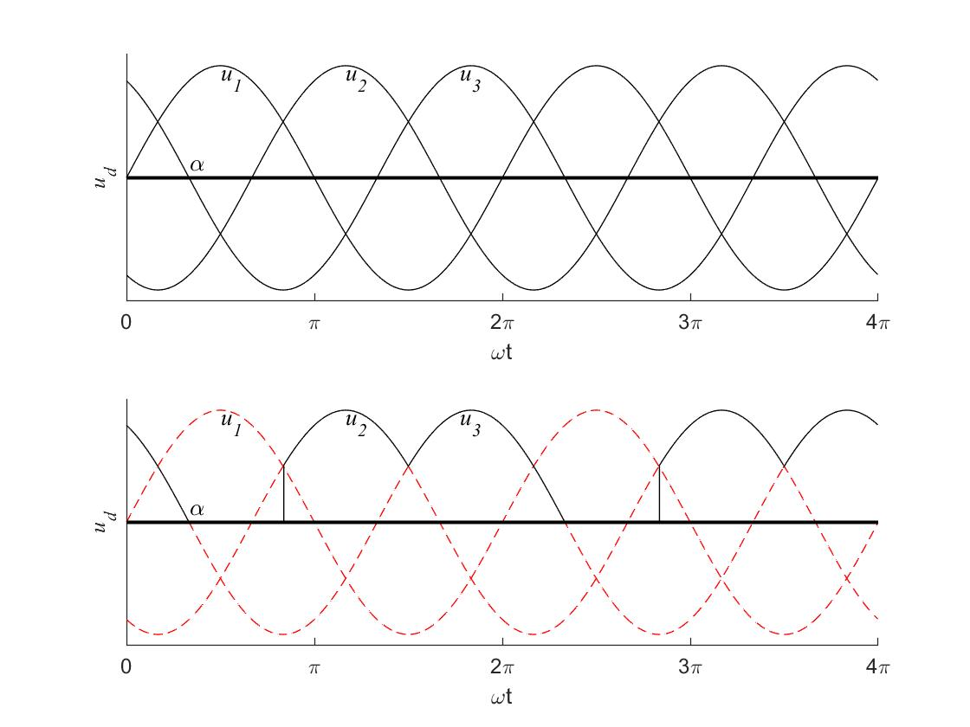

When the load is a inductance, the waveform of *ud* :

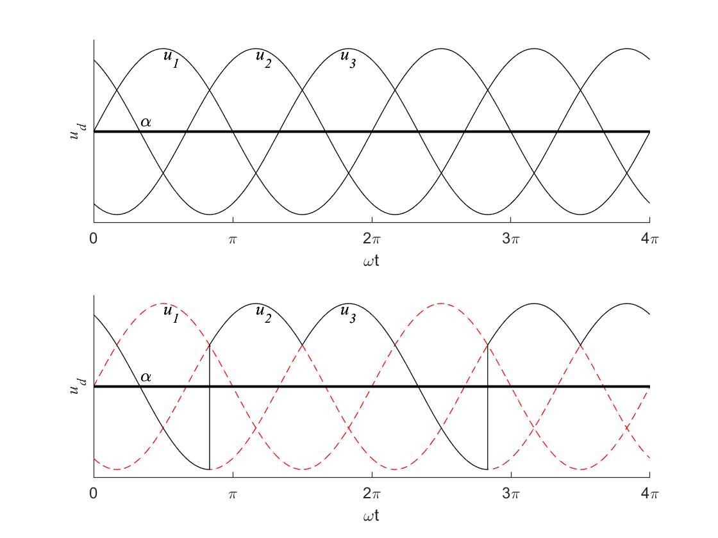

**Answer 3.11**

1.

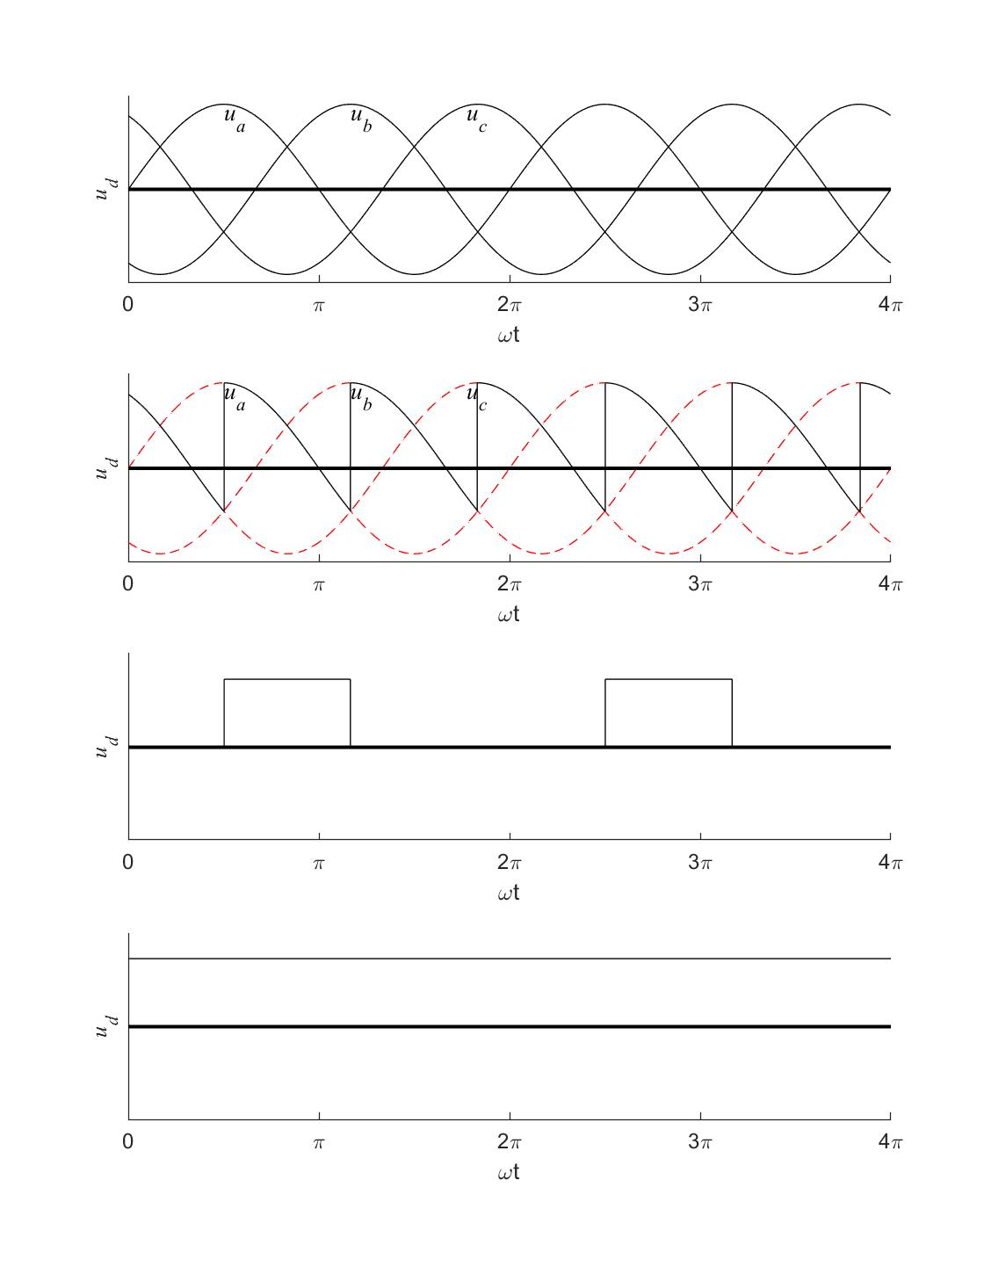

2.

