**Homework 4**

**Page 95, Chinese textbook**

**Question 12**

Considering a three-phase bridge fully-controlled rectifier circuit under a resistive load, if one thyristor cannot be conducted, what does the rectifier voltage waveform $u_{d}$ look like? If one thyristor has been broken down and is a short circuit now, what is the influence on the other thyristors?

**Question 13**

Considering a three-phase bridge fully-controlled rectifier circuit with $U_{2}=100V$, under a resistive and inductive load with $R=5Ω$ and very large inductance, when $α=60°$:

1. Draw the waveform of $u_{d}$, $i_{d}$ and $i_{VT_{1}}$;
2. Calculate $U_{d}$, $I_{d}$, $I_{dVT}$, and $I_{VT}$.

**Question 15**

Considering a three-phase half-wave controlled rectifier circuit connected to a EMF load with resistor and inductor, when $U_{2}=100V$, $R=1Ω$, $L=∞$, $L_{B}=1mH$, $α=30°$, $E=50V$, calculate the value of $U_{d}$, $I_{d}$, $γ$ and draw the waveform of $u_{d}$, $i_{VT_{1}}$, $i_{VT_{2}}$.

**Question 16**

Considering a three-phase bridge uncontrolled rectifier circuit connected to a resistive and inductive load, with $R=2Ω$, $L=∞$, $U_{2}=100V$, $X_{B}=0.1Ω$, calculate the value of $U_{d}$, $I_{d}$, $I_{VD}$, $I_{2}$ and $γ$, and draw the waveform of $u_{d}$, $i_{VD}$, and $i_{2}$.

**Answer 3.12**

Supposing the VT1 isn’t turned on, the waveform of rectified voltage *ud* is

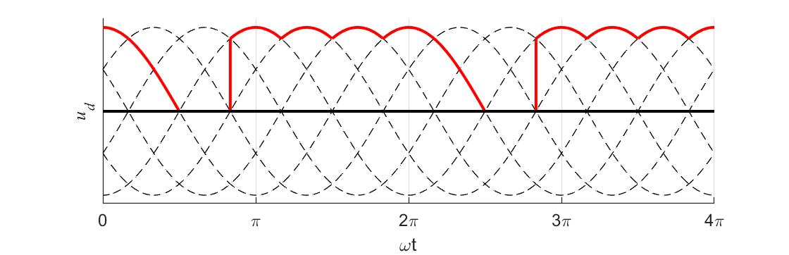

If the VT1 is broken down to become short circuit and the thyristor VT3 and VT5 is turned on, power is shorted-circuited, which will make the VT3 and VT5 break down.

**Answer 3.13**

1. The waveform of *ud*, *id* and *iVT1*:

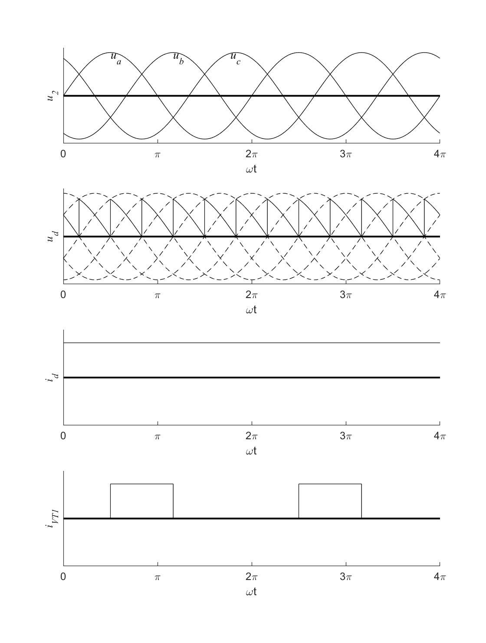

1. The result of $U_{d}$, $I_{d}$, $I_{dVT}$, and $I_{VT}$.



**Answer 3.15**

the waveform of $u_{d}$, $i_{VT_{1}}$, $i_{VT_{2}}$:

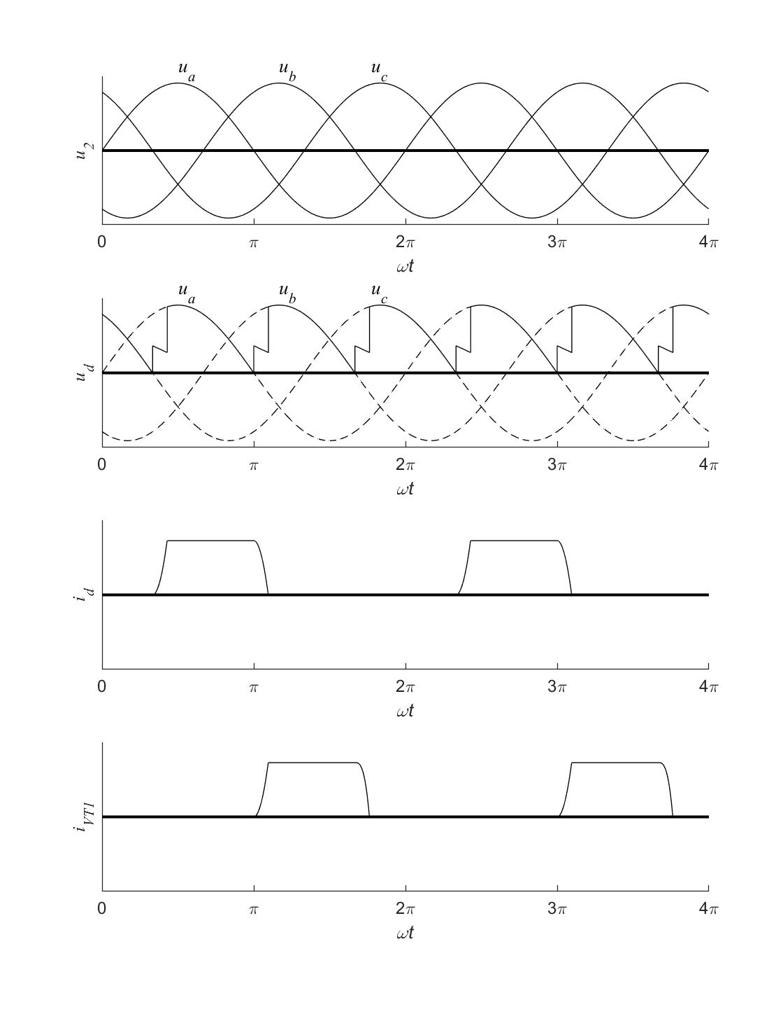

Given that *LB* = 1mH, it’s known that



Solutions of equations are:



We can get the relationship that



for the reason that



**Answer 3.16**

The waveform of $u_{d}$, $i_{VD}$, and $i_{2}$:

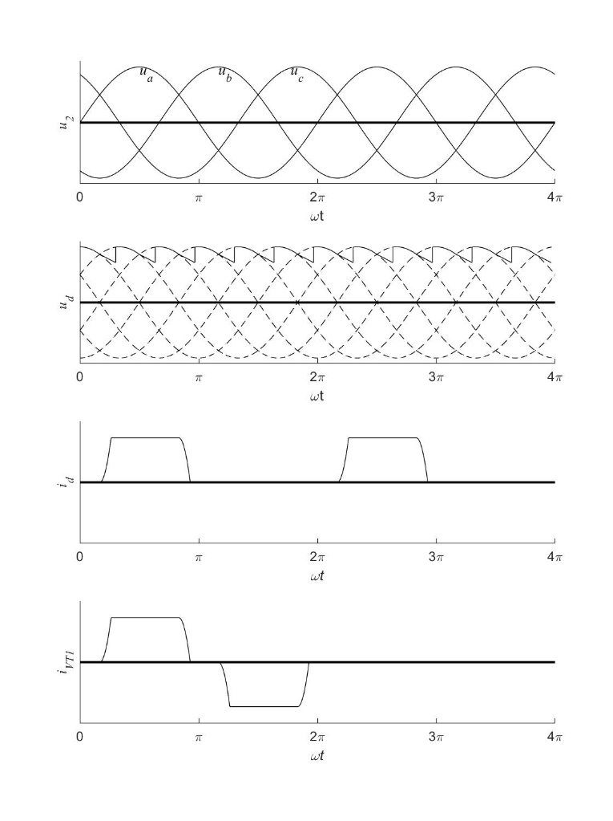

A three-phase bridge uncontrolled rectifier circuit is equivalent to A three-phase bridge controlled rectifier circuit with .



Solutions of equations are:



We can get the relationship that



for the reason that



Therefore, the RMS value of the current of diode and the secondary winding of transformer is

