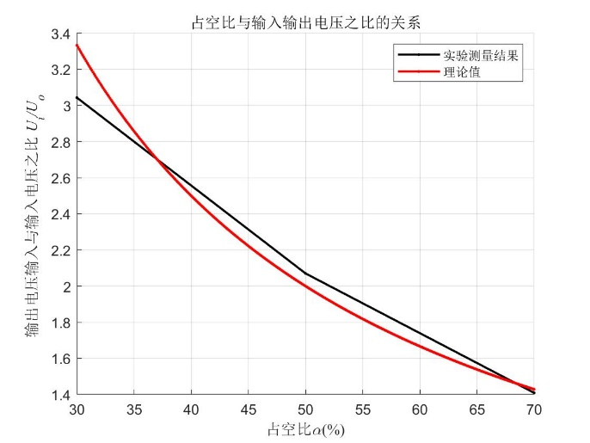

**图11 占空比与输入输出电压之比的关系**

**表1 输入输出电压实验数据测定以及计算结果**

|  |  |  |  |  |  |
| --- | --- | --- | --- | --- | --- |
| *α* | *Ui/V* | *Uo/V* | *Ui/Uo* | *1/α* | 相对误差 |
| 30% | 30.432 | 10.0 | 3.0432 | 3.3333 | 8.61% |
| 50% | 30.432 | 14.7 | 2.0702 | 2.0000 | 3.51% |
| 70% | 30.432 | 21.6 | 1.4089 | 1.429 | 1.41% |

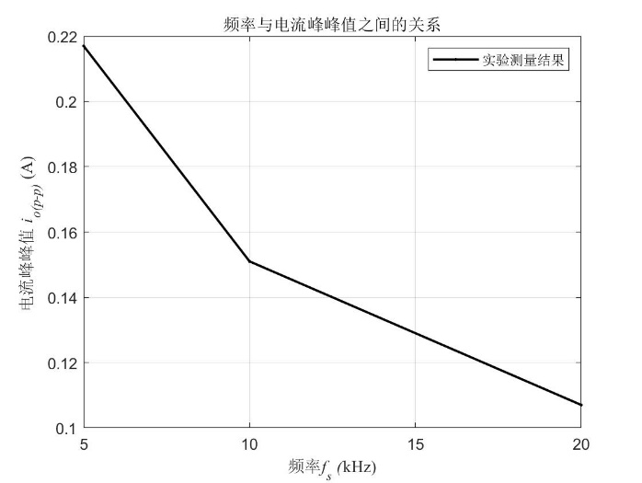

**图11频率与电流峰峰值的关系**

**表2 电流峰峰值实验数据测定以及计算结果**

|  |  |
| --- | --- |
| fs/kHz | *Io(p-p)/*A |
| 5 | 0.208 |
| 10 | 0.128 |
| 20 | 0.060 |