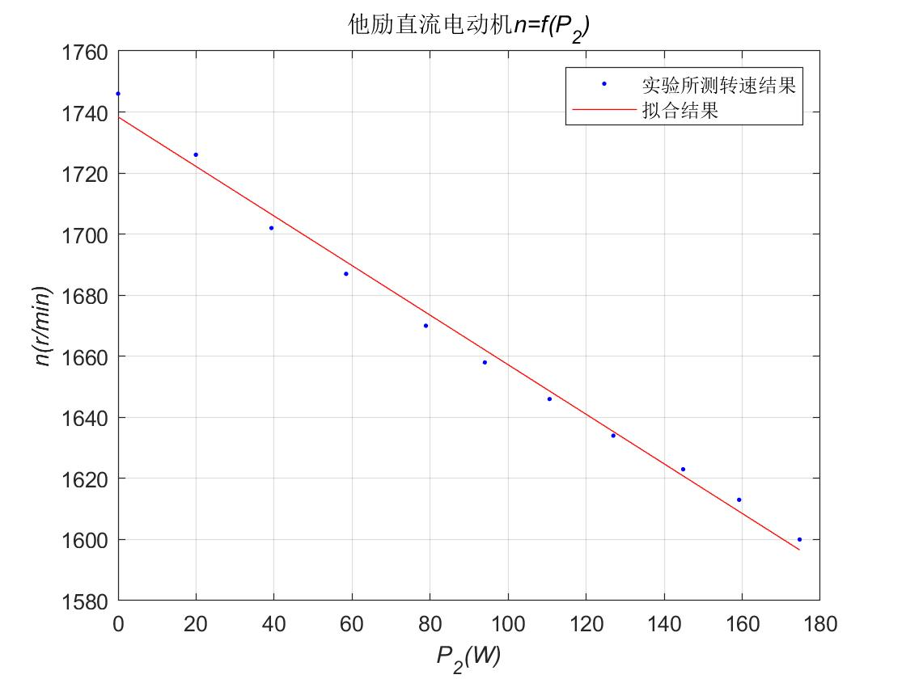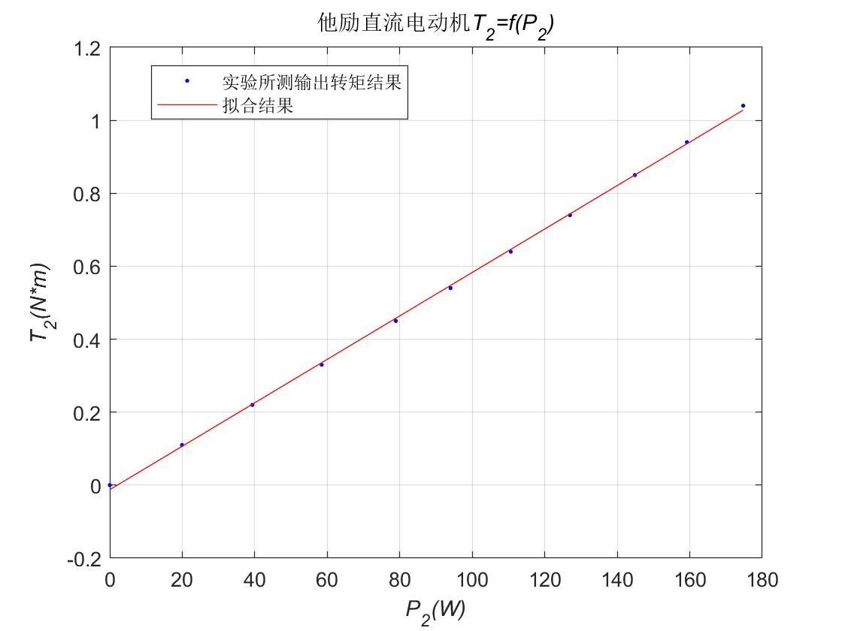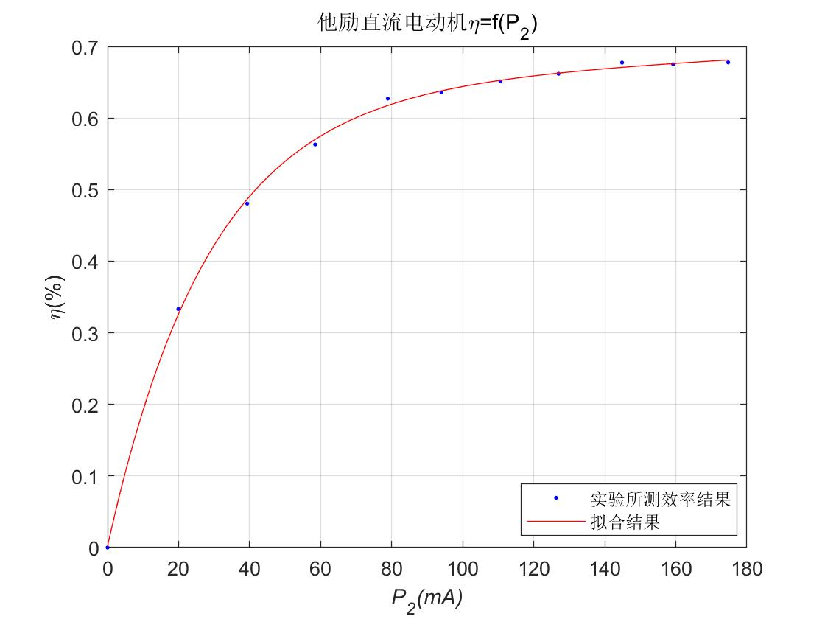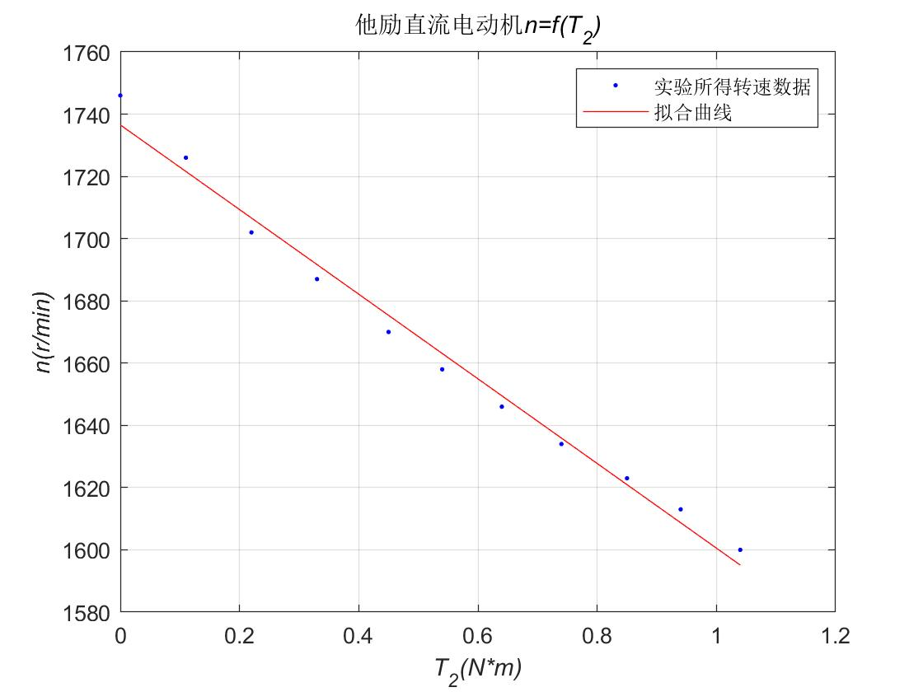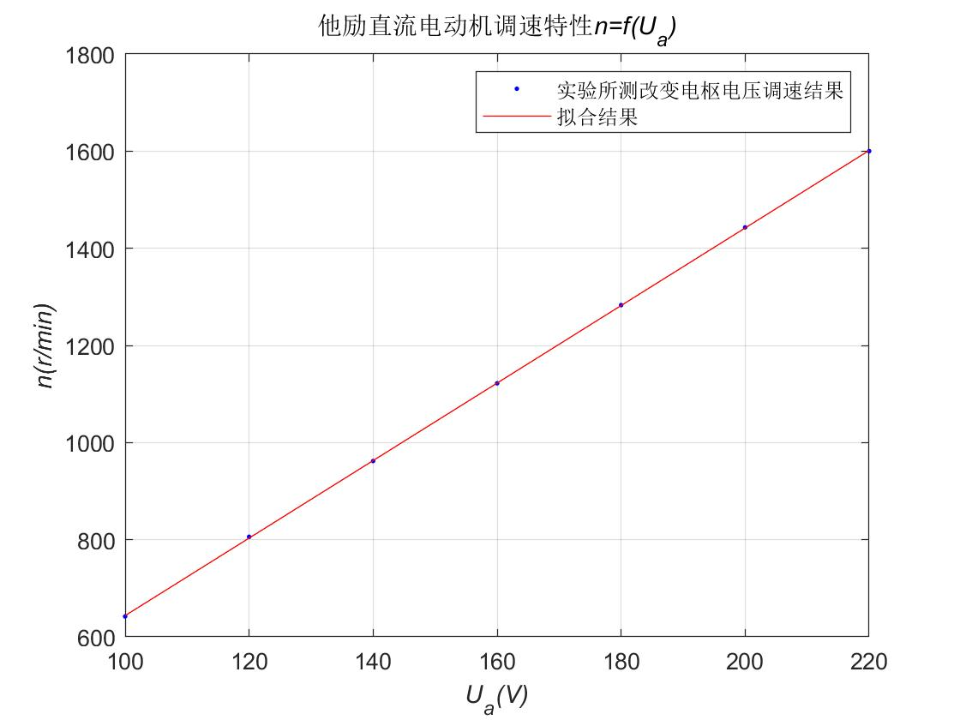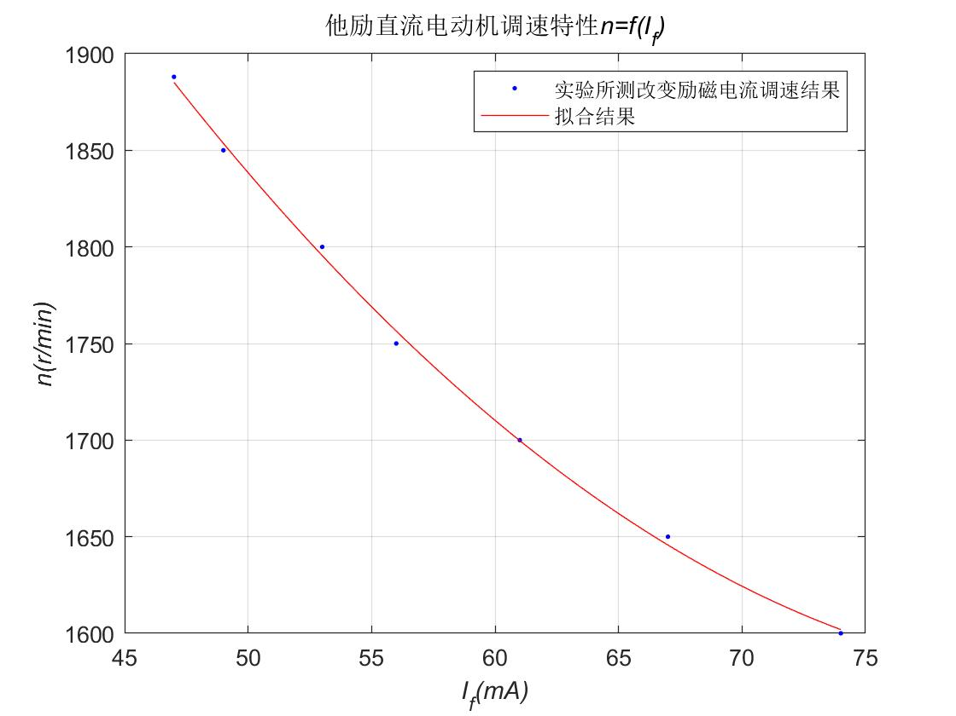

|  |  |  |  |  |  |  |  |  |  |  |  |  |
| --- | --- | --- | --- | --- | --- | --- | --- | --- | --- | --- | --- | --- |
| **实验数据** | *Ia*(A) | 1.1 | 1 | 0.9 | 0.8 | 0.7 | 0.6 | 0.5 | 0.4 | 0.3 | 0.2 | 0.11 |
| *n*(r/min) | 1600 | 1613 | 1623 | 1634 | 1646 | 1658 | 1670 | 1687 | 1702 | 1726 | 1746 |
| *T2*(N·m) | 1.04 | 0.94 | 0.85 | 0.74 | 0.64 | 0.54 | 0.45 | 0.33 | 0.22 | 0.11 | 0 |
| **计算数据** | P1(W) | 257.84 | 235.84 | 213.84 | 191.84 | 169.84 | 147.84 | 125.84 | 103.84 | 81.84 | 59.84 | 40.04 |
| P2(W) | 174.72 | 159.20 | 144.85 | 126.96 | 110.61 | 94.00 | 78.90 | 58.45 | 39.32 | 19.94 | 0 |
| *η*(%) | 67.76 | 67.50 | 67.73 | 66.18 | 65.12 | 63.50 | 62.70 | 56.29 | 48.04 | 33.31 | 0 |

|  |  |  |  |  |  |  |  |
| --- | --- | --- | --- | --- | --- | --- | --- |
| *U*(V) | 220 | 200 | 180 | 160 | 140 | 120 | 100 |
| *n*(r/min) | 1600 | 1443 | 1283 | 1122 | 962 | 806 | 642 |
| *Ia*(A) | 1.1 | 1.09 | 1.08 | 1.08 | 1.08 | 1.08 | 1.07 |

|  |  |  |  |  |  |  |  |
| --- | --- | --- | --- | --- | --- | --- | --- |
| *n*(r/min) | 1600 | 1650 | 1700 | 1750 | 1800 | 1850 | 1888 |
| *If* (mA) | 74 | 67 | 61 | 56 | 53 | 49 | 47 |
| *Ia* (A) | 0.55 | 0.57 | 0.59 | 0.61 | 0.63 | 0.65 | 0.66 |