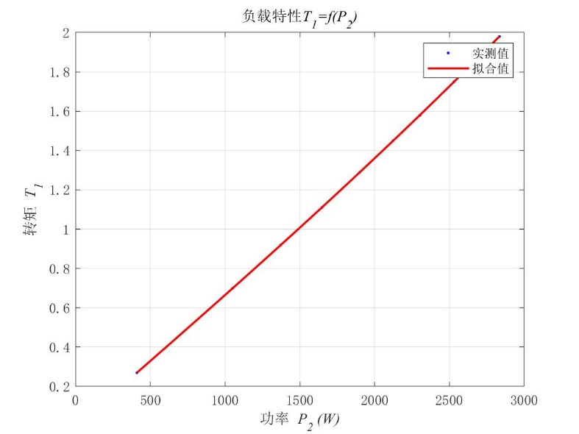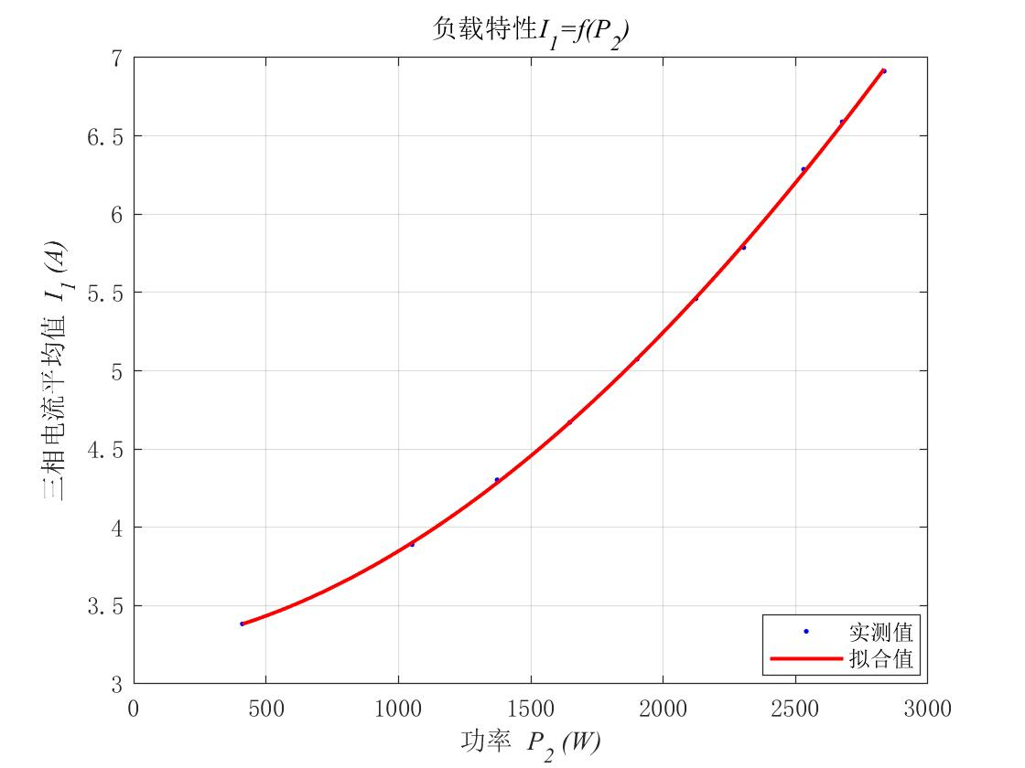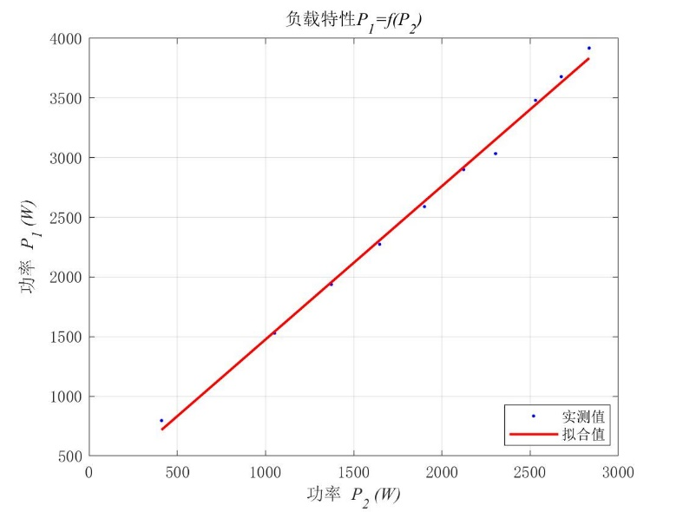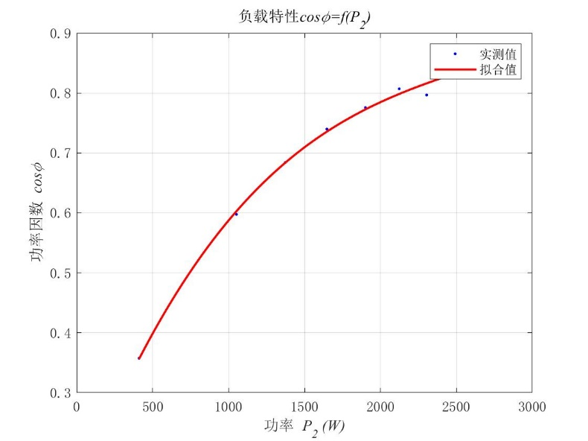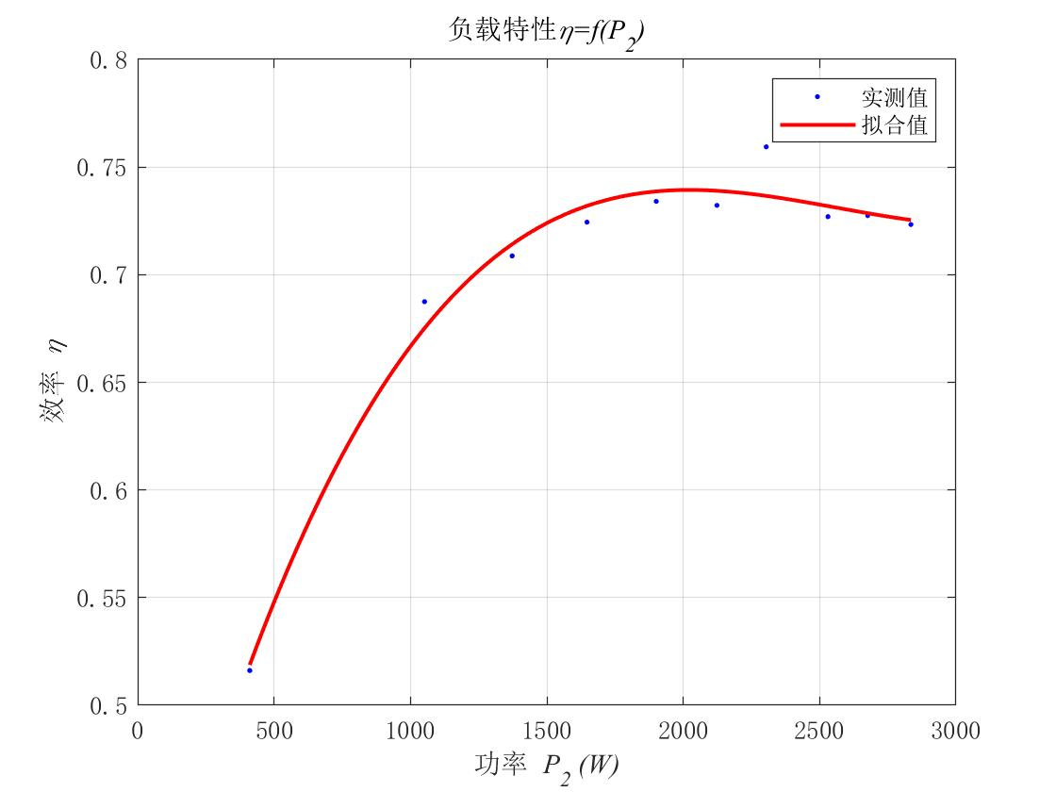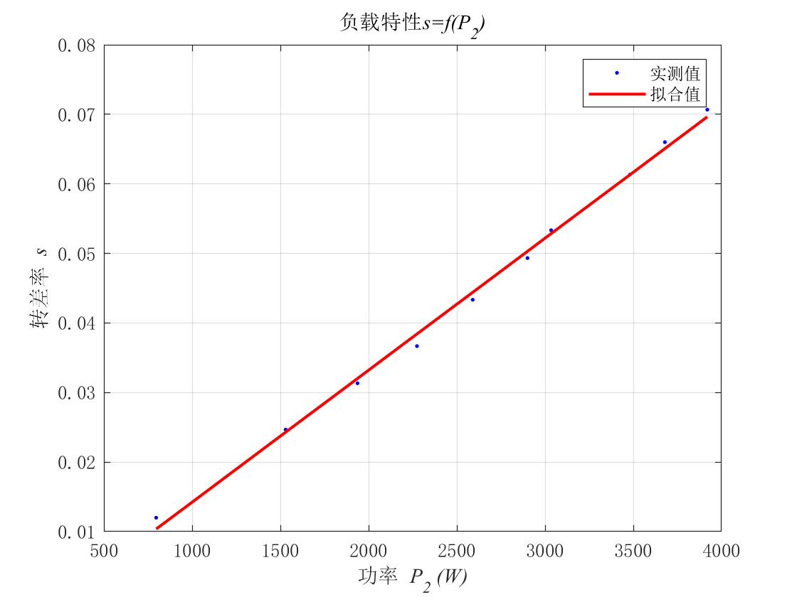

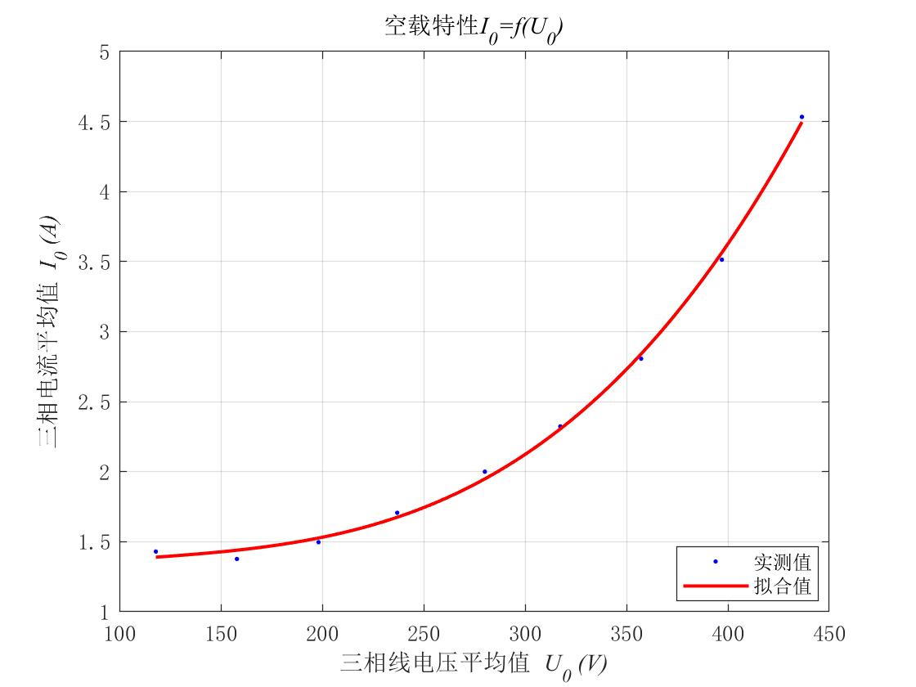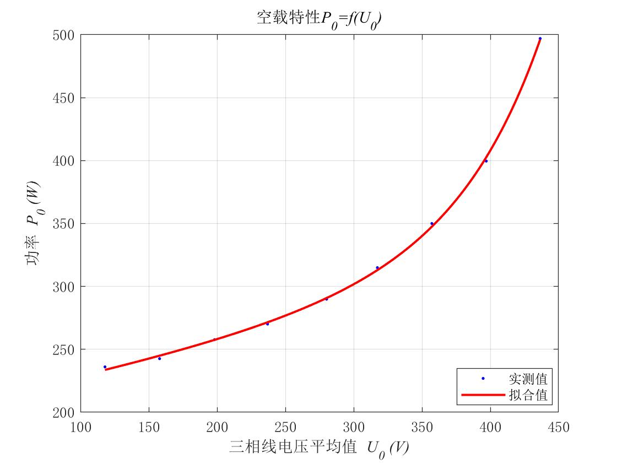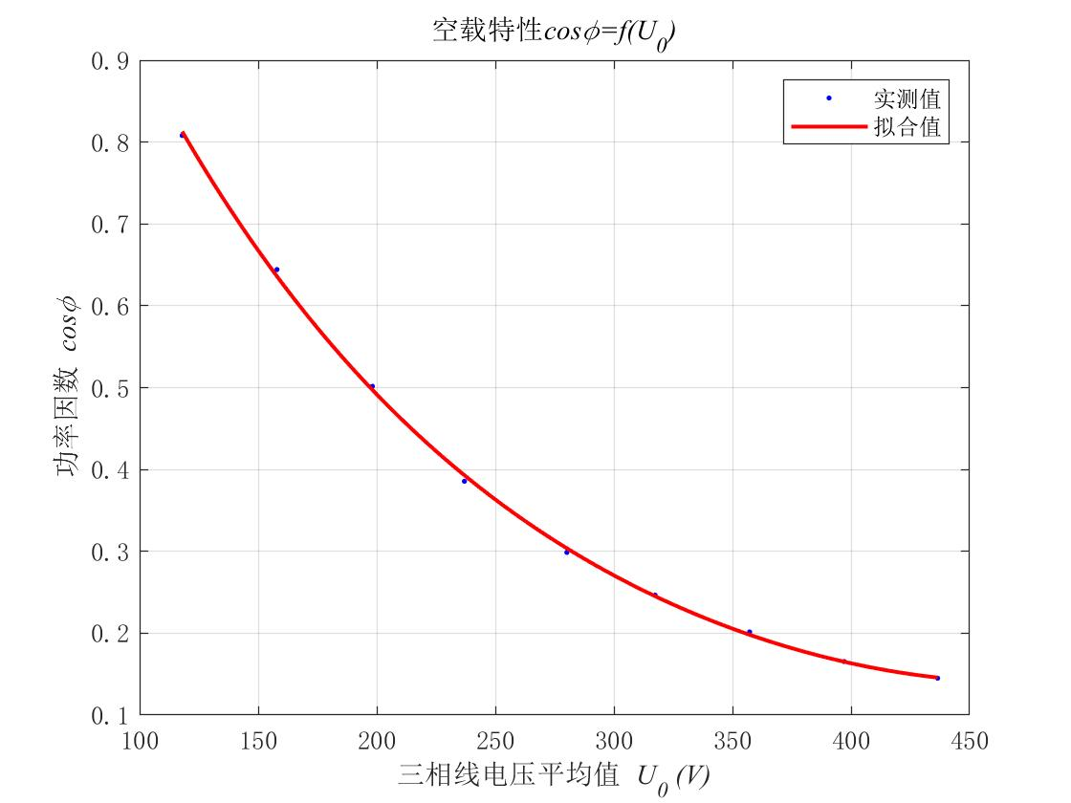

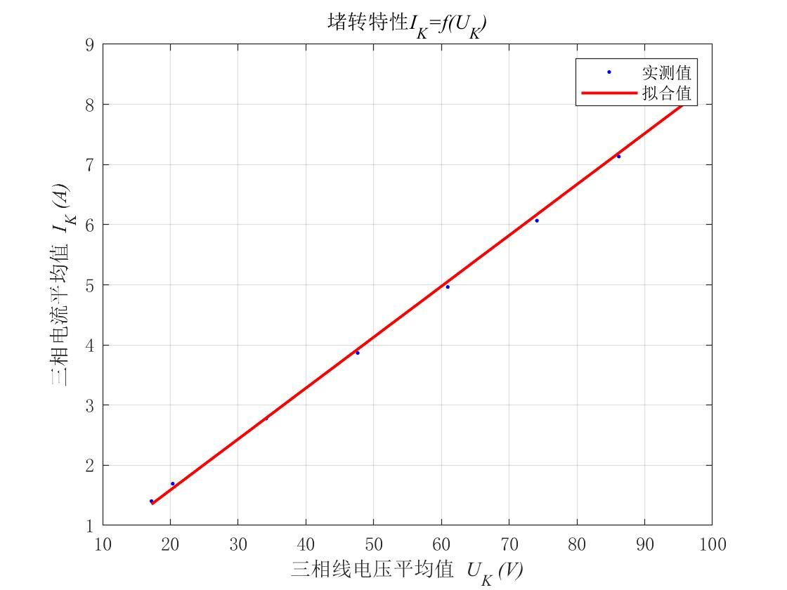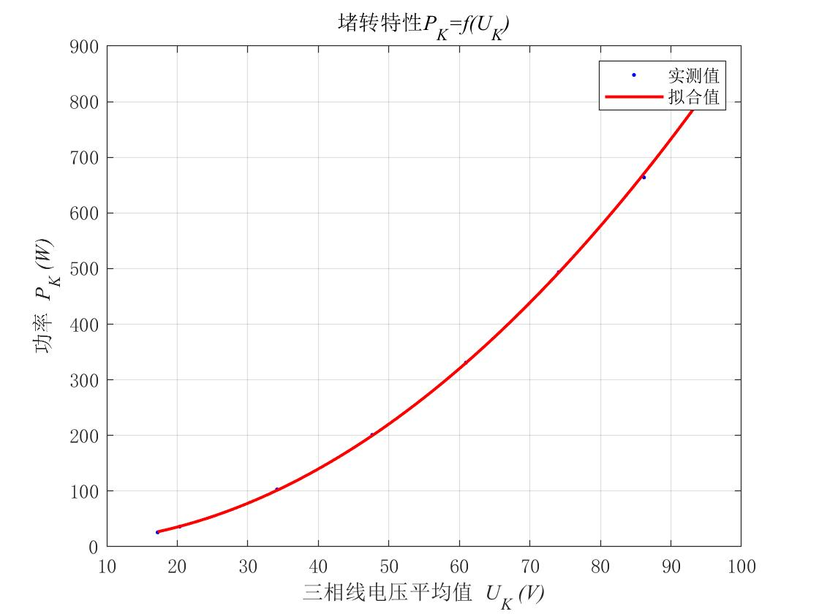

**负载实验数据**

*U1=UN*=220V

|  |  |  |  |  |  |  |  |  |  |  |  |  |  |
| --- | --- | --- | --- | --- | --- | --- | --- | --- | --- | --- | --- | --- | --- |
| 序号 | 记录数据 | | | | | | | 计算数据 | | | | | |
| *Ia* | *Ib* | *Ic* | *PI* | *PII* | *T2* | *n* | *I1* | *P1* | *P2* | *η* | *cosφ1* | *s* |
| 1 | 3.47 | 3.45 | 3.23 | 992.2 | -196 | 0.27 | 1482 | 3.3 | 796.2 | 410.944 | 0.52 | 0.36 | 0.012 |
| 2 | 3.92 | 3.94 | 3.81 | 1370 | 159.9 | 0.7 | 1463 | 3.89 | 1529.9 | 1051.751 | 0.69 | 0.60 | 0.025 |
| 3 | 4.38 | 4.33 | 4.2 | 1584 | 353.1 | 0.92 | 1453 | 4.30 | 1937.1 | 1372.853 | 0.71 | 0.68 | 0.031 |
| 4 | 4.71 | 4.69 | 4.61 | 1752 | 522 | 1.11 | 1445 | 4.67 | 2274 | 1647.257 | 0.72 | 0.74 | 0.037 |
| 5 | 5.09 | 5.1 | 5.03 | 1915 | 674.9 | 1.29 | 1435 | 5.07 | 2589.9 | 1901.131 | 0.73 | 0.78 | 0.043 |
| 6 | 5.51 | 5.45 | 5.42 | 2082 | 818.2 | 1.45 | 1426 | 5.46 | 2900.2 | 2123.528 | 0.73 | 0.81 | 0.049 |
| 7 | 5.79 | 5.81 | 5.76 | 2194 | 840.2 | 1.58 | 1420 | 5.79 | 3034.2 | 2304.177 | 0.76 | 0.80 | 0.053 |
| 8 | 6.31 | 6.32 | 6.23 | 2384 | 1097 | 1.75 | 1408 | 6.29 | 3481 | 2530.528 | 0.73 | 0.84 | 0.061 |
| 9 | 6.62 | 6.61 | 6.54 | 2490 | 1189 | 1.86 | 1401 | 6.59 | 3679 | 2676.22 | 0.73 | 0.85 | 0.066 |
| 10 | 6.97 | 6.93 | 6.84 | 2643 | 1276 | 1.98 | 1394 | 6.91 | 3919 | 2834.64 | 0.72 | 0.86 | 0.071 |

**空载实验数据**

*P2*=0

|  |  |  |  |  |  |  |  |  |  |  |  |  |
| --- | --- | --- | --- | --- | --- | --- | --- | --- | --- | --- | --- | --- |
| 序号 | 记录数据 | | | | | | | | 计算数据 | | | |
| *UAB* | *UBC* | *UCA* | *IA* | *IB* | *IC* | *PI* | *PII* | *U0* | *I0* | *P0* | *cosφ0* |
| 1 | 437.9 | 433.3 | 438.3 | 4.57 | 4.43 | 4.6 | 4.6 | 1265 | 436.5 | 4.53 | 497 | 0.145 |
| 2 | 398.9 | 393.9 | 398.3 | 3.63 | 3.43 | 3.48 | 3.48 | 922.6 | 397.0 | 3.51 | 399.6 | 0.165 |
| 3 | 358.7 | 354.3 | 358.7 | 2.9 | 2.71 | 2.81 | 2.81 | 688 | 357.2 | 2.87 | 350 | 0.201 |
| 4 | 318.4 | 315.4 | 318.3 | 2.37 | 2.29 | 2.31 | 2.31 | 526.9 | 317.4 | 2.32 | 314.9 | 0.247 |
| 5 | 281.3 | 278.5 | 280.7 | 2.05 | 2.00 | 1.95 | 1.95 | 413.9 | 280.2 | 2 | 289.9 | 0.299 |
| 6 | 238.3 | 235.5 | 237.1 | 1.75 | 1.72 | 1.65 | 1.65 | 324.5 | 237.0 | 1.71 | 270.1 | 0.386 |
| 7 | 198.2 | 197.6 | 198.7 | 1.5 | 1.52 | 1.47 | 1.47 | 253.3 | 198.2 | 1.50 | 257.68 | 0.502 |
| 8 | 158.3 | 157.3 | 158.2 | 1.42 | 1.38 | 1.33 | 1.33 | 209.1 | 157.9 | 1.38 | 242.62 | 0.644 |
| 9 | 118.6 | 117.3 | 118.0 | 1.44 | 1.48 | 1.37 | 1.37 | 168.5 | 118.0 | 1.43 | 236.09 | 0.808 |

**堵转实验数据**

*n*=0

|  |  |  |  |  |  |  |  |  |  |  |  |
| --- | --- | --- | --- | --- | --- | --- | --- | --- | --- | --- | --- |
| 序号 | 记录数据 | | | | | | | 计算数据 | | | |
| *UAB* | *UBC* | *UCA* | *IA* | *IB* | *PI* | *PII* | *UK* | *IK* | *PK* | *cosφK* |
| 1 | 97.02 | 96.16 | 97.33 | 8.32 | 8.28 | 8.28 | 745.3 | 96.84 | 8.29 | 855.3 | 0.615 |
| 2 | 86.26 | 85.75 | 86.53 | 7.16 | 7.12 | 7.12 | 574.1 | 86.18 | 7.13 | 663.9 | 0.623 |
| 3 | 73.72 | 73.51 | 75.04 | 6.1 | 6.02 | 6.08 | 420.1 | 74.09 | 6.07 | 493.68 | 0.634 |
| 4 | 60.57 | 60.44 | 61.79 | 4.98 | 4.92 | 4.99 | 281.4 | 60.93 | 4.96 | 330.93 | 0.632 |
| 5 | 47.25 | 47.16 | 48.52 | 3.88 | 3.82 | 3.90 | 171.2 | 47.64 | 3.87 | 201.06 | 0.630 |
| 6 | 33.70 | 33.82 | 34.91 | 2.79 | 2.74 | 2.80 | 87.38 | 34.14 | 2.78 | 102.9 | 0.627 |
| 7 | 20.07 | 20.66 | 20.32 | 1.71 | 1.69 | 1.68 | 30.11 | 20.35 | 1.69 | 36.28 | 0.608 |
| 8 | 17.29 | 16.95 | 17.41 | 1.42 | 1.40 | 1.39 | 22.41 | 17.21 | 1.40 | 25.86 | 0.618 |

|  |  |  |  |  |  |  |  |  |  |
| --- | --- | --- | --- | --- | --- | --- | --- | --- | --- |
| *I0* | 4.53 | 3.51 | 2.81 | 2.32 | 2 | 1.71 | 1.50 | 1.37 | 1.43 |
| *P0* | 497 | 399.6 | 350 | 314.9 | 289.9 | 270.1 | 257.68 | 242.62 | 236.09 |
| *U02* | 190532 | 157635 | 127616 | 100722 | 78493 | 56153 | 39270 | 24943 | 13916 |
| *P0’* | 358.28 | 316.28 | 296.83 | 278.46 | 262.9 | 250.44 | 242.56 | 229.82 | 222.29 |

图表, 折线图

已生成极高可信度的说明