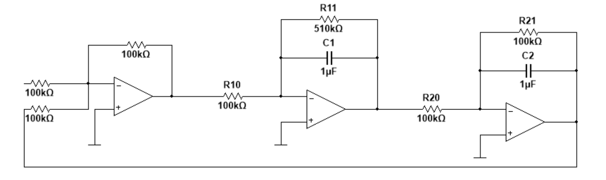

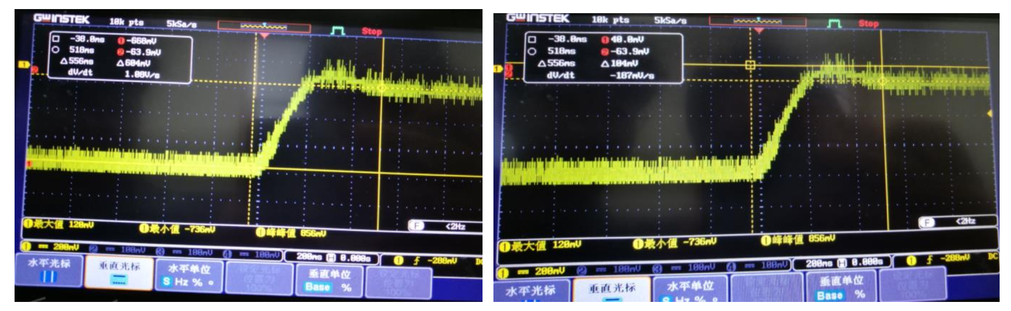

未校正系统动态指标

|  |  |  |  |  |  |
| --- | --- | --- | --- | --- | --- |
|  | 超调量*σ* | 峰值时间*tp* | 震荡次数*N* | 过渡过程时间*ts* | 系统稳态误差*ess* |
| 理论值 | 12.77% | 0.343 | 0.97 | 0.667 | 0.1667 |
| 实测值 | 17.2% | 0.356 | 1 | 0.556 | 0.400 |
| 实测值误差 | 34.7% | 3.8% | 3.8% | 3.1% | 16.6% |

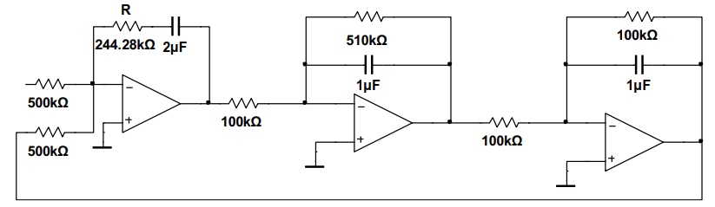

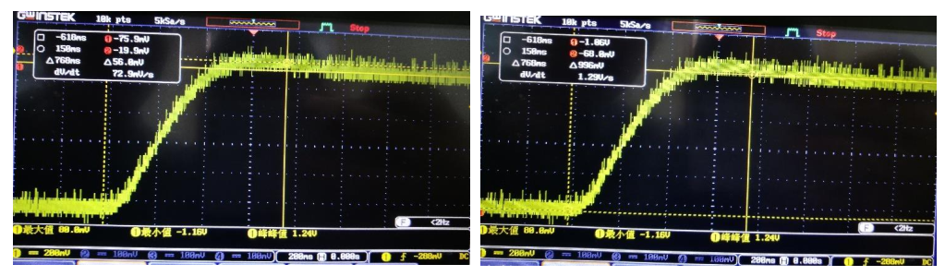

未校正系统动态指标

|  |  |  |  |  |  |
| --- | --- | --- | --- | --- | --- |
|  | 超调量*σ* | 峰值时间*tp* | 震荡次数*N* | 过渡过程时间*ts* | 系统稳态误差*ess* |
| 理论值 | 4.3% | 0.62 | 0.63 | 0.79 | 0 |
| 实测值 | 5.6 | 0.6 | 0.5 | 0.768 | 0.004 |
| 实测值误差 | 30.2% | 3.2% | 20.6% | 2.8% | / |