**Time-domain reflectometer**

Group 6

# overview

A time-domain reflectometer (TDR) is an electronic instrument used to determine the characteristics of electrical lines by observing reflected waveforms.

It can be used to characterize and locate faults in metallic cables (for example, twisted pair wire or coaxial cable). It can also be used to locate discontinuities in a connector, printed circuit board, or any other electrical path. It can visually display and measure the electrical energy reflected by the circuit (PCB, cable, IC package, ...).

The signal is transmitted on a certain transmission path. When an impedance change occurs in the transmission path, part of the signal will be reflected, and another part of the signal will continue to be transmitted along the transmission path.

TDR calculates the impedance change by measuring the voltage amplitude of the reflected wave; as long as the time value from the reflection point to the emission point is measured, the position of the impedance change point in the transmission path can be calculated.

## Description

A TDR measures reflections along a conductor. In order to measure those reflections, the TDR will transmit an incident signal onto the conductor and listen for its reflections. If the conductor is of a uniform impedance and is properly terminated, then there will be no reflections and the remaining incident signal will be absorbed at the far-end by the termination. Instead, if there are impedance variations, then some of the incident signal will be reflected back to the source. A TDR is similar in principle to radar.

The impedance of the discontinuity can be determined from the amplitude of the reflected signal. The distance to the reflecting impedance can also be determined from the time that a pulse takes to return. The limitation of this method is the minimum system rise time. The total rise time consists of the combined rise time of the driving pulse and that of the oscilloscope or sampler that monitors the reflections.



*Fig.1* Signal (or energy) transmitted and reflected from a discontinuity

## Method

The TDR analysis begins with the propagation of a step or impulse of energy into a system and the subsequent observation of the energy reflected by the system. By analyzing the magnitude, duration and shape of the reflected waveform, the nature of the impedance variation in the transmission system can be determined.

If a pure resistive load is placed on the output of the reflectometer and a step signal is applied, a step signal is observed on the display, and its height is a function of the resistance.

The basic formula of TDR is as follows:





It can be seen from the above formula that since the incident voltage is known, the reflection coefficient ρ value can be calculated as long as the voltage value of the reflection point is measured;

The output impedance Z0 of the instrument can be set by the user, so that the impedance Z value of the reflection point can be calculated.

The magnitude of the step produced by the resistive load may be expressed as a fraction of the input signal as given by:



where Z0 is the characteristic impedance of the transmission line.

## Reflection

Generally, the reflections will have the same shape as the incident signal, but their sign and magnitude depend on the change in impedance level. If there is a step increase in the impedance, then the reflection will have the same sign as the incident signal; if there is a step decrease in impedance, the reflection will have the opposite sign. The magnitude of the reflection depends not only on the amount of the impedance change, but also upon the loss in the conductor.

The reflections are measured at the output/input to the TDR and displayed or plotted as a function of time. Alternatively, the display can be read as a function of cable length because the speed of signal propagation is almost constant for a given transmission medium.

Because of its sensitivity to impedance variations, a TDR may be used to verify cable impedance characteristics, splice and connector locations and associated losses, and estimate cable lengths.

# TDR test

## Test1

### Model and Problem



When the terminal impedance changes, what do you observe?

* *ZL*= ∞
* *ZL*= *Z*C
* *ZL*= 0

### Analysis

As the incident voltage is known, the reflection coefficient can be calculated as long as the voltage value of the reflection point is measured.

In this experiment:

*ZL*=∞, =1

*ZL*=*Z*C, =0

*ZL*=0, =-1

### Experimental Result

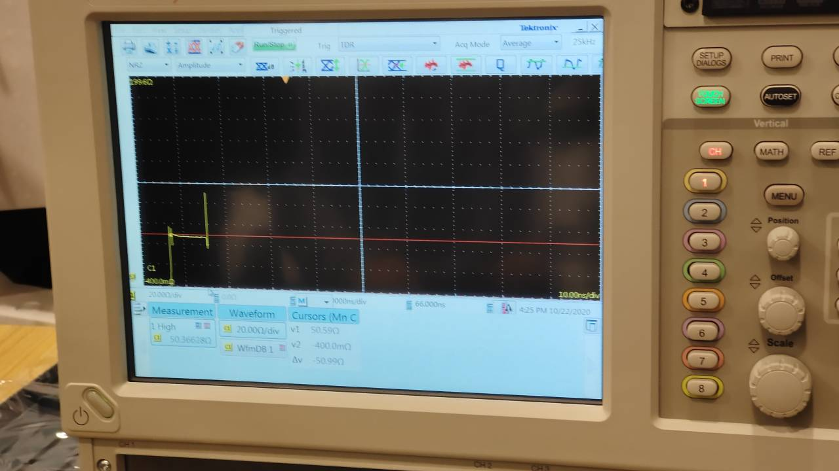

*Fig.1.1* waveform when

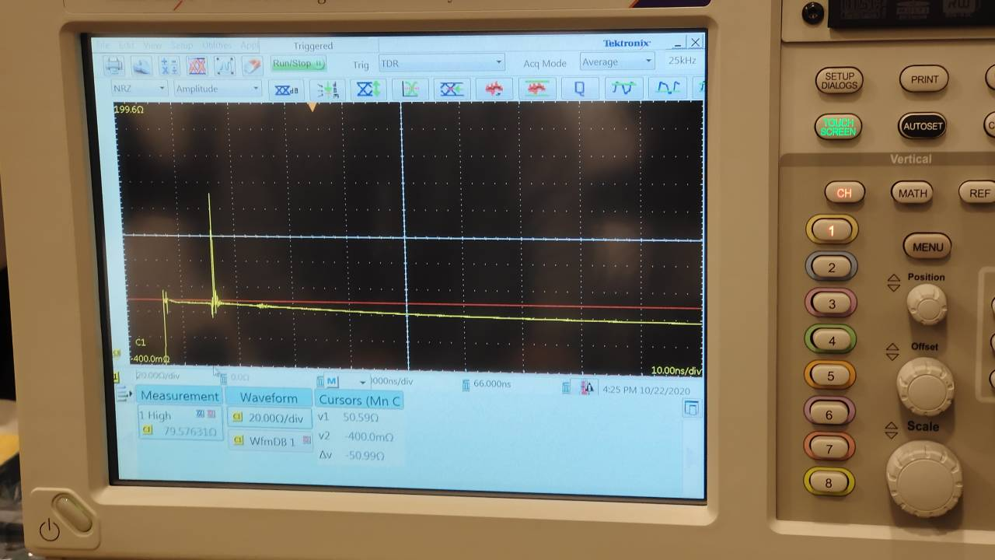

*Fig.1.2* waveform when

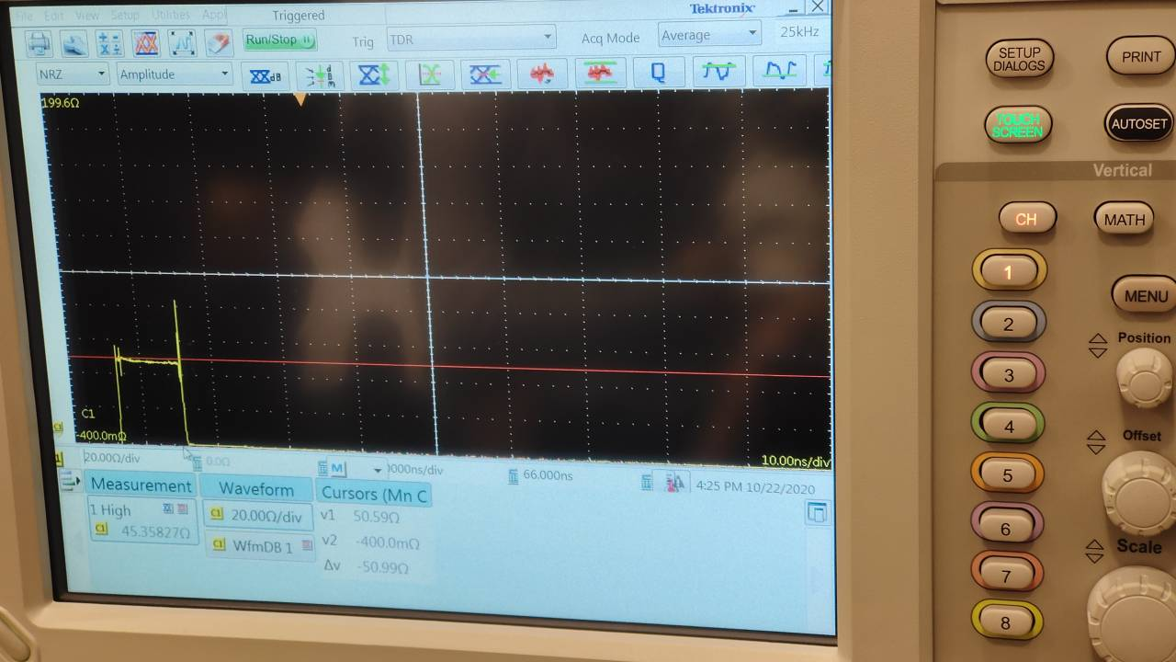

*Fig.1.3* waveform when

### Experimental conclusion

* *ZL*= ∞, =1, so the reflection voltage is the same as the incident voltage, therefore, the voltage in the transmission line is 2 times of the incident voltage, just like we have observed in the scope.
* *ZL*= *Z*C, =0, so the reflection voltage is zero, therefore, the voltage in the transmission line is incident voltage, just like we have observed in the scope.
* *ZL*= 0 , =-1, so the reflection voltage will eliminate the incident voltage therefore, the voltage in the transmission line is zero, just like we have observed in the scope.

### Model and problem



The dielectric constant of the coaxial cable *εr* is 1.6.

* What’s the wave velocity along TL1?
* What’s the length of TL1?

### Experimental conclusion

In this task we are assigned to derive the velocity along the TLI1, and get the length of TL1.

Since the dielectric constant of the coaxial cable, so use the formulation we can get the velocity is:



To get the length of the TL1, we can use the following formulation:



In the scope we can read the is 8.59ns, so the length of the TL1 is 1.015m

## Test 2



At the fault point, the impedance is distorted.

* Where is the fault point? (length of TL2)

### Analysis

At the fault point on the transmission line, the impedance of the transmission line is discontinuous or distorted, causing a portion of the incident voltage of the transmission line to be abnormally reflected back. Therefore, the TDR measurement technique can be used to measure the impedance of the transmission line and observe the abnormal change point of the transmission line to determine the position of the fault point on the transmission line.

In this experiment, the distance from the fault point to the input port of the transmission line is the length of the transmission line TL2.

### Experimental result

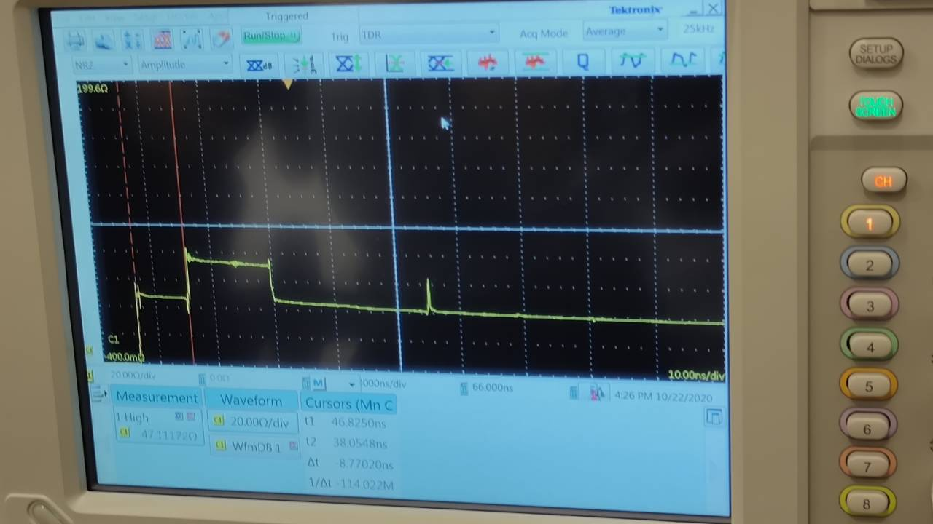

*Fig.2.1* Waveform Showing the Fault Point





## Test 3

### Model and problem

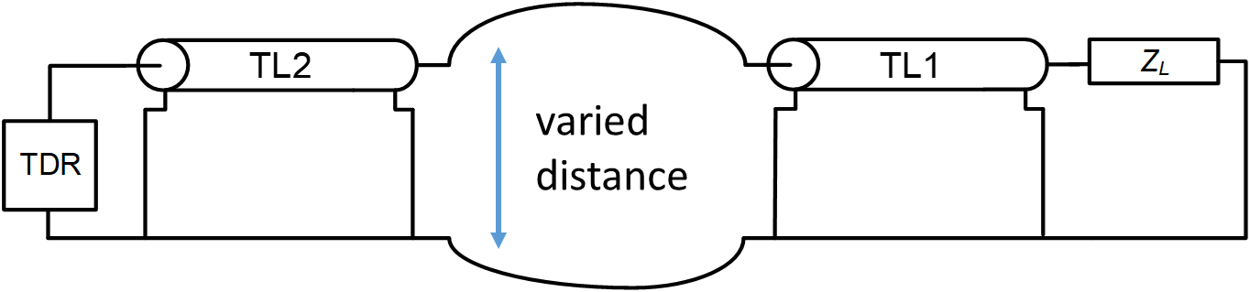

The distance between conductors varies, what do you observe?

### Analysis

The coupling between the two wires includes both electric field coupling and magnetic field coupling.

Electric field coupling：It refers to two conductors in a circuit. When they are close together and there is a potential difference, the electric field of the conductor in one circuit generates an electric field induction phenomenon on the conductor in the other circuit.

Magnetic field coupling :It is based on the principle of electromagnetic induction. The alternating current flowing in one conductor loop generates an induced voltage in the other loop through the alternating magnetic field to realize energy transfer

### Result

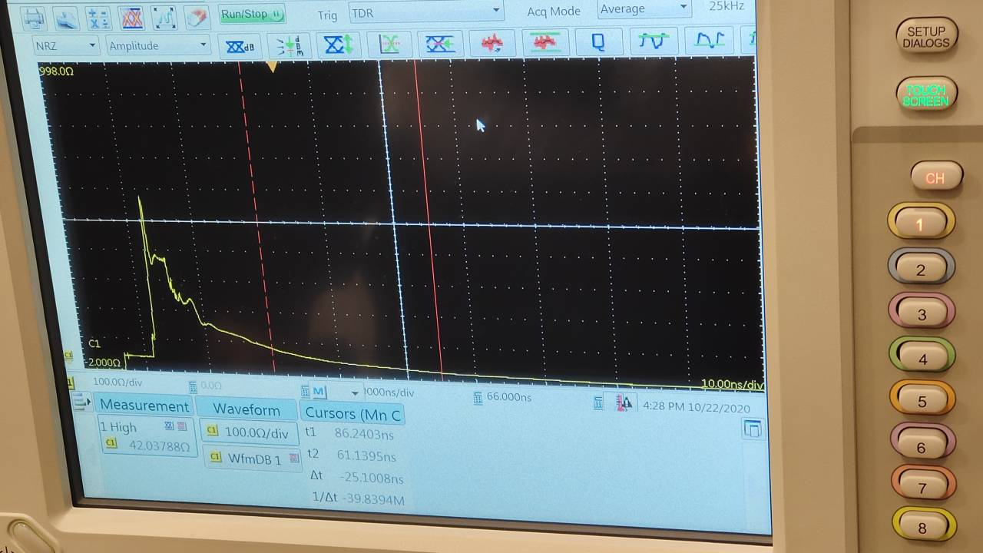

*Fig.3.1* waveform when tow conductors are near

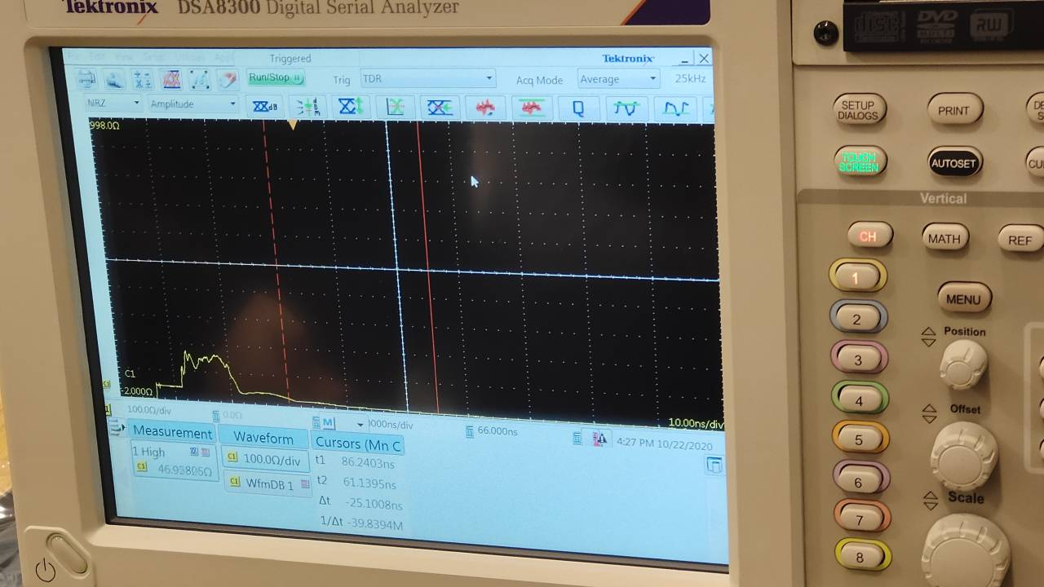

*Fig.3.2* waveform when tow conductors are a little far away then Fig.1

### Experimental Conclusion

* The closer the distance between the conductors, the higher the amplitude of the fluctuation
* The coupling between the two wires includes both electric field coupling and magnetic field coupling.
* Magnetic field coupling can be analyzed by mutual coupling inductance between two conductors, generally denoted by M.

# Crosstalk test

## Test 1

### Model and Problem



Measure: *V*12, *V*22

Observe: crosstalk phenomenon on TL2

### Result

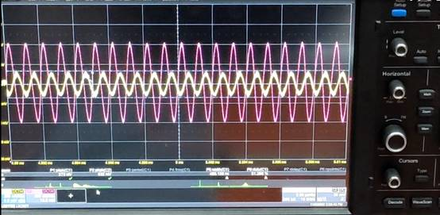

Peak to peak value of crosstalk signal *V22*=273*mV*

Peak value of interference line voltage *V12*=832*mV*

### Analysis

crosstalk signal appears on the receiving line.

* Crosstalk is the noise caused by coupling between two signal lines, liver protection and mutual capacitance between signal lines.Capacitive coupling leads to coupling current, while inductive coupling leads to coupling voltage.The parameters of PCB layer, the distance between signal lines, the electrical characteristics of driver and receiver, and the way of line termination have certain effects on crosstalk.
* Influencing factors: frequency of coupling and interference signal, cable spacing, distance to ground, cable shielding, etc

## Test 2

### Model and Problem



### Result

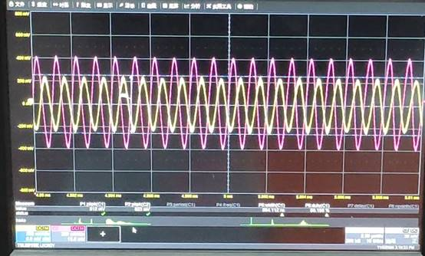

Peak to peak value of crosstalk signal *V22* = 512*mV*

Peak value of interference line voltage *V12* = 823*mV*

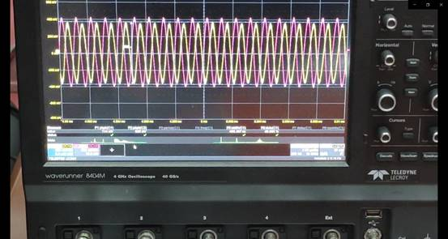

Peak to peak value of crosstalk signal *V22* = 744*mV*

Peak value of interference line voltage *V12* = 855*mV*

The experimental phenomena were as follows

When the distance between two lines decreases, the amplitude of crosstalk signal increases gradually

### Cause analysis

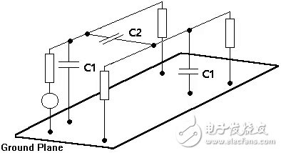

A capacitor is formed when two regular parallel plate conductors are filled with dielectric.In the case of PCB, capacitors will also be formed between the two traces and the reference plane. In the figure, C1 represents the capacitance formed between the trace and the reference plane, and C2 represents the capacitance formed between the two traces.From the point of view of capacitance, when a line voltage changes, it is equivalent to the voltage change at both ends of capacitor C2. When capacitor C2 is charged, there must be current on the adjacent conductor (the other end of capacitor), and the crosstalk will occur.The capacitance between the lines is closely related to the distance between the lines. When the spacing is reduced, the coupling capacitance increases rapidly and the coupling effect strengthens sharply.

## Test 3

### Model and problem



Change: frequency of signal source

Measure: V12, V22

Observe: crosstalk phenomenon on TL2

### result

When the signal of signal generator is reduced from 100MHz to 600kHz

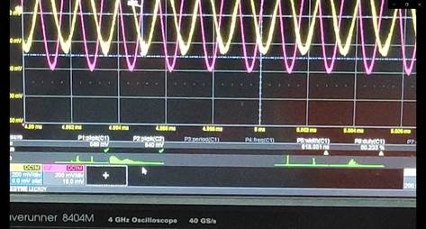

Peak to peak value of crosstalk signal *V22* = 589*mV*

Peak value of interference line voltage *V12* = 840*mV*

It can be seen that the peak value of crosstalk signal decreases from 744mv to 589mv compared with 1MHz

When the frequency continues to decrease to 300kHz

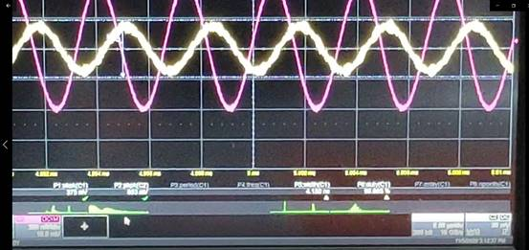

Peak to peak value of crosstalk signal *V22* = 375*mV*

Peak value of interference line voltage *V22* = 853*mV*

### Cause analysis

As the frequency increases, the capacitance reactance of coupling capacitance increases, which weakens the coupling effect and reduces the peak value of crosstalk signal

## Test 4

### Model and problem



Change: introduction of TL3 (Z31 = Z32 = 0)

Measure: V12, V22

Observe: suppression of crosstalk phenomenon on TL2

### result

When the third transmission line is not grounded (1MHz)

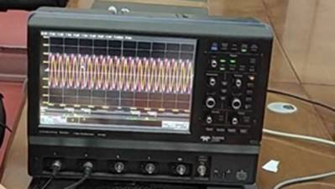

Fig 4.1 Waveforms of crosstalk signal and attack line signal

When the third transmission line is grounded (1MHz)

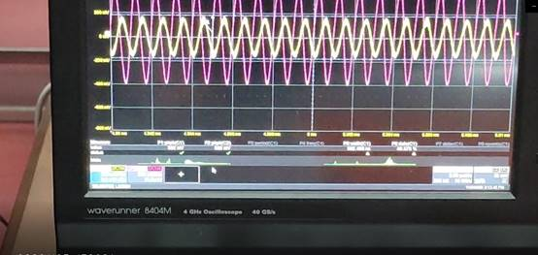

Fig.4.2 Waveforms of crosstalk signal and attack line signal

Peak to peak value of crosstalk signal *V22* = 362*mV*

Peak value of interference line voltage *V12* = 830*mV*

### Cause analysis

When the transmission line is grounded, the ground plane has shielding effect, so the peak value of crosstalk signal decreases.

## Question

If Z31, Z32 are not zero (low impedance/ high impedance/ open circuit), how will V12 and V22 change? Why?

### Answer

With the increase of terminal impedance, the voltage of V12 changes little, and the remote voltage of V22 increases. Because when the third wire is not connected, it is equivalent to the open circuit of the third wire, and the voltage of V2 becomes smaller after the third wire is connected.