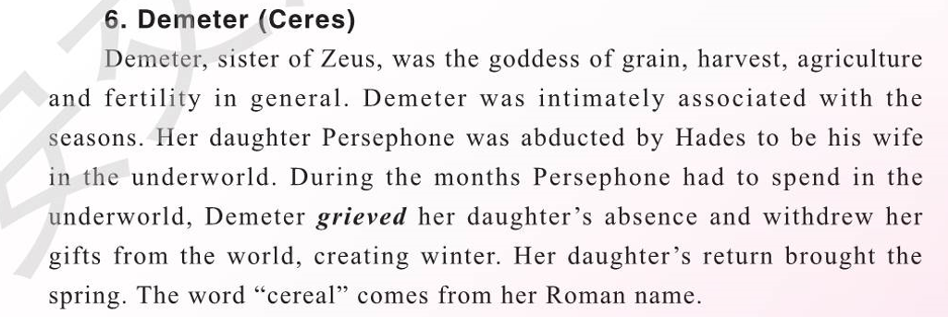

德墨忒尔

德墨忒尔（希腊语：Δήμητρα、英语：Demeter），是[古希腊神话](https://baike.baidu.com/item/%E5%8F%A4%E5%B8%8C%E8%85%8A%E7%A5%9E%E8%AF%9D/1962436" \t "_blank)中的农业、谷物和丰收的女神，[奥林匹斯十二主神](https://baike.baidu.com/item/%E5%A5%A5%E6%9E%97%E5%8C%B9%E6%96%AF%E5%8D%81%E4%BA%8C%E4%B8%BB%E7%A5%9E/34825)之一。

德墨忒尔教会人类耕种，给予大地生机。她具有无边的法力，可以使土地肥沃、植物茂盛、五谷丰登，也可以令大地枯萎、万物凋零、寸草不生。可以让人拥有享之不尽的财富，同时也可以让人家徒四壁、一贫如洗。

德墨忒尔是[克洛诺斯](https://baike.baidu.com/item/%E5%85%8B%E6%B4%9B%E8%AF%BA%E6%96%AF/3399553" \t "_blank)和[瑞亚](https://baike.baidu.com/item/%E7%91%9E%E4%BA%9A/4626933)的女儿，[赫斯提亚](https://baike.baidu.com/item/%E8%B5%AB%E6%96%AF%E6%8F%90%E4%BA%9A/1310019)的妹妹，[赫拉](https://baike.baidu.com/item/%E8%B5%AB%E6%8B%89/550771)、[哈迪斯](https://baike.baidu.com/item/%E5%93%88%E8%BF%AA%E6%96%AF/36717)、[波塞冬](https://baike.baidu.com/item/%E6%B3%A2%E5%A1%9E%E5%86%AC/21434)和[宙斯](https://baike.baidu.com/item/%E5%AE%99%E6%96%AF/82054)的姐姐，后与宙斯生下了冥后[珀耳塞福涅](https://baike.baidu.com/item/%E7%8F%80%E8%80%B3%E5%A1%9E%E7%A6%8F%E6%B6%85)。

**In ancient Greek religion and mythology, Demeter is the goddess of the harvest and agriculture, presiding over grains and the fertility of the earth.**

**Demeter, in Greek religion, daughter of the deities Cronus and Rhea, sister and consort of Zeus (the king of the gods), and goddess of agriculture. Her name indicates that she is a mother.**

**Though Demeter is often described simply as the goddess of the harvest, she presided also over the sacred law, and the cycle of life and death. She and her daughter Persephone were the central figures of the Eleusinian Mysteries, a religious tradition that predated the Olympian pantheon, and which may have its roots in the Mycenaean period c. 1400–1200 BC.[4] Demeter was often considered to be the same figure as the Anatolian goddess Cybele, and in Rome she was identified as the Latin goddess Ceres.**

**Demeter is rarely mentioned by Homer, nor is she included among the Olympian gods, but the roots of her legend are probably ancient. The legend centred on the story of her daughter Persephone, who was carried off by Hades, the god of the underworld.**

**Both Homer and Hesiod described Persephone as the daughter of Zeus and his older sister, Demeter,[63] though no myths exist describing her conception or birth. The exception is a fragment of the lost Orphic theogony, which preserves part of a myth in which Zeus mates with his mother, Rhea, in the form of a snake, explaining the origin of the symbol on Hermes' staff. Their daughter is said to be Persephone, whom Zeus in turn mates with to conceive Dionysus. According to the Orphic fragments, "After becoming the mother of Zeus, she who was formerly Rhea became Demeter."[64][65]**

**Before her abduction by Hades, Persephone was known as Kore ("maiden"), and there is some evidence that the figures of Persephone Queen of the Underworld and Kore daughter of Demeter were originally considered separate goddesses.[66] However, they must have become conflated with each other by the time of Hesiod in the 7th century BC.[61] Demeter and Persephone were often worshiped together and were often referred to by joint cultic titles. In their cult at Eleusis, they were referred to simply as "the goddesses", often distinguished as "the older" and "the younger"; in Rhodes and Sparta, they were worshiped as "the Demeters"; in the Thesmophoria, they were known as "the thesmophoroi" ("the legislators").[67] In Arcadia they were known as "the Great Goddesses" and "the mistresses".[68] In Mycenaean Pylos, Demeter and Persephone were probably called the "queens" (wa-na-ssoi).[46]**

