## 









   





  



   





  



















 





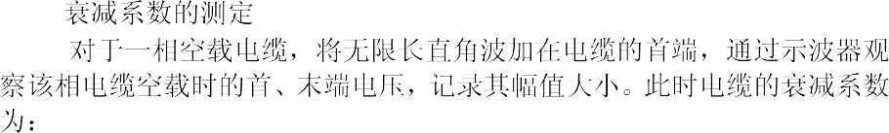

## 



*U*

2*U*





   



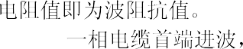

  



 

# *U R*



2 *U*

*R*

*ZC R*

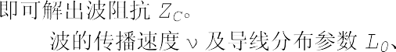

   





2*l*



 *l *

*T*

*L*0 *C*0

*ZC*





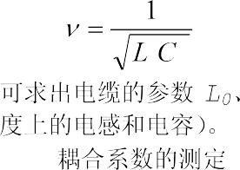

0 0



 





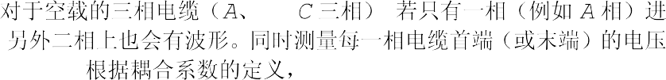

*K UB*

*AB U*

*A*

*K UC*

*AC U*

*A*

*KAB*



*UB*

*U A Z AA*



*Z AB*

*AB*

*UC*

*K AC*

*U*

*A*

*ZAC*

*Z AC Z AA*

*ZAA*



## 

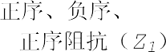

  

  



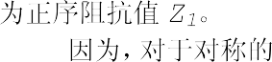*A B C *

*AA BB CC S*



*AB BA AC M*





*uA iAZAA*

*iBZBA*

*iC ZCA*

*iAZS iAZS*

(*iB*

*iAZM*

*iC* )*ZM*

*iA* (*ZS*



*ZM* )

*u A*

*Z*1 *Z A*

*i*

*A*



*ZS ZM*

*uA iAZS*

*iBZM*

*iC ZM*

*iB i A iC* 0

*iAZS iA* (*ZS*

( *iA* )*ZM ZM* )

# *Z u A*



*A*

*i A*

*Z S ZM Z*1



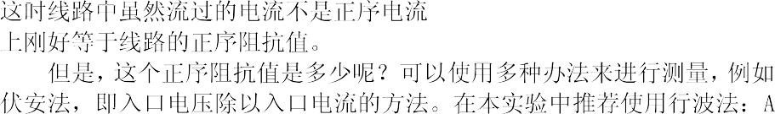

1



*R*1 *Z*1



Z1 *iA*



R1

|  |  |  |  |  |
| --- | --- | --- | --- | --- |
| Z1 | | *iB* |  | *iA* |
|  | *iC* | | 0 | |





*Z* 2 *Z*1

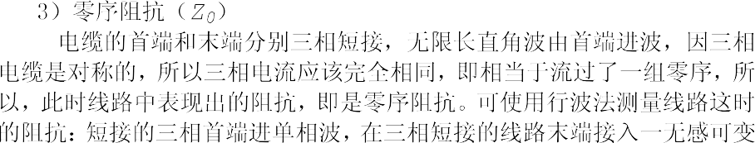

*R*0

*Z* 0 3*R*0



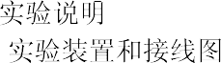R0



*iA*

Z0

Z0

*iC iA*

Z0

*iB iA*





















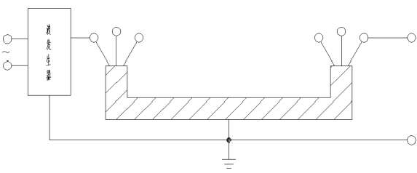

 







 













2

1 2



*U Z* 2 *Z*1



*U Z*1 *Z* 2





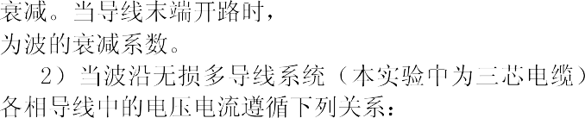

*uA iAZAA*

*uB iAZAB*

*uC iAZAC*

*iBZBA iBZBB iBZBC*

*iC ZCA iC ZCB iC ZCC*

*UB*



*K AB*

*U*

*A*

*UC*

*K AC*

*U*

*A*



*Z AB Z AA Z AC Z AA*

*iB=iC=*0 





 

 











 









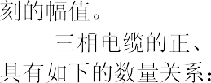

1 2



*Z* 0 *ZS*

*S M*

2*ZM*



*K ZM ZS*







 























 





  

