

***Using the CROW – Information for Clerical Matchers***

Instructions for Clerical Matchers to run the clerical matching script are as followed:

1. Open a Python IDE (e.g. Spyder, Visual Studio Code) within your work environment. **NOTE: Steps 2-3 are shown in the Spyder IDE.**
2. Click the ‘Open’ button in your IDE and navigate to the project folder where the CROW python file you are using exists.
3. In Spyder the open button is here:

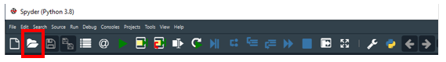

1. Click the ‘Run’ button in your IDE and run the script.
2. In Spyder the run button is here:

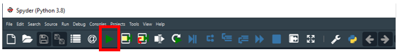

1. Wait for the Intro window to display on your monitor. **TIP: Sometimes this may not appear right away and instead will just appear as a open tab at the menu bar at the bottom of your screen. Simply click that to open it if that is the case.**When you are ready please click ‘Choose File’ to choose your file.

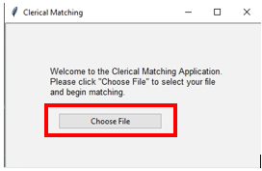

1. Choose a matching file and click ‘Open’.

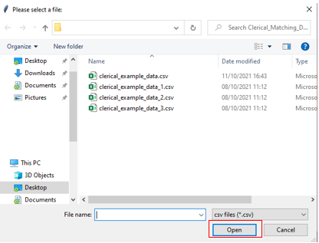

***Note:*** files in your directory marked with different user initials to yours and ‘_inProgress’ or ‘_DONE’ are being worked on by others and should not be chosen.

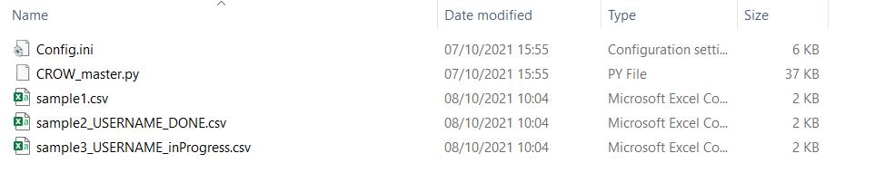

1. Once the file has opened a window should appear that will contain a Tools section and a Current Record section (see picture below). The Tools section contains lots of useful functions for you to use and the Current Record section contains the current record pairs for you to review separated onto their own rows.

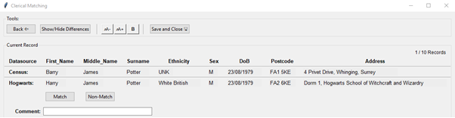

In the Tools section there are the following buttons for you to use:

* Go back to Previous record matches using the C:\Users\scottc1\AppData\Local\Microsoft\Windows\INetCache\Content.MSO\68EE1ED3.tmp button. For instance, if you feel that you have made a mistake, then you can click the ‘Back’ button to go back and change your decision.
* Show/hide differences between record pairs using the C:\Users\scottc1\AppData\Local\Microsoft\Windows\INetCache\Content.MSO\8B879359.tmp button. This will highlight differences between the first row and subsequent dataset rows and text will be highlighted where there is a difference. **Note**: that this highlights text characters in place.

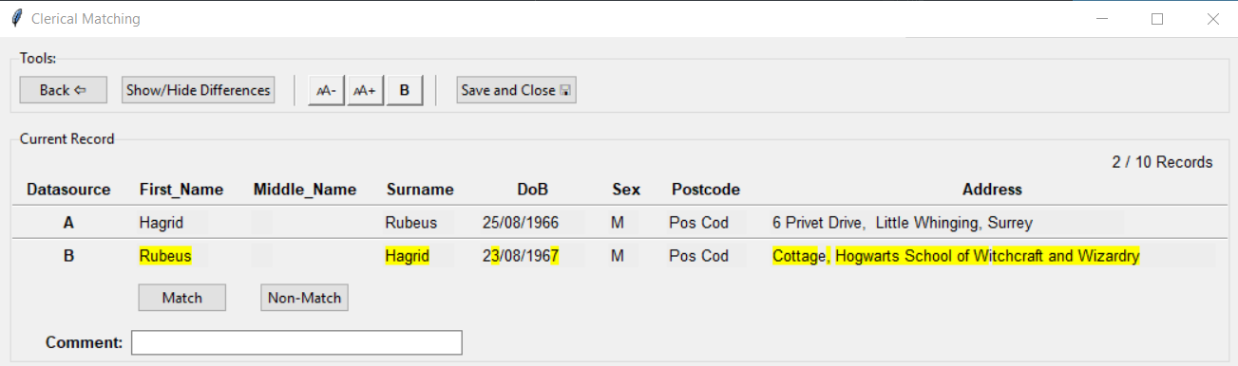

* Make the text smaller, bigger or **Bold**using the following buttons

C:\Users\scottc1\AppData\Local\Microsoft\Windows\INetCache\Content.MSO\EA6B91B5.tmp

* Save and Close your current matches using the C:\Users\scottc1\AppData\Local\Microsoft\Windows\INetCache\Content.MSO\8C11A28B.tmp button. At any time you can click ‘Save and Close’ and your progress will be saved. You can then come back to that file later and the filename will be marked as ‘_[your_userID]_inProgress.csv’

In the Current Record section you can:

* Begin matching by first reviewing the presented record pairs and advancing onto the next one by clicking either the Match or Non-Match buttons highlighted below.

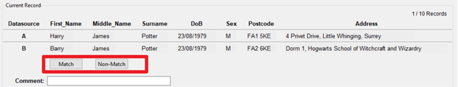

* If your project leader has opted for the Comment Box version - you can use that comment box to add information that you might feel is useful for that record pair. This comment will appear in a row adjacent to your records in the CSV file.

C:\Users\scottc1\AppData\Local\Microsoft\Windows\INetCache\Content.MSO\BCF64B07.tmp

* If you click the ‘X’ in the top right of the window, a window will appear asking ‘Are you sure you want to exit WITHOUT saving?’ (see picture below). You should proceed by clicking ‘No’ and then clicking ‘Save and Close’ so to avoid losing the matches you have made. Alternatively, if you don’t want to save your progress, click ‘Yes’.

