BHASKARACHARYA NATIONAL INSTITUTE FOR SPACE APPLICATIONS AND GEO-INFORMATICS
WEEKLY PROGRESS REPORT
(18/05/2026 – 22/05/2026)
WEEK 1
PROJECT NAME | AUTOMATIC GEO-REFERENCING
PROJECT DESCRIPTION : | Manual georeferencing in QGIS requires human selection of Ground Control Points (GCPs) — a time-consuming and error-prone process. This project automates GCP detection using SIFT feature matching and RANSAC, fetches satellite reference tiles for a given geographic bounding box, computes the geometric transformation automatically, and produces a georeferenced GeoTIFF output without any manual intervention.
GROUP MEMBER : | Chirag Jindani, Vedant Pathak
GROUP ID :
GROUP GUIDE : | Dr. Manoj Pandya
GROUP COORDINATOR :
COLLEGE GUIDE NAME : | Dr. Shweta Saharan
COLLEGE GUIDE No. : | 9509676076
COLLEGE GUIDE EMAIL : | shweta.saharan@gsv.ac.in
COLLEGE NAME : | GatiShakti Vishwavidyalaya, Vadodara
DATE | WORK DONE
18/05/2026 | Received project brief on Automatic Geo-Referencing. Understood the existing manual georeferencing workflow in QGIS — how Ground Control Points (GCPs) are selected manually, how transformation is computed, and how the GeoTIFF output is produced.
19/05/2026 | Research and exploration day. Studied GeoTIFF format and the spatial metadata it carries (CRS, affine transform matrix). Studied EPSG:4326 and EPSG:3857 coordinate systems. Studied GDAL architecture, its core tools gdal_translate and gdalwarp, and Rasterio as a Python wrapper over GDAL. Studied the Google Maps XYZ tile system — zoom levels, tile coordinate math, and satellite tile URL format.
20/05/2026 | Met with project guide Dr. Manoj Pandya. Clarified exact project scope — given a raw image and a confined geographic bounding box, automatically detect corresponding GCPs between the image and satellite reference tiles without any human input. Studied SIFT feature detection, descriptor computation, and Lowe's ratio test. Studied RANSAC for filtering geometrically inconsistent matches and retaining reliable inliers.
21/05/2026 | Designed the full automatic pipeline architecture: (1) input image + bounding box → (2) fetch and stitch Google satellite tiles → (3) SIFT feature extraction on both → (4) BFMatcher + Lowe ratio test → (5) RANSAC filtering → (6) homography computation → (7) pixel-to-GPS coordinate mapping → (8) GeoTIFF output via Rasterio. Finalized tech stack: Python, opencv-contrib-python, Pillow, NumPy, requests, Rasterio, GDAL. Studied QGIS verification workflow for output validation.
22/05/2026 | Set up Python development environment on Windows — installed opencv-contrib-python, Pillow, NumPy, requests, matplotlib via pip. Implemented XYZ tile coordinate conversion math and tile fetching logic using Google satellite tile URLs. Implemented tile stitching — assembling a grid of downloaded tiles into a single reference image using NumPy.  - Tested the tile fetch and stitch pipeline on a Manhattan bounding box and verified the output visually.  - Tested the tile fetch and stitch pipeline on an area in Vadodara - bounding box and verified the output visually.
23/05/2026 | Holiday (Saturday)
24/05/2026 | Holiday (Sunday)
Next Week Plan | Run the complete SIFT + RANSAC + homography pipeline on a real provided image over a larger area (city scale). Validate feature matching quality — number of inliers and match confidence score. Produce a correctly georeferenced GeoTIFF output and verify alignment in QGIS. Begin development of the two-panel interactive dashboard (Leaflet.js satellite map + image viewer with numbered GCP correspondence visualization).

REFERENCES :
1. Yong Hu et al., "A Fast and Reliable Matching Method for Automated Georeferencing of Remotely-Sensed Imagery," Remote Sensing, MDPI, 2016.
https://www.mdpi.com/2072-4292/8/1/56
2. OpenCV Documentation — Feature Matching + Homography to find Objects (SIFT + RANSAC).
https://docs.opencv.org/3.4/d1/de0/tutorial_py_feature_homography.html
3. Rasterio Documentation — Georeferencing raster datasets (CRS and affine transforms).
https://rasterio.readthedocs.io/en/stable/topics/georeferencing.html
4. Rasterio Python Quickstart — Reading and writing GeoTIFF files.
https://rasterio.readthedocs.io/en/stable/quickstart.html
5. GeeksforGeeks — Step-by-Step Guide to Using RANSAC in OpenCV using Python.
https://www.geeksforgeeks.org/python/step-by-step-guide-to-using-ransac-in-opencv-using-python/

SCREENSHOTS
EX 1 -  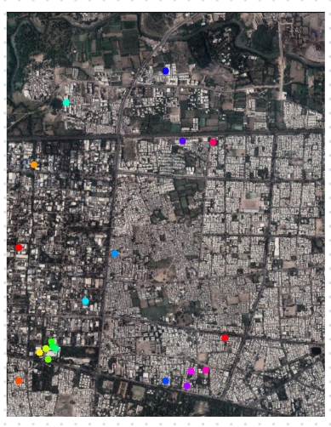  SATELLITE EXTRACTED 2026 | EX 1 -  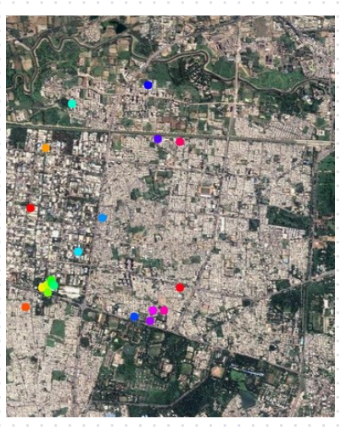  SATELLITE EXTRACTED 2020
------------------------------------ | ------------------------------------
EX 2 -  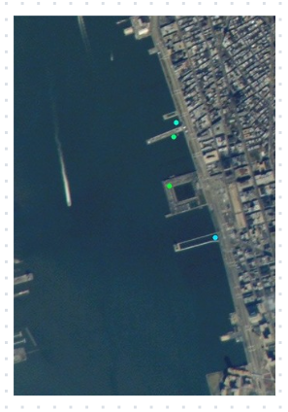  MANHATTAN IMAGE FROM NET  ------------------------------------ | EX 2 –  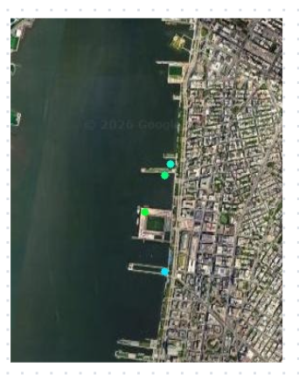  SATELLITE IMAGE EXTRACTED REAL TIME  ------------------------------------

