
O/o the Inspector General of Police,
Cyber Centre of Excellence,
7th Floor, Block-2, Karmyogi Bhavan,
Sector-10 A, Gandhinagar-382010,
Phone No: 079-23250798
E-Mail: helpline-cyber-cid@gujarat.gov.in

No. CCoE/1930/DR/01/01/2000 Date: 01-01-2000
Notice u/s 94 BNSS read with Section 168 BNSS
To,
All Nodal Officer,
Subject: Provision of Know Your Customer (KYC) Details of Account Holder(s).
This office has received an intimation through NCCRP regarding a suspicious/fraudulent transaction linked to the bank account(s) mentioned below. In this connection, you are hereby directed to furnish the Know Your Customer (KYC) details — including Name, Address, and Mobile Number — of the concerned account holder(s) at the earliest.
Suspect Account Details:
Sr.  No. | ACK. No. | Account No. | Bank Name
1. | 00000000000000 | 00000000000000 | Template Bank

You are instructed to comply with this notice and provide the above information without delay, as required under Section 168 BNSS read with Section 94 BNSS.
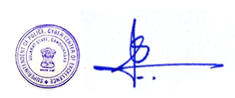

(Sanjaykumar Keshvala),
Superintendent of Police,
Cyber Center of Excellence,
Gandhinagar, Gujarat State.

