**Group 2**

(Aditya Jha - 11010102, Harshil Lodhi - 11010121, Shobhit Chaurasia - 11010179)

PLACEMENT PORTAL

ER-Diagram

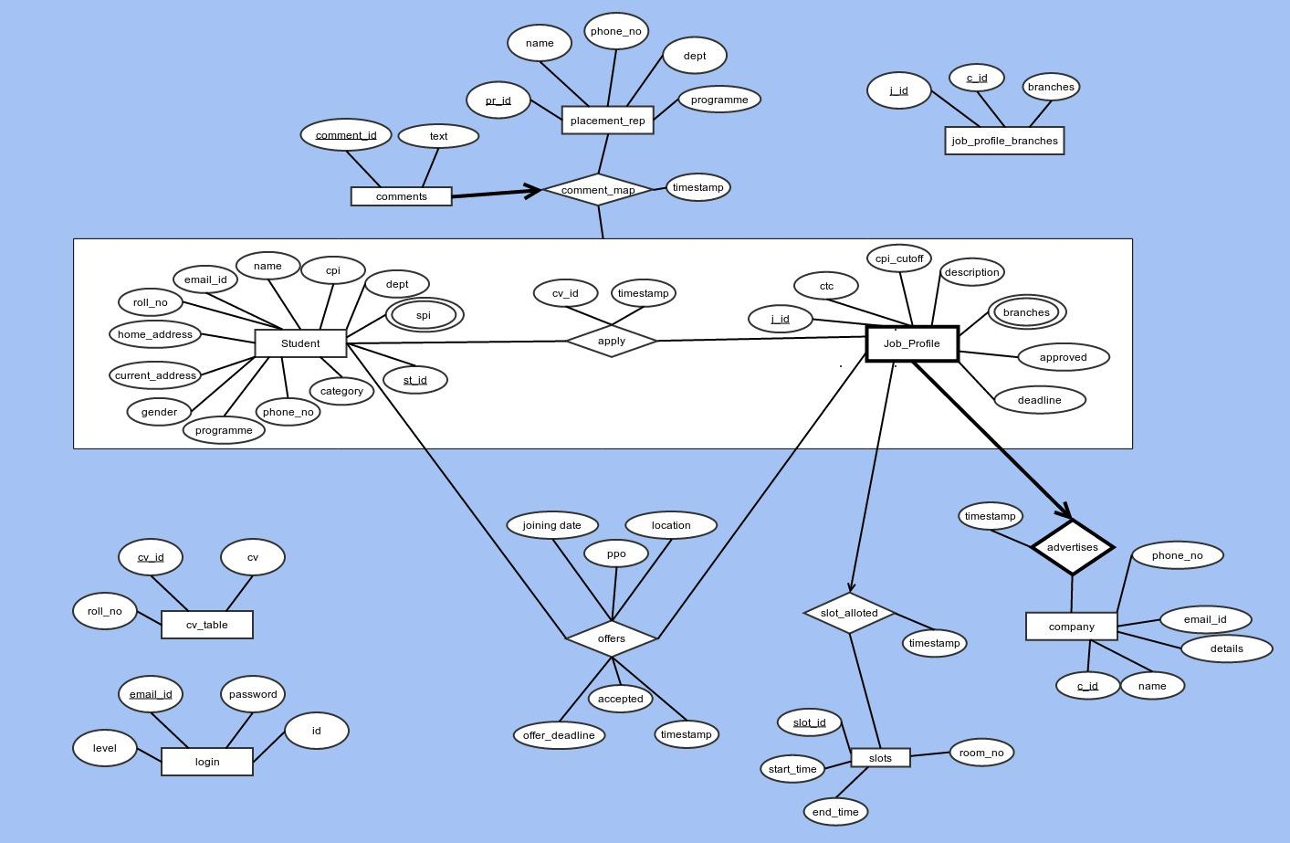

### DDL for each table ….

drop table comments;

drop table offers;

drop table slot_alloted;

drop table ppt_slots;

drop table slots;

drop table IF EXISTS placement_rep;

drop table IF EXISTS apply;

drop table IF EXISTS cv_table;

drop table IF EXISTS job_profile_branches;

drop table IF EXISTS job_profile;

drop table IF EXISTS company;

drop table IF EXISTS student;

drop table IF EXISTS login;

create table login(

id int unique not null auto_increment,

email_id varchar(50) not null,

level int not null,

password varchar(32) not null,

constraint login_pk primary key(email_id)

);

create table student (

roll_no int not null unique,

st_id int,

name varchar(50) not null,

gender enum('M','F') not null default 'F',

cpi decimal(3,2) not null,

dept enum('CSE', 'MNC', 'EEE', 'ECE', 'CL', 'CE', 'EP','BT','DOD','ME','CST','HSS') not null,

programme enum('BTECH','MTECH','PhD','MSc','BSc','BA','MA') not null,

category enum('GEN','SC','ST','OBC','PD') not null,

phone_no bigint(10),

current_address varchar(200) not null,

home_address varchar(200) not null,

constraint student_pk primary key(st_id),

constraint student_fk foreign key(st_id) references login(id) on delete cascade on update cascade

);

create table company (

c_id int not null,

name varchar(50) not null,

details varchar(1000),

phone_no bigint(10) not null,

email_id varchar(50) not null,

constraint company_pk primary key(c_id),

constraint company_fk foreign key(c_id) references login(id) on delete cascade on update cascade

);

create table job_profile (

j_id int not null auto_increment,

ctc int not null,

cpi_cutoff decimal(3,2) default 0,

description varchar(500),

approved enum('Y','N', 'P') default 'P',

tstamp timestamp not null default current_timestamp on update current_timestamp,

c_id int not null,

deadline datetime not null,

constraint job_profile_pk primary key(j_id,c_id),

constraint job_profile_fk foreign key(c_id) references company(c_id) on delete cascade on update cascade

);

create table job_profile_branches (

j_id int not null,

c_id int not null,

dept enum('CSE', 'MNC', 'EEE', 'ECE', 'CL', 'CE', 'EP','BT','DOD','ME','CST','HSS', 'ALL'),

constraint job_profile_branches_pk primary key(j_id, c_id, dept),

constraint job_profile_branches_fk1 foreign key (j_id) references job_profile(j_id) on delete cascade on update cascade,

constraint job_profile_branches_fk2 foreign key (c_id) references company(c_id) on delete cascade on update cascade

);

create table cv_table(

st_id int not null,

cv_id int auto_increment,

cv varchar(1000),

cv_name varchar(50) not null,

constraint cv_table_pk primary key(cv_id),

constraint cv_table_fk foreign key (st_id) references student(st_id) on delete cascade on update cascade

);

create table apply(

st_id int not null,

j_id int not null,

c_id int not null,

cv_id int not null,

tstamp timestamp default current_timestamp on update current_timestamp,

constraint apply_pk primary key(st_id,j_id, c_id),

constraint apply_fk1 foreign key (j_id) references job_profile(j_id) on delete cascade on update cascade,

constraint apply_fk2 foreign key (c_id) references company(c_id) on delete cascade on update cascade,

constraint apply_fk3 foreign key (st_id) references student(st_id) on delete cascade on update cascade,

constraint apply_fk4 foreign key (cv_id) references cv_table(cv_id)

);

create table placement_rep (

name varchar(50) not null,

phone_no bigint(10) not null,

pr_id int not null,

dept enum('CSE', 'MNC', 'EEE', 'ECE', 'CL', 'CE', 'EP','BT','DOD','ME','CST','HSS') not null,

programme enum('BTECH','MTECH','PhD','MSc','BSc','BA','MA') not null,

constraint placement_rep_pk primary key(pr_id),

constraint placement_rep_fk foreign key (pr_id) references login(id) on delete cascade on update cascade

);

create table slots (

slot_id int not null auto_increment,

room_no varchar(20) not null,

start_time datetime not null,

end_time datetime not null,

constraint slots_pk primary key(slot_id)

);

create table ppt_slots(

slot_id int not null,

c_id int not null unique,

constraint ppt_slots_pk primary key(slot_id),

constraint ppt_slots_fk1 foreign key (c_id) references company(c_id) on delete cascade on update cascade,

constraint ppt_slots_fk2 foreign key (slot_id) references slots(slot_id) on delete cascade on update cascade

);

create table slot_alloted(

slot_id int not null,

c_id int not null,

j_id int not null,

constraint slot_alloted_pk primary key(slot_id),

constraint slot_alloted_fk1 foreign key (c_id) references company(c_id) on delete cascade on update cascade,

constraint slot_alloted_fk2 foreign key (slot_id) references slots(slot_id) on delete cascade on update cascade,

constraint slot_alloted_fk3 foreign key (j_id) references job_profile(j_id) on delete cascade on update cascade

);

create table offers(

st_id int not null,

c_id int not null,

j_id int not null,

joining_date datetime,

ppo enum('Y','N') not null,

location varchar(50),

accepted enum('Y','N') not null default 'N',

offer_deadline datetime not null,

tstamp timestamp default current_timestamp on update current_timestamp,

constraint offers_pk primary key(st_id,j_id, c_id),

constraint offers_fk1 foreign key (j_id) references job_profile(j_id) on delete cascade on update cascade,

constraint offers_fk2 foreign key (c_id) references company(c_id) on delete cascade on update cascade,

constraint offers_fk3 foreign key (st_id) references student(st_id) on delete cascade on update cascade

);

create table comments(

comment_id int not null auto_increment,

txt varchar(1000) not null,

st_id int not null,

c_id int not null,

j_id int not null,

pr_id int not null,

tstamp timestamp default current_timestamp on update current_timestamp,

constraint comment_map_pk primary key(comment_id),

constraint comment_map_fk1 foreign key (j_id) references job_profile(j_id) on delete cascade on update cascade,

constraint comment_map_fk2 foreign key (c_id) references company(c_id) on delete cascade on update cascade,

constraint comment_map_fk3 foreign key (st_id) references student(st_id) on delete cascade on update cascade,

constraint comment_map_fk4 foreign key (pr_id) references placement_rep(pr_id) on delete cascade on update cascade

);

## VIEWS

### -- views for job Profiles for each dept ….

create view cseJobProfiles as select j.c_id, j.j_id from job_profile as j, job_profile_branches as jb where j.j_id = jb.j_id and j.c_id = jb.c_id and jb.dept = "CSE";

create view eceJobProfiles as select j.c_id, j.j_id from job_profile as j, job_profile_branches as jb where j.j_id = jb.j_id and j.c_id = jb.c_id and jb.dept = "ECE";

create view eeeJobProfiles as select j.c_id, j.j_id from job_profile as j, job_profile_branches as jb where j.j_id = jb.j_id and j.c_id = jb.c_id and jb.dept = "EEE";

create view mncJobProfiles as select j.c_id, j.j_id from job_profile as j, job_profile_branches as jb where j.j_id = jb.j_id and j.c_id = jb.c_id and jb.dept = "MNC";

create view meJobProfiles as select j.c_id, j.j_id from job_profile as j, job_profile_branches as jb where j.j_id = jb.j_id and j.c_id = jb.c_id and jb.dept = "ME";

create view cstJobProfiles as select j.c_id, j.j_id from job_profile as j, job_profile_branches as jb where j.j_id = jb.j_id and j.c_id = jb.c_id and jb.dept = "CST";

create view clJobProfiles as select j.c_id, j.j_id from job_profile as j, job_profile_branches as jb where j.j_id = jb.j_id and j.c_id = jb.c_id and jb.dept = "CL";

create view ceJobProfiles as select j.c_id, j.j_id from job_profile as j, job_profile_branches as jb where j.j_id = jb.j_id and j.c_id = jb.c_id and jb.dept = "CE";

create view hssJobProfiles as select j.c_id, j.j_id from job_profile as j, job_profile_branches as jb where j.j_id = jb.j_id and j.c_id = jb.c_id and jb.dept = "HSS";

create view dodJobProfiles as select j.c_id, j.j_id from job_profile as j, job_profile_branches as jb where j.j_id = jb.j_id and j.c_id = jb.c_id and jb.dept = "DOD";

create view epJobProfiles as select j.c_id, j.j_id from job_profile as j, job_profile_branches as jb where j.j_id = jb.j_id and j.c_id = jb.c_id and jb.dept = "EP";

create view btJobProfiles as select j.c_id, j.j_id from job_profile as j, job_profile_branches as jb where j.j_id = jb.j_id and j.c_id = jb.c_id and jb.dept = "BT";

### -- views for Offers of each dept ….

create view cseOffers as select o.c_id, o.j_id, o.st_id from offers as o, student as s where o.st_id = s.st_id and s.dept = "CSE";

create view eceOffers as select o.c_id, o.j_id, o.st_id from offers as o, student as s where o.st_id = s.st_id and s.dept = "ECE";

create view eeeOffers as select o.c_id, o.j_id, o.st_id from offers as o, student as s where o.st_id = s.st_id and s.dept = "EEE";

create view mncOffers as select o.c_id, o.j_id, o.st_id from offers as o, student as s where o.st_id = s.st_id and s.dept = "MNC";

create view meOffers as select o.c_id, o.j_id, o.st_id from offers as o, student as s where o.st_id = s.st_id and s.dept = "ME";

create view cstOffers as select o.c_id, o.j_id, o.st_id from offers as o, student as s where o.st_id = s.st_id and s.dept = "CST";

create view clOffers as select o.c_id, o.j_id, o.st_id from offers as o, student as s where o.st_id = s.st_id and s.dept = "CL";

create view ceOffers as select o.c_id, o.j_id, o.st_id from offers as o, student as s where o.st_id = s.st_id and s.dept = "CE";

create view hssOffers as select o.c_id, o.j_id, o.st_id from offers as o, student as s where o.st_id = s.st_id and s.dept = "HSS";

create view dodOffers as select o.c_id, o.j_id, o.st_id from offers as o, student as s where o.st_id = s.st_id and s.dept = "DOD";

create view epOffers as select o.c_id, o.j_id, o.st_id from offers as o, student as s where o.st_id = s.st_id and s.dept = "EP";

create view btOffers as select o.c_id, o.j_id, o.st_id from offers as o, student as s where o.st_id = s.st_id and s.dept = "BT";

### view for slots….

create view slot_time as (select s.*, sa.j_id,sa.c_id from slot_alloted sa, slots s where s.slot_id = sa.slot_id);

**Some queries for displaying statisctics ….**

**DEPT WISE :-**

#registered students

select count(*), dept from student group by dept

#total offers

select count(*), s.dept from offers as o, student as s where o.st_id = s.st_id

group by s.dept

#actual no. of students placed

select count(*), s.dept from (select distinct(oTemp.st_id) from offers as oTemp) as o, student as s

where o.st_id = s.st_id

group by s.dept

#%age placed

#average salary

select s.dept, avg(j.ctc) from offers as o, student as s, job_profile as j where j.j_id = o.j_id and j.c_id = o.c_id and o.st_id = s.st_id group by s.dept

#company wise no. of offers

select temp.cnt, c.name from (select count(*) as cnt, o.c_id from offers as o group by o.c_id) as temp, company as c

where c.c_id = temp.c_id

**Some other Queries**

* Display all the applications for a company

select * from apply as a, student as s, job_profile as j where s.st_id = a.st_id and a.j_id = j.j_id and a.c_id = j.c_id and j.c_id = 2

* Display all the application for a job profile

select * from apply as a, student as s, job_profile as j where s.st_id = a.st_id and a.j_id = j.j_id and a.c_id = j.c_id and j.c_id = 2 and j.j_id = 1

* Show pending application

select * from company as c,job_profile as j where c.c_id = j.c_id and j.approved='P'

* Update to make a job profile approved.

UPDATE `job_profile` SET `approved`='Y' where j_id = 1 and c_id = 2

* See all the offers which a company has made, along with yes or no from student

select * from offers as o, student as s, job_profile as j

where o.c_id=1 and s.st_id = o.st_id and o.j_id = j.j_id and o.c_id = j.c_id

* See all the students who were not offered job by a company

select * from student as s1 where s1.st_id in

(

select a.st_id from apply as a, job_profile as j1 where a.j_id = j1.j_id and a.c_id = j1.c_id and j1.c_id = 2 and a.st_id not in (

select o.st_id from offers as o, job_profile as j2

where o.c_id=2 and o.j_id = j2.j_id and o.c_id = j2.c_id

)

)