A Project Synopsis On

## Car Price Predictor

Second Year of Engineering In

Department of Electronics and Computer Science

Submitted By

**Chirag Wadkar**

Supervisor

**Guide: Prof. Suchitra Patil**



### Department of Electronics and Computer Science PILLAI COLLEGE OF ENGINEERING

### New Panvel – 410 206

**Academic Year 2023 – 24**



DEPARTMENT OF ELECTRONICS AND COMPUTER SCIENCE

Pillai College of Engineering New Panvel – 410 206

CERTIFICATE

This is to certify that the requirements for the BE Project entitled ‘**Car Price Predictor**’ have been successfully completed by the following students.

|  |  |
| --- | --- |
| **Name** | **Admission No.** |
| Chirag Wadkar | 2020PE0280 |

In partial fulfillment of Bachelor of Engineering of Mumbai University in the Department of Electronics and Computer Science, Pillai College of Engineering, New Panvel – 410 206 during the Academic Year 2020-2021.

**Supervisor Prof. Suchitra Patil**

**DECLARATION**

We declare that this written submission for Mini Project entitled “**Car Price Predictor**” represents our ideas in our own words and where others' ideas or words have been included. We have adequately cited and referenced the original sources. We also declare that we have adhered to all principles of academic honesty and integrity and have not misrepresented or fabricated or falsified any ideas / data / fact / source in our submission. We understand that any violation of the above will cause disciplinary action by the institute and also evoke penal action from the sources which have not been properly cited or from whom prior permission has not been taken when needed.

Project Group

Member:

Chirag Wadkar & Sign,

Date:

Place:

**CONTENTS**

1. Abstract & Objective. v
2. Goals vii
3. Need of the System viii
4. Purpose… ix

6. Project Scope……………………………………………………………… x

7. Modules…………………………………………………………………… x

1. Frontend (Language Used)……………………………………………… xi
2. Software Use & Snapshots of working Project xii
3. Use Cases xiv
4. Conclusion & Future Scope xv
5. References xvi
6. Acknowledgement xvii
7. **ABSTRACT**

Currently, owning a car is a necessity, as it plays a significant role in human transportation for different purposes such as going to work and to the hospital. However, with the current economic challenges, buying expensive cars can be a burden. The car market has shifted toward more affordable used cars. Due to the increasing number of used cars being sold, the price of used cars has become a major issue that could affect our sustainable way of living. The objective of this research is to understand the impact of the problem and to find empirical solutions by implementing a variety of machine learning techniques and big data tools on the prices of used cars.

There has been related work done with machine learning algorithms like linear regression, multiple regression, random forest and so on. We wanted to study which algorithm predicts the car price more reliably and accurately. So that this solution will be helpful for first time used car buyers and also for sellers for determining the selling cost of the car. In this project, we develop a linear regression model that can estimate used car prices based on various features such as Company, Model, Purchase Year and Distance_Travelled.

1. **OBJECTIVE**

The primary objective of the Car Price Predictor project is to develop a robust and user-friendly system that leverages Simple Linear Regression to predict the selling prices of used cars based on key features, specifically manufacturing year. The goal is to provide valuable insights to potential buyers, sellers, and other stakeholders in the automotive industry. By utilizing a diverse and comprehensive dataset, the project aims to create a predictive model capable of accurately estimating car prices, thus assisting buyers in making informed decisions and sellers in devising competitive pricing strategies. The integration of Flask, HTML, CSS, Bootstrap, and AJAX in the project's frontend ensures an intuitive user interface, facilitating seamless interactions with the predictive model. The objective also extends to enhancing market research capabilities, aiding dealerships in inventory management, and providing valuable information to insurance companies for assessing the value of insured vehicles. Additionally, the project aims to contribute to financial decision-making processes by offering potential car buyers insights into the estimated future values of cars, thus fostering a more transparent and informed used car market. Overall, the Car Price Predictor project aspires to be a valuable tool for multiple stakeholders, contributing to a more efficient and data-driven approach to buying and selling used cars.

# GOALS

The primary goal of this project is to comprehensively investigate, analyze, and present the development and performance of a Car Price Predictor utilizing linear regression and real-world automotive data. This study aims to achieve the following objectives:

1. Develop a predictive model capable of estimating car selling prices based on relevant features, with a focus on the impact of linear regression in this context.
2. Evaluate the effectiveness of the model in handling diverse scenarios, emphasizing the challenges and solutions associated with predicting prices for specific car models in certain years.
3. Assess the influence of dataset completeness and quality on the accuracy of predictions, emphasizing the importance of robust data handling in machine learning applications.
4. Investigate user experiences and feedback regarding the Car Price Predictor, emphasizing transparency, interpretability, and user-centric considerations.
5. Compare the predictive performance of the developed model against alternative methods, highlighting the strengths and limitations of the proposed approach.
6. Contribute valuable insights to the field of car price prediction, addressing practical implications for decision-making in the automotive industry and providing a foundation for future research in this domain.
7. Discuss potential enhancements and extensions to the predictive model, including the integration of additional features, algorithmic refinements, and exploration of advanced machine learning techniques.
8. By achieving these goals, this research paper aims to advance the understanding of car price prediction models, providing a valuable resource for researchers, practitioners, and stakeholders in the automotive sector.

# NEED OF THE SYSTEM

The need for the Car Price Predictor system can be articulated based on several factors and potential benefits. Here's an outline of the need for the system:

**1. Informed Decision-Making:**

The automotive industry and consumers can benefit from a reliable car price prediction system to make informed decisions when buying or selling vehicles. Predicting accurate prices assists in establishing fair market values.

**2. Market Transparency:**

The system contributes to market transparency by providing users with insights into the expected selling prices of cars. This transparency is essential for creating fair and competitive markets.

**3. User Empowerment:**

Potential buyers and sellers gain empowerment through access to a predictive tool that helps them understand the potential value of a car based on various features. This empowers users in negotiations and decision-making.

**4. Time and Resource Efficiency:**

Automating the price prediction process through machine learning algorithms saves time and resources compared to manual evaluation. The system offers efficiency in providing quick and accurate predictions.

**5. Improved User Experience:**

The system enhances the overall user experience by providing a valuable and user-friendly tool. It enables users to access pricing information easily, fostering a positive experience in the car buying and selling process.

**6. Research and Insights:**

Researchers and analysts in the automotive sector can benefit from the system's data-driven insights. The system serves as a valuable resource for studying market trends, consumer behavior, and the impact of various factors on car prices.

**7. Continuous Improvement:**

The need for the system is also rooted in its potential for continuous improvement. User feedback and ongoing research can contribute to refining the model, ensuring it stays relevant and accurate. Articulating the need for the Car Price Predictor system helps highlight the practical and strategic value it brings to users, business and the automotive industry as a whole.

# PURPOSE

This project is dedicated to the development and evaluation of a machine learning-based Car Price Predictor system, with a primary focus on advancing methodologies in the field of automotive pricing. The overarching goals encompass enhancing the precision of market valuation for automobiles through the utilization of historical datasets and sophisticated machine learning algorithms. The project aspires to be a comprehensive decision support tool, empowering both buyers and sellers in making informed decisions and formulating competitive pricing strategies. Moreover, it endeavors to elevate the overall user experience in car transactions, employing an intuitive interface and providing valuable insights to foster transparency and efficiency. A key aspect of the project is the application and showcase of advanced machine learning techniques, particularly the utilization of linear regression, to achieve precise predictions in the realm of automotive pricing. By contributing predicted prices for a diverse array of cars, the project aims to enhance market transparency, aiding users in comprehending fair market values. Furthermore, it seeks to provide businesses in the automotive industry with a strategic decision support tool, facilitating critical areas such as inventory management, pricing strategies, and market analyses. The research project also functions as a robust platform for researchers and analysts, offering insights into market trends, consumer behavior, and the intricate dynamics influencing car prices. Finally, the project establishes a foundation for iterative refinement, emphasizing continuous user feedback and ongoing research to ensure the model's sustained relevance and effectiveness in a dynamically evolving automotive landscape.

# METHODOLOGY

The methodology employed in developing the Car Price Predictor using Simple Linear Regression involved a systematic approach encompassing various key steps. The initial phase involved the comprehensive collection of a diverse dataset, capturing essential information about used cars, including details such as car companies, models, manufacturing years, and corresponding selling prices. Subsequently, rigorous data preprocessing procedures were implemented to address missing values, outliers, and inconsistencies. Standardization and normalization techniques were applied to numerical features to ensure uniform scales for subsequent model training. Following data preprocessing, an Exploratory Data Analysis (EDA) was conducted to gain valuable insights into the distribution and characteristics of the dataset. This involved visualizing key relationships between features and the target variable (car prices) through the utilization of charts and graphs. Feature selection played a crucial role in identifying the most relevant predictors for car prices, with manufacturing year emerging as a primary feature for the initial Simple Linear Regression model. The model development phase involved the implementation of Simple Linear Regression in Python using the scikit-learn library. The dataset was strategically split into training and testing sets to facilitate a thorough evaluation of model performance. The training process encompassed the use of the manufacturing year as the independent variable and car prices as the dependent variable, with a focus on addressing multicollinearity and overfitting. Performance evaluation metrics, such as Mean Squared Error (MSE) and R-squared, were employed to assess the effectiveness of the trained model. The analysis of residuals provided valuable insights into the model's ability to capture variance in car prices. Validation on a separate dataset and testing on unseen data ensured the generalization of the model to diverse scenarios. The user interface was developed using Flask, HTML, CSS, and Bootstrap to facilitate user interaction. The integration of the Simple Linear Regression model into the Flask application enabled real-time predictions. Frontend-backend communication was established, ensuring seamless data transfer for user input and the display of predicted car prices. Error handling mechanisms were implemented to manage unexpected scenarios, and validation checks were introduced to verify the existence of selected car combinations in the dataset before making predictions.

# Block Diagram

Data Collection

Data Pre-processing & Cleaning

Exploratory Data Analysis

Model Development

(Linear Regression)

Testing the Predict Function

Deployment of the Model

* 1. **PROJECT SCOPE & MODULES**

This project focuses on developing a machine learning-based Car Price Predictor system, leveraging linear regression and real-world automotive data. The scope encompasses precise market valuation, comprehensive decision support for buyers and sellers, enhanced user experience, and contributions to market transparency. Additionally, the project showcases advanced machine learning techniques, provides strategic decision support for businesses, serves as a platform for research insights, and establishes a foundation for iterative refinement.

* 1. **FEATURES**

The Car Price Predictor project aims to develop a robust system utilizing linear regression for precise predictions of car selling prices based on key features, including car company, model, and manufacturing year.

1. Model Development:

The linear regression model is implemented and trained on the processed dataset. Evaluation metrics, including mean squared error and R-squared, are employed to assess the model's performance.

1. User Interface Design:

A user-friendly interface has been designed to facilitate user interaction. Users can input specific details about a car, such as the company, model, and year and receive a predicted selling price.

1. Prediction Functionality:

The project incorporates a dedicated module or function responsible for making predictions based on user input. This functionality is crucial for the practical application of the system.

* 1. **TECHNOLOGIES USED**

1. HTML/CSS:

* HTML for structuring the content of the web pages.
* CSS for styling and layout.

1. JavaScript:

* To enable dynamic interactions on the client side.

1. AJAX (Asynchronous JavaScript and XML):

* For asynchronous data retrieval from the server without needing to reload the entire page.

1. Bootstrap:

* CSS frameworks that facilitate quick and responsive UI development.
  1. **SOFTWARE USED & SNAPSHOTS OF WORKING PROJECT**

### Jupyter Notebook: For Data Processing and Analysis.

### PyCharm: IDE for Python.

**SNAPSHOTS OF WORKING PROJECT**

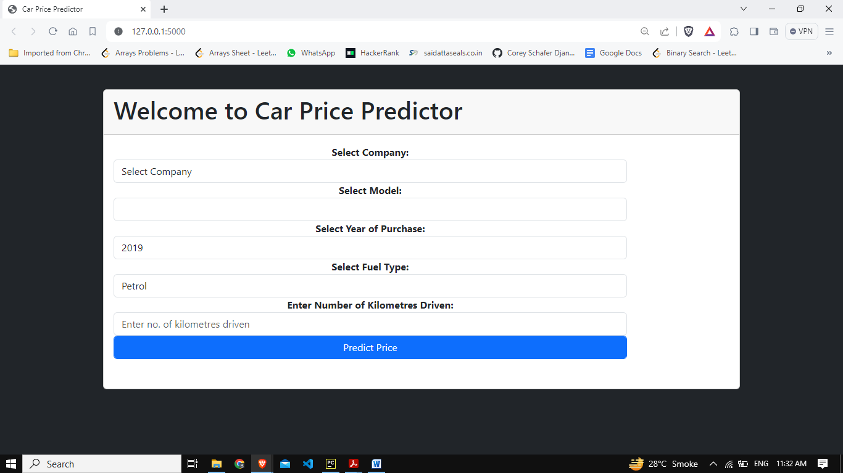

**Fig. 1: User Interface of the Car Price Predictor Web Application**

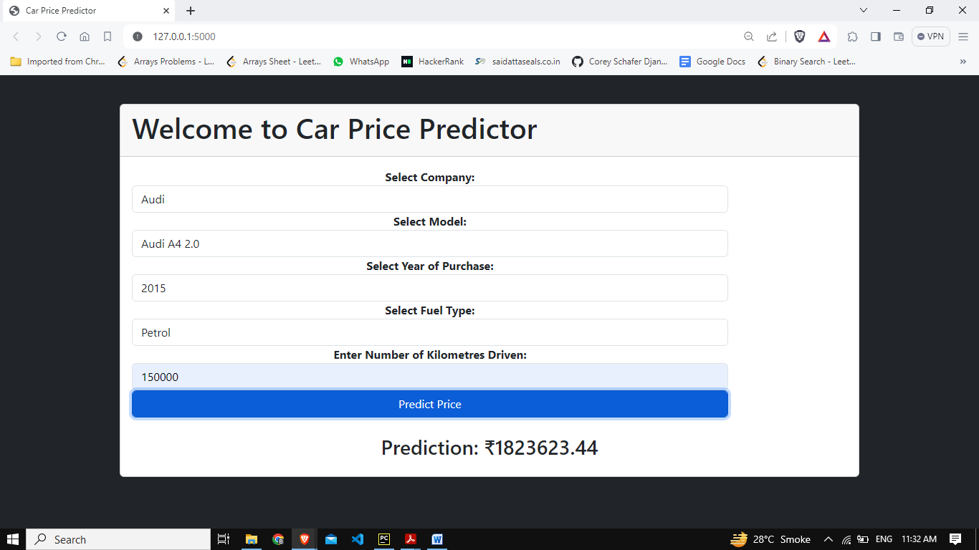

**Fig. 2: Prediction of Price of a Car**

# USE CASE

The Car Price Predictor project has several potential use cases, particularly in the automotive industry and related sectors. Here are some primary use cases for the project:

**Buyer Guidance:**

**Scenario:** Individuals looking to purchase a used car.

**Use Case:** The Car Price Predictor can assist potential buyers by providing estimated selling prices for specific car models based on historical data. This information helps buyers make informed decisions and negotiate fair prices.

**Seller Pricing Strategy:**

**Scenario:** Individuals or dealerships selling used cars.

**Use Case:** Sellers can utilize the Car Price Predictor to determine competitive and fair pricing strategies for their inventory. This tool aids in optimizing pricing to attract buyers while ensuring profitability.

**Market Research:**

**Scenario:** Automotive market analysts and researchers.

**Use Case:** Researchers can leverage the Car Price Predictor to study market trends, analyze pricing dynamics, and gain insights into the factors influencing car prices. This contributes to a deeper understanding of the automotive market.

**Insurance Assessment:**

**Scenario:** Insurance companies evaluating car values.

**Use Case:** Insurance providers can use the Car Price Predictor to estimate the current market value of insured vehicles. This assists in determining appropriate coverage and settlement amounts in the event of accidents or total loss claims.

**Financial Decision-Making:**

**Scenario:** Individuals considering financing options.

**Use Case:** Potential car buyers exploring financing options can use the Car Price Predictor to estimate the future value of a car. This information is valuable for financial planning and decision-making.

# 11. CONCLUSION & FUTURE SCOPE

## FUTURE SCOPE:

This web application involves the most basic machine learning algorithm, known as Linear Regression. In particular cases, difficult questions of judgment may arise.

## CONCLUSION:

The project entitled “Car Price Predictor” is developed using Machine Learning in Python and Flask as frontend to predict the correct price of the car.

This project only covers the basic features required to predict the price of an old car.

* 1. **REFERENCES**

1. <https://www.kaggle.com/datasets/abhikalpsrivastava15/quikr-cars-dataset>: Dataset
2. Alhakamy, A.; Alhowaity, A.; Alatawi, A.A.; Alsaadi, H. “Are Used Cars More Sustainable? Price Prediction Based on Linear Regression.” **2023**, 15, 911. <https://doi.org/10.3390/su15020911>
3. Abishek R, Student, Big Data Analytics, SRM University, Chennai, Tamil Nadu, India; “Car Price Prediction Using Machine Learning Techniques”; Volume:04/Issue:02/February-2022 Impact Factor- 6.752 [www.irjmets.com](http://www.irjmets.com)
4. Enis Gegic, Becir Isakovic, Dino Keco, Zerina Masetic, Jasmin Kevric, International Burch University, Sarajevo, Bosnia and Herzegovina, “Car Price Prediction Using Machine Learning Techniques”, Feb 2019, TEM Journal
5. Ramgiri Siva and Adimoola M, “Linear Regression Algorithm Based Price Prediction of Car and Accuracy Comparison with Support Vector Machine Algorithm”, 2022, The Electrochemical Society (ECS).
6. Sameerchand Pudaruth, Computer Science and Engineering Department, University of Mauritius, Reduit, Mauritius,“Predicting the Price of used Cars using Machine Learning Techniques”, International Journal of Information & Computation Technology. ISSN 0974-2239 Volume 4, Number 7 (2014)

**13. ACKNOWLEDGEMENT**

It is our privilege to express our sincerest regards to our project guide Prof. Suchitra Patil for the valuable inputs, able guidance, encouragement and constructive criticism throughout the duration of our project.

We deeply express our sincere thanks to our principal Dr. S.M. Joshi and our Head of the Department Dr. Monika Bhagwat for encouraging and allowing us to present the project on the topic “Car Price Predictor” at our department premises for the partial fulfillments of the requirements leading to the award of B-tech degree.

We take this opportunity to thank all our lecturers who have directly or indirectly helped for steering us through as well as easy phases of the project in a result-oriented manner with concern attention and support.

Chirag Wadkar