**IBM IOC V5.1.0.3**

IBM Intelligent Operations Center uses the power of the real-world data that is generated by computer systems by performing the following tasks:

* Collecting and managing the right data
* Integrating and analyzing that data
* Facilitating easy and timely access to information
* Presenting related information in a coherent way

**IBM Intelligent Operations Center Architecture:**

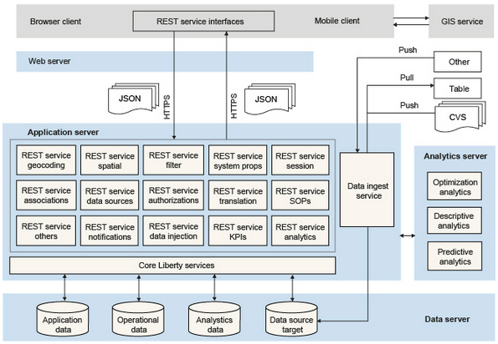

# Installing the multi-server platform and application

Install the following Red Hat Package Manager (RPM) files that are required by the IBM Intelligent Operations Center installation:

1. Mount the rhel-server-6.6-x86_64-dvd.iso file to the system.   
2. Select open a terminal window as a root.  
3. Execute the commands:   
[root@localhost]# mkdir /mnt/cdrom  
[root@localhost]# mount -o ro /dev/cdrom /mnt/cdrom  
4. Create the text file server.repo in the /etc/yum.repos.d directory.   
Note: To use gedit, execute the command:

[root@localhost]# gedit /etc/yum.repos.d/server.repo  
Add the following text to the file:   
  
[server]  
name=server  
baseurl=file:///mnt/cdrom/   
enabled=1  
  
where baseurl depends on the mounting point and the RHEL distribution.   
  
In the example, the mounting point is cdrom and the RHEL distribution is Workstation but could be sever.  
  
5. Execute the command:  
[root@localhost]# yum clean all  
6. Execute the command to import related public keys:  
[root@localhost]# rpm --import /mnt/cdrom/*GPG*  
7. Execute the commands to install the required libraries:  
[root@localhost]# yum install gtk2.i686  
[root@localhost]# yum install libXtst.i686  
If you received the missing libstdc++ message above, install the libstdc++ library:  
[root@localhost]# yum install compat-libstdc++  
yum install the following libraries as well

* yum install audit-libs.i686
* yum install audit-libs.x86_64
* yum install compat-libstdc++*i686
* yum install dos2unix.x86_64
* yum install gettext.x86_64
* yum install glibc.i686
* yum install glibc.x86_64
* yum install ksh.x86_64
* yum install libaio.i686
* yum install libaio.x86_64
* yum install libgcc.i686
* yum install libgcc.x86_64
* yum install libstdc++.i686
* yum install nss-softokn-freebl.i686
* yum install nss-softokn-freebl.x86_64
* yum install ntp.x86_64
* yum install openssh-clients.x86_64 pam.i686
* yum install pam-devel.i686
* yum install pam_passwdqc.x86_64
* yum install tcsh.x86_64 unzip.x86_64
* yum install xorg-x11-xauth.x86_64
* yum install zlib.i686 zlib.x86_64
* yum install gtk2.i686 gtk2.x86_64
* yum install gtk2-engines.i686
* yum install gtk2-engines.x86_64 libXtst.i686
* yum install libXtst.x86_64
* yum install nfs-utils

During the install you might receive prompts similar to the example. Answer with 'y'.

Do the following steps on each of the four servers.

* Data server
* Analytics server
* Application server
* Web server

1. Open a terminal window, and log on as a root user.
2. Define a fully qualified name and short host name either by using a DNS server, or by creating a definition in the /etc/hosts file.

Note: Ensure that the database server host name is not the same as either of the following database names:

* + IOCDB
  + IOCDATA

1. Ensure that the HOSTNAME value that is defined in the /etc/sysconfig/network file is set to the short host name, and that it is not set to the fully qualified host name. For example, set HOSTNAME=xyz instead of HOSTNAME=xyz.yourco.com.
2. Verify that the host name, fully qualified host name, and domain name are configured correctly on each server:
   * Enter the following command: hostname -s. The verification is successful if the command returns the defined short host name for the server.
   * Enter the following command: hostname -f. The verification is successful if the command returns the fully qualified domain and host name for the server.
   * Enter the following command: hostname -d. The verification is successful if the command returns the domain name of the server.
3. In the /etc/selinux/config file, configure the SELinux setting to either permissive or disabled. For example, to configure the SELinux setting to permissive, in the /etc/selinux/config file, edit the SELinux setting as shown in the following example and then restart the server:

SELINUX=permissive

Note: The SELinux setting must not be enabled.

1. Reboot the operating system using the following command to make the SELinux changes effective:

reboot

1. To disable the server firewalls, enter the following commands:

service iptables save

service iptables stop

chkconfig --level 123456 iptables off

1. To install the prerequisite RPM files, enter the following command:

yum install -y audit-libs.i686 audit-libs.x86_64 compat-libstdc++*i686 compat-libstdc++_*x86_64 dos2unix.x86_64 gettext.x86_64 glibc.i686 glibc.x86_64 ksh.x86_64 libaio.i686 libaio.x86_64 libgcc.i686 libgcc.x86_64 libstdc++.i686 nss-softokn-freebl.i686 nss-softokn-freebl.x86_64 ntp.x86_64 openssh-clients.x86_64 pam.i686 pam-devel.i686 pam_passwdqc.x86_64 tcsh.x86_64 unzip.x86_64 xorg-x11-xauth.x86_64 zlib.i686 zlib.x86_64 gtk2.i686 gtk2.x86_64 gtk2-engines.i686 gtk2-engines.x86_64 libXtst.i686 libXtst.x86_64 nfs-utils

1. Install the Red Hat Enterprise Linux packages for the X Window System on the analytics, application, and web servers.

X Windows is not required for the initial installation of IBM Intelligent Operations Center, but it is required if you want to update the underlying IBM products by using IBM Installation Manager. For example, you can update WebSphere® Application Server Liberty Profile and IBM HTTP Server. You can install either the GNU Object Model Environment (GNOME) desktop or the K Desktop Environment (KDE) desktop to use with IBM Installation Manager.

Note: DB2® does not use the IBM Installation Manager, so the data server does not require the graphical user interface (GUI) that is provided by either the GNOME desktop or the KDE desktop.

1. Choose one of the following options:
   * To install the GNOME desktop, enter the following command:

yum -y groupinstall "X Window System" Desktop

* + To install the KDE desktop, enter the following command:

yum -y groupinstall "X Window System" "KDE Desktop"

1. Enter the following command: yum -y update
2. To start the desktop, enter the following command: init 5
3. To configure the GUI desktop to be the default desktop, edit the /etc/inittab file and change the value of the initdefault property from 3 to 5. The following example shows the updated line:

id:5:initdefault:

1. Save the changes, and then restart the server.

Data Server

1)Make sure that you have all the files copied from 1,2,3 of .iso files

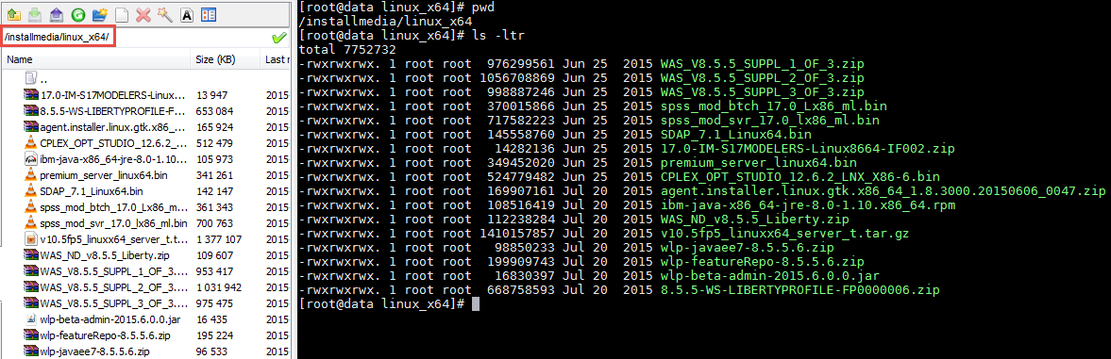

2)Copy file from 4th iso file to /opt/IBM/

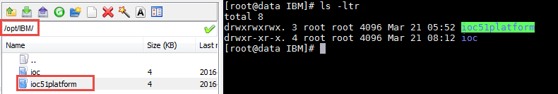

3)Edit ioc.5_1.install.properties file 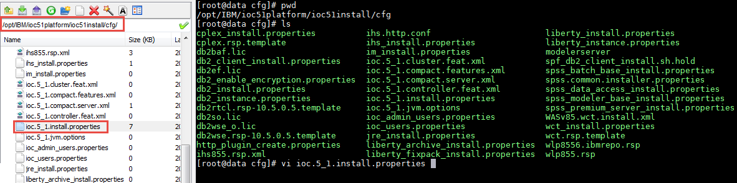

4)Give hostnames to the respective servers

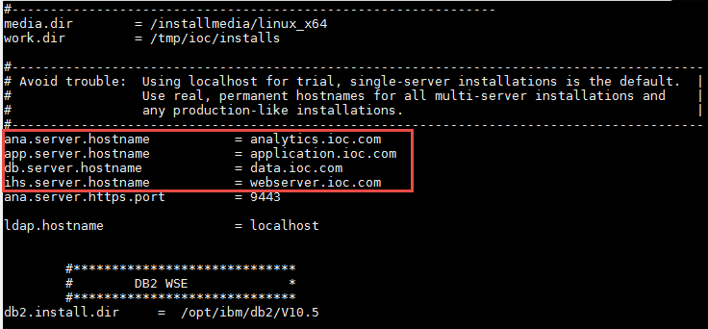

5) Accept the license by hitting the ‘q’ button and enter y

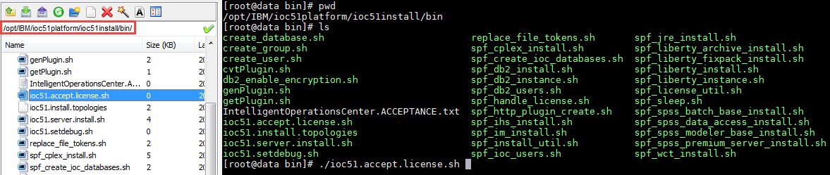

6)Run ioc51.server.install.sh file to install the DataServer by mentioning the ‘4.dat’

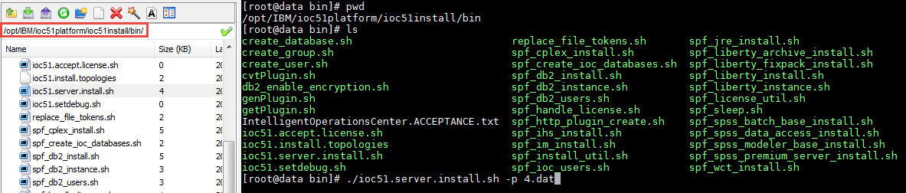

**Analytics Server**

1)Make sure that you have all the files copied from 1,2,3 of .iso files

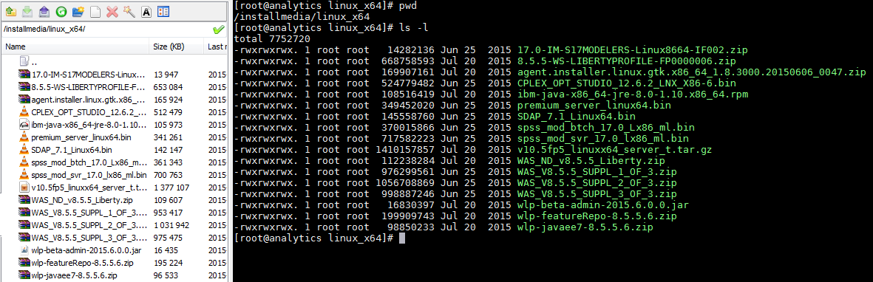

2)Copy file from 4th iso file to /opt/IBM/

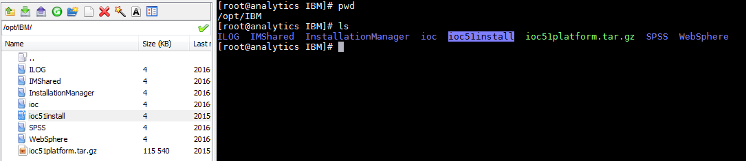

3)Edit ioc.5_1.install.properties file 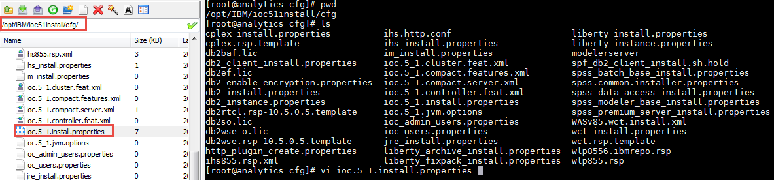

4)Give hostnames to the respective servers

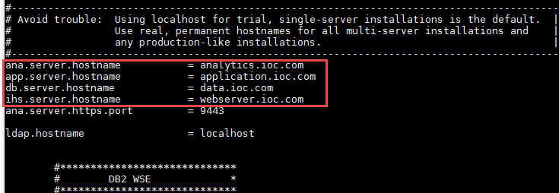

5) Accept the license by hitting the ‘q’ button and enter y

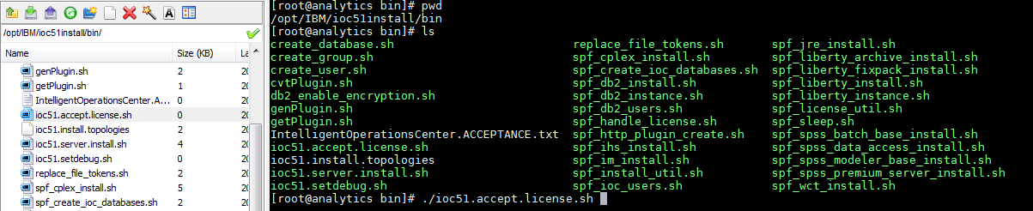

6)Run ioc51.server.install.sh file to install the AnalyticsServer by mentioning the ‘4.ana’

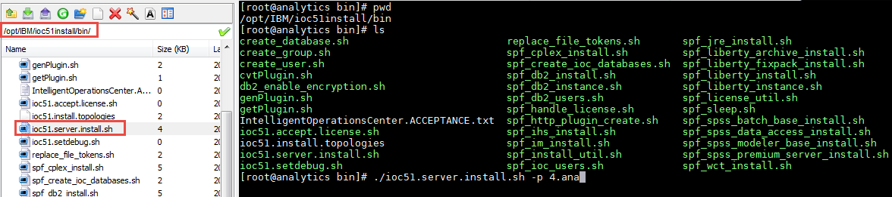

**Application Server**

1)Make sure that you have all the files copied from 1,2,3 of .iso files

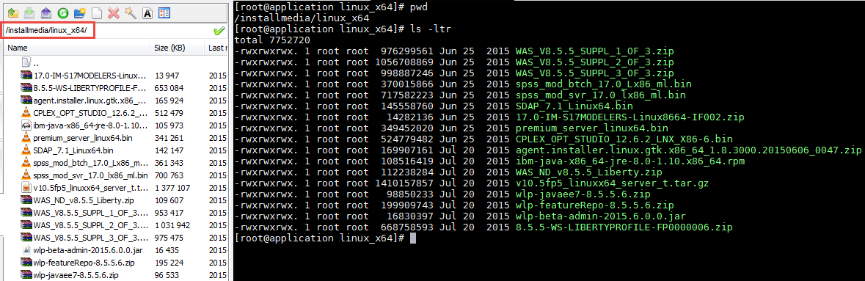

2)Copy file from 4th iso file to /opt/IBM/

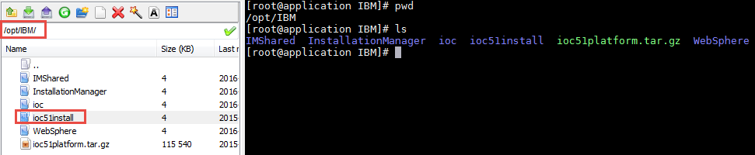

3)Edit ioc.5_1.install.properties file 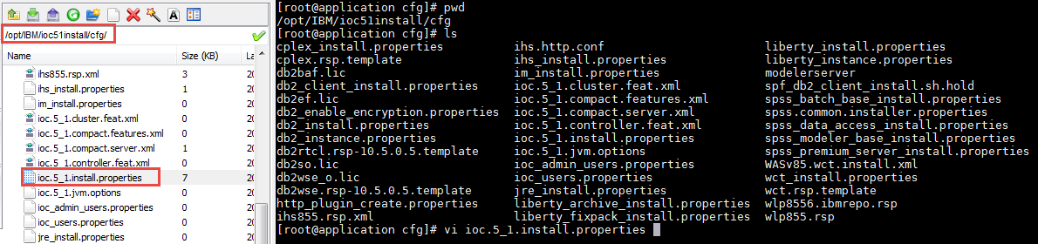

4)Give hostnames to the respective servers

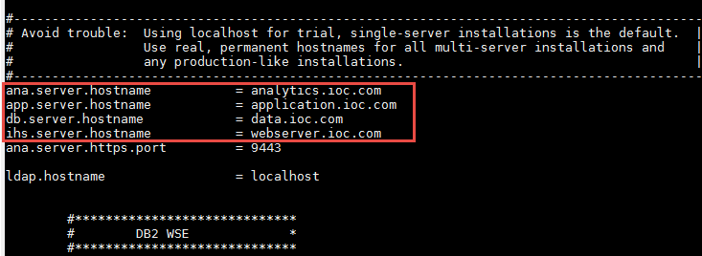

5) Accept the license by hitting the ‘q’ button and enter y

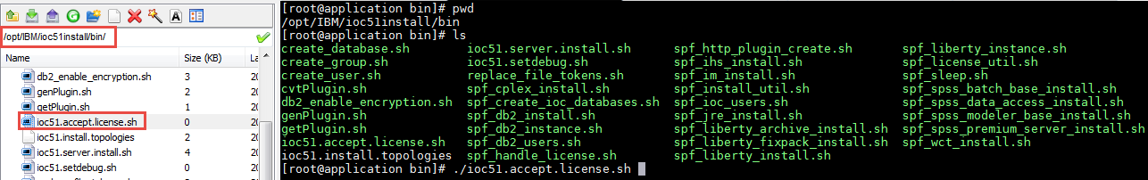

6)Run ioc51.server.install.sh file to install the ApplicationServer by mentioning the ‘4.app’

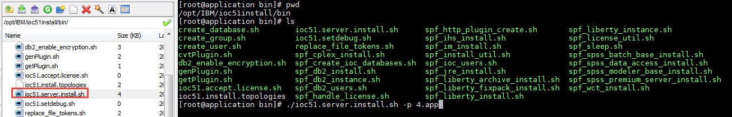

**Web Server**

1)Make sure that you have all the files copied from 1,2,3 of .iso files

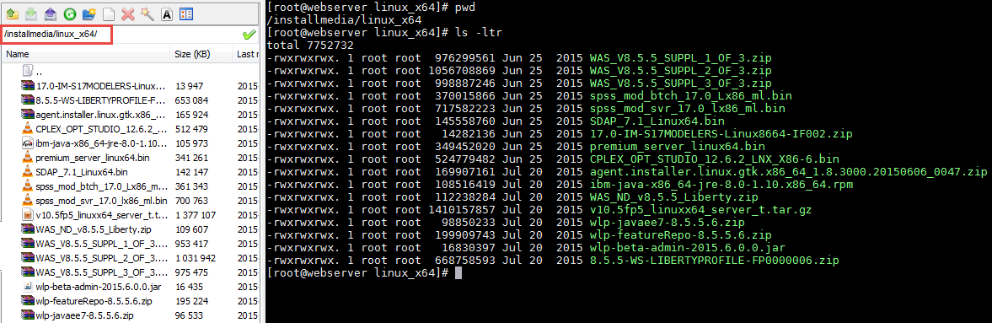

2)Copy file from 4th iso file to /opt/IBM/

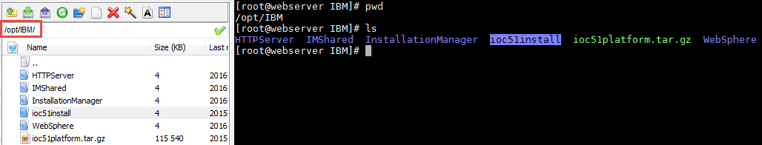

3)Edit ioc.5_1.install.properties file 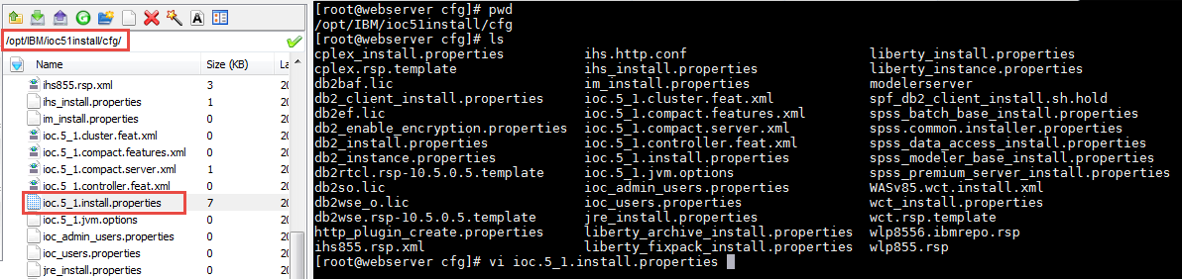

4)Give hostnames to the respective servers



5) Accept the license by hitting the ‘q’ button and enter y

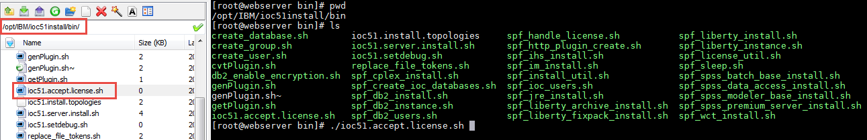

6)Run ioc51.server.install.sh file to install the WebServer by mentioning the ‘4.web’

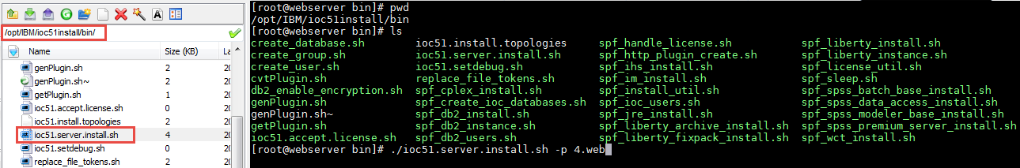

**BaseMaps**

Add and configure **base maps** in the system

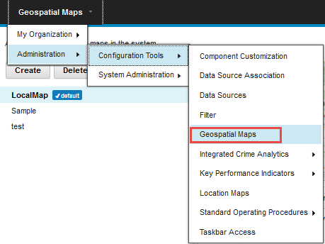

Create New Base Map for GeoSpecialMap by providing the server map url

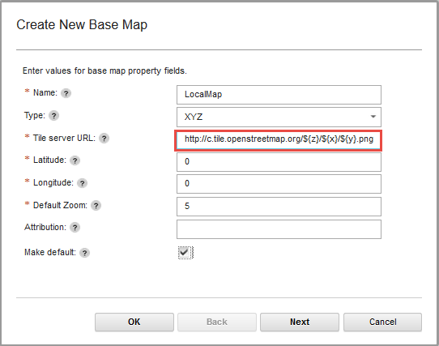

**Creating Data Sources**

A data source is used to exchange information between the IBM Intelligent Operations Center and external systems.

In IBM Intelligent Operations Center, data sources provide a generic format for exchanging data. Data source configuration is compatible with emerging techniques, such as web services, while offering enhanced capabilities. Data sources provide the following capabilities:

* Flexible geographic targeting using latitude and longitude shapes and other geospatial representations in three dimensions
* Multilingual and multi-audience messaging
* Phased and delayed effective times and expirations
* Enhanced message update and cancellation features
* Digital encryption and signature compatibility
* Digital images and audio facilities

**Publishing CSV files**

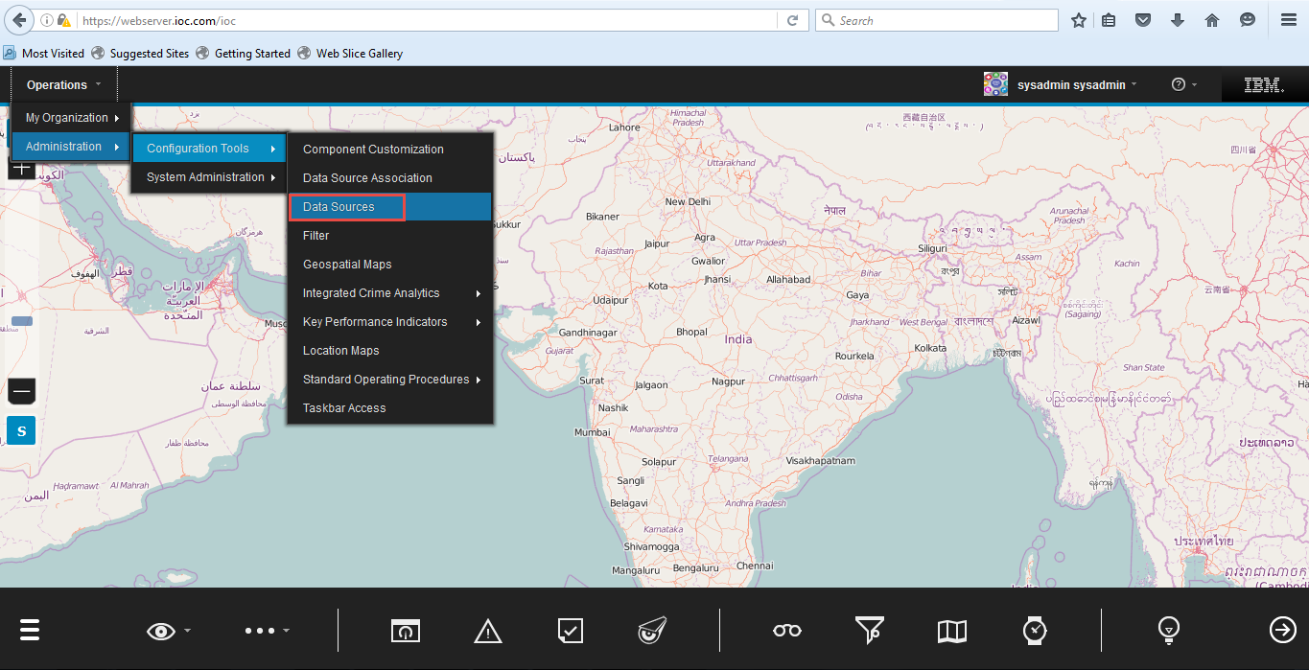

Publishing CSV file from localsystem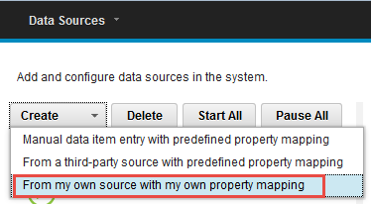

Step1: Make sure that Data Source Identifier is unique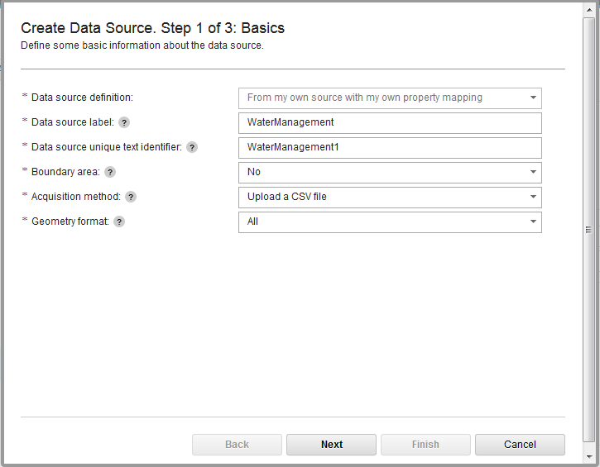

Step2: Upload CSV file from local machine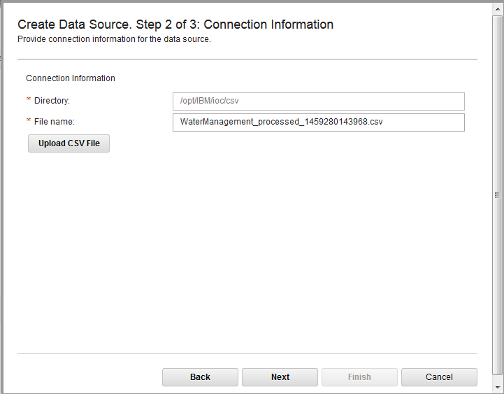

Step3: By default all data field’s, data type is VARCHAR you can change the data type later by editing data fields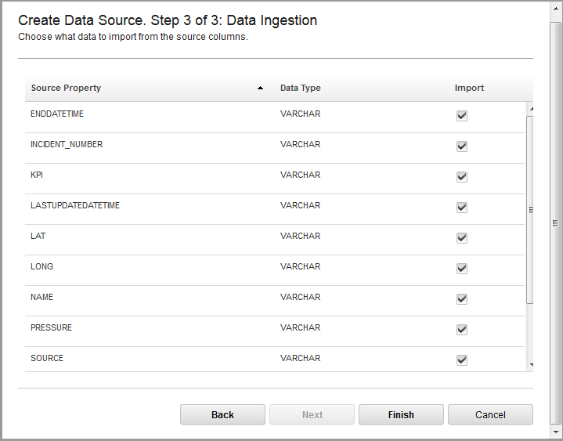

Fill the Basics of data source fields before saving, once it got saved it won’t allow us to change the field values 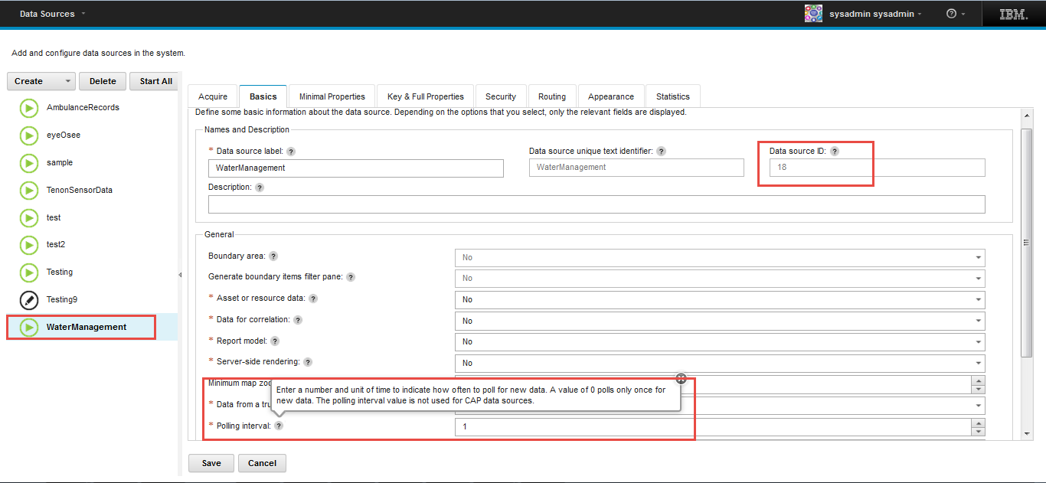

Select the fields from the drop down list

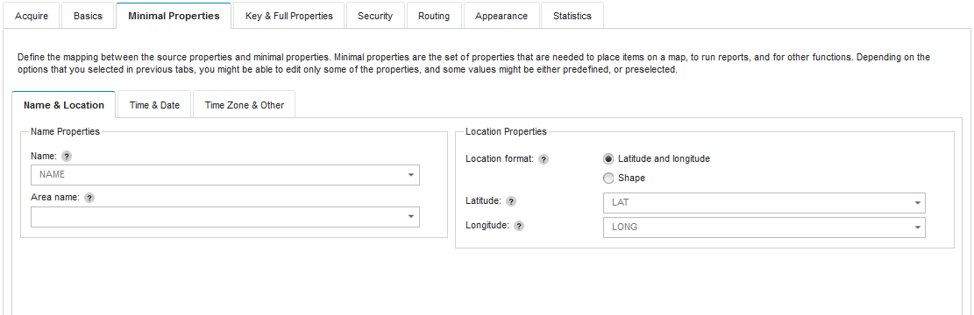

Select the field values from the drop down list as provided in the CSV file

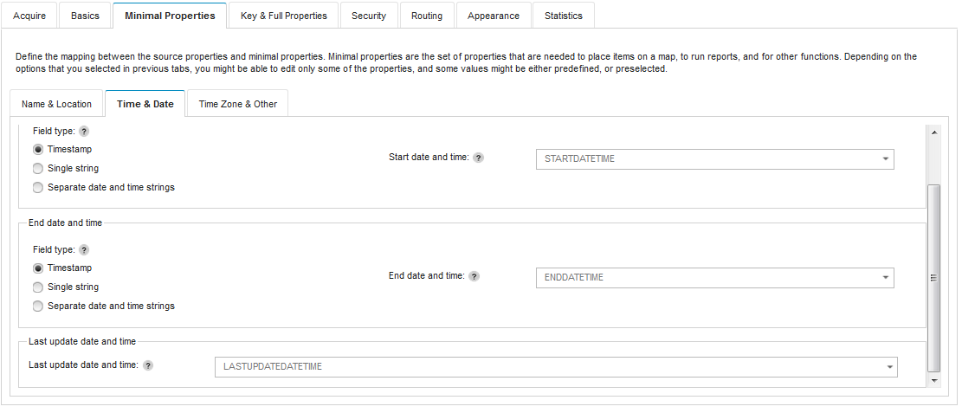

We can change the field items Data Type before saving the data source configuration 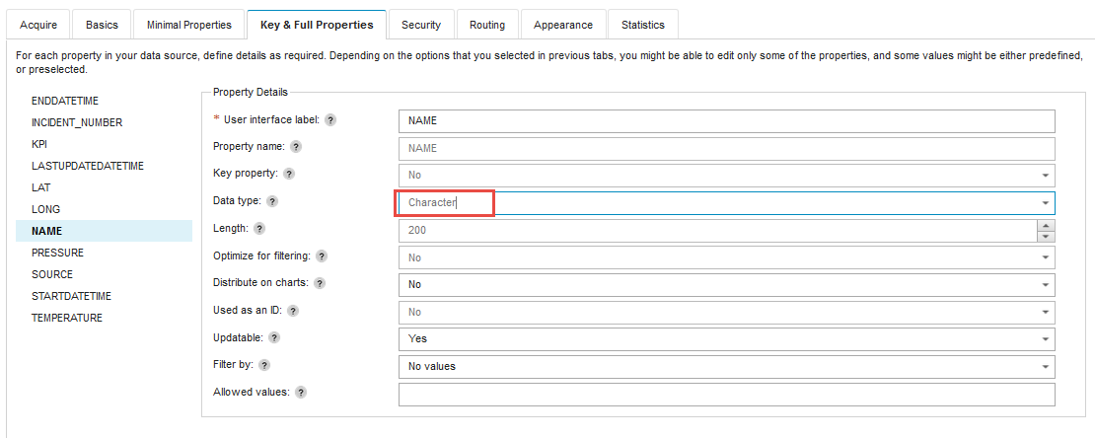

We can set the access privileges for the data items from your data source.

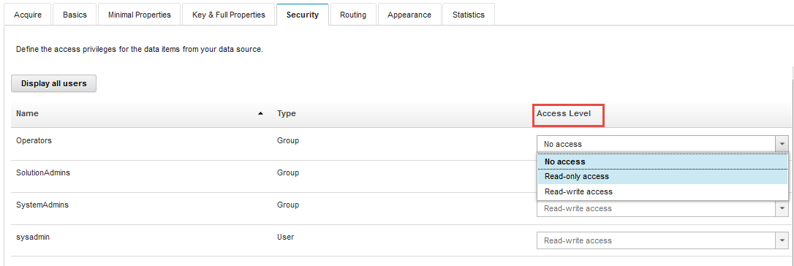

Data can be represented on a map by icons, shapes, line segments, polygons, or circles. You can select either an icon or a shape to represent a data item with point locations.You can also define styles and assign expressions that determine how data items are displayed on the map.

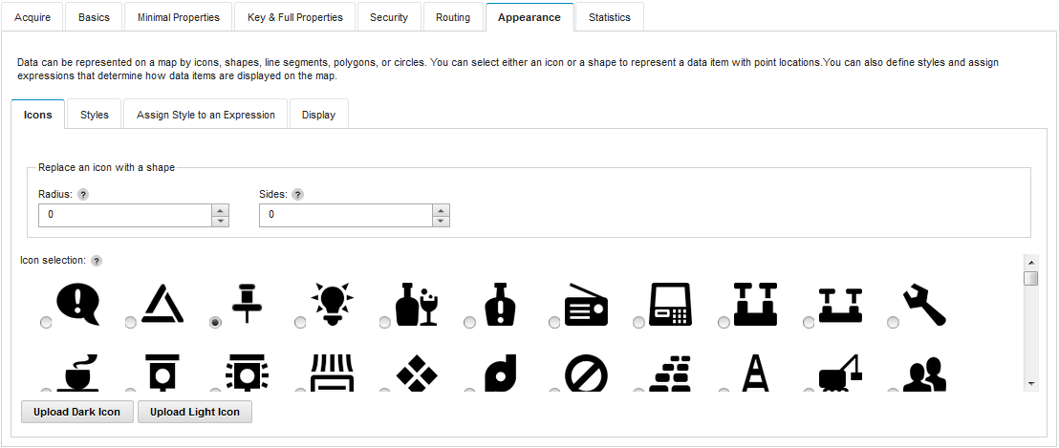

Here is the statistics of Data Source after saving configurations. 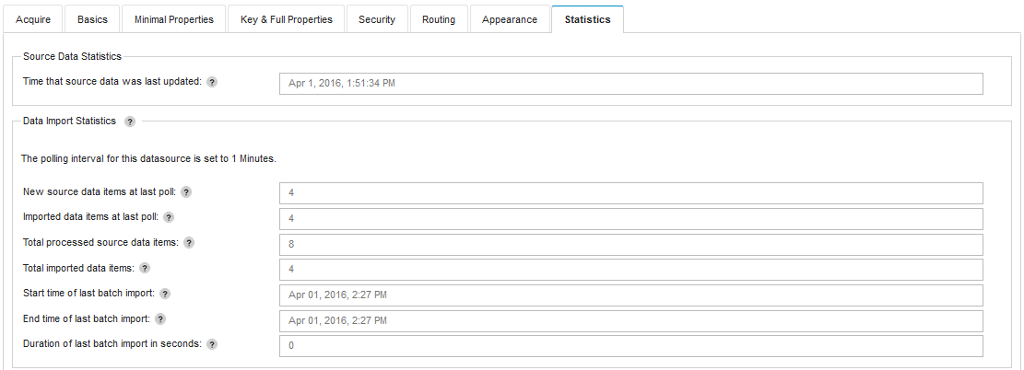

**Creating Filters**

Create Filters to filter Data Source Items

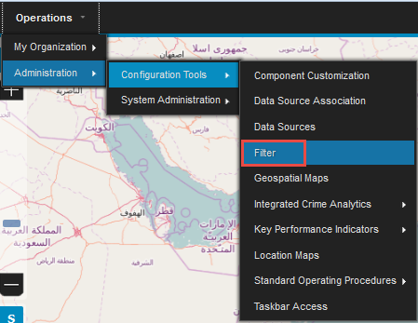

Create filter with proper name and include Data Source for the filter

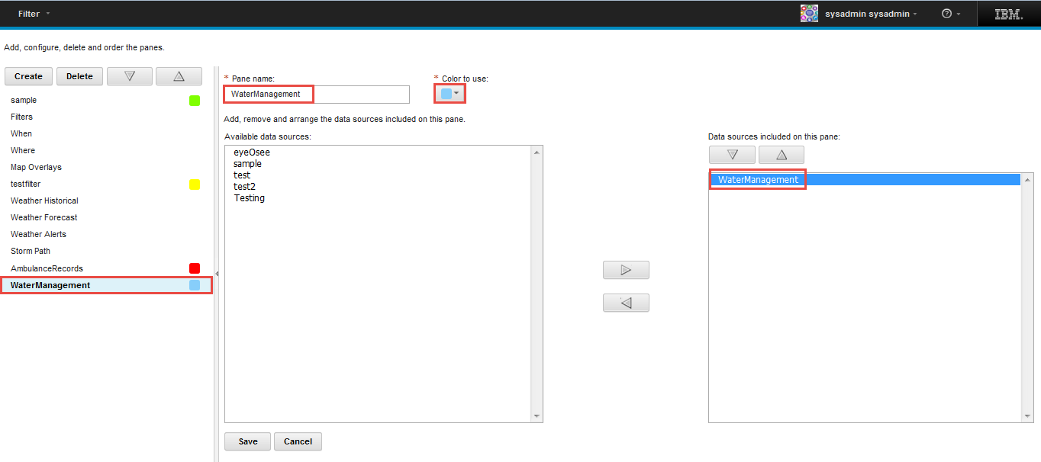

Filter the data source items based on When and Where clause, those filtered items will be displayed on map

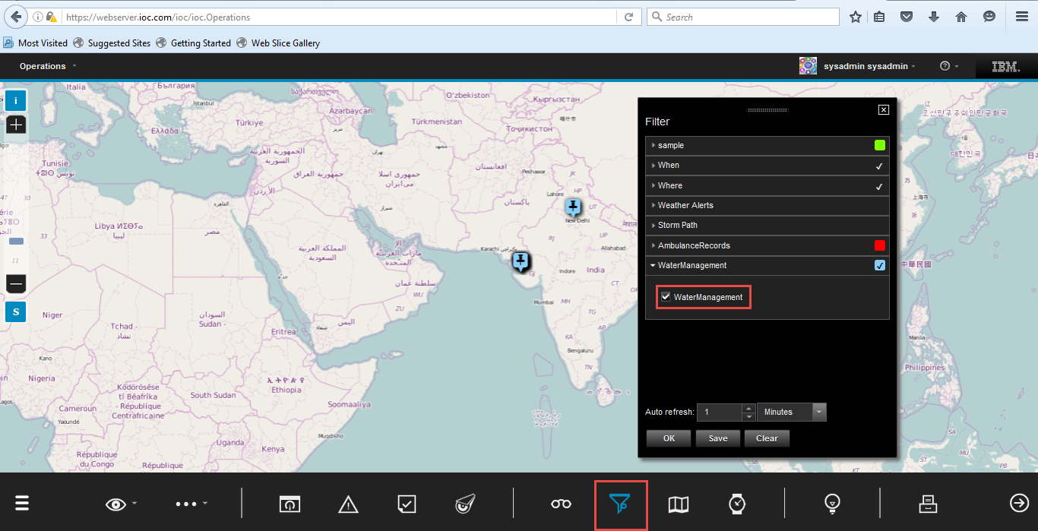

**Standard Operating Procedures**

Create SOP Reference

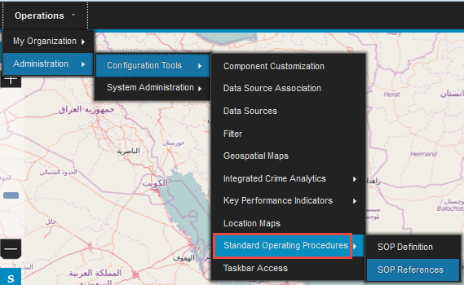

Specify the reference URL

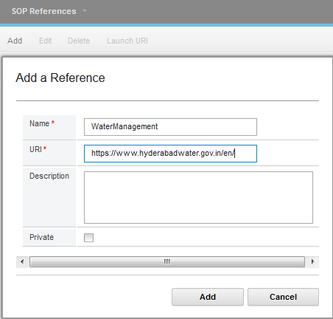

Create SOP Definition

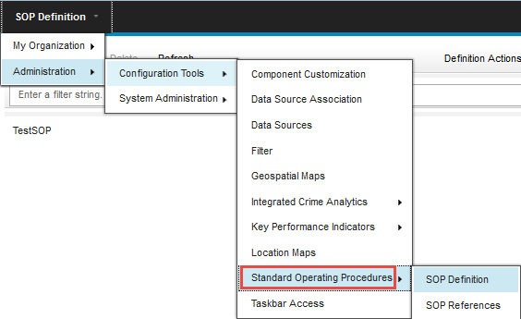

Select the SOP Reference for SOP Definition 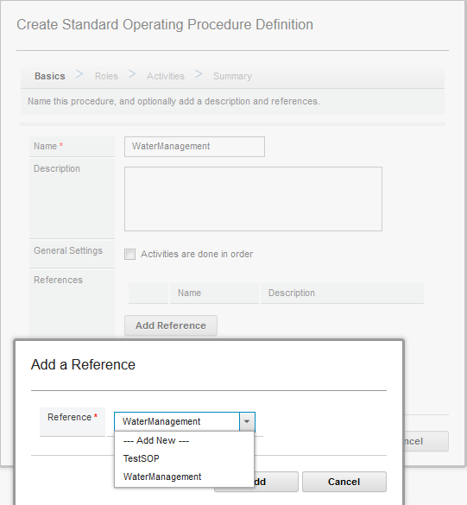

Select the Roles for SOP Definition 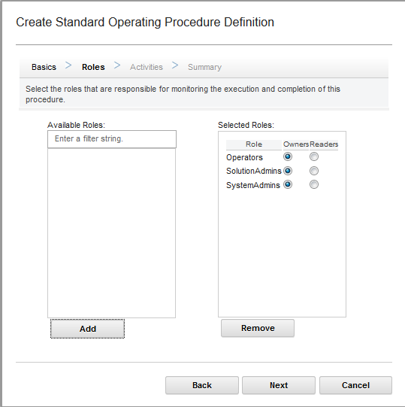

Add Activities for SOP 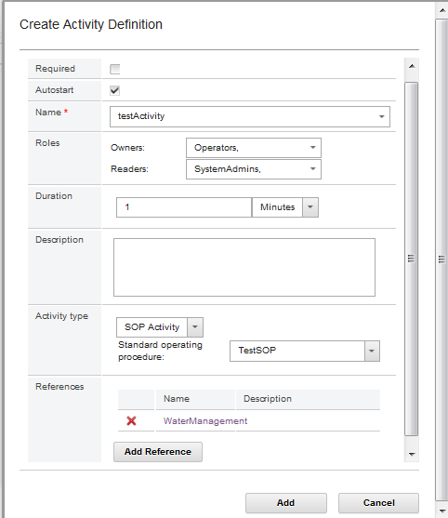

Summary of the SOP Definition

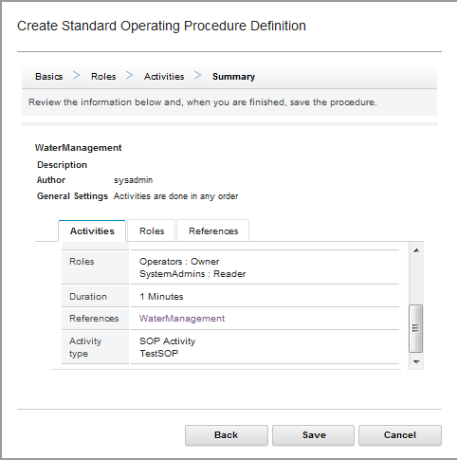

Note: Submit the SOP for Approval as a Admin User, otherwise SOP won’t be available for Data Source Routing

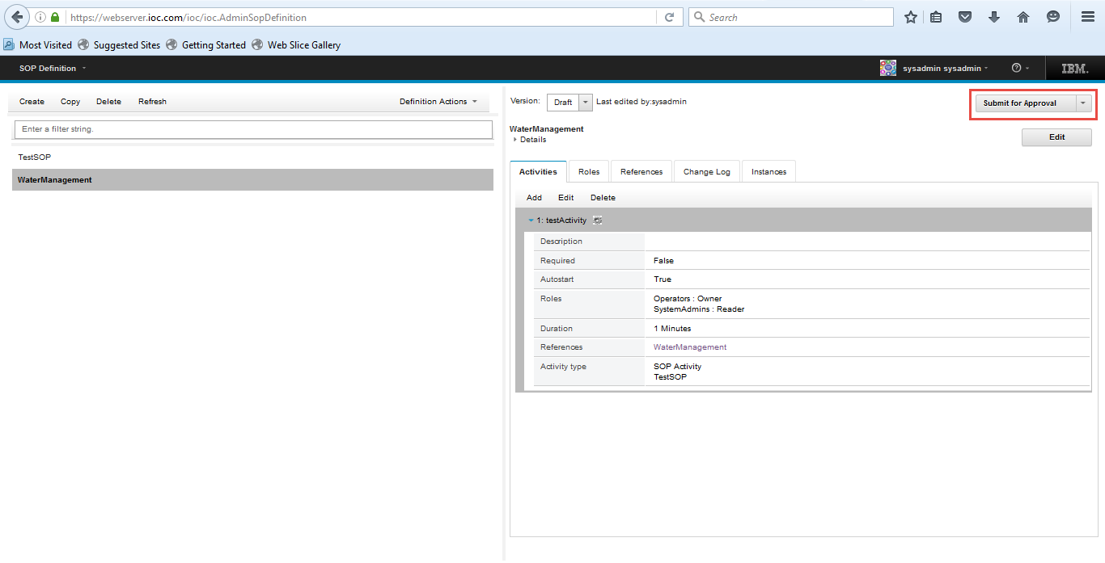

Select the SOP while Routing Expressions for Data Source

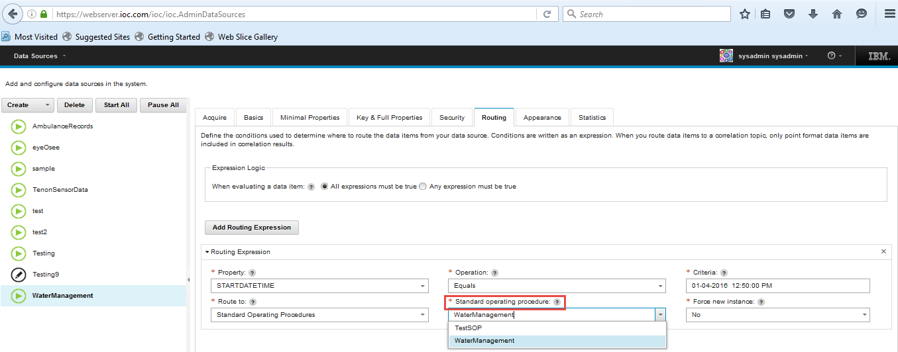

Launch SOP for Data Item 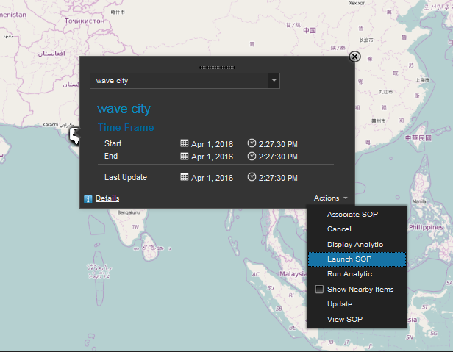

Select the respective SOP

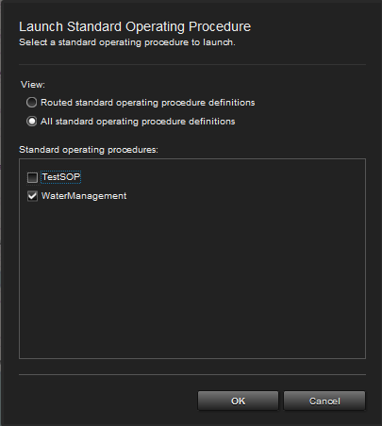

After SOP Launched it will generates activates to complete

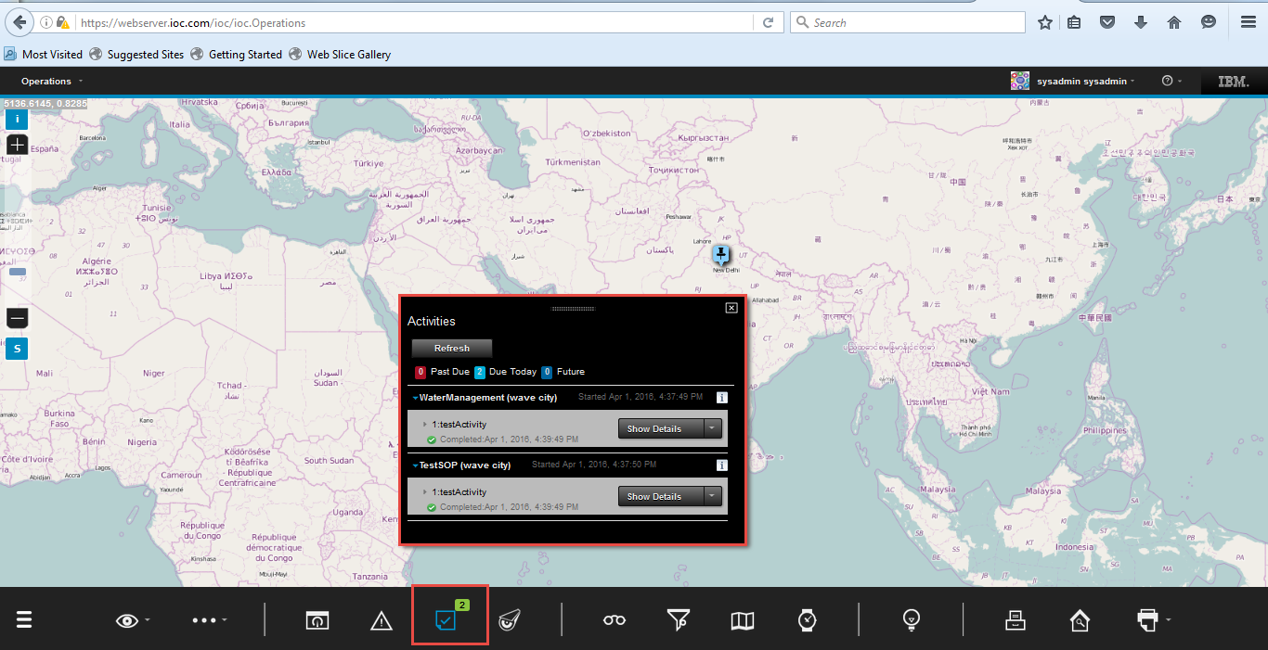

Data Source tables in IOCDATA database:

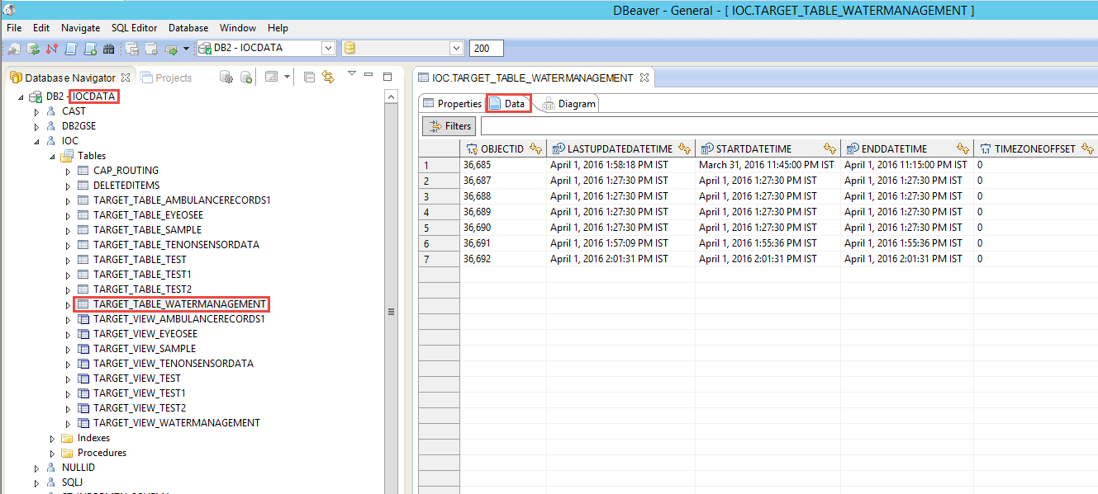

Reference URLs:

<http://www.ibm.com/support/knowledgecenter/SS3NGB_5.1.0.3/ioc/install_prepsvr.dita>

<http://www.ibm.com/support/knowledgecenter/SS3NGB_5.1.0.3/ioc/install_svrcfgmulti_inst.dita>

<http://www.ibm.com/support/knowledgecenter/SS3NGB_5.1.0.3/ioc/conf_4s_httpman.dita>

<http://www.ibm.com/support/knowledgecenter/SS3NGB_5.1.0.3/ioc/conf_4s_httpauto.dita>

# <https://www.ibm.com/support/knowledgecenter/SS3NGB_5.1.0.3/ioc/install_upgrademulti_5101.dita?lang=en>

https://www.youtube.com/watch?v=arb1yqRtwqs