**TEST PLAN FOR PhpTravelAdminPage**

**1.Scop**

Scop of the testing would be handle the food safety management version release 20.10.1 release.

**2.Objective**

The objective of the test is to deliver all the features which are planned as part of 20.10.1 release.

**3.Testapproach**

For the new user story testing, the new functionality will be tested in manually and regression testing will be handled with automation. The process model that is following will be an agile scrum that will be a monthly release.

**4.Features to be tested**

|  |  |  |  |  |
| --- | --- | --- | --- | --- |
| Release ID | Feature ID | Feature description | Userstory ID | Description |
| 24.10.1 | F-101 | manage Login in Phptravels | Php-101 | Admin login |
| 24.10.1 | F102 | Dashboard | Php-102 | User |
| Php-103 | pages |
| Php-104 | bookings |
| Php-105 | Cancelled bookings |
| Php-106 | Unpaid bookings |
| 24.10.1 | F-103 | Manage users | Php-107 | Adding Users |
|  | | | Php-108 | Search Users |
| 24.10.1 | F-104 | Manage pages | Php-109 | Adding pages |
|  | | | Php-110 | Search pages |
| 24.10.1 | F-105 | Manage Bookings | Php111 | Search Bookings |
| 24.10.1 | F-106 | Cancelled Bookings | Php112 | Search cancelled bookings |
| 24.10.1 | F-107 | Manage unpaid bookings | Php113 | Search Unpaid bookings |

**5.Configuration**

These are the configuration planned for the upcoming release.

|  |  |  |
| --- | --- | --- |
| **Release id** | **Desktop configuration** | **Device configuration** |
| 20.10.1 | Chrome | Iphone |
| 20.11.1 | Firefox | Ipad |
| 20.12.1 | Safari | Surface Pro |
| 21.01.1 | IE | Android |
| 21.02.1 | Edge | ipad |

**6.Test Management**

The test management will be handled with JIRA and the process model followed would be AGILE Scrum and the release would be in monthly basis.

* 1. **Flow Chart of User Stories Life Cycle**

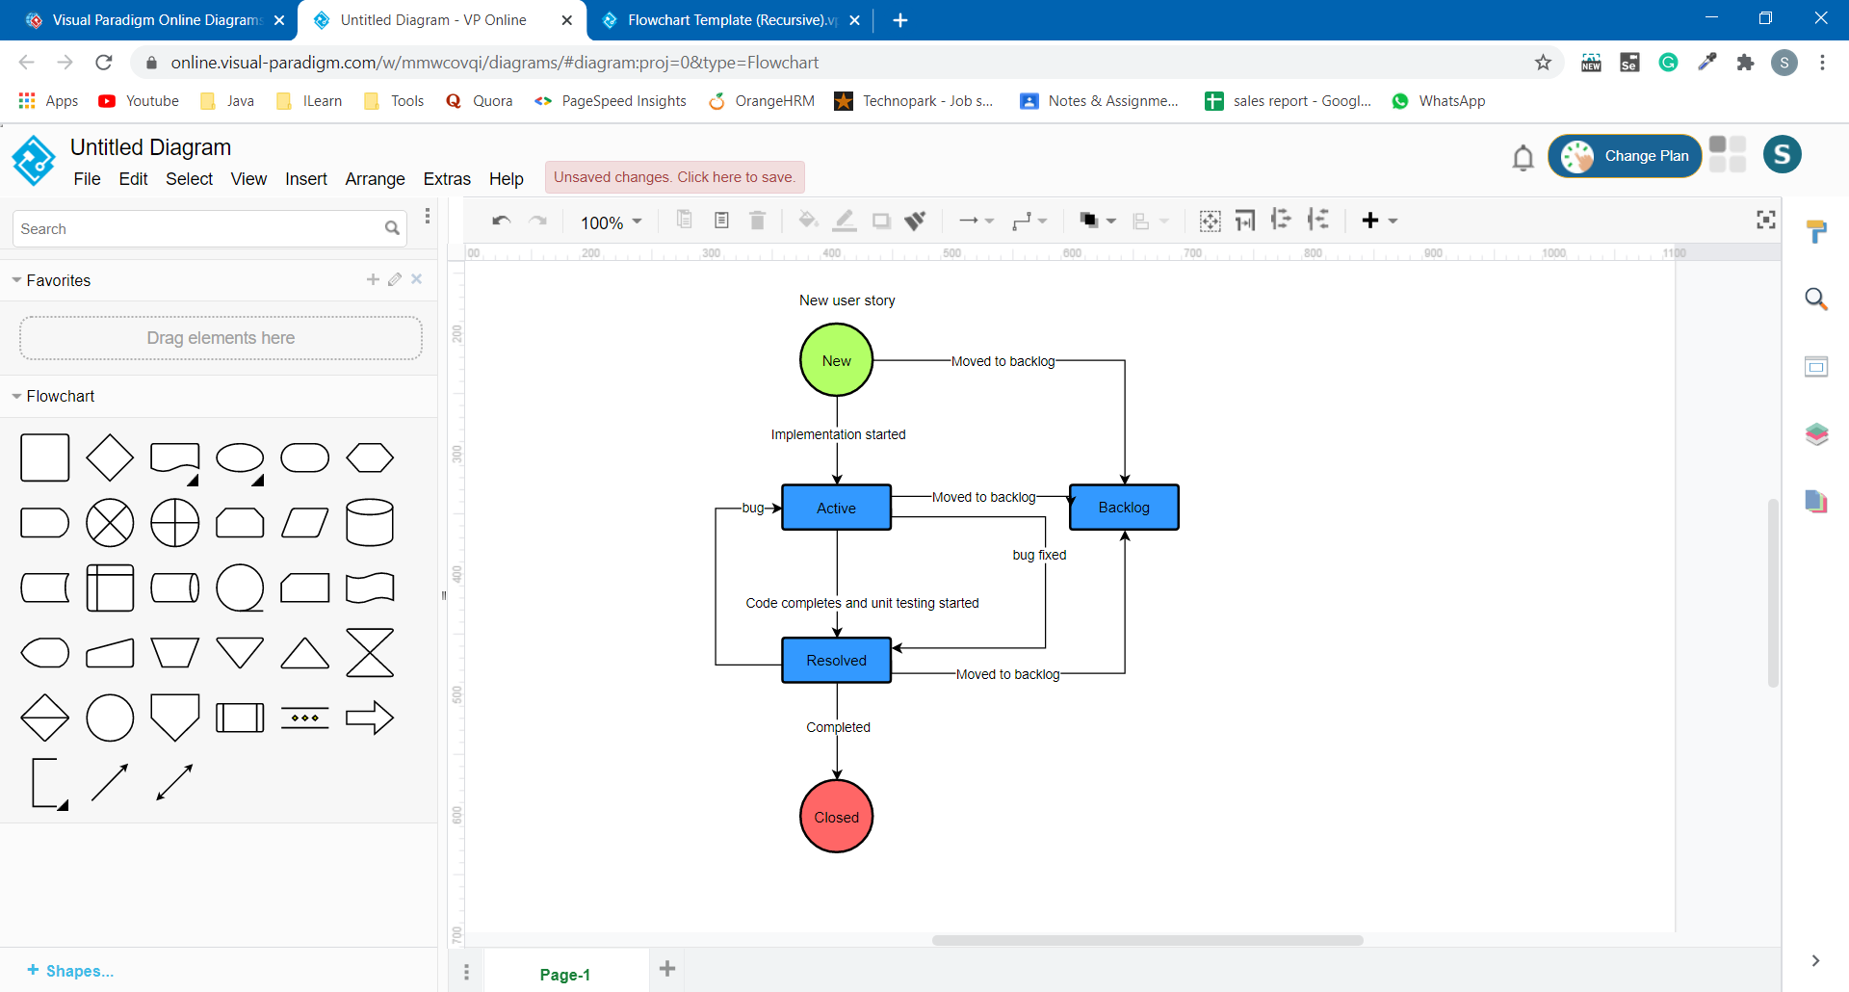

* 1. **Flow Chart of Bug Life Cycle**

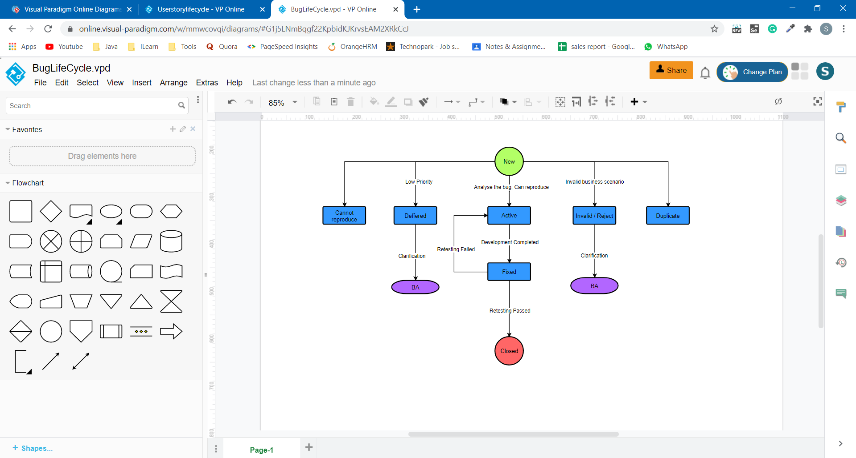

**7.Schedules and deliverables**

User story testing will be starting in the first day of the sprint and will be end in the 16th day of the sprint. Regression testing will be handled for 3 days. User acceptance testing will be for 2 day. Product will be moved on 21th day of Sprint.

|  |  |  |
| --- | --- | --- |
| **Activities** | **Start Date** | **End date** |
| New user story testing | 1-11-2024 | 22-11-2024 |
| Regression testing | 25-11-2024 | 27-11-2024 |
| QA sign off | 28-11-2024 | 29-11-2024 |
| UAT testing | 02-12-2024 | 04-12-2024 |
| Production move | 05-12-2024 | 09-12-2024 |

1. **Test deliverables**

Test deliverables plan along with its release are:-

* Test Plan Document
* Test Case
* Test Report
* Bug Report

1. **Resources**
   1. **Human Resource**

|  |  |  |
| --- | --- | --- |
| **Resource Name** | **Designation** | **RACI(Responsible Accountable Consulted Informed)** |
| Divya | QA Engineer | R |
| Saranya | Sr. QA Engineer | R |
| John | QA Lead | A |
| Sam | Dev Lead | A,C |
| Monica | Client Representative | I |
| Kin | QA Manager | C |
| Tom | Project Manager | I |

* 1. **System Resource**

Testing tool

* Taiga Test management tool is to enter and track all bugs and project issues.
* Automation tools like Selenium, JMeter
* Configuration management: SVN
* Microsoft Excel, Microsoft Word

Test Environment

Emulators, Mac OS X, iphone 5/6, ipad 3, Browsers, Windows 8 and above

1. **Execution Strategy**
   1. **Entry Criteria**

* All test cases should be reviewed and approved.
* Environment should be ready along with test data should be available.
* User story should be in resolved status.
* Unit testing should be performed by developer.
  1. **Exit Criteria**
* All test cases should be executed.
* There should not be any failed or blocked test cases.
* There can be not-applicable test cases.
* There should not be any active critical or blocker issue in open status.
* The release date should be met.

1. **Risk Management & Mitigation**

* Resource unavailability.
* Test data availability.

User stories are tested in UAT environment.

* Environment dependency that can be Development environment, QA environment, Production environment, UAT environment

All servers are moved to cloud platform like AWS