Take-home_Ex01_Part2
CHJ1
2025-05-11

Objectives of the Assignment
I will be providing a critique of the visualisation created by my classmate, Wang Anqi. This critique will highlight 3 strengths and 3 areas for improvement in her visualisation. Following the critique, I will present a redesigned version of the visualisation based on the feedback provided.
Link to Anqi’s Assignment: https://isss608-25t3-anqi.netlify.app/take-home_ex/take-home_ex01/take-home_ex01

My Critique

Strength 1:
Anqi presented the population distribution of Singapore Residents using a population pyramid, with males on the left and females on the right. This is a commonly used method for visualising a country’s population structure by age group, offering a clear and intuitive overview.
Area of Improvement 1:
Anqi did not group the ages into bins, which makes the visualisation harder to interpret for readers who are interested in specific age ranges.

Strength 2:
Anqi sorted the Planning Areas in descending order of population, making the visualisation easier to read and interpret.
Area of Improvement 2:
Readers are unable to determine the exact population of each Planning Area, as there are no tooltips or data labels displayed in the visualisation.

Strength 3:
Anqi used a stacked bar chart to clearly show the proportion of the working and non-working age population, allowing readers to grasp the breakdown at a glance.
Area of Improvement 3:
Similarly, readers are unable to discern the exact values in the stacked bar charts, as there are no tooltips to display this information.

Codes to Re-create Anqi’s Visualisations
pacman::p_load(tidyverse, ggrepel, patchwork,
ggthemes, hrbrthemes,)
popu_data <- read_csv("data/respopagesex2024.csv", show_col_types = FALSE)
cat("Total number of records in the dataset:", nrow(popu_data), "\n")
Total number of records in the dataset: 60424
# Remove the 'Time' column from the dataset
popu_data1 <- popu_data %>% select(-Time)
# Checks for NA in each column
colSums(is.na(popu_data1))
PA SZ Age Sex Pop
0 0 0 0 0
# Here's what the dataset looks like so far
popu_data1
# A tibble: 60,424 × 5
PA SZ Age Sex Pop
<chr> <chr> <chr> <chr> <dbl>
1 Ang Mo Kio Ang Mo Kio Town Centre 0 Males 10
2 Ang Mo Kio Ang Mo Kio Town Centre 0 Females 10
3 Ang Mo Kio Ang Mo Kio Town Centre 1 Males 10
4 Ang Mo Kio Ang Mo Kio Town Centre 1 Females 10
5 Ang Mo Kio Ang Mo Kio Town Centre 2 Males 10
6 Ang Mo Kio Ang Mo Kio Town Centre 2 Females 10
7 Ang Mo Kio Ang Mo Kio Town Centre 3 Males 10
8 Ang Mo Kio Ang Mo Kio Town Centre 3 Females 10
9 Ang Mo Kio Ang Mo Kio Town Centre 4 Males 30
10 Ang Mo Kio Ang Mo Kio Town Centre 4 Females 10
# ℹ 60,414 more rows
# Step 1: Recode "90 and over" to "90"
popu_data1 <- popu_data1 %>%
mutate(Age = ifelse(Age == "90 and over", "90", Age))
# Step 2: Convert Age to integer
popu_data1 <- popu_data1 %>%
mutate(
Age = trimws(Age),
Age = ifelse(Age == "90 and over", "90", Age),
Age = as.integer(Age)
)
popu_data1 <- popu_data1 %>%
mutate(
Sex = recode(Sex, "Males" = "Male", "Females" = "Female")
)
# Here's what the dataset looks like so far
popu_data1
# A tibble: 60,424 × 5
PA SZ Age Sex Pop
<chr> <chr> <int> <chr> <dbl>
1 Ang Mo Kio Ang Mo Kio Town Centre 0 Male 10
2 Ang Mo Kio Ang Mo Kio Town Centre 0 Female 10
3 Ang Mo Kio Ang Mo Kio Town Centre 1 Male 10
4 Ang Mo Kio Ang Mo Kio Town Centre 1 Female 10
5 Ang Mo Kio Ang Mo Kio Town Centre 2 Male 10
6 Ang Mo Kio Ang Mo Kio Town Centre 2 Female 10
7 Ang Mo Kio Ang Mo Kio Town Centre 3 Male 10
8 Ang Mo Kio Ang Mo Kio Town Centre 3 Female 10
9 Ang Mo Kio Ang Mo Kio Town Centre 4 Male 30
10 Ang Mo Kio Ang Mo Kio Town Centre 4 Female 10
# ℹ 60,414 more rows

Makeover 1
library(dplyr)
library(ggplot2)
library(scales)
# Bin ages into 5-year groups
pyramid_data <- popu_data1 %>%
mutate(
AgeGroup = cut(
Age,
breaks = c(seq(0, 85, by = 5), Inf),
labels = c("0-4", "5-9", "10-14", "15-19", "20-24", "25-29", "30-34",
"35-39", "40-44", "45-49", "50-54", "55-59", "60-64", "65-69",
"70-74", "75-79", "80-84", "85+"),
right = FALSE
),
AgeGroup = ifelse(is.na(AgeGroup), "85+", as.character(AgeGroup))
) %>%
mutate(AgeGroup = factor(AgeGroup, levels = c("0-4", "5-9", "10-14", "15-19", "20-24", "25-29", "30-34",
"35-39", "40-44", "45-49", "50-54", "55-59", "60-64",
"65-69", "70-74", "75-79", "80-84", "85+"))) %>%
group_by(Sex, AgeGroup) %>%
summarise(Pop = sum(Pop), .groups = "drop") %>%
mutate(Pop = ifelse(Sex == "Male", -Pop, Pop))
# Define color
gender_colors <- c("Male" = "#9ecae1", "Female" = "#fbb4b9")
# Plot
ggplot(pyramid_data, aes(x = AgeGroup, y = Pop, fill = Sex)) +
geom_bar(stat = "identity", width = 0.9) +
coord_flip() +
scale_y_continuous(labels = label_comma(scale = 1, accuracy = 1)) +
scale_fill_manual(values = gender_colors) +
labs(
title = "Population Pyramid of Singapore Residents (2024)",
subtitle = "Distribution by Age Group and Gender",
x = "Age Group",
y = "Population",
fill = "Gender"
) +
theme_minimal(base_size = 14) +
theme(
plot.title = element_text(face = "bold", size = 16),
plot.subtitle = element_text(size = 13, margin = margin(b = 10)),
legend.position = "bottom",
panel.grid.minor = element_blank()
)
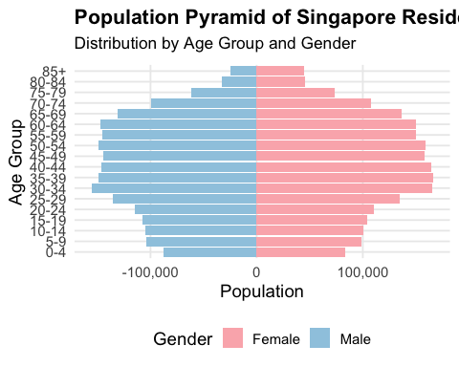
Binning the ages into 5-year intervals enhances the readability of the population pyramid, making it easier to interpret demographic trends.

Makeover 2
library(dplyr)
library(ggplot2)
library(scales)
# Summarise total population by Planning Area (PA)
top_pa <- popu_data1 %>%
group_by(PA) %>%
summarise(Total = sum(Pop)) %>%
arrange(desc(Total)) %>%
slice_head(n = 10)
# Plot
ggplot(top_pa, aes(x = reorder(PA, Total), y = Total)) +
geom_col(fill = "#4682b4") +
coord_flip() +
scale_y_continuous(labels = comma) +
geom_text(aes(label = comma(Total)), size = 4, hjust = 1.1, vjust = 0.5) +
labs(
title = "Top 10 Planning Areas by Population (2024)",
x = "Planning Area",
y = "Total Population"
) +
theme_minimal(base_size = 13)
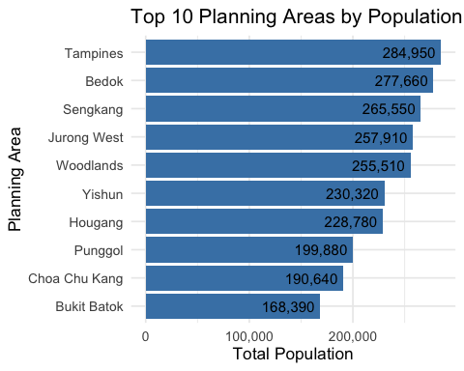
With the data labels displayed, readers can now easily determine the exact population size for each Planning Area.

Makeover 3
library(dplyr)
library(ggplot2)
library(scales)
library(plotly)
# Prepare data
top10_pa <- popu_data1 %>%
count(PA, wt = Pop) %>%
top_n(10, n) %>%
pull(PA)
age_grouped <- popu_data1 %>%
filter(PA %in% top10_pa) %>%
mutate(
AgeGroup = case_when(
Age >= 25 & Age <= 64 ~ "Working-age",
TRUE ~ "Non-working-age"
)
) %>%
group_by(PA, AgeGroup) %>%
summarise(Total = sum(Pop), .groups = "drop")
# Static ggplot object
p <- ggplot(age_grouped, aes(x = reorder(PA, -Total), y = Total, fill = AgeGroup,
text = paste0("Planning Area: ", PA,
"<br>Age Group: ", AgeGroup,
"<br>Population: ", comma(Total)))) +
geom_col(color = "black", alpha = 0.9) +
scale_fill_manual(values = c("Working-age" = "#3182bd", "Non-working-age" = "#fdae6b")) +
scale_y_continuous(labels = comma) +
labs(
title = "Working and Non-working Age Population<br> in Top 10 Planning Areas (2024)",
x = "Planning Area",
y = "Population",
fill = "Age Group"
) +
theme_minimal(base_size = 13) +
theme(
axis.text.x = element_text(angle = 30, hjust = 1),
plot.title = element_text(face = "bold", size = 15)
)
ggplotly(p, tooltip = "text")
When the mouse is hovered over the stacked bar charts, a tooltip will appear showing the exact values of the working and non-working age populations for the respective Planning Areas.

