Vast Challenge 2025 MC3
CHJ1
2025-05-18
install.packages(“webshot2”)

Load Packages
pacman::p_load(tidyverse, jsonlite,
tidygraph, ggraph,
SmartEDA, igraph)

Importing Data
MC3 <- fromJSON("data/MC3_graph.json")
MC3_schema <- fromJSON("data/MC3_schema.json")

Inspect Structure
glimpse(MC3)
List of 5
$ directed : logi TRUE
$ multigraph: logi FALSE
$ graph :List of 4
..$ mode : chr "static"
..$ edge_default: Named list()
..$ node_default: Named list()
..$ name : chr "VAST_MC3_Knowledge_Graph"
$ nodes :'data.frame': 1159 obs. of 31 variables:
..$ type : chr [1:1159] "Entity" "Entity" "Entity" "Entity" ...
..$ label : chr [1:1159] "Sam" "Kelly" "Nadia Conti" "Elise" ...
..$ name : chr [1:1159] "Sam" "Kelly" "Nadia Conti" "Elise" ...
..$ sub_type : chr [1:1159] "Person" "Person" "Person" "Person" ...
..$ id : chr [1:1159] "Sam" "Kelly" "Nadia Conti" "Elise" ...
..$ timestamp : chr [1:1159] NA NA NA NA ...
..$ monitoring_type : chr [1:1159] NA NA NA NA ...
..$ findings : chr [1:1159] NA NA NA NA ...
..$ content : chr [1:1159] NA NA NA NA ...
..$ assessment_type : chr [1:1159] NA NA NA NA ...
..$ results : chr [1:1159] NA NA NA NA ...
..$ movement_type : chr [1:1159] NA NA NA NA ...
..$ destination : chr [1:1159] NA NA NA NA ...
..$ enforcement_type : chr [1:1159] NA NA NA NA ...
..$ outcome : chr [1:1159] NA NA NA NA ...
..$ activity_type : chr [1:1159] NA NA NA NA ...
..$ participants : int [1:1159] NA NA NA NA NA NA NA NA NA NA ...
..$ thing_collected :'data.frame': 1159 obs. of 2 variables:
.. ..$ type: chr [1:1159] NA NA NA NA ...
.. ..$ name: chr [1:1159] NA NA NA NA ...
..$ reference : chr [1:1159] NA NA NA NA ...
..$ date : chr [1:1159] NA NA NA NA ...
..$ time : chr [1:1159] NA NA NA NA ...
..$ friendship_type : chr [1:1159] NA NA NA NA ...
..$ permission_type : chr [1:1159] NA NA NA NA ...
..$ start_date : chr [1:1159] NA NA NA NA ...
..$ end_date : chr [1:1159] NA NA NA NA ...
..$ report_type : chr [1:1159] NA NA NA NA ...
..$ submission_date : chr [1:1159] NA NA NA NA ...
..$ jurisdiction_type: chr [1:1159] NA NA NA NA ...
..$ authority_level : chr [1:1159] NA NA NA NA ...
..$ coordination_type: chr [1:1159] NA NA NA NA ...
..$ operational_role : chr [1:1159] NA NA NA NA ...
$ edges :'data.frame': 3226 obs. of 5 variables:
..$ id : chr [1:3226] "2" "3" "5" "3013" ...
..$ is_inferred: logi [1:3226] TRUE FALSE TRUE TRUE TRUE TRUE ...
..$ source : chr [1:3226] "Sam" "Sam" "Sam" "Sam" ...
..$ target : chr [1:3226] "Relationship_Suspicious_217" "Event_Communication_370" "Event_Assessment_600" "Relationship_Colleagues_430" ...
..$ type : chr [1:3226] NA "sent" NA NA ...

Extracting the edges and nodes tables
mc3_nodes <- as_tibble(MC3$nodes)
mc3_edges <- as_tibble(MC3$edges)

Initial EDA
ExpCatViz(data=mc3_nodes,
col="lightblue")
[[1]]
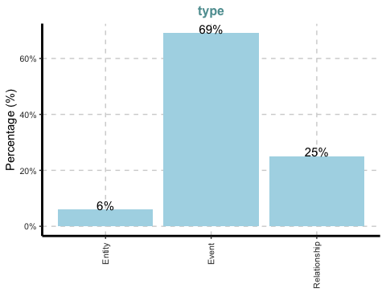
[[2]]
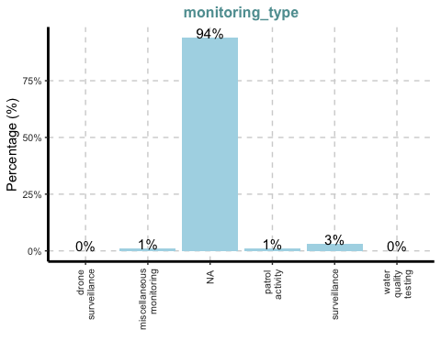
[[3]]
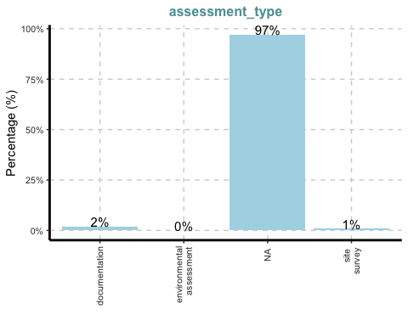
[[4]]
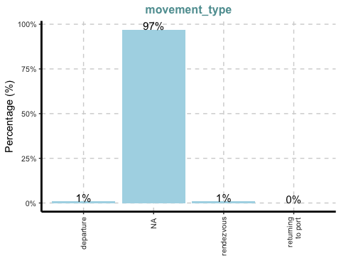
[[5]]
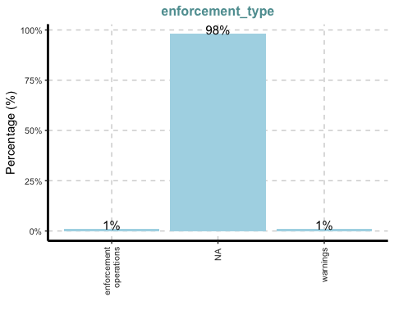
[[6]]
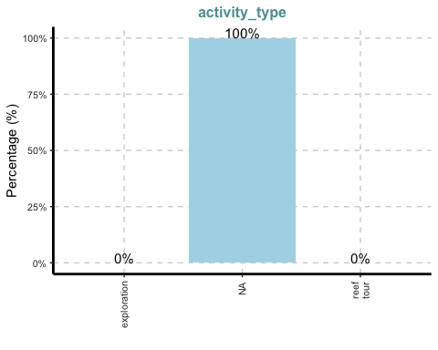
[[7]]
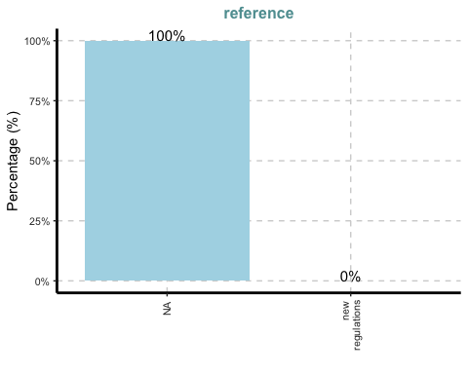
[[8]]
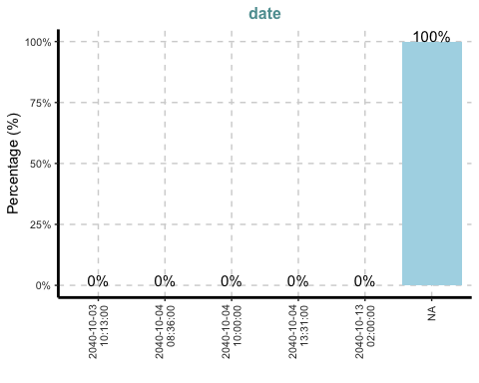
[[9]]
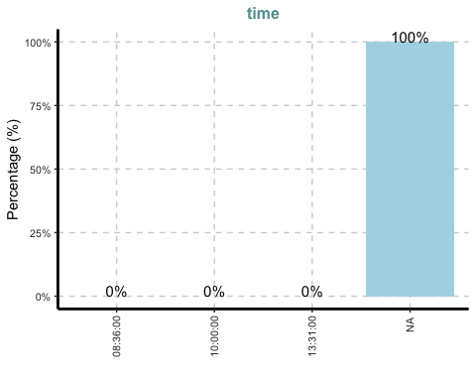
[[10]]
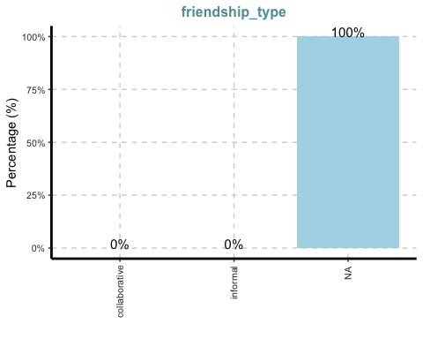
[[11]]
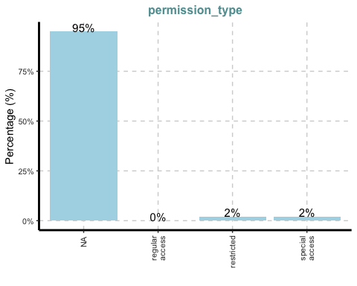
[[12]]
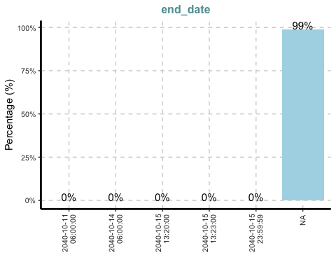
[[13]]
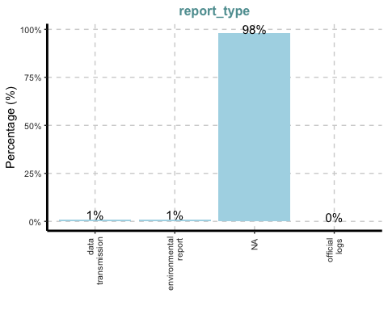
[[14]]
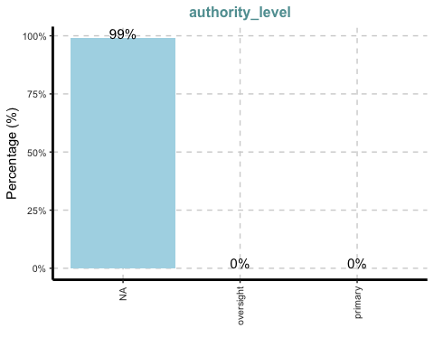
ExpCatViz(data=mc3_edges,
col="lightblue")
[[1]]
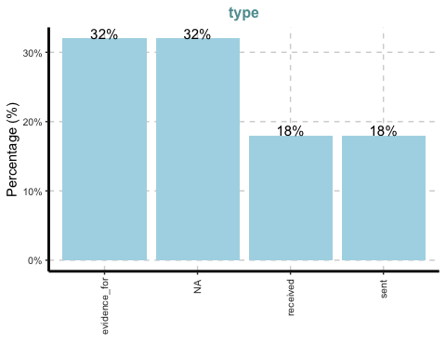

Cleaning and wrangling nodes
mc3_nodes_cleaned <- mc3_nodes %>%
mutate(id = as.character(id)) %>%
filter(!is.na(id)) %>%
distinct(id, .keep_all = TRUE) %>%
select(-thing_collected)
mc3_edges_cleaned <- mc3_edges %>%
rename(from_id = source,
to_id = target) %>%
mutate(across(c(from_id, to_id),
as.character)) %>%
filter(from_id %in% mc3_nodes_cleaned$id,
to_id %in% mc3_nodes_cleaned$id) %>%
filter(!is.na(from_id), !is.na(to_id))
node_index_lookup <- mc3_nodes_cleaned %>%
mutate(.row_id = row_number()) %>%
select(id, .row_id)
mc3_edges_indexed <- mc3_edges_cleaned %>%
left_join(node_index_lookup,
by = c("from_id" = "id")) %>%
rename(from = .row_id) %>%
left_join(node_index_lookup,
by = c("to_id" = "id")) %>%
rename(to = .row_id) %>%
select(from, to, is_inferred, type) %>%
filter(!is.na(from) & !is.na(to))
used_node_indices <- sort(
unique(c(mc3_edges_indexed$from,
mc3_edges_indexed$to)))
mc3_nodes_final <- mc3_nodes_cleaned %>%
slice(used_node_indices) %>%
mutate(new_index = row_number())
old_to_new_index <- tibble(
old_index = used_node_indices,
new_index = seq_along(
used_node_indices))
mc3_edges_final <- mc3_edges_indexed %>%
left_join(old_to_new_index,
by = c("from" = "old_index")) %>%
rename(from_new = new_index) %>%
left_join(old_to_new_index,
by = c("to" = "old_index")) %>%
rename(to_new = new_index) %>%
select(from = from_new, to = to_new,
is_inferred, type)

Building the tidygraph object
mc3_graph <- tbl_graph(
nodes = mc3_nodes_final,
edges = mc3_edges_final,
directed = TRUE
)
str(mc3_graph)
Classes 'tbl_graph', 'igraph' hidden list of 10
$ : num 1159
$ : logi TRUE
$ : num [1:3226] 0 0 0 0 0 0 0 1 1 1 ...
$ : num [1:3226] 1137 356 746 894 875 ...
$ : NULL
$ : NULL
$ : NULL
$ : NULL
$ :List of 4
..$ : num [1:3] 1 0 1
..$ : Named list()
..$ :List of 31
.. ..$ type : chr [1:1159] "Entity" "Entity" "Entity" "Entity" ...
.. ..$ label : chr [1:1159] "Sam" "Kelly" "Nadia Conti" "Elise" ...
.. ..$ name : chr [1:1159] "Sam" "Kelly" "Nadia Conti" "Elise" ...
.. ..$ sub_type : chr [1:1159] "Person" "Person" "Person" "Person" ...
.. ..$ id : chr [1:1159] "Sam" "Kelly" "Nadia Conti" "Elise" ...
.. ..$ timestamp : chr [1:1159] NA NA NA NA ...
.. ..$ monitoring_type : chr [1:1159] NA NA NA NA ...
.. ..$ findings : chr [1:1159] NA NA NA NA ...
.. ..$ content : chr [1:1159] NA NA NA NA ...
.. ..$ assessment_type : chr [1:1159] NA NA NA NA ...
.. ..$ results : chr [1:1159] NA NA NA NA ...
.. ..$ movement_type : chr [1:1159] NA NA NA NA ...
.. ..$ destination : chr [1:1159] NA NA NA NA ...
.. ..$ enforcement_type : chr [1:1159] NA NA NA NA ...
.. ..$ outcome : chr [1:1159] NA NA NA NA ...
.. ..$ activity_type : chr [1:1159] NA NA NA NA ...
.. ..$ participants : int [1:1159] NA NA NA NA NA NA NA NA NA NA ...
.. ..$ reference : chr [1:1159] NA NA NA NA ...
.. ..$ date : chr [1:1159] NA NA NA NA ...
.. ..$ time : chr [1:1159] NA NA NA NA ...
.. ..$ friendship_type : chr [1:1159] NA NA NA NA ...
.. ..$ permission_type : chr [1:1159] NA NA NA NA ...
.. ..$ start_date : chr [1:1159] NA NA NA NA ...
.. ..$ end_date : chr [1:1159] NA NA NA NA ...
.. ..$ report_type : chr [1:1159] NA NA NA NA ...
.. ..$ submission_date : chr [1:1159] NA NA NA NA ...
.. ..$ jurisdiction_type: chr [1:1159] NA NA NA NA ...
.. ..$ authority_level : chr [1:1159] NA NA NA NA ...
.. ..$ coordination_type: chr [1:1159] NA NA NA NA ...
.. ..$ operational_role : chr [1:1159] NA NA NA NA ...
.. ..$ new_index : int [1:1159] 1 2 3 4 5 6 7 8 9 10 ...
..$ :List of 2
.. ..$ is_inferred: logi [1:3226] TRUE FALSE TRUE TRUE TRUE TRUE ...
.. ..$ type : chr [1:3226] NA "sent" NA NA ...
$ :<environment: 0x12c5a82b0>
- attr(*, "active")= chr "nodes"

Visualising the knowledge graph
set.seed(1234)
ggraph(mc3_graph,
layout = "fr") +
geom_edge_link(alpha = 0.3,
colour = "gray") +
geom_node_point(aes(color = `type`),
size = 4) +
geom_node_text(aes(label = type),
repel = TRUE,
size = 2.5) +
theme_void()
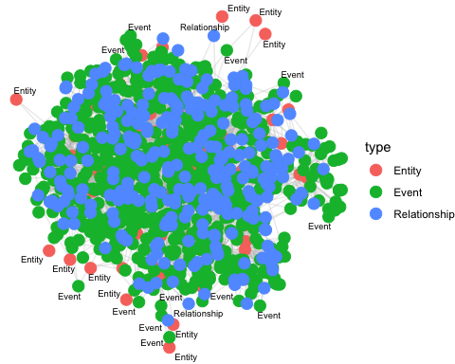

Extract and Prepare Communication Events
library(lubridate)
# Filter communication events
comm_nodes <- mc3_nodes_final %>%
filter(type == "Event", sub_type == "Communication") %>%
mutate(timestamp = ymd_hms(timestamp))
# Remove missing timestamps
comm_nodes <- comm_nodes %>% filter(!is.na(timestamp))

Aggregate Communications by Day and Hour
comm_nodes <- comm_nodes %>%
mutate(date = as.Date(timestamp),
hour = hour(timestamp))
daily_counts <- comm_nodes %>%
group_by(date) %>%
summarise(comm_count = n())
hourly_counts <- comm_nodes %>%
group_by(date, hour) %>%
summarise(comm_count = n())

Visualise Temporal Patterns
library(ggplot2)
ggplot(daily_counts, aes(x = date, y = comm_count)) +
geom_col(fill = "steelblue") +
geom_text(aes(label = comm_count),
vjust = -0.5,
size = 3) +
geom_smooth(method = "lm", se = FALSE, color = "red", linetype = "dashed") +
scale_x_date(date_labels = "%Y-%m-%d", expand = expansion(mult = c(0.01, 0.1))
) +
labs(title = "Daily Communication Volume",
x = "Date", y = "Number of Communications") +
theme_minimal()
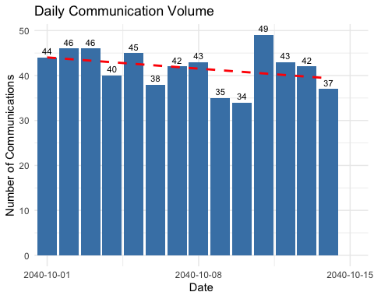
hourly_totals <- comm_nodes %>%
group_by(hour) %>%
summarise(comm_count = n())
ggplot(hourly_totals, aes(x = hour, y = comm_count)) +
geom_col(fill = "steelblue") +
geom_text(aes(label = comm_count),
vjust = -0.5,
size = 3) +
geom_smooth(method = "lm", se = FALSE, color = "red", linetype = "dashed") +
labs(title = "Hourly Communication Volume",
x = "Hour", y = "Number of Communications") +
theme_minimal()
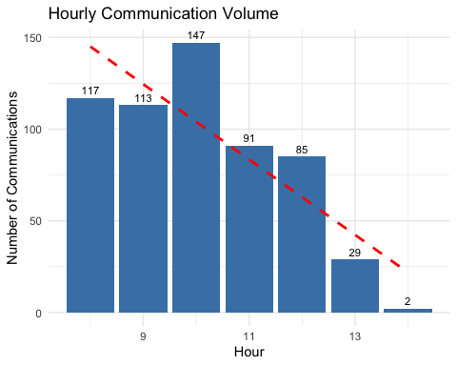
ggplot(hourly_counts, aes(x = hour, y = date, fill = comm_count)) +
geom_tile(color = "white") +
scale_fill_gradient(low = "white", high = "firebrick") +
scale_y_date(date_labels = "%Y-%m-%d") +
labs(title = "Hourly Communication Patterns",
x = "Hour of Day", y = "Date") +
theme_minimal()
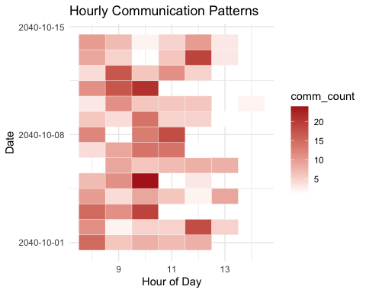
Question 1 A
Develop a graph-based visual analytics approach to identify any daily temporal patterns in communications.
Answer
The heatmap displays the number of communications for each hour of each day.
There are clear, consistent bands of higher activity around 8 - 11 AM each day. The darkest cells often appear in the morning hours, confirming that communication peaks at roughly the same time each day. Some days show additional activity at noon or early afternoon, but the morning peak is most pronounced.
The hourly communication volume bar chart aggregates all communications by hour over the observation period, with a red dashed trend line.
The highest communication volumes occur at 8 - 10 AM, peaking at 10 AM. There is a steady decline in communications after 10 AM, with very few messages in the early afternoon. The trend line confirms a strong downward trend in communication volume as the day progresses.
The daily communication volume bar chart aggregates communications by day, with a red dashed trend line.
Daily communication volumes are relatively stable, with minor fluctuations. There is a slight down ward trend in daily communication volume over the 2 weeks’ period, but no dramatic spikes or drops.
Question 1 B
How do these patterns shift over the two weeks of observations?
Answer
Hourly Patterns
The heatmap shows that the peak in communications remains consistently in the morning hours (8 - 11 AM) throughout the two-week period. There is little evidence of a major shift in the timing of daily peaks. The pattern is stable, with only minor day-to-day variation in exact hour of maximum activity.
Volume Trends
The daily communication volume bar chart shows a slight downward trend over the two weeks period, suggesting that while the timing of peak activity remains stable, the overall number of communications per day is gradually decreasing.
Intensity of Peaks
The hourly communication volume bar chart confirms that the bulk of communications are concentrated in the morning, and this does not change significantly over the observation window. The trend line indicates that, across all days, later hours consistently see less activity.
Clepper’s observation is correct. Messages indeed cluster at around the same time each day, with a strong morning peak. The main shift over the 2 weeks is a slight reduction in total daily communications, not a change in the time-of-day pattern.

Network Visualisation by Time
peak_hour <- 10
peak_comm_ids <- comm_nodes %>% filter(hour == peak_hour) %>% pull(new_index)
# Get edges involving peak hour nodes
peak_edges <- mc3_edges_final %>%
filter(from %in% peak_comm_ids | to %in% peak_comm_ids)
# Get unique node indices from edges
used_indices <- unique(c(peak_edges$from, peak_edges$to))
# Create filtered node table with new sequential index
peak_nodes_sub <- mc3_nodes_final %>%
filter(new_index %in% used_indices) %>%
mutate(sub_index = row_number())
# Update edge indices using the node table's sub_index
peak_edges_sub <- peak_edges %>%
left_join(select(peak_nodes_sub, old_index = new_index, from_sub = sub_index),
by = c("from" = "old_index")) %>%
left_join(select(peak_nodes_sub, old_index = new_index, to_sub = sub_index),
by = c("to" = "old_index")) %>%
select(from = from_sub, to = to_sub, is_inferred, type) %>%
filter(!is.na(from) & !is.na(to))
# Build graph
peak_graph <- tbl_graph(
nodes = peak_nodes_sub,
edges = peak_edges_sub,
directed = TRUE
)
ggraph(peak_graph, layout = "fr") +
geom_edge_link(alpha = 0.3, colour = "gray") +
geom_node_point(aes(color = type), size = 4) +
geom_node_text(aes(label = label), repel = TRUE, size = 2.5) +
theme_void() +
labs(title = paste("Communication Network at", peak_hour, ":00am"))
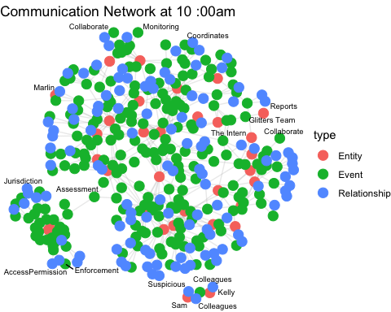
The communication network graph at 10 AM provides a snapshot of the structure and scale of the communication network at the daily peak hour. The dense interconnections at 10 AM visually confirm that this is a period of high activity, supporting the temporal findings from the bar and heatmap charts.
library(visNetwork)
# Convert to visNetwork format
nodes_vis <- peak_nodes_sub %>%
mutate(
id = sub_index,
label = paste0(label, "\n(", type, ")"),
group = type,
title = paste0(
"Name: ", label,
"\nType: ", type,
"\nSubtype: ", sub_type,
"\nConnections: ", map_dbl(sub_index, ~sum(peak_edges_sub$from == .x | peak_edges_sub$to == .x))
)
)
edges_vis <- peak_edges_sub %>%
mutate(
arrows = ifelse(is_inferred, "to;from", "to"),
dashes = is_inferred,
title = paste("Edge type:", type)
)
# Create interactive network
visNetwork(nodes_vis, edges_vis, height = "800px", width = "100%") %>%
visOptions(
highlightNearest = list(enabled = TRUE, degree = 2, hover = FALSE),
nodesIdSelection = TRUE,
selectedBy = list(variable = "group", multiple = TRUE)
) %>%
visPhysics(stabilization = TRUE) %>%
visInteraction(navigationButtons = TRUE) %>%
visLegend() %>%
visEvents(
selectNode = "function(properties) {
var nodeId = properties.nodes[0];
this.body.data.nodes.update({id: nodeId, color: {background:'#FFA500'}});
this.body.data.edges.update(
this.body.data.edges.get().filter(function(edge) {
return edge.from == nodeId || edge.to == nodeId;
}).map(function(edge) { return {id: edge.id, color: {color:'red'}}; })
);
}"
)

Full Network (All Dates and Hours)

Use All Communication/Event Nodes and Their Edges
library(visNetwork)
library(purrr)
# Filter for events of interest
all_event_ids <- mc3_nodes_final %>%
filter(type == "Event", sub_type %in% c("Communication")) %>%
pull(new_index)
# Get all edges involving these events
all_edges <- mc3_edges_final %>%
filter(from %in% all_event_ids | to %in% all_event_ids)
# Get all nodes involved in these edges
used_indices <- unique(c(all_edges$from, all_edges$to))
nodes_vis <- mc3_nodes_final %>%
filter(new_index %in% used_indices) %>%
mutate(
id = new_index,
label = paste0(label, "\n(", type, ")"),
group = type,
title = paste0(
"Name: ", label,
"\nType: ", type,
"\nSubtype: ", sub_type,
"\nConnections: ", map_dbl(new_index, ~sum(all_edges$from == .x | all_edges$to == .x))
)
)
edges_vis <- all_edges %>%
mutate(
arrows = ifelse(is_inferred, "to;from", "to"),
dashes = is_inferred,
title = paste("Edge type:", type)
)

Visualise the Full Network
visNetwork(nodes_vis, edges_vis, height = "800px", width = "100%") %>%
visOptions(
highlightNearest = list(enabled = TRUE, degree = 2, hover = FALSE),
nodesIdSelection = TRUE,
selectedBy = list(variable = "group", multiple = TRUE)
) %>%
visPhysics(stabilization = TRUE) %>%
visInteraction(navigationButtons = TRUE) %>%
visLegend()
Question 1 C
Focus on a specific entity and use this information to determine who has influence over them.
Answer
We shall focused our analysis of influence over the “Boss” entity.
To determine who has influence over Boss, we first identify Boss as a central blue node (entity) in the network. We select Boss in the interactive network graph and immediately visualise all nodes directly connected to them. In a directed network like this, the incoming edges (arrows pointing to Boss) are particularly important, as they indicate entities or events exerting influence on Boss.
Upon examining both the visual network and the communication records, several key influencers emerge:
Mrs. Money is a primary influencer, frequently initiating communications with Boss regarding financial planning, resource allocation, and operational funding. She brings financial intelligence, discusses allocation priorities, and provides strategic recommendations for ventures such as tourism operations near Nemo Reef. Her messages often prompt Boss to make decisions or schedule further meetings, indicating her advisory and influential role.
The Middleman is another significant influencer, providing Boss with political intelligence, council updates, and insights into regulatory loopholes. The Middleman’s information about council activities and protection zone regulations directly shapes Boss’s decisions regarding expansion plans and operational focus. Communications show that Boss relies on The Middleman’s updates to adjust strategies and exploit opportunities.
V. Miesel Shipping also exerts operational influence over Boss. This organisation coordinates equipment transfers, vessel documentation, and asset reallocation, all of which are critical to Boss’s operations. When conservation scrutiny increases, Boss requests confirmation from V. Miesel Shipping that all vessel documentation is in order, underscoring the operational dependency.
The network graph visually reinforces these findings. Boss is situated at the intersection of multiple clusters, with direct links to Mrs. Money, The Middleman and V. Miesel Shipping. The density of connections and the flow of information toward Boss highlight the entity’s central role and the influence exerted by these key players.

Visualise Nadia’s Direct and Indirect Connections
# Find Nadia's node ID
nadia_id <- 3
# Find all edges involving Nadia (direct connections)
nadia_edges <- edges_vis %>% filter(from == nadia_id | to == nadia_id)
# Find all nodes connected to Nadia (1st degree neighbours)
nadia_neighbours <- unique(c(nadia_edges$from, nadia_edges$to))
# Find all edges involving those neighbours (to get 2nd degree)
second_degree_edges <- edges_vis %>%
filter(from %in% nadia_neighbours | to %in% nadia_neighbours)
# Find all nodes involved in these edges (2nd degree)
second_degree_nodes <- unique(c(second_degree_edges$from, second_degree_edges$to))
# Visualise this subgraph
nodes_to_show <- nodes_vis %>% filter(id %in% second_degree_nodes)
edges_to_show <- edges_vis %>%
filter(from %in% second_degree_nodes & to %in% second_degree_nodes)
visNetwork(nodes_to_show, edges_to_show, height = "600px", width = "100%") %>%
visOptions(highlightNearest = TRUE, nodesIdSelection = TRUE) %>%
visPhysics(stabilization = TRUE) %>%
visLegend()
Questions 4 A and B
Through visual analytics, provide evidence that Nadia is, or is not, doing something illegal.
Summarise Nadia’s actions visually.
Answer
Nadia’s specific involvement in permit expediting is well-documented. On October 5, she is directly engaged in discussions with Haacklee Harbor and the Oceanus City Council regarding the establishment of special access corridors for Nemo Reef. Her communications with harbour authorities and permit offices reveal her central role in facilitating these arrangements. Crew members, such as those from the Sailor Shifts Team, explicitly acknowledge her influence, thanking her for “calling in favours” at the permit office. This influence results in Commissioner Torres signing off on permits at unprecedented speed, effectively bypassing standard review processes.
A particularly telling indicator of suspicious behaviour is Nadia’s abrupt cancellation of special access arrangements and her urgent request for the destruction of related documentation. This sequence of events occurs after increased scrutiny from harbour authorities and suggests a deliberate attempt to cover up her involvement and erase evidence of irregular activities. Such actions are signs of cover-up behaviour and are consistent with corrupt or illegal influence.
Visual analytics of the network further substantiate these findings. Nadia is directly connected to harbour authorities, permit offices, crew members, and V. Miesel Shipping. The timeline of Nadia’s communications and actions aligns closely with sudden permit approvals and the establishment of special access corridors that bypass standard protocols.
Nadia’s actions throughout the timeline from initiating special access arrangements to urgently canceling and requesting documentation destruction demonstrate a consistent pattern of bypassing oversight and leveraging influence for expedited outcomes. These behaviours, combined with her central position in the network and the acknowledgment of her influence by crew members, provide compelling evidence that Nadia Conti is involved in ongoing illicit activity within Oceanus. Her role is key to the flow of influence and information that enable suspicious permit expediting and unauthorised access to protected areas, making her a central figure in the network of individuals and organisations implicated in these activities.
Question 4 B
Are Clepper’s suspicions justified?
Answer
Clepper’s suspicions regarding Nadia Conti’s involvement in illicit activity are strongly justified by the available evidence. Nadia is personally thanked by crew members for calling in favours at the permit office, which resulted in Commissioner Torres signing off on permits at what is described as “unprecedented speed.” This expedited approval process bypasses standard reviews and strongly suggests the use of influence or back-channel arrangements. Further supporting these suspicions, when scrutiny increased, Nadia urgently canceled special access arrangements and requested the destruction of related documentation. This is a classic sign of attempted cover-up. Additionally, Nadia’s central position within the network is notable. She is directly connected to harbour authorities, event staff, and vessels involved in questionable access to Nemo Reef. Her actions consistently align with the interests of known suspicious actors such as Boss, Middleman, and Mrs. Money. Collectively, these patterns of behaviour are consistent with corrupt or illegal conduct, reinforcing the validity of Clepper’s concerns.

