



Smart In Media

[www.smartinmedia.com](http://www.smartinmedia.com)

Mr. Miller

89 Brook St

Brookline MA 02115  
USA

Date, 28 Jul 2019

Invoice No. 5

Dear customer:

Below, you will find your invoice about the products, which you ordered.

|  |  |  |
| --- | --- | --- |
| **Qty** | **Product** | **Price** |
| 2 | Software development | U$ 2,000 |
| 5 | Customization | U$ 1,000 |
| 7 | Travel expenses | U$ 1,500 |
|  | Total | U$ 4,500 |

Here is an image of our product:

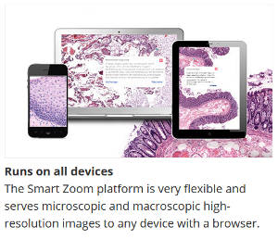

And here a table how you can contact us:

|  |  |  |  |
| --- | --- | --- | --- |
| **Name** | **Department** | **Responsibility** | **Telephone number** |
| Homer Simpson | Power Plant | Oversight | 888-234-2353 |
| Mr. Burns | Administration | CEO | 888-295-8383 |
| Mr. Smithers | Administration | Assistant | 888-848-2803 |

Yours sincerely

Sales Department