哈尔滨工业大学计算机科学与技术学院
2016年秋季学期《软件工程》
Lab 2：MVC编程与云平台部署

姓名 | 学号 | 联系方式
 |  | /

目 录

1 实验要求 1
2 开发环境配置 1
2.1 在Eclipse中配置Struts2 1
2.2 在Eclipse中配置MySQL 1
2.3 在Eclipse中配置Tomcat 1
3 图书SaaS设计 1
3.1 Web.xml 1
3.2 Struts.xml 1
3.3 Action类 2
3.4 辅助类 2
3.5 JSP页面 2
3.6 各Action/JSP之间的调用和消息传递关系 2
4 图书SaaS核心代码 2
4.1 按作者查询 2
4.2 展示图书详细信息 2
4.3 删除图书 3
4.4 新增图书/作者(可选) 3
4.5 更新图书信息(可选) 3
4.6 数据库连接与访问 3
5 图书SaaS的SAE部署 3
5.1 步骤 3
5.2 外在访问结果 3
6 计划与实际进度 3
7 小结 3

[文档全部完成之后，请更新上述区域]

实验要求

掌握MVC架构下的SaaS开发的基本流程；

开发环境：JAVA+Struts 2+Eclipse+Tomcat+MySQL+SAE；

在Eclipse中配置Struts开发环境，开发一个小型SaaS，在Web页面中 对数据库中的数据进行CRUD操作；

部署在SAE上并对外发布，模拟用户访问。

开发环境配置

在Eclipse中配置Struts2
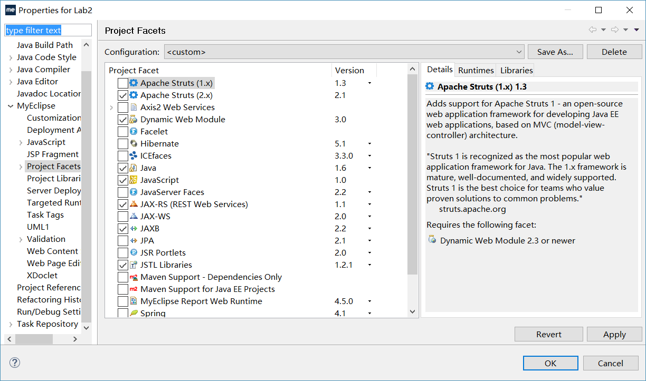

在Eclipse中配置MySQL
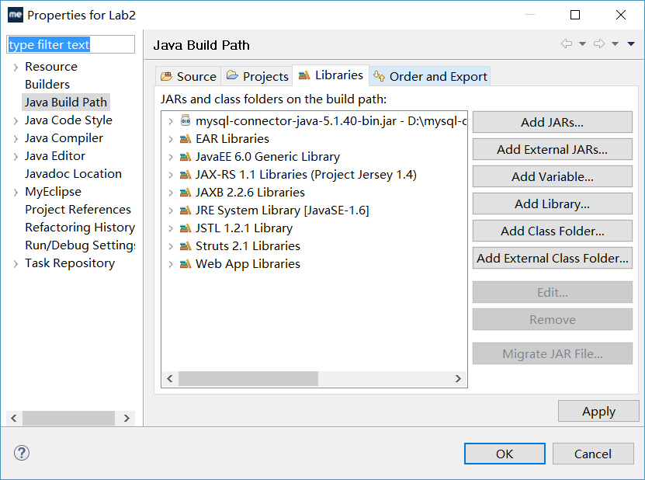

在Eclipse中配置Tomcat
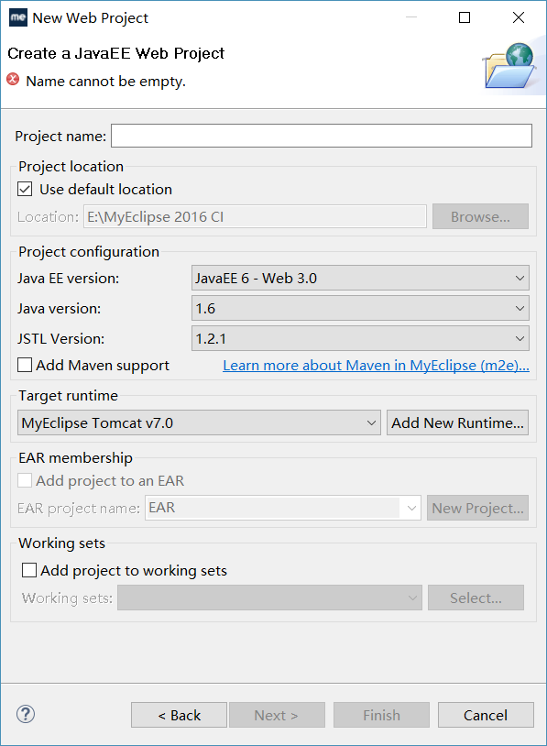

图书SaaS设计

Web.xml
<?xml version="1.0" encoding="UTF-8"?>
<web-app xmlns:xsi="http://www.w3.org/2001/XMLSchema-instance" xmlns="http://java.sun.com/xml/ns/javaee" xsi:schemaLocation="http://java.sun.com/xml/ns/javaee http://java.sun.com/xml/ns/javaee/web-app_3_0.xsd" version="3.0">
<display-name>lab2</display-name>
<servlet>
<description>JAX-RS Tools Generated - Do not modify</description>
<servlet-name>JAX-RS Servlet</servlet-name>
<servlet-class>com.sun.jersey.spi.container.servlet.ServletContainer</servlet-class>
<load-on-startup>1</load-on-startup>
</servlet>
<servlet-mapping>
<servlet-name>JAX-RS Servlet</servlet-name>
<url-pattern>/jaxrs/*</url-pattern>
</servlet-mapping>
<filter>
<filter-name>struts2</filter-name>
<filter-class>org.apache.struts2.dispatcher.ng.filter.StrutsPrepareAndExecuteFilter</filter-class>
</filter>
<filter-mapping>
<filter-name>struts2</filter-name>
<url-pattern>*.action</url-pattern>这里把过滤器设置为.action
</filter-mapping>
</web-app>

Struts.xml
源代码(XML)
附加关键部分的说明

Action类
序号 | Action类名 | 作用 | 操作列表 | 操作说明
1 | DetectAuthor | 检查用户输入的作者是否在数据库中 | Excute() | 作者存在返回success，不存在返回error
2 | UpdateBook | 修改一本书的信息，若书的作者不存在则创建作者 | excute() | 修改成功返回success，修改失败返回error
3 | AddBook | 增加一本书进入数据库，若作者不存在，创建作者 | excute() | 添加成功返回success  添加失败返回error
4 | DelBook | 从数据库中删除一本书的信息 | excute() | 删除成功返回success  删除失败返回error

辅助类
package database:
MyDatabase:数据库的驱动信息以及账号密码
GetConnection:获取与数据库的连接
AddAuthor:根据name,age,country三个参数向数据库里增加作者信息
AddBook:添加书到数据库中
AllBooks:返回值List<book>，包含所有图书的信息
BookInformation:返回一本书的全部信息
DeleteBook:删除一本书
DetectAuthor:检查作者是否在数据库中
SearchAccordingToAuthor:根据作者名字进行查询，返回该作者所写全部书
SearchAccordingToIsbn:根据Isbn返回书的信息
UpdateBook:更新一本书的信息
package po:
book:书的类，成员变量为一本书的所有信息
author:成员变量为作者的所有信息

JSP页面
序号 | 页面名 | 作用 | 页面核心元素(form) | Form对应的action name | Form中提交的数据项
1 | AddBook | 填写要增加书籍的相关信息的页面 | 用于提交一本书的所有信息 | AddBook.action | isbn title author age country publishetr publishdate price
2 | UpdateBook | 填写更新书籍信息的页面 | 用于提交更新后的信息 | UpdateBook.action | isbn title author age country publishetr publishdate price
3 | Search | 输入作者名字查找给作者所作全部书籍 | 用于提交作者名字 | Detect.action | name
4 | Allbooks | 用于展示全部书籍的信息 | 无form
5 | BookInformatica | 用于展示某本书的全部信息 | 无form
6 | SearchAccordingToAuthor | 用于展示某个作者所作的全部书的题目 | 无form
7 | Index | 首页，展示按作者查询、查看全部书籍、添加书籍三个功能按钮 | 无form
8 | AddSuccess | 展示添加作者成功的信息 | 无form
9 | DeleteSuccess | 展示删除成功的信息 | 无form
10 | AuthorError | 作者不存在 | 无form
11 | UpdateSuccess | 更新信息成功的页面 | 无form

各Action/JSP之间的调用和消息传递关系
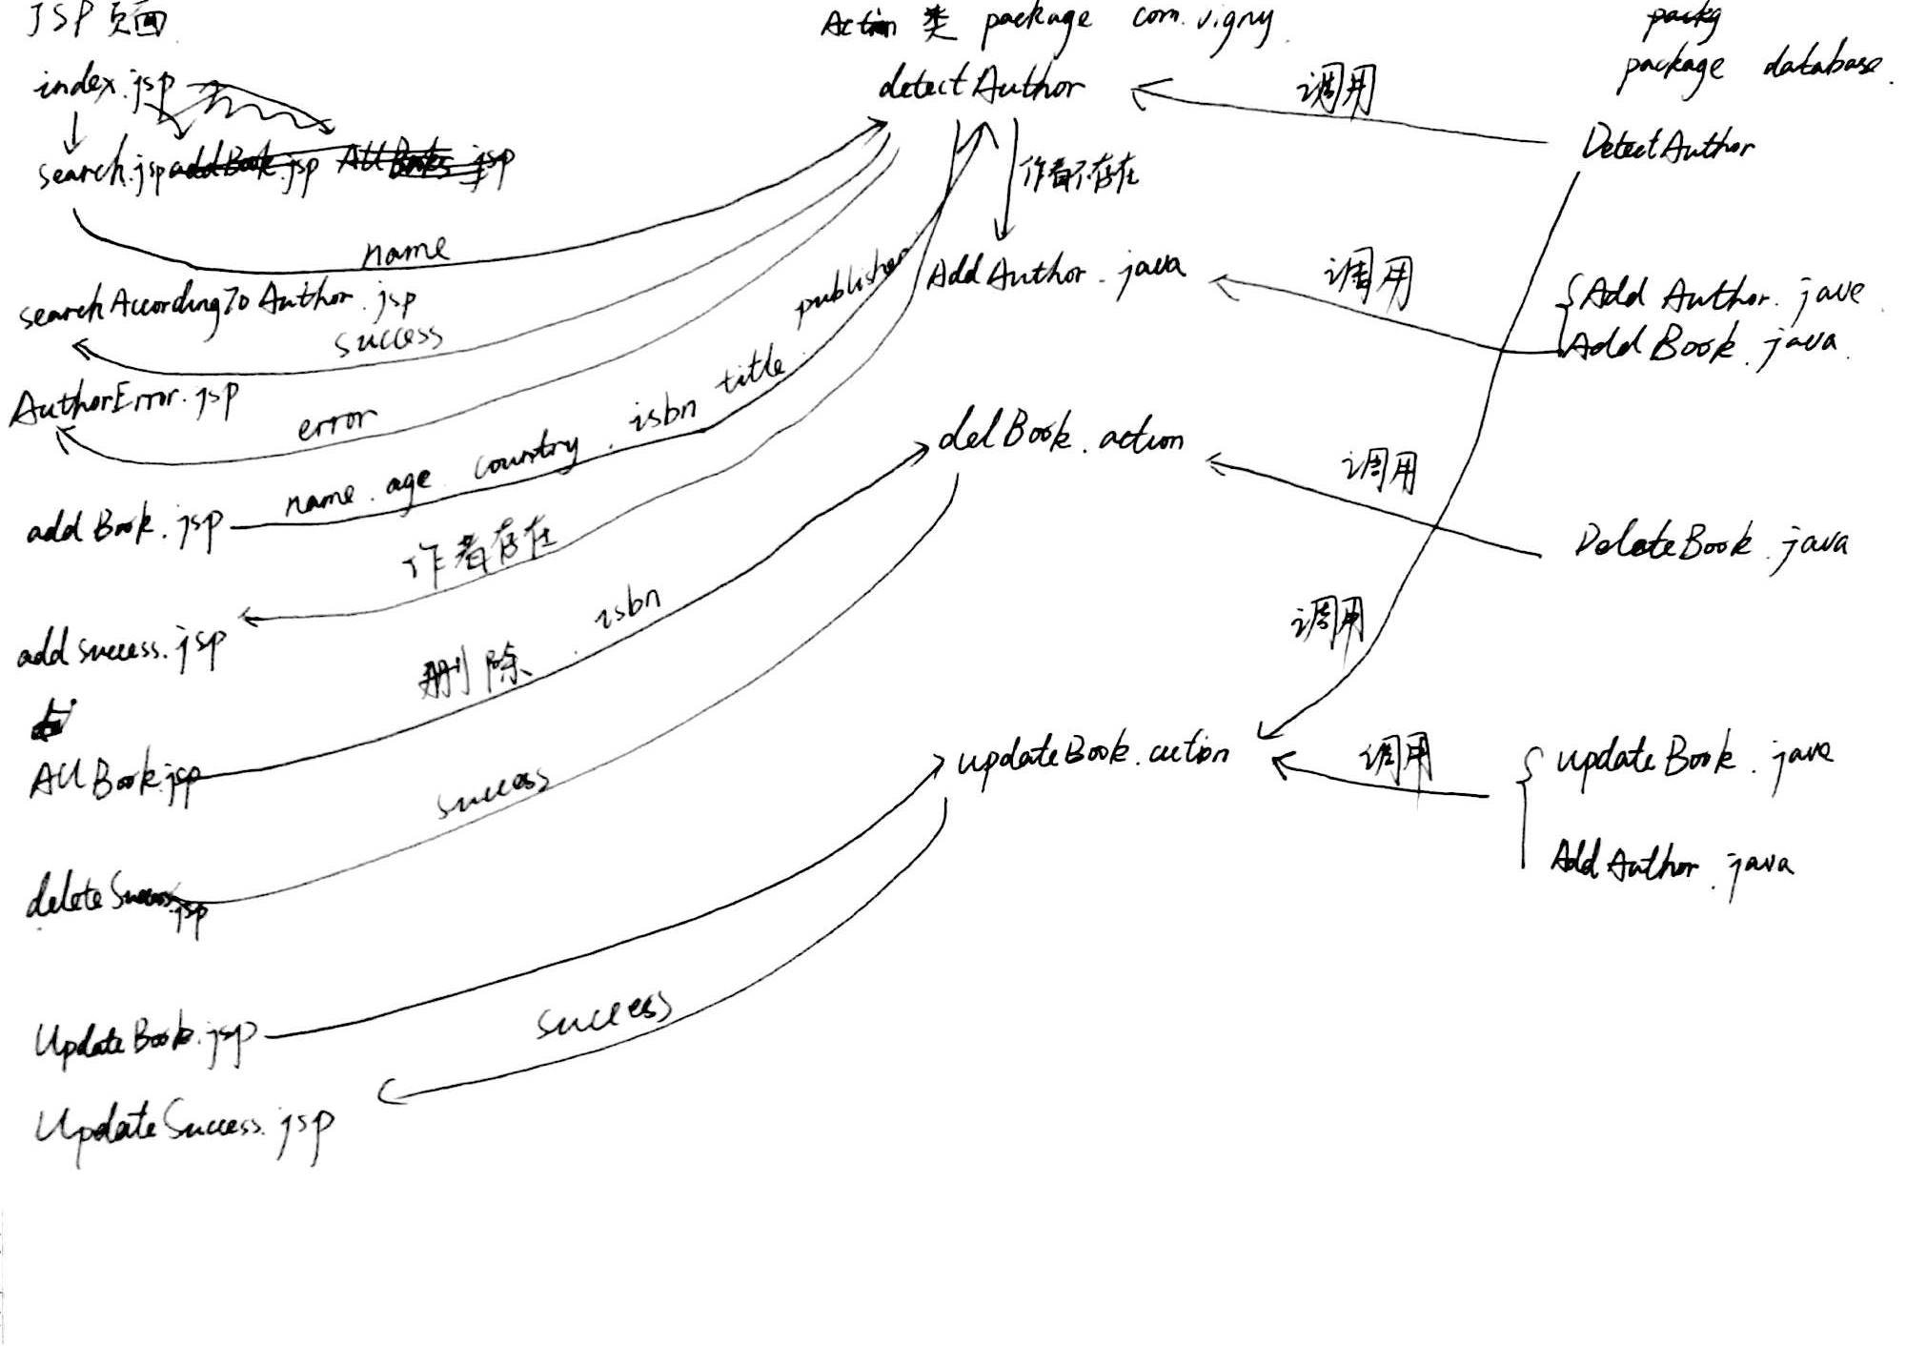

图书SaaS核心代码

按作者查询
Action类：
检查作者是否存在，若存在则进行查询，否则报错。
package com.vigny;

import database.DetectAuthor;
import com.opensymphony.xwork2.ActionSupport;
public class detectAuthor extends ActionSupport{

private String name;
public String excute() throws Exception
{

int i=0;
try{
i=DetectAuthor.detectAuthor1(name);
if(i==1) return "success";
else return "error";
}catch (Exception e){
e.printStackTrace();
return "error";
}

}
public String getName() {
return name;
}
public void setName(String name) {
this.name = name;
}
}

public static int detectAuthor1(String name)throws SQLException, UnsupportedEncodingException{//检查作者是否存在与数据库中
//name=new String(name.getBytes("ISO-8859-1"),"UTF-8");
java.sql.Connection conn = null;
PreparedStatement pstmt = null;
ResultSet rs=null;
int i=0;
conn = GetConnection.getConn();
try {
System.out.println("Creating statement...");

String sql = "SELECT * FROM author where name=?";
pstmt = (PreparedStatement) conn.prepareStatement(sql);
pstmt.setString(1, name);
rs=pstmt.executeQuery();
if(rs.next()){
i=1;//存在
}
rs.close();
pstmt.close();
conn.close();
return i;

} catch (SQLException se) {
// Handle errors for JDBC
se.printStackTrace();
}
finally {
// finally block used to close resources
try {
if (rs != null)
rs.close();
} catch (SQLException se) {
se.printStackTrace();
} // nothing we can do
try {
if (pstmt != null)
pstmt.close();
} catch (SQLException se2) {
se2.printStackTrace();
} // nothing we can do
try {
if (conn != null)
conn.close();
} catch (SQLException se) {
se.printStackTrace();
} // end finally try
} // end try

return i;//不存在
}

public List<book> getBook(String name) throws UnsupportedEncodingException {//返回作者所作的全部书籍
//name=new String(name.getBytes("ISO-8859-1"),"UTF-8");
List<book> list = new ArrayList<book>();
java.sql.Connection conn = null;
Statement stmt = null;
Statement stmt1 = null;
try {
// STEP 2: Register JDBC driver
conn = GetConnection.getConn();

System.out.println("Creating statement...");
stmt = conn.createStatement();
stmt1 = conn.createStatement();
String sql;
sql = "SELECT * FROM author where name='"+name+"'";
ResultSet authorrs = stmt.executeQuery(sql);
while(authorrs.next()){
String authorid = String.valueOf(authorrs.getInt("authorid"));
String sql1 = "SELECT * FROM book where authorid='"+authorid+"'";
ResultSet rs = stmt1.executeQuery(sql1);
while (rs.next()) {// rs.next()==null˵�����ѯ�����ݲ����ڡ�

String title = rs.getString("title");
String isbn = rs.getString("isbn");

int authorid1 = rs.getInt("authorid");
String publisher = rs.getString("publisher");
String publishdate = rs.getString("publishdate");
String price = rs.getString("price");
book bk = new book();
bk.setIsbn(isbn);
bk.setTitle(title);
bk.setPublisher(publisher);
bk.setPublishdate(publishdate);
bk.setPrice(price);
bk.setAuthorid(authorid1);
list.add(bk);

}
// STEP 6: Clean-up environment
rs.close();

}
stmt.close();
conn.close();
return list;

// �Ҳ������ߵ������ʱ��֪����ô����

} catch (SQLException se) {
// Handle errors for JDBC
se.printStackTrace();
} catch (Exception e) {
// Handle errors for Class.forName
e.printStackTrace();
} finally {
// finally block used to close resources
try {
if (stmt != null)
stmt.close();
} catch (SQLException se2) {
} // nothing we can do
try {
if (conn != null)
conn.close();
} catch (SQLException se) {
se.printStackTrace();
} // end finally try
} // end try
return null;
}
JSP页面:
以表格的形式展示每本书的信息
<div align="center">
<table id="table-2">

<tr>

<td>title</td>
<td></td>

</tr>
<%String name=request.getParameter("name");%>

<%
SearchAccordingToAuthor sa=new SearchAccordingToAuthor();
List<book> list=sa.getBook(name);
for(book bk:list)
{%>
<tr>
<td><a style="text-decoration:none" href="BookInformation.jsp?isbn=<%=bk.getIsbn() %>"><%=bk.getTitle() %></a></td>
<td><a style="text-decoration:none" href="DeleteBook.action?isbn=<%=bk.getIsbn() %>&name=<%=name %>">delete</a></td>
<%} %>
</tr>
</table>
</div>
<br>
</div>

展示图书详细信息
说明：我没有写这个action类，而是在BookInformation.jsp中直接调用下面的方法，返回一本书的全部信息
public book bookInformation(String isbn) throws SQLException{
book bk = new book();
java.sql.Connection conn = null;
PreparedStatement pstmt = null;
PreparedStatement pstmt1 = null;
try {
// STEP 2: Register JDBC driver

conn = GetConnection.getConn();

// STEP 4: ��ѯ���
System.out.println("Creating statement...");

String sql;
sql = "SELECT * FROM book where isbn=?";
pstmt = (PreparedStatement) conn.prepareStatement(sql);
pstmt.setString(1, isbn);
ResultSet rs=pstmt.executeQuery();
while (rs.next()) {// rs.next()==null˵�����ѯ�����ݲ����ڡ�
// Retrieve by column name

//String isbn = rs.getString("isbn");

String title = rs.getString("title");
int authorid = rs.getInt("authorid");
String publisher = rs.getString("publisher");
String publishdate = rs.getString("publishdate");
String price = rs.getString("price");
bk.setIsbn(isbn);
bk.setTitle(title);
bk.setPublisher(publisher);
bk.setPublishdate(publishdate);
bk.setPrice(price);
bk.setAuthorid(authorid);
//book bk=new book(isbn, title, authorid, publisher, publishdate, price);

String sql1= "SELECT * FROM author where authorid=?";
pstmt1 = (PreparedStatement) conn.prepareStatement(sql1);
pstmt1.setInt(1, authorid);
ResultSet rs1=pstmt1.executeQuery();
if(rs1.next()){
String name=rs1.getString("name");
int age=rs1.getInt("age");
String country=rs1.getString("country");
bk.setAuthor(name);
bk.setAuthorAge(age);
bk.setAuthorCountry(country);
rs1.close();

}

//String country = rs.getString("country");

// Display values
//System.out.print("authorid: " + authorid);
//System.out.print(", name: " + name);
//System.out.print(", Age: " + age);
//System.out.println(", country: " + country);
}
// STEP 6: Clean-up environment
rs.close();

pstmt.close();
pstmt1.close();
conn.close();
return bk;

} catch (SQLException se) {
// Handle errors for JDBC
se.printStackTrace();
} catch (Exception e) {
// Handle errors for Class.forName
e.printStackTrace();
} finally {
// finally block used to close resources
try {
if (pstmt != null)
pstmt.close();
} catch (SQLException se2) {
} // nothing we can do
try {
if (conn != null)
conn.close();
} catch (SQLException se) {
se.printStackTrace();
} // end finally try
} // end try
return null;
}
JSP页面:通过表格展示全部信息，利用isbn查找一本书的全部信息
<%String isbn=request.getParameter("isbn");%>
<div align="center">
<table id="table-2">

<tr>

<td>isbn</td>
<td>title</td>
<td>publisher</td>
<td>publishdate</td>
<td>price</td>
<td>author</td>
<td>age</td>
<td>country</td>
<td></td>
<td></td>

</tr>

<%
BookInformation bi = new BookInformation();
book tl = new book();
tl=bi.bookInformation(isbn);
%>

<tr>

<td><%=tl.getIsbn() %></td>
<td><%=tl.getTitle() %></td>
<td><%=tl.getPublisher() %></td>
<td><%=tl.getPublishdate() %></td>
<td><%=tl.getPrice() %></td>
<td><%=tl.getAuthor() %></td>
<td><%=tl.getAuthorAge() %></td>
<td><%=tl.getAuthorCountry() %></td>
<td><a style="text-decoration:none" href="updateBook_setIsbn.action?isbn=<%=tl.getIsbn() %>">update</a></td>
<td><a style="text-decoration:none" href="DeleteBook.action?isbn=<%=tl.getIsbn() %>&name=<%=tl.getAuthor() %>">delete</a></td>
</tr>

</table>
</div>

删除图书
Action类:调用DeleteBook类中deleteBook()这个方法，删除一本书;
package com.vigny;
import java.util.Map;
import database.DeleteBook;
import com.opensymphony.xwork2.ActionSupport;
public class delBook extends ActionSupport{

private String isbn;
private String name;
public String getName() {
return name;
}
public void setName(String name) {
this.name = name;
}
public String getIsbn() {
return isbn;
}
public void setIsbn(String isbn) {
this.isbn = isbn;
}
public String excute() throws Exception
{
int i=0;
DeleteBook del=new DeleteBook();
i=del.delete(isbn);
if(i!=0)
return SUCCESS;
else
return ERROR;
}
}

public int delete(String isbn) throws SQLException{
java.sql.Connection conn = null;
PreparedStatement pstmt = null;
int i=0;
conn = GetConnection.getConn();
// STEP 4: ��ѯ���
System.out.println("Creating statement...");

String sql;
sql = "delete from book where isbn=?";
try {
pstmt = (PreparedStatement) conn.prepareStatement(sql);
pstmt.setString(1, isbn);
i = pstmt.executeUpdate();
pstmt.close();
conn.close();
return i;
} catch (SQLException e) {
e.printStackTrace();
}
return i;
}

新增图书/作者(可选)
Action类:调用DetectAuthor类中的detectAuthor方法，若作者不存在可以新增作者。
package com.vigny;

import java.io.UnsupportedEncodingException;
import java.sql.SQLException;

import com.opensymphony.xwork2.ActionSupport;
import database.DetectAuthor;
import database.AddAuthor;
import database.AddBook;

public class addBook extends ActionSupport {
private String isbn;
private String title;
private String publisher;
private String publishdate;
private String price;
private String name;
private int age;
private String country;
public String getName() {
return name;
}
public void setName(String name) throws UnsupportedEncodingException {
//name=new String(name.getBytes("ISO-8859-1"),"UTF-8");
this.name = name;
}
public int getAge() {
return age;
}
public void setAge(int age) {
this.age = age;
}
public String getCountry() {
return country;
}
public void setCountry(String country) throws UnsupportedEncodingException {
//country=new String(country.getBytes("ISO-8859-1"),"UTF-8");
this.country = country;
}
public String getIsbn() {
return isbn;
}
public void setIsbn(String isbn) throws UnsupportedEncodingException {
//isbn=new String(isbn.getBytes("ISO-8859-1"),"UTF-8");
this.isbn = isbn;
}
public String getTitle() {
return title;
}
public void setTitle(String title) throws UnsupportedEncodingException {
//title=new String(title.getBytes("ISO-8859-1"),"UTF-8");
this.title = title;
}
public String getPublisher() {
return publisher;
}
public void setPublisher(String publisher) throws UnsupportedEncodingException {
//publisher=new String(publisher.getBytes("ISO-8859-1"),"UTF-8");
this.publisher = publisher;
}
public String getPublishdate() {
return publishdate;
}
public void setPublishdate(String publishdate) throws UnsupportedEncodingException {
//publishdate=new String(publishdate.getBytes("ISO-8859-1"),"UTF-8");
this.publishdate = publishdate;
}
public String getPrice() {
return price;
}
public void setPrice(String price) throws UnsupportedEncodingException {
//price=new String(price.getBytes("ISO-8859-1"),"UTF-8");
this.price = price;
}

public String addBook() throws SQLException, UnsupportedEncodingException{
int i=0;
int authorid=0;
i=DetectAuthor.detectAuthor3(name, age, country);
if(i==0){
AddAuthor.addAuthor(name, age, country);
}
authorid=AddAuthor.getAuthorid(name, age, country);
i=AddBook.addBook(isbn, title, authorid, publisher, publishdate, price);
if(i==1) return "success";
else return "error";
}
}
public static int detectAuthor3(String name, int age, String country)throws SQLException, UnsupportedEncodingException{
//name=new String(name.getBytes("ISO-8859-1"),"UTF-8");
//country=new String(country.getBytes("ISO-8859-1"),"UTF-8");
java.sql.Connection conn = null;
PreparedStatement pstmt = null;
ResultSet rs=null;
int i=0;
conn = GetConnection.getConn();
// STEP 4: ��ѯ���

try {
// STEP 2: Register JDBC driver
// STEP 4: ��ѯ���
System.out.println("Creating statement...");

String sql = "SELECT * FROM author where name=? and age=? and country=?";
pstmt = (PreparedStatement) conn.prepareStatement(sql);
pstmt.setString(1, name);
pstmt.setInt(2, age);
pstmt.setString(3, country);
rs=pstmt.executeQuery();
if(rs.next()){
i=1;
}
rs.close();
pstmt.close();
conn.close();
return i;

} catch (SQLException se) {
// Handle errors for JDBC
se.printStackTrace();
}
finally {
// finally block used to close resources
try {
if (rs != null)
rs.close();
} catch (SQLException se) {
se.printStackTrace();
} // nothing we can do
try {
if (pstmt != null)
pstmt.close();
} catch (SQLException se2) {
se2.printStackTrace();
} // nothing we can do
try {
if (conn != null)
conn.close();
} catch (SQLException se) {
se.printStackTrace();
} // end finally try
} // end try

return i;//不存在
}
Jsp页面:将表单做成表格的样式提交
<form action="addBook.action" accept-charset="UTF-8">
<table id="table-2" align="center">

<tr>

<td>isbn</td>
<td>title</td>
<td>publisher</td>
<td>publishdate</td>
<td>price</td>
<td>author</td>
<td>author age</td>
<td>author country</td>
<td></td>
<td></td>
</tr>

<tr>

<td><input style="width:120px;" class="span3" type=text name="isbn"></td>
<td><input style="width:120px;" class="span3" type=text name="title"></td>
<td><input style="width:120px;" class="span3" type=text name="publisher"></td>
<td><input style="width:120px;" class="span3" type=text name="publishdate"></td>
<td><input style="width:120px;" class="span3" type=text name="price"></td>
<td><input style="width:120px;" class="span3" type=text name="name"></td>
<td><input style="width:120px;" class="span3" type=text name="age"></td>
<td><input style="width:120px;" class="span3" type=text name="country"></td>
<td><input class="btn btn-warning btn-large btn-block" type=submit value="submit"></td>
<td><a href="index.jsp" class="btn btn-large btn-block btn-danger" style="width:52.8px;">主页</a></td>

</tr>

</table>

更新图书信息(可选)
Action类：调用DeteceAuthor类中的detectAuthor方法，若更新的作者不存在则添加作者
package com.vigny;

import java.io.UnsupportedEncodingException;
import java.sql.SQLException;

import com.opensymphony.xwork2.ActionSupport;

import database.AddAuthor;
import database.AddBook;
import database.DetectAuthor;
import database.UpdateBook;

public class updateBook extends ActionSupport {
private String isbn;
private String title;
private String publisher;
private String publishdate;
private String price;
private String name;
private int age;
private String country;
public String getIsbn() {
return isbn;
}
public void setIsbn(String isbn) {
this.isbn = isbn;
}
public String getTitle() {
return title;
}
public void setTitle(String title) {
this.title = title;
}
public String getPublisher() {
return publisher;
}
public void setPublisher(String publisher) {
this.publisher = publisher;
}
public String getPublishdate() {
return publishdate;
}
public void setPublishdate(String publishdate) {
this.publishdate = publishdate;
}
public String getPrice() {
return price;
}
public void setPrice(String price) {
this.price = price;
}
public String getName() {
return name;
}
public void setName(String name) {
this.name = name;
}
public int getAge() {
return age;
}
public void setAge(int age) {
this.age = age;
}
public String getCountry() {
return country;
}
public void setCountry(String country) {
this.country = country;
}
public String set(){
return "success";
}
public String update() throws UnsupportedEncodingException, SQLException{
int i=0;
int authorid=0;
i=DetectAuthor.detectAuthor3(name, age, country);
if(i==0){
AddAuthor.addAuthor(name, age, country);
}
authorid=AddAuthor.getAuthorid(name, age, country);
i=UpdateBook.updateBook(isbn, authorid, publisher, publishdate, price);
if(i==1) return "success";
else return "error";
}
}
JSP页面:通过表格的形式提交表单
<div class="span3" align="center">
<form action="updateBook.action">

<table id="table-2">

<tr>

<td><div align="center">title</div></td>
<td><div align="center">publisher</div></td>
<td><div align="center">publishdate</div></td>
<td><div align="center">price</div></td>
<td><div align="center">author</div></td>
<td><div align="center">author age</div></td>
<td><div align="center">author country</div></td>
</tr>
<%
String isbn=request.getParameter("isbn");
BookInformation bi = new BookInformation();
book tl = new book();
tl=bi.bookInformation(isbn);
%>
<tr>

<td ><div style="width:135px;"><%=tl.getTitle() %></div></td>
<td><input style="width:120px;" class="span3" type=text name="publisher" value="<%=tl.getPublisher() %>"></td>
<td><input style="width:120px;" class="span3" type=text name="publishdate" value="<%=tl.getPublishdate() %>"></td>
<td><input style="width:120px;" class="span3" type=text name="price" value="<%=tl.getPrice() %>"></td>
<td><input style="width:120px;" class="span3" type=text name="name" value="<%=tl.getAuthor() %>"></td>
<td><input style="width:120px;" class="span3" type=text name="age" value="<%=tl.getAuthorAge() %>"></td>
<td><input style="width:120px;" class="span3" type=text name="country" value="<%=tl.getAuthorCountry() %>"></td>
<td><input style="width:120px;" class="span3" type=hidden name="title" value="<%=tl.getTitle() %>"></td>
<td><input style="width:120px;" class="span3" type=hidden name="isbn" value="<%=tl.getIsbn() %>"></td>
<td><input type=submit value="提交" class="btn btn-warning btn-large btn-block" >

</tr>

</table>

</form>
<div align="center"></div>
</div>
<div align="center">
<script src="http://cdn.bootcss.com/jquery/1.9.1/jquery.min.js"></script>
<script src="js/jquery-ui-1.10.0.custom.min.js"></script>
<script src="js/jquery.dropkick-1.0.0.js"></script>
<script src="js/custom_checkbox_and_radio.js"></script>
<script src="js/custom_radio.js"></script>
<script src="js/bootstrap-tooltip.js"></script>
<script src="js/jquery.tagsinput.js"></script>
<script src="http://cdn.bootcss.com/jquery-placeholder/2.0.7/jquery.placeholder.min.js"></script>
<script src="http://vjs.zencdn.net/c/video.js"></script>
<script src="js/application.js"></script>
<script src="/p/projects.js"></script>
<script src="http://cdn.bootcss.com/prettify/r298/prettify.min.js"></script>
<script src="http://cdn.bootcss.com/jquery/1.11.2/jquery.min.js"></script>
<script type="text/javascript" src="js/scrollMonitor.js"></script>
<script type="text/javascript" src="js/zeroclipboard/dist/ZeroClipboard.js"></script>
<script type="text/javascript" src="js/polyfill.js"></script>
<script type="text/javascript" src="js/smooth-scroll.js"></script>
<script type="text/javascript" src="js/handlebars.js"></script>
<script type="text/javascript" src="js/showcase.js"></script>
<script type="text/javascript" src="js/buttons.js"></script>
<script src="/p/projects.js"></script>
</div>
添加成功的返回页面
<h3 align="center" class="demo-logo">Success! </h3><br>
<div align="center"><br>
<div class="container">
<div class="row demo-row">
<div class="span3">
<div align="center"><a href="Allbooks.jsp" class="btn btn-large btn-block btn-danger">所有书籍</a></div>
</div>
</div> <!-- /row -->
</div> <!-- /container -->
<br>

<div class="container">
<div class="row demo-row">
<div class="span3">
<div align="center"><a href="index.jsp" class="btn btn-large btn-block btn-danger">返回首页</a></div>
</div>
</div> <!-- /row -->
</div> <!-- /container -->

数据库连接与访问
无JSP页面。
存放连接数据库要用的所有关键字。
package database;

public class MyDataBase {
private static final String JDBC_DRIVER = "com.mysql.jdbc.Driver";
private static final String DB_URL = "jdbc:mysql://jbwdfwljhjna.rds.sae.sina.com.cn:10448/bookdb?useUnicode=true&character=UTF-8";
//private static final String DB_URL = "jdbc:mysql://localhost:3306/bookdb?useUnicode=true&character=UTF-8";
private static final String USER = "root";
private static final String PASS = "332319";
public static String JDBC_DRIVER(){
return JDBC_DRIVER;
}
public static String DB_URL(){
return DB_URL;
}
public static String USER(){
return USER;
}
public static String PASS(){
return PASS;
}
}
获取连接。
package database;
import database.MyDataBase;
import java.sql.*;
import com.mysql.jdbc.*;
import com.mysql.jdbc.Connection;
import database.MyDataBase;
import java.sql.DriverManager;
import java.sql.ResultSet;
import java.sql.SQLException;
public class GetConnection {
public static Connection getConn(){
Connection conn = null;
try {
Class.forName("com.mysql.jdbc.Driver");
// STEP 3: Open a connection
System.out.println("Connecting to database...");
conn = (Connection) DriverManager.getConnection(MyDataBase.DB_URL(), MyDataBase.USER(), MyDataBase.PASS());

} catch (ClassNotFoundException e) {
e.printStackTrace();
} catch (SQLException e) {
e.printStackTrace();
}
return conn;
}
}

图书SaaS的SAE部署

步骤
- 选择信息
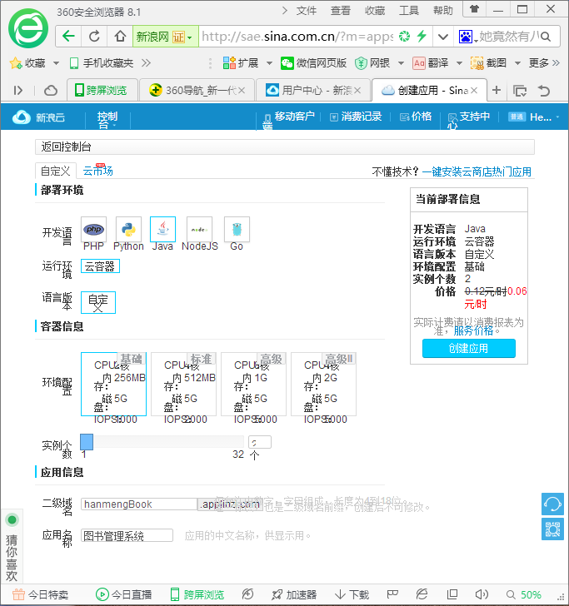
- 上传war包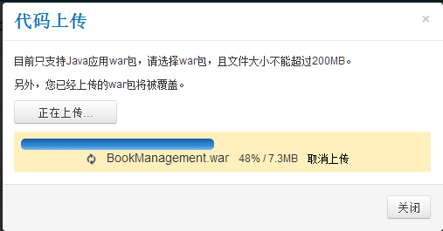
- 初始化数据库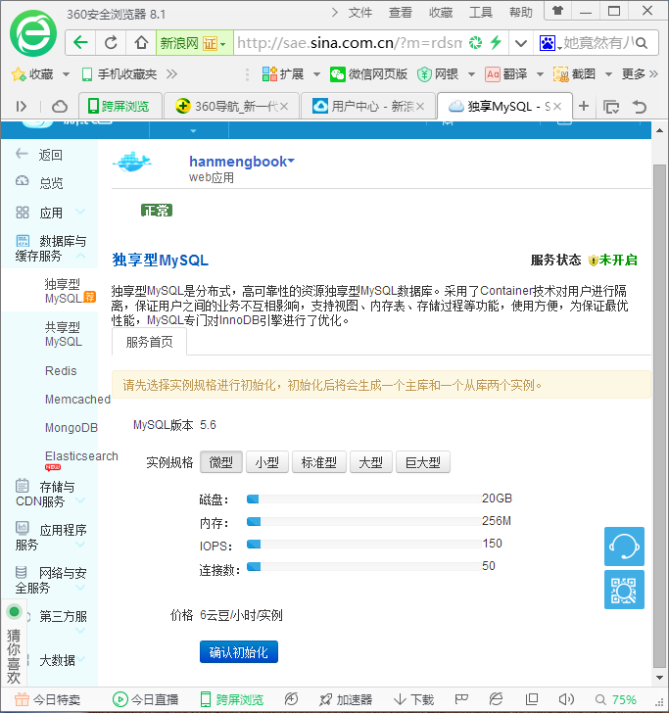
- 创建账号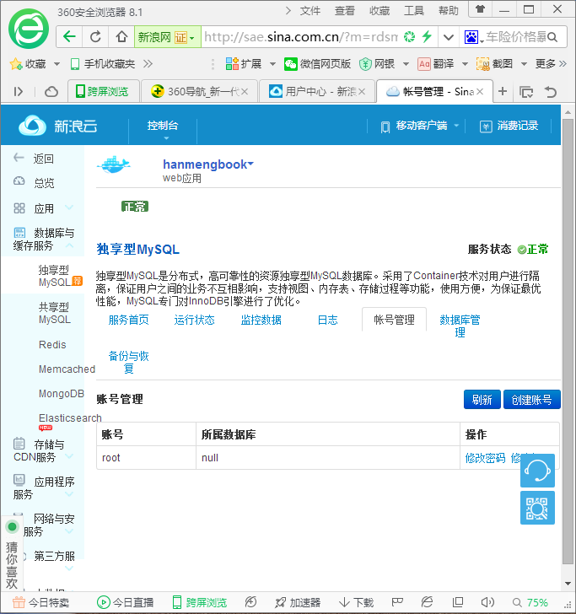
- 创建数据库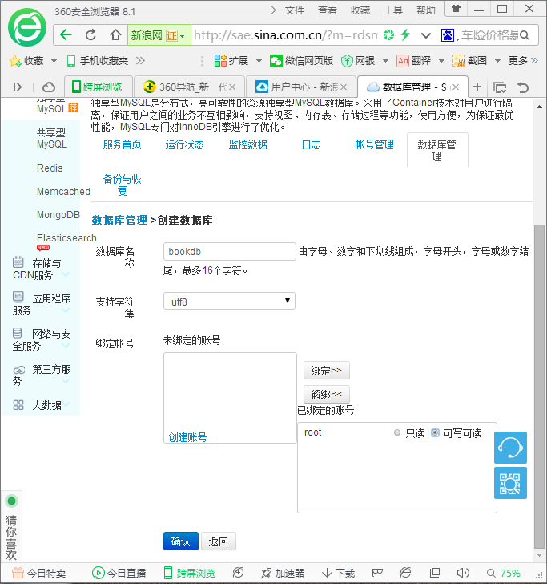
- 登录数据库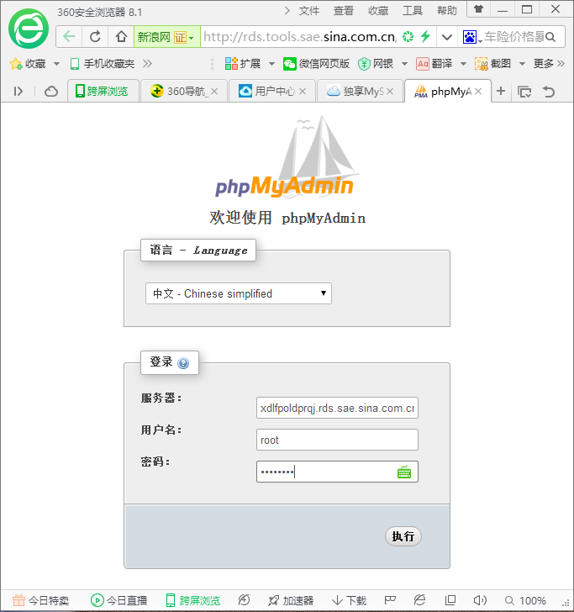
- 建表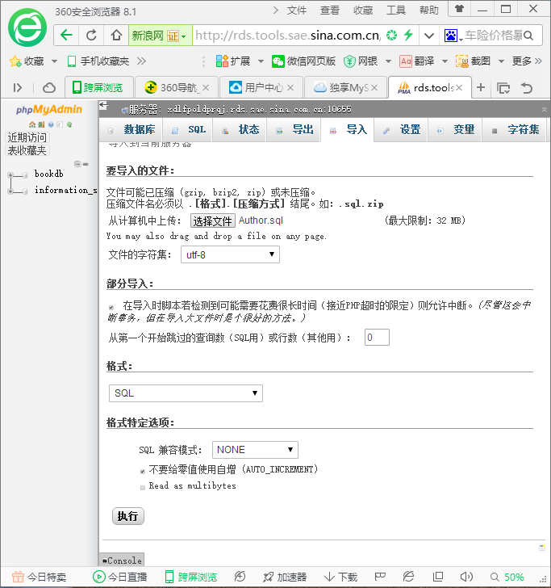
- 表导入成功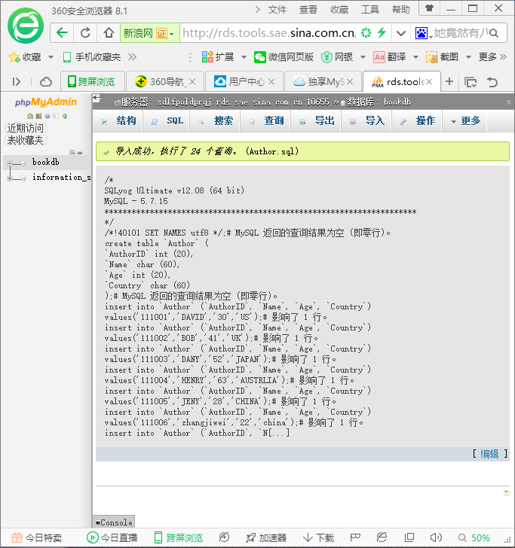

外在访问结果
地址：http://vigny.applinzi.com/
首页
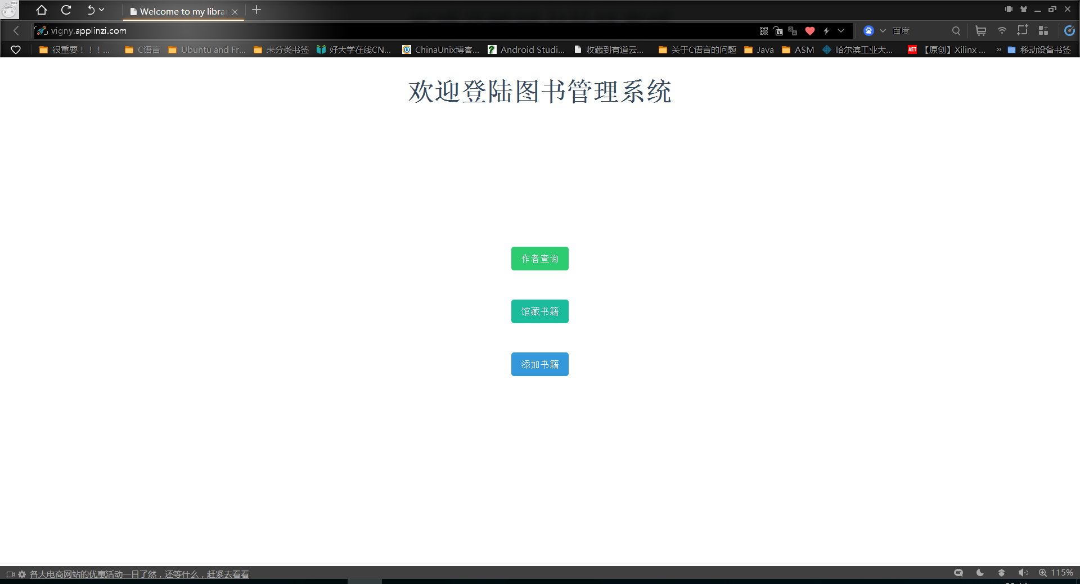
查询页面
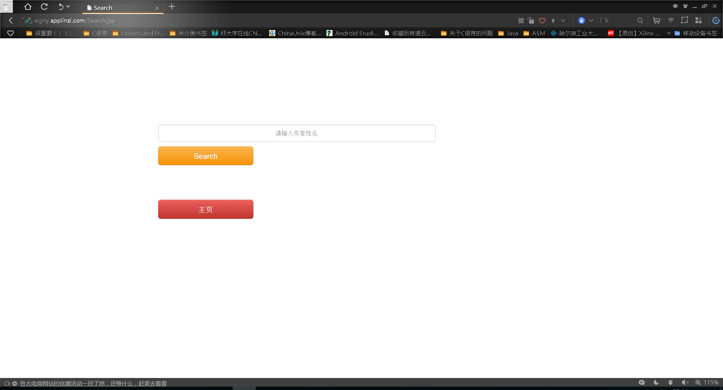
查询结果
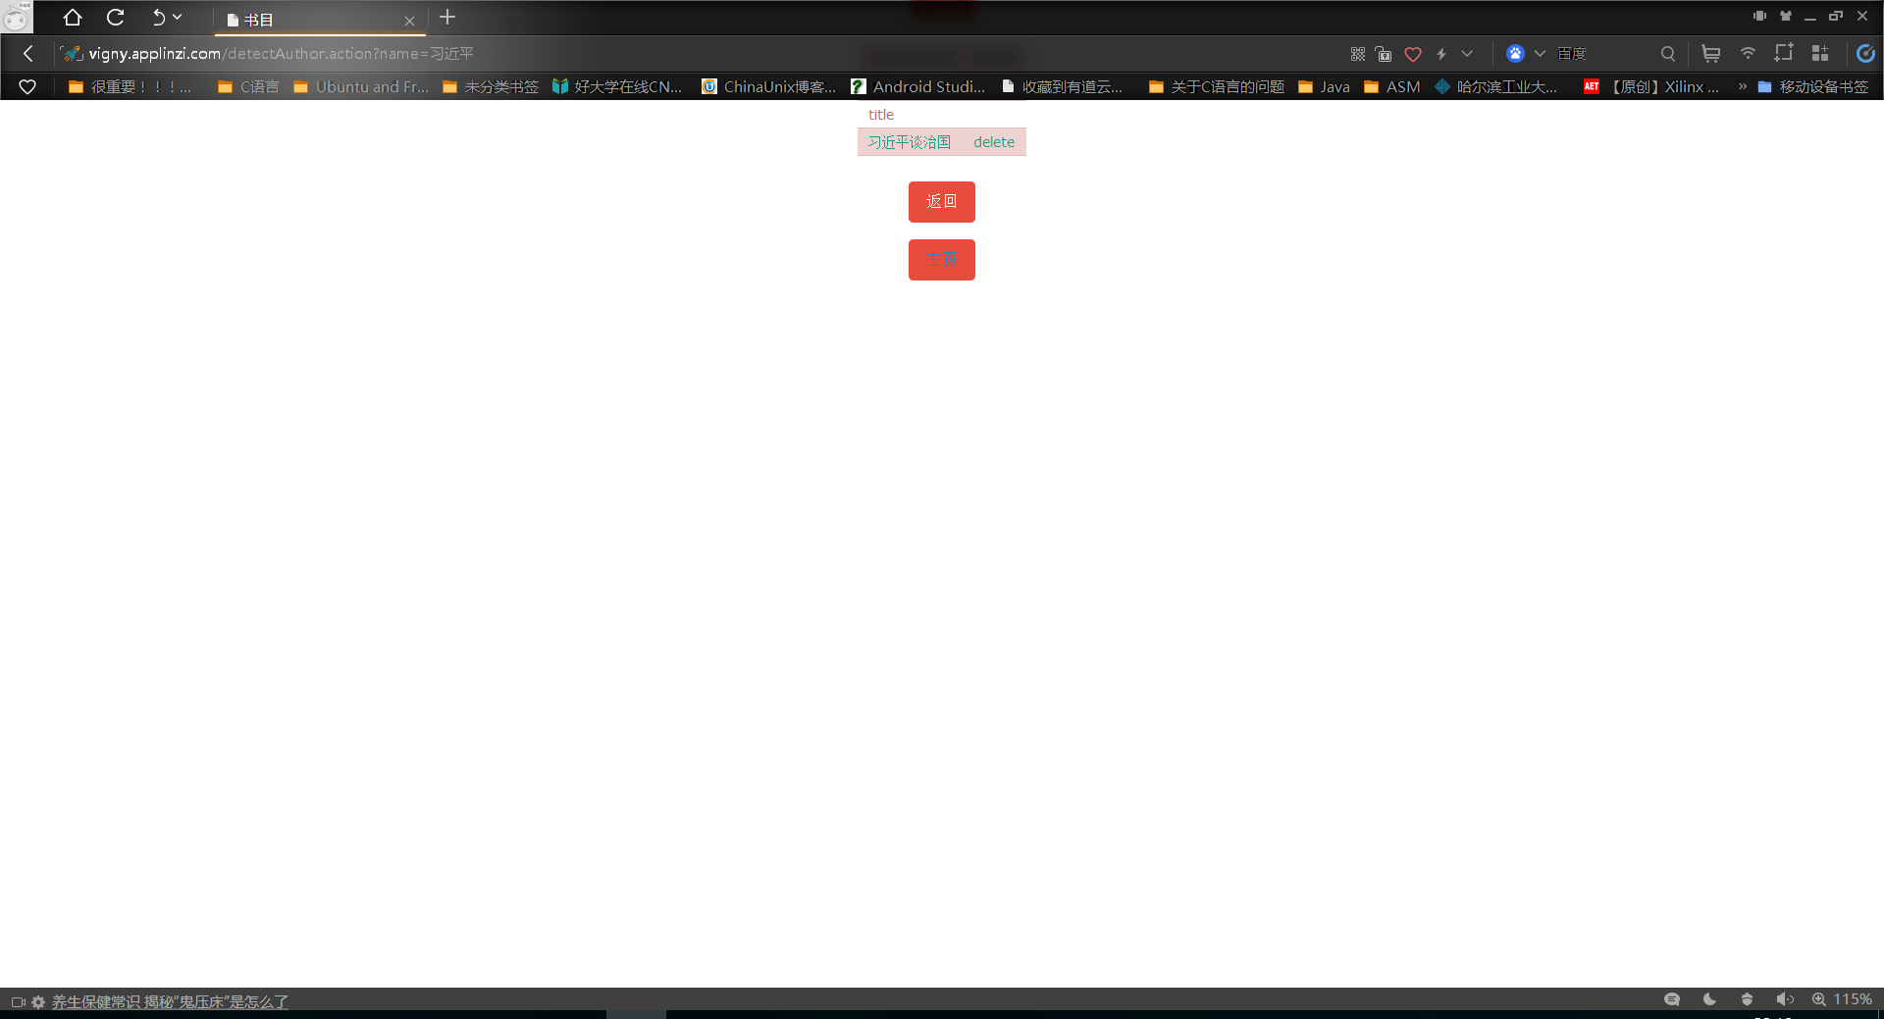
书记详细信息
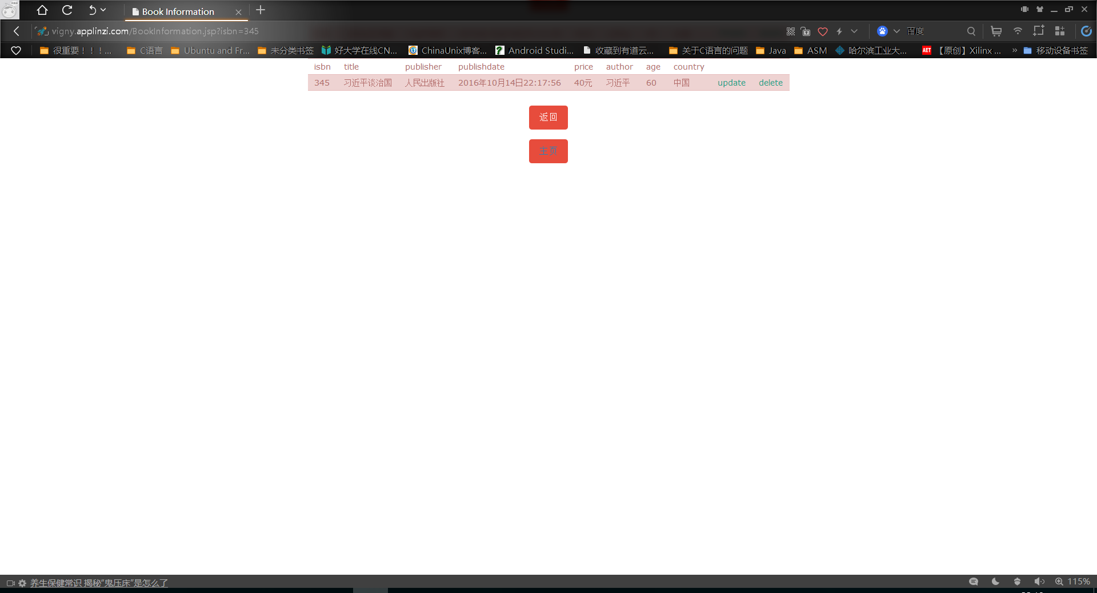
删除成功
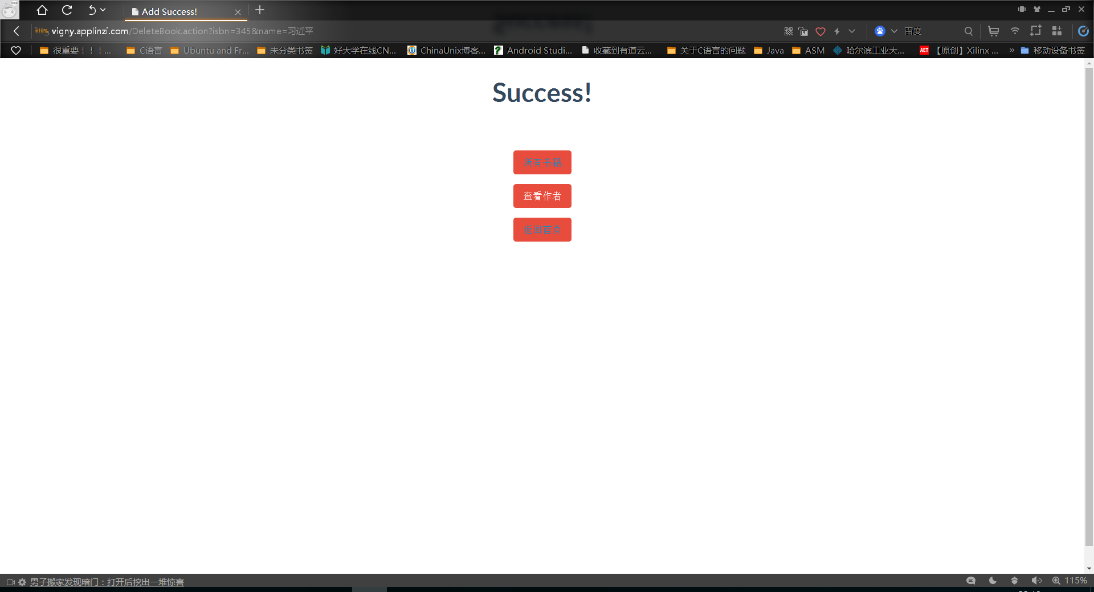
查看全部书籍
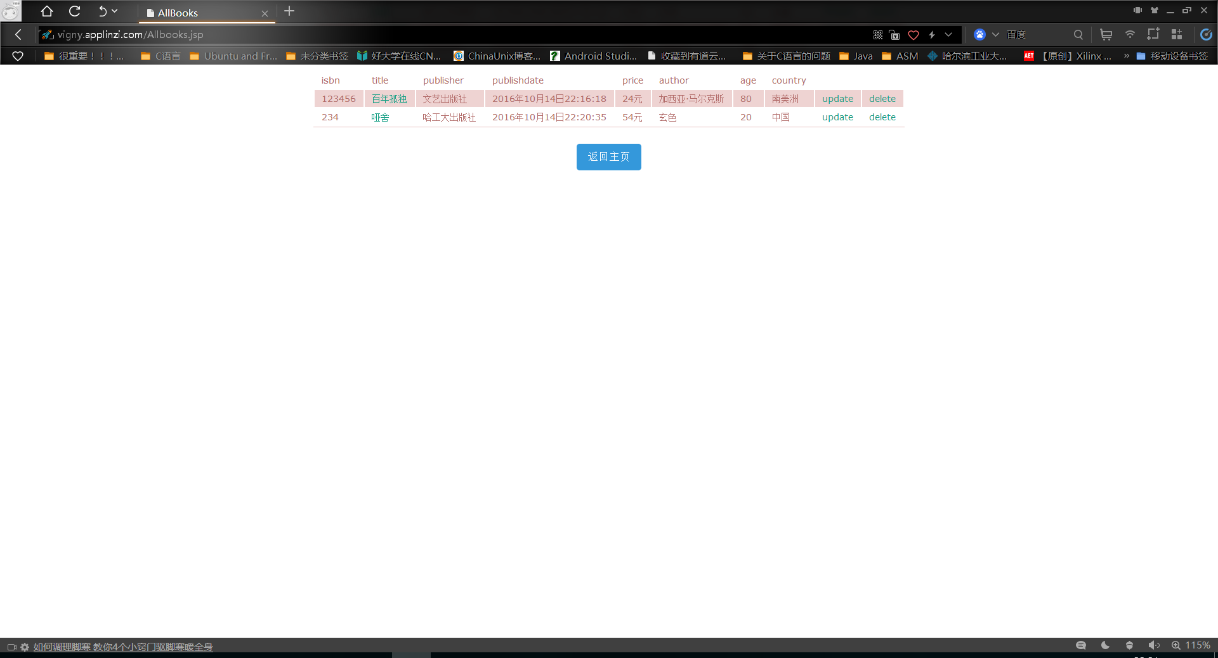
修改书籍信息
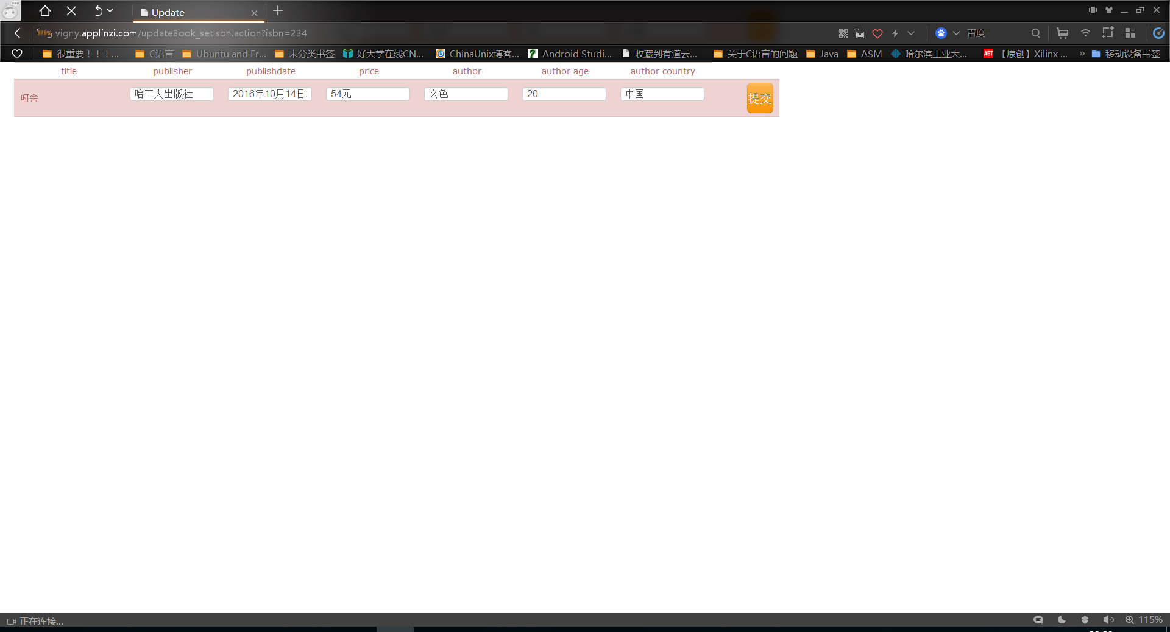
修改成功
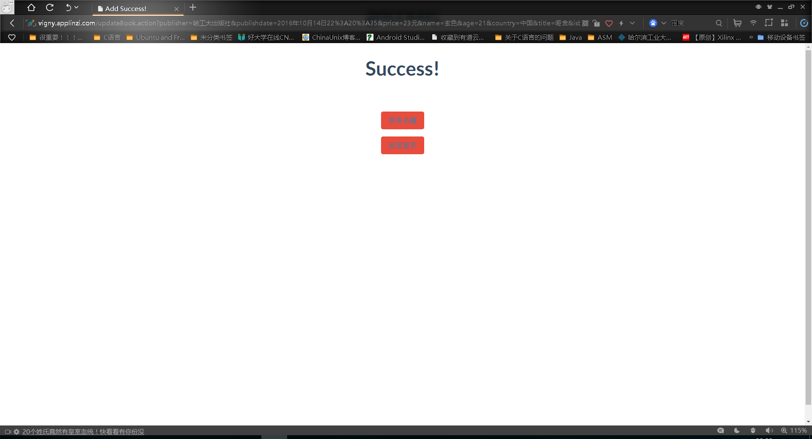
信息已更改
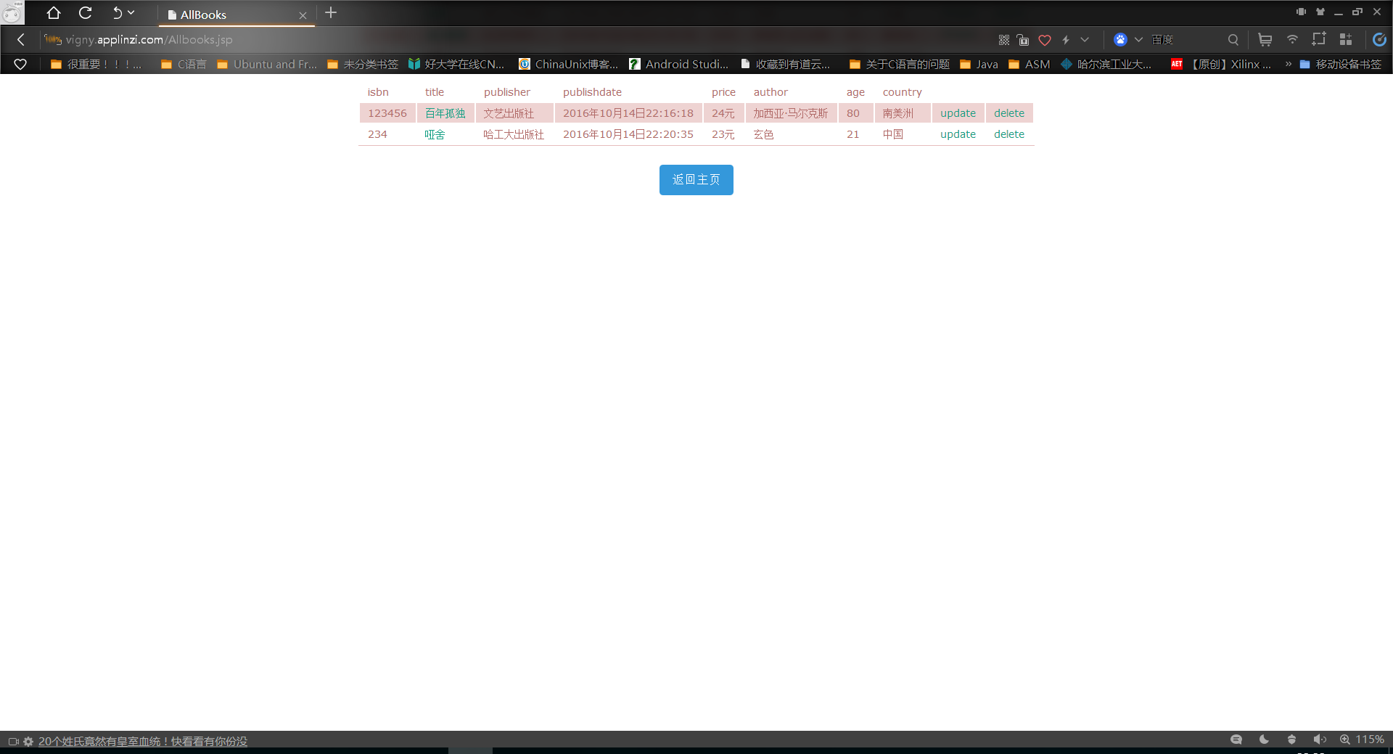

计划与实际进度
任务编号 | 计划时间长度（分钟） | 实际耗费时间（分钟） | 提前或延期的原因分析
1 | 180分钟 | 240分钟 | 刚刚接触JDBC与数据库使用不熟练，编写的程序出现了bug
2 | 120分钟 | 120分钟 | 编写了删除功能
3 | 120分钟 | 90分钟 | 完善程序功能，花费时间不多
4 | 150分钟 | 300分钟或更多 | 美化前端，耗费很多时间

小结
通过本次试验我学会了数据库的用法，以及用java代码操作数据库的代码写法。更重要的是，我费尽心血熬了一周，终于做了一个成型的网站出来，虽然实现的功能很简单，页面也不够精致，但毕竟是心血之作，以后再接再厉，争取做出更好的网站。

