**Database Systems Laboratory**

**Homework 3**

**Team Member**

**2015112230 조재환**

**2015112227 조일현**

**1. Select four queries from the SQL queries in HW2. Any two queries can't belong to the same category I - VI). All the queries should include one or more host variables.**

* 1. **show the four queries from HW2 you selected, including the host variables.**
  2. **write a C (or Python etc) program which can process the four SQL queries. You should include as many comments as possible to make it easier to be read.**
  3. **show that your program works.**
* **Sender table**

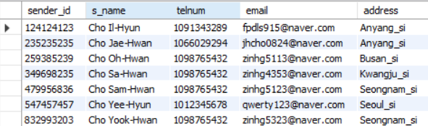

* **Product table**

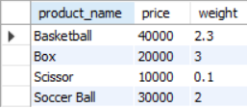

* **Find sender information whose name is ‘Cho Sam-Hwan’ (select * from sender where s_name = ‘Cho Sam-Hwan’)**
* C source for query 1

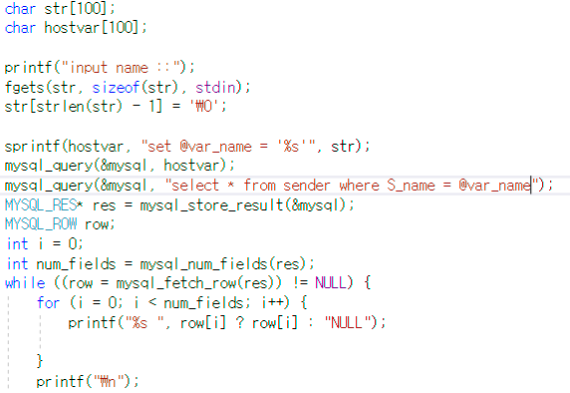

* Running program 1

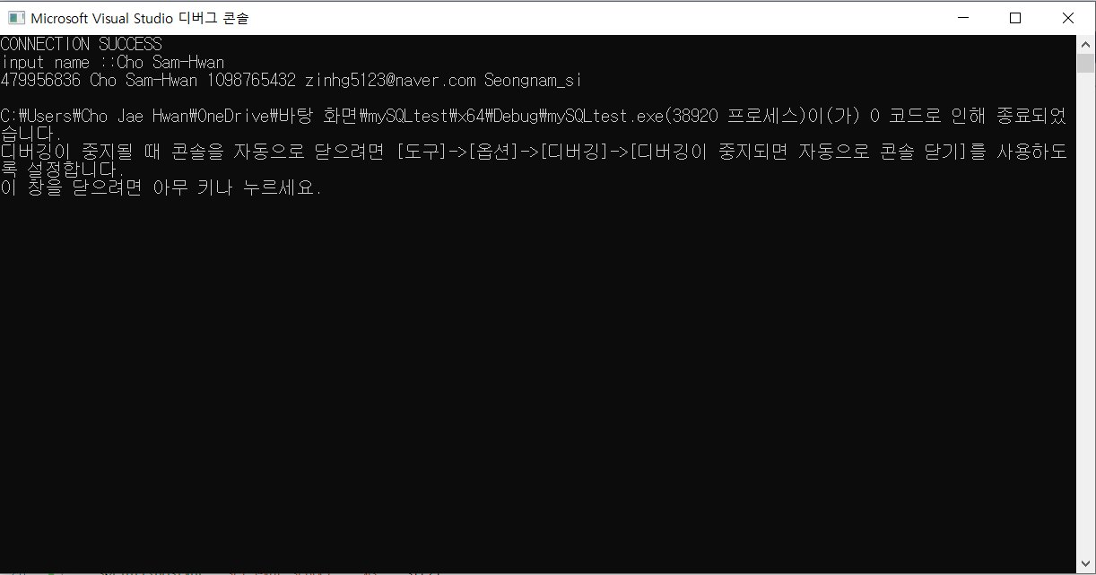

* **Enter the sender’s name and the price of the product and print the sender’s cell phone number and product name. (select two telnum and product_name from table sender, product)**
* C source for query 2

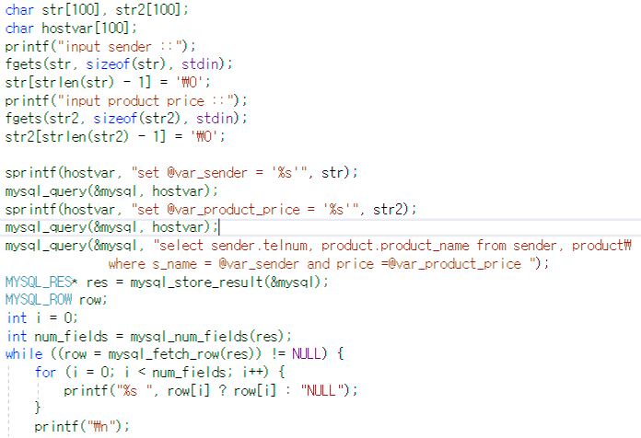

**-** Running program 2

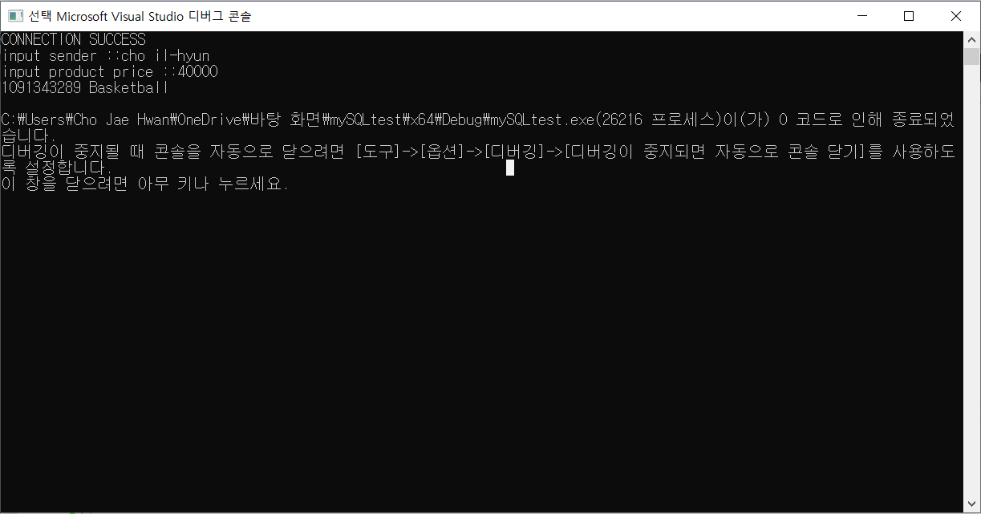

* **Find the sender’s name, cell phone number whose name is ‘Cho Il-Hyun and address is ‘Anyang_si’ (select S_name, telnum from sender\ where (s_name = @var_sender and address in (select address from sender\ where address = @var_address)))**
* C source for query 3

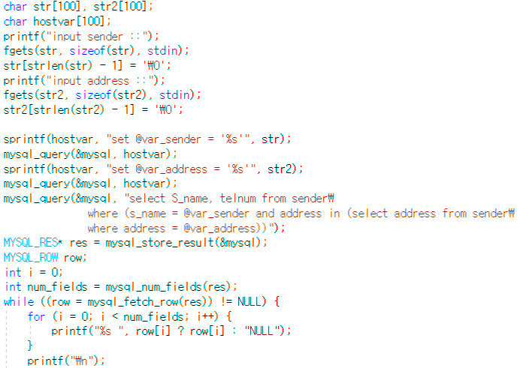

* Running program 3

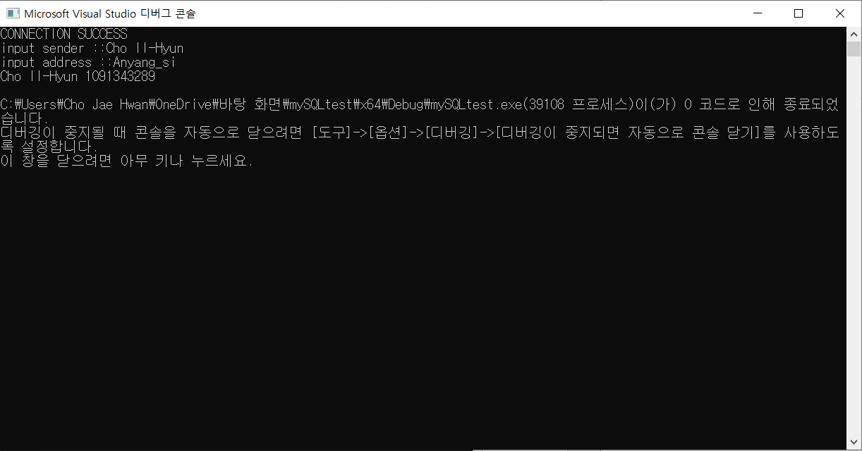

**Print two sender’s name and cell phone number whose name is ‘Cho Jae-Hwan’ and ‘Cho Il-Hyun’ ((select S_name, telnum from sender\ where s_name = @var_sender)\ union\ (select S_name, telnum from sender\ where s_name = @var_sender2)"))**

* C source for query 4

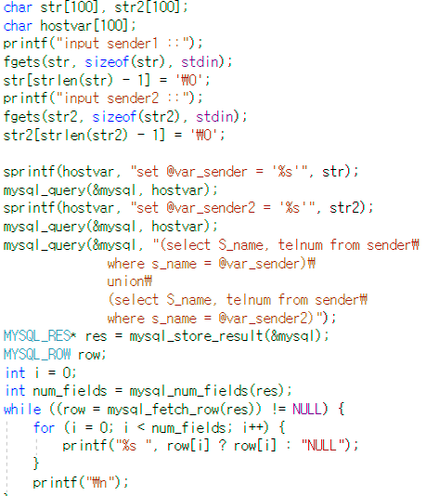

- Running program 4

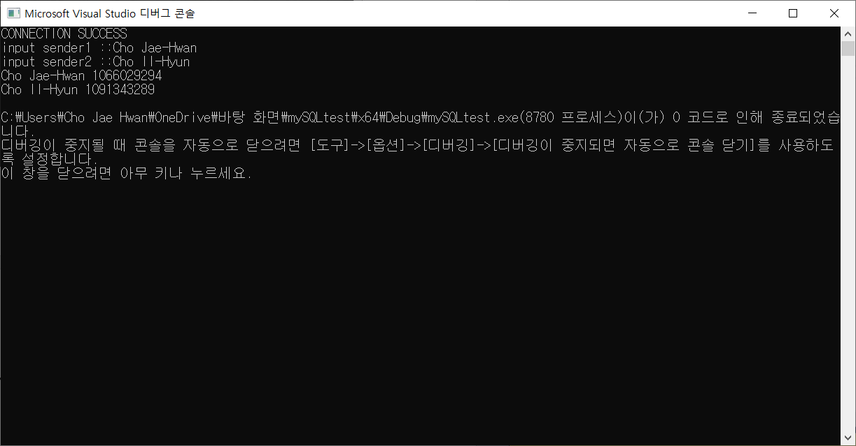

**2. Implement the following.**

**2-1) define a procedure which contains an aggregate function.**

* Procedure count_reservation which count number of tuples in reservation.

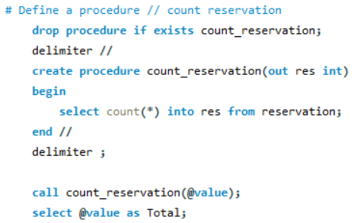



**<result>**

**2-2) define a function which returns a value.**

* Function sender_adrs which count number of reservations at a specific city.

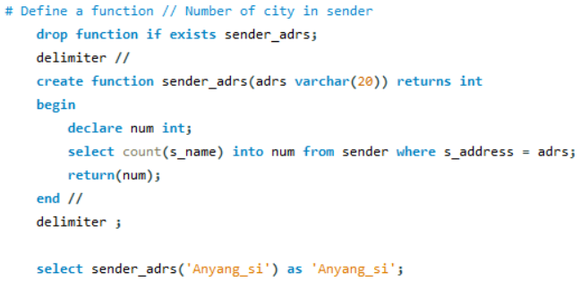

**<result>**

**2-3) write a C (or Python etc) program which calls/uses both of the procedures/functions defined in 1)-2).**

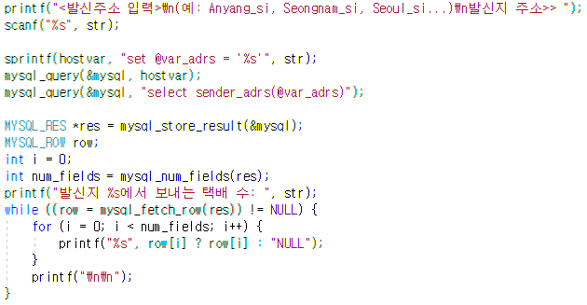

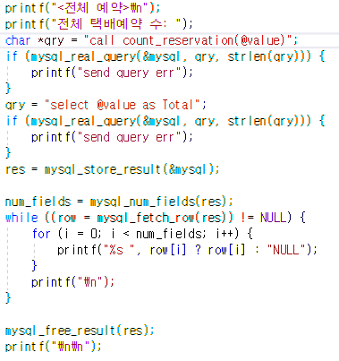

**2-4) show that your program works.**

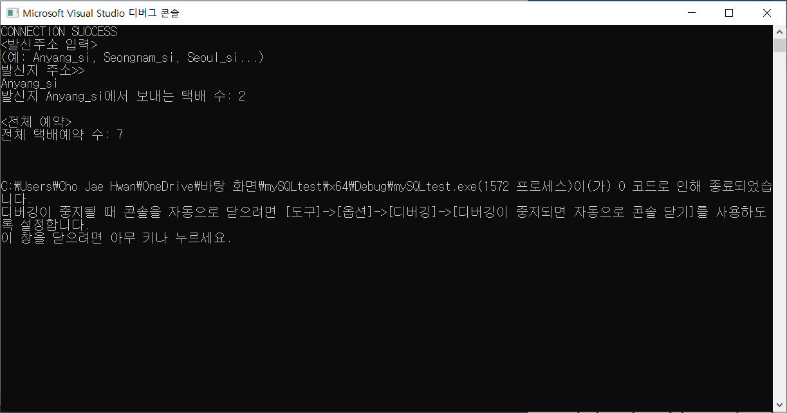

**3. The boundary of the Question 3 is flexible, and you can do as much work as you like to do. The grade will depend on the amount and quality of your work. Among the tasks you intended to do in HW 1, implement some of (if not all of, or more than) them. For each task you will implement, provide the following information in the report.**

**3-1) describe what you are going to do with the use of web pages. Show the current web pages or you can draw ones yourself.**

* **Web pages**

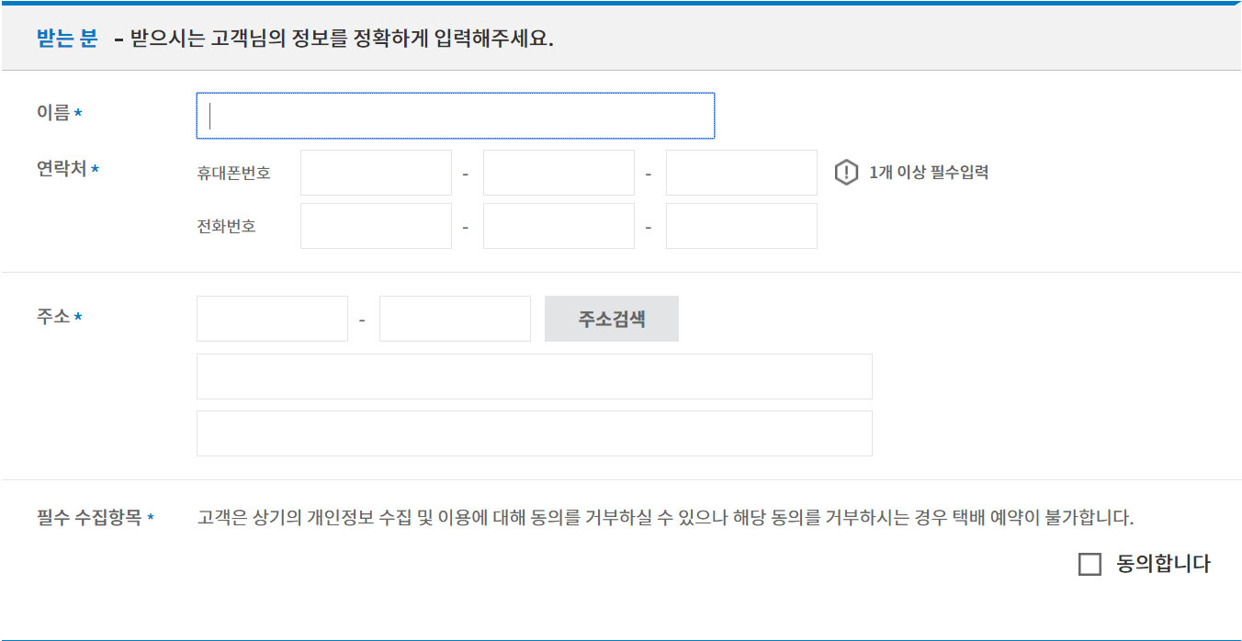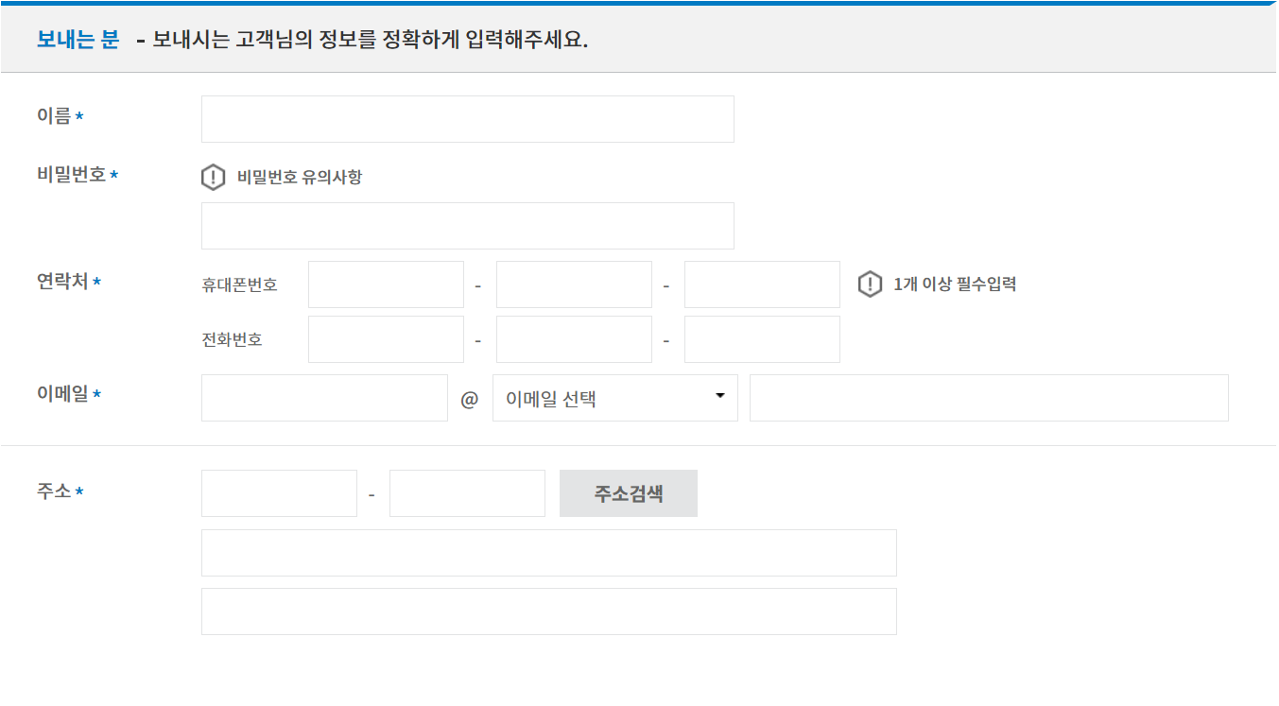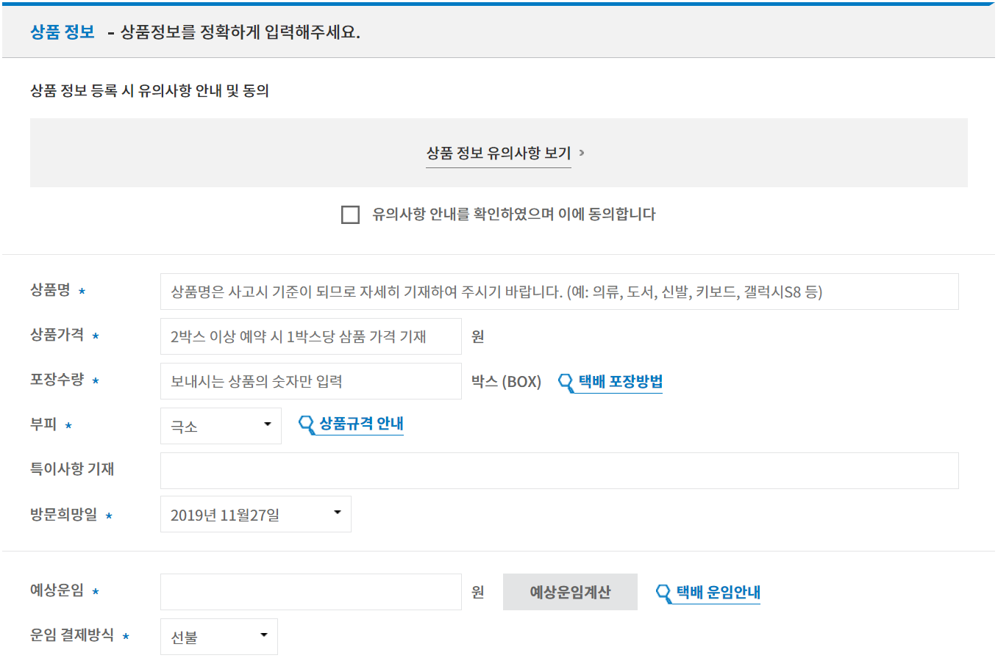

**3-2) implement a program using host language plus Mysql.**

* We made a program using C. The implemented functions are :

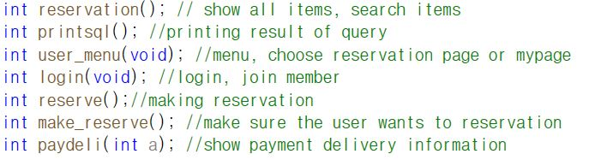

**3-3) show that your program is working correctly. In case you don't use GUI(graphic user interface), make sure you provide a proof that your program is working correctly. For example, suppose the task is about showing a summary report for a given input. Then you should clearly demonstrate that your program correctly displays all necessary information when a certain input is given. There will be extra points for GUI development, though.**

* **Menu**

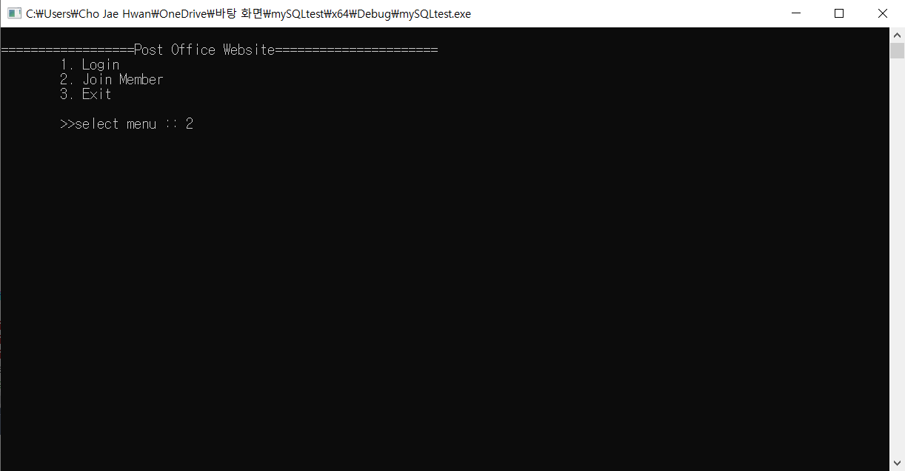

// First screen. Before reserve delivery service, you should join membership.

* **Join membership**

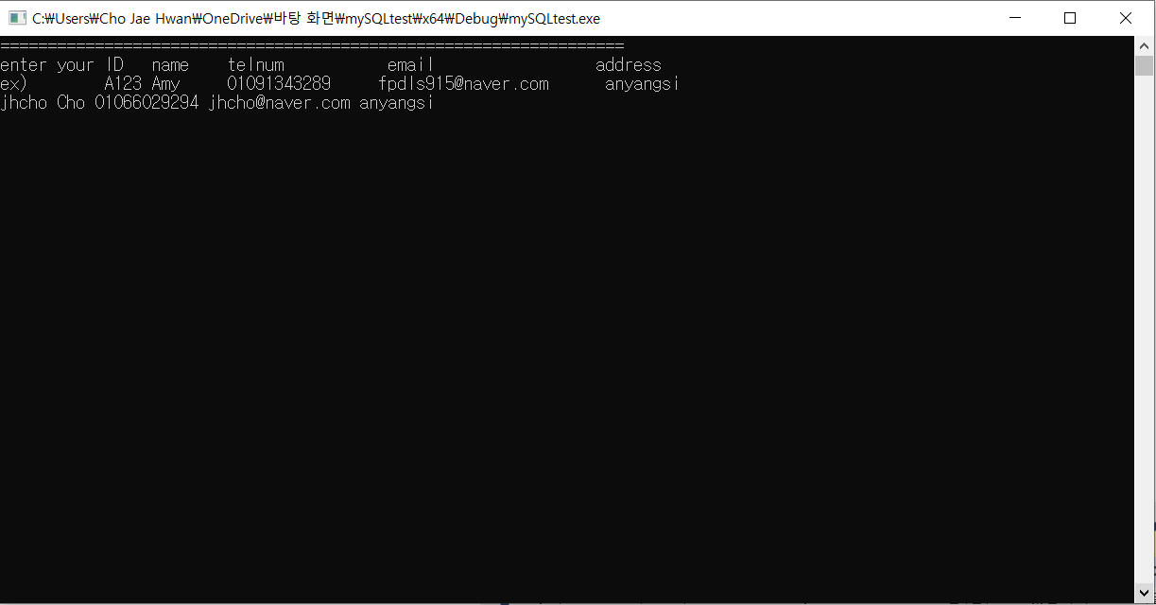

// To join membership you should input your information (ID, Name, cell phone number, email, address)

* **Login**

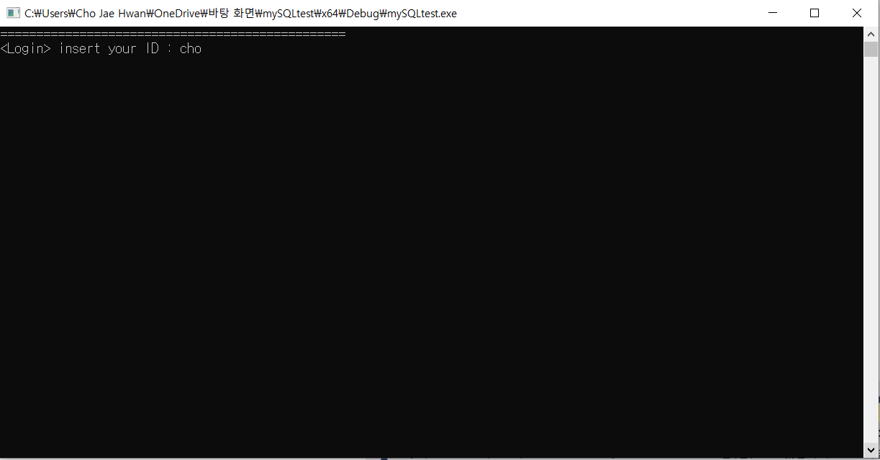

// You should put your ID to login. If ID is wrong (not in Web site ID list), log-in fail and you should try again.

* **User menu (Delivery reservation, My reservation, previous page)**

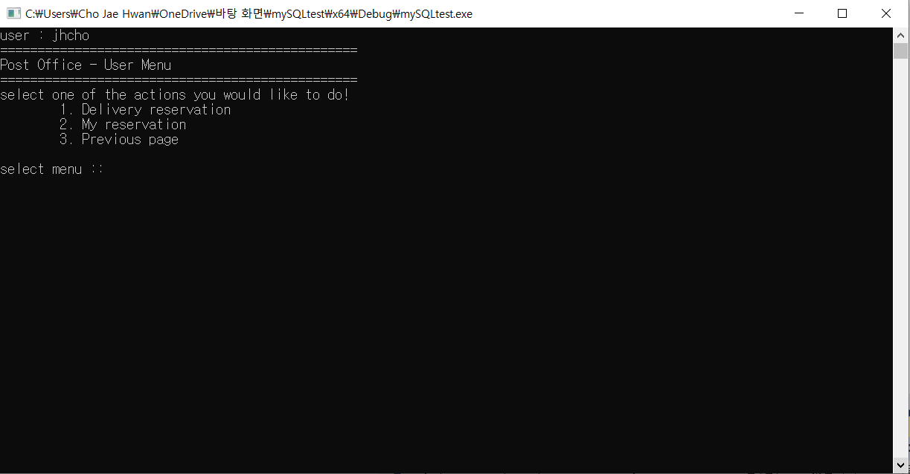

//Select service that you want to do (Delivery reservation, My reservation, previous page). If you select 1, you can reserve delivery. If you select 2, you can see what you reserved before. If you select 3, you can go previous page.

* **Reserve delivery**

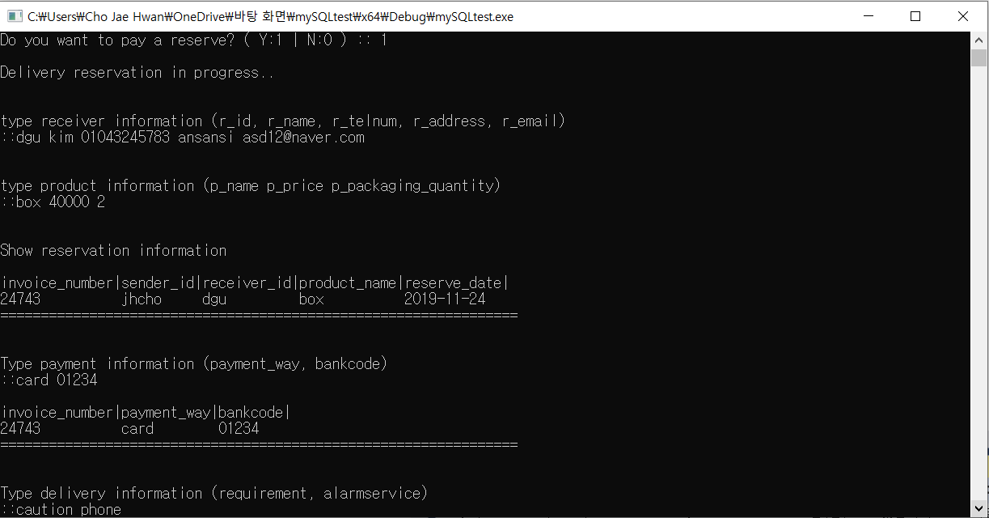

// To reserve delivery you have to put information about product, receiver

* **Show my reservation**

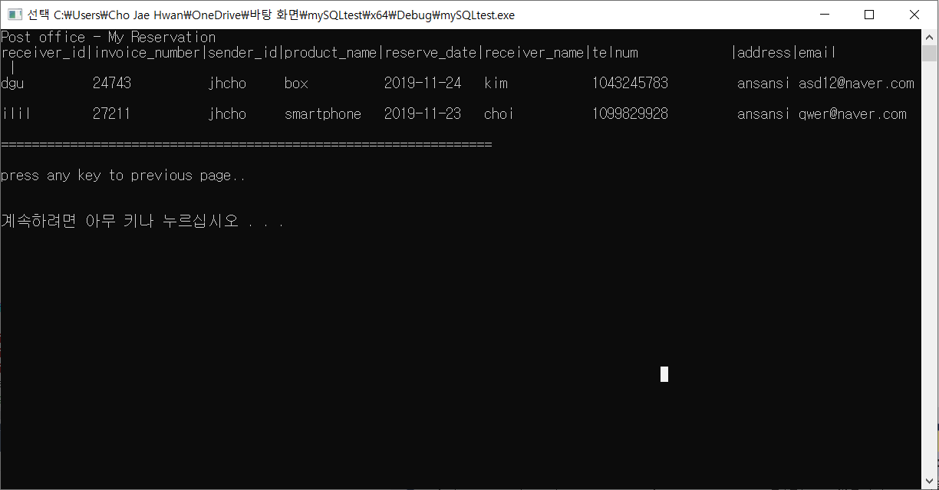

// This page shows what you’ve reserved before and contains receiver’s ID, phone number, address, email, name, invoice number, reservation date, sender’s ID.

* **Show latest delivery**

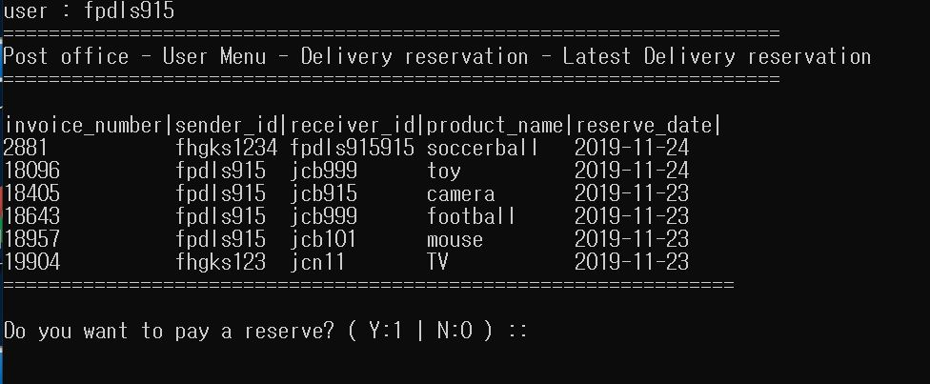

// This page shows the latest reservation of delivery.