
Gachon University
2026-1 DATA SCIENCE
TEAM PROJECT REPORT
Bank Marketing Classification Project
Course Title | Data Science
Project Topic | Bank Marketing Classification Project
Professor | Prof. Loh Woong-Kee
Team Members | Shin In-seub / Jo Yoon-sung / Moon Ji-seok / Choi Yu-ri / Han Sang-hoo
Submission Date | 2026. 06. 08.

Contents

1. Objective Setting
1.1 Motivation
1.2 Project Objectives
2. Data Exploration
2.1 Data Source
2.2 Data Overview
2.3 Data Integrity
2.4 Target Class Distribution
2.5 Scaling Necessity
3. Data Preprocessing
3.1 Data Cleaning
3.2 Data Transformation
3.3 Numerical Feature Scaling
4. Algorithms / Modeling
4.1 Modeling Overview
4.2 Input Data for Modeling
4.3 Missing Value Imputation Versions
4.4 Model Selection
4.5 Cross-Validation Setting
4.6 Modeling Process
4.7 Modeling Summary
5. Evaluation
5.1 Evaluation Overview
5.2 Evaluation Metrics
5.3 K-Fold Cross-Validation
5.4 Cross-Validation Results
5.5 Best Model Selection
5.6 Final Test-Set Evaluation
5.7 Confusion Matrix Analysis
6. Conclusion
7. Open-Source SW
7.1 Overview
7.2 Preprocessing Code
7.3 Modeling Code
7.4 Evaluation Code
7.5 Function Specification
7.6 Library and Module Explanation
7.7 GitHub Repository
8. Learning Experience
9. Role
- Objective Setting

1.1 Motivation
Today, saving money safely has become harder due to the changing economy and interest rates. While fixed-term deposits are a great way to save, banks often struggle to find the right customers. Traditional methods like random phone calls are not only expensive for banks but also annoying for people, which can hurt a bank’s image.
Inspired by how data is used to solve problems in other fields, we want to apply data analysis to banking. Our goal is to use data to find people who are actually interested in these deposits. This way, banks can stop making unwanted calls and focus on a more personal, customer-friendly approach.

1.2 Project Objectives
The main goal of this project is to build a classification model that predicts whether a customer will subscribe to a fixed-term deposit (‘y’). We will follow the standard steps of a big data project to achieve the following:
- Model Comparison: Use two different machine learning models - Logistic Regression and Random Forest – and compare them to see which one predicts customer behavior better.
- Finding Key Factors: Beyond mere prediction, we aim to extract meaningful insights into which features are most indicative of customer intent.
- Optimized Marketing Strategy: By utilizing optimized marketing strategies, we can reduce wasted time and costs, leading to more efficient resource management and a higher success rate in attracting customers.
- Ensuring Reliable Results: Use k-fold cross-validation to prevent overfitting and ensure the model’s reliability. This process confirms that the model provides consistent and accurate predictions regardless of how the training and validation sets are split within our dataset.

- Data Exploration
2.1 Data Source
The dataset used in this project is Bank Marketing Dataset, sourced from the UCI Machine Learning Repository and hosted on Kaggle. The dataset used in this project was obtained from the following URL: https://www.kaggle.com/datasets/ruthgn/bank-marketing-data-set
It contains information about direct marketing campaigns of a Portuguese banking institution. The marketing campaign was executed through phone calls. The classification goal is to predict if the client will subscribe (yes/no) to a term deposit (variable ‘y’).

2.2 Data Overview
Based on CSV file, we analyzed the initial structure and dimensions of the dataset. As shown in the output below, the dataset consists of 41,188 entries and 20 features, confirming the consistency of the data. This satisfies the project requirement of at least 1,000 records and 10 features.
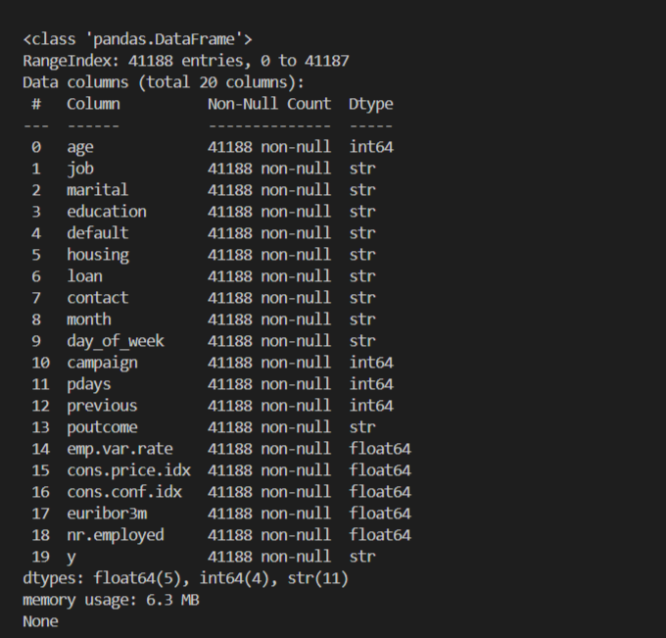
While the ‘Non-Null Count’ indicates that there are no technical null values (NaN), it is observed that several categorical features contain ‘unknown’ values. These will be addressed as a form of missing data during the data preprocessing stage. The dataset contains a mix of numerical and categorical data. The following is a detailed description of each feature.
Bank client data:
age (numeric)
job - type of job (categorical: ‘admin.’, ’blue-collar’, ’entrepreneur’, ’housemaid’, ’management’, ‘retired’, ‘self-employed’, ‘services’, ‘student’, ‘technician’, ‘unemployed’, ‘unknown’)
marital - marital status (categorical: 'divorced', 'married', 'single', 'unknown'; note: 'divorced' means divorced or widowed)
education (categorical: 'basic.4y', 'basic.6y', 'basic.9y', 'high.school', 'illiterate', 'professional.course', 'university.degree', 'unknown')
default - has credit in default? (categorical: 'no', 'yes', 'unknown')
housing - has housing loan? (categorical: 'no', 'yes', 'unknown')
loan - has personal loan? (categorical: 'no', 'yes', 'unknown')

Related with the last contract of the current campaign:
contact - contact communication type (categorical: ‘cellular’, ‘telephone’)
month - last contact month of year (categorical: ‘jan’, ‘feb’, ‘mar’, ..., ‘nov’, ‘dec’)
day_of_week - last contact day of the week (categorical: ‘mon’, ‘tue’, ‘wed’, ‘thu’, ‘fri’)

Other attributes:
campaign - number of contacts performed during this campaign and for this client (numeric, includes last contact)
pdays - number of days that passed by after the client was last contacted from a previous campaign (numeric; 999 means client was not previously contacted)
previous - number of contacts performed before this campaign and for this client (numeric)
poutcome - outcome of the previous marketing campaign (categorical: 'failure', 'nonexistent', 'success')

Social and economic context attributes:
emp.var.rate - employment variation rate; quarterly indicator (numeric)
cons.price.idx - consumer price index; monthly indicator (numeric)
cons.conf.idx - consumer confidence index; monthly indicator (numeric)
euribor3m - euribor 3 month rate; daily indicator (numeric)
nr.employed - number of employees; quarterly indicator (numeric)
Output variable (desired target):
y – has the client subscribed a term deposit? (binary: ‘yes’, ‘no’)

2.3 Data Integrity
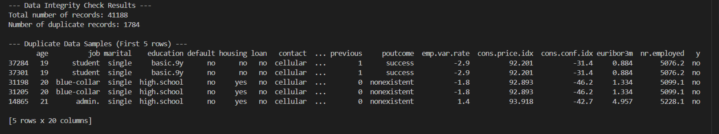Through the duplication check, we identified 1,784 duplicate records (approximately 4.3% of the total dataset). These duplicates consist of entries where all 20 features, including social and economic indicators, are identical.
Leaving these duplicates in the dataset can lead to model bias, where the classification algorithm over-learns specific instances, potentially reducing its ability to generalize new data. To ensure the robustness of the model as stated in our project objectives, we plan to remove these duplicate records during the data preprocessing stage. This will ensure that our training process is based on unique observations, leading to more reliable and consistent performance.

2.4 Target Class Distribution
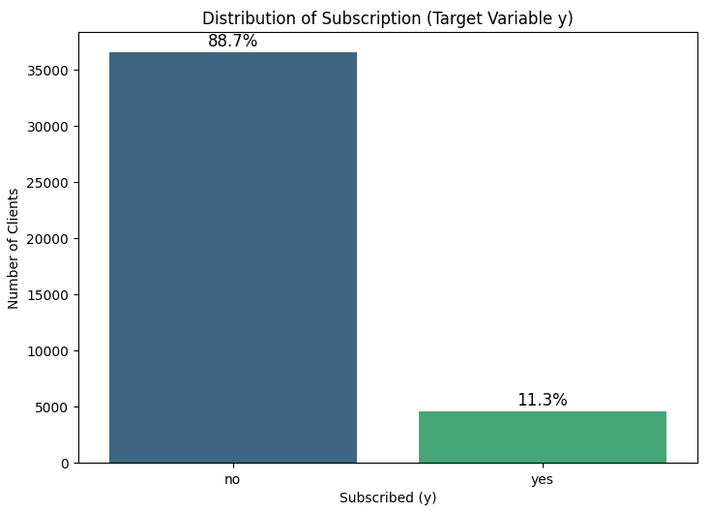
The dataset exhibits a significant class imbalance, with nearly 89% of the clients not subscribing to the term deposit. This finding is crucial because if a model simply predicts ‘no’ for every client, it would still achieve an 89% accuracy rate, yet fail to find any actual subscribers. Therefore, to ensure a robust and useful model, we will not rely solely on overall accuracy. Instead, we will prioritize how effectively the model identifies the ‘yes’ class during the evaluation phase.

2.5 Scaling Necessity
During the feature exploration, we observed a vast difference in the scales of numerical features. For instance, the ‘age’ feature ranges from 17 to 98, while economic indicators like ‘nr.employed’ range between 4,000 and 5,000. Such disparities can cause certain features with larger numerical values to dominate the learning process of machine learning models. To prevent this bias and ensure each feature contributes equally to the prediction, we have determined that feature scaling is a mandatory step in the upcoming preprocessing phase.

- Data Preprocessing
3.1 Data Cleaning
Removing Duplicate
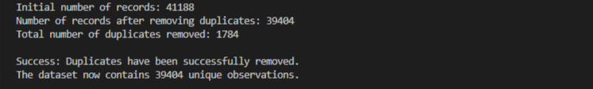Based on the insights from the Data Exploration phase, we identified 1,784 duplicate entries. To prevent the model from over-learning these identical instances, we performed Data Restructuring by removing all duplicates using ‘drop_duplicates()’ function. This process reduced our dataset from 41,188 to 39,404 unique records, ensuring that our training process is based on distinct customer observations.
Handling ‘unknown’ Values
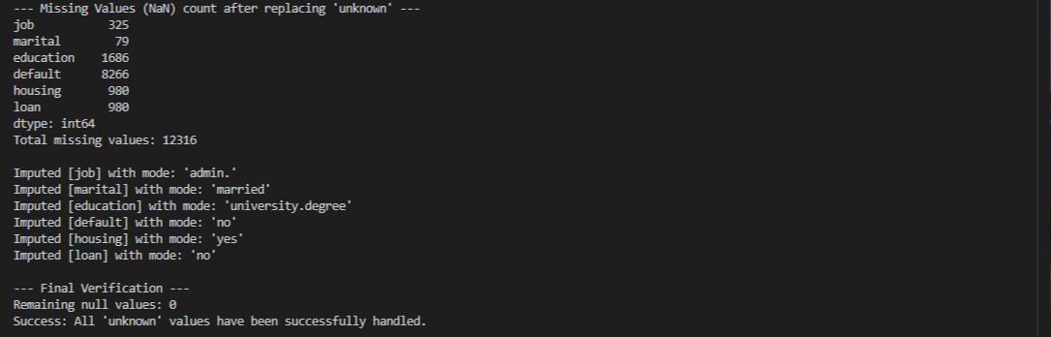In the cleaned dataset where duplicate records were removed, all ‘unknown’ labels were converted to ‘np.nan’ to facilitate systematic missing value processing. We then applied Mode Imputation, replacing these null values with the most frequent value of each respective feature. Finally, a verification check confirmed that the total number of remaining null values reached 0.
In addition to the initial cleaned dataset, two model-ready preprocessing versions were generated for modeling and evaluation: Mean Imputation and Forward-Fill. These two versions were used to compare how different missing-value handling strategies affect classification performance.
3.2 Data Transformation
Categorical Encoding
In the data transformation stage, we applied two different encoding strategies based on the nature of the categorical variables to prepare the dataset for machine learning models. For binary features, we utilized label encoding (mapping ‘yes’ to 1 and ‘no’ to 0) to simplify the data structure into a binary format.
For multi-categorical features such as ‘job’ and ‘marital’, we performed one-hot encoding. This approach prevents the model from assuming any non-existent ordinal relationships between categories, which could otherwise lead to biased predictions. To ensure the statistical robustness of the model, we implemented the ‘drop_first’ parameter during this process to prevent the dummy variable trap.
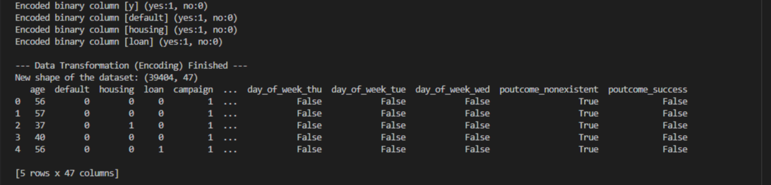The categorical encoding process was successfully completed, resulting in the feature count expanding from 20 to 47. This transformation was achieved while maintaining the integrity of the dataset, preserving all 39,404 observations for the subsequent modeling phase.

3.3 Numerical Feature Scaling
Necessity of Scaling
In our dataset, numerical features exhibit significantly different scales and units. For example, ‘age’ ranges from 17 to 98, while economic indicators like ‘nr.employed’ have values exceeding 5,000.
Without scaling, features with larger numerical magnitudes would disproportionately dominate the model’s weight updates during the learning process. This is particularly critical for gradient-based or distance-based optimization algorithms, where inconsistent scales can lead to slow convergence or biased results. By standardizing these values, we ensure that each feature contributes equally to the model’s predictive performance regardless of its original unit.
StandardScaler (Z-score Normalization)
We selected StandardScaler as our primary scaling method. This technique transforms each feature to have a mean ($μ$) of 0 and a standard deviation ($σ$) of 1.
Reasons for selecting StandardScaler:
- Algorithm Compatibility: It is a standard requirement for many classification algorithms to ensure that the objective function works correctly.
- Preserving Distribution: Unlike other methods that squash data into a small range, StandardScaler preserves the shape of the original distribution while centering the data around 0.
Implementation and Verification
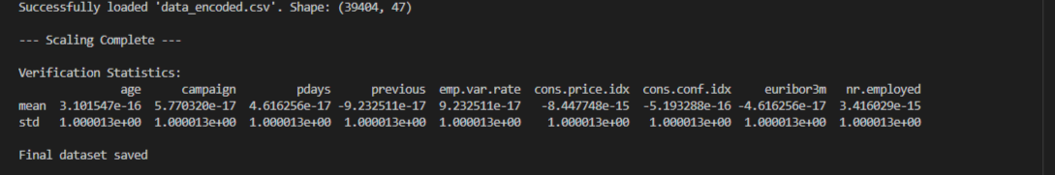The scaling results were empirically verified through statistical analysis. The mean of all 9 numerical features reached approximately 0 (ranging from 10^-15 to 10^-17), and the standard deviation was consistently normalized to 1.0. This confirms that the StandardScaler was applied correctly, effectively eliminating scale disparities between features such as ‘age’ and ‘nr.employed’. The dataset is now fully optimized for the modeling phase, with a final structure of 39,404 records and 47 columns, including the target variable y.
4. Algorithms / Modeling
4.1 Modeling Overview

This project implements a binary classification pipeline that predicts whether a customer will subscribe to a term deposit (y) based on bank direct marketing data. The modeling stage uses the preprocessed datasets generated from the previous preprocessing stage and applies two classification models: Logistic Regression and Random Forest.

The purpose of this stage is to compare the performance of different preprocessing strategies and machine learning models. Specifically, the model uses two preprocessed dataset versions, which differ in their missing-value handling strategy. Each dataset version is used to train and evaluate both classification models.

The overall modeling pipeline can be summarized as follows:

Preprocessed CSVs → Model Training and Testing → 5-Fold Stratified Cross-Validation → Summary Comparison

4.2 Input Data for Modeling

The modeling code uses two model-ready CSV files as input.

preprocessed_mean.csv
- Dataset created using mean/mode imputation, encoding, and scaling
preprocessed_ffill.csv
- Dataset created using forward-fill/backfill imputation, encoding, and scaling

Both files are already processed through categorical encoding and numerical feature scaling. Therefore, the modeling script can directly separate the target variable y from the feature variables and use them for model training.

4.3 Missing Value Imputation Versions

The script treats the two imputation methods as independent dataset versions and compares model performance across them.

Mean Imputation

Mean imputation replaces missing numerical values with the column mean and categorical missing values with the most frequent value. This method is stable and simple, but it may reduce the variance of the original distribution.

Forward-Fill

Forward-fill replaces missing values with the previous row’s value. In this project, it is used as an experimental comparison method to examine whether a different imputation strategy affects classification performance.

By comparing these two versions, the project can evaluate whether the missing-value handling strategy influences the final model performance.

4.4 Model Selection

Two machine learning models are applied in the modeling stage: Logistic Regression and Random Forest.

Logistic Regression

Logistic Regression is used as the baseline classification model. Since the target variable y has two possible values, yes or no, Logistic Regression is suitable for predicting the probability of term deposit subscription. In the code, max_iter=2000 is used to ensure stable convergence during training.

Random Forest

Random Forest is used as a stronger comparative model. It consists of multiple decision trees and can capture non-linear patterns and interactions among features. In the code, n_estimators=200 is used, meaning that the model builds 200 decision trees. This setting provides a balance between prediction stability and computational cost.

4.5 Cross-Validation Setting

To evaluate the models reliably, the modeling stage applies 5-Fold Stratified Cross-Validation.

The cross-validation setting is as follows:

cv = StratifiedKFold(n_splits=5, shuffle=True, random_state=42)

scores = cross_val_score(model, X, y, cv=cv, scoring="accuracy")

Stratified K-Fold is appropriate for this project because the target variable is imbalanced. Since most customers did not subscribe to the term deposit, preserving the class ratio in each fold helps make the evaluation more stable.

The use of shuffle=True and random_state=42 ensures that the experiment is reproducible. The parameter n_jobs=-1 is used to parallelize the computation and improve execution speed.

4.6 Modeling Process

The modeling process consists of the following steps.

First, the two preprocessed CSV files are loaded. Each dataset version contains the same target variable, y, and the same set of processed features.

Second, the target column y is separated from the feature columns. The feature matrix is defined as X, and the target variable is defined as y.

Third, Logistic Regression and Random Forest models are defined. Both models use the same random state to ensure reproducibility.

Fourth, each model is trained and evaluated using 5-Fold Stratified Cross-Validation. The model performance is measured using accuracy in the original modeling script.

Finally, the fold accuracies, mean accuracy, and standard deviation are calculated and summarized in a DataFrame. The best configuration is selected based on the highest mean accuracy.

4.7 Modeling Summary
This structure allows the project to compare both preprocessing strategies and classification models. Logistic Regression serves as a simple and interpretable baseline model, while Random Forest serves as a non-linear ensemble model that can capture more complex relationships in the data.

The detailed performance comparison and final model selection are discussed in the following Evaluation section.

5. Evaluation
5.1 Evaluation Overview
The evaluation stage aims to compare the performance of classification models and identify the most appropriate model for predicting term deposit subscription. In the previous modeling stage, Logistic Regression and Random Forest were used as classification models. To strengthen the evaluation, multiple hyperparameter configurations were tested for each model.
In this project, two preprocessing versions were used: Mean Imputation and Forward-Fill. For each preprocessing version, six model configurations were evaluated. Therefore, the evaluation function compared 12 combinations in total.
The evaluation process includes the following steps:
- Compare all preprocessing and model configuration combinations using Stratified 5-Fold Cross-Validation.
- Calculate multiple evaluation metrics: Accuracy, Precision, Recall, F1-score, and ROC-AUC.
- Select the best model configuration based on F1-score.
- Evaluate the selected model on a separate test set.
- Save the evaluation results and confusion matrix as output files.
Since the target variable is highly imbalanced, accuracy alone may not be sufficient to evaluate the model properly. Therefore, F1-score was used as the main metric for selecting the best model, while other metrics were also considered for additional interpretation.

5.2 Evaluation Metrics
The following evaluation metrics were used to analyze model performance.
Metric | Description
Accuracy | Measures the overall proportion of correct predictions.
Precision | Measures how many predicted positive cases were actually positive.
Recall | Measures how many actual positive cases were correctly identified.
F1-score | Harmonic mean of precision and recall. Useful for imbalanced datasets.
ROC-AUC | Measures the model’s ability to distinguish between positive and negative classes.
Confusion Matrix | Shows the number of true positives, true negatives, false positives, and false negatives.

Since the dataset has a strong class imbalance, F1-score was used as the main metric for selecting the best model. This is because F1-score considers both precision and recall, making it more suitable than accuracy alone when the positive class is relatively small.

5.3 K-Fold Cross-Validation
To evaluate the models reliably, Stratified 5-Fold Cross-Validation was applied. Stratified K-Fold preserves the class distribution of the target variable in each fold, which is important for this project because the number of customers who subscribed to the term deposit is much smaller than the number of customers who did not subscribe.
The evaluation code used the following setting:
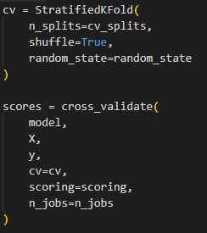
Figure. StratifiedKFold and cross_validate implementation in evaluation.py
The parameter n_splits=5 means that the dataset was divided into five folds. Each model was trained and tested five times, and the average performance was calculated. The parameter shuffle=True randomly shuffles the data before splitting, and random_state=42 ensures reproducibility. The cross_validate() function was used to calculate multiple metrics at the same time.

5.4 Cross-Validation Results
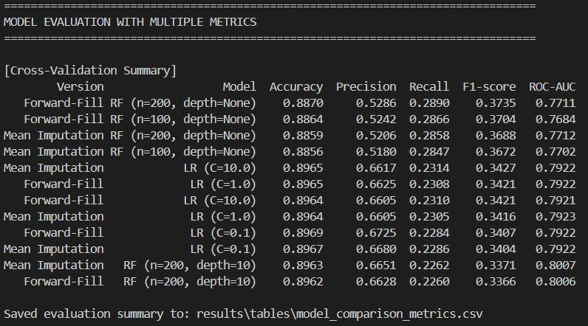
Figure. Cross-validation execution result from evaluation.py

The evaluation function compared 12 combinations in total: two preprocessing versions and six model configurations. The six configurations included three Logistic Regression models with different C values and three Random Forest models with different n_estimators and max_depth settings.
The cross-validation results are summarized below.
Version | Model | Accuracy | Precision | Recall | F1-score | ROC-AUC
Forward-Fill | RF (n=200, depth=None) | 0.8870 | 0.5286 | 0.2890 | 0.3735 | 0.7711
Forward-Fill | RF (n=100, depth=None) | 0.8864 | 0.5263 | 0.2853 | 0.3704 | 0.7684
Mean Imputation | RF (n=200, depth=None) | 0.8859 | 0.5206 | 0.2858 | 0.3688 | 0.7712
Mean Imputation | RF (n=100, depth=None) | 0.8853 | 0.5174 | 0.2843 | 0.3672 | 0.7702
Mean Imputation | LR (C=10.0) | 0.8964 | 0.6597 | 0.2312 | 0.3427 | 0.7922
Forward-Fill | LR (C=1.0) | 0.8965 | 0.6625 | 0.2308 | 0.3421 | 0.7922
Forward-Fill | LR (C=10.0) | 0.8964 | 0.6618 | 0.2308 | 0.3421 | 0.7921
Mean Imputation | LR (C=1.0) | 0.8964 | 0.6605 | 0.2305 | 0.3416 | 0.7923
Forward-Fill | LR (C=0.1) | 0.8962 | 0.6592 | 0.2294 | 0.3407 | 0.7922
Mean Imputation | LR (C=0.1) | 0.8962 | 0.6582 | 0.2290 | 0.3404 | 0.7922
Mean Imputation | RF (n=200, depth=10) | 0.8991 | 0.6804 | 0.2239 | 0.3371 | 0.8007
Forward-Fill | RF (n=200, depth=10) | 0.8992 | 0.6833 | 0.2230 | 0.3366 | 0.8006
Table. Cross-validation results of model comparison with hyperparameter configurations
Based on accuracy and ROC-AUC, RF (n=200, depth=10) and Logistic Regression showed strong overall performance. However, because the dataset is highly imbalanced, accuracy alone may overestimate model performance. For example, a model that predicts most customers as non-subscribers can still achieve high accuracy, but it would not be useful for identifying actual potential subscribers.
Therefore, F1-score was used as the main selection metric. In terms of F1-score, Forward-Fill with RF (n=200, depth=None) achieved the best result, with an F1-score of 0.3735. This result means that the selected Random Forest configuration achieved the best balance between precision and recall among the tested combinations.

5.5 Best Model Selection
The best model was selected based on F1-score. Although some models achieved slightly higher accuracy or ROC-AUC, F1-score was considered more appropriate for this project because the dataset has a strong class imbalance.
Item | Selected Result
Best Preprocessing Version | Forward-Fill
Best Model Configuration | RF (n=200, depth=None)
Cross-Validation F1-score | 0.3735
Cross-Validation Accuracy | 0.8870
Cross-Validation ROC-AUC | 0.7711
Table. Best model selected based on F1-score
The selected best configuration was Forward-Fill with RF (n=200, depth=None), which achieved the highest F1-score of 0.3735.
This model was selected because the main business objective is not only to maximize overall accuracy, but also to identify customers who are likely to subscribe to a term deposit. Therefore, balancing precision and recall was more important than relying only on accuracy.

5.6 Final Test-Set Evaluation
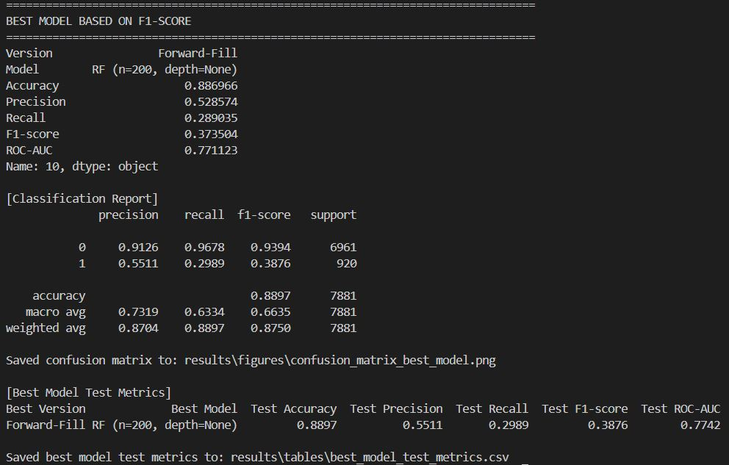
Figure. Final test-set evaluation result of the selected best model

After selecting the best model through cross-validation, the Forward-Fill dataset and RF (n=200, depth=None) model were evaluated again using a train-test split. The test set size was set to 20% of the dataset, and stratified splitting was applied to preserve the target class distribution.
The final test-set results are shown below.
Best Version | Best Model | Test Accuracy | Test Precision | Test Recall | Test F1-score | Test ROC-AUC
Forward-Fill | RF (n=200, depth=None) | 0.8897 | 0.5511 | 0.2989 | 0.3876 | 0.7742
Table. Final test-set evaluation result of the selected best model
The final model achieved an accuracy of 0.8897 and an F1-score of 0.3876. The precision value of 0.5511 means that among the customers predicted as subscribers, about 55.11% were actual subscribers. The recall value of 0.2989 indicates that the model correctly identified about 29.89% of actual subscribers.
This recall value is relatively low, which shows that identifying positive customers is still difficult due to class imbalance. However, compared to using accuracy alone, this multi-metric evaluation provides a more realistic understanding of the model’s strengths and limitations.
5.7 Confusion Matrix Analysis
The confusion matrix was generated for the selected best model, Forward-Fill with RF (n=200, depth=None).
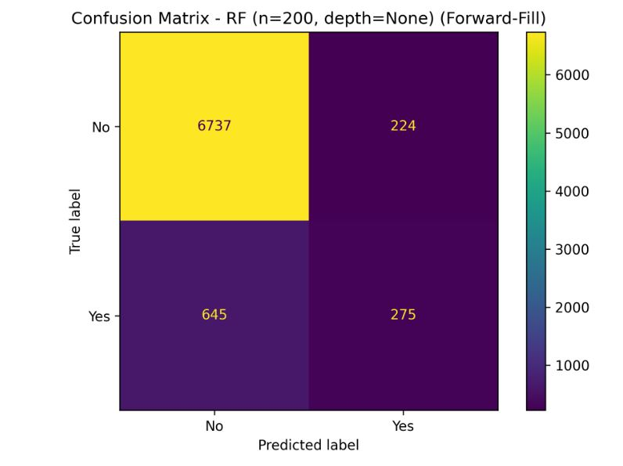
Figure. Confusion matrix of the selected best model: RF (n=200, depth=None)
The confusion matrix shows that the selected Random Forest model correctly predicted 6,737 non-subscribers and 275 subscribers. However, it also misclassified 645 actual subscribers as non-subscribers and 224 non-subscribers as subscribers.
This result shows that the model performs strongly in identifying the majority class, which is non-subscribers, but still has difficulty detecting the minority class, which is actual subscribers. This pattern is consistent with the class imbalance observed in the dataset, where most customers did not subscribe to the term deposit.
From a business perspective, the model can help reduce unnecessary marketing calls by filtering out many unlikely customers. However, if the bank wants to identify more potential subscribers, further improvements may be needed, such as applying class balancing techniques, threshold adjustment, or hyperparameter tuning.

6. Conclusion
This project aimed to predict whether a customer would subscribe to a fixed-term deposit using the Bank Marketing dataset. The project followed the main steps of a data science process, including objective setting, data exploration, preprocessing, modeling, and evaluation.
In the preprocessing stage, duplicate records were removed, unknown values were handled, categorical variables were encoded, and numerical features were scaled using StandardScaler. As a result, the final dataset was transformed into a model-ready format with 39,404 records and 47 columns, including the target variable y.
In the modeling stage, two classification models were applied: Logistic Regression and Random Forest. The models were tested on two different preprocessed datasets, Mean Imputation and Forward-Fill. In the evaluation stage, six hyperparameter configurations were compared, including three Logistic Regression settings and three Random Forest settings.
The evaluation results showed that accuracy alone was not sufficient because the dataset was highly imbalanced. Some models achieved high accuracy, but this did not necessarily mean that they performed well in identifying actual subscribers. Therefore, additional metrics such as precision, recall, F1-score, ROC-AUC, and confusion matrix were used to evaluate the models more appropriately.
As a result, Forward-Fill with RF (n=200, depth=None) was selected as the best model based on F1-score. The final selected model achieved an accuracy of 0.8897, precision of 0.5511, recall of 0.2989, F1-score of 0.3876, and ROC-AUC of 0.7742 on the test set.
These results show that the model is effective at identifying non-subscribers, but still has limitations in detecting actual subscribers. This limitation is mainly related to the class imbalance of the dataset, where the number of non-subscribers is much larger than the number of subscribers.
Overall, this project demonstrates how machine learning can be applied to improve bank marketing strategies. By using customer and economic data, banks can make more data-driven decisions and reduce inefficient marketing attempts. Future improvements could include class imbalance handling, probability threshold adjustment, and additional hyperparameter tuning to improve the detection of potential subscribers.

7. Open-Source SW
7.1 Overview
The project source code was organized into modular Python scripts and published on GitHub. Together, the scripts cover the main stages of the machine learning pipeline: data preprocessing, model training and comparison, and multi-metric evaluation.
As required by the Open-Source SW contribution guidelines, the project code was organized to improve reusability and readability. The evaluation stage was especially implemented as a reusable top-level function following the documentation style of pandas and scikit-learn. The function accepts flexible parameters, includes detailed descriptions of parameters and return values, and can be reused for binary classification evaluation tasks using cleaned tabular datasets.
The table below summarizes the role of each script and its primary function.

Script | Primary Function | Responsible Member | Stage
TermProject.py | Step-by-step preprocessing and scaling verification | Jo Yoon-sung | Preprocessing
preprocess.py | Full preprocessing pipeline: imputation, encoding, and scaling | Moon Ji-seok | Preprocessing and Modeling
predict.py | Model training and K-Fold accuracy comparison | Moon Ji-seok | Modeling
evaluation.py | evaluate_classification_models(): multi-metric evaluation and output saving | Choi Yu-ri | Evaluation
Table. Summary of project scripts and responsibilities
7.2 Preprocessing Code
The preprocessing stage consists of two scripts: TermProject.py, which was used for step-by-step exploratory preprocessing, and preprocess.py, which integrates the preprocessing pipeline into reusable functions.
7.2.1 Step-by-step Preprocessing - TermProject.py
TermProject.py was used during the initial data exploration and preprocessing phase. It covers duplicate detection, target class distribution analysis, unknown value handling, categorical encoding, and numerical feature scaling. The active portion of the script applies StandardScaler to nine numerical features and saves the final preprocessed dataset.
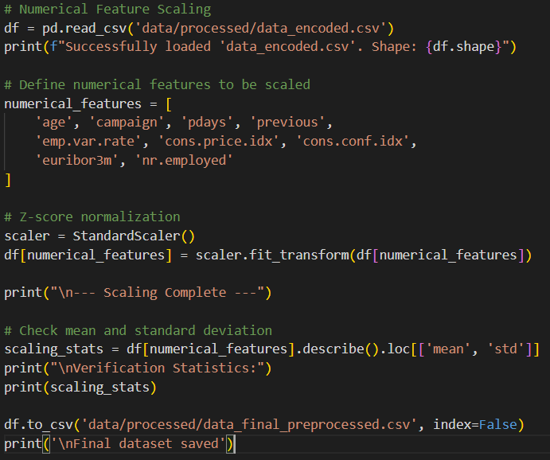
Figure. Numerical feature scaling and final dataset saving in TermProject.py
StandardScaler standardizes each numerical feature to have a mean of 0 and a standard deviation of 1 using the formula x' = (x - mean) / standard deviation. This ensures that features with different scales, such as age and euribor3m, do not disproportionately influence the learning process.
7.2.2 Full Pipeline Functions - preprocess.py
preprocess.py integrates the preprocessing steps into modular functions that can be called independently or in sequence. It produces two model-ready datasets: preprocessed_mean.csv and preprocessed_ffill.csv.
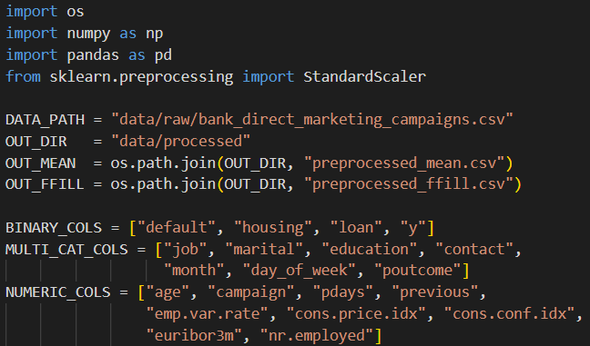
Figure. Module overview and preprocessing column definitions in preprocess.py
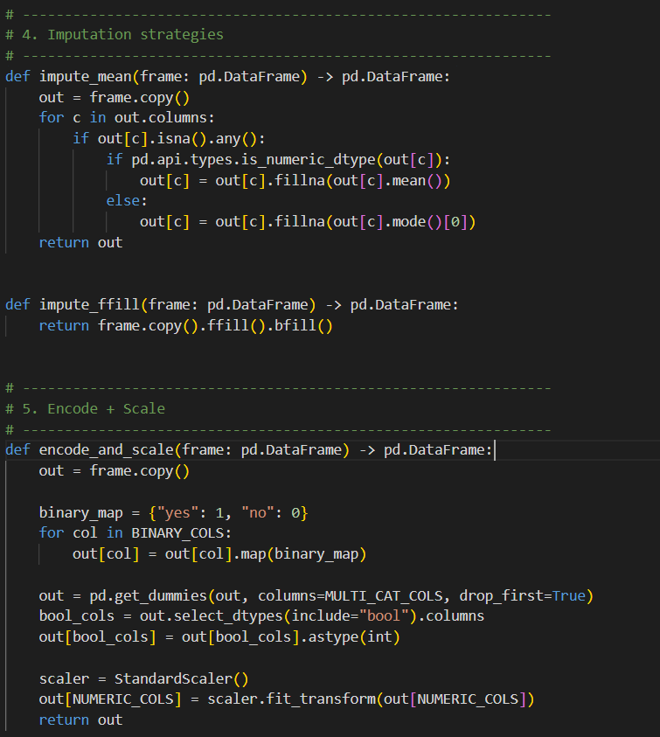
Figure. Preprocessing functions for imputation, encoding, and scaling in preprocess.py

The three functions serve the following purposes.
Function | Purpose
impute_mean(frame) | Fills missing values with the column mean for numeric features or the mode for categorical features.
impute_ffill(frame) | Fills missing values using forward-fill followed by backward-fill.
encode_and_scale(frame) | Applies binary label encoding, one-hot encoding using pd.get_dummies(), and StandardScaler to produce a model-ready dataset.
Table. Preprocessing functions in preprocess.py
Two separate preprocessing versions are produced by combining impute_mean() or impute_ffill() with encode_and_scale(). These outputs are used as inputs to both the modeling and evaluation stages.
7.3 Modeling Code
The modeling stage was implemented in predict.py. The script trains two classification models, Logistic Regression and Random Forest, on both preprocessed datasets and compares their performance using Stratified K-Fold Cross-Validation with accuracy as the initial comparison metric.
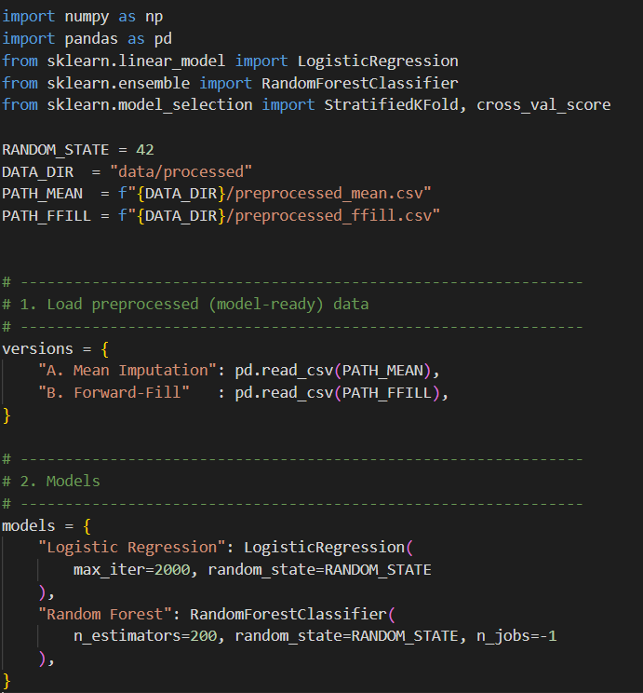
Figure. Model definitions in predict.py
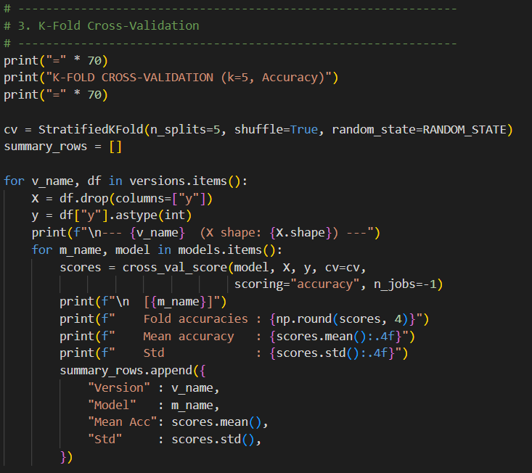
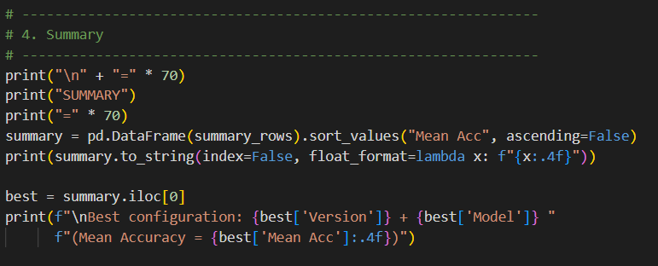
Figure. K-Fold cross-validation and summary comparison in predict.py
The key design decisions in predict.py are summarized below.
Component | Choice | Reason
Cross-validation | StratifiedKFold (k=5) | Preserves class ratio in each fold, which is important for imbalanced datasets.
Scoring metric | Accuracy | Used as the baseline metric for initial model comparison.
Random Forest | n_estimators=200 | A larger number of trees can reduce variance and improve prediction stability.
Logistic Regression | max_iter=2000 | Ensures convergence on high-dimensional one-hot encoded features.
Table. Design decisions in predict.py
The modeling script uses cross_val_score(), which returns one metric per fold. The evaluation script extends this by using cross_validate(), which computes multiple metrics simultaneously and provides a more comprehensive comparison.
7.4 Evaluation Code - evaluate_classification_models()
The evaluation stage was implemented as a reusable open-source function named evaluate_classification_models() in evaluation.py. This function follows the parameter documentation style of pandas and scikit-learn and provides a structured way to evaluate multiple classification model configurations.
7.4.1 Module Overview and Function Signature
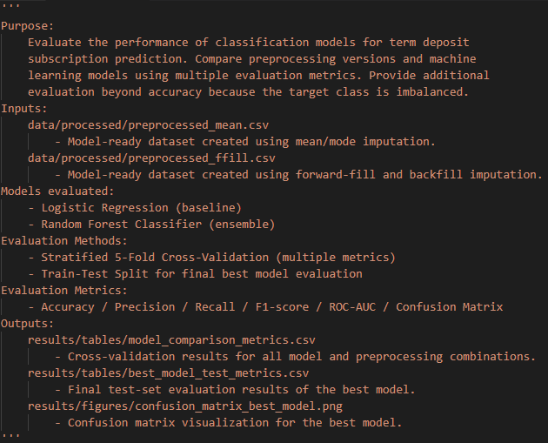 Figure. Overview docstring of evaluation.py
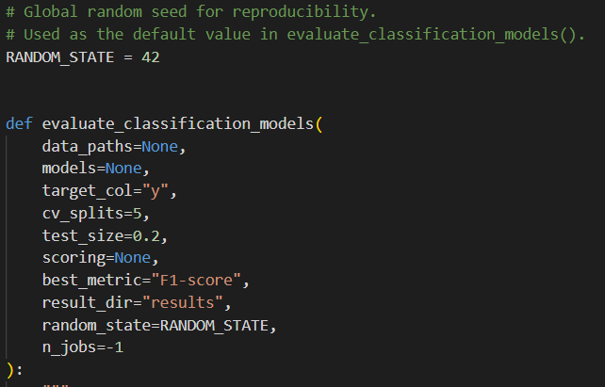
Figure. Function signature of evaluate_classification_models()
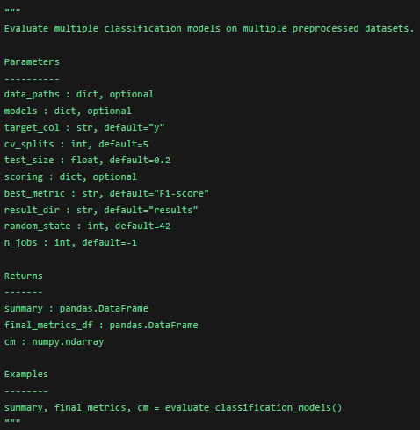
Figure. User manual style docstring for function specification
The docstring explains the purpose of the function, all parameters, return values, and example usage. This makes the function easier to understand and reuse, following the documentation style commonly used in pandas and scikit-learn.
7.4.2 Various Parameter Combinations
A key requirement of the Open-Source SW contribution is training and testing models with various parameter combinations. The evaluation function includes six default model configurations: three Logistic Regression configurations and three Random Forest configurations.
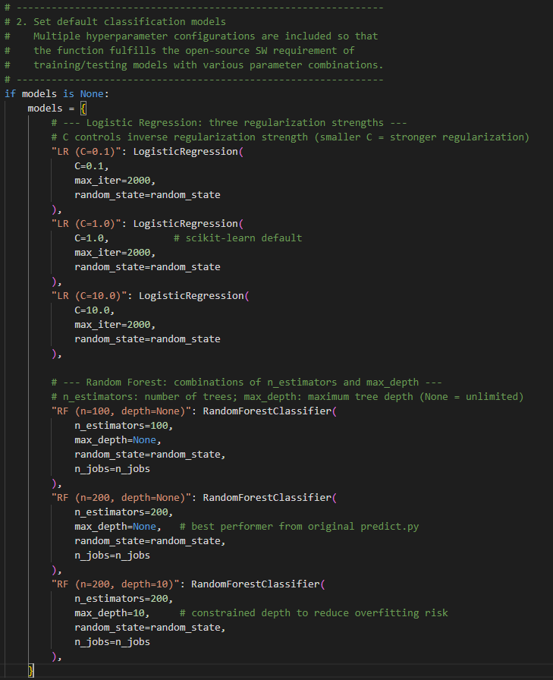
Figure. Default model configurations with multiple hyperparameter combinations
The parameter choices are summarized below.
Model | Parameter Varied | Values Tested | Effect
Logistic Regression | C (regularization strength) | 0.1 / 1.0 / 10.0 | Smaller C means stronger regularization and can reduce overfitting.
Random Forest | n_estimators | 100 / 200 | More trees can make predictions more stable.
Random Forest | max_depth | None / 10 | Limiting depth can reduce overfitting risk.
Table. Hyperparameter combinations used in evaluation.py
7.4.3 Multi-Metric Cross-Validation
Unlike predict.py, which uses cross_val_score() for a single accuracy metric, evaluation.py uses cross_validate() to evaluate multiple metrics in one call for each model configuration.
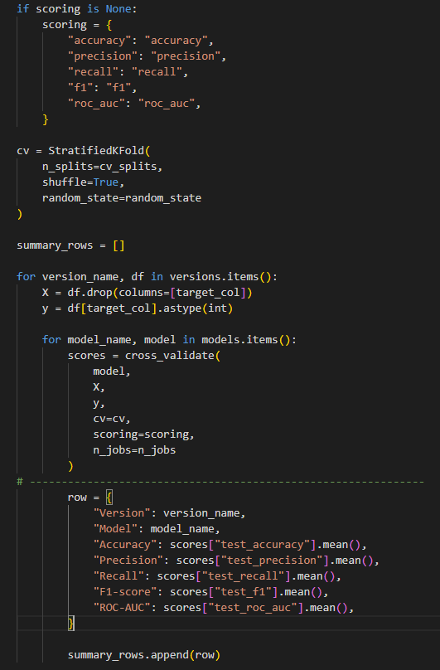
Figure. Stratified K-Fold cross-validation and multi-metric evaluation

The difference between the two cross-validation functions used in this project is as follows.
Function | Number of Metrics per Call | Return Type | Use Case in This Project
cross_val_score() | One | numpy.ndarray of scores | Baseline accuracy comparison in predict.py
cross_validate() | Multiple | Dictionary of score arrays | Full multi-metric evaluation in evaluation.py
Table. Comparison between cross_val_score() and cross_validate()
7.4.4 Best Model Selection, Test Evaluation, and Output Saving
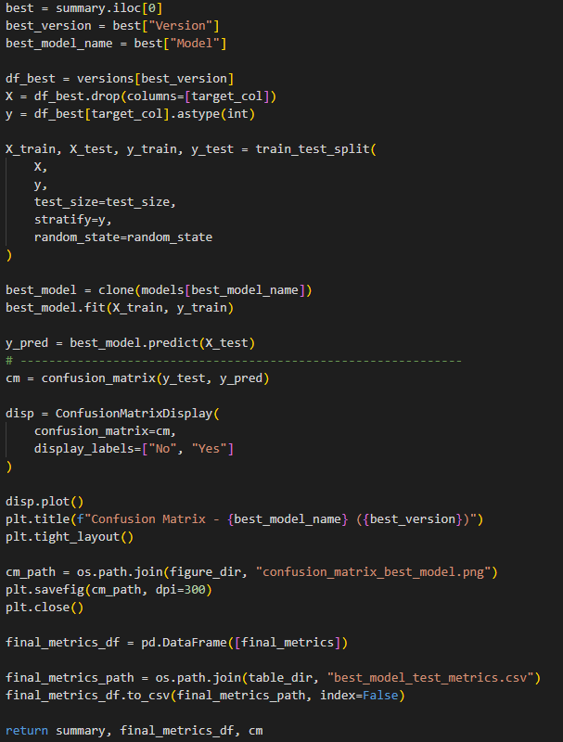
Figure. Best model selection, final test evaluation, and output saving process
The function selects the best model based on the chosen metric, which is F1-score by default. The clone() function creates a fresh untrained copy of the selected model, ensuring that the final test evaluation is independent from the cross-validation phase. The function also saves the result tables and confusion matrix image automatically.
7.5 Function Specification
7.5.1 Parameters
Parameter | Type | Default | Description
data_paths | dict, optional | None | Dataset names mapped to CSV file paths.
models | dict, optional | None | Model names mapped to scikit-learn classifier objects. The default setting includes six configurations.
target_col | str | "y" | Name of the target column.
cv_splits | int | 5 | Number of folds for Stratified K-Fold Cross-Validation.
test_size | float | 0.2 | Proportion of the dataset held out for final test evaluation.
scoring | dict, optional | None | Metrics for cross-validation. Defaults to accuracy, precision, recall, F1-score, and ROC-AUC.
best_metric | str | "F1-score" | Metric used to rank and select the best model.
result_dir | str | "results" | Root directory for saving output files.
random_state | int | 42 | Random seed applied to models, splits, and shuffling.
n_jobs | int | -1 | Number of CPU cores for parallel evaluation. -1 means all available cores.
Table. Parameters of evaluate_classification_models()
7.5.2 Return Values
Return Value | Type | Description
summary | pandas.DataFrame | Cross-validation results for all preprocessing and model configuration combinations, sorted by the selected best_metric.
final_metrics_df | pandas.DataFrame | Final test-set evaluation results of the selected best model.
cm | numpy.ndarray | Confusion matrix of the selected best model on the test set.
Table. Return values of evaluate_classification_models()
7.5.3 Output Files
File | Description
results/tables/model_comparison_metrics.csv | Cross-validation results for all 12 preprocessing and model configuration combinations.
results/tables/best_model_test_metrics.csv | Final test-set evaluation results of the selected best model.
results/figures/confusion_matrix_best_model.png | Confusion matrix visualization saved at 300 DPI.
Table. Output files generated by evaluation.py
7.6 Library and Module Explanation
The evaluation code uses the following Python libraries and modules.
Library / Module | Purpose
os | Creates output directories such as tables/ and figures/ automatically using os.makedirs().
numpy | Handles numerical arrays and numerical values returned by cross-validation scoring.
pandas | Loads CSV datasets and saves evaluation result tables as DataFrames.
matplotlib.pyplot | Renders and saves the confusion matrix image at 300 DPI.
sklearn.base.clone | Creates a fresh untrained copy of the best model for final test evaluation.
sklearn.linear_model.LogisticRegression | Builds the baseline linear classifier; the C parameter controls regularization strength.
sklearn.ensemble.RandomForestClassifier | Builds the ensemble classifier; n_estimators and max_depth are varied across configurations.
sklearn.model_selection.StratifiedKFold | Performs K-Fold splitting while preserving class distribution in each fold.
sklearn.model_selection.cross_validate | Evaluates multiple scoring metrics in one call.
sklearn.model_selection.train_test_split | Splits data into training and test sets with stratified sampling.
sklearn.metrics | Provides accuracy, precision, recall, F1-score, ROC-AUC, confusion matrix, ConfusionMatrixDisplay, and classification_report.
Table. Library and module explanation
7.7 GitHub Repository
The project source code, datasets, result files, and report materials were published on GitHub for open-source contribution.
GitHub Repository:
https://github.com/CHOIYURI8/26-1-data-science-term-project
Folder / File | Description
data/raw/ | Original dataset: bank_direct_marketing_campaigns.csv
data/processed/ | Model-ready datasets such as preprocessed_mean.csv and preprocessed_ffill.csv
src/TermProject.py | Step-by-step preprocessing and feature scaling script.
src/preprocess.py | Full preprocessing pipeline with impute_mean(), impute_ffill(), and encode_and_scale().
src/predict.py | Modeling script using K-Fold Cross-Validation with accuracy as the baseline metric.
src/evaluation.py | Evaluation script containing evaluate_classification_models() with multi-metric evaluation.
results/tables/ | CSV output files generated from the evaluation stage.
results/figures/ | Confusion matrix image generated from the evaluation stage.
requirements.txt | Python package dependencies.
Table. GitHub repository structure

8. Learning Experience
Shin In-seub :
~~
Jo Yoon-sung:
~~
Moon Ji-seok:
~~
Choi Yu-ri :
Through this project, I learned that model evaluation should not be based only on accuracy. At first, I thought the model with the highest accuracy would naturally be the best model. However, while checking the target class distribution and evaluation results, I realized that the dataset was highly imbalanced, so accuracy alone could give a misleading result.
My main role was to evaluate the models, write the conclusion, and organize the Open-Source SW section. While working on the evaluation part, I compared the models using precision, recall, F1-score, ROC-AUC, and confusion matrix. This helped me understand why F1-score can be more useful when the positive class is small, especially in a marketing problem where finding actual subscribers is important.
I also learned how the preprocessing and modeling parts are connected to the final evaluation. The preprocessing results became the input for the models, and the modeling results had to be interpreted carefully through multiple metrics. In addition, organizing the code and outputs in GitHub helped me understand the importance of reproducibility and clear project structure.
Overall, this project helped me experience the full flow of a data science project, from data preprocessing to model evaluation and result interpretation. It also showed me that choosing the “best” model depends on the purpose of the project, not just on one high score.
Han Sang-hoo:
~~

9. Role
Shin In-seub | Jo Yoon-sung | Moon Ji-seok | Choi Yu-ri | Han Sang-hoo
Topic Management and Project Direction | Objective Setting | Algorithms | Evaluation
PPT | Data Preprocessing | Modeling | Conclusion
script preparation | Report writing | Report writing | Open Source SW
Presentation |  |  | Report writing
25% | 25% | 25% | 25%

