- Objective Setting

1.1 Motivation
Today, saving money safely has become harder due to the changing economy and interest rates. While fixed-term deposits are a great way to save, banks often struggle to find the right customers. Traditional methods like random phone calls are not only expensive for banks but also annoying for people, which can hurt a bank’s image.
Inspired by how data is used to solve problems in other fields, we want to apply data analysis to banking. Our goal is to use data to find people who are actually interested in these deposits. This way, banks can stop making unwanted calls and focus on a more personal, customer-friendly approach.

1.2 Project Objectives
The main goal of this project is to build a classification model that predicts whether a customer will subscribe to a fixed-term deposit (‘y’). We will follow the standard steps of a big data project to achieve the following:
- Model Comparison: Use two different machine learning models - Logistic Regression and Random Forest – and compare them to see which one predicts customer behavior better.
- Finding Key Factors: Beyond mere prediction, we aim to extract meaningful insights into which features are most indicative of customer intent.
- Optimized Marketing Strategy: By utilizing optimized marketing strategies, we can reduce wasted time and costs, leading to more efficient resource management and a higher success rate in attracting customers.
- Ensuring Reliable Results: Use k-fold cross-validation to prevent overfitting and ensure the model’s reliability. This process confirms that the model provides consistent and accurate predictions regardless of how the training and validation sets are split within our dataset.

- Data Exploration
2.1 Data Source
The dataset used in this project is Bank Marketing Dataset, sourced from the UCI Machine Learning Repository and hosted on Kaggle. The dataset used in this project was obtained from the following URL: https://www.kaggle.com/datasets/ruthgn/bank-marketing-data-set
It contains information about direct marketing campaigns of a Portuguese banking institution. The marketing campaign was executed through phone calls. The classification goal is to predict if the client will subscribe (yes/no) to a term deposit (variable ‘y’).

2.2 Data Overview
Based on CSV file, we analyzed the initial structure and dimensions of the dataset. As shown in the output below, the dataset consists of 41,188 entries and 20 features, confirming the consistency of the data. This satisfies the project requirement of at least 1,000 records and 10 features.
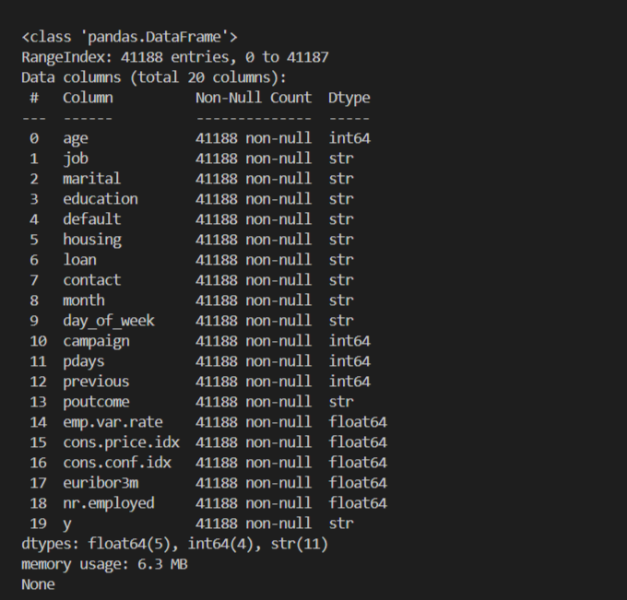
While the ‘Non-Null Count’ indicates that there are no technical null values (NaN), it is observed that several categorical features contain ‘unknown’ values. These will be addressed as a form of missing data during the data preprocessing stage. The dataset contains a mix of numerical and categorical data. The following is a detailed description of each feature.
Bank client data:
age (numeric)
job - type of job (categorical: ‘admin.’, ’blue-collar’, ’entrepreneur’, ’housemaid’, ’management’, ‘retired’, ‘self-employed’, ‘services’, ‘student’, ‘technician’, ‘unemployed’, ‘unknown’)
marital - marital status (categorical: 'divorced', 'married', 'single', 'unknown'; note: 'divorced' means divorced or widowed)
education (categorical: 'basic.4y', 'basic.6y', 'basic.9y', 'high.school', 'illiterate', 'professional.course', 'university.degree', 'unknown')
default - has credit in default? (categorical: 'no', 'yes', 'unknown')
housing - has housing loan? (categorical: 'no', 'yes', 'unknown')
loan - has personal loan? (categorical: 'no', 'yes', 'unknown')

Related with the last contract of the current campaign:
contact - contact communication type (categorical: ‘cellular’, ‘telephone’)
month - last contact month of year (categorical: ‘jan’, ‘feb’, ‘mar’, ..., ‘nov’, ‘dec’)
day_of_week - last contact day of the week (categorical: ‘mon’, ‘tue’, ‘wed’, ‘thu’, ‘fri’)

Other attributes:
campaign - number of contacts performed during this campaign and for this client (numeric, includes last contact)
pdays - number of days that passed by after the client was last contacted from a previous campaign (numeric; 999 means client was not previously contacted)
previous - number of contacts performed before this campaign and for this client (numeric)
poutcome - outcome of the previous marketing campaign (categorical: 'failure', 'nonexistent', 'success')

Social and economic context attributes:
emp.var.rate - employment variation rate; quarterly indicator (numeric)
cons.price.idx - consumer price index; monthly indicator (numeric)
cons.conf.idx - consumer confidence index; monthly indicator (numeric)
euribor3m - euribor 3 month rate; daily indicator (numeric)
nr.employed - number of employees; quarterly indicator (numeric)
Output variable (desired target):
y – has the client subscribed a term deposit? (binary: ‘yes’, ‘no’)

2.3 Data Integrity
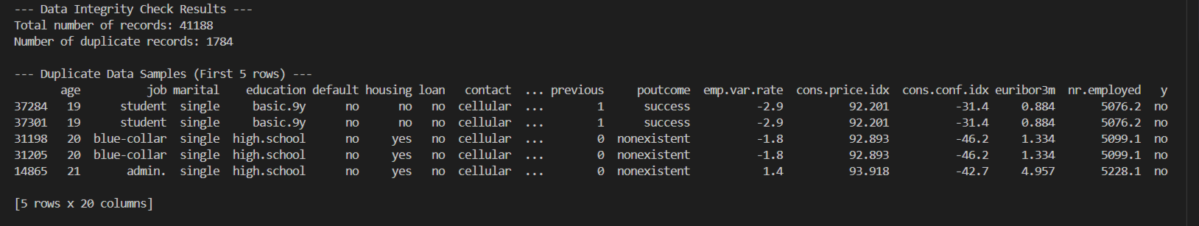Through the duplication check, we identified 1,784 duplicate records (approximately 4.3% of the total dataset). These duplicates consist of entries where all 20 features, including social and economic indicators, are identical.
Leaving these duplicates in the dataset can lead to model bias, where the classification algorithm over-learns specific instances, potentially reducing its ability to generalize new data. To ensure the robustness of the model as stated in our project objectives, we plan to remove these duplicate records during the data preprocessing stage. This will ensure that our training process is based on unique observations, leading to more reliable and consistent performance.

2.4 Target Class Distribution
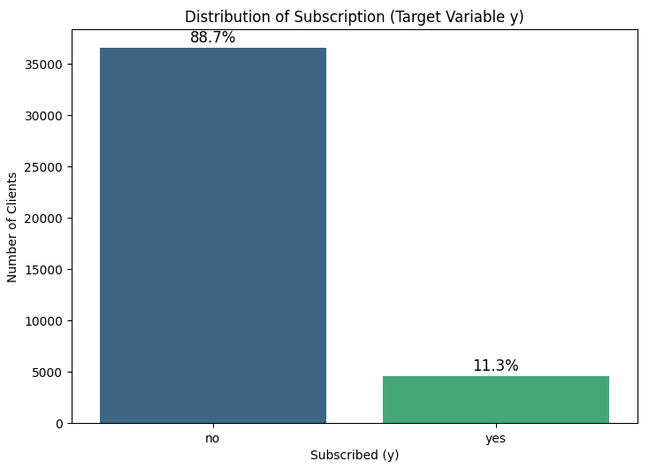
The dataset exhibits a significant class imbalance, with nearly 89% of the clients not subscribing to the term deposit. This finding is crucial because if a model simply predicts ‘no’ for every client, it would still achieve an 89% accuracy rate, yet fail to find any actual subscribers. Therefore, to ensure a robust and useful model, we will not rely solely on overall accuracy. Instead, we will prioritize how effectively the model identifies the ‘yes’ class during the evaluation phase.

2.5 Scaling Necessity
During the feature exploration, we observed a vast difference in the scales of numerical features. For instance, the ‘age’ feature ranges from 17 to 98, while economic indicators like ‘nr.employed’ range between 4,000 and 5,000. Such disparities can cause certain features with larger numerical values to dominate the learning process of machine learning models. To prevent this bias and ensure each feature contributes equally to the prediction, we have determined that feature scaling is a mandatory step in the upcoming preprocessing phase.

- Data Preprocessing
3.1 Data Cleaning
Removing Duplicate
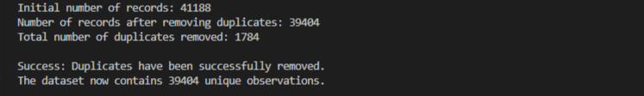Based on the insights from the Data Exploration phase, we identified 1,784 duplicate entries. To prevent the model from over-learning these identical instances, we performed Data Restructuring by removing all duplicates using ‘drop_duplicates()’ function. This process reduced our dataset from 41,188 to 39,404 unique records, ensuring that our training process is based on distinct customer observations.
Handling ‘unknown’ Values
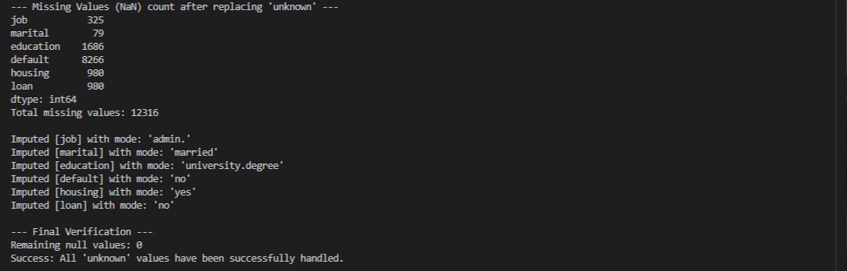In the cleaned dataset where duplicate records were removed, all ‘unknown’ labels were converted to ‘np.nan’ to facilitate systematic missing value processing. We then applied Mode Imputation, replacing these null values with the most frequent value of each respective feature. Finally, a verification check confirmed that the total number of remaining null values reached 0.

3.2 Data Transformation
Categorical Encoding
In the data transformation stage, we applied two different encoding strategies based on the nature of the categorical variables to prepare the dataset for machine learning models. For binary features, we utilized label encoding (mapping ‘yes’ to 1 and ‘no’ to 0) to simplify the data structure into a binary format.
For multi-categorical features such as ‘job’ and ‘marital’, we performed one-hot encoding. This approach prevents the model from assuming any non-existent ordinal relationships between categories, which could otherwise lead to biased predictions. To ensure the statistical robustness of the model, we implemented the ‘drop_first’ parameter during this process to prevent the dummy variable trap.
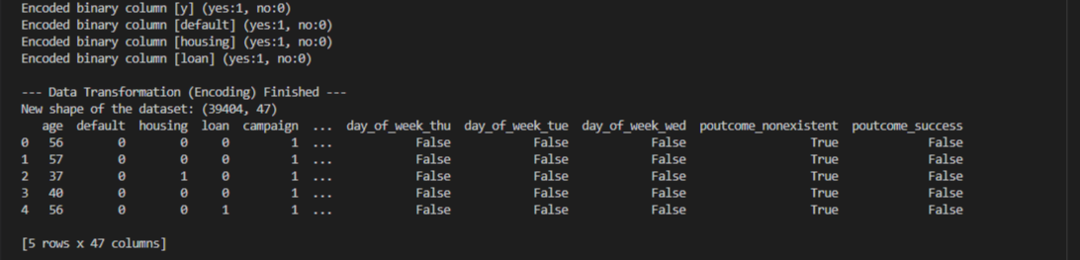The categorical encoding process was successfully completed, resulting in the feature count expanding from 20 to 47. This transformation was achieved while maintaining the integrity of the dataset, preserving all 39,404 observations for the subsequent modeling phase.

3.3 Numerical Feature Scaling
Necessity of Scaling
In our dataset, numerical features exhibit significantly different scales and units. For example, ‘age’ ranges from 17 to 98, while economic indicators like ‘nr.employed’ have values exceeding 5,000.
Without scaling, features with larger numerical magnitudes would disproportionately dominate the model’s weight updates during the learning process. This is particularly critical for gradient-based or distance-based optimization algorithms, where inconsistent scales can lead to slow convergence or biased results. By standardizing these values, we ensure that each feature contributes equally to the model’s predictive performance regardless of its original unit.
StandardScaler (Z-score Normalization)
We selected StandardScaler as our primary scaling method. This technique transforms each feature to have a mean ($μ$) of 0 and a standard deviation ($σ$) of 1.
Reasons for selecting StandardScaler:
- Algorithm Compatibility: It is a standard requirement for many classification algorithms to ensure that the objective function works correctly.
- Preserving Distribution: Unlike other methods that squash data into a small range, StandardScaler preserves the shape of the original distribution while centering the data around 0.
Implementation and Verification
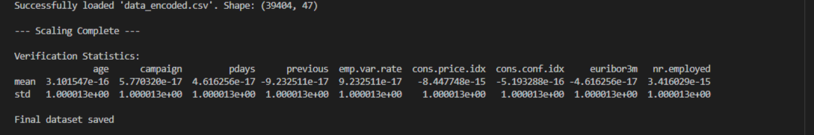The scaling results were empirically verified through statistical analysis. The mean of all 9 numerical features reached approximately 0 (ranging from 10^-15 to 10^-17), and the standard deviation was consistently normalized to 1.0. This confirms that the StandardScaler was applied correctly, effectively eliminating scale disparities between features such as ‘age’ and ‘nr.employed’. The dataset is now fully optimized for the modeling phase, with a final structure 39,404 records and 47 features.

4. Algorithms / Modeling
4.1 Modeling Overview

This project implements a binary classification pipeline that predicts whether a customer will subscribe to a term deposit (y) based on bank direct marketing data. The modeling stage uses the preprocessed datasets generated from the previous preprocessing stage and applies two classification models: Logistic Regression and Random Forest.

The purpose of this stage is to compare the performance of different preprocessing strategies and machine learning models. Specifically, the model uses two preprocessed dataset versions, which differ in their missing-value handling strategy. Each dataset version is used to train and evaluate both classification models.

The overall modeling pipeline can be summarized as follows:

Preprocessed CSVs → Model Training and Testing → 5-Fold Stratified Cross-Validation → Summary Comparison

4.2 Input Data for Modeling

The modeling code uses two model-ready CSV files as input.

preprocessed_mean.csv
- Dataset created using mean/mode imputation, encoding, and scaling
preprocessed_ffill.csv
- Dataset created using forward-fill/backfill imputation, encoding, and scaling

Both files are already processed through categorical encoding and numerical feature scaling. Therefore, the modeling script can directly separate the target variable y from the feature variables and use them for model training.

4.3 Missing Value Imputation Versions

The script treats the two imputation methods as independent dataset versions and compares model performance across them.

Mean Imputation

Mean imputation replaces missing numerical values with the column mean and categorical missing values with the most frequent value. This method is stable and simple, but it may reduce the variance of the original distribution.

Forward-Fill

Forward-fill replaces missing values with the previous row’s value. In this project, it is used as an experimental comparison method to examine whether a different imputation strategy affects classification performance.

By comparing these two versions, the project can evaluate whether the missing-value handling strategy influences the final model performance.

4.4 Model Selection

Two machine learning models are applied in the modeling stage: Logistic Regression and Random Forest.

Logistic Regression

Logistic Regression is used as the baseline classification model. Since the target variable y has two possible values, yes or no, Logistic Regression is suitable for predicting the probability of term deposit subscription. In the code, max_iter=2000 is used to ensure stable convergence during training.

Random Forest

Random Forest is used as a stronger comparative model. It consists of multiple decision trees and can capture non-linear patterns and interactions among features. In the code, n_estimators=200 is used, meaning that the model builds 200 decision trees. This setting provides a balance between prediction stability and computational cost.

4.5 Cross-Validation Setting

To evaluate the models reliably, the modeling stage applies 5-Fold Stratified Cross-Validation.

The cross-validation setting is as follows:

cv = StratifiedKFold(n_splits=5, shuffle=True, random_state=42)
scores = cross_val_score(model, X, y, cv=cv, scoring="accuracy")

Stratified K-Fold is appropriate for this project because the target variable is imbalanced. Since most customers did not subscribe to the term deposit, preserving the class ratio in each fold helps make the evaluation more stable.

The use of shuffle=True and random_state=42 ensures that the experiment is reproducible. The parameter n_jobs=-1 is used to parallelize the computation and improve execution speed.

4.6 Modeling Process

The modeling process consists of the following steps.

First, the two preprocessed CSV files are loaded. Each dataset version contains the same target variable, y, and the same set of processed features.

Second, the target column y is separated from the feature columns. The feature matrix is defined as X, and the target variable is defined as y.

Third, Logistic Regression and Random Forest models are defined. Both models use the same random state to ensure reproducibility.

Fourth, each model is trained and evaluated using 5-Fold Stratified Cross-Validation. The model performance is measured using accuracy in the original modeling script.

Finally, the fold accuracies, mean accuracy, and standard deviation are calculated and summarized in a DataFrame. The best configuration is selected based on the highest mean accuracy.

4.7 Modeling Summary
This structure allows the project to compare both preprocessing strategies and classification models. Logistic Regression serves as a simple and interpretable baseline model, while Random Forest serves as a non-linear ensemble model that can capture more complex relationships in the data.

The detailed performance comparison and final model selection are discussed in the following Evaluation section.

5. Evaluation
5.1 Evaluation Overview

The evaluation stage aims to compare the performance of the classification models and identify the most appropriate model for predicting term deposit subscription. In the previous modeling stage, Logistic Regression and Random Forest were trained and tested using two different preprocessed datasets: Mean Imputation and Forward-Fill.
In the original modeling script, model performance was mainly compared using accuracy. However, the target variable in this dataset is highly imbalanced, because most customers did not subscribe to the term deposit. Therefore, accuracy alone may not be sufficient to evaluate the model properly. To provide a more reliable evaluation, additional metrics were used in this stage.

The evaluation process includes the following steps:
- Compare all preprocessing and model combinations using Stratified 5-Fold Cross-Validation.
- Calculate multiple evaluation metrics: Accuracy, Precision, Recall, F1-score, and ROC-AUC.
- Select the best model based on F1-score.
- Evaluate the selected model on a separate test set.
- Save the evaluation results and confusion matrix as output files.
5.2 Evaluation Metrics

The following evaluation metrics were used to analyze model performance.

Metric | Description
Accuracy | Measures the overall proportion of correct predictions.
Precision | Measures how many predicted positive cases were actually positive.
Recall | Measures how many actual positive cases were correctly identified.
F1-score | Harmonic mean of precision and recall. Useful for imbalanced datasets.
ROC-AUC | Measures the model’s ability to distinguish between positive and negative classes.
Confusion Matrix | Shows the number of true positives, true negatives, false positives, and false negatives.

Since the dataset has a strong class imbalance, F1-score was used as the main metric for selecting the best model. This is because F1-score considers both precision and recall, making it more suitable than accuracy alone when the positive class is relatively small.

5.3 K-Fold Cross-Validation

To evaluate the models reliably, Stratified 5-Fold Cross-Validation was applied. Stratified K-Fold preserves the class distribution of the target variable in each fold, which is important for this project because the number of customers who subscribed to the term deposit is much smaller than the number of customers who did not subscribe.

The evaluation code used the following setting:
The parameter n_splits=5 means that the dataset was divided into five folds. Each model was trained and tested five times, and the average performance was calculated. The parameter shuffle=True randomly shuffles the data before splitting, and random_state=42 ensures reproducibility.

5.4 Cross-Validation Results
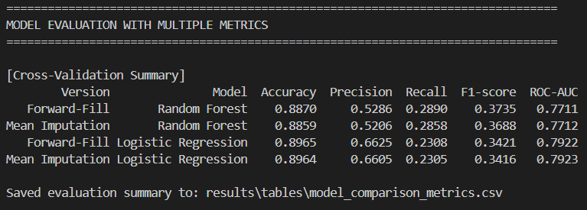
Figure. Cross-validation result from evaluation.py

The cross-validation results are summarized below.
Version | Model | Accuracy | Precision | Recall | F1-score | ROC-AUC
Forward-Fill | Random Forest | 0.8870 | 0.5286 | 0.2890 | 0.3735 | 0.7711
Mean Imputation | Random Forest | 0.8859 | 0.5206 | 0.2858 | 0.3688 | 0.7712
Forward-Fill | Logistic Regression | 0.8965 | 0.6625 | 0.2308 | 0.3421 | 0.7922
Mean Imputation | Logistic Regression | 0.8964 | 0.6605 | 0.2305 | 0.3416 | 0.7923
Table X. Cross-validation results of model comparison
Based on accuracy, Forward-Fill with Logistic Regression showed the highest value, with an accuracy of 0.8965. However, because the dataset is imbalanced, accuracy alone may overestimate model performance. For example, a model that predicts most customers as non-subscribers can still achieve high accuracy, but it would not be useful for identifying actual potential subscribers.
When F1-score was considered, Forward-Fill with Random Forest showed the best result, with an F1-score of 0.3735. This means that Random Forest achieved a better balance between precision and recall compared to Logistic Regression.

5.5 Best Model Selection

The best model was selected based on F1-score. The selected best configuration was:
Item | Selected Result
Best Preprocessing Version | Forward-Fill
Best Model | Random Forest
Cross-Validation F1-score | 0.3735
Cross-Validation Accuracy | 0.8870
Cross-Validation ROC-AUC | 0.7711

Although Logistic Regression achieved slightly higher accuracy and ROC-AUC, Random Forest showed better F1-score and recall. Since the main business objective is to identify customers who are likely to subscribe to a term deposit, detecting the positive class is important. Therefore, Random Forest was selected as the final model based on F1-score.

5.6 Final Test-Set Evaluation
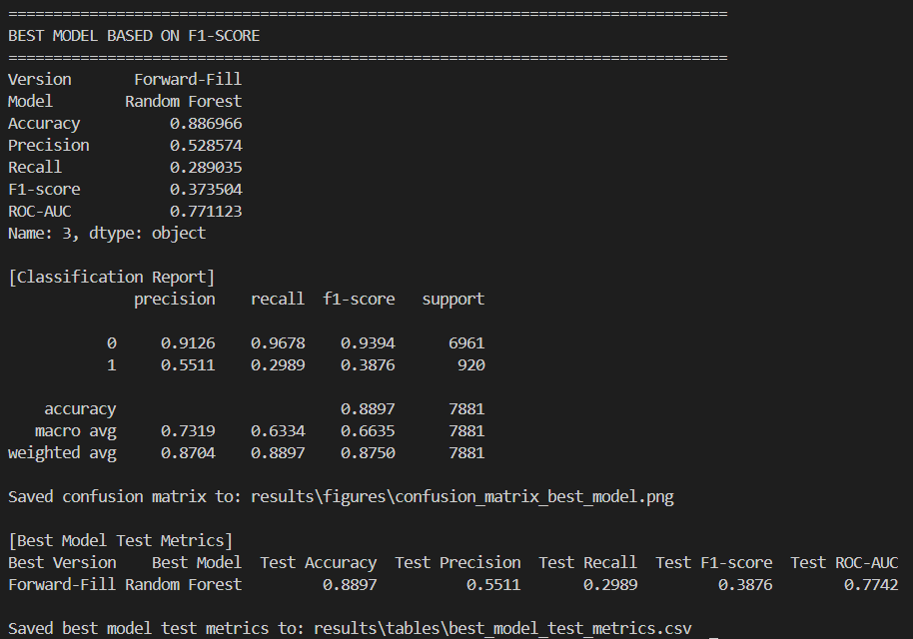
Figure. Final test-set evaluation result of the selected best model

After selecting the best model through cross-validation, the Forward-Fill dataset and Random Forest model were evaluated again using a train-test split. The test set size was set to 20% of the dataset, and stratified splitting was applied to preserve the target class distribution.
The final test-set results are shown below.
Best Version | Best Model | Test Accuracy | Test Precision | Test Recall | Test F1-score | Test ROC-AUC
Forward-Fill | Random Forest | 0.8897 | 0.5511 | 0.2989 | 0.3876 | 0.7742
Table X. Final test-set evaluation result of the selected best model
The final model achieved an accuracy of 0.8897 and an F1-score of 0.3876. The precision value of 0.5511 means that among the customers predicted as subscribers, about 55.11% were actual subscribers. The recall value of 0.2989 indicates that the model correctly identified about 29.89% of actual subscribers.
This recall value is relatively low, which shows that identifying positive customers is still difficult due to class imbalance. However, compared to using accuracy alone, this multi-metric evaluation provides a more realistic understanding of the model’s strengths and limitations.

5.7 Confusion Matrix Analysis
The confusion matrix was generated for the selected best model, Forward-Fill with Random Forest.
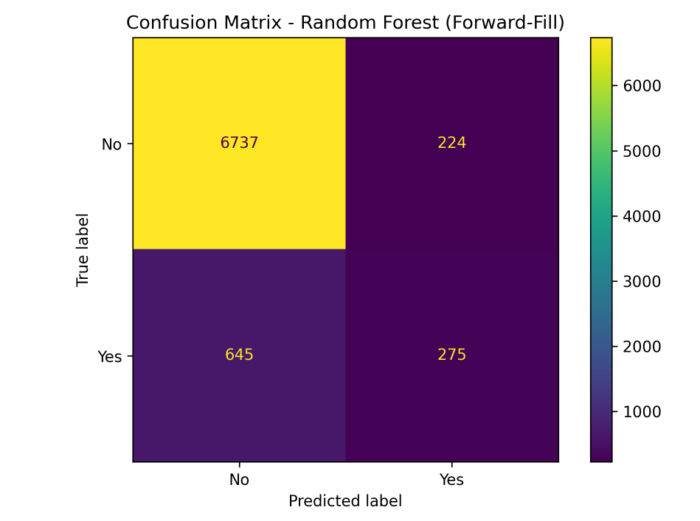
Figure. Confusion matrix of the selected best model
The confusion matrix shows that the selected Random Forest model correctly predicted 6,737 non-subscribers and 275 subscribers. However, it also misclassified 645 actual subscribers as non-subscribers and 224 non-subscribers as subscribers.
This result shows that the model performs strongly in identifying the majority class, which is non-subscribers, but still has difficulty detecting the minority class, which is actual subscribers. This pattern is consistent with the class imbalance observed in the dataset, where most customers did not subscribe to the term deposit.
From a business perspective, the model can help reduce unnecessary marketing calls by filtering out many unlikely customers. However, if the bank wants to identify more potential subscribers, further improvements may be needed, such as applying class balancing techniques, threshold adjustment, or hyperparameter tuning.

6. Conclusion

This project aimed to predict whether a customer would subscribe to a fixed-term deposit using the Bank Marketing dataset. The project followed the main steps of a data science process, including objective setting, data exploration, preprocessing, modeling, and evaluation.
In the preprocessing stage, duplicate records were removed, unknown values were handled, categorical variables were encoded, and numerical features were scaled using StandardScaler. As a result, the final dataset was transformed into a model-ready format with 39,404 records and 47 features.
In the modeling stage, two classification models were applied: Logistic Regression and Random Forest. The models were tested on two different preprocessed datasets, Mean Imputation and Forward-Fill. The original model comparison showed that Logistic Regression achieved the highest accuracy.
However, the evaluation stage showed that accuracy alone was not sufficient because the dataset was highly imbalanced. Therefore, additional metrics such as precision, recall, F1-score, ROC-AUC, and confusion matrix were used. As a result, Forward-Fill with Random Forest was selected as the best model based on F1-score.
The final selected model achieved an accuracy of 0.8897, precision of 0.5511, recall of 0.2989, F1-score of 0.3876, and ROC-AUC of 0.7742 on the test set. These results show that the model is effective at identifying non-subscribers, but still has limitations in detecting actual subscribers.
Overall, this project demonstrates how machine learning can be applied to improve bank marketing strategies. By using customer and economic data, banks can make more data-driven decisions and reduce inefficient marketing attempts. Future improvements could include hyperparameter tuning, class imbalance handling, and probability threshold adjustment to improve the detection of potential subscribers.

7. Open Source SW
7.1 Overview

As part of the Open Source SW contribution, the project code was organized and published on GitHub. The repository includes the dataset, preprocessing code, modeling code, evaluation code, result files, and report materials.
The evaluation part was implemented as a reusable top-level function named evaluate_classification_models(). This function was designed to evaluate multiple classification models on multiple preprocessed datasets and save the evaluation outputs automatically.

7.2 Function Definition

The main function developed for the evaluation stage is:
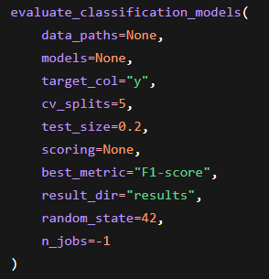
This function compares multiple preprocessing versions and classification models using Stratified K-Fold Cross-Validation. It calculates several evaluation metrics, selects the best model based on the selected metric, evaluates the best model on a separate test set, and saves the result files.
7.3 Function Specification
Parameter | Type | Description
`data_paths` | dict, optional | Dictionary containing dataset names and CSV file paths.
`models` | dict, optional | Dictionary containing model names and scikit-learn classifier objects.
`target_col` | str, default=`"y"` | Name of the target column.
`cv_splits` | int, default=`5` | Number of folds for Stratified K-Fold Cross-Validation.
`test_size` | float, default=`0.2` | Proportion of the dataset used for final test-set evaluation.
`scoring` | dict, optional | Evaluation metrics used in cross-validation.
`best_metric` | str, default=`"F1-score"` | Metric used to select the best model.
`result_dir` | str, default=`"results"` | Directory where result tables and figures are saved.
`random_state` | int, default=`42` | Random seed for reproducibility.
`n_jobs` | int, default=`-1` | Number of CPU cores used for model evaluation.

7.4 Return Values
Return Value | Type | Description
`summary` | pandas.DataFrame | Cross-validation results for all preprocessing and model combinations.
`final_metrics_df` | pandas.DataFrame | Final test-set evaluation results of the selected best model.
`cm` | numpy.ndarray | Confusion matrix of the selected best model on the test set.

7.5 Output Files

The function saves the following output files.
Output File | Description
`results/tables/model_comparison_metrics.csv` | Cross-validation results for all preprocessing and model combinations.
`results/tables/best_model_test_metrics.csv` | Final test-set evaluation results of the selected best model.
`results/figures/confusion_matrix_best_model.png` | Confusion matrix visualization for the selected best model.
These outputs can be used directly in the final report and presentation.

7.6 Library and Module Explanation

The evaluation code uses the following Python libraries and modules.
Library / Module | Purpose
`os` | Creates and manages output directories.
`numpy` | Handles numerical values and arrays.
`pandas` | Loads CSV files and saves evaluation results as DataFrames.
`matplotlib.pyplot` | Saves the confusion matrix visualization as an image file.
`sklearn.linear_model.LogisticRegression` | Builds the baseline classification model.
`sklearn.ensemble.RandomForestClassifier` | Builds the ensemble classification model.
`sklearn.model_selection.StratifiedKFold` | Performs stratified k-fold cross-validation.
`sklearn.model_selection.cross_validate` | Evaluates models using multiple metrics.
`sklearn.model_selection.train_test_split` | Splits the dataset into training and test sets.
`sklearn.metrics` | Provides evaluation metrics such as accuracy, precision, recall, F1-score, ROC-AUC, and confusion matrix.

7.7 GitHub Repository

The project source code and related files were published on GitHub.
GitHub Repository:
https://github.com/CHOIYURI8/26-1-data-science-term-project

The repository contains the following major components:
Folder / File | Description
`data/raw` | Original dataset files.
`data/processed` | Preprocessed datasets used for modeling and evaluation.
`src/preprocess.py` | Data preprocessing script.
`src/predict.py` | Modeling script for Logistic Regression and Random Forest.
`src/evaluation.py` | Evaluation script with multi-metric evaluation and output saving.
`results/tables` | CSV files containing evaluation results.
`results/figures` | Confusion matrix image file.
`requirements.txt` | Python package dependencies.

8. Learning Experience

Through this project, I learned that model evaluation is not simply about checking whether the accuracy is high. At first, the model with the highest accuracy appeared to be the best model. However, after examining the target class distribution, I realized that the dataset was highly imbalanced, and that accuracy alone could be misleading.
By applying additional metrics such as precision, recall, F1-score, and ROC-AUC, I was able to understand the model performance more clearly. In particular, I learned that recall and F1-score are important when the goal is to identify a smaller positive class, such as customers who actually subscribe to a term deposit.
I also learned how to organize evaluation code into a reusable function and save outputs such as CSV result tables and confusion matrix images. This helped me understand the importance of reproducibility and code organization in a data science project.
Finally, this project showed me that the best model depends on the evaluation objective. If the goal is overall correctness, accuracy may be useful. However, if the goal is to find potential customers, metrics related to the positive class should be considered more carefully.

