SCREENSHOTS + ANSWERS FOR EVERY SUBPROBLEM(output)

PROBLEM 1

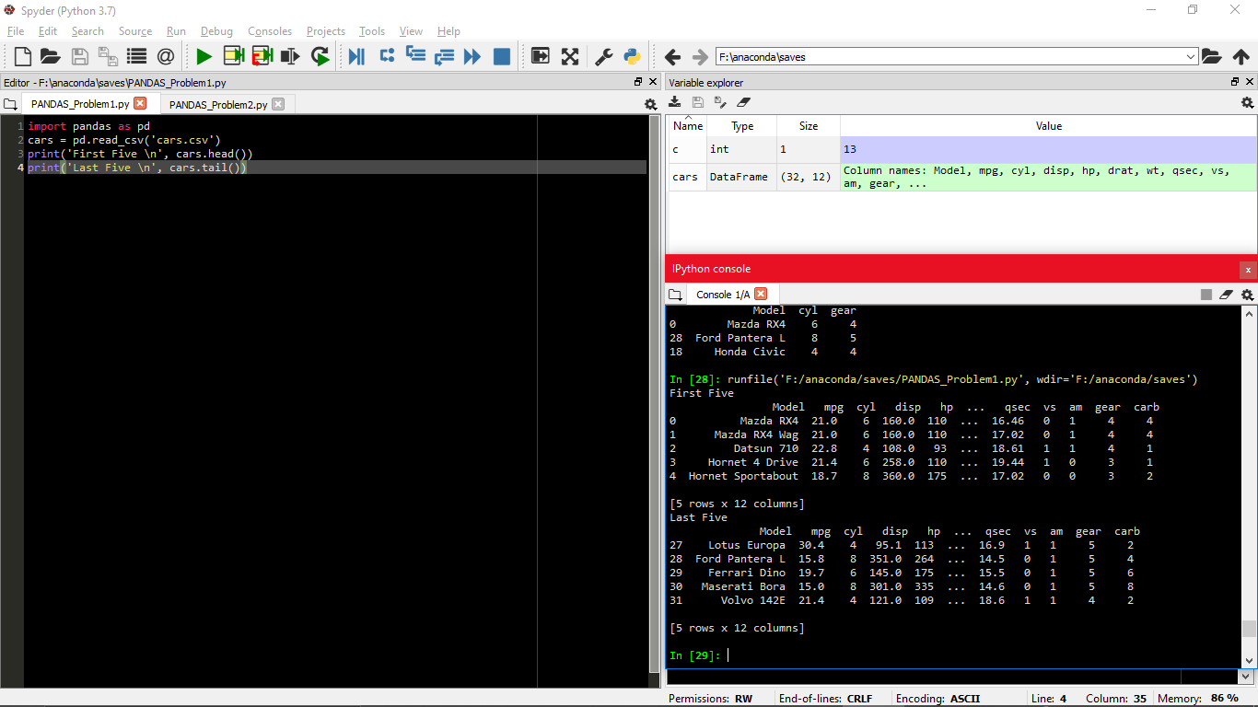

PROBLEM 2a

Screenshot answer for subproblems

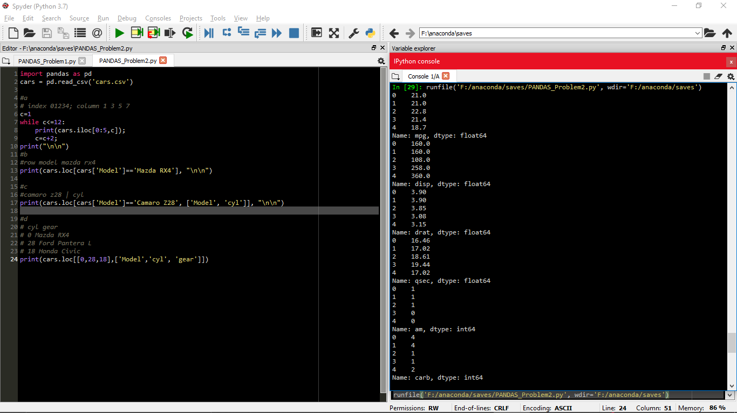

Problem 2bcd

Screenshot answer for subproblems

