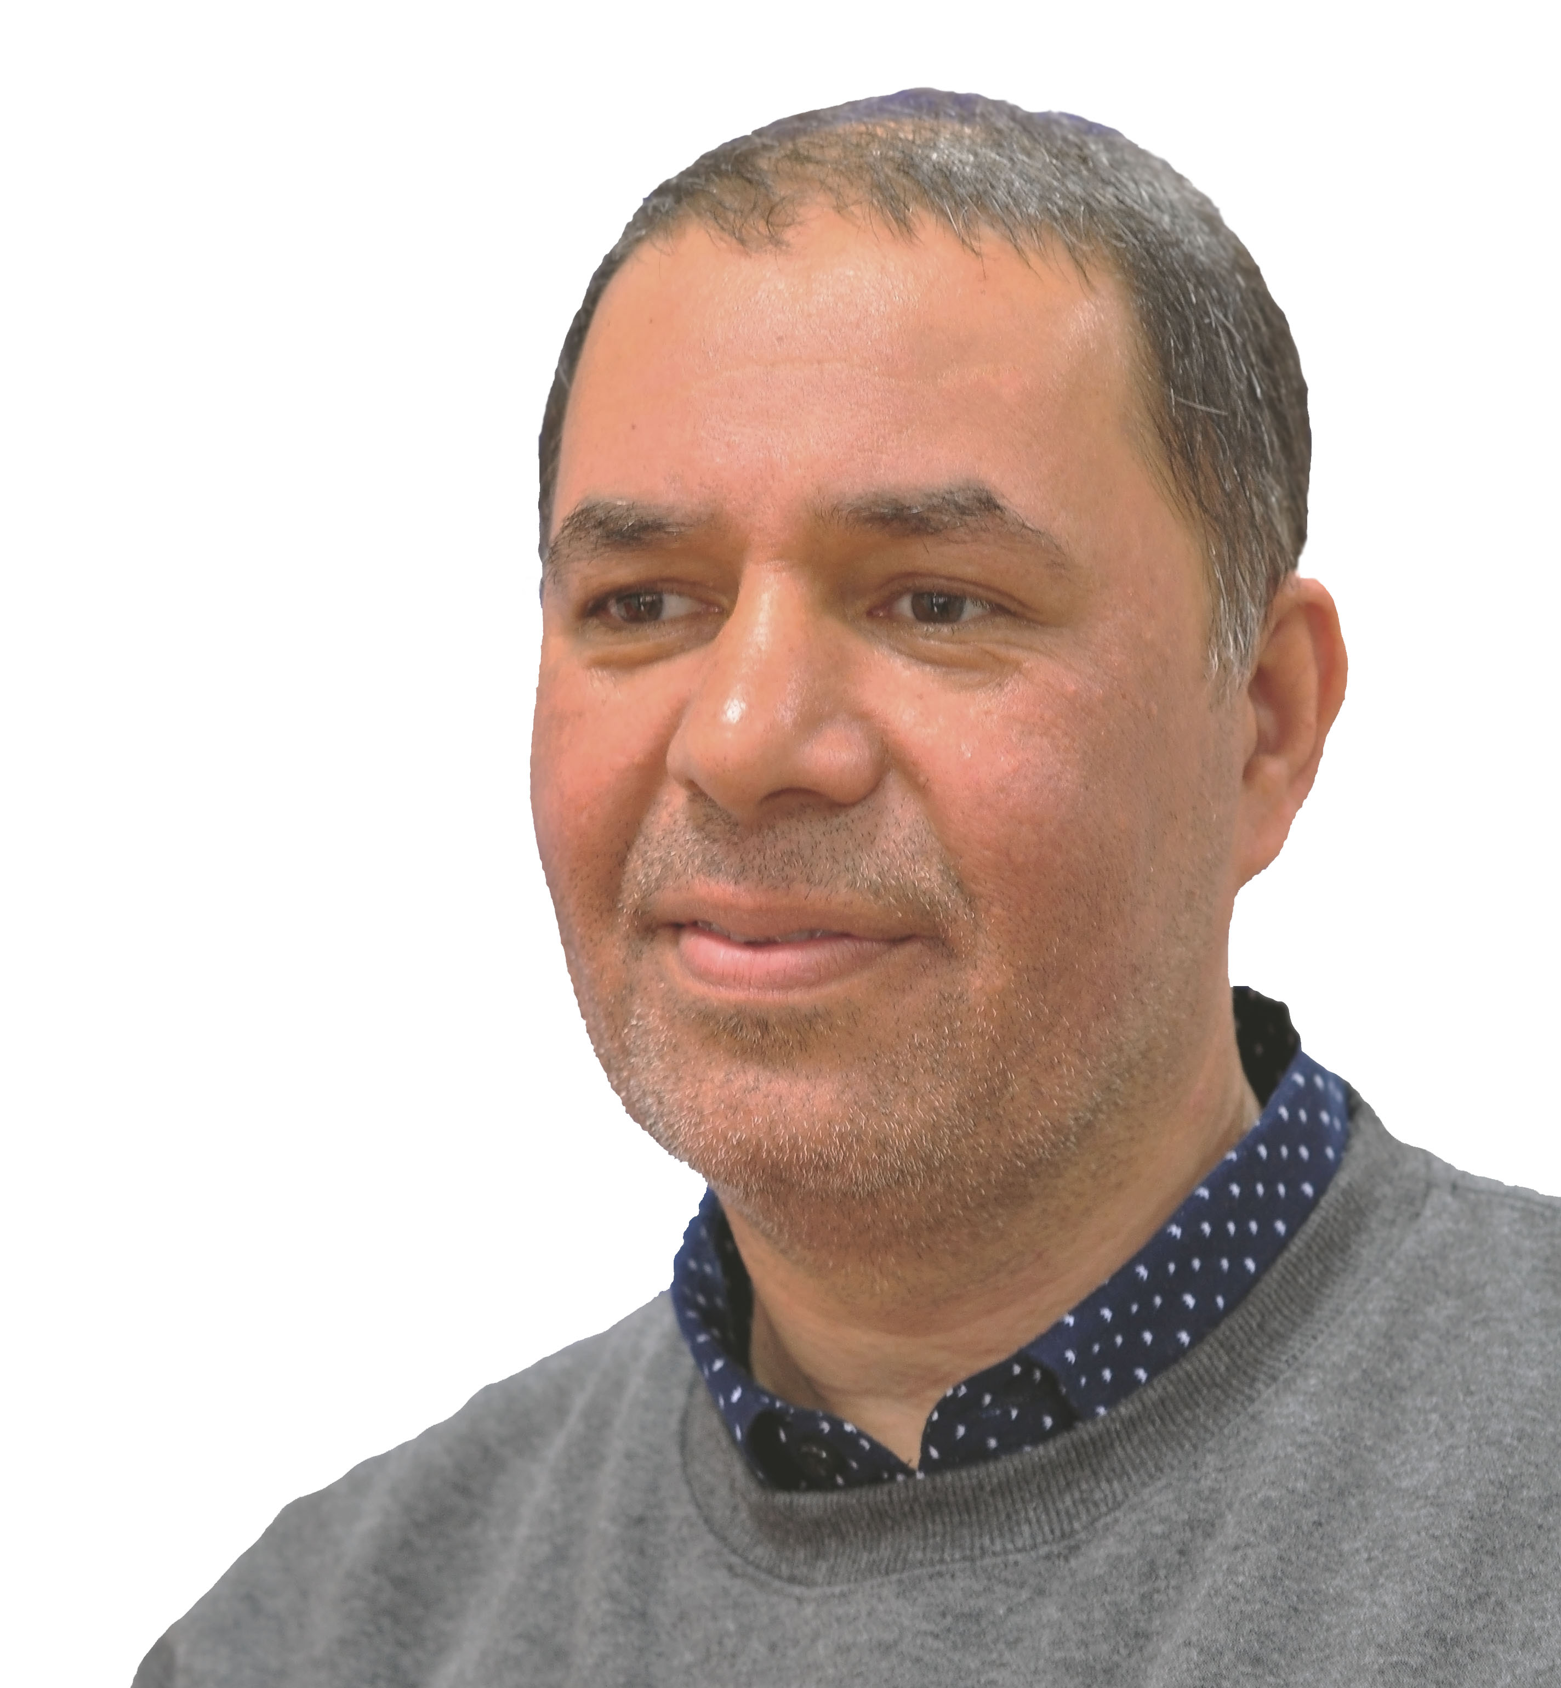
Ali Adams
Electrical and Software Engineer (1989-2003)
IT Faculty, Physics and Math Teacher (2003-2018)

Citizenship British Iraqi
Address Cardiff, Wales, United Kingdom
Email heliwave@yahoo.com
Website www.heliwave.com
Wechat heliwave
God > ∞
Career

Sep 17 – Jan 18: A-level Physics/Math Teacher
Guiyang #1 High School, Guizhou, China.
CIE Physics A-level
CIE Mathematics A-level (P1,, M1)

Sep 15 – Sep 17: A-level Physics/Math Teacher
Yancheng Foreign Language School, Jiangsu, China.
CIE Physics A-level
CIE Mathematics A-level (P1, P3, M1, S1)
CIE Mathematics Grade 2 to 9

Mar 08 – Sep 15: Numerical Researcher
UAE, Iraq, USA, UK and China
Developing open-source software for numerical and similarity research into the ever-revealing Quran. qurancode.com

Aug 09 – Jun 10: IGCSE Physics Teacher
China-UK College, Shenzhen, China.
IGCSE Physics Complete textbook by Stephen Pople, Oxford Press.

Aug 06 – Oct 08: Software Instructor
Emirates Advanced Investments, Al Ain, UAE.
Leading a team of 3 developers to build a smart client framework to dynamically generate WPF client-side container with caching management for a medical information system that connects to a C++ server using an XML/RPC middleware.

Aug 03 – Aug 06: IT Faculty
Higher Colleges of Technology, Abu Dhabi, UAE.
Teaching software development at a BSc and a HD levels with full course design and delivery, examinations, and project supervision.

Jan 03 – Aug 03: Software Developer
Scott Tod Developments, Crickhowell, Wales, UK.
Vending Machine Monitoring System using Delphi 5 and InterBase 6.

Oct 01 – Feb 02: UI Design Consultant
AWEK Integrated Systems, Gdańsk, Poland.
Automatic UI generation for using Delphi 5 and Oracle 7.4/8.

Jan 01 – Oct 01: Object Database Consultant
Versant Corporation, Basingstoke, UK.
ODBMS Proof-of-concept consultancy (and fine tuning, Java, C++).

Mar 00 - Jan 01: Senior Software Engineer
Racal Recorders Ltd, Southampton, UK.
C++/COM Telephony API for an Open Switch Interface.

Oct 96 - Mar 00: Lecturer / Demonstrator [Part-time]
Bournemouth University, UK.
MSc SE: Software Development (OOP, C++) lectures and labs.
BSc HCI: Advanced Programming (C++) lectures and labs.
BSc Project Supervision: Automatic UI Generation.

Oct 95 - Oct 96: Research Assistant
Bournemouth University, UK.
Practical evaluation of object database management systems using ObjectStore in both fine-grain and coarse granularity modes.

Education

Nov 96 – Mar 00: Ph.D. Intelligent Data [changed to part-time then abandoned]
Bournemouth University, UK. [British Telecom Sponsorship]

Fuzzy logic-based intelligent data migration to improve network responsiveness and minimize traffic. A simulation test-bed was developed in C++Builder using my own world-wide-used FuzzyLib library to evaluate a new self-organizing data management model.

Sep 93 - Sep 94: M.Sc. Software Engineering
Bournemouth University, UK. [Dorset TEC Sponsorship]

Practical investigation into object database technology using POET.
Loveline for Windows was developed in Borland C++ & OWL.

Subjects:
Software Development, Methodologies and System Architecture.

Sep 90 - Apr 91: M.Sc. Electromagnetic Engineering
Cardiff University, UK. [Higher Education Ministry Scholarship]

Subjects:
Electromagnetic Fields and Magnetic Materials.

Sep 83 - Jun 88: B.Sc. Electrical Engineering 1st rank
University of Technology, Baghdad, Iraq.

High Voltage lightening measurements and storage using Z80-based microprocessor to aid the design of a power line protection system.

Subjects:
Applied Mathematics, System Control, Electromagnetism,
Electronics, Power System Analysis, High Voltage and Physics.

Competitions

Top 3 in the 1999 European Space Agency’s SUCCESS competition in fundamental physics for my proposal of a "Time-measurement Dilation" experiment to be carried out onboard the International Space Station (ISS).

Interests

Reality = Energy + Information
In 2001, I helped extend a new theory of light called Helical Particle Waves where light travels along helical paths and gave truer meanings to the concepts of mass, electric field, magnetic moment, and light propagation.
In March 2014, a team from Japan, Ukraine and Korea proved the theory in practice. See http://heliwave.com/LightSpin.pdf

References

Richard Wu [Previous Manager]
Vice Principal
Yancheng Foreign Language School, Jiangsu, China.
Email richardwu@whccd.edu
Phone +86 181-5139-3910

John Zhang [Previous Manager]
Head of International Department
Yancheng Foreign Language School, Jiangsu, China.
Email zbwy0909@163.com
Phone +86 136-3668-3637

Shuying Chen [Research Sponsor]
CEO of PiSector Inc. www.pisector.com
Address 6 Cobb Rd, New Brunswick, NJ 08901, USA
Email info@pisector.com
Phone +1 908-868-6205

