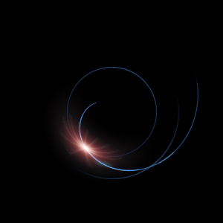

بِسْمِ ٱللَّهِ ٱلرَّحْمَٰنِ ٱلرَّحِيمِ
In the name of God, Allah,
the most Merciful qualitatively,
the most Merciful quantitatively

Helical Particle Waves
Secret of Light

Ali Adams

2009AD - 1430AH
www.heliwave.com
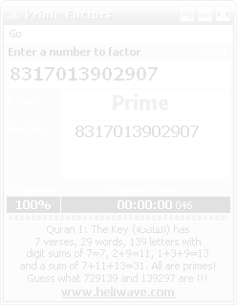

Content

Helical Particle Waves 4
Dual Nature of Light 5
Gravitons and Inertial Mass 6
Electric Charges and Magnetic Moments 7
Positive-Negative Neutrons 7
Double Helix Electromagnetic Fields 8
Nature’s Binding Forces 8
New Atomic Model 10

Helical Particle Waves
The concept of electromagnetic waves having frequency, wavelength and amplitude is easily understood today. However physicists are still today unable to explain how a stream of photons can behave as both a stream of particles and as a wave at the same time and satisfy themselves by claiming it is a mass when you look for mass and it is a wave when you look for wave properties but never at the same time. They are even unable to determine both the velocity and the position of a relativistic particle at the same time.
In his theory, Helical Particle Waves, [www.heliwave.com], Mr. J. L. Gaasenbeek proposes that all particles such as electrons, protons, and neutrons are made up of billions upon billions of photons orbiting in pairs within their particles and continuously being emitted as electric fields spiralling away along helical paths with three components of energy: forward linear motion, circular helication, and photon spin around itself as shown below:
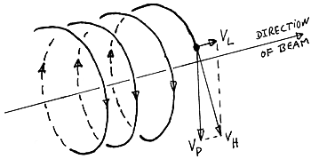
A Helical Particle Wave
Helical Particle Waves theory explains most, if not all of the observed phenomena naturally without having to resort to artificial arguments such as space-time curvature produces gravity, or magically the mass of a particle changes as a function of its velocity. It even explains that magnetism rises from the continuous spin of electrically charged particles and hence the curling of the linear motion component (the beam direction in the above diagram).
All this confusion stems from the misunderstanding of the motion of particles at relativistic velocities. Spin and helication were never taken into account when calculating the momentum and the kinetic energy of a relativistic particle and thus any excess energy had to go somewhere, so it was wrongly added to the mass even to infinity as its velocity approaches the speed of light c. That was a total falsification of reality. Such artificial concepts (e.g. time/mass/length dilation, space-time curvature) in essence turned science into a cult, which could only be understood by the selected few (the initiated).
Gaasenbeek said: “They reached the top of the wrong tree and refuse to climb down in search of the true tree of knowledge”.

Dual Nature of Light
The dual nature of light (being matter and wave at the same time) can be readily explained as a continuous stream of spinning and helicating photons forming a spring-like wave of photons; the most fundamental matter in our universe or the energy quantum of Planck’s constant (6.626×10⁻³⁴ J·s). Both wave-like and matter-like behaviors are concurrently present and do not exclude each other as assumed by current physics.
Photons consume external energy to power their three motions:
- spin motion around their own axis,
- linear motion forward limited to the speed of light c, and
- helical motion with fixed amplitude and frequency.
Accelerating a helical photon towards the speed of light increases its spin and helical moment (turning effect) not its linear momentum (velocity) because photons cannot overtake each other.
Immediately after leaving its source, a photon has to fall in step with other photons in the ocean of photons outside its source and therefore its linear velocity cannot exceed the constant speed of the light set to c (299792458 m/s) in our universe by the first formation of the photon ocean. Other universes may each have its own constant and frequency range to avoid interacting with each other and thus seem clocked to us.
Therefore, a particle’s mass does not increase to infinity with its velocity approaching the speed of light c as suggested by Relativity but instead any excess in its momentum (p = m×v) is absorbed by the increase in its spin and angular (helical) moments. This forms an intrinsic capacitor to store excess energy that cannot be transformed into further linear motion as their velocity approaches c.

Gravitons and Inertial Mass
The more energy a relativistic particle absorbs, the higher its spin moment becomes and thus gains higher resistance to directional change. That is, a stream of relativistic particles (a helical particle wave) starts to lose amplitude as the velocity at which it propagates through space approaches c. Gravitons can be thought of as photons at the highest energy possible in this universe with almost zero amplitude and thus penetrate all matter particles. Particles are giant structures of photons that continuously emit some of their photons to keep their internal orbital engine “alive” by reactive forces.
Mass is a measurement of a particle's impedance to the passage of gravity field (graviton) through its matter and is thus directly proportional to both the number of photons it is made of and the way they interlock. This is exactly what current science is missing, hence the search for God’s Particle or the Higgs boson [http://en.wikipedia.org/wiki/Higgs_boson].in the Large Hadron Collider [http://en.wikipedia.org/wiki/Large_Hadron_Collider] where scientists hope by colliding protons head on at speeds of 99.999% of c and studying the tracks of resultant fragments can reveal their new particles of higher energy that know currently.
Hadrons are large particles like protons or neutrons while Leptons are tiny particles like electrons or neutrinos. So it makes sense to use hadrons rather leptons to disintegrate and protons are used rather than neutron so their paths can be controlled by magnetic fields interacting with the positive moving electric charge (which are in essence tiny magnets).
Therefore it is suggested that the ocean of gravitons a particle swims in is the real gravity field, not the space-time curvature propose by Einstein which illogically assume time is part of reality. It must be stressed that gravity is real while time is a mere concept of before and after. No need for ideas such as time dilation as this can be easily explained by different observers observing the same event at different points in the global absolute time based on their position in the global XYZ in our Universe with respect to the event.

Electric Charges and Magnetic Moments
It is quite possible that electrons and protons start live with exactly the same number of photons giving them the same electric charge but opposite polarity (Qe⁻ ~= −1.6×10⁻¹⁹ C, Qp+ ~= 1.6×10⁻¹⁹ C) due to different internal structure arrangements. These arrangements impede gravity field differently resulting in different masses (Me⁻ ~= 9.1×10⁻³¹ kg, Mp+ ~= 1.67×10⁻²⁷ kg) [http://en.wikipedia.org/wiki/Proton and http://en.wikipedia.org/wiki/Electron].
Spinning and forward moving electrical charges distort their photon radiation paths resulting in magnetic moment (or turning effect inside the ocean of external photons). This is what magnetism is all about just as an electric conductor gives out a cylindrical magnetic field around itself when an electric current (electrons) passes through it.
On a macro level however, the half-life of a nucleus can be viewed as the stability of internal structure arrangements of protons and neutrons. The easier to disturb these arrangements, the less stable a nucleus is and its neutrons can change into protons and electrons destabilizing the whole nucleus macro structure and disintegrating it in the process into other elements or isotopes.

Positive-Negative Neutrons
Neutrons can be viewed as particles with alternating electric charge. They rapidly alternate their charge direction as their structure continuously alters its way of interlocking. When a neutron’s charge becomes positive, it repel its surrounding protons but soon it reverts back to negative pulling back the same protons. This love-hate relationship is what keeps the particles spinning (i.e. alive) and contained within the nucleus.
When gravitons bombard a particle living in this gravity ocean (or Ether as used to be called by the ancients), they either pass through without any interaction, or hit one of its photons and causes its orbital relationship with its pair to collapse, resulting in the emission of both photons along different helical paths (possibly in opposite directions).

Double Helix Electromagnetic Fields
The number of correlated helical paths and their directions (i.e. clockwise or counter clockwise) determines the characteristics of a helical photon wave. Electromagnetic fields may well be double helix photon waves, where each electric and magnetic field is a single helix wave helicating in opposite direction to the other, in a similar fashion to our genetic Deoxyribonucleic Acid (DNA) double helix [http://en.wikipedia.org/wiki/DNA].

Nature’s Binding Forces
Helical particle waves can be used to redefines nature’s binding forces as follows from weakest to strongest:
- The Gravitational Force that binds masses in the same universe. As gravitons emitted from a particle, they cause a reactive force in the opposite direction to their emission and away form their source. A mass in isolation would emit gravitons equally in all directions and therefore does not experience a resultant force. However, two masses will influence each other’s gravitational field causing each mass to emit more gravitons away than towards each other and hence resulting is a continuous but pulsating force between them and thus gravitational acceleration at the macro level.
- The Electromagnetic Force that binds electrically charged spinning particles due to the interaction between emitted photons of both particles (i.e. electrical, magnetic or electromagnetic fields).
- The Strong Nuclear Force that binds electrically charged particles of the same polarity (e.g. +ve/+ve or -ve/-ve) by continuously alternating the polarity (helication direction) of the emitted photons of the medium between them and thus continually attract and repel the particles. Neutrons inside the nucleus acts as such mediators because of their alternating positive-negative charge which glues the protons inside the nucleus and keep them from flying off. Conversely, the Weak Nuclear Force which is currently defined as the force responsible for radioactivity, or the half-life of an isotope, does not in fact exist. Instead, radioactivity can be the result of the natural photons exchange between protons and neutrons inside a nucleus as suggested above. During this process, some neutrons change their internal structure and thus become protons and electrons which result in destabilization of the nucleus and possibly the disintegration into smaller elements.
- The Gaasenbeek Force¹ is a newly proposed force that binds photons in an interlocked orbital structure resulting in a particle of a certain type. Highly energetic photons (gravitons) travelling through a particle may overcome this binding force by unlocking one of its inner orbits, which in turn may unlock its immediate surrounding orbits, and so on. This unlocking process if not controlled by the Gaasenbeek force could lead to the disintegration of the whole particle into photons only (or pure energy).
¹ In honour of J. L. Gaasenbeek, the founder of the Helical Particle Waves theory.

“The more I know, the more I realize how much more there is to know!”

New Atomic Model
How do the neutrons mediate between the repelling protons inside the nucleus? Surely strong nuclear force and its so called gluons are just a name for something more fundamental. In order to answer this question, a new atomic model is suggested. Using the Helium element let’s describe in details the inner workings of this model.
±
±
+
+
−
−
Helium Atom (²He - isotope ₄He)
At the center of the diagram there are four sphere objects making up the nucleus of the Helium atom or element. This nucleus is spinning and its internal objects are oscillating all the time. While the two [+] objects represent the two protons that determine the kind of element as Helium, the other two [±] objects represent the two neutrons that prevent these two positively charged protons from flying away.
The neutrons continuously change their charge from positive to negative and vise versa to make the protons want to leave the nucleus when the neutrons are positive only for them to come back when the neutrons become negative. This continuous pulsation within the nucleus is the strong nuclear force that binds the nucleus together instead of what current science assume to be yet another particle in the particle zoon named gluon that mysteriously glues protons and neutrons together. [http://en.wikipedia.org/wiki/Force_carrier].
Outside the nucleus, there are God-ordained, prime number-related, prefixed energy levels that house electrons. The two [−] objects represent the two electrons needed for the Helium atom to stay neutral, or else it would become a positive ion if it loses electrons to other elements or a negative ion if it gains electrons from other elements.
The electrons continuously move along their circular orbits of the same energy level forming a spherical surface over time, known as Shells. These prefixed energy levels have been shown to have a direct relationship with the distribution of prime numbers [http://www.thefreelibrary.com/Quantum+physics+may+offer+clues+to+solving+prime+number+problem:...-a0186320999
Notice how the two negative electrons are precisely aligned with the two positive protons. This configuration makes both the nucleus and the electrons spin and circulate at the same angular velocity to maximize the rate of photon interchange between them called the Electromagnetic Field.
The reason an electron does not spiral down and crash into the positively charged nucleus is that it continuously orbits at an exact speed that counteracts the attraction force with the positively charged nucleus. Although the electron wants to continue straight and away from the nucleus due to its inertia, the attraction force pulls it in to produce what is called the centripetal (or center-seeking) force.
The mystery is when an electron loses (or gain) energy and speed it ought to come gradually closer to (or go further away from) the nucleus but it doesn’t. It would only absorb energy if and only if it is sufficient to jump (with zero time) from one orbit to another which is impossible unless one electron disintegrate into photons and a new one is formed along the new orbit, or it may even suggest that we still do not understand the nature of electrons yet.
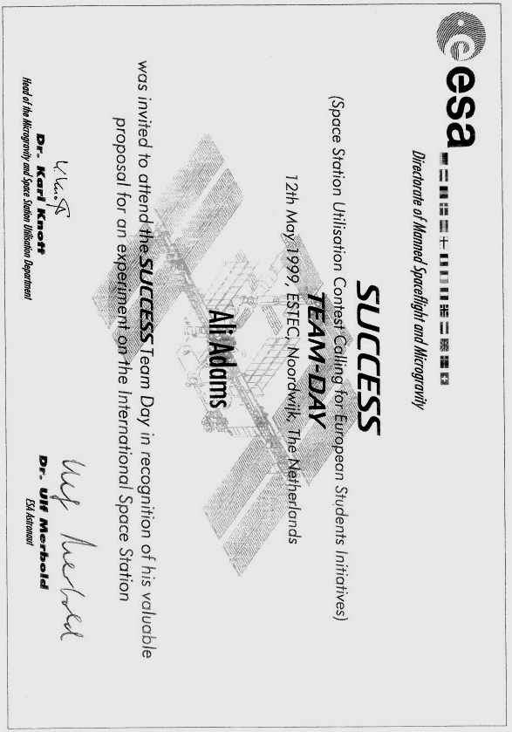
European Space Agency Invitation, 1999

The Sheeple

False has become true … and chaos has spread
Liars are upheld … and good mouths are well weld
Wisdom deserted all … but a sleepless few
Trance became the norm … and to reality blindness wed
No freethinking was left … so long as they were fed
Sleep sheep most became … buried in a borrowed bed
Wake up and uphold … what God has always said:
Don’t step over others … to reach a higher end
Love each other so … to the Truth you’d be led.

Ali Adams 2006

Please consider giving people, animals, and plants near you love, clean air, water, food, medicine, clothes, etc. and send sincere greetings to our beloved Prophet Muhammed and his progeny may Allah’s blessings be upon them all.

Allah is the only Giver and all rewards go in circles of π

www.heliwave.com

